Inferring single nucleotide activation and repression maps using deep-learning
Supplementary Tables and Figures
Selection of epigenetic datasets
To find the epigenetic features to be used in our model, we implemented a DeepTACT classification model with different inputs. Each input was composed of the sequence alone or the sequence with additional epigenetic signals (Supplemental Table 1). We analyzed the same GM12878 dataset described in the Methods section and measured the classification accuracies for silencers and enhancers. We evaluated the classification quality using the AUROC and AUPRC indexes.
Table S1. Summary of accuracies for different combinations of epigenetic datasets
Combination | AUROC enhancer | AUPRC enhancer | AUROC silencer | AUPRC silencer
Sequence (Seq.) | 0.76 | 0.29 | 0.94 | 0.76
Seq. + Methylation (Meth.) | 0.81 | 0.40 | 0.94 | 0.83
Seq. + H3K27ac | 0.87 | 0.49 | 0.95 | 0.81
Seq. + H3K27me3 | 0.81 | 0.37 | 0.95 | 0.84
Seq. + H3K4me1 | 0.90 | 0.47 | 0.96 | 0.82
Seq. + Meth. + H3K27ac | 0.90 | 0.54 | 0.96 | 0.85
Seq. + Meth. + H3K27me3 | 0.85 | 0.46 | 0.96 | 0.84
Seq. + Meth. + H3K4me1 | 0.91 | 0.52 | 0.96 | 0.83
Seq. + H3K27ac + H3K27me3 | 0.89 | 0.52 | 0.95 | 0.84
Seq. + H3K27ac + H3K4me1 | 0.90 | 0.52 | 0.96 | 0.84
Seq. + H3K27me3 + H3K4me1 | 0.90 | 0.49 | 0.96 | 0.84
Seq. + Meth. + H3K27ac + H3K4me1 | 0.92 | 0.54 | 0.96 | 0.85

Supplemental Figures
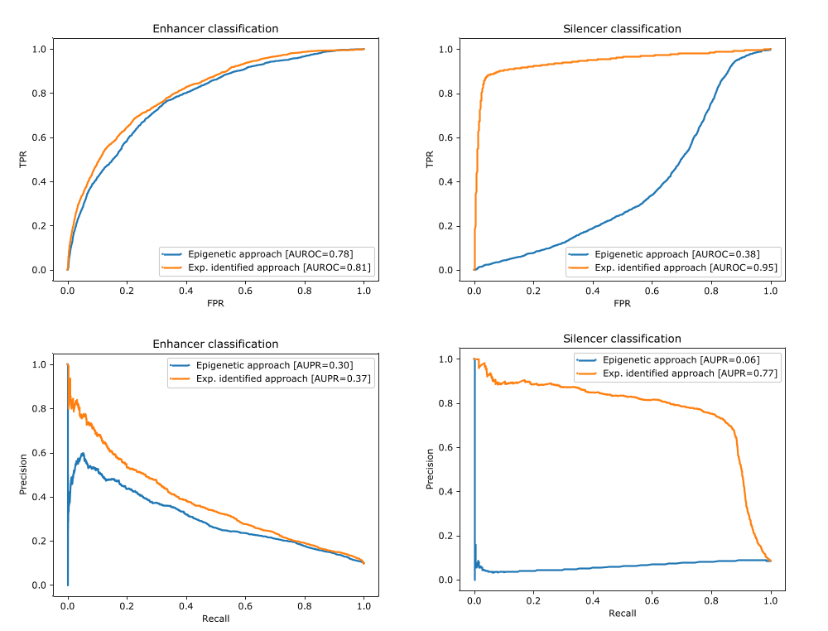
Figure S1. Performance of CNN models in predicting experimentally identified regulatory elements in GM12878. We trained the CNN models twice: first using putative enhancers and silencers defined based on epigenetic marks, and second, using the elements experimentally identified by ATAC-STARR-Seq in this cell line. Both approaches were tested for their ability to correctly detect experimentally identified elements.

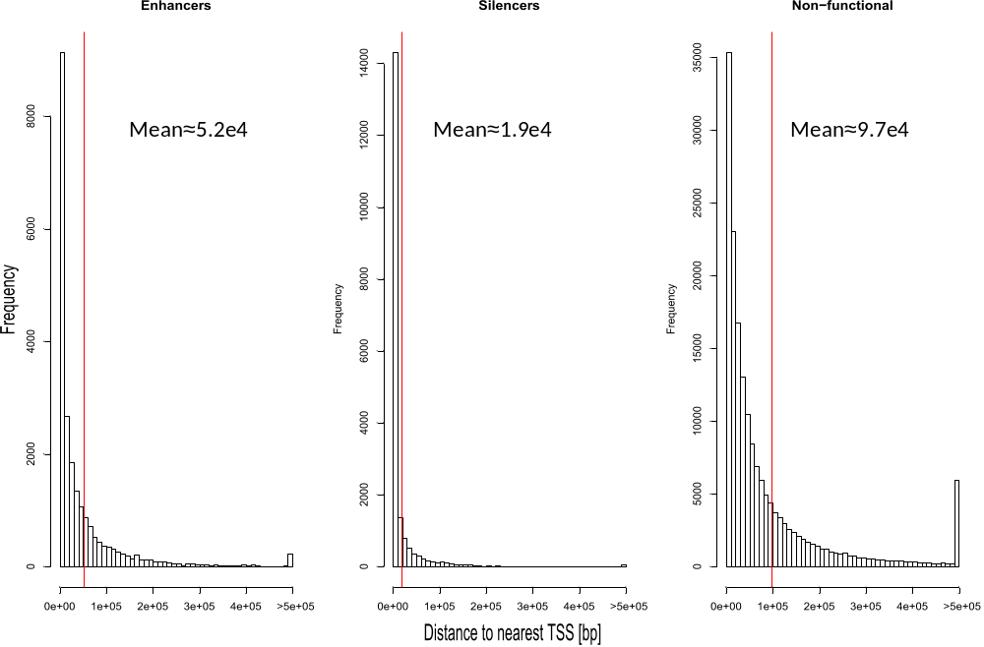
Figure S2. Distance to nearest TSS. Enhancers, silencers and non-functional distances to the TSS of their nearest gene. Vertical red line denotes the mean distance.

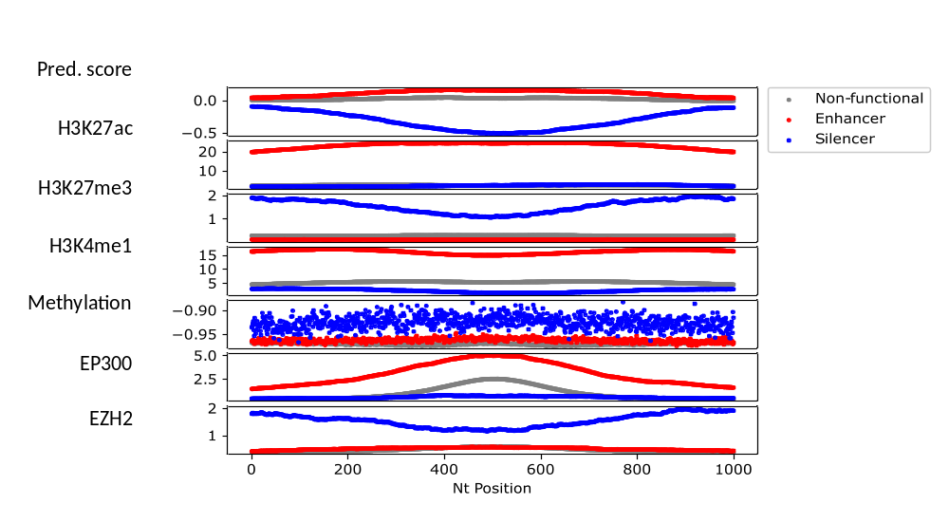
Figure S3. Summary of epigenetic markers in the exploratory set. Top to bottom: predicted scores (output of Step1 – the regression model), H3K27ac, H3K27me3, H3K27me1, Methylation, EP300 and EZH2. Predicted enhancers, silencers and nonfunctional are marked by red, blue and grey colors, respectively. In each predicted class and each track, the average signal per position in the 1kb sequences is shown. In b, the grey curve overlaps the blue curve for H3K27ac and the red curve for the EZH2.
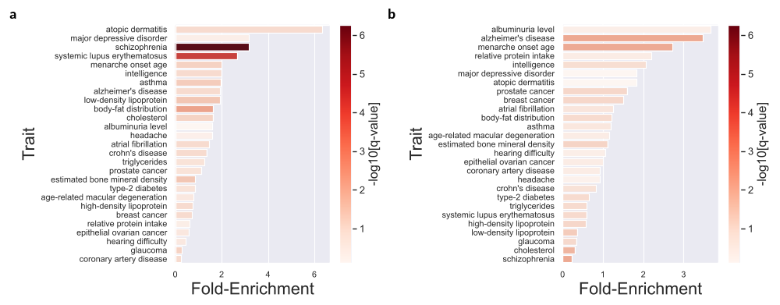
Figure S4. GWAS enrichment in the experimentally identified (a) enhancers and (b) silencers.

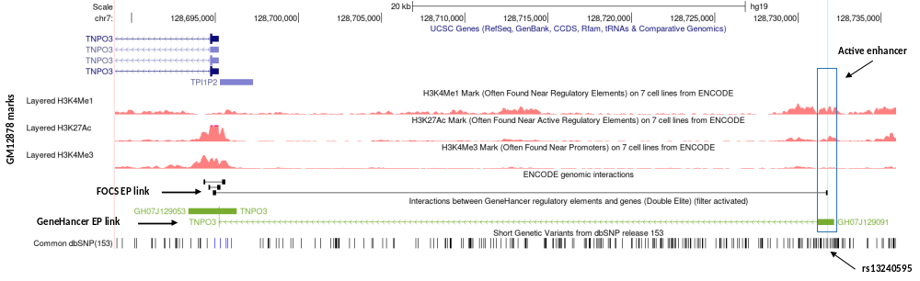
Figure S5. UCSC genome browser tracks of SLE risk SNP, rs13240595 (marked in arrow), falling within a predicted active enhancer linked to TNPO3 gene.

a | 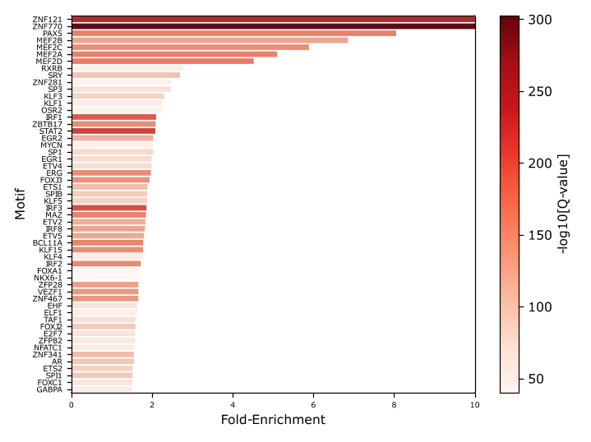
b | 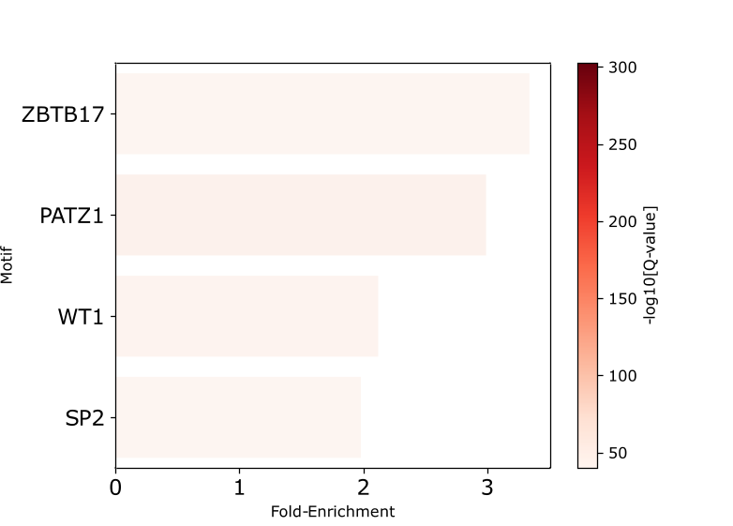
Figure S6. Motif enrichment. Enriched motifs within predicted (a) enhancers and (b) silencers.

a | 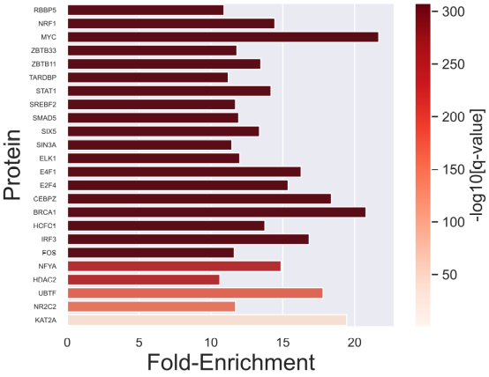
b | 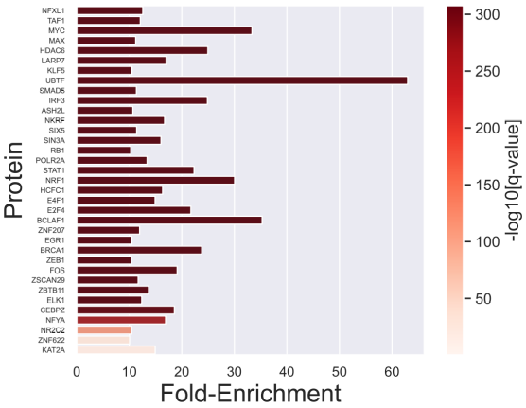
Figure S7. ChIP-seq enrichment in the experimentally identified sets of (a) Enhancers and (b) Silencers.

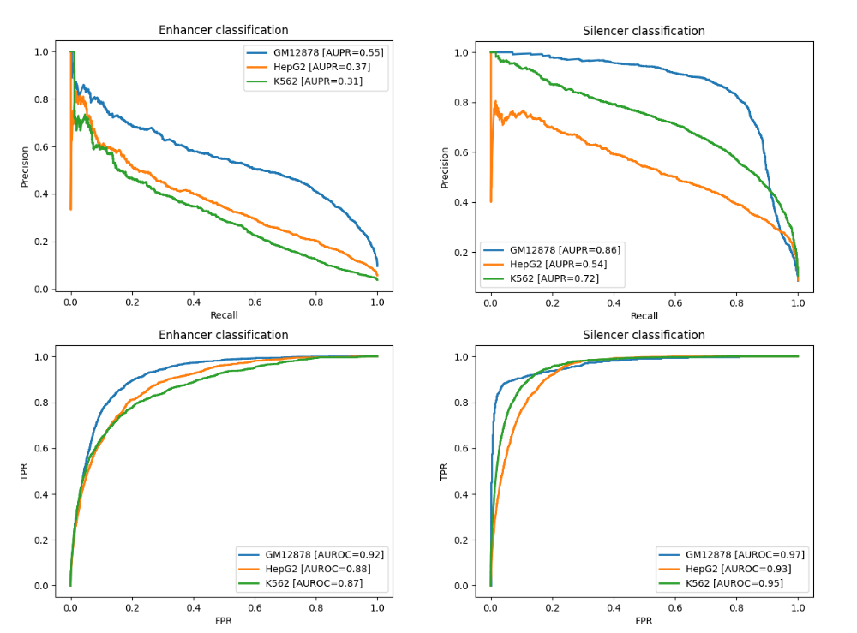
Figure S8. Performance of transfer learning of GM12878 model to K562 and HepG2 cell lines. Original GM18278 performances are in blue curves.

References
1. Huang,D. and Ovcharenko,I. (2022) Enhancer-silencer transitions in the human genome. Genome Res., 32, 437–448.
2. Hansen,T.J. and Hodges,E. (2022) ATAC-STARR-seq reveals transcription factor--bound activators and silencers within chromatin-accessible regions of the human genome. Genome Res., 32, 1529–1541.

