Supplementary Figure and legends

S-Figure 1

S-Fig. 1 Altered synaptic connection of excitatory and inhibitory synapses in hippocampal CA1 of Scn2a-deficient (HOM) mice from early development to adulthood. (A) Representative images of colocalized excitatory synaptic puncta (VGLUT1 + PSD95) in WT and HOM mice. Pre-synaptic markers were in green, and post-synaptic markers were in red. Scale bar: 10 μm. (B-E) Quantitation of colocalized pre and post-synaptic markers VGLUT1 + PSD95, at P5 (B), P10 (C), P30 (D), P>90 (E). Unpaired student’s t-test, n=17/5 mice for both genotypes. (F) Representative images of colocalized excitatory synaptic puncta (Synapsin1/2 + Homer1) in WT and HOM mice. (G-J) Quantitation of colocalized pre and post-synaptic markers Synapsin1/2 + Homer1 at P5 (G), P10 (H), P30 (I), P>90 (J). Unpaired student’s t-test, n=17/5 mice for both genotypes. (K) Representative images of colocalized inhibitory synaptic puncta (VGAT + Gephyrin) in WT and HOM mice. (L-O) quantitation of colocalized pre and post-synaptic markers VGAT + Gephyrin at P5 (L), P10 (M), P30 (N), P>90 (O). Unpaired student’s t-test, n=17/5 mice for both genotypes. Results are presented as mean ± standard error of the mean (SEM). p<0.01 (**), and p<0.001 (***). ns means not significant.

S-Figure 2

S-Fig. 2 Dendritic spine morphology in hippocampal CA1 of Scn2a-deficient (HOM) mice during the development. (A-C) Quantitation of different types of basal spine morphology to total basal spine at P5 (A), P10 (B), and P30 (C). Unpaired student’s t-test, P5: WT, n=40 cells/5 mice; HOM, n=40 cells/5 mice. P10: WT, n=40 cells/5 mice; HOM, n=40 cells/5 mice. P30: WT, n=40 cells/5 mice; HOM, n=40 cells/5 mice. (D-F) Quantitation of different types of apical spine morphology to total basal spine at P5 (D), P10 (E), and P30 (F). Unpaired student’s t-test, P5: WT, n=40 cells/5 mice; HOM, n=40 cells/5 mice. P10: WT, n=40 cells/5 mice; HOM, n=40 cells/5 mice. P30: WT, n=40 cells /5 mice; HOM, n=40 cells /5 mice. Mature spine types: mushroom; immature spine types: thin, stubby, and filopodia spine. Results are presented as mean ± standard error of the mean (SEM). P<0.05 (*), p<0.01 (**), and p<0.001 (***), and ns means not significant.

S-Figure 3

S-Fig. 3 Altered morphology of microglia in the medial prefrontal cortex of adult Scn2a-deficient (HOM). (A) Representative images of Iba1 labeled microglia in the medial prefrontal cortex from each genotype. Left two panels scale bar: 40 μm, right two panels scale bar: 20 μm. (B) Quantitation of microglial cell body area from each genotype. Unpaired student’s t-test, WT, n=20 cells/5 mice; HOM, n=20 cells/5 mice. (C) Quantitation of the number of microglial branches from each genotype. Unpaired student’s t-test, WT, n=20 cells/5 mice; HOM, n=20 cells/5 mice. (D) Quantitation of the total length of the microglial process from each genotype. Unpaired student’s t-test, WT, n=20 cells/5 mice; HOM, n=20 cells/5 mice. Results are presented as mean ± standard error of the mean (SEM). p<0.05 (*), and p<0.001 (***).

S-Figure 4

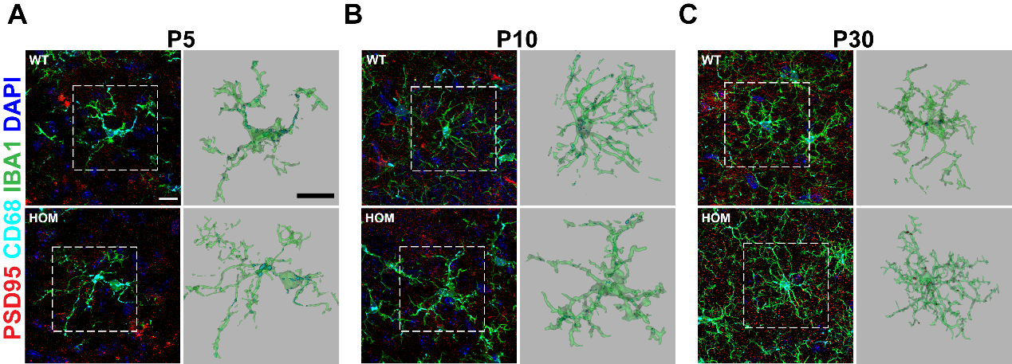

S-Fig. 4 PSD95/CD68/IBA1 immunolabeling. (A-C) Representative images of post-synapse engulfment by hippocampal microglia at P5 (A), P10 (B), and P30 (C). Scale bar: 10 μm.

S-Figure 5

S-Fig. 5 Complement components C1q localized to post-synapses in hippocampal CA1 of Scn2a-deficient (HOM) mice during the development. (A) Representative images of hippocampal CA1 immunolabeled with post-synaptic PSD95 (red) and complement component C1q (green) at P5 from each genotype. Scale bar: 10 μm. (A1) Quantitation of colocalized puncta of C1q with PSD95 at P5. Unpaired student’s t-test, n=12/3 mice for both genotypes. (B) Representative images of hippocampal CA1 immunolabeled with post-synaptic PSD95 (red) and complement component C1q (green) at P10 from each genotype. Scale bar: 10 μm. (B1) Quantitation of colocalized puncta of C1q with PSD95 at P10. Unpaired student’s t-test, n=12/3 mice for both genotypes. (C) Representative images of hippocampal CA1 immunolabeled with post-synaptic PSD95 (red) and complement component C1q (green) at P30 from each genotype. Scale bar: 10 μm. (C1) Quantitation of colocalized puncta of C1q with PSD95 at P30. Unpaired student’s t-test, n=12/3 mice for both genotypes. (D) Representative images of hippocampal CA1 immunolabeling of C1q deposits from each genotype. Scale bar: 20 μm. (D1) Quantitation of the number of C1q deposits. Unpaired student’s t-test, n=12/3 mice for both genotypes. Results were presented as mean ± SEM. p<0.05 (*), p<0.01 (**), and p<0.001 (***), and ns means not significant.

S-Figure 6

S-Fig. 6 Microglia depletion during development enhances neural transmission and spine density of hippocampal pyramidal neurons of WT mice. (A) Representative mEPSCs recordings of hippocampal CA1 pyramidal neurons from each group. Scale bars, 20 pA (vertical) and 200 ms (horizontal). (B) Quantitation of mEPSCs frequency from each group. Unpaired student’s t-test, WT with control chow: n=18 cells/3 mice; WT with PLX3397 chow: n=18 cells/3 mice. (C) Associated cumulative probability from each group. (D) Representative images of Golgi-stained apical dendrites of hippocampal CA1 pyramidal neurons from each group. Scale bar: 10 μm. (E) Quantitation of the spine density of apical dendrites of hippocampal CA1 neurons from each group. Unpaired student’s t-test, WT with control chow: n=33 cells/4 mice; WT with PLX3397 chow: n=36 cells/4 mice. Results were presented as mean ± SEM. p<0.001 (***).

