Supporting Information
Ruthenate perovskite with face-sharing motifs for sustainable alkaline hydrogen evolution

Chuanhui Zhu,^{a,b,c,#} Hao Tian,^{b,c,#} Pengfei Tan,ª Bin Huang,^{a,d} Shuang Zhao,ª Guo-Hong Cai,ª Chongyang Yuan,ª Mei-Huan Zhao,ª Meng Cao,^{b} Jianfa Zhao,^{e} Shi Luchuan,^{e} Haili Song,ª Keke Huang,^{f} Shouhua Feng,^{f} Mark Croft,^{g} Chang-Qing Jin,^{e} Shuk-Yin Tong,^{b,h,}* Man-Rong Li^{a,i,}*

ª Key Laboratory of Bioinorganic and Synthetic Chemistry of Ministry of Education, School of Chemistry, Sun Yat-Sen University, Guangzhou 510275, P. R. China
E-mail: limanrong@mail.sysu.edu.cn
^{b} School of Science and Engineering, The Chinese University of Hong Kong, Shenzhen 518172, P. R. China
E-mail: tongsy@cuhk.edu.cn
^{c} School of Chemistry and Materials Science, University of Science and Technology of
China, Hefei 230026, P. R. China
^{d} School of Computer Science and Technology, Dongguan University of Technology, Dongguan 523808, P. R. China
^{e} Beijing National Laboratory for Condensed Matter Physics, Institute of Physics, Chinese Academy of Sciences, Beijing 100190, P. R. China
^{f} State Key Laboratory of Inorganic Synthesis and Preparative Chemistry, International Joint Research Laboratory of Nano Micro Architecture Chemistry (NMAC), College of Chemistry, Jilin University, Changchun 130012, P. R. China
^{g} Department of Physics and Astronomy, Rutgers, The State University of New Jersey, 136 Frelinghuysen Road, Piscataway, New Jersey 08854, USA
^{h} Institute of Materials Science and Devices, Suzhou University of Science and Technology, Suzhou 215009, P. R. China
^{i} School of Chemistry and Chemical Engineering, Hainan University, Haikou 570228, P. R. China
# These authors contributed equally.
Supplementary Figures
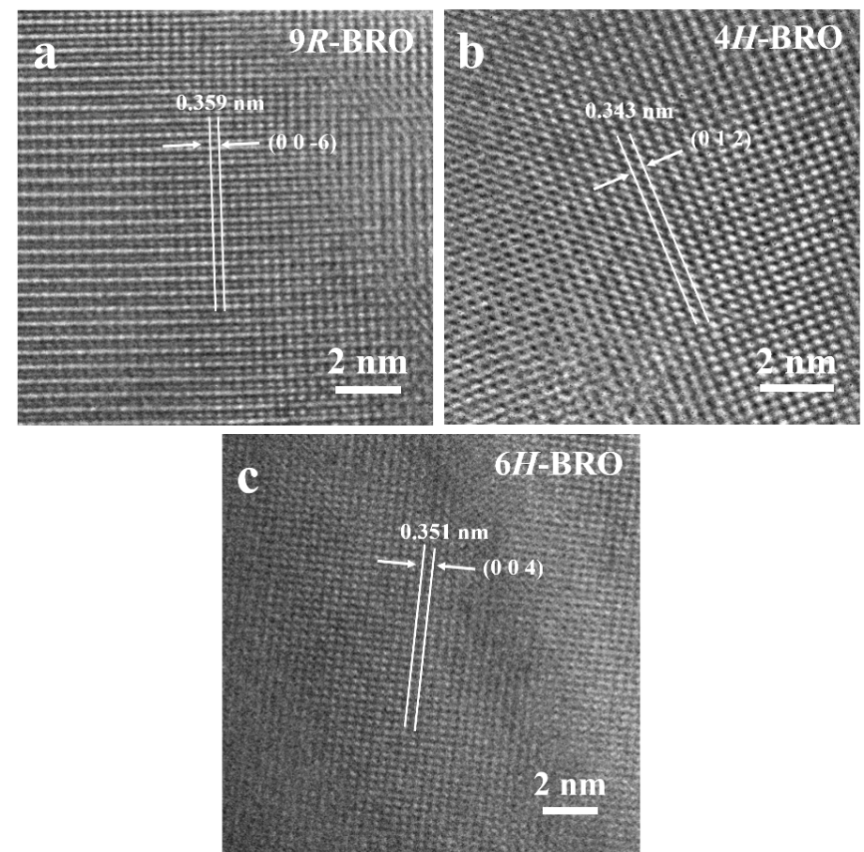
Figure S1. HRTEM images of different BaRuO₃ polymorphs. (a) 9R-BRO; (b) 4H-BRO; (c) 6H-BRO.

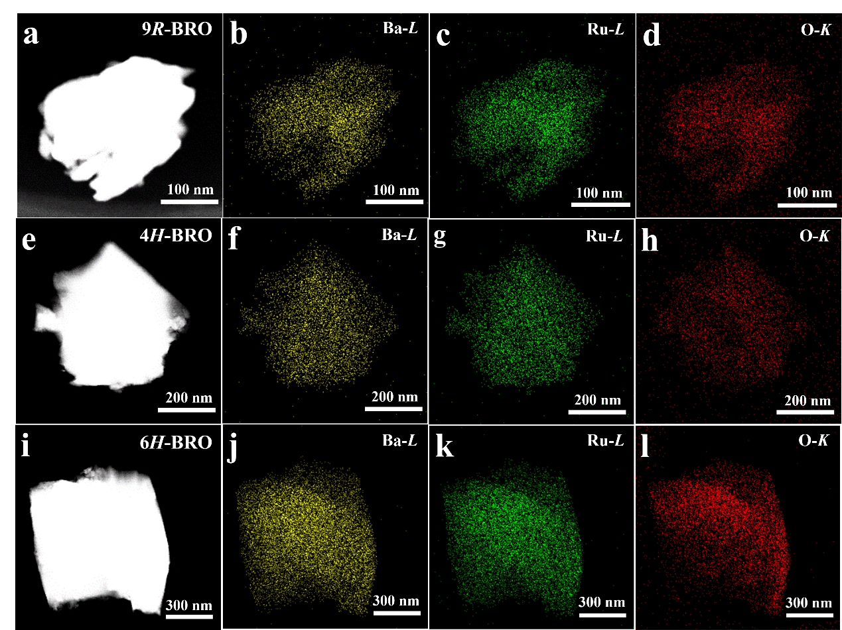
Figure S2. Elemental-mapping of (a-d) 9R-BRO; (e-h) 4H-BRO; (i-l) 6H-BRO.

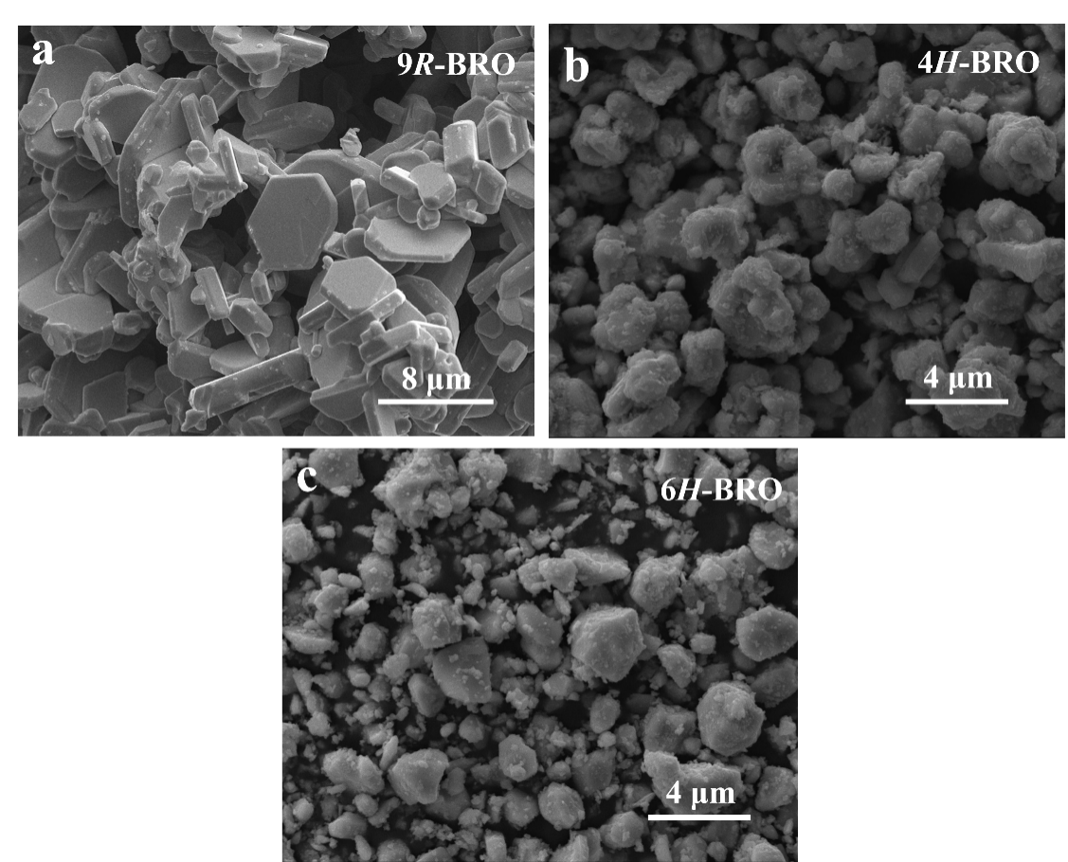
Figure S3. SEM images of (a) 9R-BRO; (b) 4H-BRO; (c) 6H-BRO.

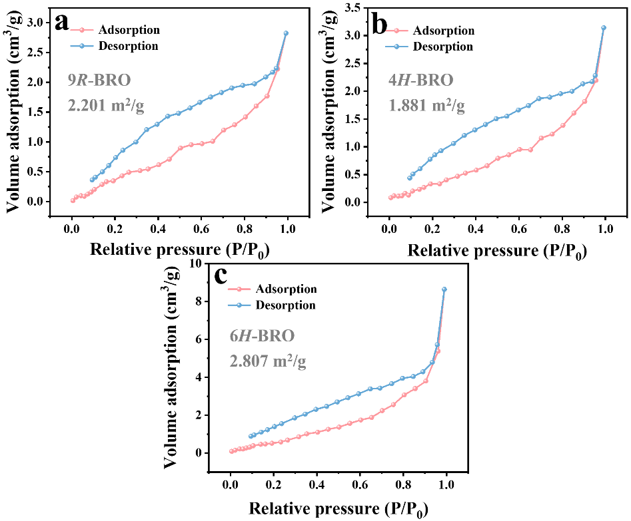
Figure S4. Brunauer-Emmett-Teller measurements of (a) 9R-BRO; (b) 4H-BRO; (c) 6H-BRO.

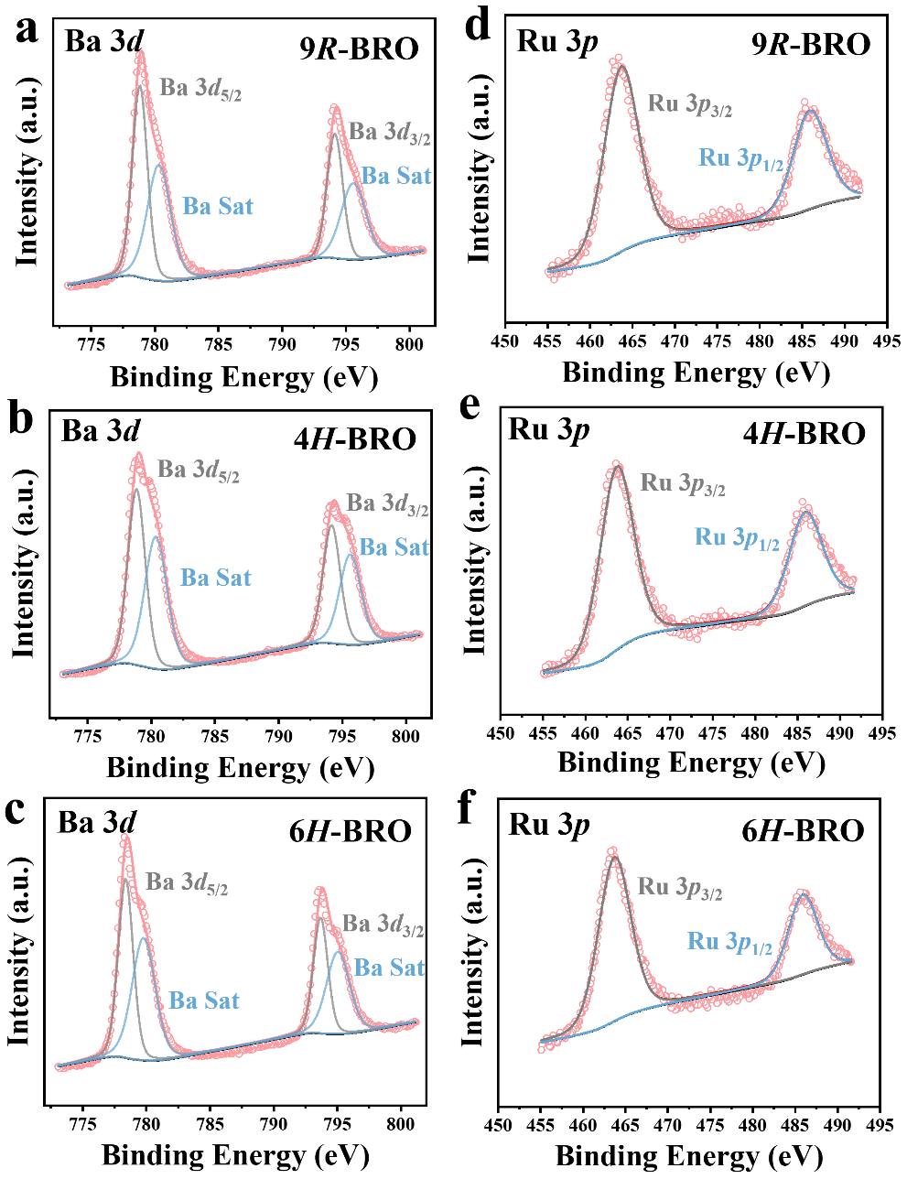
Figure S5. XPS spectra showing Ba 3d and Ru 3p core level peak regions of different BaRuO₃ phases.

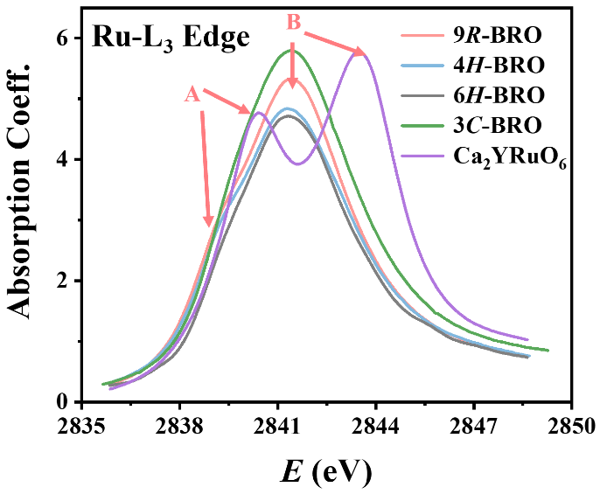
Figure S6. Normalized Ru L₃-edge XANES of the different phases of BaRuO₃ compared to the Ru⁵⁺ standard Ca₂YRuO₆. Note the A (t_{2g}-final state) and B (e_{g}-final state) features.

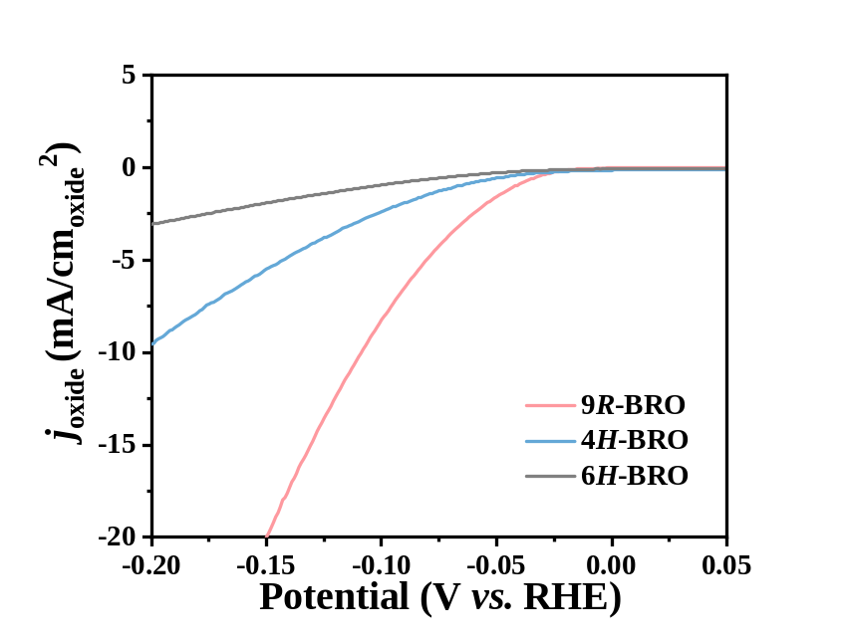
Figure S7. Specific activity normalized to BET surface area of the different phases of BaRuO₃.

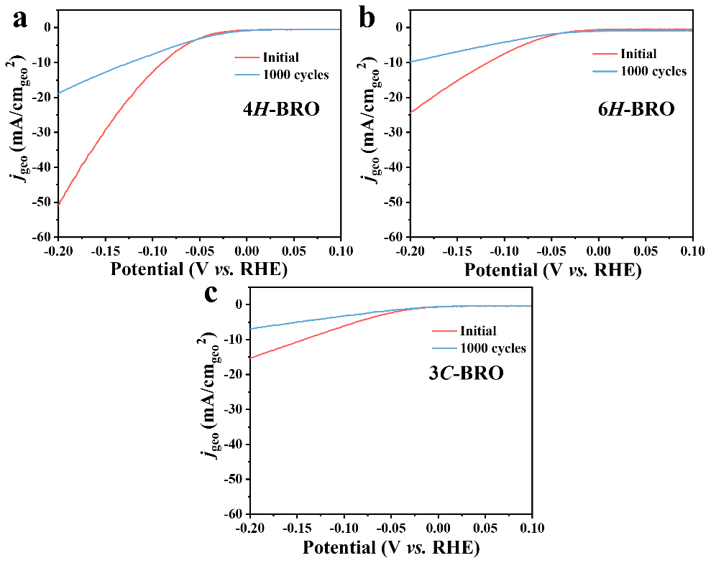
Figure S8. The polarization curves of (a) 4H-, (b) 6H- and (c) 3C-BRO catalyst before and after 1000 cycles of voltammetry operation.

Figure S9. XPS spectra for Ru 3p of 9R-BRO and PXD patterns before and after the 1,000 cycles voltammetry operation and leaching in 1 M KOH and 1 M HCl for 2 weeks.

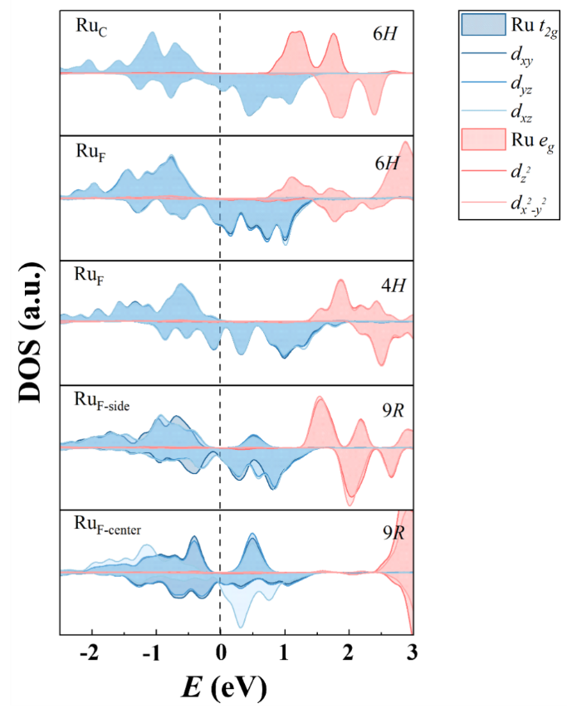
Figure S10. Ru 4d-state in BaRuO₃ polymorphs. The subscript “center” and “side” denote as central atom and sideward atom in the Ru₃O₉ trimer for 9R-BRO, respectively. The blue and red curves indicate t_{2g}- and e_{g}-orbitals, respectively.

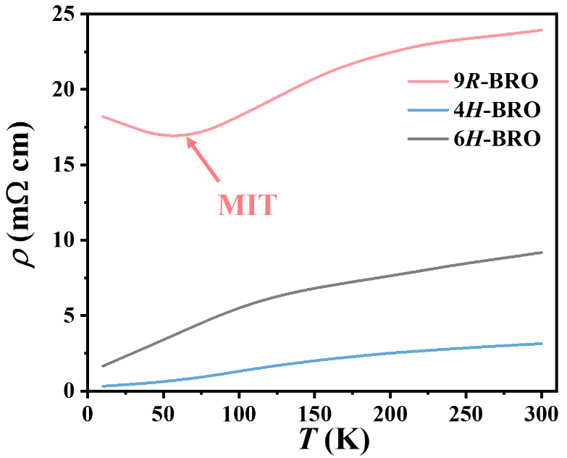
Figure S11. Temperature dependences of electrical resistivity for the different BRO-polymorphs. MIT refers to metal-insulator transition.

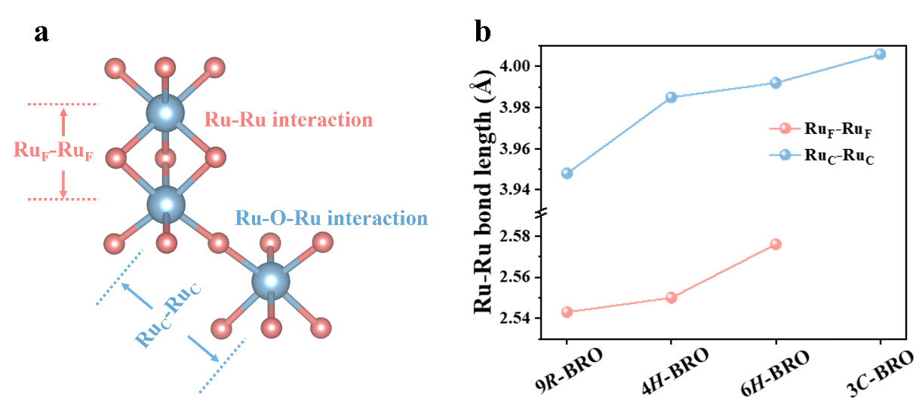
Figure S12. (a) Building blocks of RuO₆ of BRO, the subscripts “F” and “C” denote face- and corner-shared octahedra, respectively. (b) Selected Ru-Ru bond lengths in face-shared and corner-shared octahedra for the different BRO-polymorphs.

Supplementary Tables
Table S1. Unit cell parameters, atomic coordinates and atomic displacement parameters for the 9R-, 4H-, 6H-, and 3C-polymorphs of BaRuO₃ at room temperature.

Sample | 9R-BRO | 4H-BRO | 6H-BRO | 3C-BRO
Space Group | R-3mH | P6₃/mmc | P6₃/mmc | Pm-3m
a, Å | 5.75085(5) | 5.74197 (3) | 5.73201(10) | 4.00593(1)
c, Å | 21.61277(2) | 9.52340 (7) | 14.0843(3) | /
V, Å³ | 619.018(14) | 271.922 (4) | 400.757(16) | 64.285(1)
Ba1 (x, y, z) | 0, 0, 0 | 0, 0, 0 | 0, 0, 1/4 | 0, 0, 0
B_{iso}, Å² | 1.03(2) | 1.07(4) | 0.83(8) | 0.28(1)
Ba2 (x, y, z) | 0, 0, 0.2181(1) | 1/3, 2/3, 1/4 | 1/3, 2/3, 0.0899(1) | /
B_{iso}, Å² | 1.03(2) | 1.07(4) | 0.94(4) | /
Ru1 (x, y, z) | 0, 0, 1/2 | 2/3, 1/3, 0.1161(2) | 0, 0, 0 | 1/2, 1/2, 1/2
B_{iso}, Å² | 0.69(3) | 0.52(5) | 1.34(12) | 0.12(1)
Ru2 (x, y, z) | 0, 0, 0.3830(1) | / | 1/3, 2/3, 0.6586(1) | /
B_{iso}, Å² | 0.69(3) | / | 0.88(5) | /
O1 (x, y, z) | 1/2, 0, 0 | 1/2, 1/2, 0 | 0.5168(9), -x, 1/4 | 1/2, 1/2, 0
B_{iso}, Å² | 1.19(6) | 1.32(12) | 1.2(2) | 0.49(5)
O2 (x, y, z) | 0.1561(5), 1-x, 0.5609(3) | 0.3602(7), x/2, 1/4 | 0.8355(8), -x, 0.0819(5) | /
B_{iso}, Å² | 1.19(6) | 1.32(12) | 1.89(18) | /
R_{p}/R_{wp}/% | 4.33/4.45 | 5.43/9.50 | 4.02/5.05 | 6.54/8.44

Table S2. Selected interatomic distances (Å), octahedral distortion parameter (Δ), bond valence sums (BVS) calculations, and bond angles (º) in the crystal structure for the 9R-, 4H-, 6H-, and 3C-polymorphs of BaRuO₃ at room temperature.

Sample | 9R-BRO | 4H-BRO | 6H-BRO | 3C-BRO
RuO₆
Ru1-O | O2, 2.000(3)×6 | O1, 1.992(1)×3 | O2, 1.999(5)×6 | 2.003(1)×6
 |  | O2, 1.987(4)×3
< Ru1-O> | 2.000(3) | 1.989(5) | 1.999(5) | 2.003(1)
Δ*10⁻⁶ | 0 | 1.64 | 0 | 0
BVS | 3.80 | 3.91 | 3.81 | 3.78
Ru2-O | O1, 1.974(6)×3 | / | O1, 1.968(3)×3 | /
 | O2, 2.036(8)×3 | / | O2, 1.994(4)×3 | /
< Ru2-O> | 2.005(5) | / | 1.981(1) | /
Δ*10⁻⁶ | 239.05 | / | 43.06 | /
BVS | 3.76 | / | 4.01 | /
< Ru-O> | 2.002(5) | 1.989(5) | 1.980(1) | /
BaO₁₂
Ba1-O | O1, 2.879(1)×6 | O1, 2.871(1)×6 | O1, 2.871(4)×6 | 2.833(1)×12
 | O2, 2.974(3)×6 | O2, 2.979(1)×6 | O2, 2.876(4)×6
< Ba1-O> | 2.926(5) | 2.925(1) | 2.873(5) | 2.833(1)
BVS | 2.14 | 2.15 | 2.44 | 2.72
Ba2-O | O1, 2.998(6)×3 | O1, 2.901(1)×6 | O1, 2.898(3)×3 | /
 | O2, 2.940(7)×3 | O2, 2.874(5)×6 | O2, 2.944(7)×3 | /
 | O2, 2.884(1)×6 |  | O2, 2.868(6)×6 | /
< Ba2-O> | 2.926(5) | 2.887(5) | 2.894(5) | /
BVS | 2.14 | 2.35 | 2.31 | /
< Ba-O> | 2.926(5) | 2.906(1) | 2.883(5) | /
Ru_{F}-Ru_{F} | 2.525(2) | 2.550(1) | 2.576(3) | /
Ru_{C}-Ru_{C} | 3.948(9) | 3.985(1) | 3.992(1) | 4.006(1)
Ru_{F}-O-Ru_{F} | 78.1(2) | 79.8(2) | 81.8(2) | /
Ru_{C}-O-Ru_{C} | 180.0(0) | 180.0(0) | 177.6(3) | 180.0(0)

Table S3: Mass activity (A/g) and price activity (A/$) for 9R-BRO, Pt/C, RuO₂ and Nano-Ni
Sample | Mass activity (A/g) | Price ($/g) | Price activity (A/$)
9R-BRO | 180.3 | 6.8 | 26.5
Pt/C | 137.8 | 31 | 4.4
RuO₂ | 97.4 | 26.5 | 3.7
Nano-Ni | 2.9 | 4.1 | 0.7

