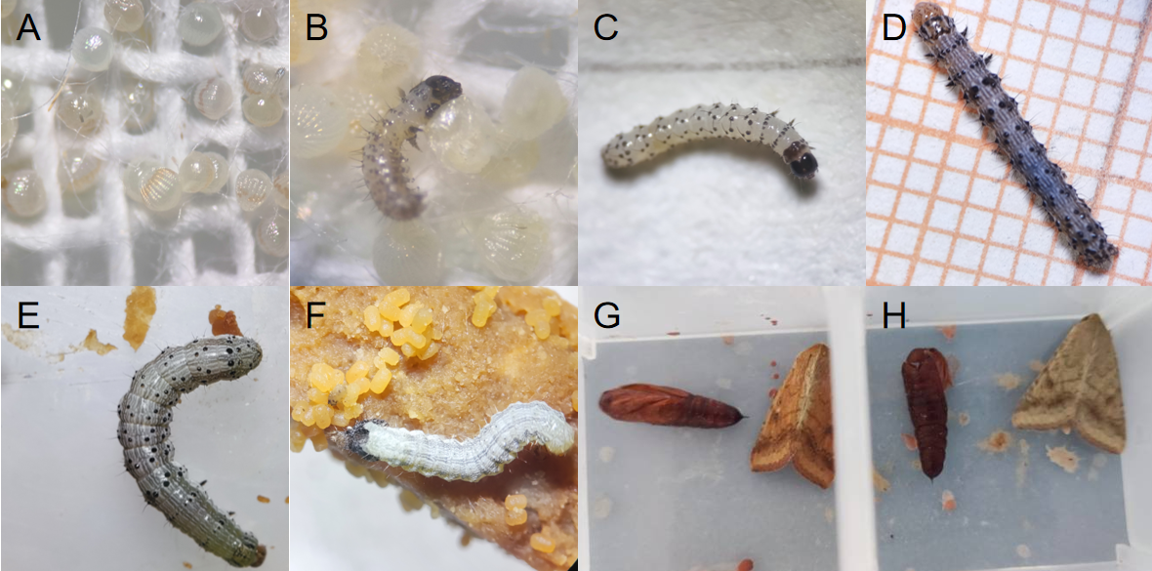
S1. Laboratory Artificial Feeding of Cotton Bollworm Insects(A: egg; B: first instar larvae; C:second instar larvae; D: third instar larvae; E: fourth instar larvae; F: fifth instar larvae; G: female adults and pupae; H: male adults and pupae)

