Supplementary Information
In support of
Tracking the first electron transfer step at the donor side of oxygen-evolving photosystem II by time-resolved infrared spectroscopy
Mohamad Yahia Dekmak¹, Sarah M. Mäusle^{1, *}, Janosch Brandhorst¹, Philipp S. Simon^{1,2}, Holger Dau^{1, *}
1 Department of Physics, Freie Universität Berlin, Berlin, Germany.
2 Molecular Biophysics and Integrated Bioimaging Division, Lawrence Berkeley National Laboratory, Berkeley, CA, USA.
* Authors to whom correspondence should be addressed:
holger.dau@fu-berlin.de; sarah.maeusle@fu-berlin.de

1. P680⁺ Transients: Details on the Fitting Procedure and Calculated Fit Parameters
Transients were fit in the range of 0-100 µs to a model defined by a sum of four exponentials parametrized as follows:
$y\left(t\right)=y_{o}+a_{1}e^{{-t}/{τ_{1}}}+a_{2}e^{{-t}/{τ_{2}}}+a_{3}e^{{-t}/{τ_{3}}}+a_{4}e^{{-t}/{τ_{4}}}$. (Eq. S1)
Additionally, an instrument response function (IRF) was taken into consideration which was iteratively convolved with the multi-exponential model during the least-squares optimization process. This was done to account for the laser pulse width of about 5 ns FWHM (full width at half maximum) and response time of the detector preamplifier (ca. 15 ns corresponding to 10 MHz cut-off frequency). The IRF is approximated as
$\text{IRF}\left(τ\right)=e^{\frac{{-\left(τ-τ_{o}\right)}^{2}}{{2σ}^{2}}}$, (Eq. S2)
with σ = 17 ns and t₀ = 44 ns.
The convolution of the ideal time response of PSII (Eq. S1) and the IRF (Eq. S2) was calculated according to:
$ΔA\left(t\right)=\int_{-∞}^{∞}{y}\left(t-τ\right)IRF\left(τ\right)dτ$. (Eq. 3)
For determination of the fit parameters in Eq. 1 (fit parameters) by least-squares curve fitting, the error sum was calculated as the difference between values of ΔA(t) calculated by Eq. 1 and the corresponding experimental values. The error sum was calculated for all data points within the fit range, which was selected to be 1 - 100 µs. The search areas for the time constants and amplitudes were constrained as given in Table S1. Additional constraints were that the sum off all amplitudes and y₀ should be the same for all flashes (i.e., a₁+a₂+a₃+a₄+y₀ = const.). The slowest time constant τ₄ was constrained to be the same for all four flashes.
A comprehensive overview of the fitting results is given in Fig S1. The explicit parameters found during the fitting procedure are given in Tables S2 and S3.

Table S1: Boundaries of the fit parameters during least-squares optimization. For every parameter a minimum and maximum value is given, defining an area in which feasible solutions are searched. NA indicates that no limit is defined with respect to the given direction.
 | τ₁ (ns) | τ₂ (ns) | τ₃ (µs) | τ₄ (µs) | a₁ (mOD) | a₂ (mOD) | a₃ (mOD) | a₄ (mOD) | y₀ (mOD)
min | 20 | 100 | 2 | 20 | 0 | 0 | 0 | 0 | -1
max | 100 | 2000 | 12 | 70 | NA | NA | NA | NA | 1

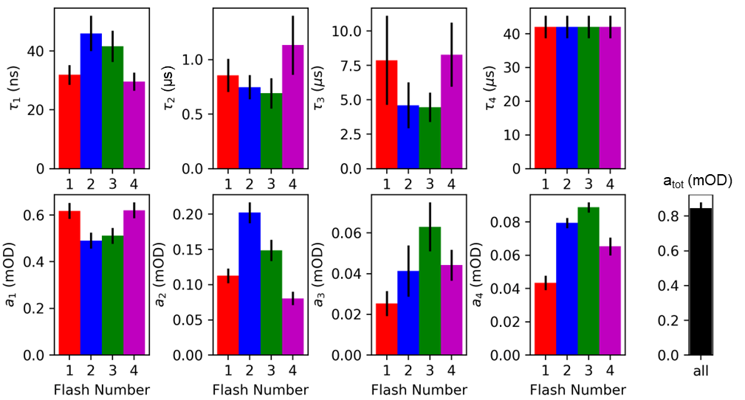
Figure S1: Fit parameters of the multi-exponential fits of the IR transients obtained at wavenumbers greater than 1760 cm⁻¹. The first row indicates the time constants of the four components determined for the multi-exponential function of Eq. S1 The second row indicates the amplitudes of the corresponding components. The black bars indicate the standard error, determined from the covariance matrix provided by the least-squares optimization algorithm. Fitting was done under the constraint that the slowest time constant as well as the sum of all amplitudes plus offset is the same for all flashes. Fit parameters associated with the S₁→S₂ transition (1st flash) are shown in red, the S₂→S₃ transition (2nd flash) in blue, the S₃→S₀ transition (3rd flash) in green, and the S₀→S₁ (4th flash) in magenta.
Table S2: Amplitudes and offset determined by fitting the-flash induced IR transients of wavenumbers greater than 1760 cm⁻¹ to a multi-exponential function. The given 1σ error ranges are the standard error as determined from the covariance matrix provided by the least-squares optimization algorithm. The values are the same as shown in Fig. S1.
Flash | a₁(mOD) | a₂(mOD) | a₃(mOD) | a₄(mOD) | y₀(mOD)
1 | 0.618 ± 0.035 | 0.113 ± 0.011 | 0.025 ± 0.007 | 0.043 ± 0.005 | 0.046 ±0.002
2 | 0.491 ± 0.034 | 0.202 ± 0.015 | 0.041 ± 0.013 | 0.079 ± 0.004 | 0.032 ± 0.002
3 | 0.512 ± 0.035 | 0.149 ± 0.015 | 0.063 ± 0.013 | 0.089 ± 0.004 | 0.034 ± 0.002
4 | 0.621± 0.035 | 0.081 ± 0.010 | 0.044 ± 0.008 | 0.065 ± 0.006 | 0.042 ± 0.004

Table S3: Time constants determined by fitting the flash induced IR transients of wavenumbers greater than 1760 cm⁻¹ to a multi-exponential function. The given 1σ error ranges are the standard error as determined from the covariance matrix provided by the least-squares optimization algorithm. The values are the same as plotted in Fig. S1.
Flash | τ₁ (ns) | τ₂ (ns) | τ₃ (µs) | τ₄ (µs)
1 | 32.9 ± 3.4 | 855 ± 152 | 7.9 ± 3.2 | 42.0 ± 3.3
2 | 46.0 ± 6.0 | 747 ± 110 | 4.6 ± 1.7 | 42.0 ± 3.3
3 | 41.6 ± 5.3 | 692 ± 139 | 4.5 ± 1.1 | 42.0 ± 3.3
4 | 29.6 ± 3.1 | 1133 ± 270 | 8.3 ± 2.3 | 42.0 ± 3.3

2. P680⁺ Transients: Additional Information on Peak Suppression by IRF
As it is not immediately clear why the peak intensity in the 2nd and 3rd flash are higher than the peak intensity in the 1st and 4th flashes, we convolved a four component multi-exponential model with a previously determined Gaussian IRF (Mäusle et al. 2023). Figure S2 shows the effect of such a convolution process on the measurement of hypothetical two-component multi-exponentials. Figure S3 is very similar to the respective figure presented in the main paper (Fig. 6). However, the presence of multiple exponential components has a qualitatively different effect on the on the position of the peak of recorded transient with respect to the fast time constant. Importantly the presence of additional components in a multi-exponential model still offers an explanation for the unexpected differences in peak amplitude observed in the different flash induced IR-transients.

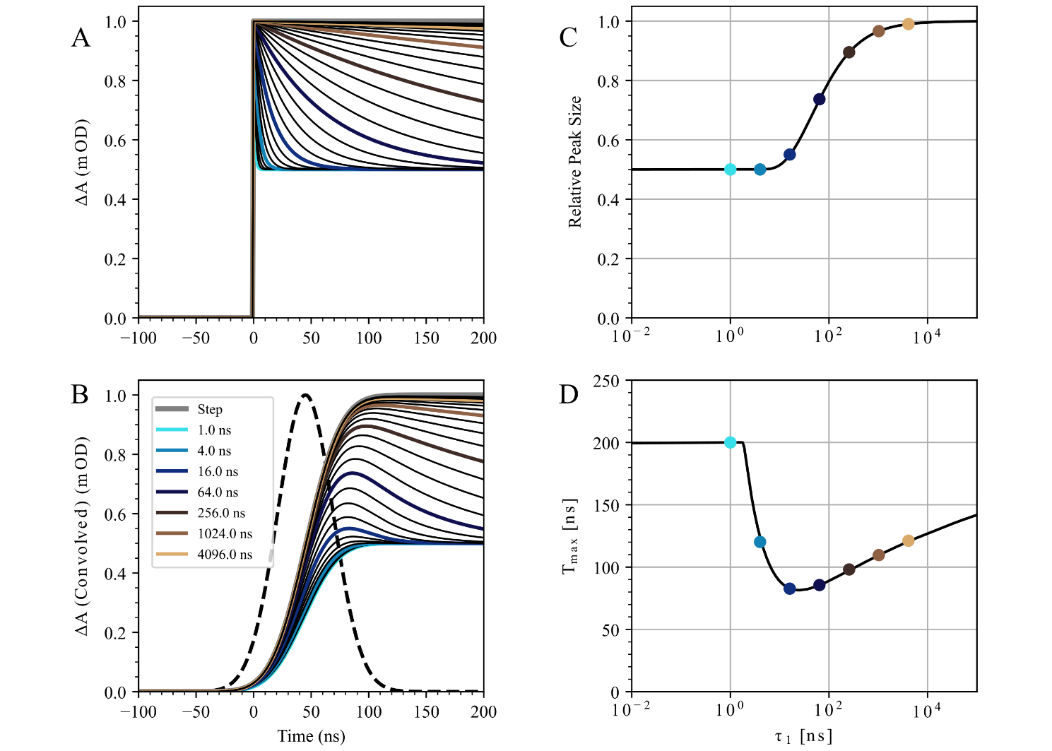Figure S2: Influence of a Gaussian instrument response function (IRF) on the peak intensity of idealized hypothetical multi-exponential transients composed of a fast component and a very slow component. (A) Idealized transients each composed of an infinitely slow component and a very fast component. The fast components range from 1 ns to 4 µs and are indicated by colored lines. Black, thinner lines in between the colored lines indicate fast components with values logarithmically placed in between those of the colored lines. The thicker gray line indicates a transient with only an infinitely slow time constant as a limit case. (B) The effect of convolving the idealized transients from A with the instrument response function indicated by the black dashed line. The convolved transients are shown in the same color code as in A. The data shown in B is the same as shown in Fig. 6E of the main paper. (C) Influence of the fast time constant of the exponential function on the peak intensity of the convolved transients. (D) Influence on the temporal position of the peak as a function of the fast time constant. The colored dots in C and D correspond to the transients shown in A and B.

3. Additional Data – Non-smoothed Spectra
Figure S3 refers to the same data as shown in Fig. 2 of the main paper, but here there was no smoothing algorithm applied. Additionally, a dark spectrum (measured without exciting the sample by a laser flash) for all selected time points (80 ns, 500 ns and 10 µs) is shown in gray, representing the noise level.
The baseline correction of the data in Fig. 2E and Fig. S3E was performed by first, subtracting the average of all data values across the entire spectral range individually for the data sets of the 1st, 2nd, 3rd, and 4th flash. Second, the mean value of all four data sets was calculated in the range from 1760 to 1810 cm⁻¹ and subtracted.
Figure S4 shows all ten flash-induced transients at wavenumbers greater than 1760 cm⁻¹ data (of which the first four are shown in Fig. 3 of the main paper). Compared to all subsequent flashes, the first flash exhibits an up-shifted signal in the range from ∼100 µs to 800 ms, while all other flashes look identical in that region, for presently not understood reasons.
IR-transients recorded after the first four flashes were fitted as described before in the range 0 to 100 µs. The transients overlayed with the fit curves for the complete time range can be seen on a logarithmic time axis in Fig S5. The weighted residuals, i.e., the weighted difference between the fit and the recorded data, are also shown. The weighting is done by taking into account that later timepoints represent larger amount of data due to quasi-logarithmic sampling of timepoints. Fig. S6 shows a section of the same data between 1.5 µs before the laser excitation until 10 µs after the excitation on a linear scale; the fit errors are again given by the weighted residuals. Both figures represent the same fits and data as shown in the main paper (Fig. 7).
In the early time domain of the time-resolved IR transients, we observe a recurring oscillatory behavior which we attribute to an experimental artefact (Fig. S7A). All flash-induced transients show oscillations that are approximately equal in phase, frequency and amplitude. Fig. S7B shows a Fourier transform of the averaged IR-transients of Fig. S7A, which clearly indicates the presence of an oscillatory feature of about 3.2 MHz. The origin of this artifact is still under investigation.
Figure S3: Flash-induced time resolved IR difference spectra of spinach PSII membrane particles at 10°C. The difference absorbance (ΔA) was obtained at every ∼2 cm⁻¹ between ∼1310 and 1890 cm⁻¹ by acquiring flash-induced transients, resulting in an effective resolution of 6-8 cm⁻¹. (A) This spectrum was obtained by averaging the transient data acquired between 50 and 110 ns. (B) IR difference spectrum of around 500 ns (250-750 ns) after excitation. (C) IR difference spectrum of around 10 μs (8-12 μs) after excitation. (D) Double difference spectrum of the 10 μs spectrum minus the 500 ns spectrum (C – B). The resulting double difference absorption (ΔΔA) was small compared to the data in A-C and was thus multiplied by a factor of 3 for better visualization. (E) A baseline-corrected version of the double difference spectrum shown in D, i.e. the spectrum of 10 μs minus 500 ns. The noise level is indicated by dark spectra (grey), obtained in the same way as the flash-induced data, but without applying excitation flashes

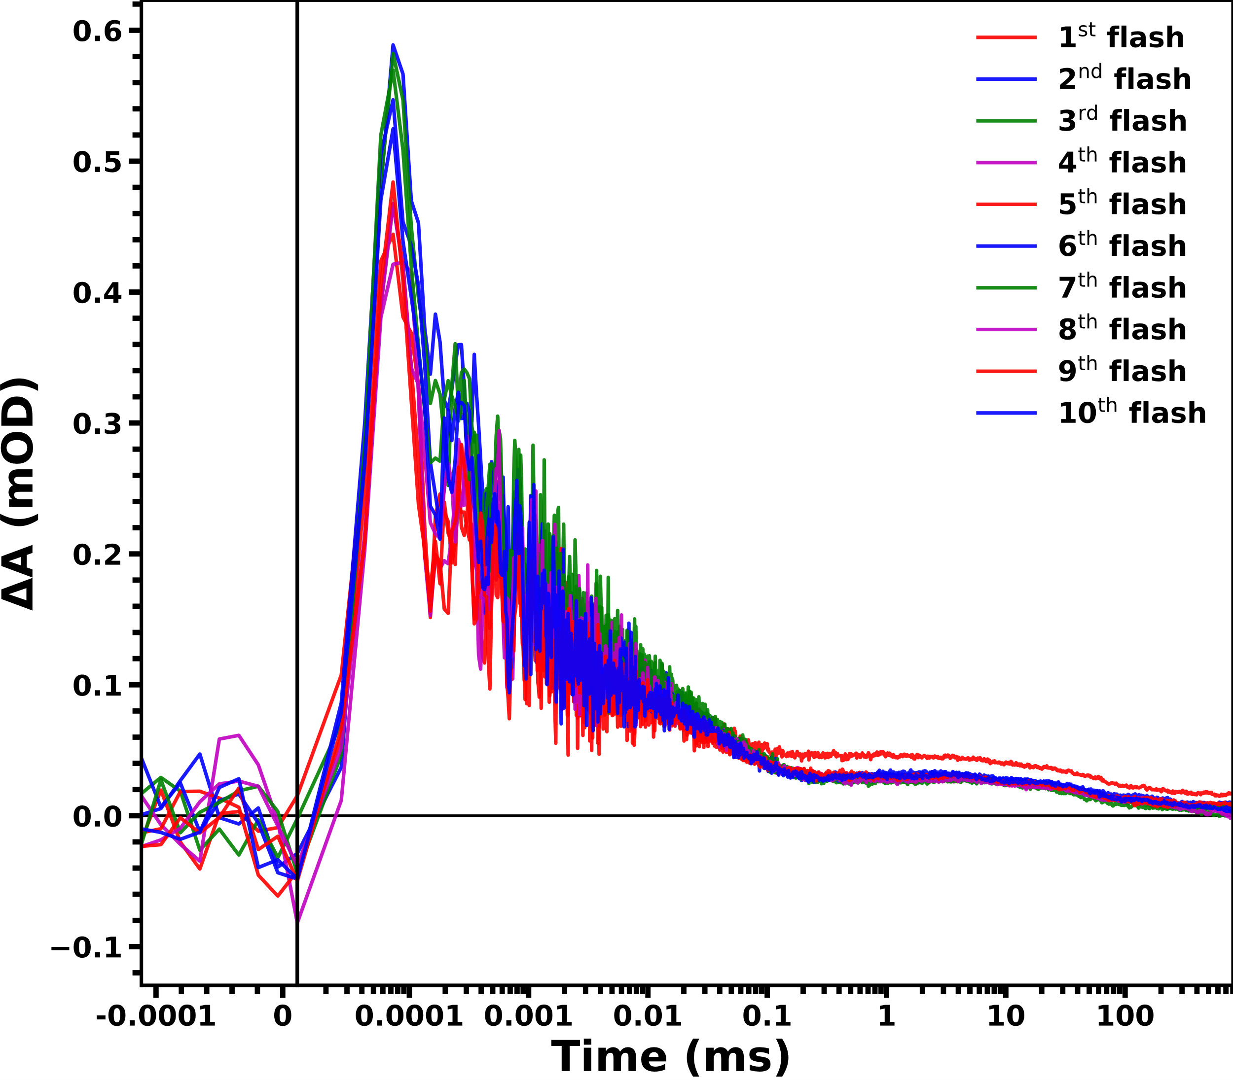
Figure S4: Time-dependence of the broad background in the infrared absorption detected above 1760 cm⁻¹. All time resolved IR-transients acquired between 1760 – 1884 cm⁻¹ were averaged to improve the SNR. All flash-induced transients, obtained by a sequence of ten excitation flashes, are shown. Data associated mostly with the S₁→S₂ transition (1st, 5th and 9th flash) is shown in red, the S₂→S₃ transition (2nd, 6th and 10th flash) in blue, the S₃→S₀ transition (3rd and 7th flash) in (green) and the S₀→S₁ (4th and 8th flash) in magenta. The signal from 100 ns before the excitation flash up to 11.5 ns after the flash is shown on a linear scale, while the data between 11.5 ns and 800 ms is shown on a logarithmic x-axis; the two different axes are separated by a vertical line. The first four flash-induced transients are also shown in Fig. 3 of the main paper.

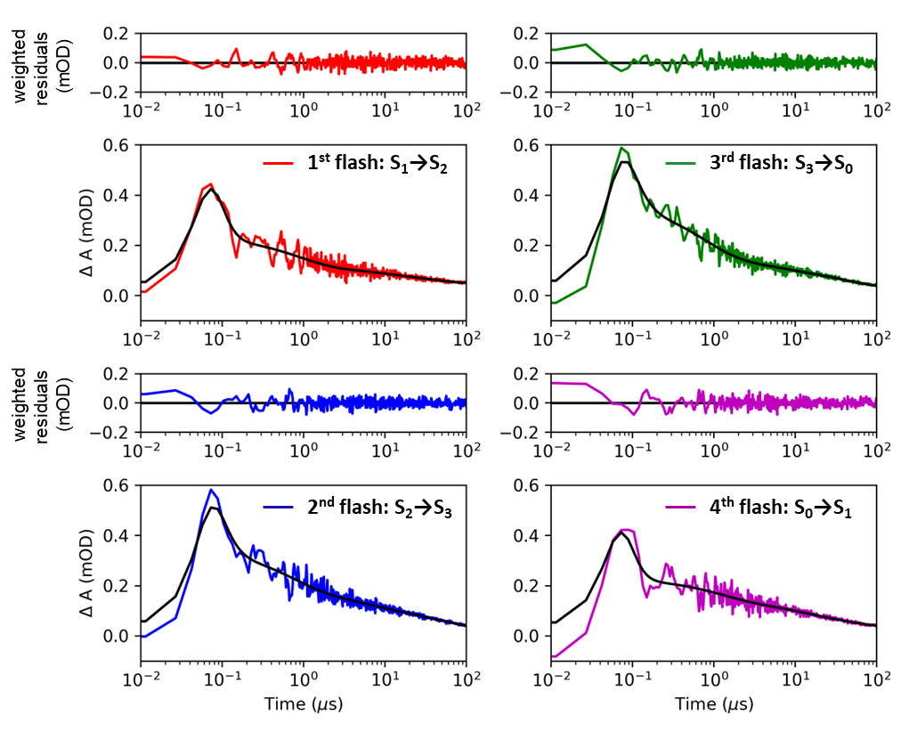
Figure S5: Multi-exponential fits of the P680⁺ IR transients (averaged transients for wavenumbers greater than 1760 cm⁻¹), shown on a logarithmic x-axis. The colored lines indicate the recorded data while the black lines indicate the fits. Panels of lower height provide the deviation of the fits from the data, weighted by the averaged time per data point (weighted residuals). For each of the four transients, a four-component sum of exponentials plus offset (y₀) was fitted to the data. Data associated mostly with the S₁→S₂ transition (1st flash) is shown in red, the S₂→S₃ transition (2nd flash) in blue, the S₃→S₀ transition (3rd flash) in (green) and the S₀→S₁ (4th flash) in magenta. The shown data is identical to the data shown in Fig. 7 of the main paper.

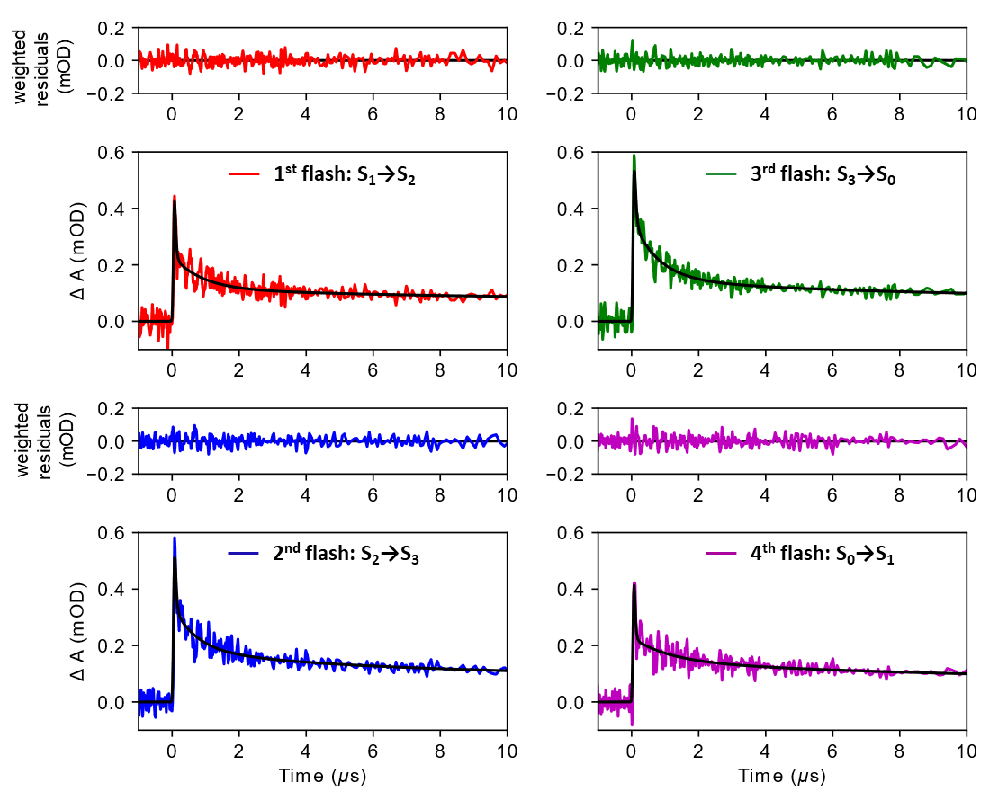
Figure S6: Multi-exponential fits of the P680⁺ IR transients (averaged transients for wavenumbers greater than 1760 cm⁻¹), of the first four excitation flashes on a linear time scale. The colored lines indicate the recorded data while the black lines indicate the fits. Panels of lower height provide the deviation of the fits from the data, weighted by the averaged time per data point (weighted residuals). For each of the four transients, a four-component sum of exponentials plus offset (y₀) was used as a fit function. Data associated mostly with the S₁→S₂ transition (1st flash) is shown in red, the S₂→S₃ transition (2nd flash) in blue, the S₃→S₀ transition (3rd flash) in (green) and the S₀→S₁ (4th flash) in magenta. The shown data is identical to the data shown in Fig. 7 and Fig. S5.

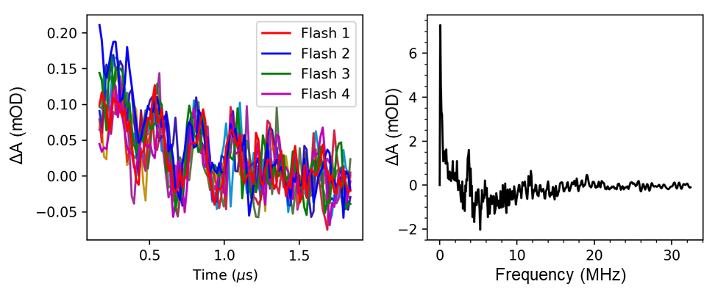Figure S7: Experimental MHz artefact found in the nanosecond to microsecond range of the IR transients. (A) Smoothed IR transients averaged for wavenumbers greater than 1760 cm⁻¹, for the first ten excitation flashes. The data, which is logarithmically binned during measurements, was interpolated to a linear time scale. All transients were shifted along the y-axis for better visual comparison, such that their value around 1.5 µs approaches zero. Clear oscillations can be seen in all recorded transients that extend well into the microsecond range. (B) Fourier transform of the data in (A), revealing that the oscillatory behavior has a frequency of around 3.2 MHz. The origin of this experimental artefact is still unclear. There are no indications that this artefact has affected the fit results reported further above significantly.

References
Mäusle, SM, Agarwala N, Eichmann VG, Dau H, Nürnberg DJ, Hastings G (2023) Nanosecond time-resolved infrared spectroscopy for the study of electron transfer in photosystem I. Photosynth Res. https://doi.org/10.1007/s11120-023-01035-9

