Supplementary Information:
1. Excel spreadsheets of structures used to build QSAR and ActivityClass models and their associated attributes (separate file: Model_structures.xlsx)
2. triazolopyrimidine query molecule
3. Supplementary Figures 1-3
4. Text of RxnIDs.txt file
5. Text of structural filter file

triazolopyrimidine query molecule
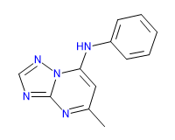
SLQ [#7;D2]1:;@[#6]:;@[#7;D2]:;@[#6;D3]2:;@[#7;D3]:;@1-;@[#6;D3](=;@[#6;D2]-;@[#6;D3](=;@[#7;D2]-;@2)-;!@[#6;D1])-;!@[#7;D2]-;!@[#6;D3]3:;@[#6;D2]:;@[#6]:;@[#6]:;@[#6]:;@[#6;D2]:;@3
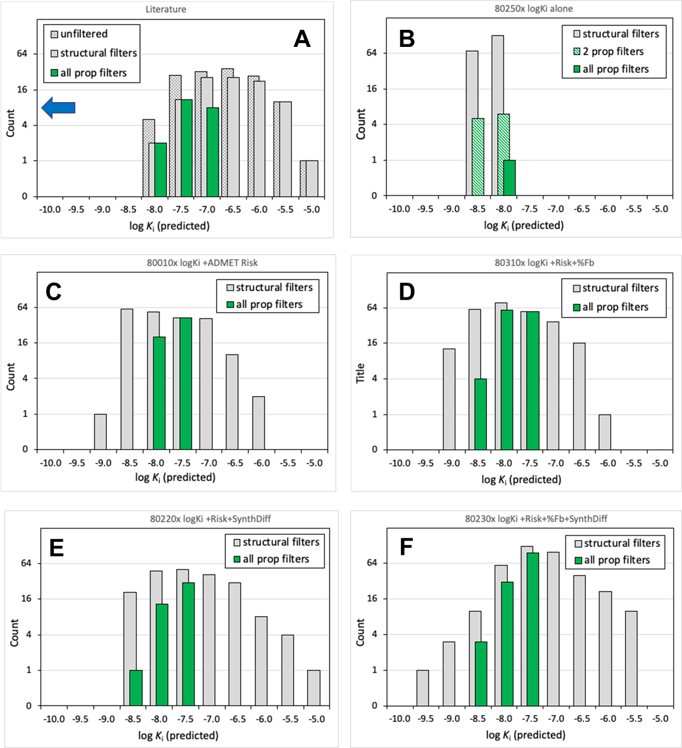
Supplementary Figure 1: LogKi profiles in final generation with different optimization parameters before and after secondary property filters were applied. The total number of molecules in the final generation (G50) that passed structural filters (gray) and secondary property filters (logKi ≤ -7.5, ADMET Risk ≤ 6, %Fb of 70%, SynthDiff ≤ 5; green) are shown on a logarithmic scale for (A) compounds from the literature, (B) logKi alone, (C) logKi and ADMET Risk, (D) logKi, ADMET Risk, and %Fb, (E) logKi, ADMET Risk, and SynthDiff, and (F) logKi, ADMET Risk, %Fb, and SynthDiff. Counts are summed across two replicate runs. In (A), the number of total compounds before filtering is also shown (hatched gray). In (B), the number of compounds passing when only ADMET risk and logKi filters were applied is also shown (hatched green).
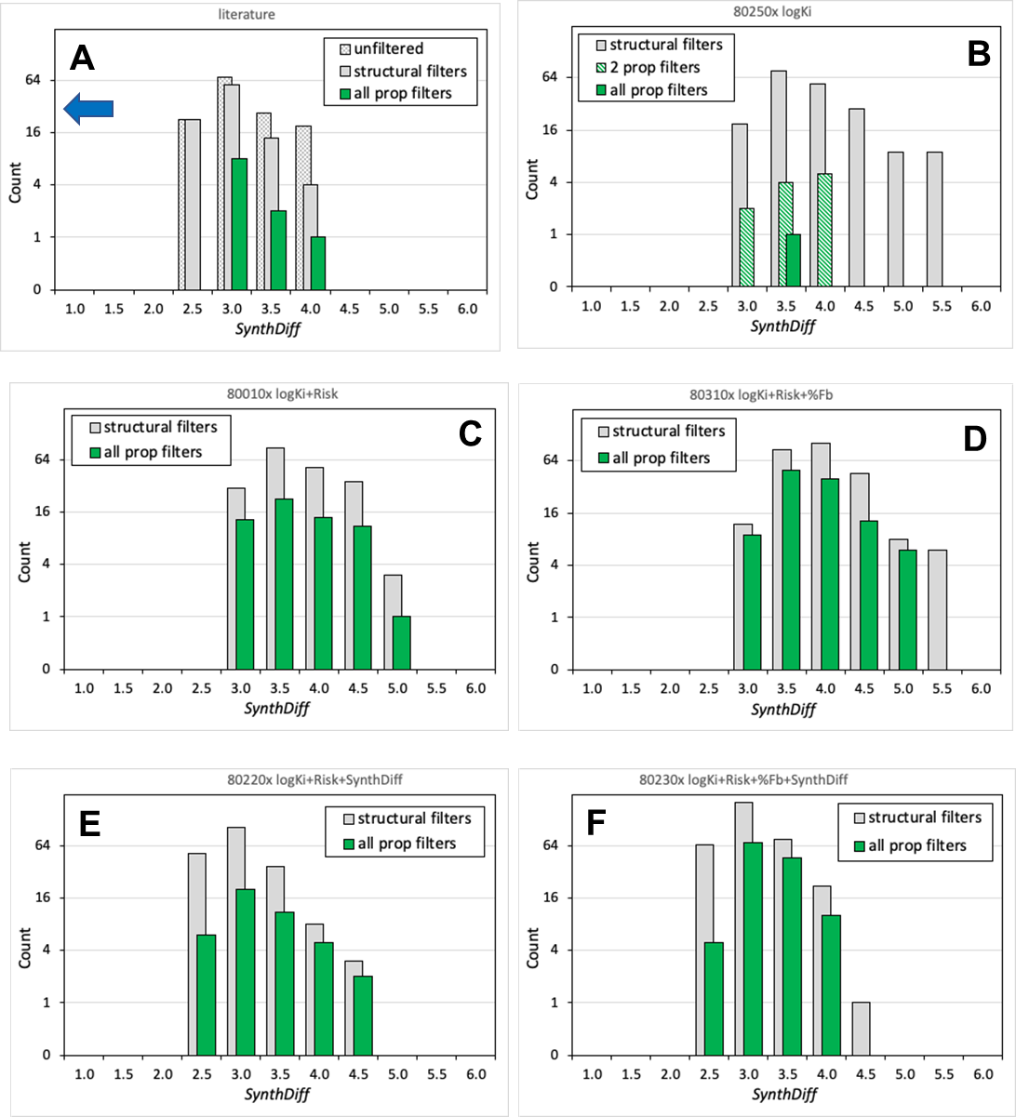
Supplementary Figure 2: SynthDiff profiles in final generation with different optimization parameters before and after secondary property filters were applied. The total number of molecules in the final generation (G50) that passed structural filters (gray) and secondary property filters (logKi ≤ -7.5, ADMET Risk ≤ 6, %Fb of 70%, SynthDiff ≤ 5; green) are shown on a logarithmic scale for (A) compounds from the literature, (B) logKi alone, (C) logKi and ADMET Risk, (D) logKi, ADMET Risk, and %Fb, (E) logKi, ADMET Risk, and SynthDiff, and (F) logKi, ADMET Risk, %Fb, and SynthDiff. Counts are summed across two replicate runs. In (A), the number of total compounds before filtering is also shown (hatched gray). In (B), the number of compounds passing when only ADMET risk and logKi filters were applied is also shown (hatched green).
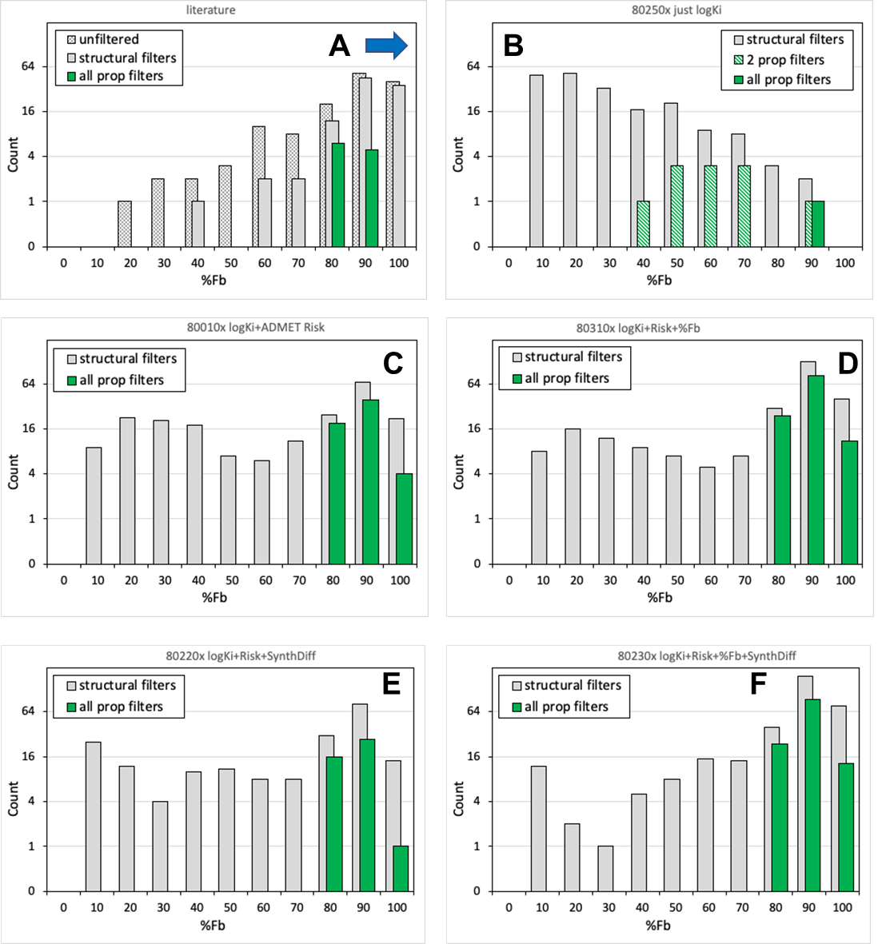
Supplementary Figure 3: %Fb profiles in final generation with different optimization parameters before and after secondary property filters were applied. The total number of molecules in the final generation (G50) that passed structural filters (gray) and secondary property filters (logKi ≤ -7.5, ADMET Risk ≤ 6, %Fb of 70%, SynthDiff ≤ 5; green) are shown on a logarithmic scale for (A) compounds from the literature, (B) logKi alone, (C) logKi and ADMET Risk, (D) logKi, ADMET Risk, and %Fb, (E) logKi, ADMET Risk, and SynthDiff, and (F) logKi, ADMET Risk, %Fb, and SynthDiff. Counts are summed across two replicate runs. In (A), the number of total compounds before filtering is also shown (hatched gray). In (B), the number of compounds passing when only ADMET risk and logKi filters were applied is also shown (hatched green).

Reaction ID file documentation:
0 Carbonyl_to_sulfonyl
1 Sulfonyl_to_carbonyl
2 Add_double_bond_oxygen
3 Charged_nitrogen_to_carbon
4 N-oxide_to_hydroxy
5 Two-pi_arom_shift(1)
6 Two-pi_arom_shift(2)
7 Two-pi_arom_shift(3)
8 Two-pi_arom_shift(4)
9 Two-pi_arom_shift(5)
10 Two-pi_arom_shift(6)
11 Two-pi_arom_shift(7)
12 Two-pi_arom_shift(8)
13 Amide_reversal
14 Amide_to_olefin
15 Amide_to_hydroxy
16 Amide_to_hydroxy(2)
17 Ester_to_retroamide
18 Ester_to_amine
19 Ester_to_sulfonamide
20 Olefin_to_amide
21 Acid_to_tetrazole
22 Acid_to_arom_ring
23 Acid_to_aliph_ring
24 Tetrazole_to_acid
25 Catechol_to_imidazole
26 Imidazole_to_catechol
27 Catechol_to_pyridone
28 Pyridone_to_catechol
29 Ester_to_arom_ring
30 Arom_ring_to_ester(1)
31 Arom_ring_to_ester(2)
32 Propyl_to_phenyl
33 Arom_ring_to_propyl
34 Hydroxy_to_amide
35 Ether_to_ethylene
36 Ethylene_to_ether
37 Nitrobenzene_to_pyridine
38 Amide_arom_insertion
39 Pyridone-N_shift(1)
40 Pyridone-N_shift(2)
41 Tautomer_H_shift
42 Het_to_sulfone
43 Sulfone_to_sulfide
44 Phenyl_to_2-pyrone
45 4-Hydroxypyridine_to_pyridone
46 Pyridone_to_4-hydroxypyridine
47 CF3_to_methyl
48 Phenyl_to_Pyrimidone
49 2-Pyridone_to_Phenyl
50 Phenyl_to_4-Pyridone
51 4-Pyridone_to_Phenyl
52 Ketone_to_amide
53 Make_CF3
54 Insert_chain_carbon
55 Remove_chain_atom
56 Create_ring(1)
57 Create_ring(2)
58 Break_ring
59 Arom_6_ring_to_5(1)
60 Arom_6_ring_to_5(2)
61 Arom_5_ring_to_6
62 Increase_ring_size
63 Decrease_ring_size
64 Change_ring_topology(1)
65 Change_ring_topology(2)
66 Shift_ring_substituents(1)
67 Shift_ring_substituents(2)
68 Shift_ring_substituents(3)
69 Shift_ring_substituents(4)
70 Single_to_double_bond
71 Double_or_triple_to_single_bond
72 Aromatic_to_single_bond
73 Triple_to_double_bond
74 Aromatize_6-membered_ring
75 Aromatize_5-membered_ring
76 De-aromatize_6-membered_ring
77 De-aromatize_5-membered_ring
78 Non-carbon_to_carbon
79 Non-nitrogen_to_nitrogen
80 Non-oxygen_to_oxygen
81 Non-sulfur_to_sulfur
82 Non-fluorine_to_fluorine
83 Non-chlorine_to_chlorine
84 Non-bromine_to_bromine
85 Add_methyl
86 Add_hydroxyl
87 Add_amine
88 Add_fluro
89 Add_chloro
90 Add_bromo
91 Add_phenyl
92 Add_carboxylic_acid
93 Add_amide
94 Add_reverse_amide
95 Add_methyl_imide
96 Add_CF3
97 Add_cyano
98 Add_nitro
99 Add_ortho_pyrrole
100 Add_meta_pyrrole
101 Add_1-imidazole
102 Add_2-imidazole
103 Add_1-tetrazole
104 Add_2-tetrazole
105 Add_3-piperideine
106 Add_cyclohexyl
107 Add_cyclopentanone
108 Add_ortho_furan
109 Add_meta_furan
110 Add_ortho_thiophene
111 Add_meta_thiophene
112 Add_1-thiazole
113 Add_2-thiazole
114 Add_3-thiazole
115 Add_triazole
116 Add_3-tetrazole
117 Add_oxazole
118 Add_oxadiazole
119 Add_n_sulfonamide
120 Add_s_sulfonamide
121 Add_urea
122 Add_thiourea
123 Fuse_phenyl
124 Fuse_pyrrole
125 Fuse_cyclohexyl
126 Fuse_cyclopentyl
127 Fuse_imidazole
128 Fuse_furan
129 Fuse_oxazole
130 Fuse_thiazole
131 Delete_ring5
132 Delete_ring6
133 Delete_ring7
134 Delete_ring5(2)
135 Delete_ring6(2)
136 Delete_fused_ring5
137 Delete_fused_ring6
138 Delete_fused_ring7
139 Delete_terminal_atom
140 Delete_terminal_group(1)
141 Delete_terminal_group(2)
142 Delete_terminal_group(3)
143 Delete_terminal_group(4)
144 Delete_cyclopentanone
145 Delete_n_sulfonamide
146 Delete_methylimide
147 Delete_urea_thiourea
148 CF3_to_SF5
149 SF5_to_CF3
150 Add_SF5
151 Delete_SF5

Structural filter documentation:
# This file can be used to identify undesirable (non-drug-like) properties of compounds.
# It can be used with a number of ADMET Predictor features:
# 1. Substructure search (click Load From File on search dialog)
# 2. Compound score attribute column (DATA >> Add Compound Attributes >> Query)
# 3. Filter for analog generation (e.g., DESIGN >> Combinatorial Transforms >> Filters)
#
# NOTES
# 1. This file is constructed as a single query with multiple subqueries.
# Each subquery has a name, and uses the SCORE keyword. If the SCORE is
# omitted, the file may not work as expected. Please see the section of
# the ADMET Predictor manual on Encoded Queries for additional information
# 2. Many of the substructures in the file are taken from the following:
# Brenk et al., ChemMedChem 3, 435 (2008)
#
QUERYNAME DLF_Score
#
# The following subqueries represent undesirable substructures
#
QUERYNAME N_O_bond
# Covers any bond between uncharged atoms. Flags hydroxamic acid,
# hydroxylamine, nitroso and others
SLQ [#7+0]~[O+0] S SCORE 1

QUERYNAME S_O_bond
# Covers single bonds with S not in a sulfonyl group
SLQ [S;!$(S(=O)=O)]-O S SCORE 1

QUERYNAME N_S_bond
# Covers aliphatic bonds with S not in a sulfonyl group
SLQ [#7;!$(*S(=O)(=O))]~S S SCORE 1

# QUERYNAME Halogen_hetero_bond
# Bond between halogen and non-carbon
# SLQ [!#6]~[_X] S SCORE 1

QUERYNAME Nitro_hetero_bond
# Non-carbon bonded to nitro
SLQ [!#6]~[N+](=O)O S SCORE 1

QUERYNAME Nitro_Caliph_bond
# Aliphatic carbon bonded to nitro
SLQ [C;_S,$(C=[D1])]~[N+](=O)O S SCORE 1

QUERYNAME Nitrile_hetero_bond
# Non-carbon bonded to nitrile (cyano)
# Exception = nitrogen (e.g., cimetidine)
SLQ [!#6;!N]~C#N S SCORE 1

QUERYNAME CF3_hetero_bond
# Non-carbon or non-oxygen bonded to CF3
SLQ [$([!#6]);$([!#8])]-C(F)(F)F S SCORE 1

QUERYNAME Acid_halide
SLQ [_X]C=[O,S] S SCORE 1

QUERYNAME Allene
SLQ C=C=C S SCORE 1

QUERYNAME Isocyanate
SLQ N=C=[O,S] S SCORE 1

QUERYNAME Thiocarbonyl
# Any C=S bond; OK if C is connected both N and [#6,N,OD2,SD2]
SLQ S=[C;!$(C(N)[#6,N,OD2,SD2])] S SCORE 1

QUERYNAME Alkyl_halide
# Halogen (Cl, Br or I) bonded to alphatic carbon
SLQ [Cl,Br,I]-[C;_S,$(C=[D1])] S SCORE 1

QUERYNAME Three_nitrogens
# Three aliphatic nitrogens connected by single bonds
SLQ NNN S SCORE 1

QUERYNAME ocO
# ocO motif (note aromaticity)
SLQ ocO S SCORE 1

QUERYNAME Pos_Charge_With_H
# Positively charged atom with hydrogen
# Such protonated products should not be produced by AP's compound design tools
SLQ [+;_H] S SCORE 1

#QUERYNAME 2-halo_pyridine
# Adapted from Brenk et al.
#SLQ n1c([_X])cccc1 S SCORE 1

QUERYNAME Vinyl_ether_enol
# Covers vinyl ether and enol motifs
# Adapted from Brenk et al.
SLQ [C;!R]=[C;!R]-O S SCORE 1

QUERYNAME Acyl_cyanide
# Adapted from Brenk et al.
SLQ N#CC=[O,S] S SCORE 1

QUERYNAME Acyl_hydrazine
# Adapted from Brenk et al.
SLQ [C,S](=[O,S])N[NH2] S SCORE 1

QUERYNAME Amidotetrazole
# Adapted from Brenk et al.
SLQ c1nnnn1[C,S]=[O,S] S SCORE 1

QUERYNAME Azide
# Adapted from Brenk et al.
SLQ N=[N+]=[N-] S SCORE 1

QUERYNAME Azo
# Restricted to acyclic
# Adapted from Brenk et al.
SLQ [N;!R]=[N;!R] S SCORE 1

QUERYNAME Anhydride
# Adapted from Brenk et al.
SLQ [O,S]=[C,S][O,S][C,S]=[O,S] S SCORE 1

QUERYNAME Charged_C
# Adapted from Brenk et al.
SLQ [#6,#16;!+0] S SCORE 1

QUERYNAME 1_4_Benzoquinone
# OK if fused to aromatic ring
# Adapted from Brenk et al.
SLQ [O,S]=C1C=CC(=[O,S])C=C1 S SCORE 1

QUERYNAME Conjugated_nitrile
# Adapted from Brenk et al.
SLQ C=[C;!R]C#N S SCORE 1

QUERYNAME Cyanamide
# Adapted from Brenk et al.
SLQ N[CH2]C#N S SCORE 1

QUERYNAME Cyanohydrin
# Adapted from Brenk et al.
SLQ [OH]CC#N S SCORE 1

QUERYNAME Ynamine
# Adapted from Brenk et al.
SLQ [CX2R0][NX3R0] S SCORE 1

QUERYNAME Lactone_4
# Lactone in 4-membered ring
# Adapted from Brenk et al.
SLQ O=C1OCC1 S SCORE 1

QUERYNAME Hydrazine
# Adapted from Brenk et al.
SLQ N[NH2] S SCORE 1

QUERYNAME Ketene
# Adapted from Brenk et al.
SLQ C=C=O S SCORE 1

QUERYNAME Diketone
# Adapted from Brenk et al.
SLQ [C,S](=[O,S])[C,S](=[O,S]) S SCORE 1

QUERYNAME Halogen_C_N
# Halogen bonded to C-N
# Adapted from Brenk et al.
SLQ NC[_X] S SCORE 1

QUERYNAME Disulfide
# Adapted from Brenk et al.
SLQ S~S S SCORE 1

QUERYNAME Peroxide
# Adapted from Brenk et al.
SLQ O~O S SCORE 1

QUERYNAME Sulfonic_acid
# Adapted from Brenk et al.
SLQ S(=O)(=O)[OH] S SCORE 1

QUERYNAME Thiol
# Adapted from Brenk et al.
SLQ [SH] S SCORE 1

QUERYNAME Aldehyde
# Adapted from Brenk et al.
SLQ [#6][CH](=[O,S]) S SCORE 1

QUERYNAME Polyene
# Adapted from Brenk et al.
SLQ [C!R]=[C!R][C!R]=[C!R] S SCORE 1

QUERYNAME Nitrate
# Adapted from Brenk et al.
SLQ [#6]-O-[N+](=O)[O;D1] S SCORE 1

QUERYNAME Carbonate_ester
# Adapted from Brenk et al.
SLQ OC(=O)O S SCORE 1

QUERYNAME Imine
# Adapted from Brenk et al.
SLQ [C;!R;!$(CN)]=[N;!R][#6] S SCORE 1

QUERYNAME Two_halogens
# Limit molecules to maximum of two halogens (Cl, Br, I)
SLQ [Cl,Br,I].[Cl,Br,I] > 1 SCORE 1

QUERYNAME Hydrazine_2
SLQ [#7]!@[#7] SCORE 1

QUERYNAME heavy_atom_count
NPQ AtomCount >= 66 SCORE 1

#QUERYNAME N_Ar_Rings
#NPQ ArRing > 4 SCORE 1

QUERYNAME Iminopyridines
SLQ [NH;!R]=C1[$(C),$(N)]=[$(C),$(N)][$(C),$(N)]=[$(C),$(N)][N;D3]1 SCORE 1

QUERYNAME Thioester
SLQ [#6]S!@C(=O) || [#6]O!@C(=S) SCORE 1

#QUERYNAME pyranone
#SLQ O=C1O[C;x2]=[C;x2][C;x2]=[C;x2]1 SCORE 1

QUERYNAME cyclopentadiene
SLQ [C;x2;X4]1[C;x2]=[C;x2][C;x2]=[C;x2]1 SCORE 1

#QUERYNAME floppy_rings
#SLQ [R]-[C;D2;!R]-[C;D2;!R]-[C;D2;!R]-[R] || [R]-[C;D2;!R]-[C;D2;!R]-[C;D2;!R]-[C;D2;!R]-[R] || [R]-[C;D2;!R]-[C;D2;!R]-[C;D2;!R]-[C;D2;!R]-[C;D2;!R]-[R] || [R]-[C;D2;!R]-[C;D2;!R]-[C;D2;!R]-[C;D2;!R]-[C;D2;!R]-[C;D2;!R]-[R] || [R]-[C;D2;!R]-[C;D2;!R]-[C;D2;!R]-[C;D2;!R]-[C;D2;!R]-[C;D2;!R]-[C;D2;!R]-[R] || [R]-[C;D2;!R]-[C;D2;!R]-[C;D2;!R]-[C;D2;!R]-[C;D2;!R]-[C;D2;!R]-[C;D2;!R]-[C;D2;!R]-[R] SCORE 1

#QUERYNAME Simple_esters
#SLQ [#6]C(=O)O[C;_H3] || [#6]C(=O)O[C;_H2][C;_H3] SCORE 1

QUERYNAME Hydroxy_pyrrole
SLQ [n;x2]1[c;x2][c;x2][c;x2](O)[c;x2]1 || [n;x2]1[c;x2](O)[c;x2][c;x2][c;x2]1 SCORE 1

QUERYNAME Hydroxy_imidazole
SLQ [n;_H1;x2]1[c;x2]([O;_H1])[c;x2][n;x2][c;x2]1 || [n;x2]1[c;x2]([O;_H1])[c;x2][n;_H1;x2][c;x2]1 || [n;H1;x2]1[c;x2]([O;H1])[n;x2][c;x2][c;x2]1 SCORE 1

QUERYNAME Triple_conj_double
SLQ [*]#[*]-[*;!R]=:[*] SCORE 1

QUERYNAME imidates
SLQ [C;!R](=[N;!R])[$(O),$(S);!R] SCORE 1

QUERYNAME thiourea
SLQ N[C;!R](=S)N SCORE 1

QUERYNAME terminal_alkene
SLQ C=[C;_H2] SCORE 1

#QUERYNAME quinone_like
#Nc1ncc(O)c2ccccc12 SCORE 1

#QUERYNAME Aliphatic_long_chain
#SLQ [R0;D2][R0;D2][R0;D2][R0;D2][R0;D2] SCORE 1

#
# The following subqueries represent count limits on standard functional groups
#
QUERYNAME Hydroxyl_count
SLQ [c,C&!$(C=[!#6])][OH] U >= 6 SCORE 1

QUERYNAME Carboxylic_acid_count
SLQ [#6]C(=O)[OH] U >= 3 SCORE 1

QUERYNAME Amide_count
# Note that urea is not a separate group
SLQ [#6]C(=O)N U >= 4 SCORE 1

QUERYNAME Thioamide_count
# Exclude thioamides
# Note that thiourea is not a separate group
SLQ [#6]!@C(=S)!@N U > 0 SCORE 1

QUERYNAME Ester_count
# Note that carbamate is not a separate group
SLQ [#6]C(=O)[O;D2] U >= 3 SCORE 1

QUERYNAME Sulfonamide_count
# Note that sulfonylurea is not a separate group
SLQ [#6]S(=O)(=O)N U >= 3 SCORE 1

QUERYNAME Ether_count
SLQ [c,C&!$(C=[!#6])]O[c,C&!$(C=[!#6])] U >= 5 SCORE 1

QUERYNAME Thioether_count
SLQ [c,C&!$(C=[!#6])][S;D2][c,C&!$(C=[!#6])] U >= 3 SCORE 1

QUERYNAME Ketone_count
SLQ [c,C&!$(C=[!#6])]C(=O)[c,C&!$(C=[!#6])] U >= 3 SCORE 1

QUERYNAME Sulfonyl_count
SLQ [#6]S(=O)(=O)[#6] U >= 2 SCORE 1

QUERYNAME Sulfoxide_count
SLQ [#6][S;D3](=O)[#6] U >= 2 SCORE 1

QUERYNAME Nitrile_count
SLQ C#N U >= 2 SCORE 1

QUERYNAME Nitro_count
SLQ [N+](=O)[O-] U > 1 SCORE 1

#QUERYNAME Fluorine_count
# SLQ F >= 7 SCORE 1

QUERYNAME Chlorine_count
SLQ Cl >= 3 SCORE 1

QUERYNAME Bromine_count
SLQ Br >= 2 SCORE 1

QUERYNAME Iodine_count
SLQ I >= 2 SCORE 1

QUERYNAME Triple_bond_count
# between carbon atoms
SLQ C#C U >= 2 SCORE 1

QUERYNAME 3_membered_ring_count
SLQ [*]1~[*]~[*]~1 U >= 3 SCORE 1

QUERYNAME 4_membered_ring_count
SLQ [*]1~[*]~[*]~[*]~1 U >= 2 SCORE 1

QUERYNAME 5_membered_ring_count
SLQ [*]1~[*]~[*]~[*]~[*]~1 U >= 4 SCORE 1

QUERYNAME 6_membered_ring_count
SLQ [*]1~[*]~[*]~[*]~[*]~[*]~1 U >= 6 SCORE 1

QUERYNAME 7_membered_ring_count
SLQ [*]1~[*]~[*]~[*]~[*]~[*]~[*]~1 U >= 2 SCORE 1

#################################### BC modfifications for SF5 TzPs
QUERYNAME Fluorine_count
SLQ F >= 9 SCORE 1

QUERYNAME Halogen_hetero_bond
# Bond between halogen and non-carbon
SLQ [!#6;!$(S(F)(F)(F)(F)F)]~[_X] S SCORE 1

