Supplementary Material
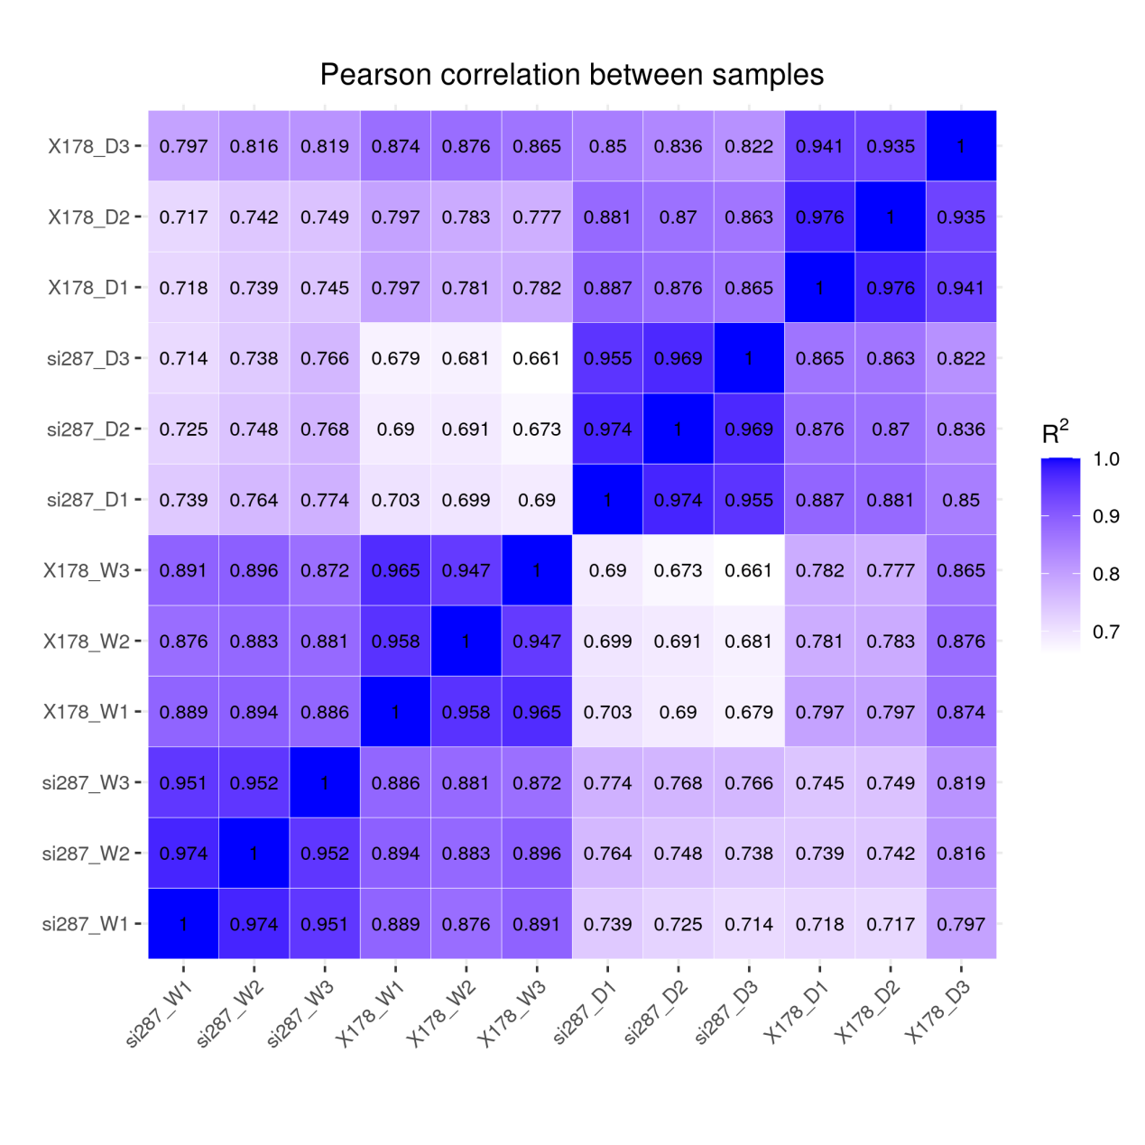
Fig. S1 Pearson correlation between transcriptome samples.

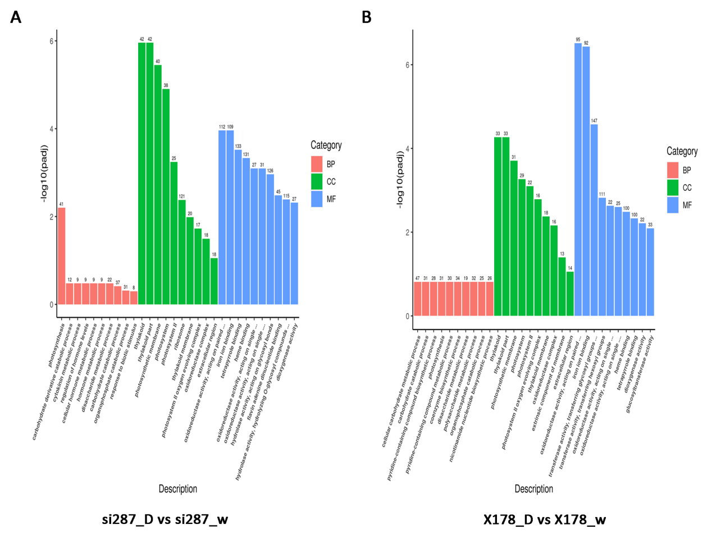

Fig. S2 GO enrichment analysis after drought stress treatment. (A) si287 D and W; (B) X178 D and X178 W.

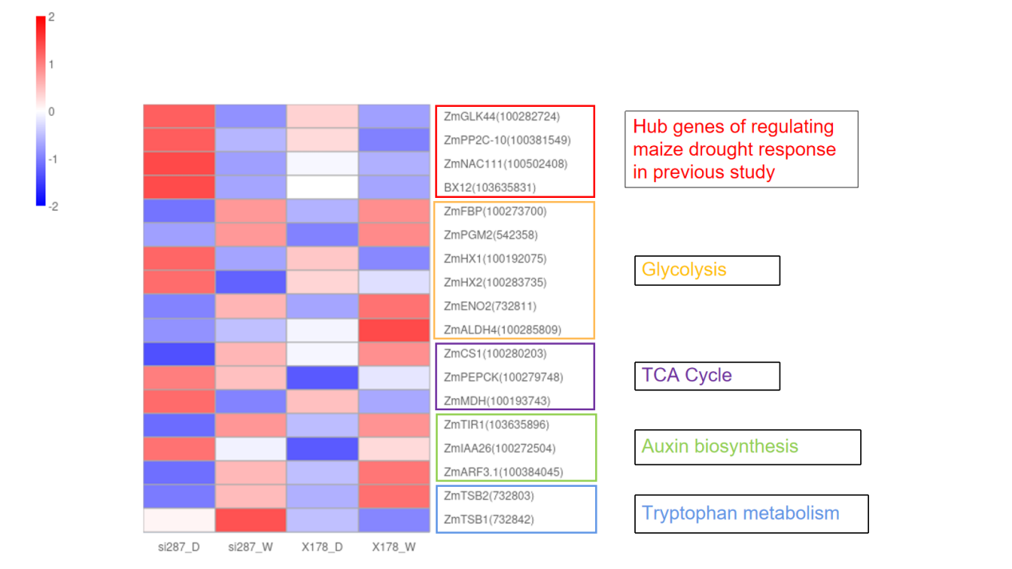
Fig. S3 The expression of key genes involved in drought response under W and D treatments. Red indicated genes with high expression level.

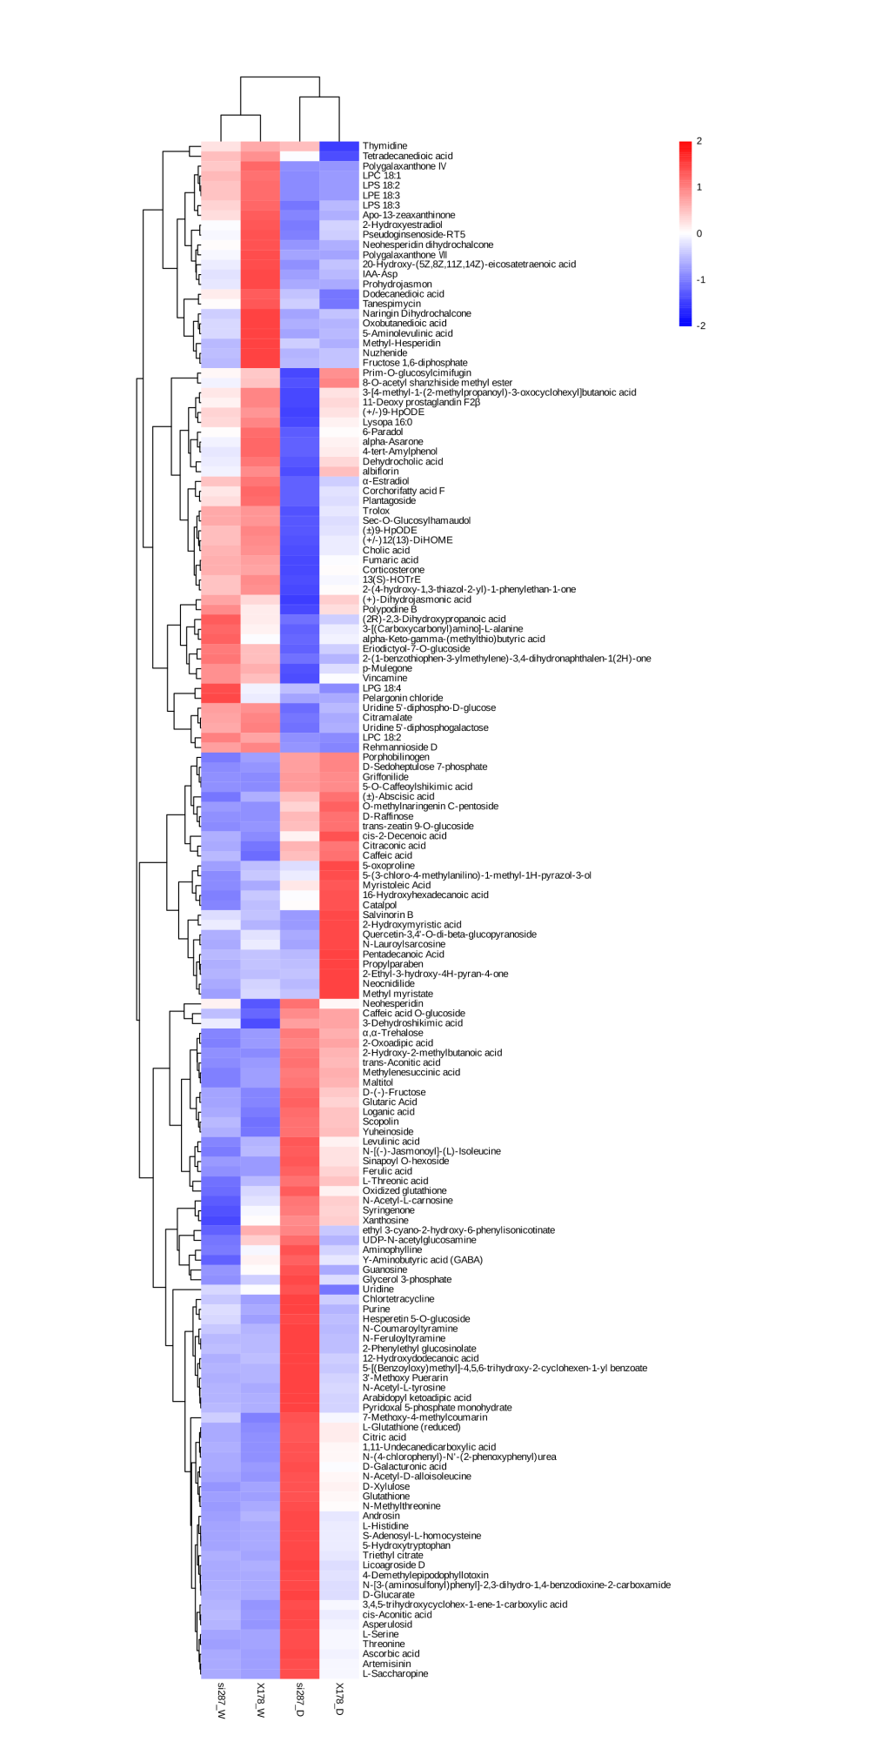

Fig. S4 Heatmap showing the differential abundance of negatively charged metabolites in response to drought stress.
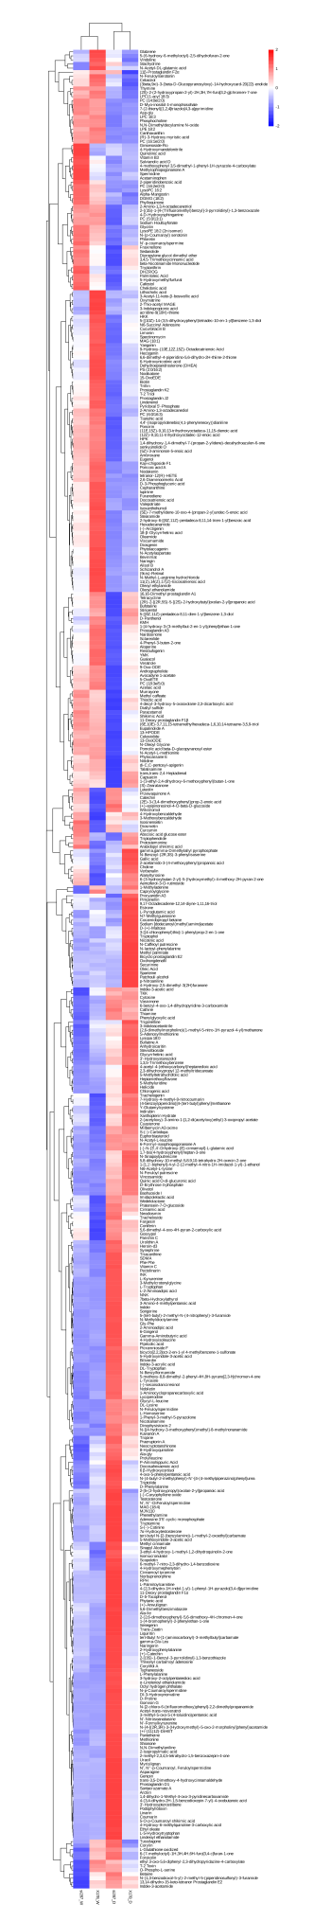

Fig. S5 Heatmap showing the differential abundance of positively charged metabolites in response to drought stress.
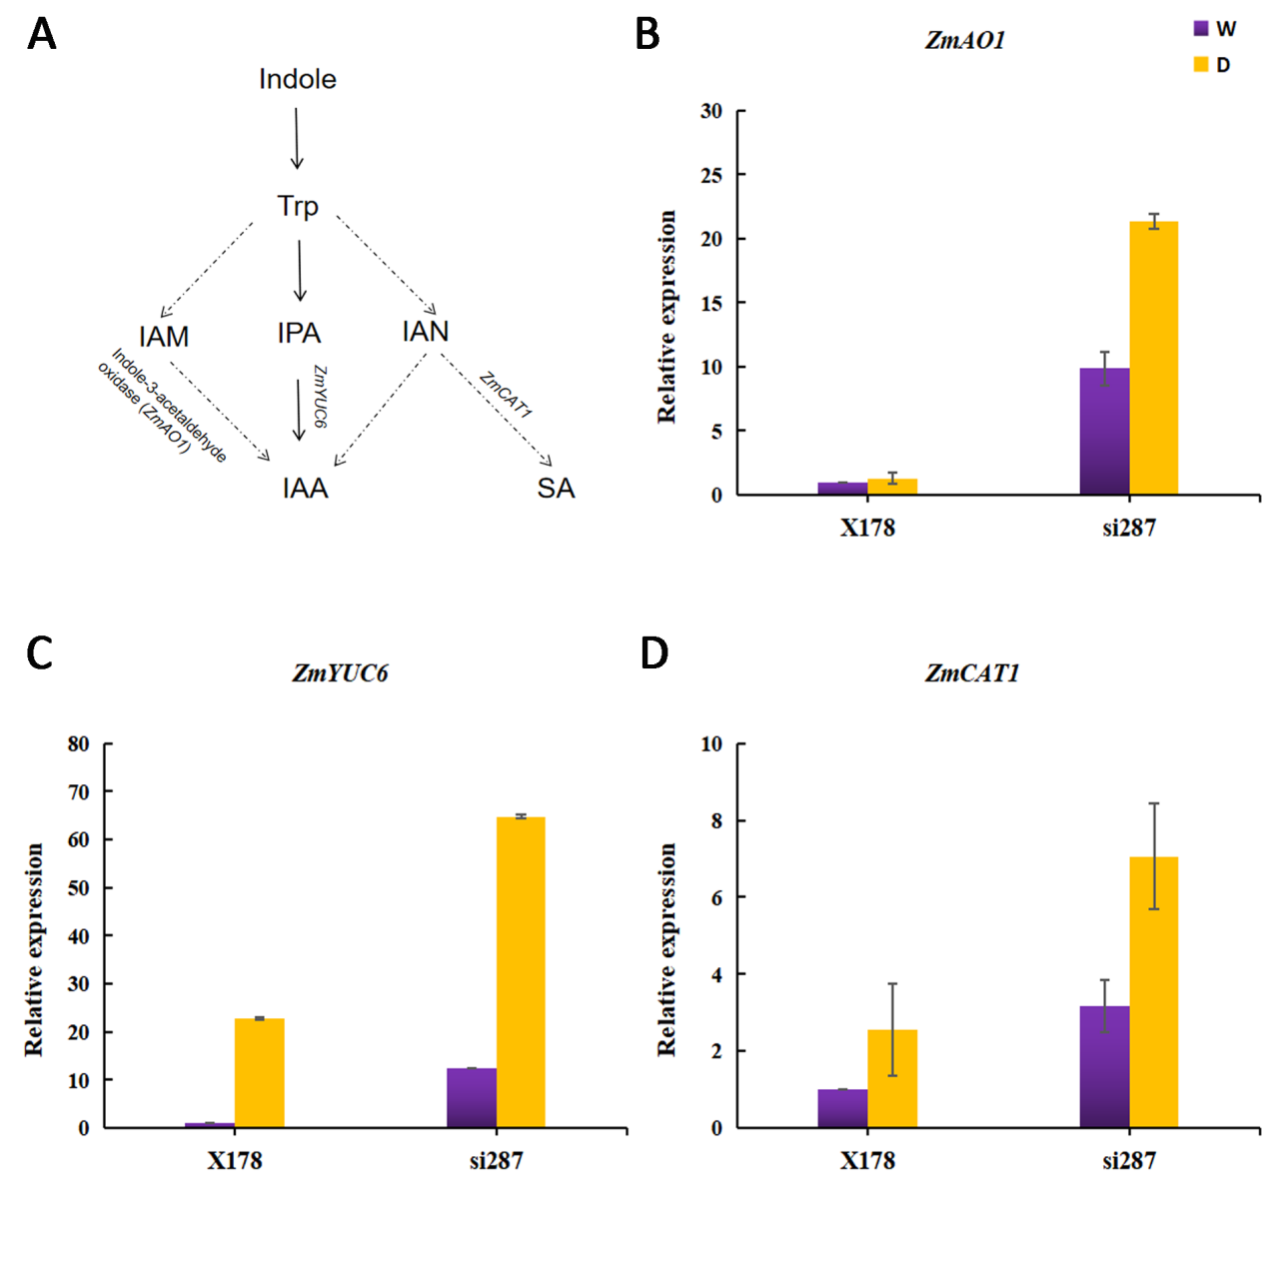
Fig. S6 Metabolite and expression of genes involved in IAA and SA biosynthesis. W represents well-watered control; D represents drought-stress treatment.

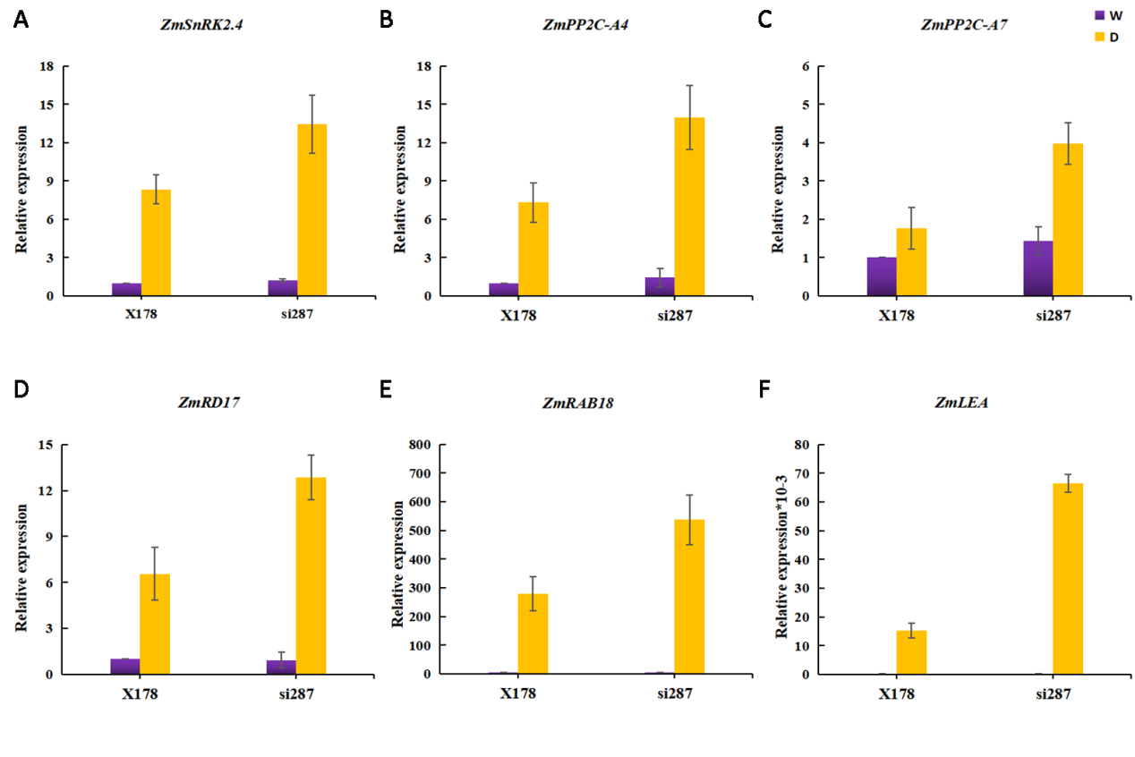Fig. S7 Expression validation of ABA responsive genes. Real-time PCR was performed to validate the expression of ABA responsive genes in the si287 and X178 under W and D conditions, including ZmSnRK2.4 (100384302), ZmPP2C-A4 (100279578), ZmPP2C-A7 (100381666), ZmRAB18 (542373), ZmRD17 (100281087) and ZmLEA (100283639).

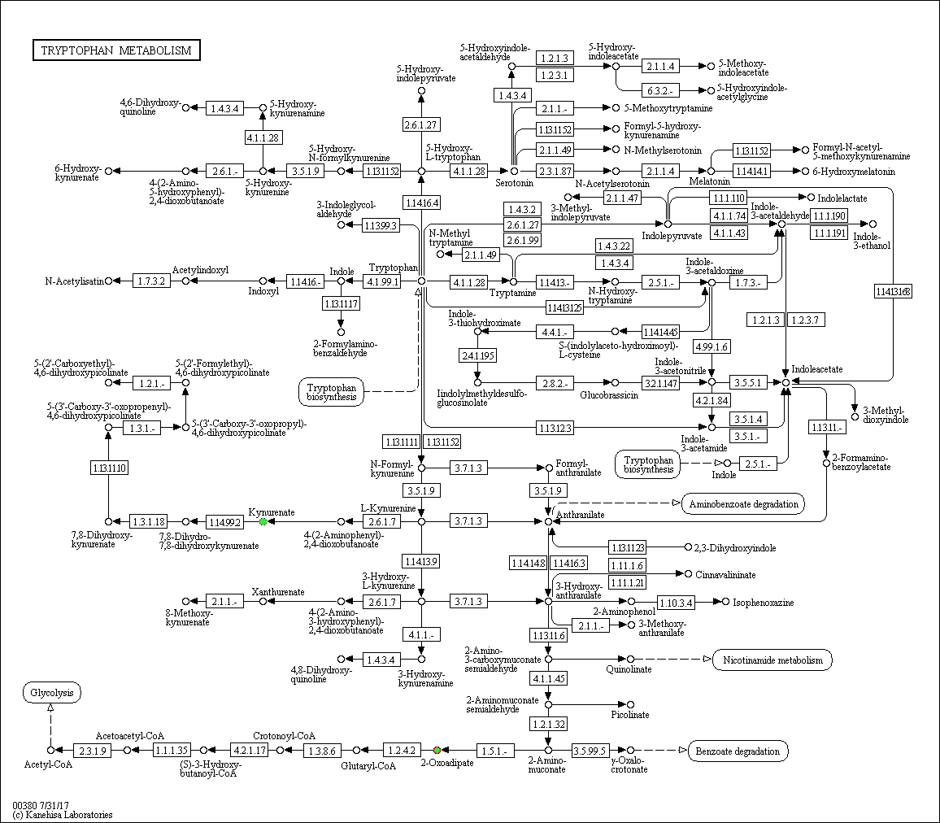
Fig. S8 Tryptophan metabolism pathway

Supplementary Tables List

Table S1 Significant enrichment (P_{adj}<0.05 ) of GO and KEGG pathways in transcriptomic data

Table S2 The expression data of key genes after drought treatments

Table S3 Significant enrichment (P_{adj}<0.05 ) of KEGG pathways in metabolomic data

Table S4 Primers for Real-time PCR

