Extended Data

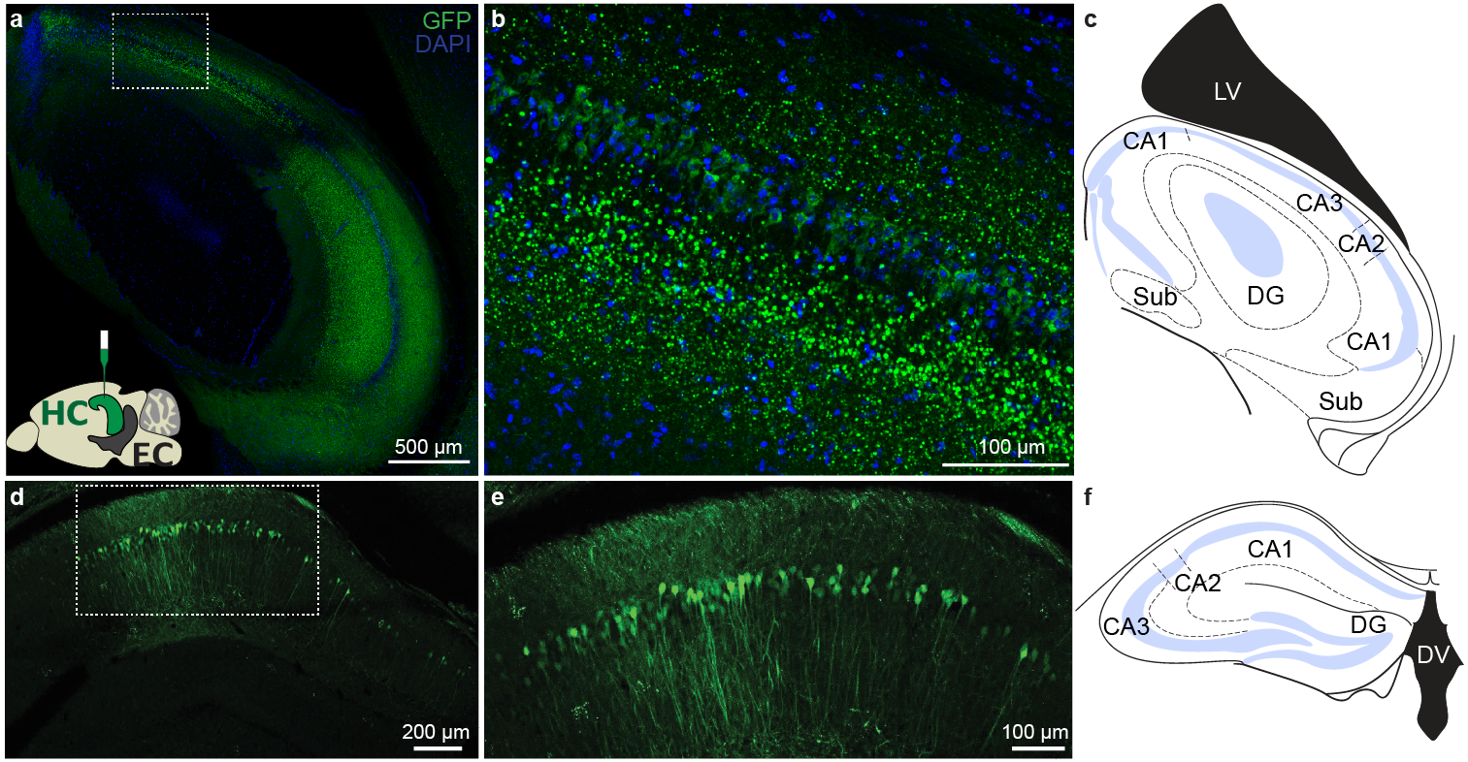

Extended Data Fig. 1. Injection site in dorsal hippocampus CA1.
a. Confocal image of a horizontal brain slice of a mouse injected with AAV 2.5 EF1α-double floxed-ChR2-eYFP into dorsal CA1 and immunostained for GFP to demarcate the injection site and DAPI (nuclear marker). Bottom inset shows a sagittal profile of a mouse brain depicting the injection strategy. CamKII Cre or CamKII Cre x Ai14 mice were injected with AAV 2.5 EF1α-double floxed-ChR2-eYFP into dorsal CA1.The area within the white dotted box is expanded in panel b.
b. Magnified view of the infected CA1 neurons within the white dotted box in panel a.
c. Schematic adapted from Paxinos mouse brain atlas depicting a horizontal section of a mouse brain showing the regions within the hippocampal formation: areas CA1, CA2, CA3, dentate gyrus (DG), and subiculum (Sub), and lateral ventricle (LV).
d. Confocal image of a coronal brain slice of a mouse injected with AAV 2.2 CAMKII-ChR2-eYFP into dorsal CA1 and immunostained for GFP to demarcate the injection site. The area within the white dotted box is expanded in panel e.
e. Magnified view of the infected CA1 neurons within the white dotted box in panel d.
f. Schematic adapted from Paxinos mouse brain atlas depicting a coronal section of a mouse brain showing the regions within the hippocampal formation: areas CA1, CA2, CA3, dentate gyrus (DG), and dorsal 3rd ventricle (DV).

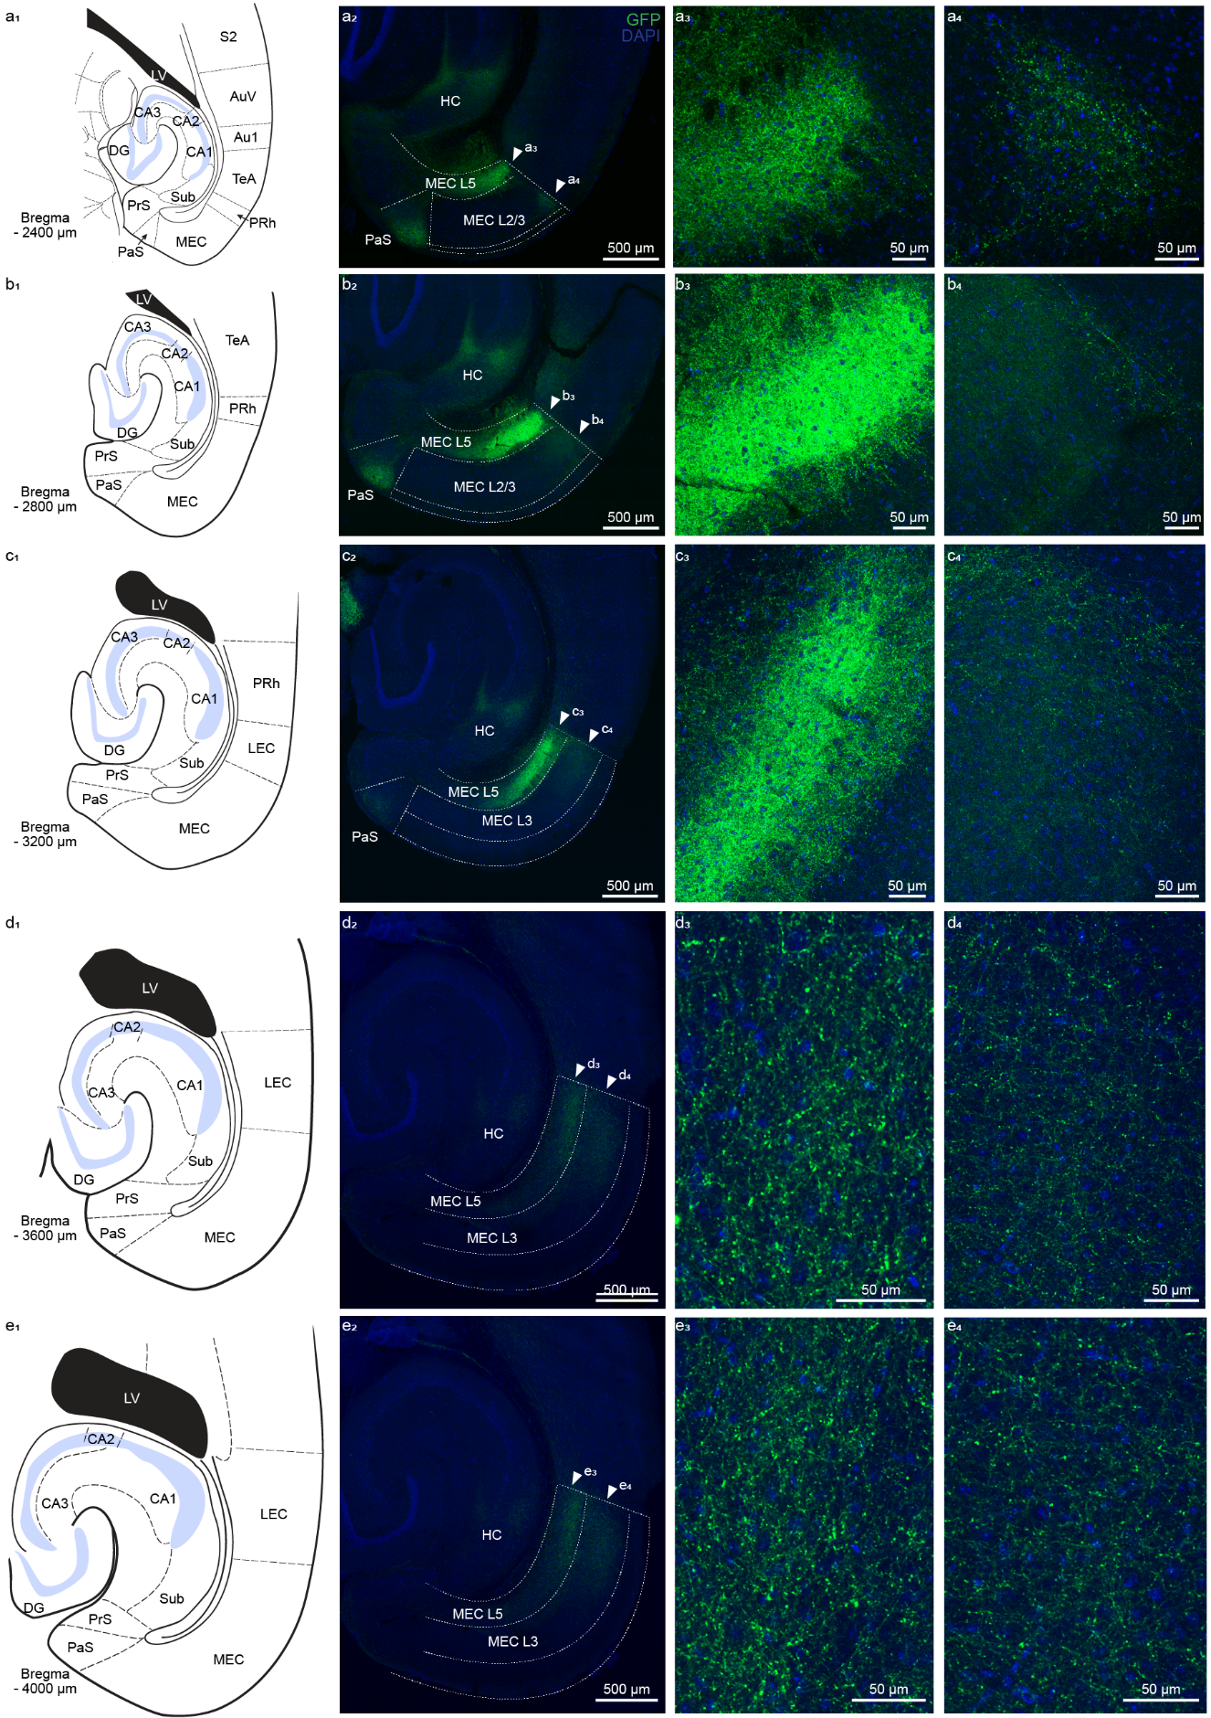

Extended Data Fig. 2. Dorsal to ventral axis of hippocampal projections to entorhinal cortex.
a. (a₁) Schematic adapted from Paxinos mouse brain atlas depicting a horizontal section of a mouse brain showing the various brain regions that are included in the confocal image in panel a₂. The position of the horizontal plane of section through the mouse brain is reported as ventral distance from bregma (-2400 µm) in the bottom left corner. (a₂) Confocal image of horizontal brain slice of a mouse injected with AAV2.5 EF1α-double floxed-ChR2-eYFP into dorsal CA1 and immunostained for GFP and DAPI (nuclear marker). Green hippocampal axons were observed in medial entorhinal cortex (MEC) layers 5 and 2/3, and parasubiculum. White dotted lines demarcate the different cortical layers and brain regions. Arrowheads point the layer detailed in panels a₃ and a₄. (a₃) Magnified view of the hippocampal axons in EC_{L5}, an area pointed by the white arrowhead labeled a₃ in panel a₂. (a₄) Magnified view of the hippocampal axons in EC_{L2/3}, an area pointed by the white arrowhead labeled a₃ in panel a₂.
b. Same as a. but for -2800 µm from bregma.
c. Same as a. but for -3200 µm from bregma.
d. Same as a. but for -3600 µm from bregma.
e. Same as a. but for -4000 µm from bregma.
Abbreviations used: Au1 – primary auditory cortex, AuV – secondary auditory cortex ventral, DG – dentate gyrus, LEC – lateral entorhinal cortex, LV – lateral ventricle, MEC – medial entorhinal cortex, PaS – parasubiculum, PRh – perirhinal cortex, PrS – presubiculum, S2 – secondary somatosensory cortex, Sub – subiculum, TeA – temporal association cortex.

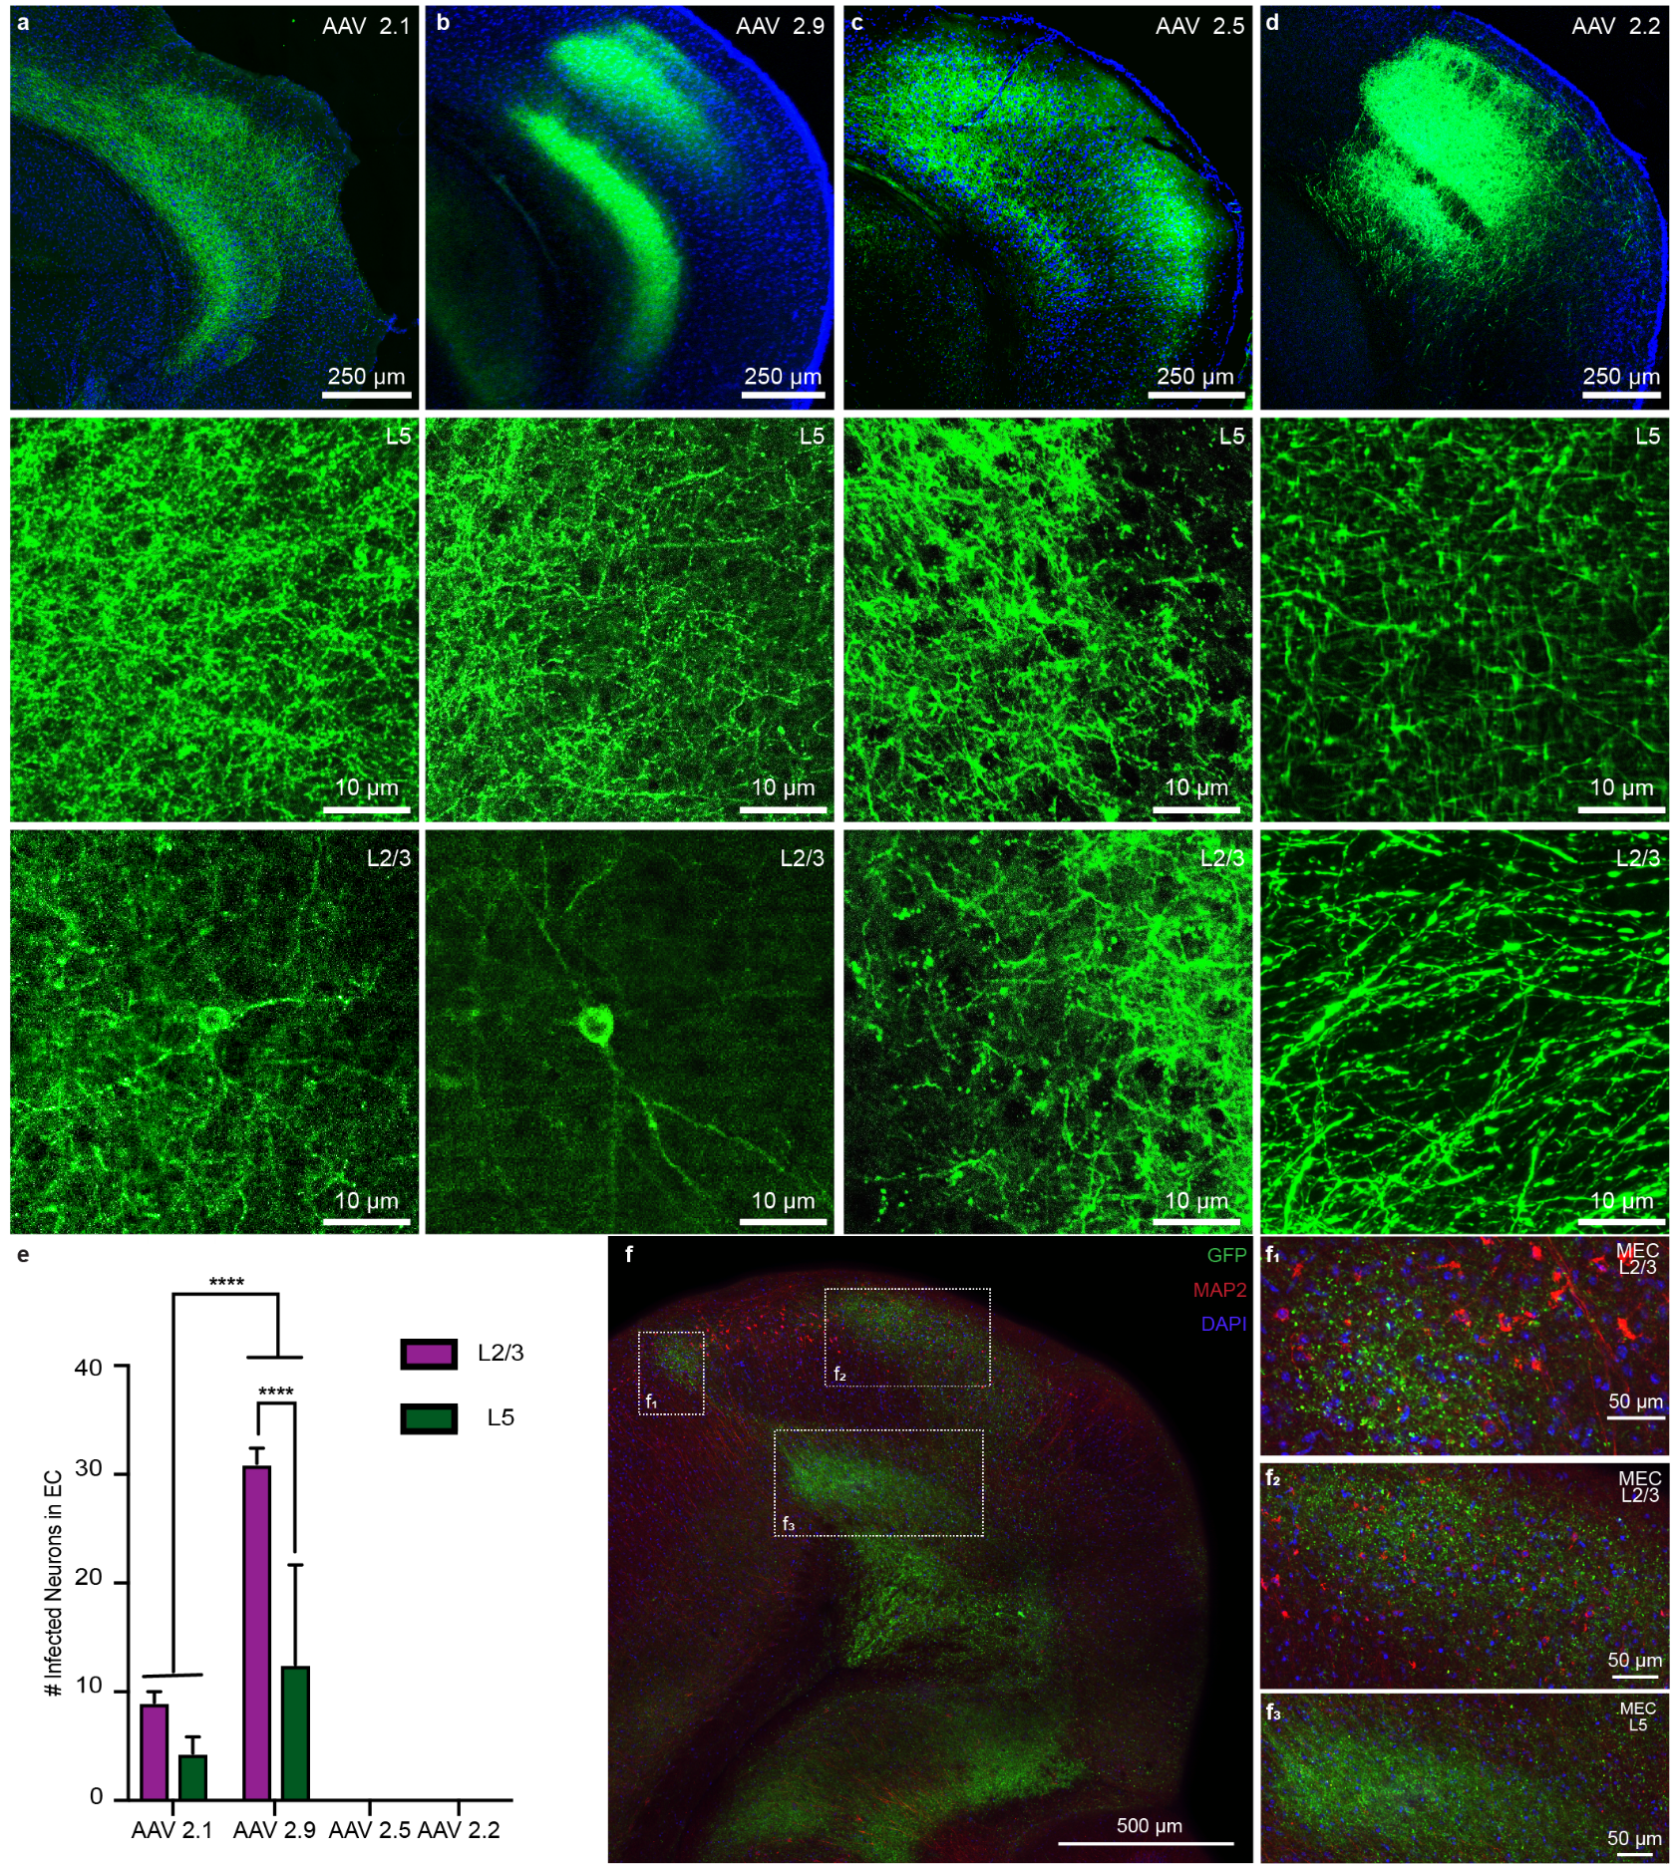

Extended Data Fig. 3. Validation of hippocampal feedback using different viral strategies.
a. Top - Confocal image of a horizontal brain slice of a mouse injected with AAV2.1 EF1α-double floxed-ChR2-eYFP (41.5 nl/site with 3 week incubation) into dorsal CA1 and immunostained for GFP and DAPI (nuclear marker). Green hippocampal axons were observed in entorhinal cortex layers 5 and 2/3. Center – Expanded view of the hippocampal projection to EC_{L5}. No infected neurons were observed in EC_{L5}. Bottom – Expanded view the hippocampal projection to EC_{L2/3} showing a sample infected EC_{L2/3} neuron.
b. Top – Confocal image of a horizontal brain slice of a mouse injected with AAV2.9 EF1α-double floxed-ChR2-eYFP (41.5 nl/site with 3 week incubation) into dorsal CA1 and immunostained for GFP and DAPI (nuclear marker). Green hippocampal axons were observed in entorhinal cortex layers 5 and 2/3. Center – Expanded view of the hippocampal projection to EC_{L5}. No infected neurons were observed in EC_{L5}. Bottom – Expanded view the hippocampal projection to EC_{L2/3} showing a sample infected EC_{L2/3} neuron.
c. Top – Confocal image of a horizontal brain slice of a mouse injected with AAV2.5 EF1α-double floxed-ChR2-eYFP (82.8 nl/site with 3 week incubation) into dorsal CA1 and immunostained for GFP and DAPI (nuclear marker). Green hippocampal axons were observed in entorhinal cortex layers 5 and 2/3. Center – Expanded view of the hippocampal projection to EC_{L5}. Bottom – Expanded view the hippocampal projection to EC_{L2/3}. No infected neurons were observed in either EC layer.
d. Top – Confocal image of a horizontal brain slice of a mouse injected with AAV2.2 CAMKII-ChR2-eYFP (41.4 nl/site with 3 week incubation) into dorsal CA1 and immunostained for GFP and DAPI (nuclear marker). Green hippocampal axons were observed in entorhinal cortex layers 5 and 2/3. Center – Expanded view of the hippocampal projection to EC_{L5}. Bottom – Expanded view the hippocampal projection to EC_{L2/3}. No infected neurons were observed in either EC layer.
e. Quantification of the number of infected neurons observed in EC after 3 weeks of viral incubation period. 41.4 nl of virus was injected per site for viral serotypes AAV 2.1 (n = 8), 2.2 (n = 8), and 2.9 (n = 22), and 82.8 nl per site for AAV 2.5 (n = 11).
f. Confocal image of a horizontal brain slice of a mouse injected with AAV 2.5 EF1α-double floxed-ChR2-eYFP into dorsal CA1 and immunostained for GFP, MAP2 (marker for dendrites), and DAPI (nuclear marker). Green hippocampal axons were observed in entorhinal cortex layers 5 and 2/3. The area within the white dotted boxes are expanded in panels f₁, f₂, and f₃. Absence of colocalization between the GFP and MAP2 immunofluorescence signals verify the absence viral infection in EC neurons.

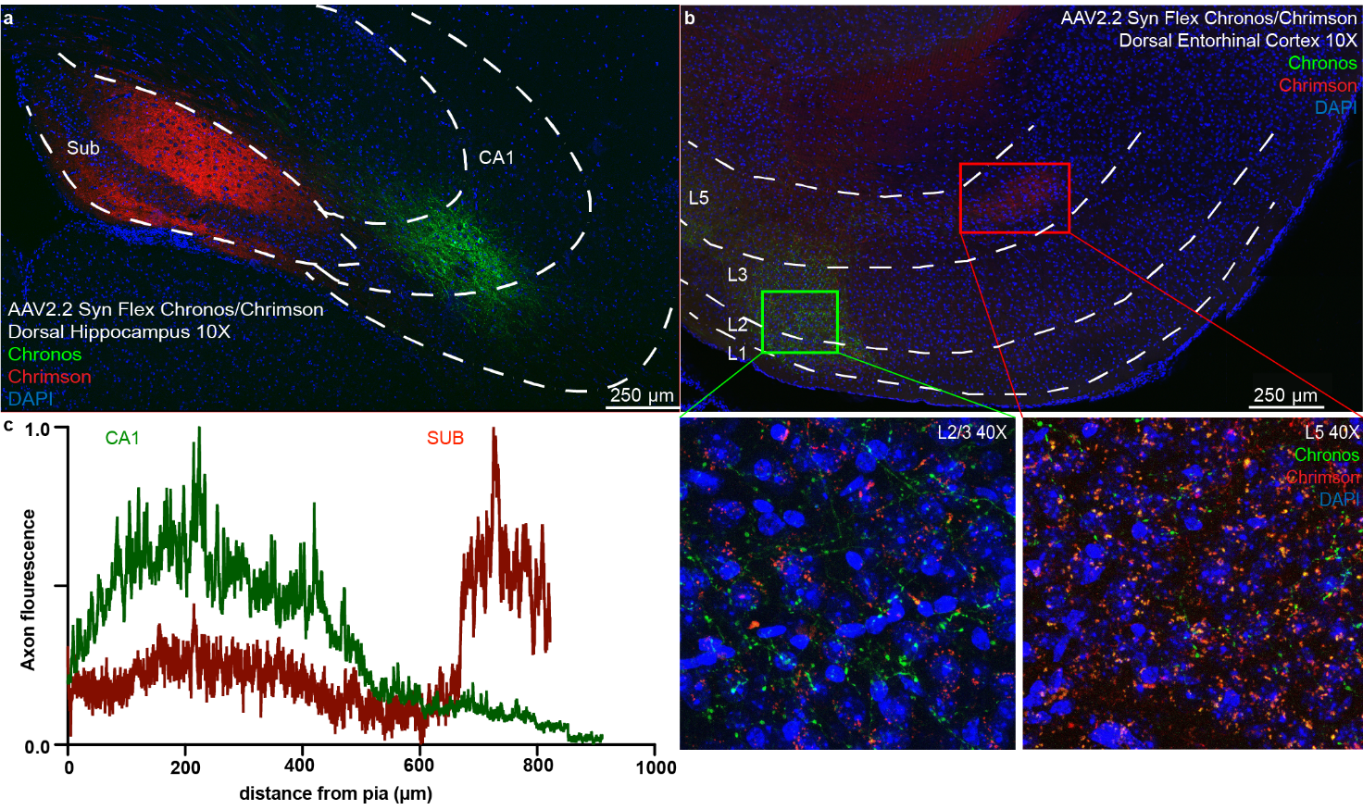
Extended Data Fig. 4. Hippocampal CA1 primarily projects to entorhinal cortex layer 2/3 while subiculum projects to layer 5.
a. Confocal image of a horizontal brain slice of a mouse injected with AAV 2.2 Syn flex Chrimson TdTom in dorsal subiculum and AAV 2.2 Syn flex Chronos GFP in dorsal CA1, immunostained for GFP, RFP, and DAPI. White dotted lines demarcate the different hippocampal areas: Sub – Subiculum, and CA1- CA1 pyramidal layer.
b. Confocal image of a horizontal brain slice of a mouse injected with AAV 2.2 Syn flex Chrimson TdTom in dorsal subiculum and AAV 2.2 Syn flex Chronos GFP in dorsal CA1, immunostained for GFP, RFP, and DAPI. Green CA1 axons were primarily observed in entorhinal cortex (EC) layers 2/3, while red subiculum axons in EC layer 5. White dotted lines demarcate the different cortical layers. Projections to EC_{L2/3} and EC_{L5} enclosed in green and red boxes respectively are magnified in bottom left and bottom right insets respectively.

c. Normalized fluorescence intensity of hippocampal axons in EC as a function of distance from pia. Red and green traces represent the fluorescence along the axons from subiculum and CA1 respectively. In total 6 animals were used to resolve HC-EC_{L2/3} and HC-EC_{L5} pathways.

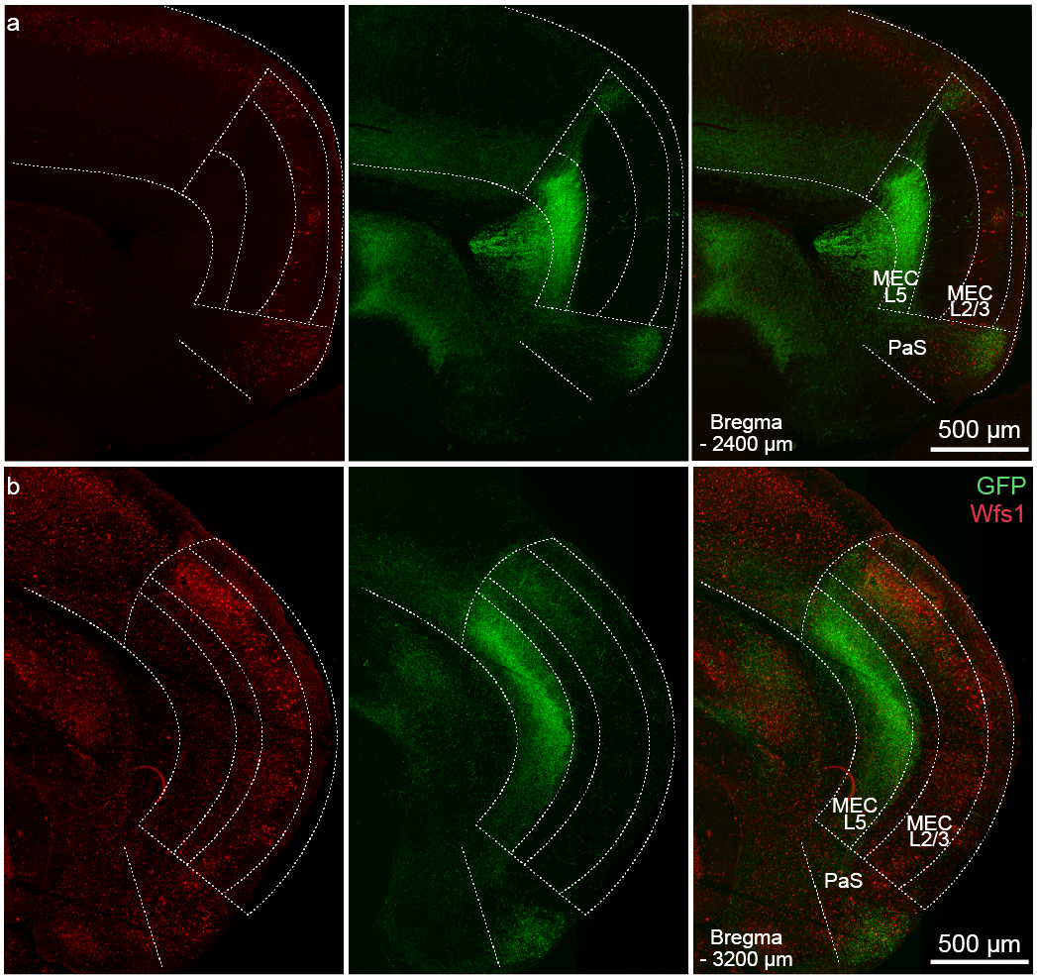

Extended Data Fig. 5. Hippocampal projections primarily target medial entorhinal cortex (MEC).

a. Confocal image of horizontal brain slice of a mouse injected with AAV2.5 EF1α-double floxed-ChR2-eYFP into dorsal CA1 and immunostained for GFP and Wfs1 (labels pyramidal cells in MEC). White dotted lines demarcate the different cortical layers and brain regions. Note the sharp cut-off of green hippocampal projections at the MEC border demarcated by the absence of clusters of pyramidal cells labeled by Wfs1. The position of the horizontal plane of section through the mouse brain is reported as ventral distance from bregma (-2400 µm) in the bottom left corner. PaS – parasubiculum.

b. Same as a. but for -3200 µm from bregma.

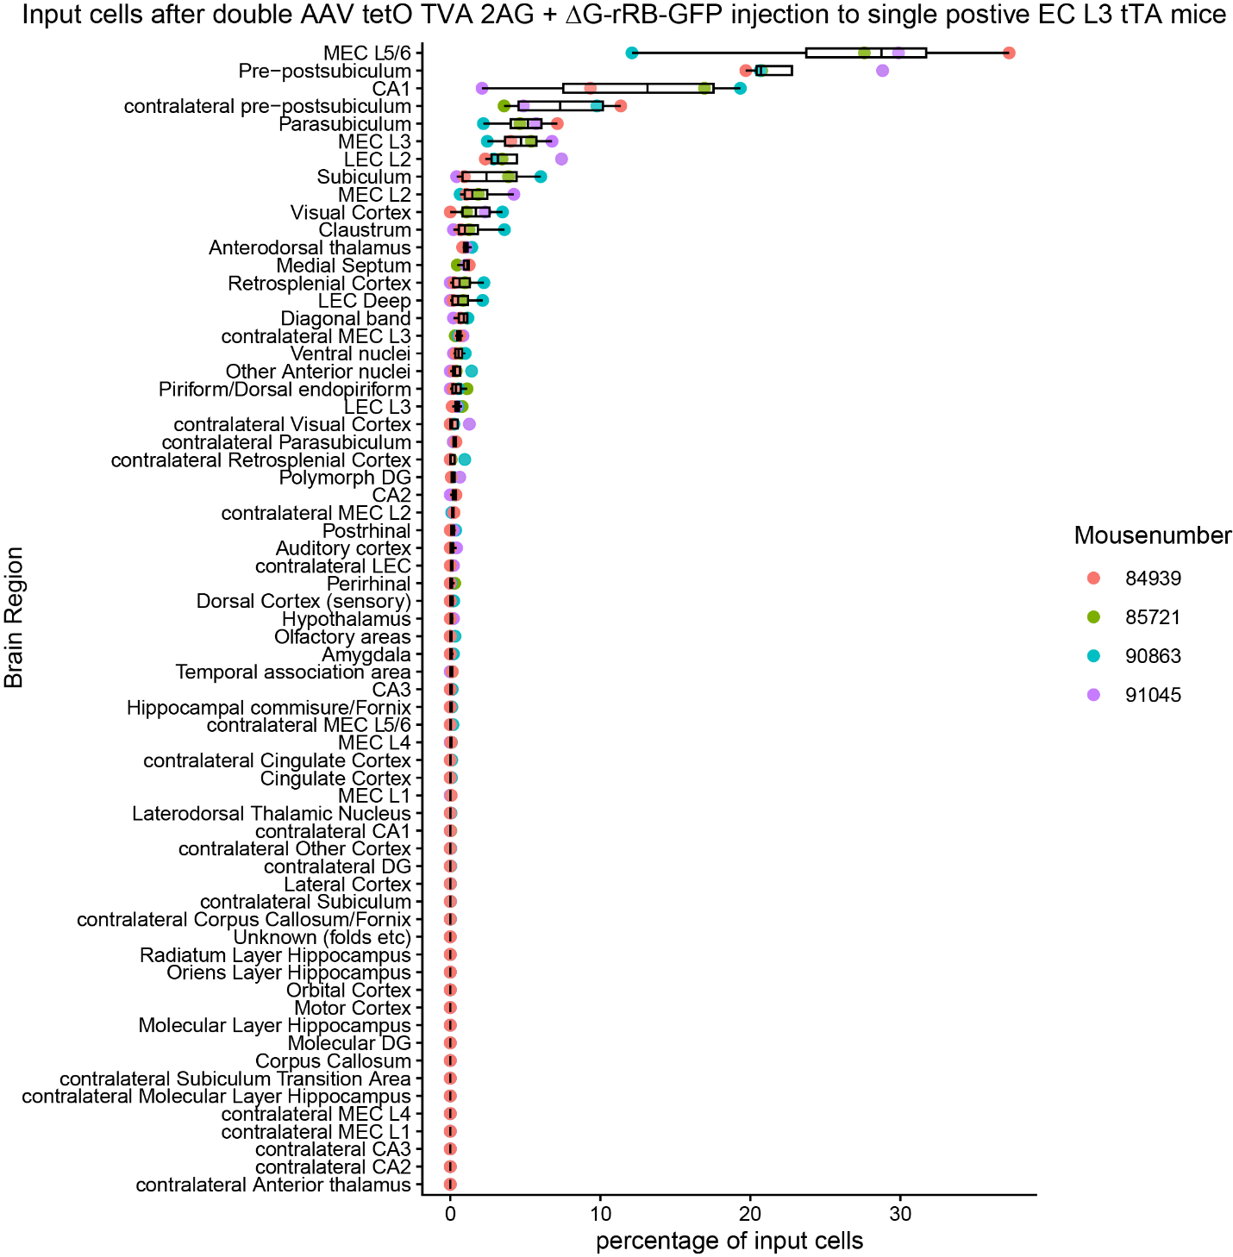

Extended Data Fig. 6. Quantification of GFP⁺ presynaptic cells.
Quantification of GFP⁺ presynaptic input cells in brain regions that project to starter neurons in MEC_{L2/3} shown by double injection of AAV tetO TVA 2AG and ∆G-rRB-GFP to EC L3 tTA mice.
Abbreviations used: DG – dentate gyrus, LEC – lateral entorhinal cortex, MEC – medial entorhinal cortex.
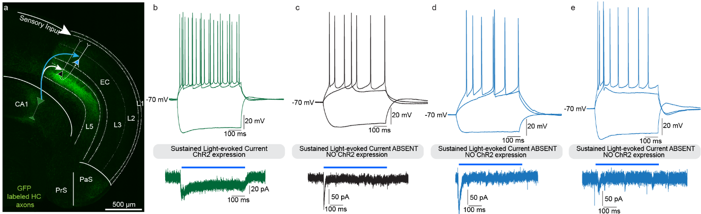

Extended Data Fig. 7. Functional channelrhodopsin 2 (ChR2) expression only in hippocampal neurons and axonal projections.
a. Schematic of the proposed circuit overlaid on a confocal image of a horizontal mouse brain slice. Green hippocampal projections from hippocampal CA1 project not only to EC_{L5} but also to EC_{L2/3}. EC – entorhinal cortex, PrS – presubiculum, PaS – parasubiculum.
b. Top – Fire and sag properties recorded from a CA1 pyramidal neuron. Shown here are the intrinsic electrical responses of the neuron to current injection of -240 pA, and current corresponding to rheobase, and 1.5 x rheobase. Bottom – Sustained photocurrent elicited in response to a 500 ms 470 nm light pulse demonstrates the expression of functional ChR2 in the CA1 pyramidal neuron.
c. Top – Fire and sag properties recorded from an EC_{L2/3} stellate cell. Shown here are the intrinsic electrical responses of the neuron to current injection of -240 pA, and current corresponding to rheobase, and 1.5 x rheobase. Bottom – Absence of sustained photocurrent elicited in response to a 500 ms 470 nm light pulse confirms the lack of off-target viral infection in the EC leading to ChR2 expression.
d – e. Same as c but for ECL_{2/3} (d) and EC_{L5} (e) pyramidal neurons.
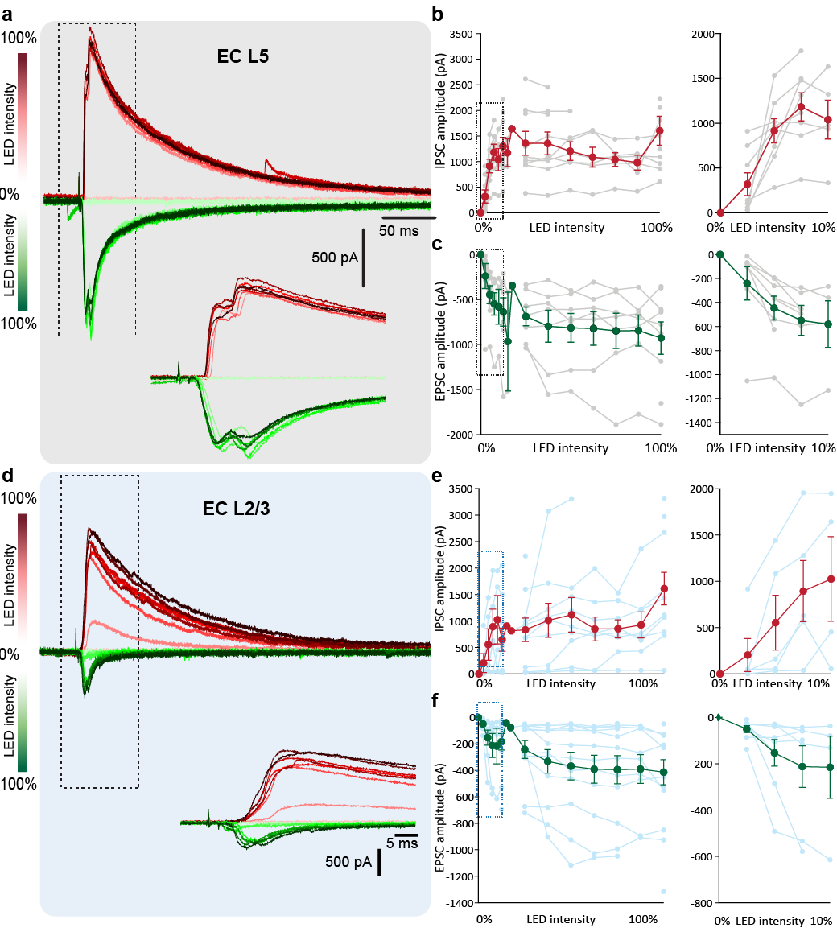

Extended Data Fig. 8. Input – output transformation of light – evoked postsynaptic currents at EC neurons upon increasing strength of optical stimulation of ChR2⁺ hippocampal axons.
a. Representative voltage clamp recordings from EC_{L5} neuron to record excitatory and inhibitory postsynaptic currents (EPSC and IPSC respectively) at -80 mV and +10 mV respectively. Insets show parts of the trace enclosed in the dotted box.
b. IPSC amplitudes recorded at EC_{L5} neurons in response to increasing LED intensity for the 470 nm optical stimulation of ChR2⁺ hippocampal projections to EC. Each gray trace is from a single neuron and the bold red trace represents the mean ± SEM across neurons. Data points within the black dotted box in the left panel are expanded in the right panel.
c. Same as b. but for EPSC amplitudes recorded at EC_{L5} neurons.
d. Same a. but for EC_{L2/3} neurons.
e. Same as b. but for EC_{L2/3} neurons.
f. Same as b. but for EPSC amplitudes recorded at EC_{L2/3} neurons.
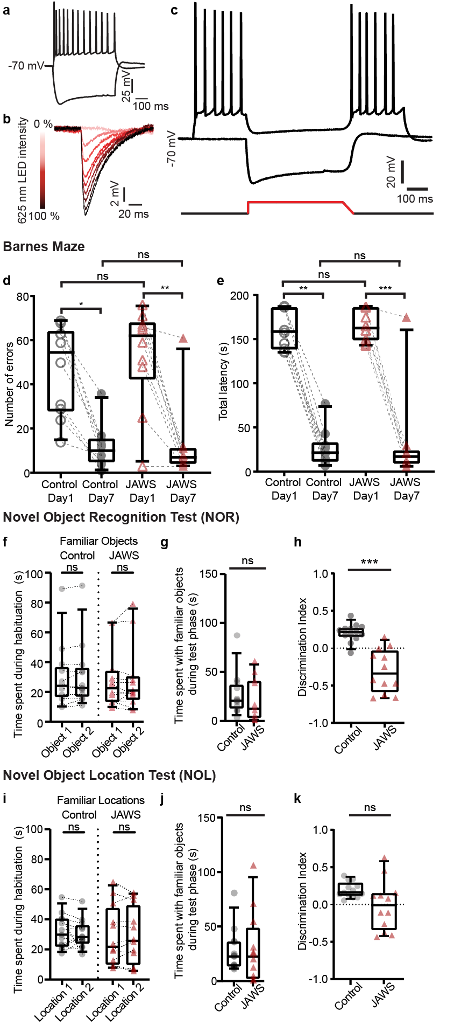

Extended Data Fig. 9. Validation in vivo optogenetic silencing of the HC-EC_{L2/3} circuit.
a – c. Validation of JAWs silencing in acute mouse brain hippocampal slices. (a) Characteristic firing and sag pattern of a CA1 pyramidal neuron (PN). (b) Step-increase in hyperpolarization in response to pulses of increasing intensity of 625 nm LED. (c) Top – validation of far-red light activated inhibitory opsin JAWs silencing. CA1 PN stays at -70 mV in the absence of current injection and fires characteristically upon depolarizing current (300 pA) current injection, except when it hyperpolarizes in the 500 ms interval of JAWs activating 625 nm light stimulation (top). Bottom – stimulation pattern: 500 ms of 625 nm light stimulation in the middle of a second-long recording period (bottom).

d. Comparison of the total number of errors made by the animal during the learning phase on day 1 vs day 7. Errors were counted as the number of times an animal explored different holes including the escape hole without entering the escape box. Box and whisker plots show the median number of errors made by the cohort of animals (control – black, JAWS – red), lower/upper quartile, 10-90th percentiles. Each gray dot and red triangle represents the number of errors made by an individual control and JAWs animal respectively. Statistical significance tested with Kruskal-Wallis test with post-doc Dunn’s correction multiple comparisons. p – value * = 0.02, ** = 0.002, ns < 0.05.
e. Comparison of the total time for which the animal explored the arena (latency) before entering the escape box, during the learning phase on day 1 vs day 7. Box and whisker plots show the median latency of entering the escape box by the cohort of animals (control – black, JAWS – red), lower/upper quartile, 10-90th percentiles. Each gray dot and red triangle represents the latency of an individual control and JAWs animal respectively. Statistical significance tested with Kruskal-Wallis test with post-doc Dunn’s correction multiple comparisons. p – value ** = 0.005, *** = 0.0004, ns < 0.05.
f. Comparison of the time that the animals spent exploring the two familiar and similar objects during habituation phase of NOR task. Box and whisker plots show the median exploration time of the cohort of animals during familiar trial (control – black, JAWS – red), lower/upper quartile, 10-90th percentiles. Each gray dot and red triangle represents the exploration time of an individual control and JAWs animal respectively. Statistical significance tested with Wilcoxon matched-pairs signed rank test for both cohorts, p – value = 0.3308 for control, p – value > 0.9999 for JAWs injected animals.
g. Comparison of the time that the animals spent exploring the familiar objects during NOR test trial. Box and whisker plots show the median exploration time of the cohort of animals during the NOR test trial (control – black, JAWS – red), lower/upper quartile, 10-90th percentiles. Each gray dot and red triangle represents the exploration time of an individual control and JAWs animal respectively. Statistical significance tested with Mann Whitney test, p – value = 0.2471.
h. Box and whisker plots showing the median novel object discrimination index for the cohort of animals (control – black, JAWS – red), lower/upper quartile, 10-90th percentiles during NOR test trial. Each gray dot and red triangle represents the novel object discrimination index an individual control and JAWs animal respectively. Statistical significance tested with unpaired t test with Welch’s correction, p – value < 0.0001.
i. Comparison of the time that the animals spent exploring the two familiar and similar objects during habituation phase of NOL task. Box and whisker plots show the median exploration time of the cohort of animals during familiar trial (control – black, JAWS – red), lower/upper quartile, 10-90th percentiles. Each gray dot and red triangle represents the exploration time of an individual control and JAWs animal respectively. Statistical significance tested with paired t-test for both cohorts, p – value = 0.5131 for control, p – value = 0.9661 for JAWs injected animals.
j. Comparison of the time that the animals spent exploring the familiar locations during NOL test trial. Box and whisker plots show the median exploration time of the cohort of animals during the NOL test trial (control – black, JAWS – red), lower/upper quartile, 10-90th percentiles. Each gray dot and red triangle represents the exploration time of an individual control and JAWs animal respectively. Statistical significance tested with Mann Whitney test, p – value = 0.7689.
k. Box and whisker plots showing the median novel location discrimination index for the cohort of animals (control – black, JAWS – red), lower/upper quartile, 10-90th percentiles during NOR test trial. Each gray dot and red triangle represents the novel location discrimination index an individual control and JAWs animal respectively. Statistical significance tested with unpaired t test with Welch’s correction, p – value = 0.0626.

