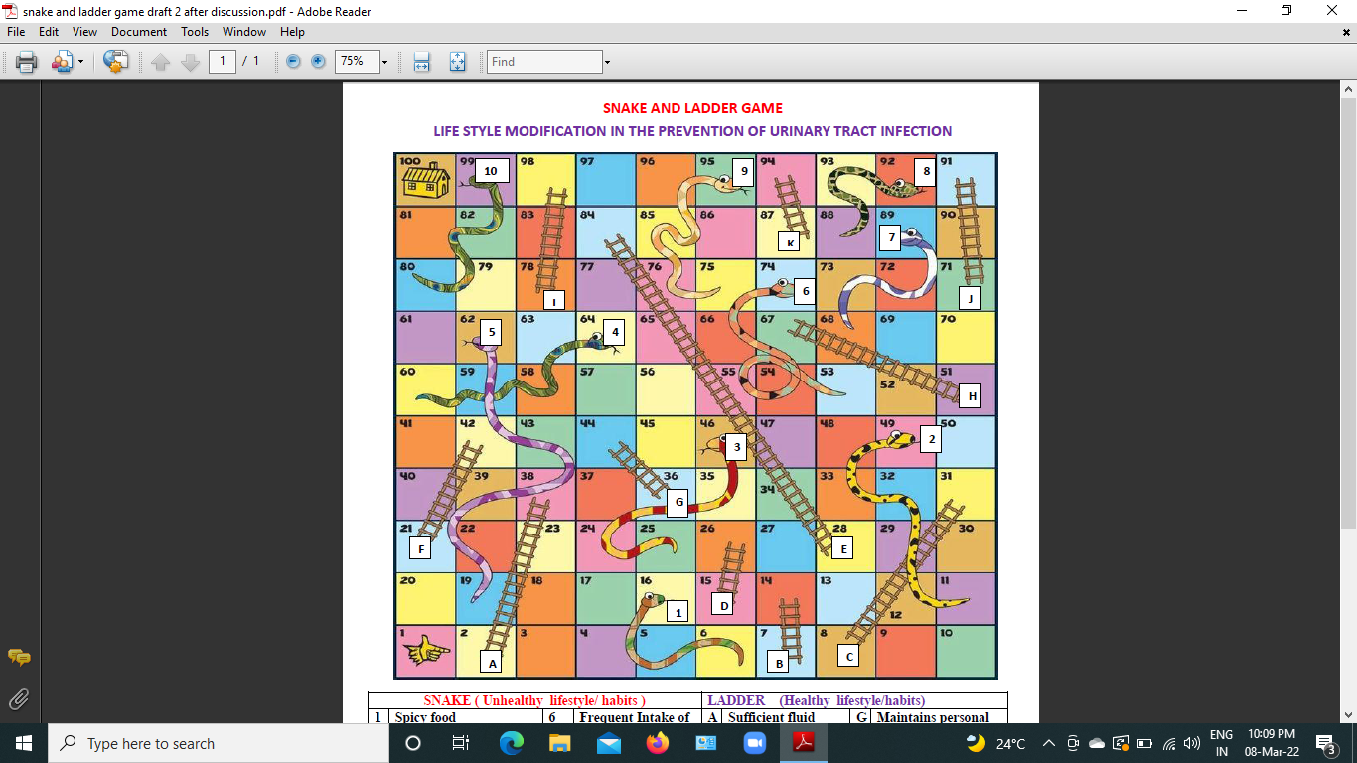

 | SNAKE (Unhealthy strategies ) |  |  |  | LADDER (Health promotion strategies)
 | 1 | Sugar and fat-containing foods are consumed in excess. | 6 | No harmonious relationship | A | Excessive consumption of fiber-rich foods, as well as a low-fat, sugar free diet | G | Consult the doctor on a regular basis for health checkup and follow-up
 | 2 | Personal Hygiene is Inadequate | 7 | Not seeking medical help if required. | B | Maintains good personal Hygiene | H | Participates in religious and spiritual pursuits.
 | 3 | No physical activity. | 8 | Not following culture or religion. | C | Walks, exercises, and practices yoga on a regular basis. | I | Maintains good communication with everyone.
 | 4 | Daily life activities are not being carried out. | 9 | Make discussions into fights | D | Participate in Day-to-Day Activities | J | Reads books, prays, listens to music, in Leisure time.
 | 5 | Sleep deprivation | 10 | Possessing unfavorable emotions | E | Proper sleep-wake cycle. | K | Being optimistic in all situations
 |  |  |  |  | F | Maintains positive interactions with family members.

