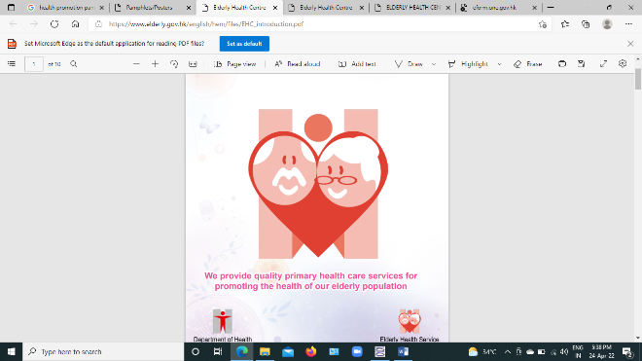

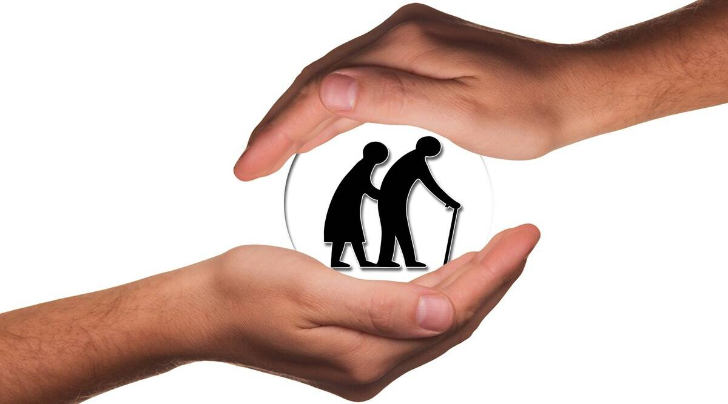
Healthy Life for Healthy Aging


INTRODUCTION

Old age is a privilege for second childhood and a new stage of opportunity and strength.
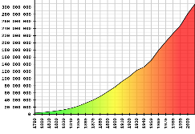
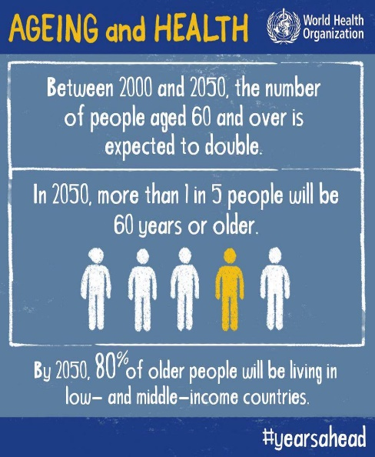
In 2050,
- 1 in 5 people will be 60 years older

- 80% of older people will be living in low- and middle-income countries

Definition: Geriatric as, >65years of the age in developed countries and >60years in developing countries.
“International Day for Elderly” is celebrated every year on 1st October.
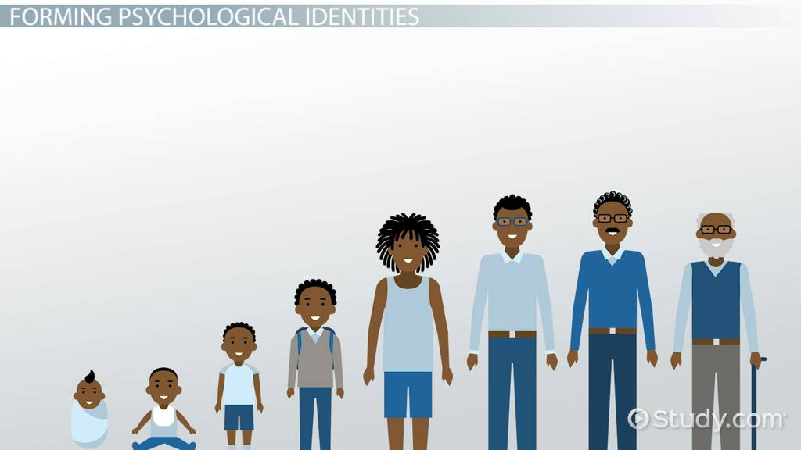

A man's life is normally divided into five stages.

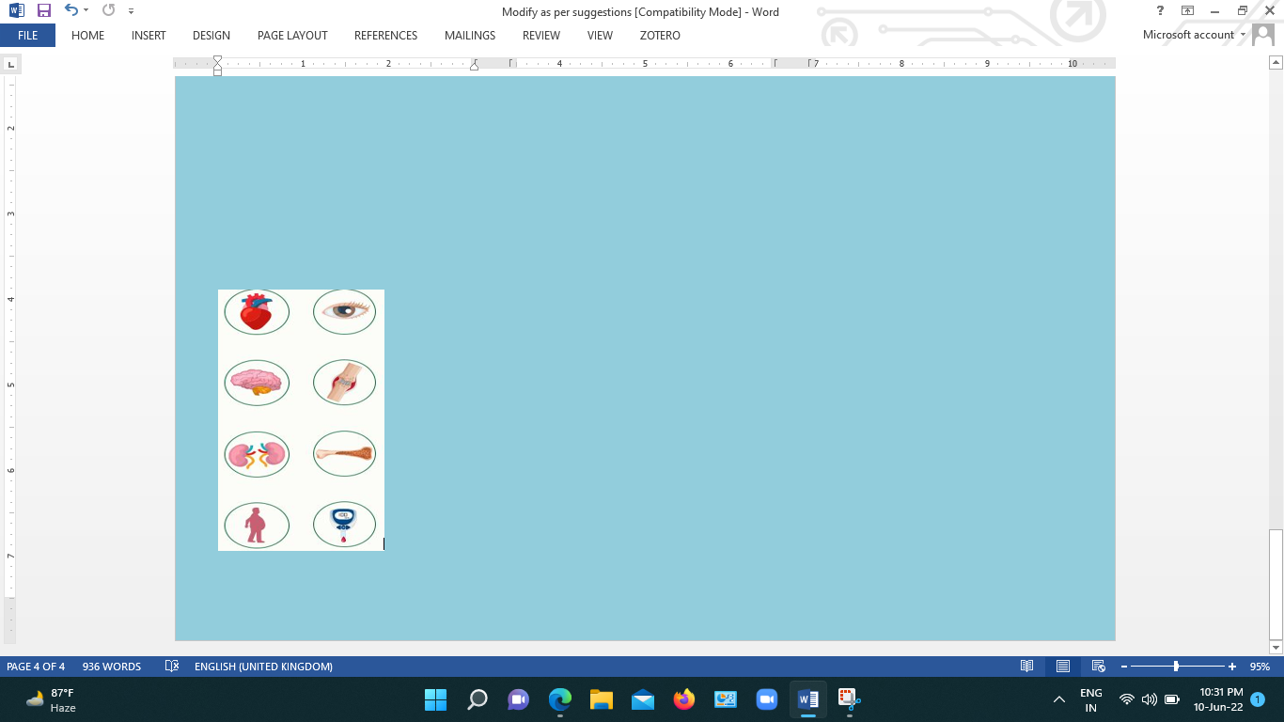
Common geriatric problems:

HEALTH PROMOTION
Enabling people to increase control over their health and empowering to adapt healthy behaviours
- WHO

Health Promotion Strategies

1. Physical Activity
2. Lifestyle & Healthy Diet
3. Socialization
4. Fall prevention
5. Stress management
6. Pain management
7. Medication & follow up 8. Spirituality & Schemes

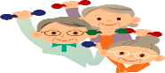
1. Physical Activity

Benefits :
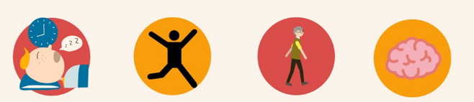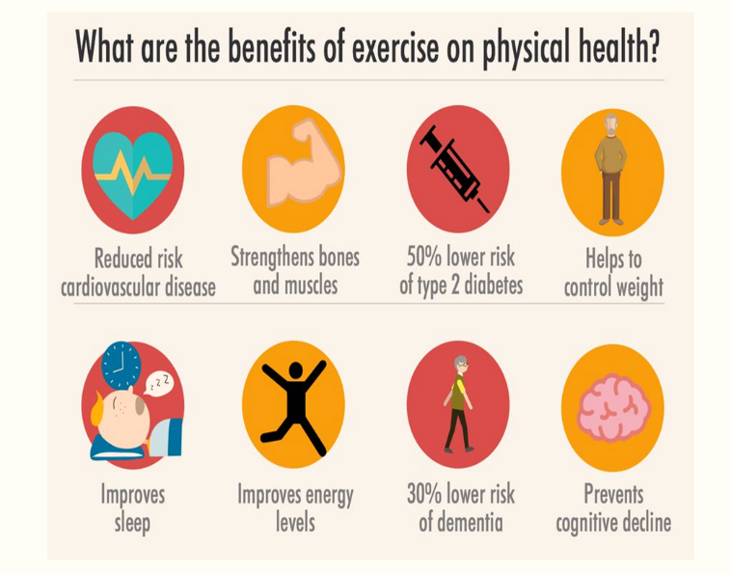

150 min: Moderate intensity activity per week
20-30 min in a week for 3days



2. Healthy Diet

Eating a well-balanced diet is an important overcome the nutritional problems.
Benefits
- Healthy Organ & Brain function
- Managing chronic illnesses
- Strengthening the immune system
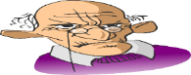
- Muscle and bone health
Tips: Healthy Senior Diet

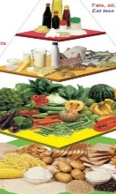
- Eat plenty of fruit and vegetables
- Choose calcium for bone health
- Go “good fat” not “no fat”
- Sources of protein
- Eat more fibre rich foods
- Avoid refined carbs & sugars
- Maintain hydration

3. Socialization

Good connections improve health and increase longevity by keeping mentally, physically and emotionally fit.

Ways to Cultivate: Healthy Social Life

- Build and maintain positive relationships
- Do volunteer work in social activities
- Move to a retirement community
- Caring for a pet, hobby.

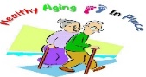
4. Fall Prevention

As per CDC,
By 2030
- 49 miliion falls and 12 million injuries
Fall prevention Strategies :
- Talk to your doctor
- Do strength and balance exercises
- Have your feet and eyes checked

- Make home safer
5.Stress Management

Stress is an everyday part of our lives & reaction to a situation where you feel under pressure.

Strategies to cope with Stress
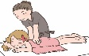
- Regular exercise

- Participate in social activities
- Do relaxation techniques
- Meditation, massage


6. Pain Management 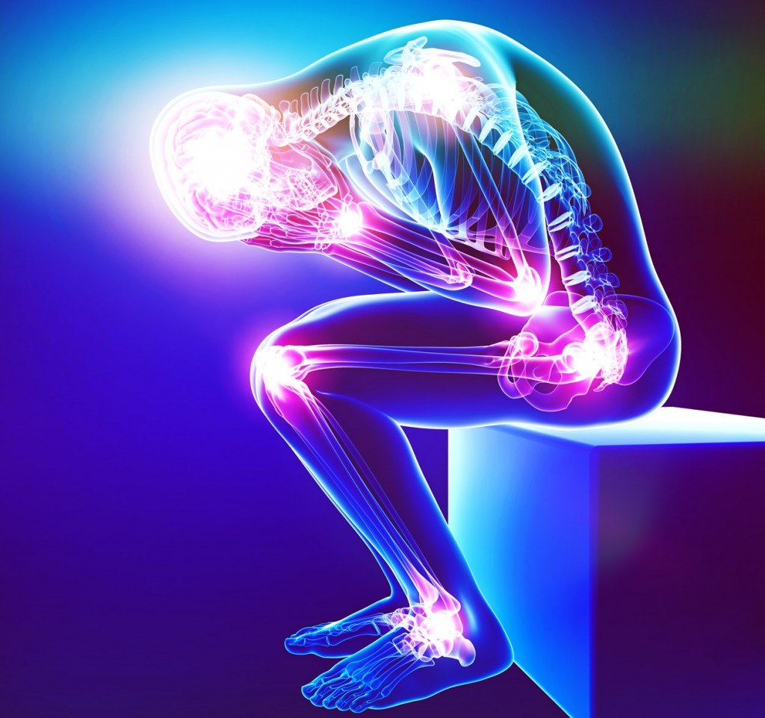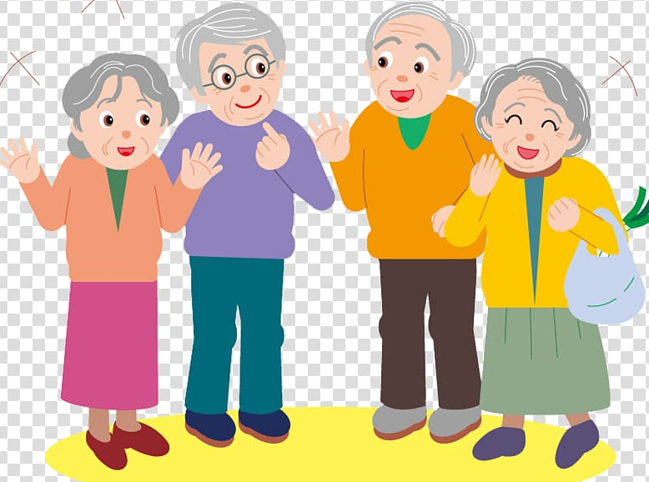

An unpleasant sensory & emotional experience

Pain management measures

- Massage therapy
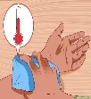
- Warm and cold compress
- Spiritual support
- Music therapy

7. Medication & Follow Up

- Take Medicine as Prescribed—with Input from Your Health Care Provider
- Keep a Medication List
- Be Aware of side effects

8. Spirituality & Schemes 

Holistic approach to improve quality of life for a positive wellness.

Schemes
- Pradhan Mantri Vaya Vandana Scheme
- Indira Gandhi National Old Age Pension Scheme (IGNOAPS)
- National Programme for the Health Care of Elderly (NPHCE)
- Varishta Mediclaim Policy
- Rashtriya Vayoshri Yojana
- Varishta Pension Bima Yojana
- Senior Citizens' Welfare Fund
- Pradhan Mantri Jan Arogya Yojana
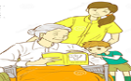
FAMILY CARE GIVER ROLE

- Assist with Personal care & health care
- Maintain a healthful environment
- Food and Medicine administration
- Keep updated about what is happening in your life.
- Visit as often as you can along with children and partner.
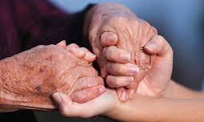
Elder abuse

Infliction of harm on an older person
- National helpline numbers: to reach out redressal of grievances lodged by senior citizens-1090(Bangalore), 14567(common to all states).

ROLE OF NURSE

- Assess and screen for health problems
- Promote health & wellness
- Encourage active lifestyle
- Strengthening self-care capacities
- Prevent disability
- Counseling, Communication,
- Improve Health & control of diseases
- Increasing life expectancy among the elderly.
“TO CARE FOR THOSE WHO ONCE CARED FOR US IS ONE OF THE HIGHEST HONOURS”


