Supporting Information
(Scientific Reports)
A protocatechuic acid-based deep eutectic solvent: a novel and versatile catalyst for the synthesis of pyranopyrimidines

Arezo Monem, Davood Habibi,* Hadis Goudarzi

Department of Organic Chemistry, Faculty of Chemistry, Bu-Ali Sina University, Hamedan 6517838683, Iran
*Corresponding author email: davood.habibi@gmail.com (& dhabibi@basu.ac.ir), Tel: 98 81 38380922; Fax: 98 81 38380709

Content Page
FT-IR spectrum of 2a 2
¹H NMR spectrum of 2a 2
¹³C NMR spectrum of 2a 3
Mass spectrum of 2a 3
FT-IR spectrum of 2b 4
¹H NMR spectrum of 2b 4
¹³C NMR spectrum of 2b 5
Mass spectrum of 2b 5
FT-IR spectrum of 2c 6
¹H NMR spectrum of 2c 6
¹³C NMR spectrum of 2c 7
Mass spectrum of 2c 7
FT-IR spectrum of 2d 8
¹H NMR spectrum of 2d 8
¹³C NMR spectrum of 2d 9
Mass spectrum of 2d 9
FT-IR spectrum of 2e 10
¹H NMR spectrum of 2e 10
¹³C NMR spectrum of 2e 11
Mass spectrum of 2e 11
FT-IR spectrum of 2f 12
¹H NMR spectrum of 2f 12
¹³C NMR spectrum of 2f 13
Mass spectrum of 2f 13
FT-IR spectrum of 2g 14
¹H NMR spectrum of 2g 14
¹³C NMR spectrum of 2g 15
Mass spectrum of 2g 15
FT-IR spectrum of 2h 16
¹H NMR spectrum of 2h 16
FT-IR spectrum of 2i 17
¹H NMR spectrum of 2i 17
FT-IR spectrum of 2j 18
FT-IR spectrum of 2k 18
FT-IR spectrum of 2l 19

FT-IR spectrum of 2a
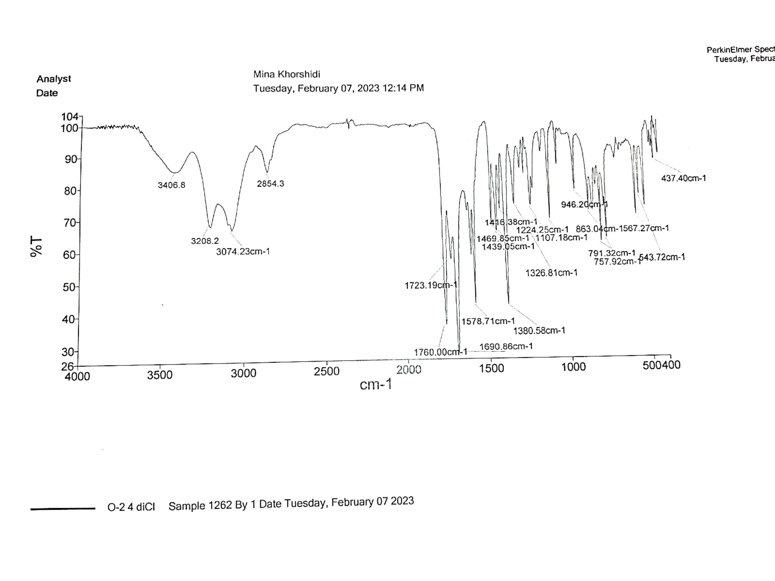

¹H NMR spectrum of 2a
¹³C NMR spectrum of 2a

Mass spectrum of 2a
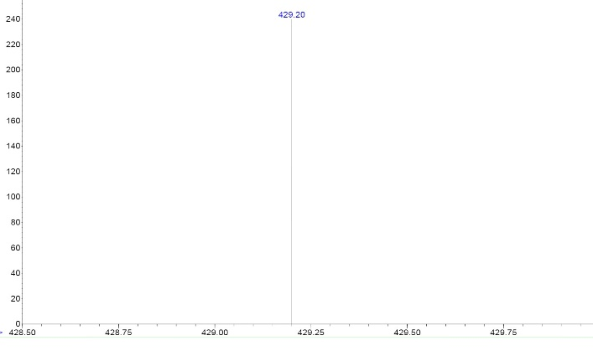
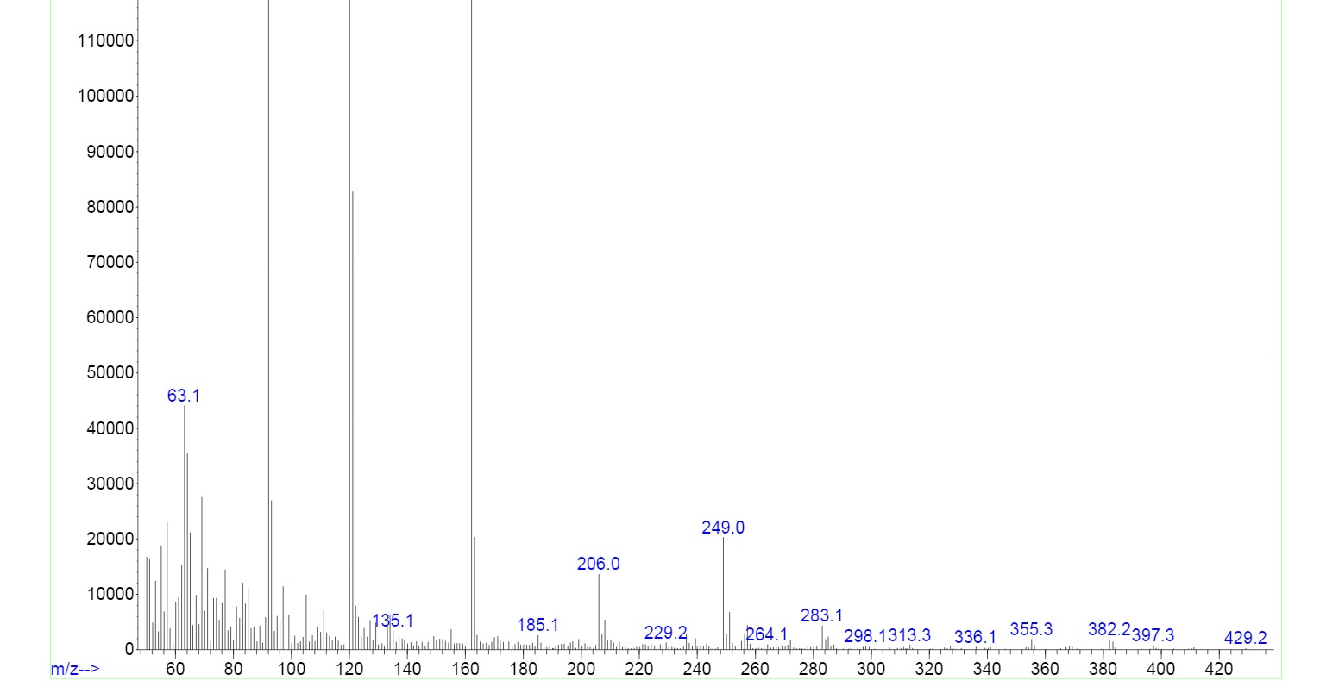
FT-IR spectrum of 2b
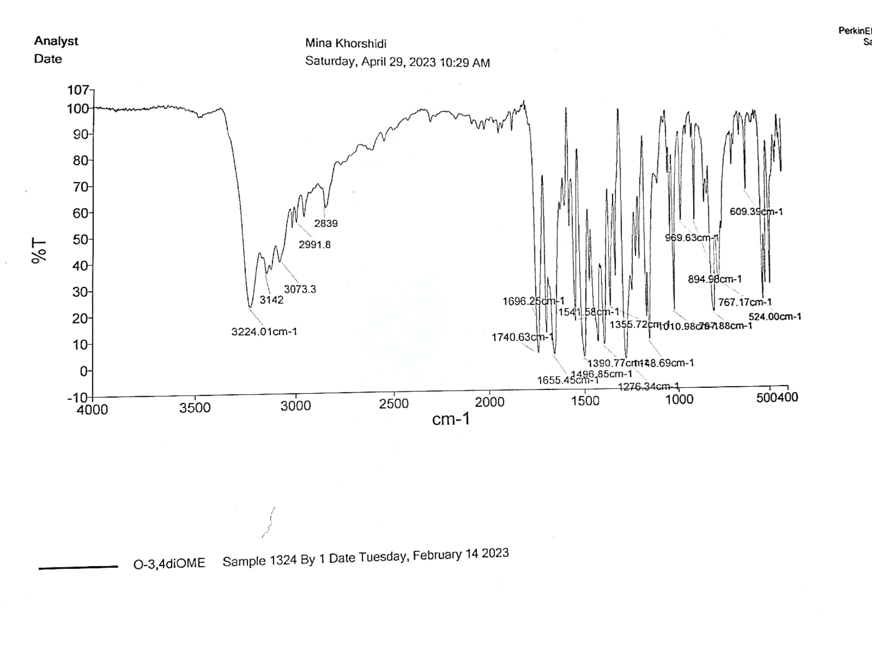

¹H NMR spectrum of 2b
¹³C NMR spectrum of 2b

Mass spectrum of 2b
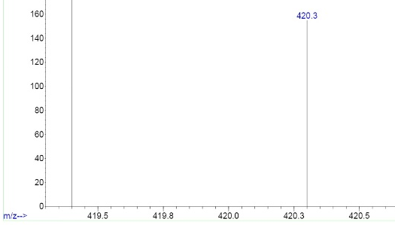
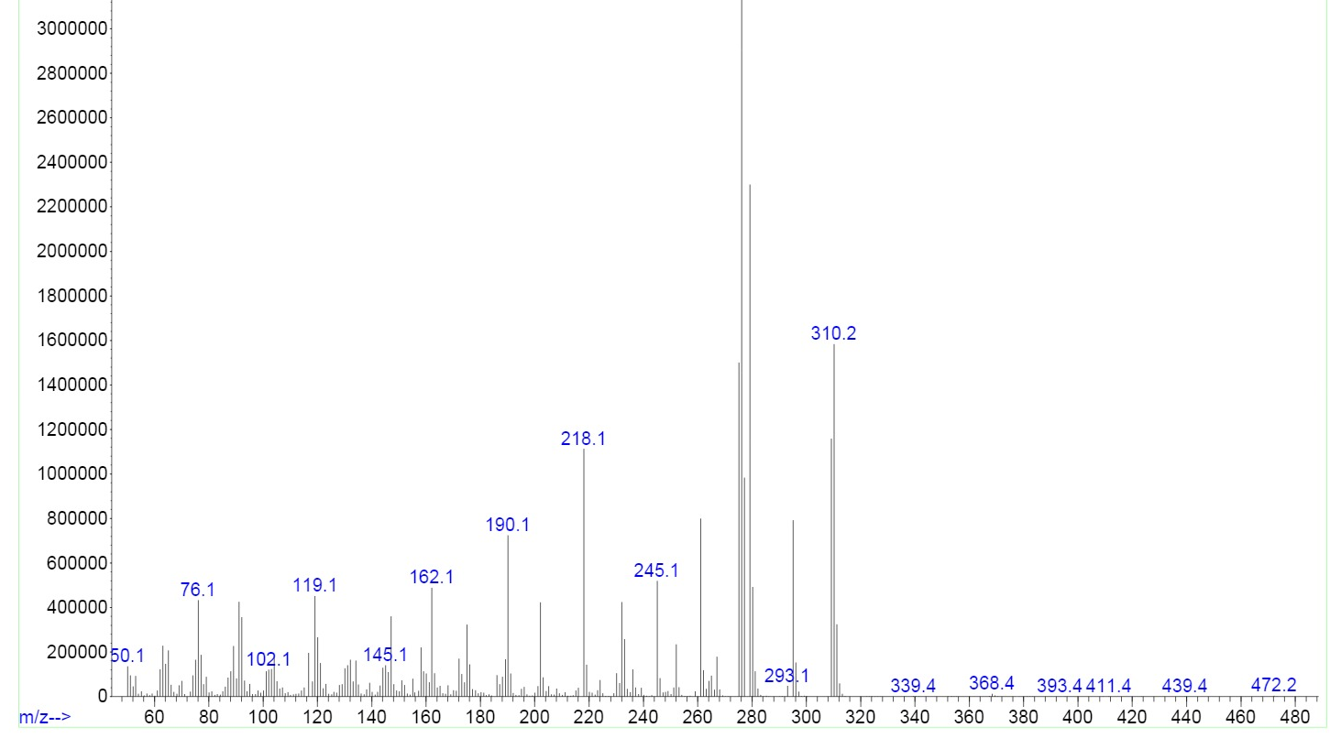
FT-IR spectrum of 2c
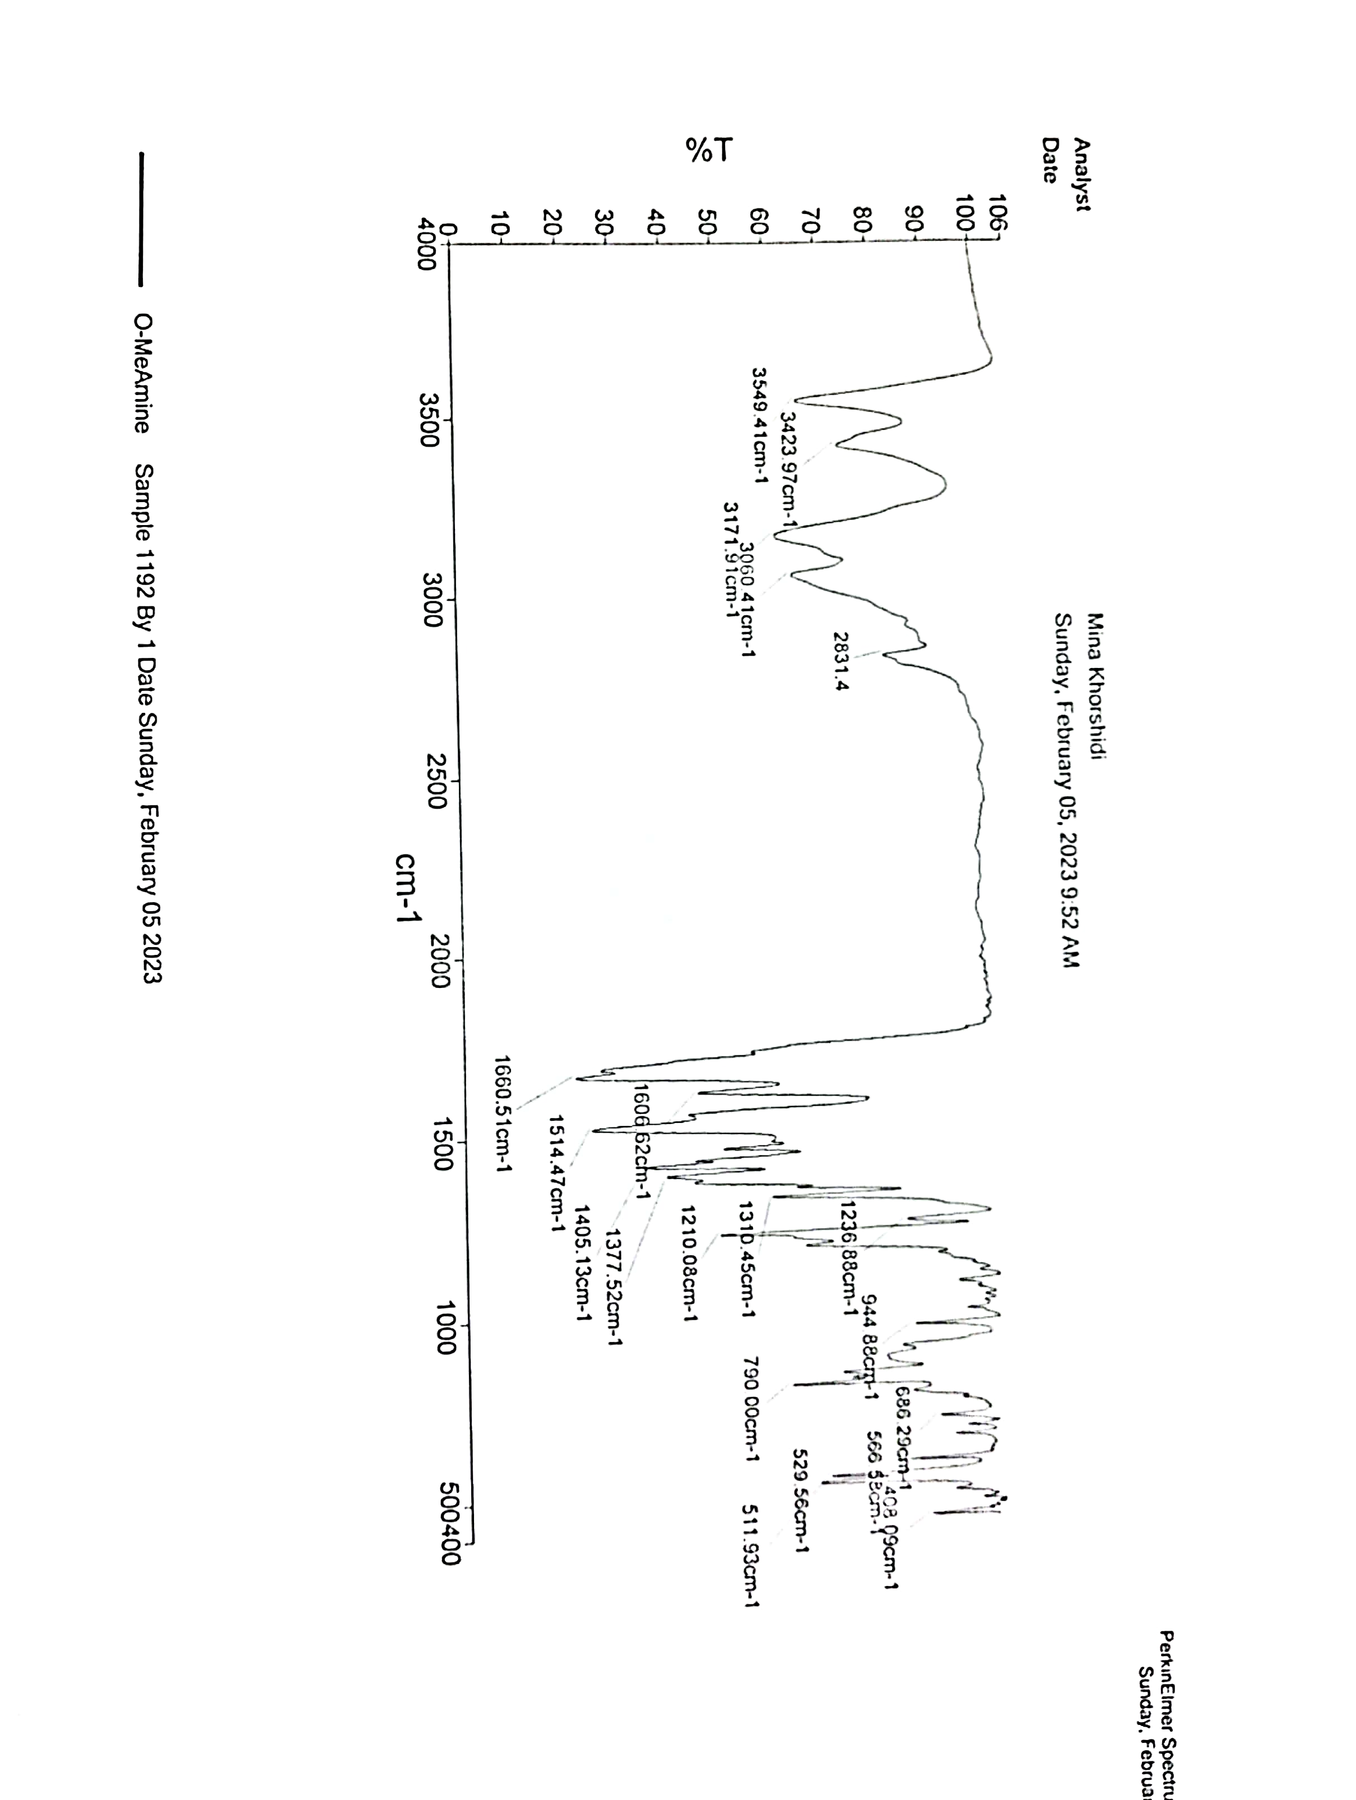

¹H NMR spectrum of 2c
¹³C NMR spectrum of 2c

Mass spectrum of 2c
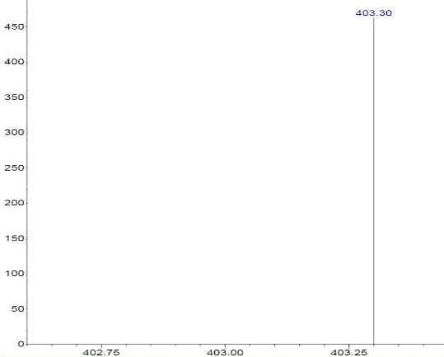
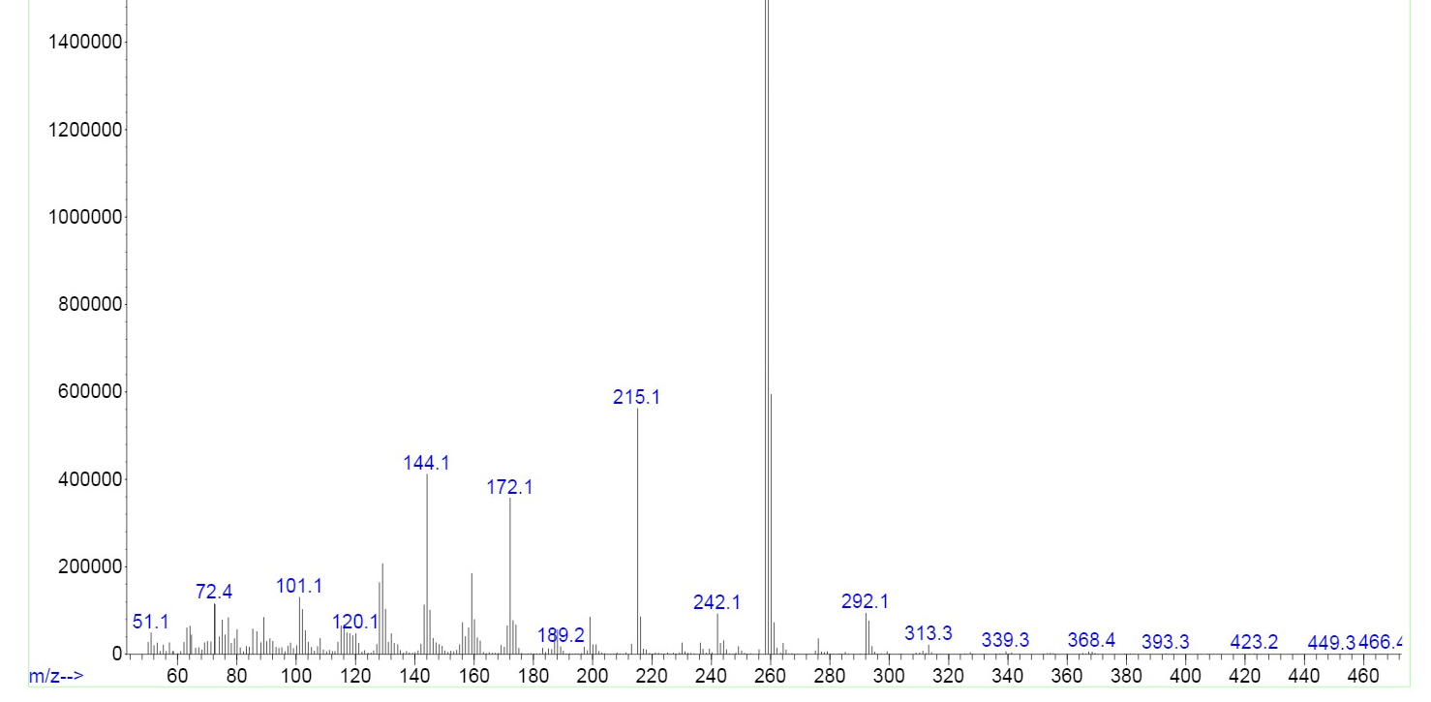
FT-IR spectrum of 2d
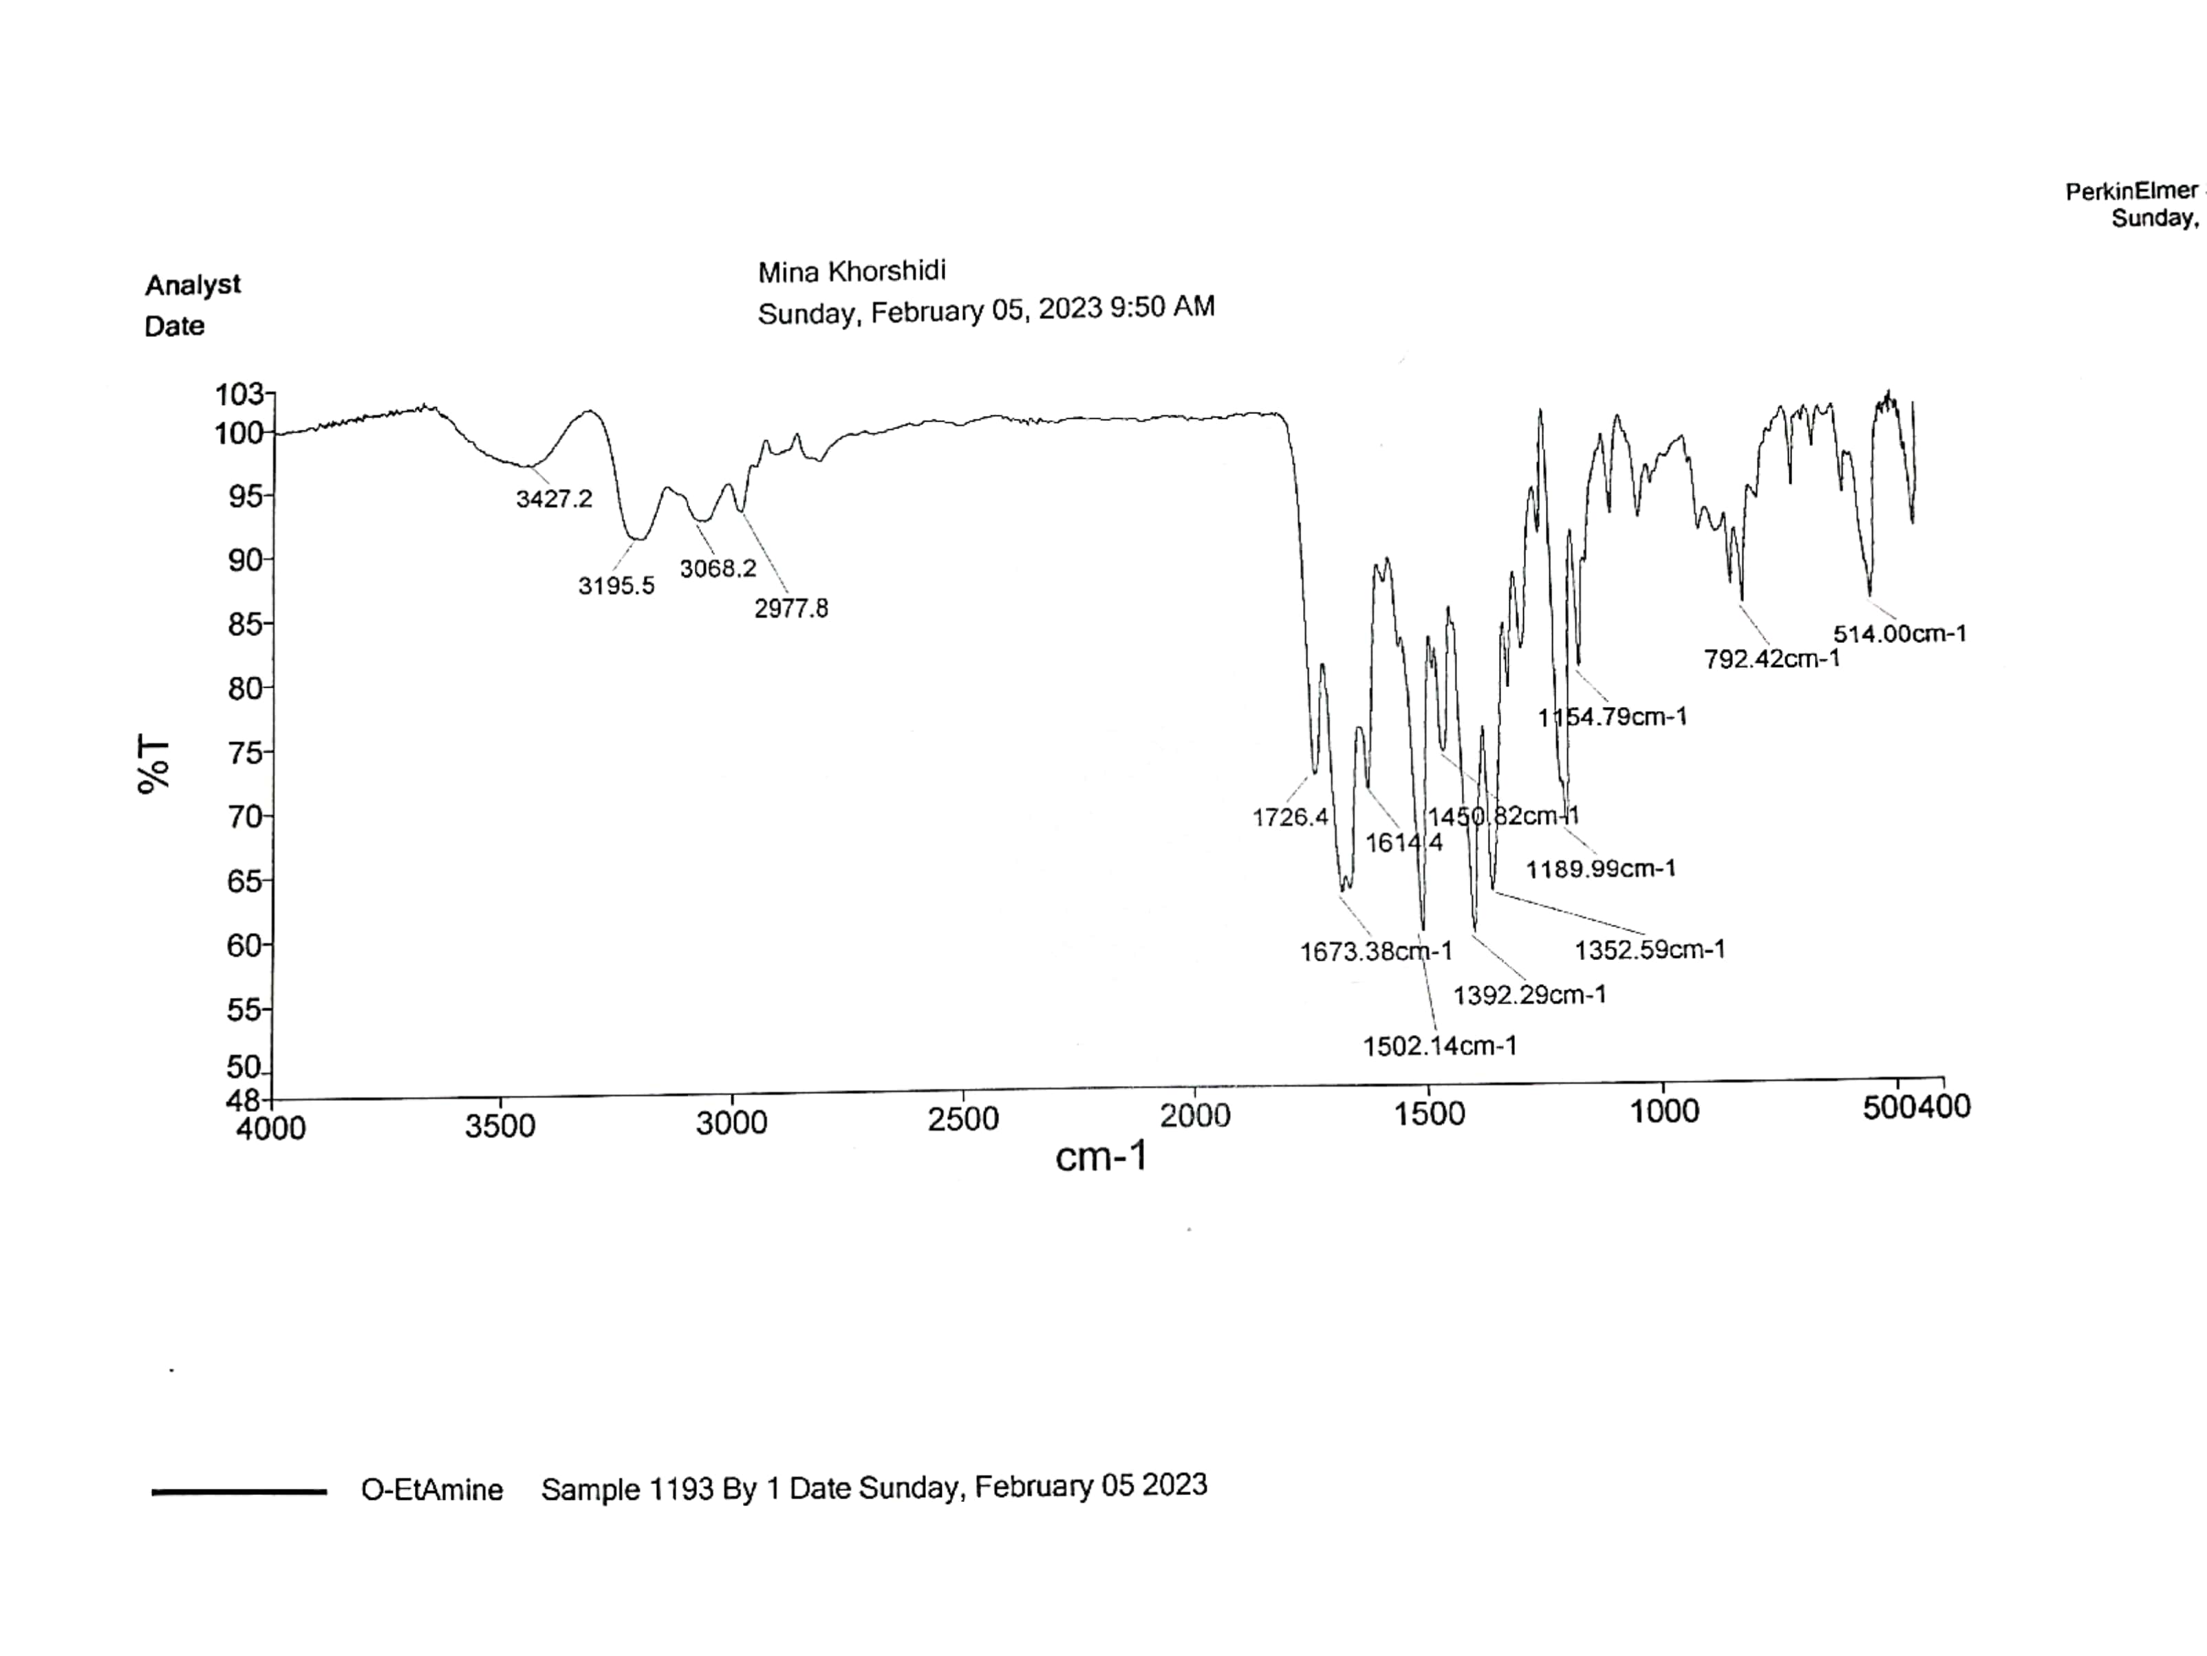

¹H NMR spectrum of 2d
¹³C NMR spectrum of 2d
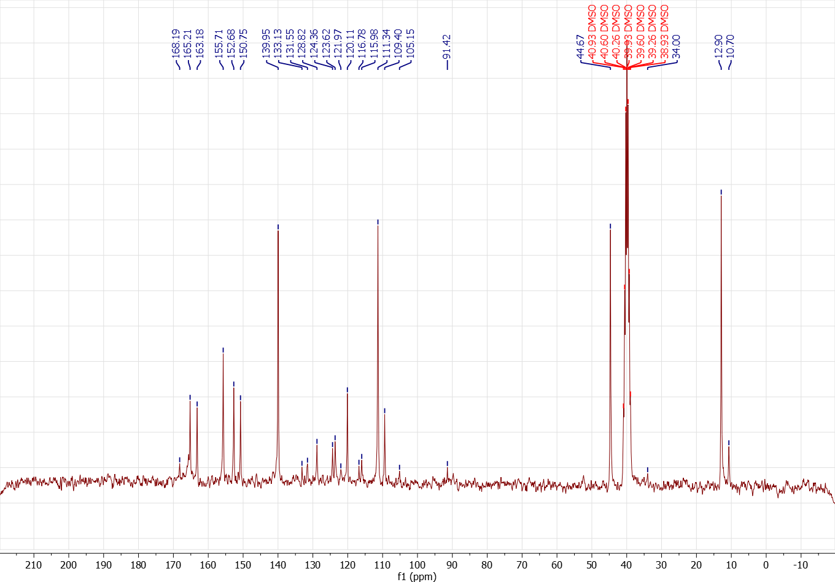

Mass spectrum of 2d
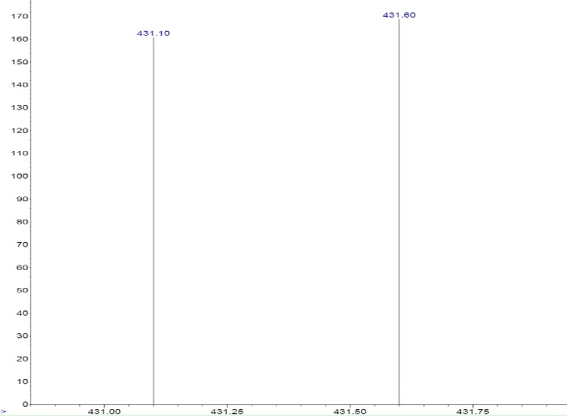
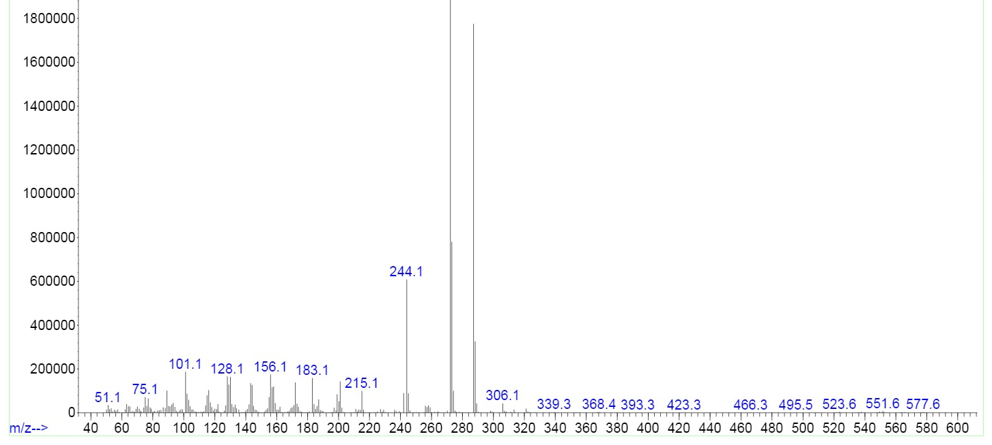

FT-IR spectrum of 2e
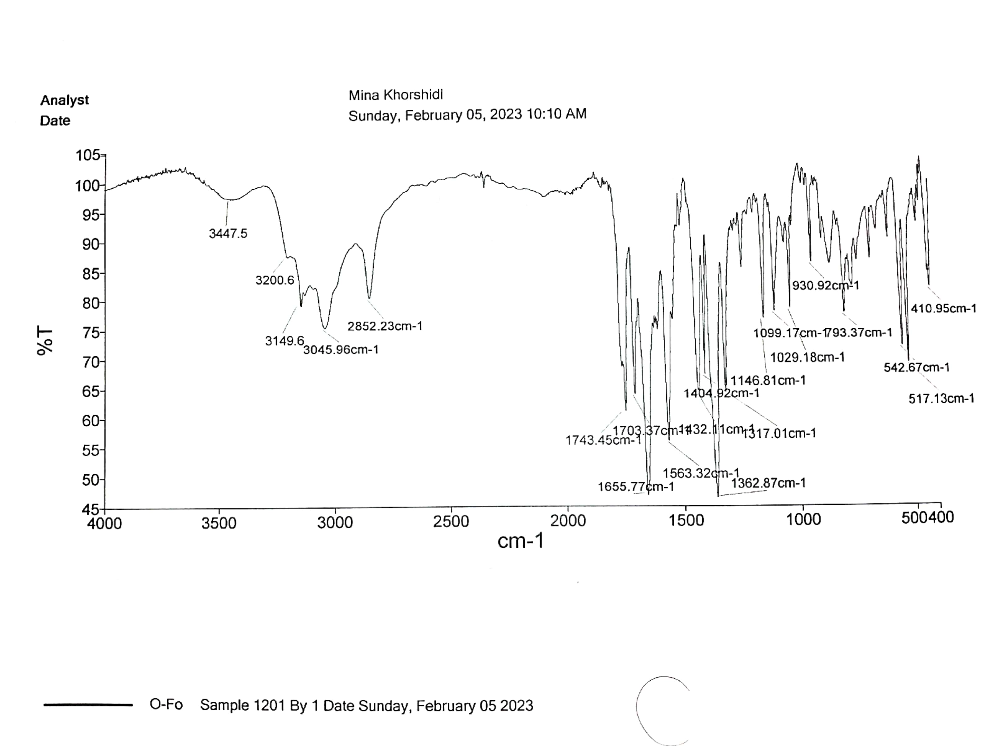

¹H NMR spectrum of 2e
¹³C NMR spectrum of 2e
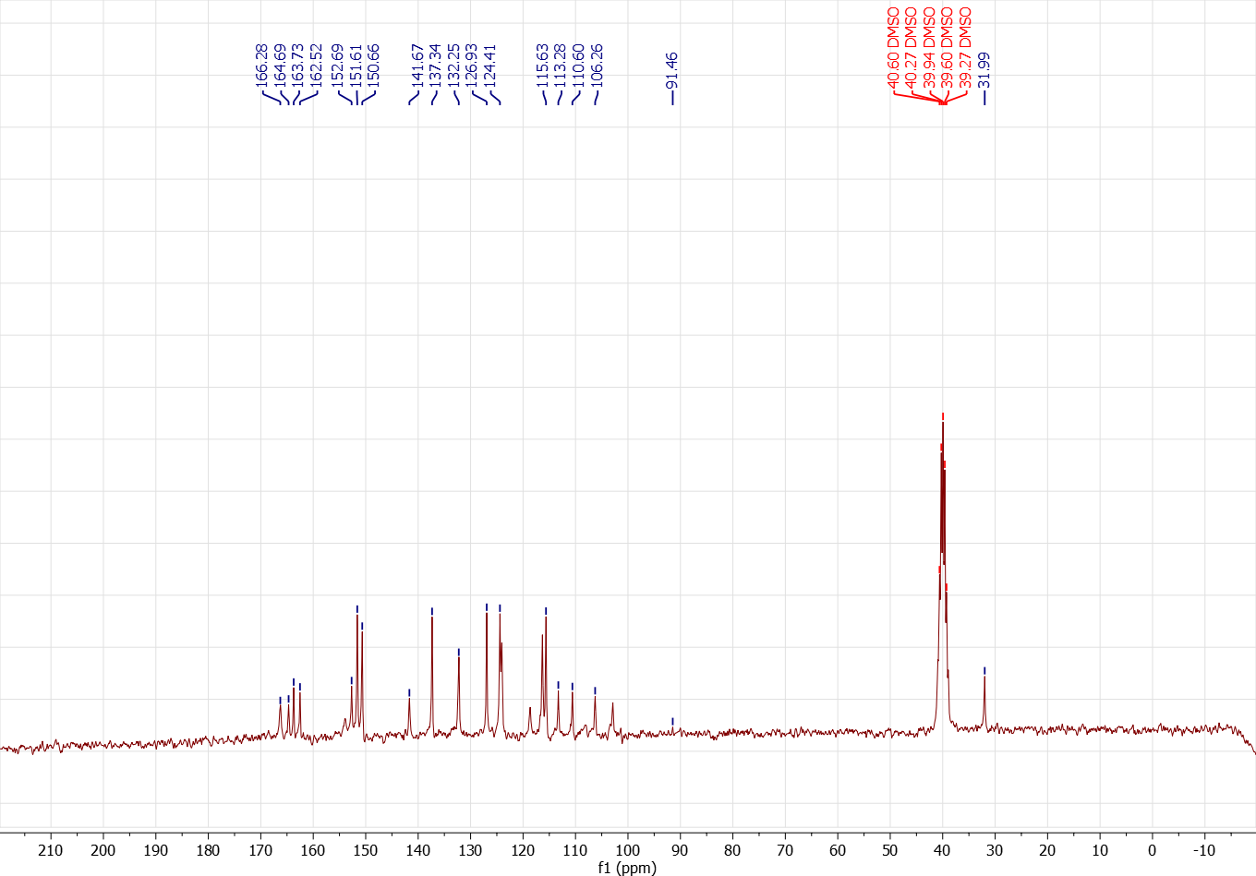

Mass spectrum of 2e
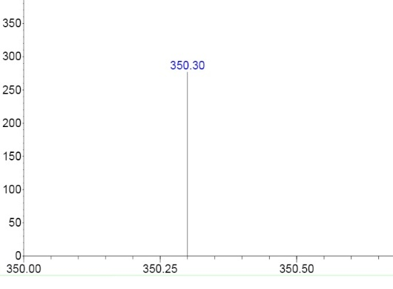
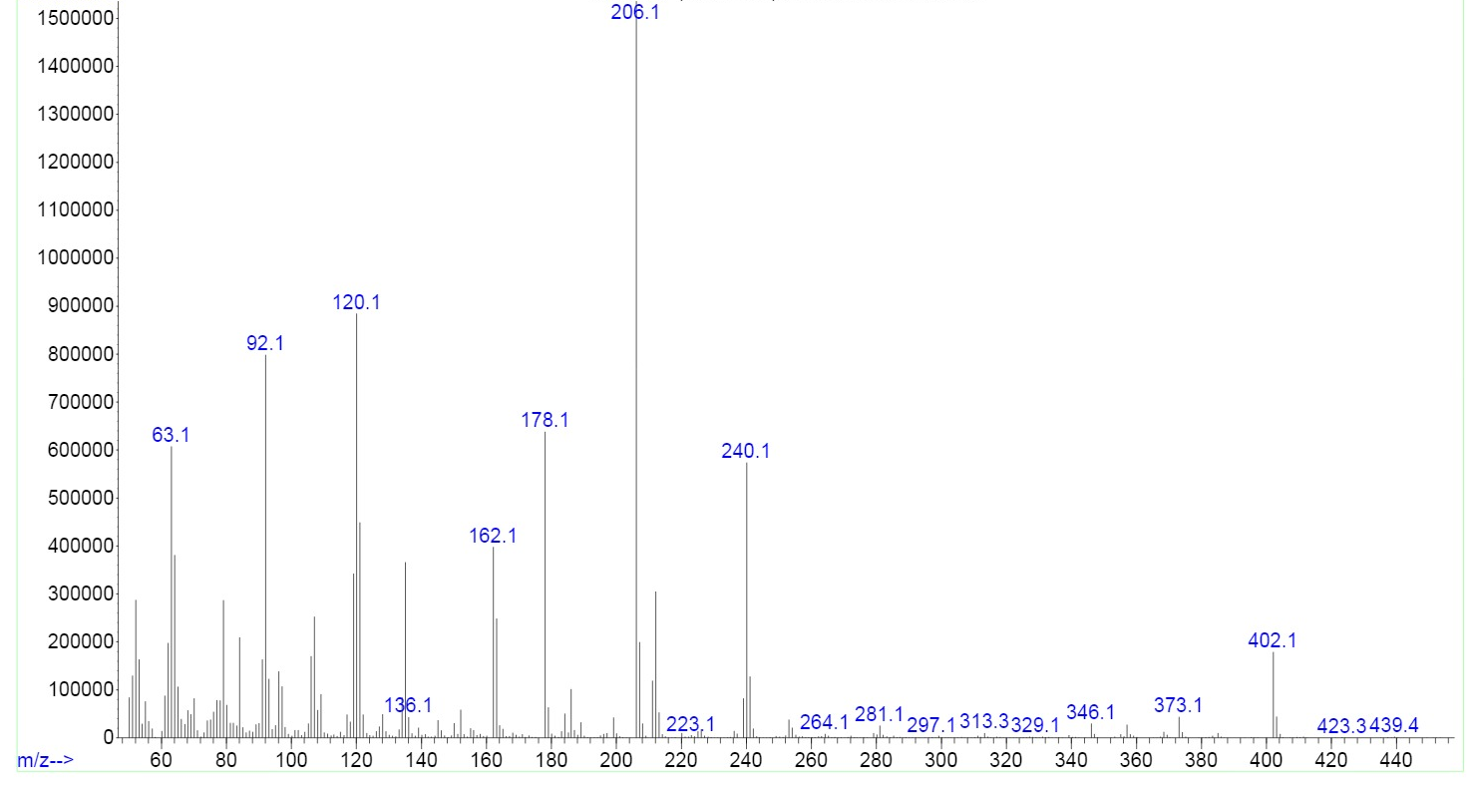
FT-IR spectrum of 2f
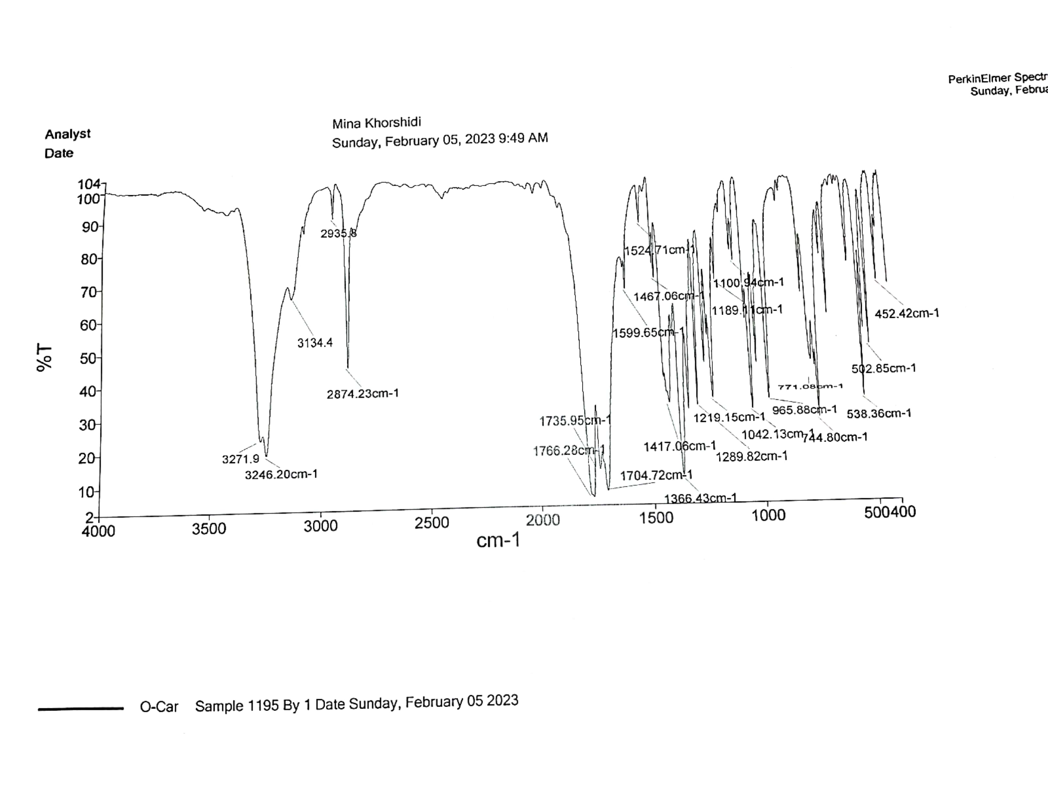

¹H NMR spectrum of 2f

¹³C NMR spectrum of 2f

Mass spectrum of 2f
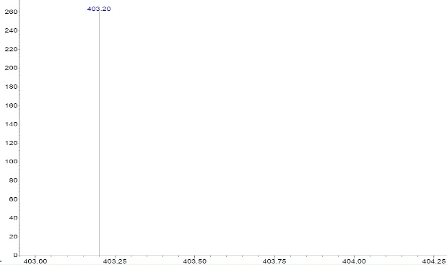
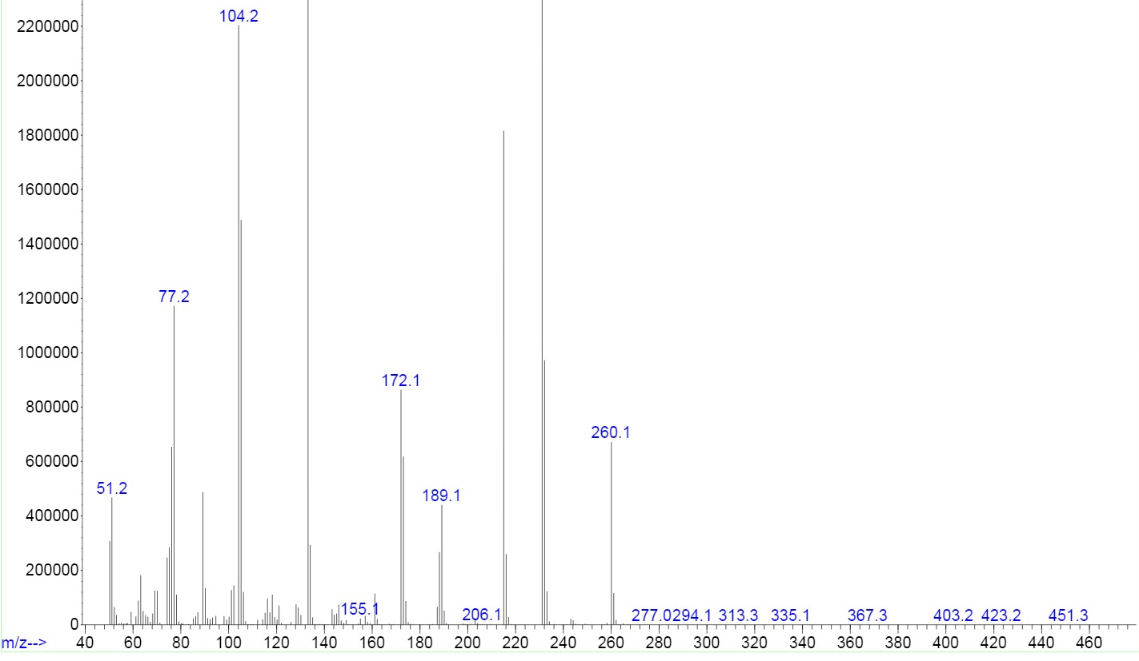
FT-IR spectrum of 2g
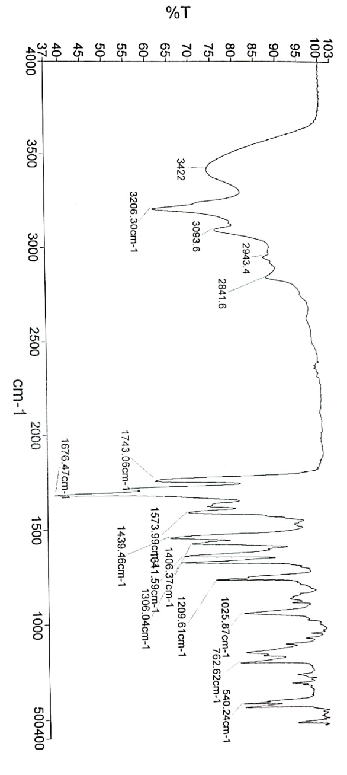

¹H NMR spectrum of 2g

FT-IR spectrum of 2h
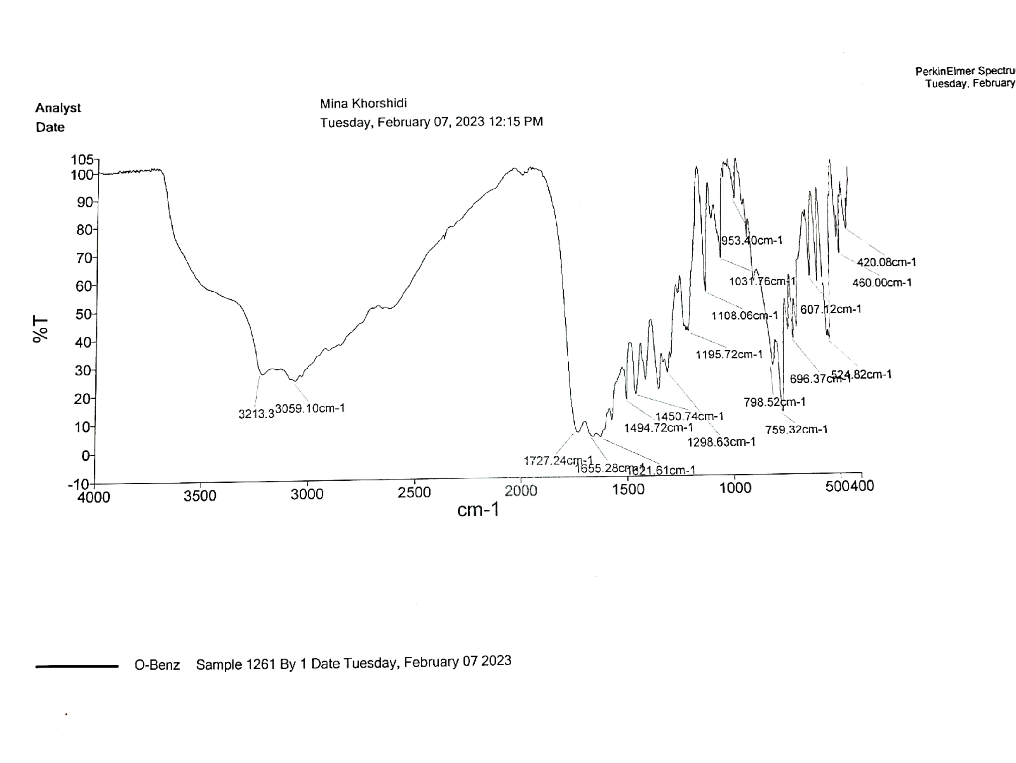

¹H NMR spectrum of 2h

FT-IR spectrum of 2i
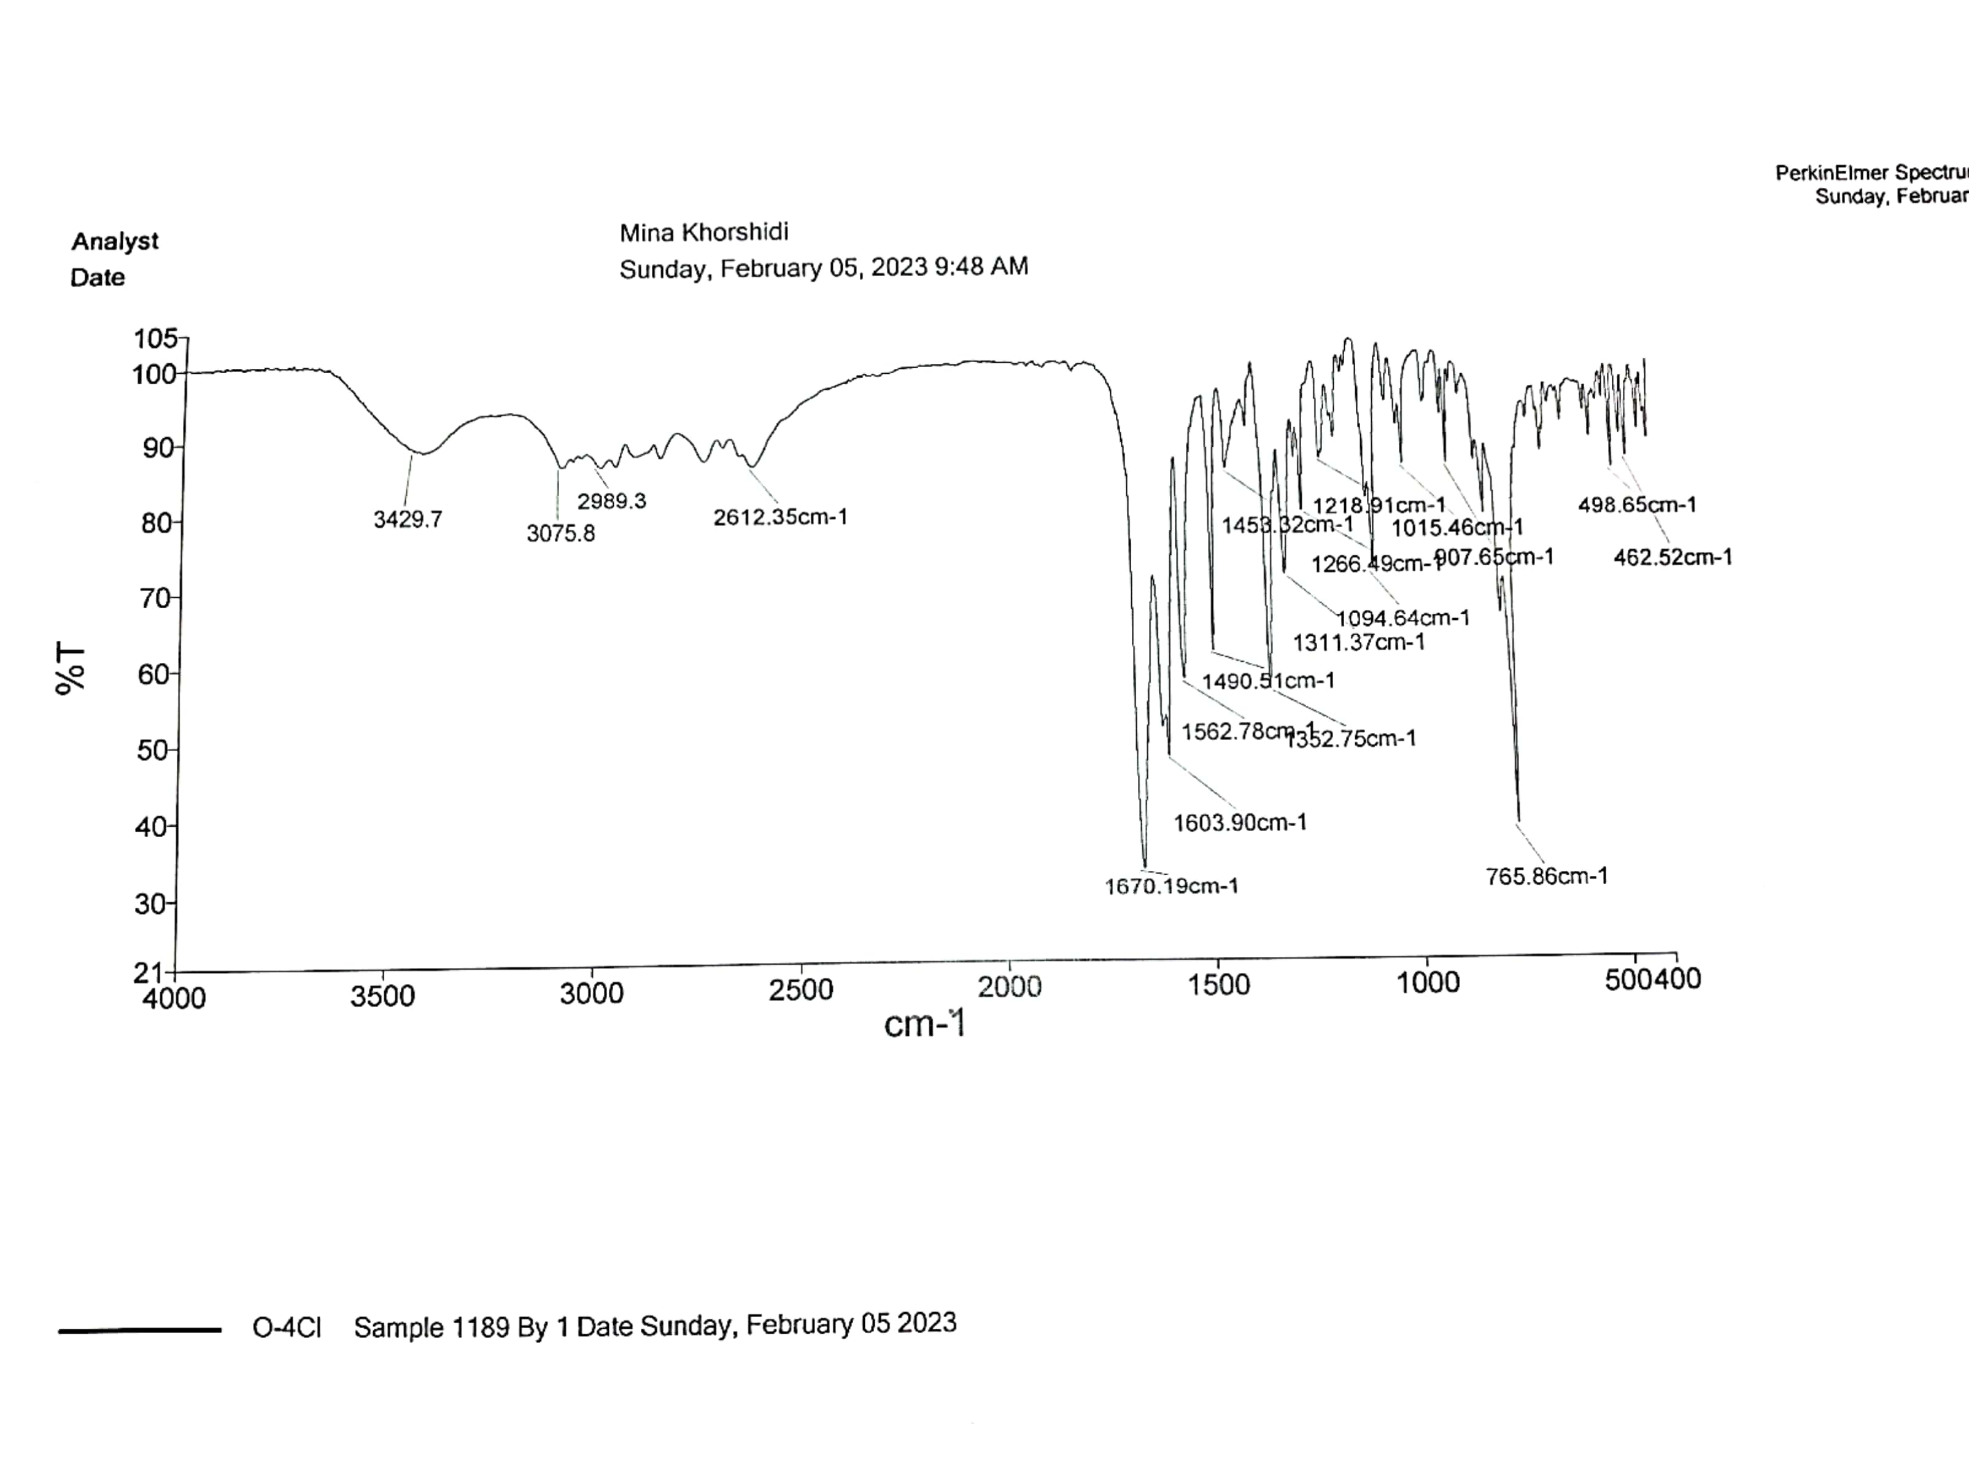

FT-IR spectrum of 2j
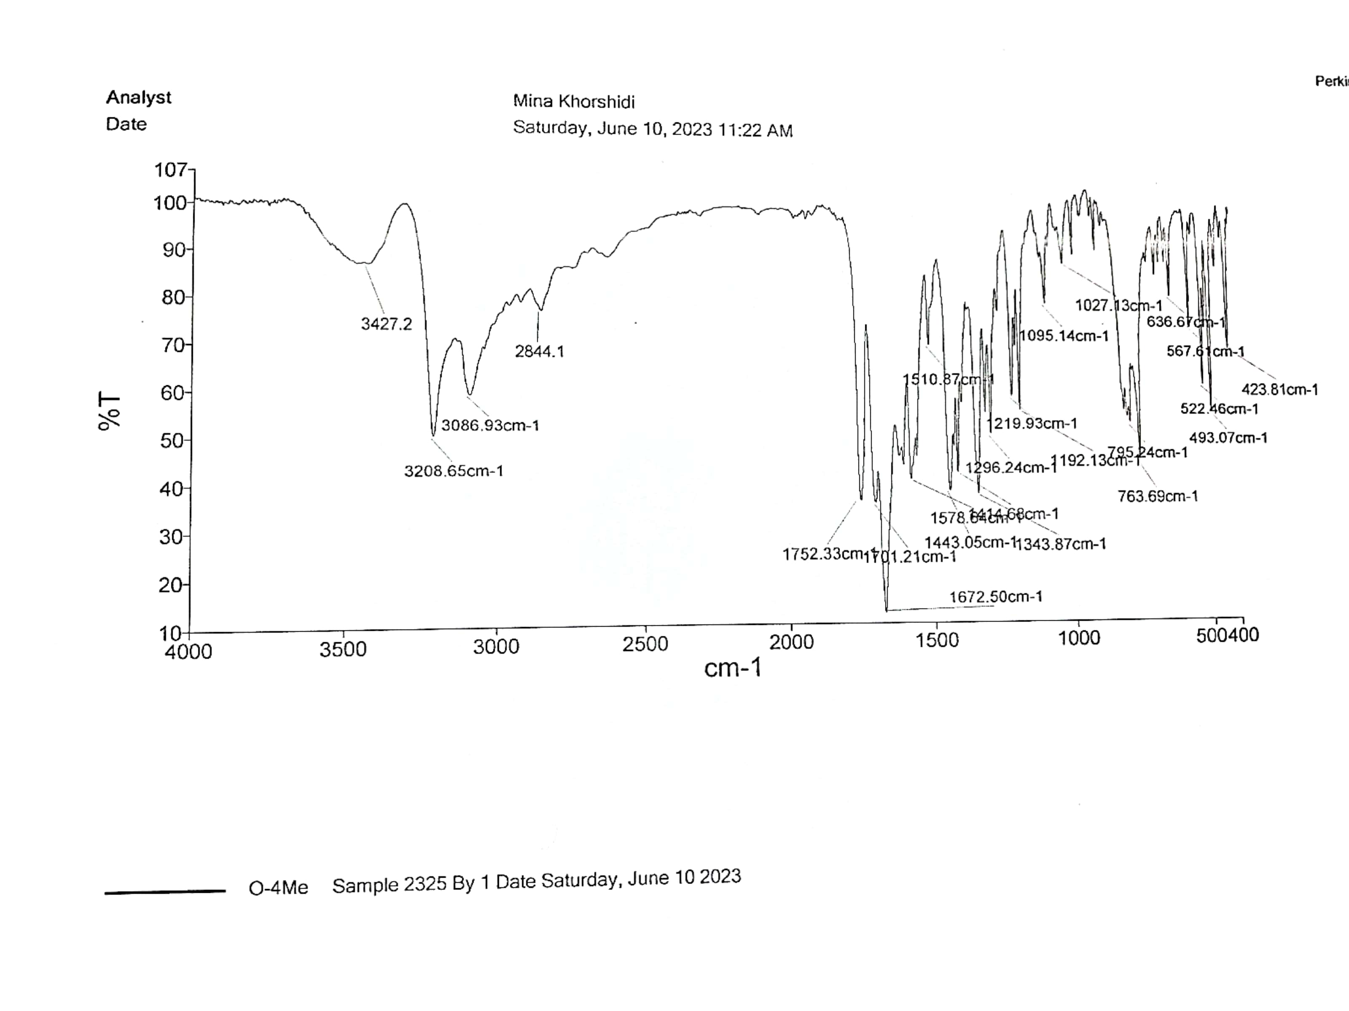

FT-IR spectrum of 2k
