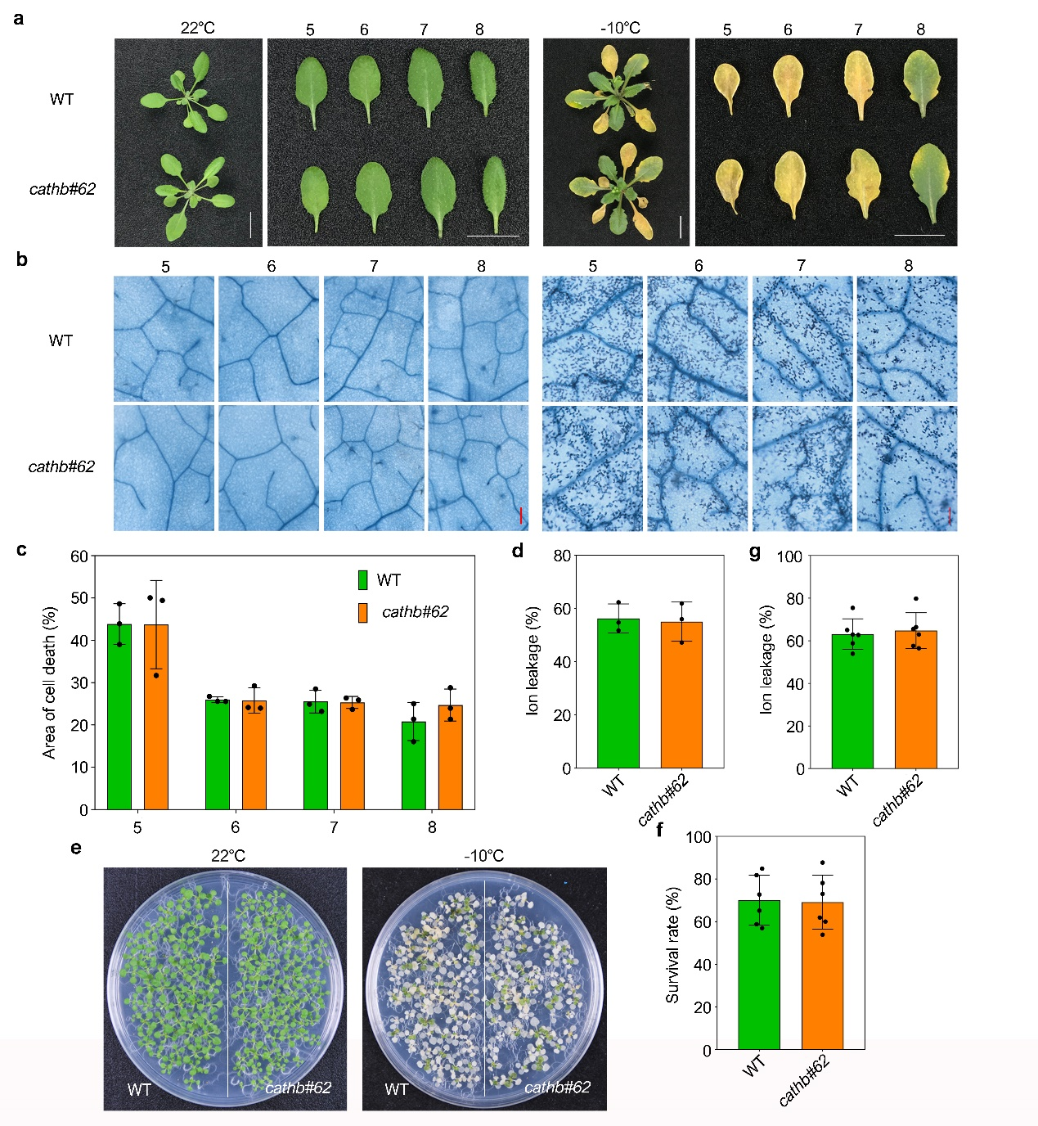
Supplementary Fig. 1 Phenotypic analysis of triple mutant for CathB. (a) The phenotypes of 3-4 weeks old wild-type and triple mutant for CathB plants before and after freezing stress. cathb#62 is a triple mutant of CathB. Scale bar, 1cm. (b) Trypan blue staining of leaves of wild-type and cathb#62 plants before and after freezing stress. Scale bar, 200μm. (c) The area of cell death in 3-4 weeks old wild-type and cathb#62 plants leaves after freezing stress. The values are means ± SD (one-way ANOVA, n=3). (d) Ion leakage of 3-4 weeks old wild-type and cathb#62 plants leaves after freezing stress. The values are means ± SD (one-way ANOVA, n=3). (e) The phenotypes of 12 days old wild-type and cathb#62 seedlings before and after freezing stress. (f) The survival rates of 12 days old wild-type and cathb#62 seedlings after freezing stress. The values are means ± SD (one-way ANOVA, n=6). (g) Ion leakage of 12 days old wild-type and cathb#62 seedlings after freezing stress. The values are means ± SD (one-way ANOVA, n=6). All experiments were performed three independent replicates with similar results.
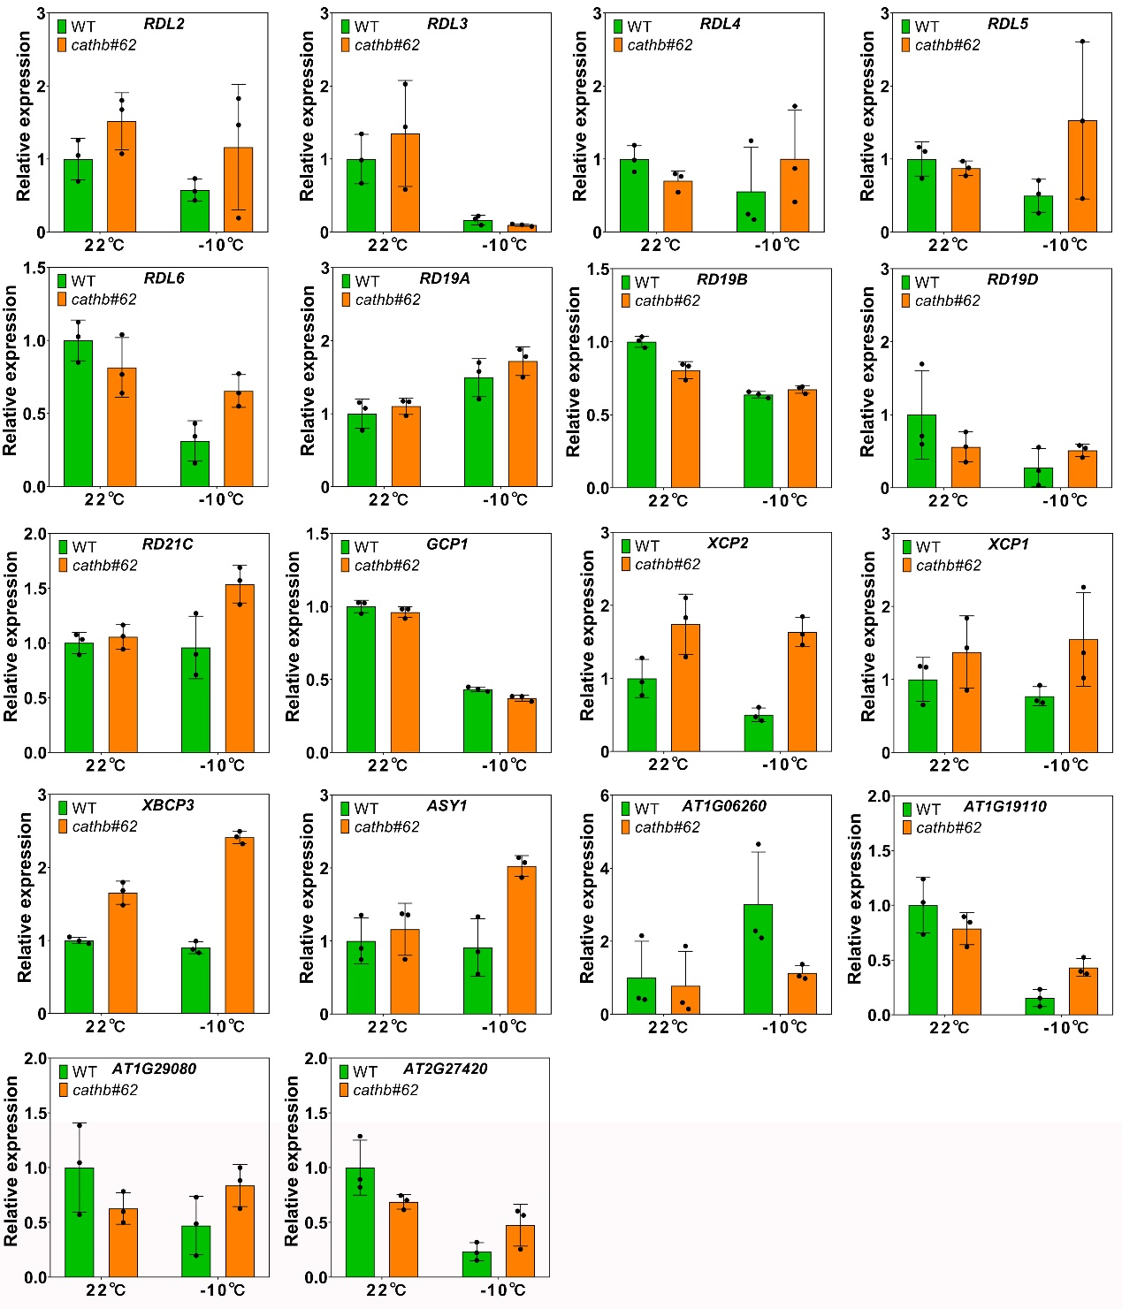
Supplementary Fig. 2 The transcriptional levels of papain-like Cys proteases family genes in wild-type and cathb#62 triple mutants before and after freezing stress. Total RNAs were extracted from the leaves of wild-type and cathb#62 triple mutant plants grown at 22°C for 3-4 weeks and at recovered 5 days after freezing stress, respectively. The transcriptional levels of genes were detected by RT-qPCR. UBC21 was used as a control gene, and the transcription levels of genes in wild-type plant leaves at 22°C were set to 1. The values are means ± SD (t test, n=3). All experiments were performed three independent replicates with similar results.

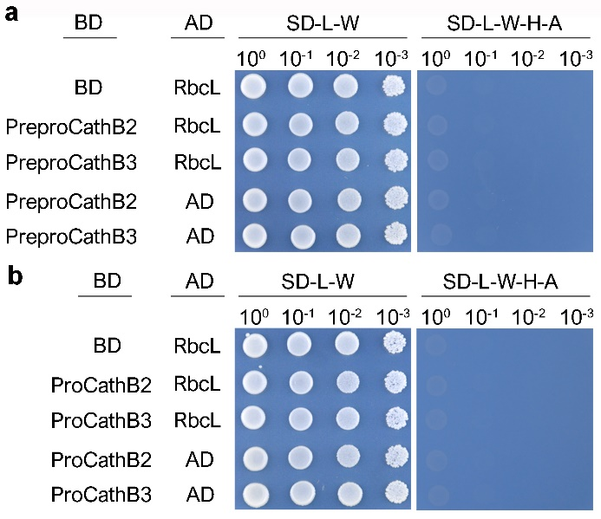
Supplementary Fig. 3 PreproCathB and ProCathB do not interact with RbcL in yeast. (a) Results of interaction between preprocathepsin B with RbcL in yeast. (b) Results of interaction between procathepsin B with RbcL in yeast.

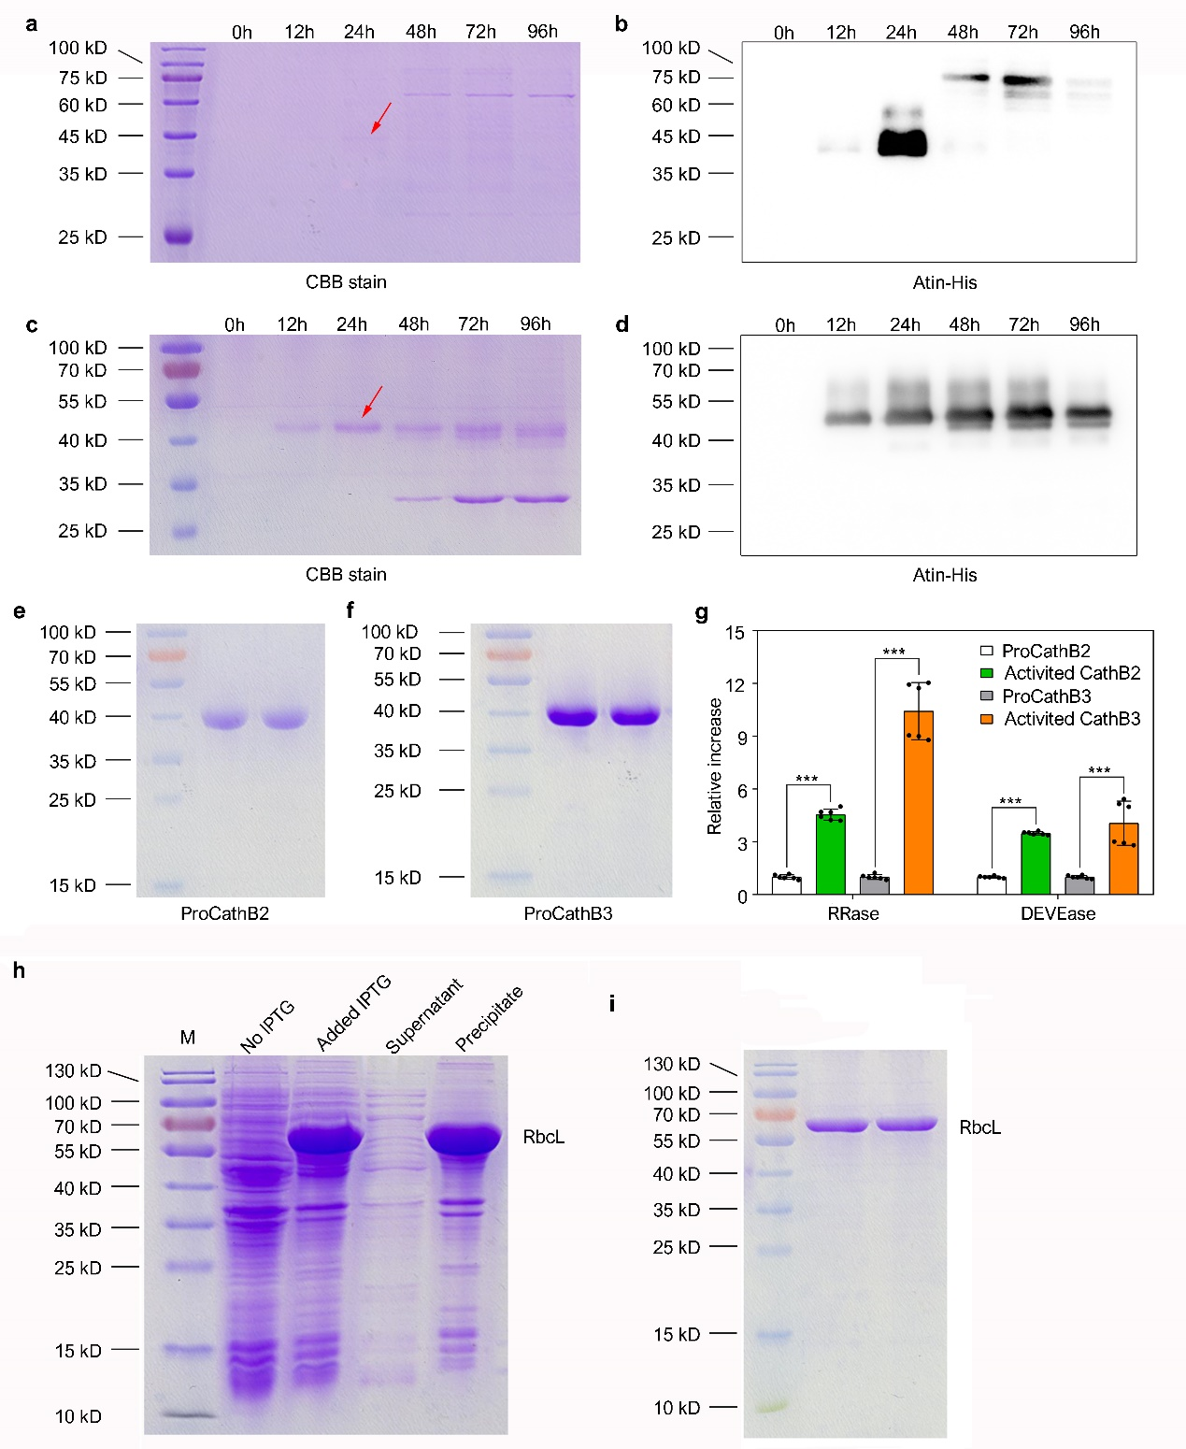

Supplementary Fig. 4 Expression and purification of cathepsin B and RbcL. (a-d) The detection of preliminary induction for cathepsin B in Pichia pastoris strain GS115. The red arrows indicate the target proteins for optimal induction time. (e, f) The detection of purified cathepsin B. (g) The detection of activity for purified cathepsin B. RRase is cathepsin B activity detected by using Z-RR-AMC and DEVEase is caspase-3 like activity detected by using Z-DEVE-Rh110. The values are means ± SD (***P<0.001, one-way ANOVA, n=6). Three independent replicates were performed with similar results. (h) Preliminary induction of RbcL in E. coli. strain BL21 and the detection of RbcL in inclusion body. (i) The detection of purified RbcL by denaturation and renaturation.

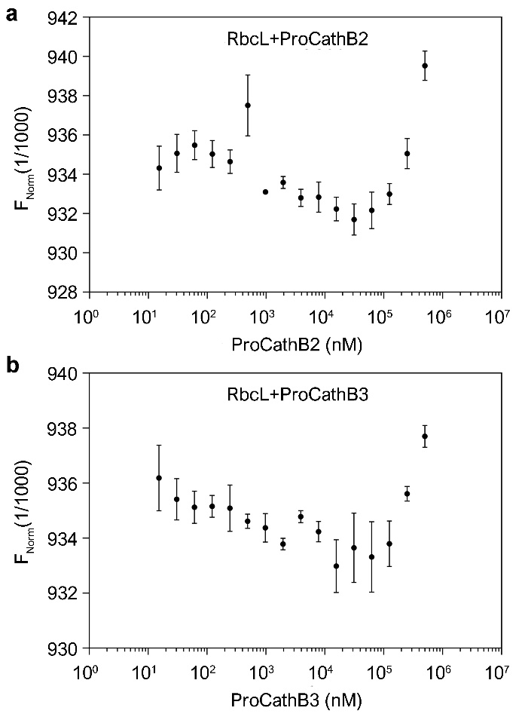
Supplementary Fig. 5 MST binding curves for ProCathB2 and ProCathB3 titrated against RbcL. RbcL was labeled with a fluorescent kit and cathepsin B was used as ligand to test their affinity. Error bars show from a triplicate experiment. KD, dissociation constant.

Supplementary Table 1 The primers used for RT-qPCR in this study.
Primer name | Sequences (5’-3’)
CathB1-qRCR-F | CCACGGTGTAGTAACCCAAGA
CathB1-qRCR-R | GTATGCGCCGACACCATAG
CathB2-qRCR-F | GTGTTAGCGGAAACCAGCTT
CathB2-qRCR-R | CAGTGAAGGCAACCTCAACA
CathB3-qRCR-F | GAAATGCGTTAGCGACAACA
CathB3-qRCR-R | CTGCCATGATATCTTGTGGATT
PBA1-qRCR-F | CATGCTCCAAACTGGTCTCA
PBA1-qRCR-R | CAAACGGTTGCTCGACTACA
ASY1-qPCR-F | GTTAACAGCAAACATCTCGTGT
SAG12-qPCR-F | TTCTCGTCCACTCGACAATG
SAG12-qPCR- R | GCGATTGTTTTCCTCCTTCA
ASY1-qPCR-R | CATCATCTTGCATGTCGTCATT
ALEU-qPCR-F | GTACAAGTCCTCAACTCAGTCA
ALEU-qPCR-R | CCTCAAATGCTATGCTTACTGG
XCP1-qPCR-F | TACAGAGATATCACGGACTTGC
XCP1-qPCR-R | TATGTACTGGAATGCGTAGTCC
XCP2-qPCR-F | AAGACTGATATAGTGAGACGCG
XCP2-qPCR-R | TCCAGTCAACAGACTTAGGAAC
XBCP3-qPCR-F | CGTCCTCCTTTATCTCTCTCAC
XBCP3-qPCR-R | GTCGAATAGCTCAGAGATGTCA
RD21A-qPCR-F | TTACTACACTTGTCCTGAGAGC
RD21A-qPCR-R | ACGCTTTAAGGCCTTAACACTA
RDL2-qPCR-F | TGGATGTGATGGAGGTATCATG
RDL2-qPCR-R | CAAGATCGTTGGCGTTATAAGG
RD21B-qPCR-F | GATTCGGTTGACTGGAGAAAAG
RD21B-qPCR-R | CTGCTCCAATAGTTGAGAATGC
CEP3-qPCR-F | CTTGTGGATTGTGACACTGAAG
CEP3-qPCR-R | CGTCACTGGAATCGTAAGGATA
AT1G06260-qPCR-F | CAGAAATCAAGGAAAATGCGGA
AT1G06260-qPCR-R | GTTTCCATTAATCCGCCACTAC
RD19C-qPCR-F | TCCAAGTACGAGAAGACTTACG
RD19C-qPCR-R | TTTCAGTCCTAAAAACTTGCGG
RD19A-qPCR-F | TGTCTTTCTTTATCGTCTCGGT
RD19A-qPCR-R | GAAAAGTGATCCTCTGAGGTCA
T1G12.4-qPCR-F | GAGAAAACGAGTAGGTTCGAGA
T1G12.4-qPCR-R | CTCGTTAACATCCAACGTGTAC
AT1G29110-qPCR-F | GAATCCGAGAAAGAAATGAGGC
AT1G29110-qPCR-R | TTCTGTTTTCCAATCCGTGAAC
AT2G34080-qPCR-F | TTCCTAGCAATACATACCGGAC
AT2G34080-qPCR-R | TTCCAAGTCTGAGACGATATCG
AT1G29080-qPCR-F | GAGGCATTTCTTCAGAAAACGA
AT1G29080-qPCR-R | CTGATTAGTATGGCGGGTCTAG
AT1G29090-qPCR-F | GGTTCTCTCGAGTTTACAGTGA
AT1G29090-qPCR-R | TCGACAAATTCAGAGGATGGAA
AT2G27420-qPCR-F | GTTAAGTATCAAGGCCGATGTG
AT2G27420-qPCR-R | ACAAGCTCGCCTTTAGTAATCT
AT3G45310-qPCR-F | TGTTGGACATTTAGCACAACTG
AT3G45310-qPCR-R | GTTGCTCGGACAAAGATATTCC
RDL4-qPCR-F | TACAAAGCTGTTAACGGAGTCT
RDL4-qPCR-R | CACAACAACTCCATGGTTTAGG
RDL5-qPCR-F | TGGTGATGTTCTTCCTAAGTCC
RDL5-qPCR-R | TGATGAACTCATAGGCTGTCTC
RDL6-qPCR-F | GAACAAATCTTGACCATGCACT
RDL6-qPCR-R | GAGCAATCTTAATGTAGCCAGC
RDL3-qPCR-F | TTATACCGGTGAAGATACTGCC
RDL3-qPCR-R | ACATGCTCCTTTATACACACCA
GCP1-qPCR-F | GAACACGGGAAAACTAACAACA
GCP1-qPCR-R | CGTTCTTGTTGTTTTCGTTGTG
RD21C-qPCR-F | AAAGACAACTTGAAGTTCGTCG
RD21C-qPCR-R | CTCATCGTTAGTCAAATCAGCG
CEP2-qPCR-F | GAGAGGGGGAAAAAGTATTGGA
CEP2-qPCR-R | AGGATTAGACGACGATAGCTTG
CEP1-qPCR-F | AAAAGCTGACATCACTCTCAGA
CEP1-qPCR-R | GAACTCAAAAGCAAGGTCCATT
RD19B-qPCR-F | ACCTTATCAAAAACGGTCCTCT
RD19B-qPCR-R | GAGCATATGTAAGGACACGAGA
RD19D-qPCR-F | GTCTTAGCGAACAACAACTTGT
RD19D-qPCR-R | CCTCGTTTACCAGTGTAAGGAT
UBC21-qPCR-F | ACAGCGAGAGAAAGTAGCAGA
UBC21-qPCR-R | TTGATAAGAGCGGTCCATTTGAA

Supplementary Table 2 The primers of vectors construction for Y2H assays.
Primer name | Sequences (5’-3’)
CathB2-CDS-F | ATGGCTGATAATTGTATCAGACTTCTTC
CathB2-CDS+stop-R | AAATGAGGAAACAAGAAGATCATCTG
CathB3-CDS-F | ATGGCTGTTTACAATACCAAACTCTG
CathB3-CDS+stop-R | AACCGATGCAACCGGAAGATC
ProCathB2-F | GAAAATCTTTCCAAGCAGAAACTGACCTC
ProCathB3-F | GAAAGTCTTACCAAACAGAAACTGGACTC
MCathB2-F | CTTCCAAAAGAATTTGATGCTAGAACCGC
MCathB2+stop-R | CCTGTCTGAAGGTAAACCAGCTAC
MCathB3-F | AAGCTACCTAAAGCTTTTGATGCTAGAAC
MCathB3+stop-R | CTTGCTTGAAGGCAAACCAGC
RbcL-CDS-F | ATGTCACCACAAACAGAGAC
RbcL-CDS+stop-R | CTACTCTTGGCCATCTAATTTATCGATG

Supplementary Table 3 The primers of vectors construction for prokaryotic expression of RbcL
Primer name | Sequences (5’-3’)
RbcL-CDS+EcoRI-F | CCGGAATTCATGTCACCACAAACAGAGACTAAAG
RbcL-CDS+XhoI-R | CCGCTCGAGCTACTCTTGGCCATCTAATTTATCGATG

Supplementary Table 4 The primers of vectors construction for expression of cathepsin B in Pichia pastoris.
Primer name | Sequences (5’-3’)
ProCathB2/EcoRI-F | CGGAATTCGAAAATCTTTCCAAGCAGAAACTGACCTC
ProCathB2/NotI-R | aaggaaaaaaGCGGCCGCAAATGAGGAAACAAGAAGATCATCTG
ProCathB3/EcoRI-F | CGGAATTCGAAAGTCTTACCAAACAGAAACTGGACTC
ProCathB3/NotI-R | aaggaaaaaaGCGGCCGCAACCGATGCAACCGGAAGATC

