Fungal community of multiple compartment niches in spring rapeseed (Brassica rapa L. and Brassica napus L.) responses to different cultivars on the Qinghai-Tibet Plateau, China
Qingqing Peng¹, Zhanling Xie¹ *, Guoyong Tang², Hongchen Jiang³, Jing Guo¹, Yujing Mao¹, Bao Wang¹, Qing Meng¹, Jiabao Yang¹, Shunbin Jia⁴, Mengyue La⁵
¹College of Ecological and Environment Engineering, State Key Laboratory Breeding Base for Innovation and Utilization of Plateau Crop Germplasm, Qinghai University, 251 Ningda Road, 810016 Xining, People’s Republic of China
²Laboratory for Research and Utilization of Qinghai Tibet Plateau Germplasm Resources, Qinghai Spring Rape Engineering Research Center, Qinghai Research Branch of the National Oil Crop Genetic Improvement Center, Spring Rape Scientific Observation Experimental Station of Ministry of Agriculture and Rural Areas, Academy of Agricultural and Forestry Sciences, Qinghai University, 251 Ningda Road, 810016 Xining, People’s Republic of China
³State Key Laboratory of Biogeology and Environmental Geology, China University of Geosciences, 388 Lumo Road, 430074 Wuhan, People’s Republic of China; Qinghai Provincial Key Laboratory of Geology and Environment of Salt Lakes, Qinghai Institute of Salt Lakes, Chinese Academy of Sciences, 18 Xinning Road, 810008 Xining, People’s Republic of China
⁴Qinghai Provincial Grassland Station, 81 Shengli Road, 810008 Xining, People’s Republic of China
⁵Haidong Development and Reform Commission, 10 Haidong Road, 810700 Haidong, People’s Republic of China
* Corresponding author: Zhanling Xie (email: xiezhanling2012@126.com)
ORCID: 0000-0001-8581-3788

Table S1 Soil physicochemical characteristics in the rhizosphere soil among seven oilseed rape cultivars
Group | pH | SMC (%) | TN (g kg⁻¹) | TP (g kg⁻¹) | SOC (g kg⁻¹)
Haoyou 11 | 8.07±0.01 c | 7.11±0.19 f | 1.39±0.04 b | 2.75±0.04 a | 13.38±0.84 b
Qingza 4 | 8.07±0.01 c | 9.44±0.21 c | 1.44±0.09 ab | 2.66±0.26 ab | 13.38±0.56 b
Qingza 7 | 7.92±0.03 e | 8.18±0.20 e | 1.47±0.04 a | 2.51±0.02 b | 14.12±0.94 ab
Qingza 5 | 8.24±0.03 a | 10.74±0.15 b | 1.42±0.03 ab | 2.66±0.04 ab | 14.73±0.53 a
Qingza 9 | 8.02±0.03 d | 9.17±0.17 d | 1.38±0.03 b | 2.51±0.05 b | 14.13±0.14 ab
Qingza 12 | 8.18±0.03 b | 7.03±0.15 f | 1.41±0.04 ab | 2.68±0.01 a | 14.38±0.28 ab
Qingza 15 | 8.21±0.02 a | 11.09±0.32 a | 1.44±0.05 ab | 2.61±0.09 ab | 13.69±0.27 b
Data are presented as the mean ± SD. Different lowercase letters in the same column indicate significant differences at the 0.05 level. SMC: soil moisture content, TN: total nitrogen, TP: total phosphorus, SOC: soil organic carbon.

Table S2 Tags information of sequencing among different niches of seven oilseed rape cultivars
Sample | Cultivars | Tags | Effective tags | Average length (bp) | Percentage of effective tags (%) | Observed OTUs
Leaf | Haoyou 11 | 20155.43 | 19674.71 | 240 | 97.61 | 708.00
 | Qingza 4 | 8123.00 | 7807.67 | 240 | 96.12 | 419.00
 | Qingza 7 | 3331.25 | 2987.25 | 240 | 89.67 | 891.00
 | Qingza 5 | 6655.86 | 6389.86 | 240 | 96.00 | 1104.00
 | Qingza 9 | 8422.14 | 7632.57 | 240 | 90.63 | 1644.00
 | Qingza 12 | 11190.14 | 10236.86 | 240 | 91.48 | 1662.00
 | Qingza 15 | 3518.67 | 3214.67 | 240 | 91.36 | 1267.00
Stem | Haoyou 11 | 22187.25 | 19951.00 | 240 | 89.92 | 899.00
 | Qingza 4 | 13063.50 | 12787.50 | 240 | 97.89 | 557.00
 | Qingza 7 | 2913.20 | 2661.80 | 240 | 91.37 | 989.00
 | Qingza 5 | 8700.50 | 8225.83 | 240 | 94.54 | 976.00
 | Qingza 9 | 7221.86 | 6642.00 | 240 | 91.97 | 1500.00
 | Qingza 12 | 6544.00 | 5913.29 | 240 | 90.36 | 1656.00
 | Qingza 15 | 4312.83 | 3936.83 | 240 | 91.28 | 1392.00
Root | Haoyou 11 | 75046.80 | 73253.60 | 240 | 97.61 | 534.00
 | Qingza 4 | 2294.00 | 2068.25 | 240 | 90.16 | 703.00
 | Qingza 7 | 7793.00 | 7521.75 | 240 | 96.52 | 613.00
 | Qingza 5 | 18663.57 | 18107.57 | 240 | 97.02 | 897.00
 | Qingza 9 | 24382.71 | 23380.00 | 240 | 95.89 | 949.00
 | Qingza 12 | 9468.00 | 8612.00 | 240 | 90.96 | 1408.00
 | Qingza 15 | 11566.86 | 10651.14 | 240 | 92.08 | 1442.00
Rhizosphere soil | Haoyou 11 | 160408.14 | 153709.29 | 240 | 95.82 | 4070.00
Rhizosphere soil | Qingza 4 | 55238.43 | 53116.29 | 240 | 96.16 | 3407.00
Rhizosphere soil | Qingza 7 | 49327.43 | 46160.86 | 240 | 93.58 | 3461.00
Rhizosphere soil | Qingza 5 | 71505.29 | 69416.86 | 240 | 97.08 | 3233.00
Rhizosphere soil | Qingza 9 | 77102.86 | 74823.86 | 240 | 97.04 | 3301.00
Rhizosphere soil | Qingza 12 | 55529.57 | 53378.14 | 240 | 96.13 | 3457.00
Rhizosphere soil | Qingza 15 | 45057.00 | 43696.80 | 240 | 96.98 | 2255.00

Table S3 Comparisons of α-diversity among different niches of seven oilseed rape cultivars
 | Haoyou 11 | Qingza 4 | Qingza 7 | Qingza 5 | Qingza 9 | Qingza 12 | Qingza 15
Shannon
Leaf | 2.846±0.79 a | 4.64±0.31 a | 4.55±0.35 a | 3.55±0.39 a | 4.62±0.50 a | 4.67±0.87 a | 4.72±0.35 a
Stem | 3.438±1.16 a | 4.08±0.78 a | 4.37±0.31 ab | 3.45±0.83 a | 4.28±0.63 a | 4.647±0.73 a | 4.52±0.55a
Root | 2.42±0.47 b | 3.79±0.10 a | 3.63±1.01 b | 2.63±0.91 b | 2.73±0.83 b | 3.95±1.03 a | 4.26±0.55 a
Rhizosphere soil | 3.58±0.60 a | 2.79±0.61 b | 2.64±0.48 c | 2.20±0.30 b | 2.24±0.22 b | 2.65±0.57 b | 2.36±0.45 b
Chao 1
Leaf | 201.00±76.85 b | 296.33±224.11 b | 433.50±106.85 b | 353.50±251.60 b | 402.60±137.70 c | 618.10±184.64 b | 528.58±119.59 b
Stem | 206.39±113.52 b | 333.71±194.97 b | 504.93±119.65 b | 372.92±185.93 b | 582.87±182.50 bc | 636.44±296.77 b | 589.85±168.82 b
Root | 249.99±47.72 b | 465.23±160.39 b | 597.06±128.88 b | 436.79±148.03 b | 649.23±156.11 b | 708.12±105.81 ab | 646.92±237.08 ab
Rhizosphere soil | 1148.06±46.67 a | 975.51±182.74 a | 908.50±131.60 a | 938.23±100.46 a | 897.94±208.38 a | 923.37±161.19 a | 836.04±85.98 a
Data are presented as the mean ± SD. Different lowercase letters in the same column indicate significant differences at the 0.05 level.

Table S4 Comparisons of the top six genera among different niches of seven oilseed rape cultivars
Genus | Sample | Haoyou 11 | Qingza 4 | Qingza 7 | Qingza 5 | Qingza 9 | Qingza 12 | Qingza 15
Olpidium | Leaf | 0.70±0.16 a | 0.68±0.24 ab | 0.49±0.045 bc | 0.66±0.11 ab | 0.56±0.075 b | 0.54±0.15 b | 0.39±0.074 c
 | Stem | 0.43±0.33 b | 0.70±0.29 ab | 0.43±0.036 b | 0.76±0.13 a | 0.62±0.089 ab | 0.54±0.13 b | 0.44±0.13 b
 | Root | 0.82±0.17 a | 0.56±0.26 b | 0.59±0.20 b | 0.80±0.16 a | 0.81±0.10 a | 0.64±0.15 ab | 0.54±0.13 b
 | Rhizosphere soil | 0.64±0.09 c | 0.79±0.11 b | 0.82±0.040 ab | 0.88±0.019 a | 0.87±0.01 a | 0.83±0.059 ab | 0.85±0.054 ab
Lactarius | Leaf | 0.0062±0.00050 d | 0.16±0.056 c | 0.35±0.05 ab | 0.25±0.11 bc | 0.31±0.051 b | 0.33±0.12 b | 0.48±0.065 a
 | Stem | 0.21±0.27 b | 0.21±0.04 b | 0.44±0.036 a | 0.14±0.09 b | 0.25±0.071 b | 0.31±0.11 ab | 0.44±0.12 a
 | Root | 0.0014±0.0001 b | 0.31±0.21 a | 0.31±0.17 a | 0.12±0.04 b | 0.11±0.075 b | 0.24±0.12 ab | 0.32±0.18 a
 | Rhizosphere soil | 0.0016±0.0005 b | 0.0039±0.0016 a | 0.0034±0.0015 ab | 0.0023±0.00066 ab | 0.0023±0.0010 ab | 0.0042±0.0007 a | 0.0031±0.0010 ab
Unidentified | Leaf | 0.039±0.008 b | 0.061±0.017 b | 0.087±0.022 ab | 0.051±0.0086 b | 0.10±0.029 a | 0.092±0.036 ab | 0.094±0.028 ab
 | Stem | 0.11±0.09 a | 0.054±0.017 b | 0.064±0.013 ab | 0.070±0.033 ab | 0.084±0.021 ab | 0.10±0.021 a | 0.082±0.026 ab
 | Root | 0.058±0.012 b | 0.077±0.029 ab | 0.051±0.0079 b | 0.053±0.015 b | 0.065±0.021 ab | 0.095±0.035 ab | 0.11±0.081 a
 | Rhizosphere soil | 0.14±0.022 a | 0.089±0.013 b | 0.095±0.015 b | 0.086±0.0059 b | 0.089±0.0069 b | 0.10±0.022 b | 0.091±0.0089 b
Verticillium | Leaf | 0.11±0.09 a | 0.0026±0.0001 b | 0.025±0.0063 b | 0.018±0.004 b | 0.0098±0.0044 b | 0.011±0.0061 b | 0.0065±0.0016 b
 | Stem | 0.18±0.08 a | 0.015±0.006 b | 0.035±0.011 b | 0.010±0.0081 b | 0.0088±0.0035 b | 0.012±0.0031 b | 0.0081±0.0023 b
 | Root | 0.080±0.13 a | 0.029±0.011 ab | 0.023±0.014 ab | 0.0076±0.0009 b | 0.0050±0.0002 b | 0.0058±0.0031 b | 0.0034±0.00103 b
 | Rhizosphere soil | 0.0036±0.00090 a | 0.00071±0.00034 b | 0.0012±0.00066 b | 0.00064±0.00032 b | 0.00089±0.00018 b | 0.0026±0.0008 ab | 0.00077±0.00005 b
Mortierella | Leaf | 0.0034±0.0017 c | 0.0078±0.0015 b | 0.013±0.0062 a | 0.0050±0.0035 bc | 0.0060±0.0014 bc | 0.011±0.0061 b | 0.0061±0.0027 bc
 | Stem | 0.18±0.08 a | 0.0059±0.0040 ab | 0.0091±0.0039 a | 0.0042±0.0023 b | 0.0075±0.0034 ab | 0.0063±0.0029 ab | 0.0081±0.0023 b
 | Root | 0.0037±0.0021 a | 0.0070±0.0031 a | 0.0067±0.0035 a | 0.0035±0.0017 a | 0.0042±0.0020 a | 0.0050±0.0026 a | 0.0062±0.0023 a
 | Rhizosphere soil | 0.0049±0.004 b | 0.012±0.0046 ab | 0.019±0.004 ab | 0.0088±0.0018 b | 0.010±0.0050 b | 0.021±0.014 ab | 0.024±0.009 a
Cystofilobasidium | Leaf | 0.061±0.002 a | 0.015±0.002 b | 0.0030±0.0027 b | 0.0024±0.0013 b | 0.0029±0.0017 b | 0.0024±0.0012 b | 0.0036±0.0010 b
 | Stem | 0.0087±0.0041 a | 0.0022±0.0001 b | 0.0019±0.0014 b | 0.0023±0.0014 b | 0.0032±0.0011 b | 0.0035±0.00050 b | 0.0036±0.0023 b
 | Root | 0.0064±0.0032 a | 0.0037±0.0029 bc | 0.0022±0.0015 bc | 0.0020±0.00060 bc | 0.0050±0.0022 c | 0.0015±0.00065 bc | 0.0022±0.0009 bc
 | Rhizosphere soil | 0.0075±0.0036 a | 0.0047±0.00030 ab | 0.0021±0.0010 b | 0.00090±0.00052 b | 0.0011±0.00066 b | 0.0016±0.0011 b | 0.0014±0.00098 b
Notes: Data are presented as the mean ± SD. Different lowercase letters in the same row indicate significant differences at the 0.05 level.

Table S5 Endophytes information of oilseed rape and their GenBank accessions numbers
Strains | Scientific Name | Query Cover | Per. Ident | Accession number
F1 | Ophiobolopsis italica | 86% | 98.59% | ON127397
F2 | Alternaria alternata | 100% | 100.00% | ON127398
F3 | Penicillium sp.1 | 99% | 97.47% | ON127399
F4 | Alternaria sp. | 100% | 100.00% | ON127400
F5 | Simplicillium aogashimaense | 99% | 99.62% | ON127401
F6 | Chaetomium sp. | 97% | 99.81% | ON127402
F7 | Penicillium expansum | 100% | 100.00% | ON127403
F8 | Penicillium crustosum | 97% | 99.82% | ON127404
F9 | Alternaria infectoria | 98% | 99.49% | ON127405
F10 | Penicillium sp.2 | 100% | 100.00% | ON127406

A
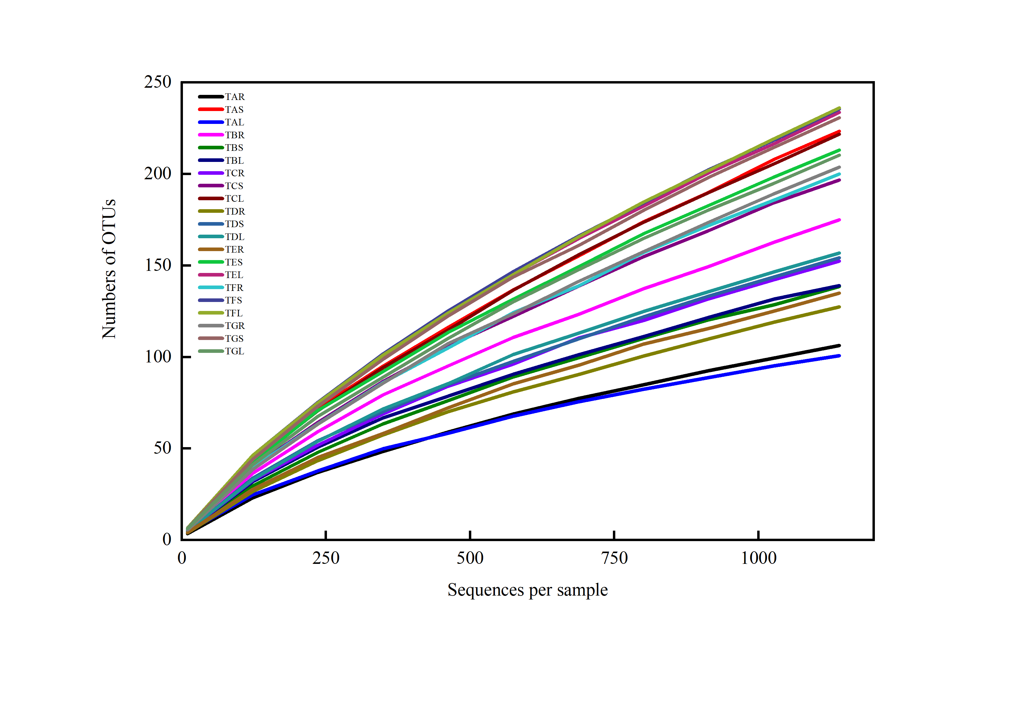

B

Fig. S1 The rarefaction curves of plant (A) and rhizosphere soil (B) in different cultivars of oilseed rape. TAR, TAS, TAL means root, stem, and leaf samples in cultivar Haoyou No. 11, TBR-TGR, TBS-TGS, TBL-TGL means root, stem, and leaf samples in cultivar Qingza No. 4, Qingza No. 7, Qingza No. 5, Qingza No. 9, Qingza No. 12 and Qingza No. 15, respectively.

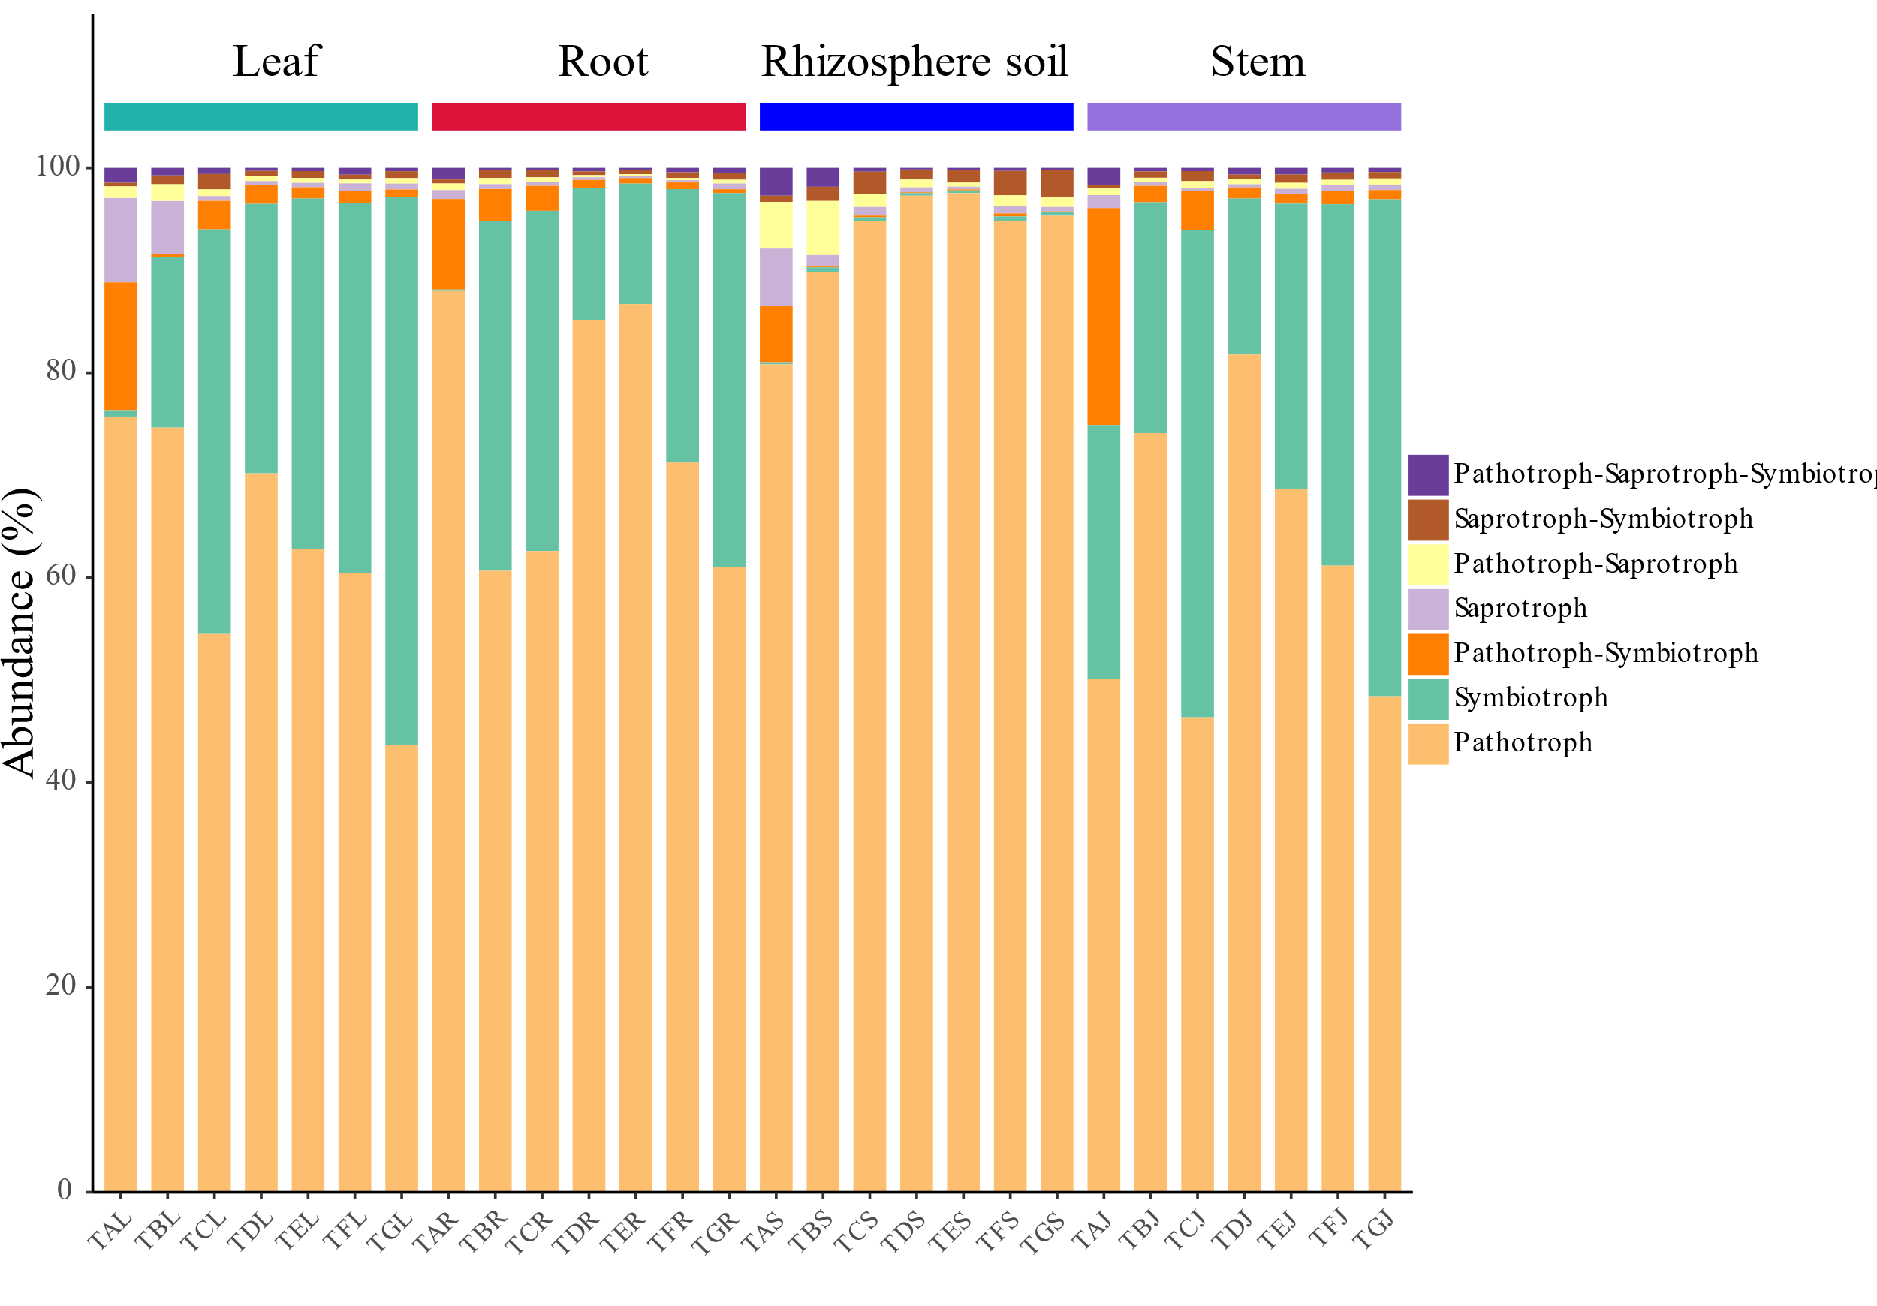

Fig. S2 (a) Sankey diagram tracing the flow of top abundant fungal genera from rhizosphere soil to leaf across the seven oilseed rape cultivar. (b) Functional groups of the top abundant genera inferred by FUNGuild. TA to TG represent cultivar Qingza No. 4, Qingza No. 7, Qingza No. 5, Qingza No. 9, Qingza No. 12, and Qingza No. 15, respectively.

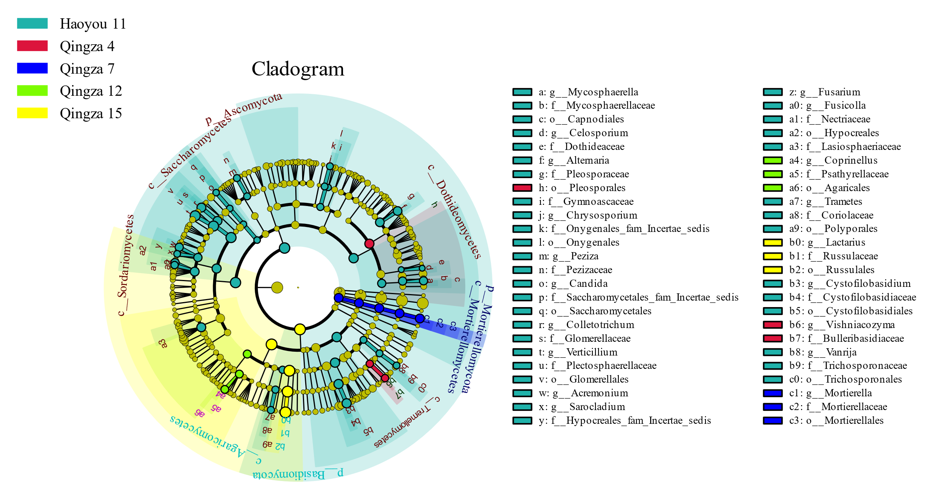

Fig. S3 Taxonomic cladogram by Linear discriminant analysis (LDA). The LDA score> 2.0 and FDR-adjusted q value < 0.05 were set for significance. Significantly discriminant taxon nodes are colored. Each circle's diameter is proportional to the taxon's abundance.

