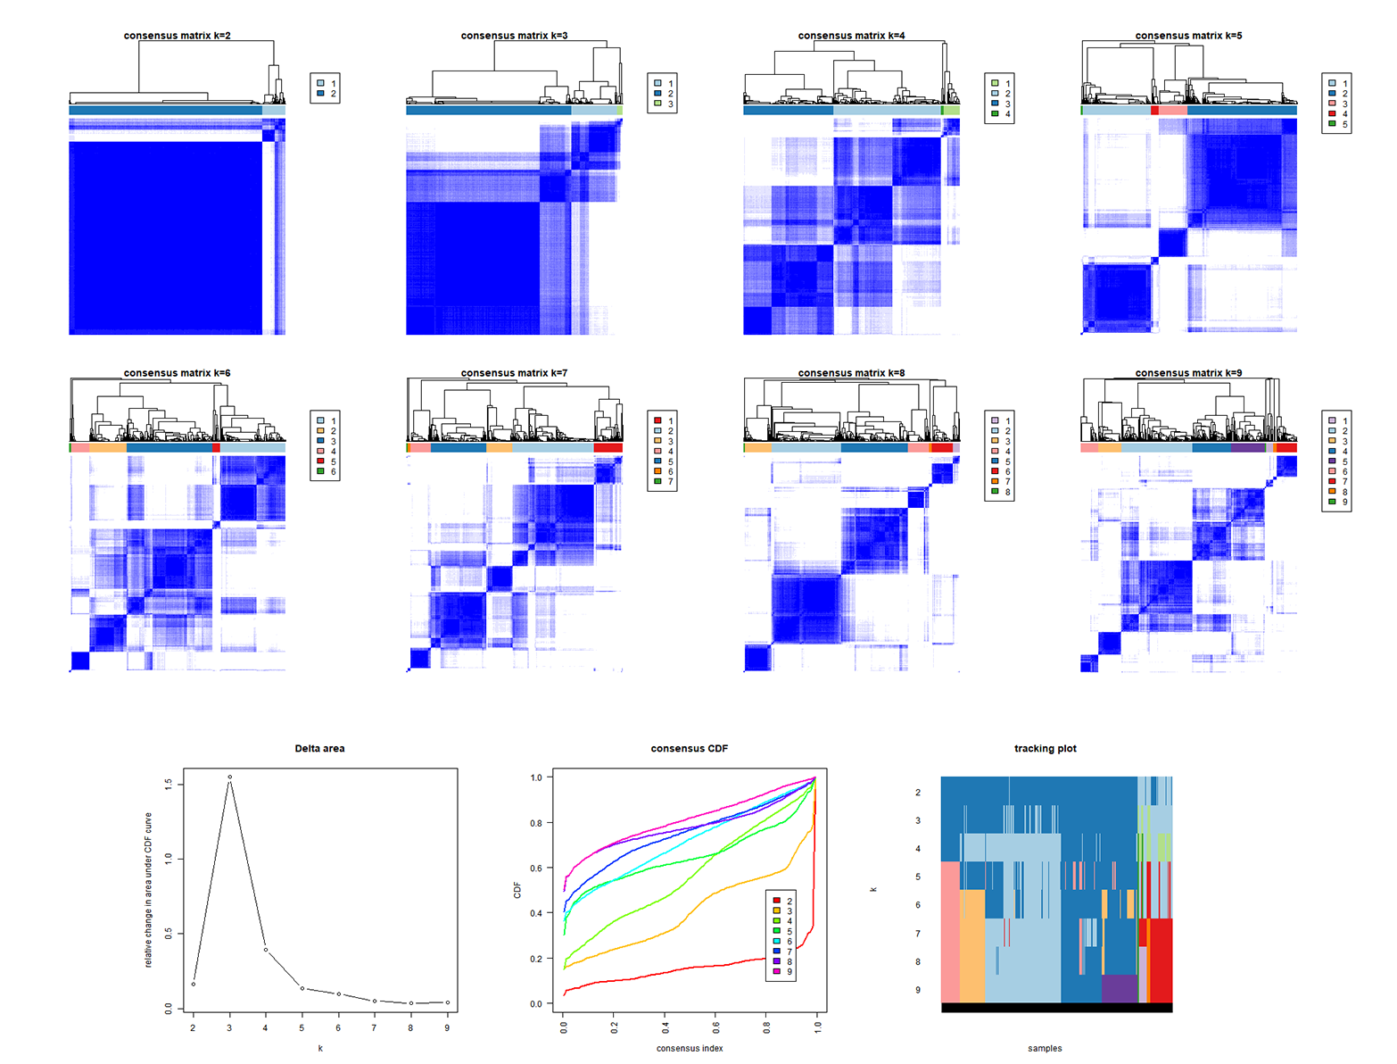
Supplement figure 1. A. Identification of molecular subtypes based on the expression of ARGs through consensus clustering analysis

Primers for genes
ACADL Forward, 5'-TTGGCAAAACAGTTGCTCAC-3'. Reverse, 5'-ACATGTATCCCCAACCTCCA-3'.
GAPDH Forward, 5'-GGACCTGACCTGCCGTCTAG-3’. Reverse, 5'-GTAGCCCAGGATGCCCTTGA-3'.
Cd36 Forward: 5'-CTTTGGCTTAATGAGACTGGGAC-3' Reverse: 5'-GCAACAAACATCACCACACCA-3'.
FABP4 Forward: 5'-TGGGCCAGGAATTTGACGA-3' Reverse: 5'-CATTTCTGCACATGTACCAGGACAC-3'.
ANGPT1 Forward: 5'- TGCAGCAACCAGCGCCGAAA-3' Reverse: 5'-CAGGGCAGTTCCCGTCGTGT-3'.
CPT2 Forward:5'-AAAGAAGCAGCAATGGGCCAG-3' Reverse:5'-CCAGGTAGAGCTCAGGCAAG-3'.

