Supplementary Materials

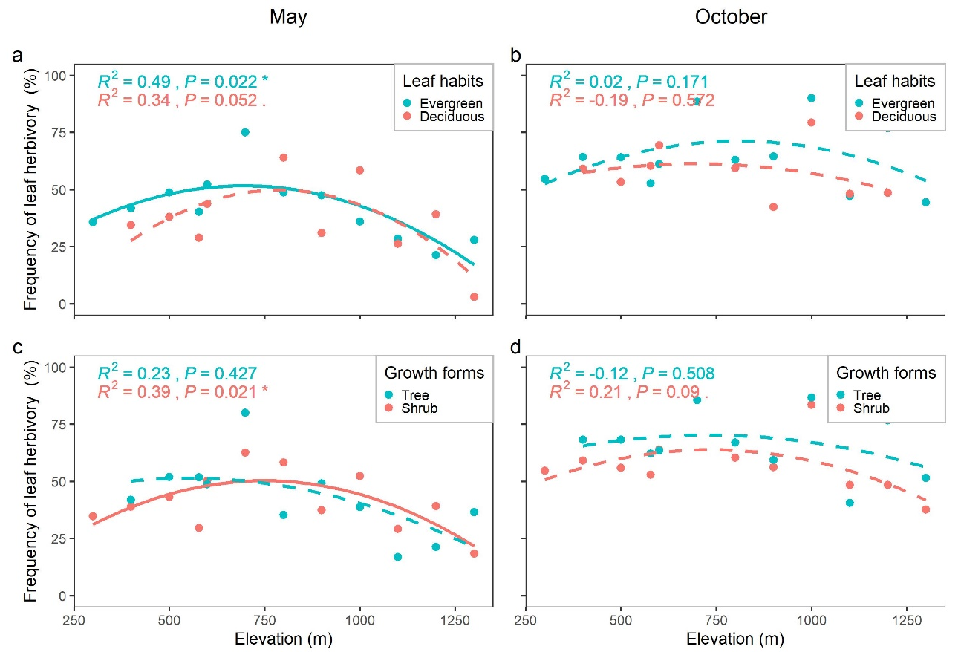
Fig. S1 Elevational patterns of leaf herbivory frequencies on woody plant seedlings of different leaf habits and growth forms in two seasons.

Table S1 Results of a full subset regression of variables as the controls of leaf herbivory frequencies on woody plant seedlings with two leaf habits (evergreen broad-leaved and deciduous broad-leaved species) and two growth forms (trees and shrubs) in two seasons.

Season | Model | Variable | Standardized coefficient | Standard error | t value | P > |t|
May | Evergreen broad-leaved species | Community height | -0.758 | 0.206 | -3.675 | 0.004
 | Deciduous broad-leaved species | Leaf area | 0.697 | 0.253 | 2.751 | 0.025
 | Tree species | Community height | -0.898 | 0.218 | -4.119 | 0.003
 |  | Diversity | -0.573 | 0.218 | -2.63 | 0.030
 | Shrub species | Leaf area | 0.777 | 0.210 | 3.698 | 0.005
October | Evergreen broad-leaved species | Height | -0.484 | 0.217 | -2.233 | 0.052
 |  | Diversity | -0.616 | 0.217 | -2.843 | 0.019
 | Deciduous broad-leaved species | Leaf area | 0.880 | 0.179 | 4.912 | 0.002
 | Tree species | Diversity | -0.516 | 0.286 | -1.808 | 0.104
 | Shrub species | Leaf area | 0.519 | 0.213 | 2.439 | 0.041
 |  | Height | -0.495 | 0.213 | -2.325 | 0.049

