Impact of pollutant as selection pressure on conjugative transfer of dioxin-catabolic plasmids harbored by Rhodococcus sp. strain p52

Authors
Gang Zhao¹, Yanan Wu¹, Xu Wang¹, Meng chen¹, Li Li¹*
Affiliations
¹ Shandong Provincial Key Laboratory of Water Pollution Control and Resource Reuse, School of Environmental Science and Engineering, Shandong University, Qingdao, China

* Corresponding author
Fax: +86-0532-5863-0278 Tel: +86-0532-5863-0986
E-mail address: lili@sdu.edu.cn
School of Environmental Science and Engineering, Shandong University, 72 Binhai Road, Jimo, Qingdao, China, 266237
Reactive oxygen species (ROS) and extracellular lactate dehydrogenase (LDH) assay for activated sludge bacteria in reactors
Duplicate activated sludge mixed-liquor samples were taken from activated sludge reactors for ROS assays according to the instructions of the Reactive Oxygen Species Assay Kit (Beyotime, Jiangsu, China). Briefly, the sample was centrifuged to remove the supernatant and washed with PBS buffer; diluted 2’,7’-dichlorodihydrofluorescein diacetate (DCFH-DA) was added, and the sample was incubated at 37°C in the dark for 20 min. After DCFH-DA enters the cell, it is hydrolyzed by intracellular esterase to 2’,7’-dichlorodihydrofluorescein (DCFH), which cannot penetrate the cell membrane. Intracellular ROS can oxidize DCFH to produce fluorescent 2’,7’-dichlorofluorescein (DCF). The fluorescence intensity of DCF at 488 nm excitation wavelength and 525 nm emission wavelength was measured using a microplate reader (TECAN, USA). The assays of ROS level under different selection pressures were repeated three times.
To assess cell membrane integrity, the activity of LDH released from bacterial cells into the water phase of the mixed liquor was measured. After the end of each cycle, 1.8 mL of the mixed liquor was taken from each reactor for LDH detection according to the instructions of the LDH Release Assay Kit (Beyotime, Jiangsu, China). Briefly, the sample was centrifuged, and the supernatant was mixed with LDH detection working solution (consisting of diaphorase, 2-p-iodophenyl-3-nitrophenyltetrazolium chloride (INT) and lactic acid) and incubated at 25°C for 30 minutes in the dark. Nicotinamide adenine dinucleotide (NAD+) was reduced to reduced nicotinamide adenine dinucleotide (NADH) by LDH, and then NADH and INT were catalyzed by diaphorase to generate NAD+ and formazan. The absorbance of the produced formazan at a wavelength of 490 nm was measured using a spectrophotometer (HACH, USA). The assay of extracellular LDH contents under different selection pressures were repeated three times.

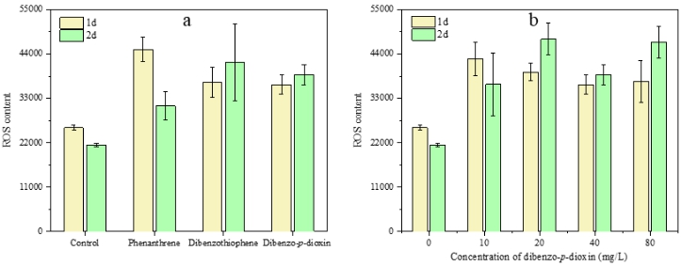
Fig. SM-1 ROS content of activated sludge bacteria during contaminant treatment. ROS contents in reactors fed with different contaminants and concentrations are shown in a and b, respectively

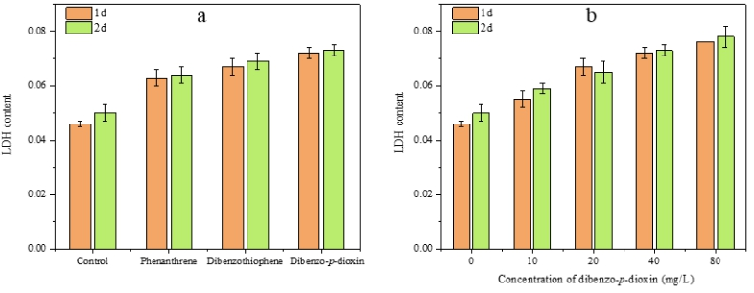
Fig. SM-2 Extracellular LDH level of activated sludge bacteria during contaminant treatment. The extracellular LDH levels of activated sludge bacteria fed with different contaminants and concentrations are shown in a and b, respectively

