Supplementary Figure 1.
The coding sequence of TmTAK1 includes 1,527 bp of nucleotide sequences encompassing eight exons (shown in blue). The intervening sequences (introns) have been shown in grey. Linear map of TmTAK1 gene structure. The cDNA sequence of TmTAK1 annotated against the T. molitor DNA-seq database.

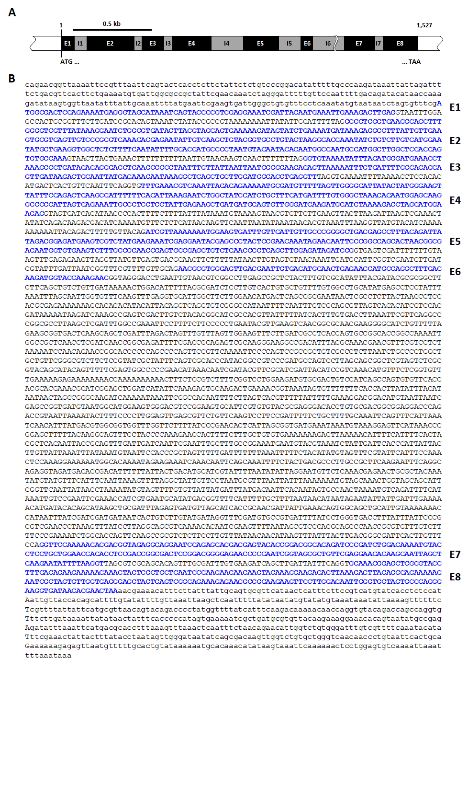
Supplementary Figure 2. Nucleotide and deduced amino acid sequence of TmTAK1. TmTAK1 contains 1,527 bp of nucleotide sequences encoding 703 amino acid residues. The nucleotide and amino acid residues are numbered. The stop codon is represented by an asterisk. The Serine/Threonine protein kinase catalytic domain is represented within the Open box.

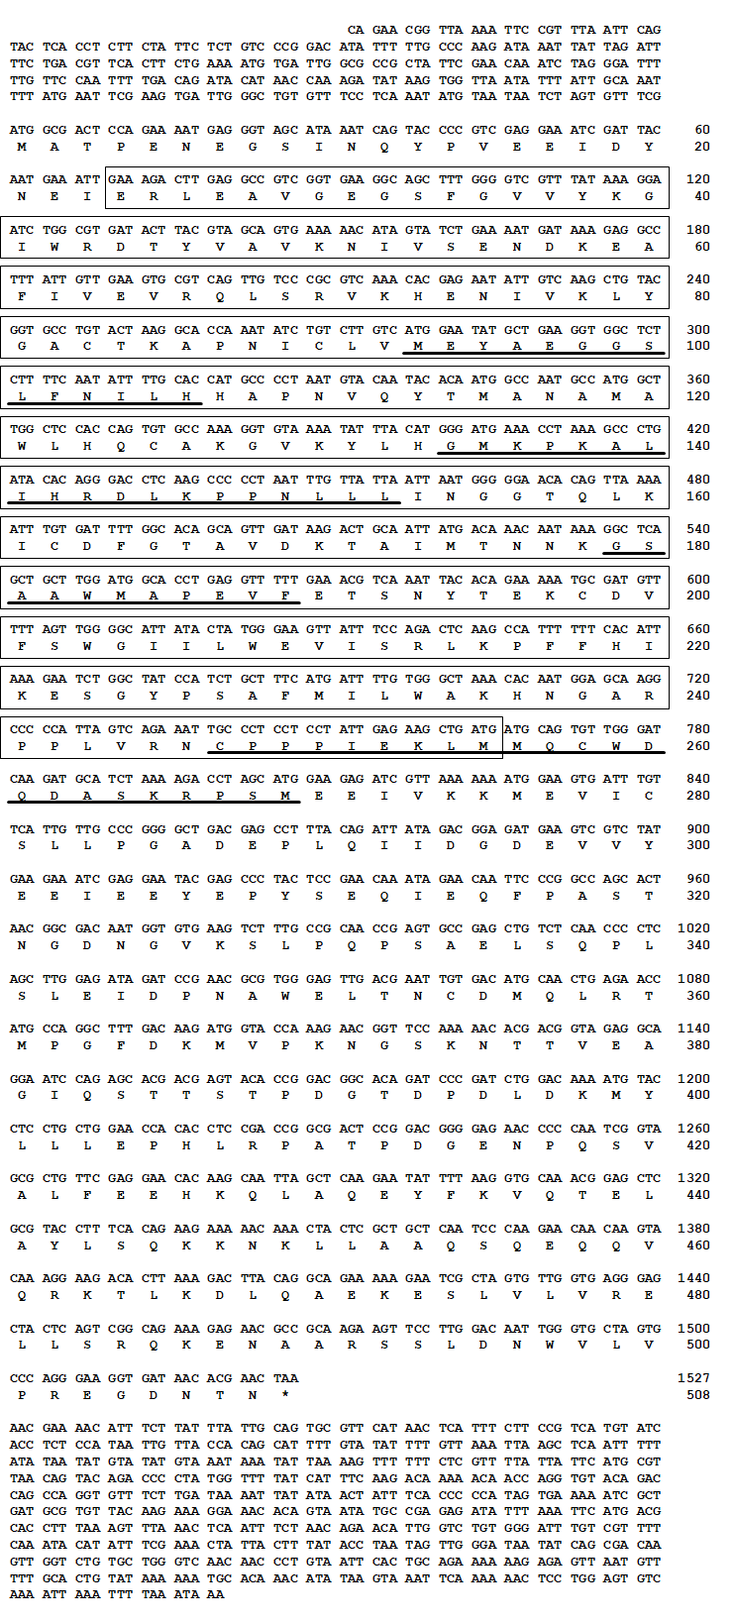
Supplementary Figure 3. Multiple alignment analysis of TmTAK1. Multiple alignments of the deduced amino acid sequence of TmTAK1 aligned using Clustal X 2.0.11. Arrows represent the phylogenetically conserved cysteine residues forming the disulfide bridge featuring in the cysteine knot domain.
The following protein sequences were used in the multiple sequence alignment and phylogenetic analysis: DmTAK1, Drosophila melanogaster TAK1 (NP_524080. 1); DmTAK1-like2, Drosophila melanogaster TAK1-like2 (NP_651090. 2); TcMKKK7, Tribolium castaneum MKKK7 (XP_968547. 1); PpMKK7-like, Photinus pyralis MKKK7-like (XP_031330485. 1); ApMKKK7, Agrilus planipennis MKKK7 (XP_018333073. 1); HzMKKK7, Helicoverpa zea MKKK7 (XP_047031840. 1); HaMKKK7, Helicoverpa armigera MKKK7 (XP_021198433. 2); BmMKKK7, Bombyx msori MKKK7 (XP_021207294. 1); HkMKK7-like, Hyposmocoma kahamanoa MKKK7-like (XP_026321167. 1); BkMKKK7-like, Belonocnema kinseyi MKKK7-like (XP_033208032. 1); ArMKKK7-like, Athalia rosae MKKK7-like (XP_012253187. 2); FvMKKK7-like, Frieseomelitta varia MKKK7-like (XP_043516360. 1); VcMKKK7-like, Venturia canescens MKKK7-like (XP_043281270. 1); SfMKKK7-like, Sipha flava MKKK7-like (XP_025413188. 1); AcMKKK7-like, Aphis craccivora MKKK7-like (KAF0770127. 1); DvMKKK7-like, Daktulosphaira virifoliae MKKK7-like (XP_050524364. 1); IeMKKK7-like-isoX2, Ischnura elegans MKKK7-like-isoX2 (XP_046405324. 1); IeMKKK7-like-isoX1, Ischnura elegans MKKK7-like-isoX1 (XP_046405323. 1); CsMKKK7-isoX2, Cryptotermes secundus MKKK7-isoX2 (XP_023703195. 1); ZnMKKK7-isoX1, Zootermopsis nevadensis (XP_021932762. 1); PvMKKK7-like, Penaeus vannamei MKKK7-like (XP_027228781. 1); PvMKKK7-like, Penaeus vannamei MKKK7-like (XP_027228781. 1); DmTAK1-like1, Drosophila melanogaster TAK1-like1 (NP_732554. 1)

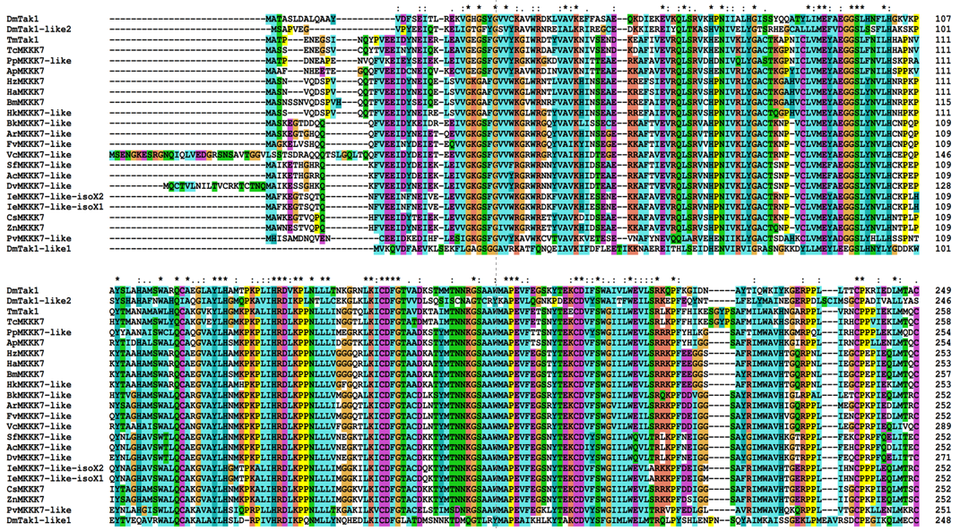
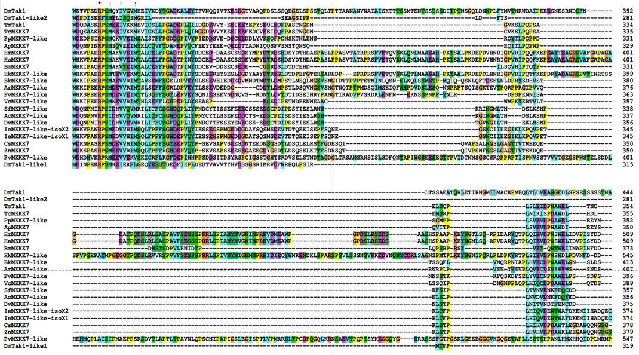
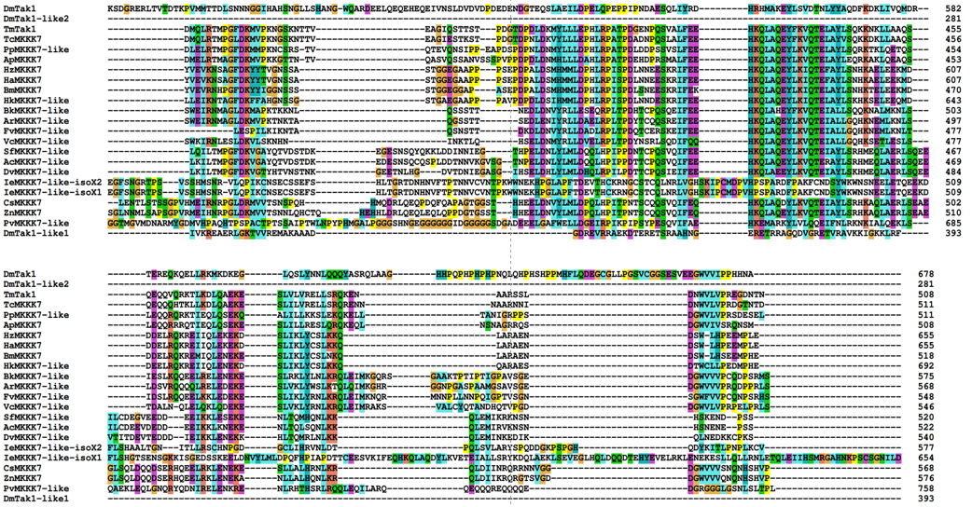

Supplementary Figure 4. Molecular phylogenetic analysis of TmTAK1. Maximum likelihood-based phylogenetic tree based on the amino acid sequence of TmTAK1 constructed using the MEGA 7.0 software.

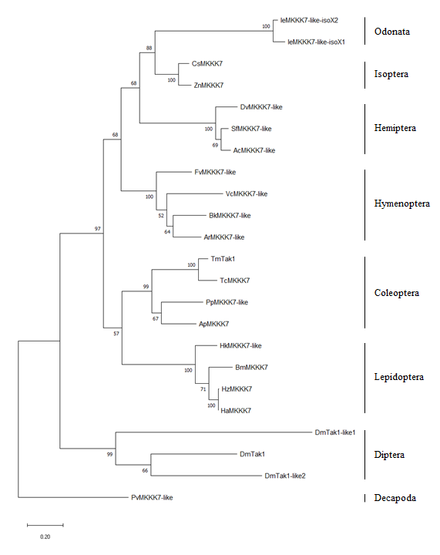

Supplementary Table

Table. Primers used in the present study
Name | Primer sequences
TmTAK1_cloning_Fw  TmTAK1_cloning_Rv | 5′- TCGAAGTGATTGGGCTGTGT -3′  5′- TTATGGAGAGGTGATACATGACGG -3′
TmTAK1_qPCR_Fw  TmTAK1_qPCR_Rv | 5′- TGTGAAGTCTTTGCCGCAAC -3′  5′- TCTTGTCAAAGCCTGGCATG -3′
TmTAK1_T7_Fw  TmTAK1_T7_Rv | 5′-TAATACGACTCACTATAGGGT  AGTACCCCGTCGAGGAAATC -3′  5′-TAATACGACTCACTATAGGGT  GCATTGGCCATTGTGTATTG -3′
TmTenecin-1_qPCR_Fw  TmTenecin-1_qPCR_Rv | 5′-CAGCTGAAGAAATCGAACAAGG-3′  5′-CAGACCCTCTTTCCGTTACAGT-3′
TmTenecin-2_qPCR_Fw  TmTenecin-2_qPCR_Rv | 5′-CAGCAAAACGGAGGATGGTC-3′  5′-CGTTGAAATCGTGATCTTGTCC-3′
TmTenecin-3_qPCR_Fw  TmTenecin-3_qPCR_Rv | 5′-GATTTGCTTGATTCTGGTGGTC-3′  5′-CTGATGGCCTCCTAAATGTCC-3′
TmTenecin-4_qPCR_Fw  TmTenecin-4_qPCR_Rv | 5′-GGACATTGAAGATCCAGGAAAG-3′  5′-CGGTGTTCCTTATGTAGAGCTG-3′
TmDefensin_qPCR_Fw  TmDefensin_qPCR_Rv | 5′-AAATCGAACAAGGCCAACAC-3′  5′-GCAAATGCAGACCCTCTTTC-3′
TmDefensin-like_qPCR_Fw  TmDefensin-like_qPCR_Rv | 5′-GCGATGCCTCATGAAGATGTAG-3′  5′-CCAATGCAAACACATTCGTC-3′
TmCecropin-2_qPCR_Fw  TmCecropin-2_qPCR_Rv | 5′-TACTAGCAGCGCCAAAACCT-3′  5′-CTGGAACATTAGGCGGAGAA-3′
TmColeoptericin-A_qPCR_Fw  TmColeoptericin-A_qPCR_Rv | 5′-GGACAGAATGGTGGATGGTC-3′  5′-CTCCAACATTCCAGGTAGGC-3′
TmColeoptericin-B_qPCR_Fw  TmColeoptericin-B_qPCR_Rv | 5′-CAGCTGTTGCCCACAAAGTG-3′  5′-CTCAACGTTGGTCCTGGTGT-3′
TmColeoptericin-C-qPCR-Fw  TmColeoptericin-C-qPCR-Rv | 5'-GGACGGTTCTGATCTTCTTGAT-3'  5'CAGCTGTTTGTTTGTTCTCGTC-3'
TmAttacin-1a_qPCR_Fw  TmAttacin-1a_qPCR_Rv | 5′-AAAGTGGTCCCCACCGATTC-3′  5′-GCGCTGAATGTTTTCGGCTT-3′
TmAttacin-1b_qPCR_Fw  TmAttacin-1b_qPCR_Rv | 5′-GAGCTGTGAATGCAGGACAA-3′  5′-CCCTCTGATGAAACCTCCAA-3′
TmAttacin-2-Fw  TmAttacin-2-Rv | 5′-AACTGGGATATTCGCACGTC-3′  5′-CCCTCCGAAATGTCTGTTGT-3′
TmThaumatin-like protein-1-Fw  TmThaumatin-like protein-1-Rv | 5′-CTCAAAGGACACGCAGGACT-3′  5′-ACTTTGAGCTTCTCGGGACA-3′
TmThaumatin-like protein-2-Fw  TmThaumatin-like protein-2-Rv | 5′-CCGTCTGGCTAGGAGTTCTG-3′  5′-ACTCCTCCAGCTCCGTTACA-3′
TmRelish_qPCR_Fw  TmRelish_qPCR_Rv | 5′-AGCGTCAAGTTGGAGCAGAT-3′  5′-GTCCGGACCTCAAGTGT-3′
Tmkayak_qPCR_Fw  Tmkayak_qPCR_Rv | 5′-AAGGGAACGCAACAAAGCAG-3′  5′-AGCTCGTCGGTTTCTTGAAC-3′
TmDorax1_qPCR_Fw  TmDorax1_qPCR_Rv | 5′-AGCGTTGAGGTTTCGGTATG-3′  5′-TCTTTGGTGACGCAAGACAC-3′
TmDorax2_qPCR_Fw  TmDorax2_qPCR_Rv | 5′-ACACCCCCGAAATCACAAAC-3′  5′-TTTCAGAGCGCCAGGTTTTG-3′
TmL27a_qPCR_Fw  TmL27a_qPCR_Rv | 5′-TCATCCTGAAGGCAAAGCTCCAGT-3′  5′-AGGTTGGTTAGGCAGGCACCTTTA-3′
※ Underline indicates T7 promotor sequences

