Supplement

Table A.1. HFMS in exposed survivors (n=42)
Exercises | 0 | 1 | 2 | Unknown
Item 12 | 2.4% | 0% | 66.7% | 31.0%
Item 13 | 0% | 0% | 69.0% | 31.0%
Item 15 | 4.8% | 0% | 64.3% | 31.0%
Item 12: Lifts head from prone (arms down by sides); Item 13: Achieves four-point kneeling-head up; Item 15: Gets to sitting from lying through side lying

Table A.2. Strength measurements in exposed survivors (n=42)
Measurements | Grade 1 | Grade 2 | Grade 3 | Grade 4 | Grade 5 | Not possible | Unknown
Neck extension | 0 | 0 | 0 | 0 | 30 | 1 | 11
Neck bending | 0 | 0 | 0 | 1 | 30 | 0 | 11
Head rotation right | 0 | 0 | 1 | 1 | 30 | 0 | 10
Head rotation left | 0 | 0 | 1 | 1 | 30 | 0 | 10
Shoulder abduction right | 0 | 0 | 1 | 1 | 30 | 0 | 10
Shoulder abduction left | 0 | 0 | 1 | 0 | 31 | 0 | 10
Elbow flexion right | 0 | 0 | 1 | 3 | 28 | 0 | 10
Elbow flexion left | 0 | 0 | 1 | 1 | 30 | 0 | 10
Elbow extension right | 0 | 0 | 1 | 0 | 31 | 0 | 10
Elbow extension left | 0 | 0 | 1 | 0 | 31 | 0 | 10
Wrist flexion right | 0 | 0 | 1 | 1 | 30 | 0 | 10
Wrist flexion left | 0 | 0 | 1 | 0 | 31 | 0 | 10
Wrist extension right | 0 | 0 | 1 | 0 | 31 | 0 | 10
Wrist extension left | 0 | 0 | 1 | 0 | 31 | 0 | 10
Finger spread right | 0 | 0 | 1 | 1 | 30 | 0 | 10
Finger spread left | 0 | 0 | 1 | 0 | 31 | 0 | 10

Table A.3. Examination of the reflexes of the exposed survivors (n=42)
Examinations | Reduced | Normal | Overactive | Unknown
Biceps reflex right | 7 | 18 | 3 | 13
Biceps reflex left | 6 | 19 | 3 | 13
Radioperiosteal reflex right | 6 | 19 | 3 | 13
Radioperiosteal reflex left | 6 | 19 | 3 | 13
Triceps reflex right | 4 | 23 | 2 | 12
Triceps reflex left | 4 | 22 | 3 | 12
Patellar reflex right | 0 | 1 | 0 | 41
Patellar reflex left | 0 | 1 | 0 | 41

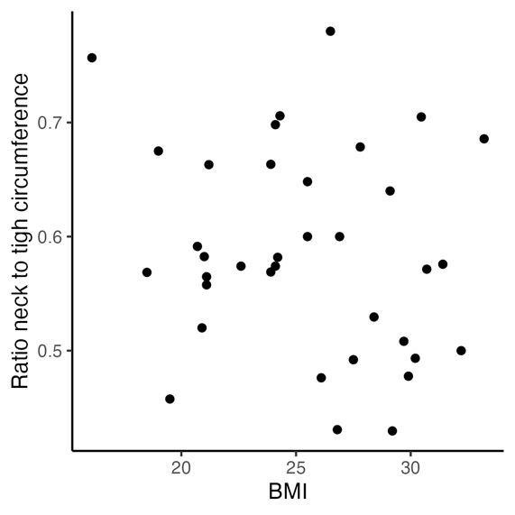
Fig. A.1. BMI compared with the ratio of neck to thigh circumference of the exposed survivors (n = 42).

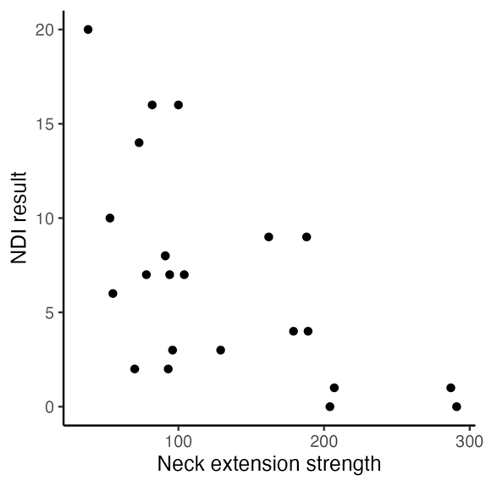 | 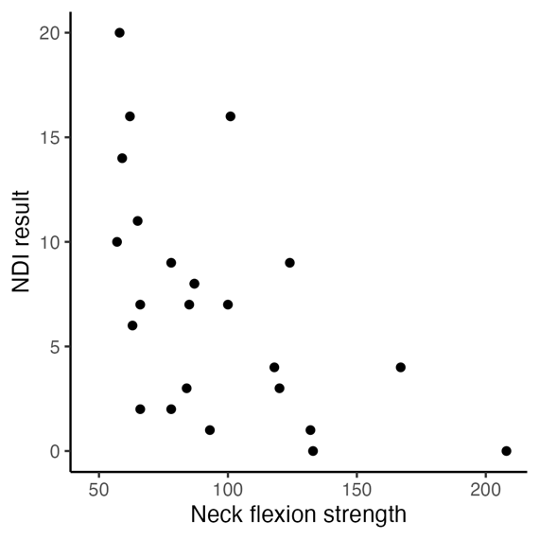
Fig. A.2. Neck extension and neck flexion strength compared with the NDI result of the exposed survivors (n = 42).

Table A.4. MRI results of the CCS (5 recommended by the neurologist, 8 during regular follow-up).
Surgery access visible | Symmetry | Asymmetry affects the following muscles | Symmetric atrophy in the following muscles | Pathological contrast agent uptake in muscles | Muscle edema | Correct patient positioning | Neurological examination
Yes | No | M. splenius capitis left; M. semispinalis capitis left; both with slight atrophy | No | No | No | Yes | Not assessed
Yes | Yes |  | No | No | No | Yes | Not assessed
Yes | No | M. rectus capitis posterior minor et mayor; M. obliquus inferior | No | No | No | Yes | Not assessed
Yes | Yes |  | deep neck muscles (M. obliquus capitis superior et inferior; Musculus rectus capitis minor et major) | No | No | Head to the left | Abnormal results
Yes | No | M. rectus capitis posterior minor et mayor; M. obliquus inferio | No | No | No | Yes | Normal results
No | Yes |  | No | No | No | Yes | Abnormal results
No | Yes |  | hypotrophic neck muscles | No | No | Yes | Abnormal results
No | Yes |  | Autochthonous back muscles on both sides; cervicothoracic with vacate fat formation; very weak neck muscles | No | No | Yes | Abnormal results
No | Yes |  | No | No | No | Yes | Normal results
No | Yes |  | No | No | No | Yes | Not assessed
No | Yes |  | No | No | No | Yes | Normal results
No | Yes |  | Autochthonous back muscles on both sides; cervicothoracic with vacate fat formation | No | No | Yes | Abnormal results
Yes | Yes |  | No | No | No | Yes | Normal results

