Additional File 1
Checklists for visual assessment during visits to abattoir/slaughterhouse and slaughter slabs (A) and butcheries (B) for interviews or sample collection as part of the HAZEL project in northern Tanzania, 2016.
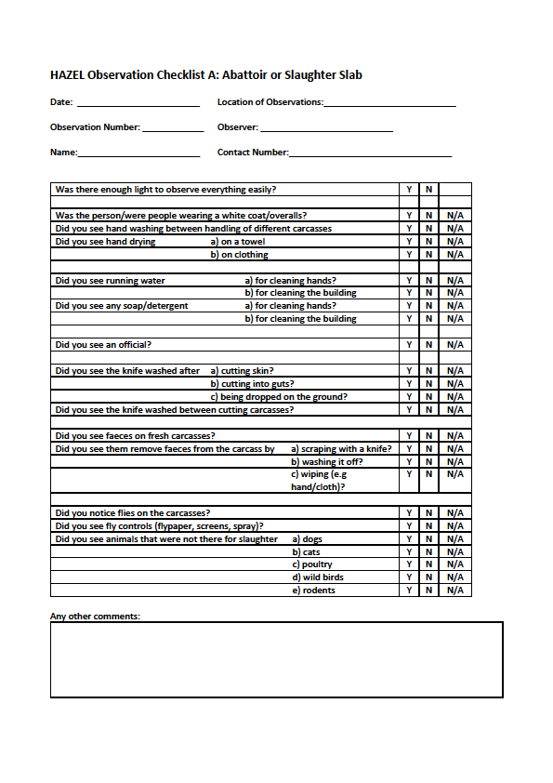
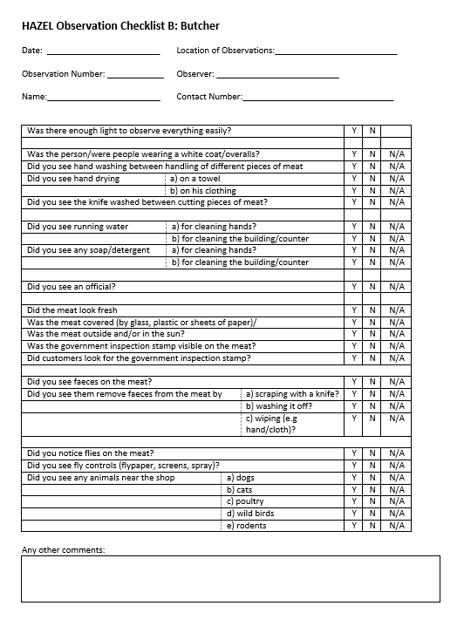

Additional File 2 – Observational Data (used in MCA)
See spreadsheet in separate document submitted.

Additional File 3 (supplementary material)
Legislation (Acts and Regulations) relevant to meat safety in Tanzania as of 2020.
Legislation | Description
The Tanzania Food, Drugs and Cosmetics Act No. 1 of 2003 and the Standards Act (2019) | Provided for regulation of premises for slaughter and butchery and transport of meat, examination of food suspected to be unfit for human consumption, and authority to seize and dispose of a carcass unfit for human consumption; this Act therefore covered the meat chain from slaughter to butchery and raw meat sales and provided national-level authority for meat inspectors (MIs) and health officers (HOs). The TFDA Risk Based Food Inspection Guidelines, 2009 (Tanzania Food and Drugs Authority, 2009) provided a uniform approach focused on food safety rather than aesthetics. These guidelines included a point system for inspectors to assess cattle, sheep, and goat slaughterhouses for presence of a chill room, insect screens, adequate lighting and ventilation, potable water supply, reservoir of water in case of shortage, hot water (>85ºC), hand washing facilities, and employees being medically examined every 6 months. The TFDA Inspection Checklist for Butchery Shops also gave points for presence of a hand washing basin, white coats, and meat suspension hooks, but did not include running water supply. The Transport of Meat Regulations, 2006, a subsidiary regulation to this Act, required meat containers and meat transport containers be inspected, cleaned and disinfected before loading with meat, and not transport meat concurrently with live or dead animals.
The Veterinary Act, 2003 | Provided legal basis for registration of veterinarians, paraprofessionals and assistants. Its prohibition against untrained professionals practicing veterinary medicine, meat inspection, or laboratory testing unless a registered veterinarian or paraprofessional assistant (with the exception that owners may treat their own animals) aimed to support food safety at livestock level.
The Animal Diseases Act No. 17 of 2003 | Explicitly addressed need for prevention and control of infectious animal diseases, calling for the Director for Veterinary Services to make lists of notifiable diseases including zoonoses. Other provisions included publication of official methods for diagnosis and control of notifiable diseases, and establishment and maintenance of a national veterinary epidemiological surveillance and diagnostic laboratory system. Related regulations, the Animal Diseases (Appointment and Duties of Inspectors) Regulations 2007, described the authority and duties of inspectors, disposal of carcasses deemed unfit for human consumption, and cleanliness of slaughter equipment.
The Occupational Health and Safety Act, 2003 | Delineated requirements for safety around machinery, including flywheels, driving belts, etc. Specifications for hoists, lifts and lifting tackle may have relevance for slaughter premises with mechanical hoists for carcasses. Outlined requirements for sufficient sanitary conveniences, including toilets and washing facilities in workplaces with 25 or more employees.
The Environmental Management Act, 2004 | Expressed the rights of all Tanzanians to a healthy environment. It had little direct impact on meat safety but did provide authority to local governments to set guidelines for liquid waste treatment and disposal (e.g., from a slaughter facility).
The Meat Industry Act No. 10 of 2006 | Established the Annual Council and the Tanzania Meat Board with mandates to promote development of sustainable meat industry standards and a livestock traceability system.
The Animal Welfare Act No. 19 of 2008 (Revised 2010) | Established that animal welfare inspectors may be retired veterinarians, paraprofessionals, livestock officers or law enforcers. Inspector duties included protection of animals from ill treatment, ensuring humane transport and slaughter, and reporting to the veterinary authority. The Act also stipulated instantaneous killing or rendering animals unconscious before slaughter.
The Livestock Identification, Registration and Traceability Act No. 12 of 2010. (The Livestock Identification, Registration and Traceability Act No. 1 of 2011) | Called for the establishment and maintenance of such a livestock traceability system, including registration and tracking of both imported and domestically raised animals.
The Grazing-Land and Animal Feed Resources Act No. 13 of 2010 | Established governance of feed manufacture premises, sterilization of bone and animal products and procedures for sterilization.
The Pharmacy Act No. 1 of 2011 | Established the Pharmacy Council to regulate the pharmacy profession and sales of medicinal products, which includes veterinary medicine
The Tanzania Livestock Research Institute Act No. 4 of 2012 | Established the institute of its namesake to carry out research on livestock production, including livestock health.
The Public Health Act 2009 | While primarily focused on human health, included a section on food hygiene and slaughter facility, meat and poultry inspection. Relegated most authority to local district and urban officials, specifying authorities to inspect, condemn or seize food or close unhygienic slaughter facilities or food markets.
The Environment Health Practitioners (Registration) Act, 2007 | Provided legal basis for registration of public health environmental health professionals and called for them to practice with clear knowledge, skills and competence, and ethics.
University Act 2005: SUA Charter 2007 | Stipulated Charter and Rules for Sokoine University of Agriculture (SUA), indicating its primary purpose of carrying out research and training on livestock, including production, animal health, feed resources, public health, and food safety.
Executive Agency Act: 245 (Revised 2009) | Established the Tanzania Veterinary Laboratory Agency (TVLA) mandated to undertake animal disease and vector control research, testing of veterinary pharmaceuticals, development and production of biologicals, testing for safety and quality of animal feeds and animal products, consultancy and advisory services, and animal disease diagnostic services.

Additional File 4
Table 1. Strengths and weaknesses of meat safety internal to meat safety policy and regulations in Tanzania, based on policies, acts, regulations and observations.
Strengths | Weaknesses
Legal and administrative
- National policies, especially the National Livestock Policy 2006 and the Public Health Policy, created the framework for the establishment of the MLF and the MoHCDGEC (now split) respectively, and empowered them to support activities for meat safety.  - Ministry activities have included studies to determine barriers to the use of livestock services (Tanzania National Bureau of Statistics (NBS), 2013), and reasons for discrepancies between meat safety policy and practice (United Republic of Tanzania, 2020) .  - The DVS was formally established by the Animal Disease Act of 2003 and is a delegate to the WOAH ensuring two-way communication and opportunities to access resources from this and other agencies and organisations.  - Regulatory infrastructure for local-level meat safety has been in place and has formal and informal mechanisms for regular communication and updates (Hrynick et al., 2019).  - Local entities from village to ward to district have been empowered to develop and implement by-laws, driven by locally perceived needs (Mowo et al., 2016). | - The National Livestock Policy, the Tanzanian Livestock Modernization Initiative and the National Health Policies (of 2007 and 2017) only briefly or tangentially refer to food safety.  - PO-RALG administers the local and regional workforce, while MIs and HOs get technical guidance from the MLF and MoHCDGEC respectively. Other ministries’ specific inter-agency overlaps with regards to reporting and regulatory purview (such as between the TBS and DVS) also created confusion among meat safety actors. National policies have not addressed inter-agency coordination.  - While policies, regulations and by-laws exist at different levels to support meat safety, they have not necessarily reflected conditions on the ground, and thus may not be entirely fit for purpose across many settings in Tanzania (next table section).  - The public health disease burden associated with meat-borne diseases such as salmonellosis and campylobacteriosis, and their importance relative to other disease threats, is unknown. This knowledge gap impedes development of appropriate, targeted policies for food safety where resources are limited.
Infrastructure and implementation
- The National Environmental Management Council (NEMC) inspects manufacturing and slaughter facilities to ensure they abide by the Environmental Management Act of 2004. It also gives local authorities the power to enforce penalties and closures for non-compliance.  - Infrastructures supportive of meat safety, including official livestock markets and the tracking of animal movements in relation to markets have been in place (Chaters, 2021).  - District, ward, and village-level veterinary support systems are in place; these include local Veterinary Officers and LFOs who provide animal health and movement permit services which can support meat safety.  - Meat and hygiene inspections are carried out locally by MIs and HOs regularly. Along with LFOs, they also work together to support meat safety through engaging in relationship building, learning strategies and pragmatic enforcement with livestock keepers and meat sellers in ways sensitive to their economic constraints and capacities to make changes (Hrynick et al., 2019). For instance, in lieu of running water, buckets with spigots were supported, and most slaughter and butchery facilities seemed to have these (Waldman et al., 2020).  - With the encouragement of inspectors, many butcheries, including in rural areas, have made economically feasible changes conducive to meat safety such as construction of permanent structures with easily cleaned tiled walls and counters (Hrynick et al., 2019; Prinsen et al., 2020; Waldman et al., 2020). | - The NEMC is unable to inspect all slaughter facilities. Environmental contamination in slaughter and butchery environments makes an important contribution to the presence of NTS on meat (Zadoks et al., 2021).  - Evidence from whole genome sequencing shows some NTS serovars and sequence types are shared between red meat and human bloodstream and diarrheal disease isolates suggesting the meat pathway contributes to human disease (Crump et al., 2020).  - National regulations (e.g., Animal Disease Regulations 2007) can be difficult to implement for many slaughter facilities, especially in rural areas. Lack of running water, as observed at many facilities in our study, for example, makes cleanliness of equipment difficult. They may also lack electric lighting and protections against insects and animals among other important infrastructure (Waldman et al., 2020), Lack of detergent for cleaning the premises and behavioural aspects such as customers not seeking inspection stamps, and workers not drying their hands on a towel, were among the most common results of the MCA.  - LFOs, MIs and HOs face many challenges including limited transportation, and inadequate resources (e.g., staffing, availability of animal vaccines etc.). MIs for instance, may not reach slaughter facilities in time to complete both pre- and post-mortem inspection, while HOs may only be able to visit butcheries seldomly (Hrynick et al., 2019; Prinsen et al., 2020; United Republic of Tanzania, 2016; Waldman et al., 2020).
Knowledge and training
- Tanzania is home to Sokoine University of Agriculture, Morogoro and other tertiary training institutions which represent centres of expertise in livestock health and epidemiology of zoonotic disease.  - Communication networks that may be utilised for educational or mutual learning purposes exist, for example in Hrynick et al. (2019) LFOs mentioned ward meetings where they learned of policy, and more informal mobile phone networks with other inspectors for comparing notes and getting support.  - The use of workers skilled at preventing cross-contamination during slaughter, e.g., between hides and carcasses or by inadvertent visceral punctures, may reduce meat contamination and therefore disease. | - Many actors along the meat value chain, including inspectors and workers, may not be familiar with, or may never have been exposed to, meat safety guidelines, leading to implementation gaps. This lack of familiarity may be due to inadequate staffing, limited field-based experience of new staff, variable levels of education, lack of refresher training, informational materials and other resources (Hrynick et al., 2019; Waldman et al., 2020).  - There is limited awareness or concern among slaughterers, butchers and inspectors of foodborne pathogens that do not cause visible lesions in carcasses/meat, e.g., gastrointestinal carriage organisms such as non-typhoidal Salmonella (NTS) or Campylobacter spp. (Waldman et al., 2020).

Additional File 5
Table 2. Opportunities and threats to meat safety external to meat safety policy and regulation in Tanzania, based on policies, acts, regulations and observations
Opportunities | Threats
National economy
- Tanzania has the third highest national livestock population (cattle, small ruminants, pigs, and poultry) in Africa (United Republic of Tanzania & Ministry of Agriculture, Livestock and Fisheries, 2015). This represents an economic resource to build upon, potentially through support for animal health services to increase exports and other types of support (feed, animal genetics) that could result in improved productivity and meat safety (Michael et al., 2018).  - Changing consumer preference and expanding regional and international markets for meat and livestock represent an economic opportunity that could have indirect benefits to the meat safety infrastructure as producers seek to comply with international and regional food safety requirements to meet consumer demand (Cockx et al., 2017; Prinsen et al., 2020).  - An increase in large commercial production and economies of scale may provide increased opportunity for investment in food safety infrastructure (Zadoks et al., 2021). | - Rising demand for meat due to population increases and more urbanised populations may create more domestic demand for warm meat that, if food safety implementation does not keep pace, is not safely produced (for example, may contribute to salmonellosis) (Crump et al., 2020).  - While efforts to meet increased demand for meat in neighbouring African countries and beyond may spur capable producers of improving food safety standards to meet international requirements, policy makers and other stakeholders may end up deprioritising food safety standards and investments in the domestic market in favour of focusing on ensuring access and growth in potentially more financially lucrative international markets.
Food safety and human health
- High levels of interest in animal disease, research and food safety exist in Tanzania. The creation of the Tanzania Livestock Research Institute and Tropical Pesticide Research Institute in 2012 are examples.  - There is collaboration of Tanzanian administration with food safety standard setting organisations (WOAH, FAO, WTO) that formulate technical guidelines and facilitate safe trade of live animal and animal source foods.  - East African Community (EAC), and African Union Inter-African Bureau for Animal Resources (AU-IBAR), Southern African Development Community (SADC) – regional economic blocks (not AU-IBAR) – technical and strategic guidance (e.g. tools) including for harmonisation of policy (e.g. surveillance) (not setting standards), facilitate and mobilise access to resources. | - Meat-borne diseases such as anthrax and brucellosis may be increasing while reporting of these diseases, needed to trigger agency responses, is often hampered by delay in sample submission, poor sample quality, or lack of diagnostic capacity (United Republic of Tanzania, 2016, 2020; Warioba et al., 2023).  Policy related to meat safety is gender-blind and thus does not recognise there may be different risks faced by women and men, due to the different roles they might play in animal health, meat safety and even meat consumption (Barasa and Virhia, 2022; Diarz et al., 2020. For example, cattle-keeping and work in the slaughter and butcher components of the red meat value chain are male-dominated, whereas food preparation is female-dominated (Galiè et al., 2015; Prinsen et al., 2020)
Knowledge and training
- Existing tertiary training institutions (e.g., Sokoine University of Agriculture) are a potential source of continuing education for LFOs and MIs.  - The MLF listed a national food safety education campaign as a priority action (United Republic of Tanzania & Ministry of Agriculture and Fisheries, 2015).  - Partnerships between training institutions, private veterinarians, the WOAH and NGOs have high potential for ‘training the trainers’ educational opportunities (FAO, 2014; Mtui-Malamsha et al., 2020).  - There is an opportunity to increase investment in women’s participation in training for animal health and meat safety as men currently dominate this professional space, as well as to increase awareness within training programmes of the gendered nature of livestock production and of the zoonotic risks that may be associated with this in Tanzania (Barasa & Virhia, 2021; Galiè et al., 2017). | - Despite food safety training being a priority, there remain too few training centres to support the number of professionals needed to adequately ensure meat safety in Tanzania, or to support those already working with ongoing training to assure quality.  - Access and cost of education and training – for field staff and other actors in the meat value chain – may also be prohibitive to many who would like to avail of such training, posing issues of equity, in addition to barriers to improved meat safety.  - Even if individuals can access training, there is no guarantee a job will be available for them. This may not only discourage potential students, but may also result in many qualified professionals not utilising their training to support meat safety and public health in their communities (authors’ field notes during interviews).

