Supplementary Figure S1: Plots of “leave-one-out” analyses for MR analyses of causal link of kidney stone on BMDs at multiple ages.
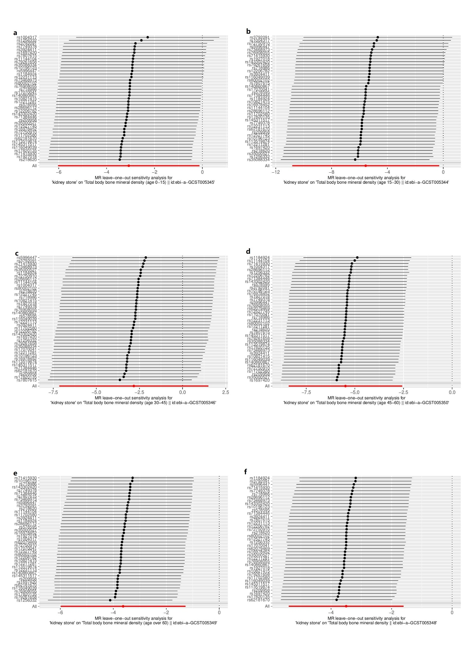

The black straight line represents each SNP beta values after leave-one-out. The red straight line represents all beta values after leave-one-out. (a)age0-15 (b)age15-30 (c)age 30-45 (d)age45-60 (e) age over60 (f)all age
Supplementary Figure S2: Forest plot for MR analyses of causal link of kidney stone on BMDs at multiple ages.
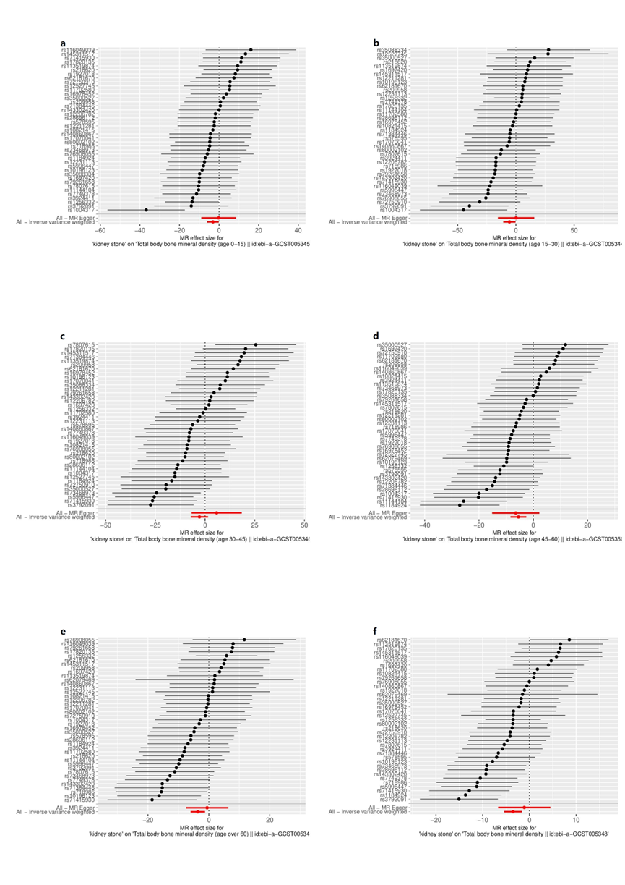
(a)age0-15 (b)age15-30 (c)age 30-45 (d)age45-60 (e) age over60 (f)all age
Supplementary Figure S3: Plots of MR estimates of the causal link between kidney stone on BMDs at multiple ages.
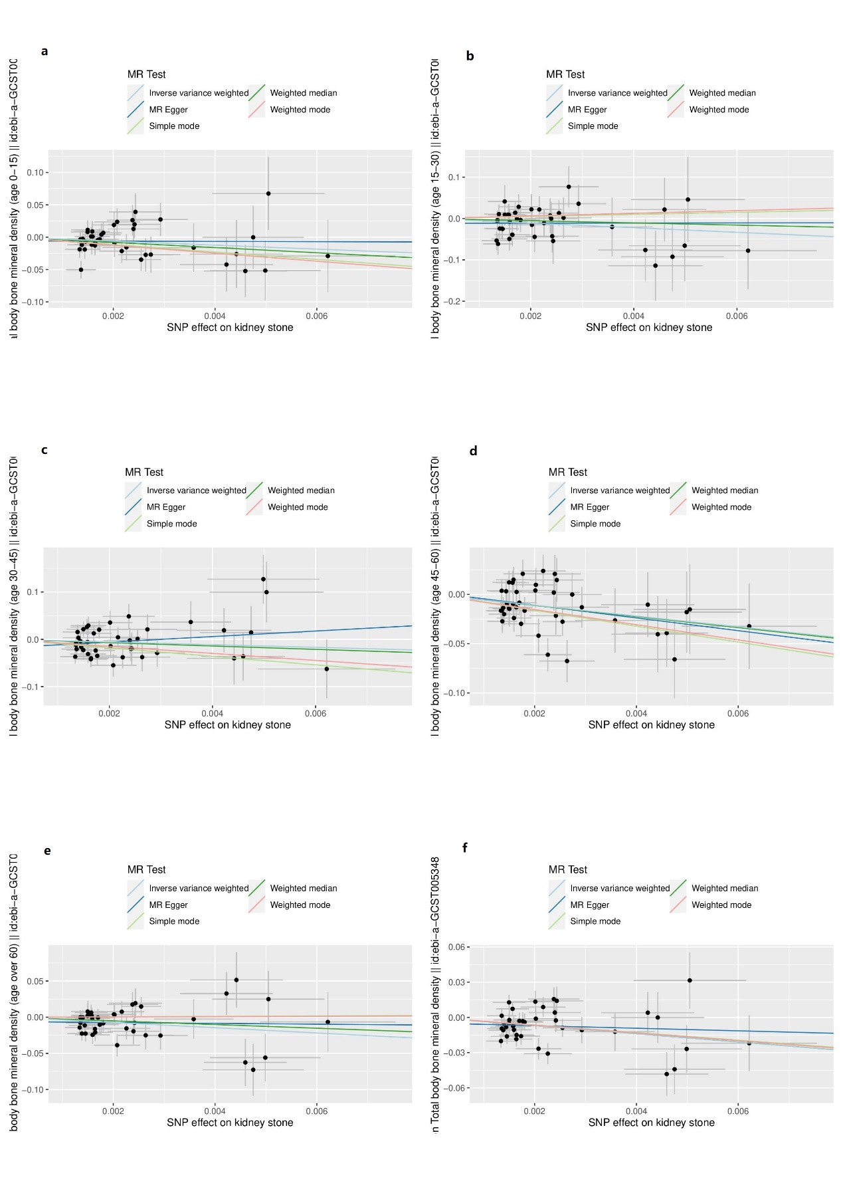
(a)age0-15 (b)age15-30 (c)age 30-45 (d)age45-60 (e) age over60 (f)all age

Supplementary Figure S4: Plots of “leave-one-out” analyses for MR analyses of causal link of kidney stone on BMDs at multiple sites.
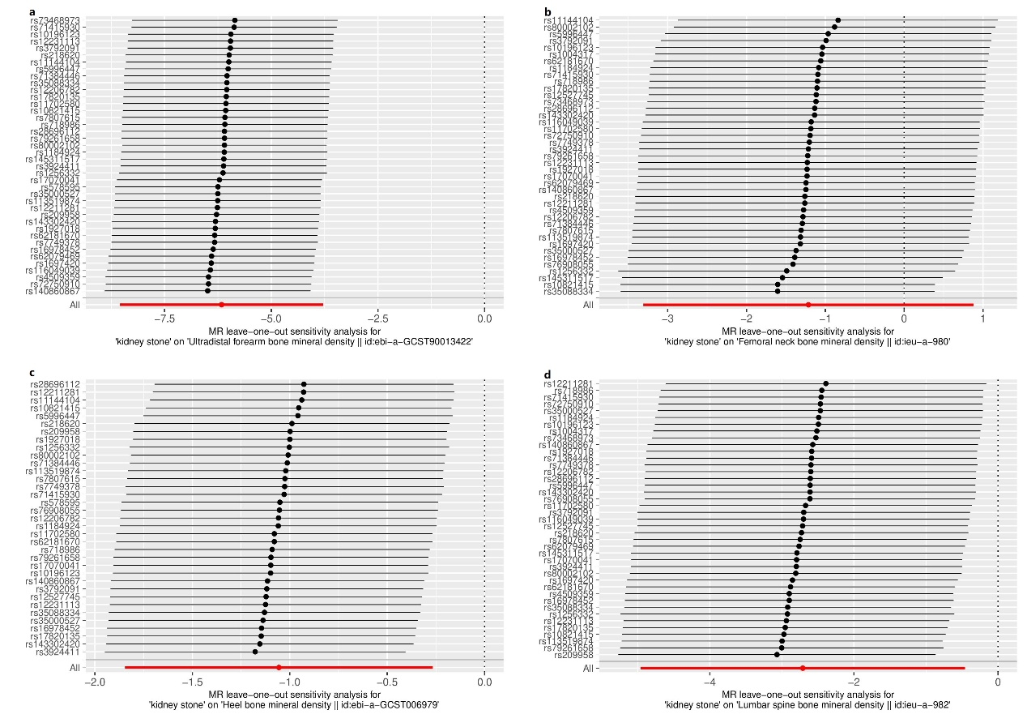

The black straight line represents each SNP beta values after leave-one-out. The red straight line represents all beta values after leave-one-out. (a)FA-BMD (b)FN-BMD (c)H-BMD (d)LS-BMD

Supplementary Figure S5: Forest plot for MR analyses of causal link of kidney stone on BMDs at multiple sites.
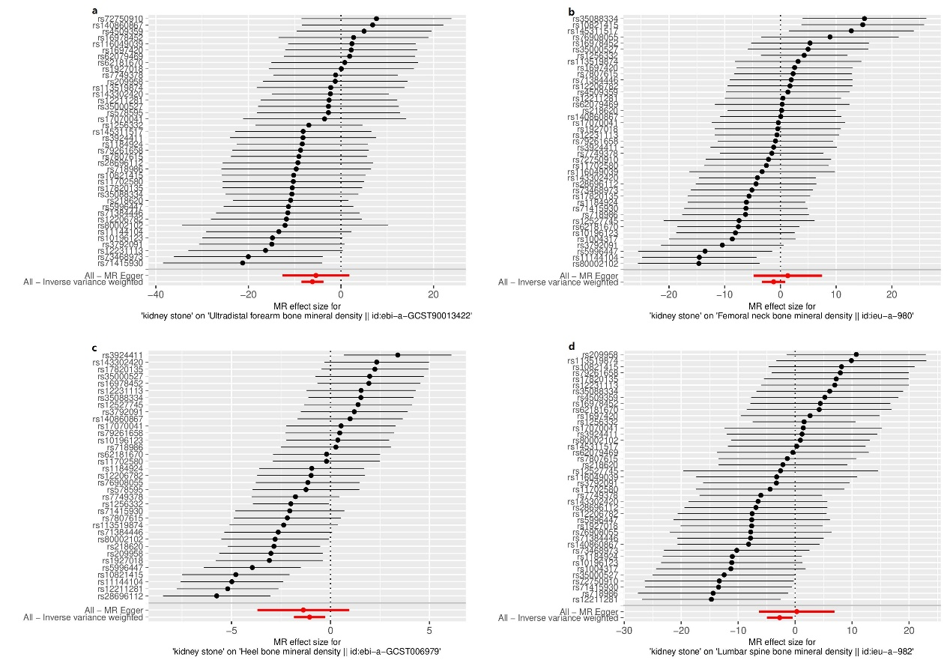
(a)FA-BMD (b)FN-BMD (c)H-BMD (d)LS-BMD

Supplementary Figure S3: Plots of MR estimates of the causal link between kidney stone on BMDs at multiple sites.
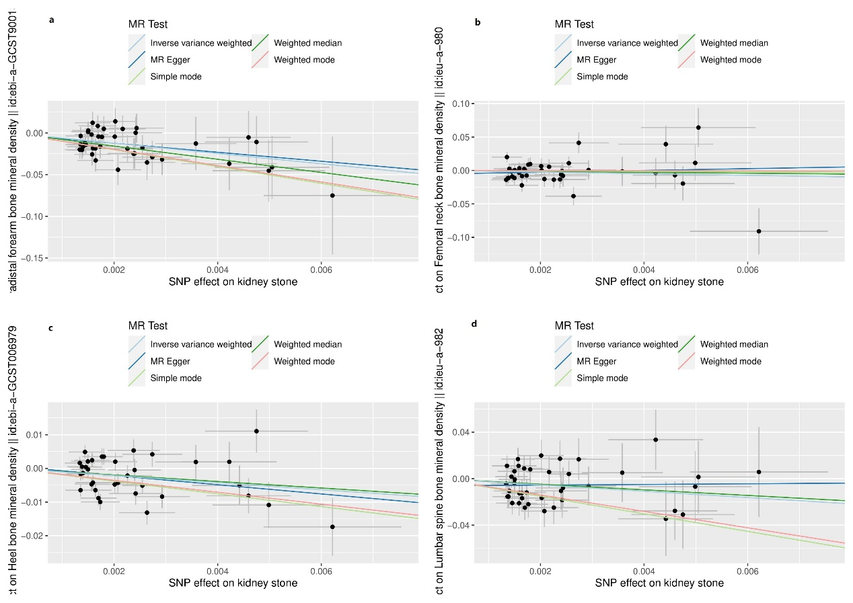

(a)FA-BMD (b)FN-BMD (c)H-BMD (d)LS-BMD

