Supplementary Materials2
The supplementary materials include:
- Figures and legends
- Tables. S1 to S4

1.Figures and legends
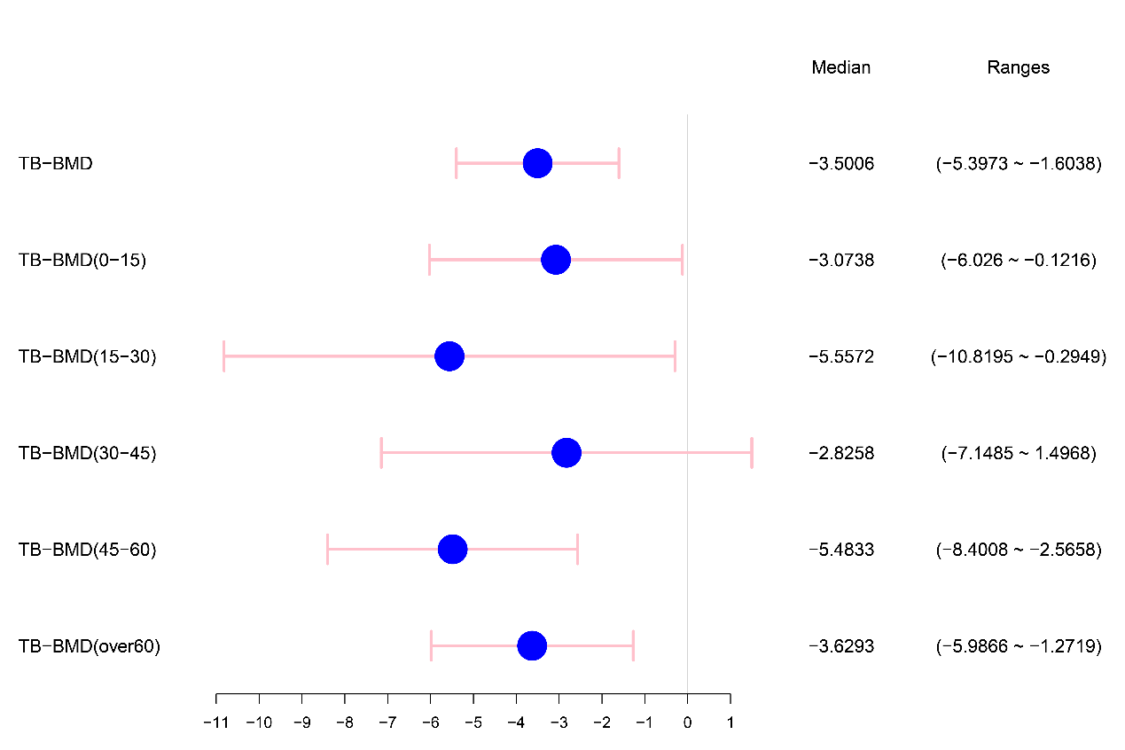
Figure 1. Causal impact of genetically predicted the total-body bone mineral density at multiple ages using genome-wide significant SNPs on the kidney stone disease. Forest plot depicting the effect using inverse-variance weighted Mendelian randomization.

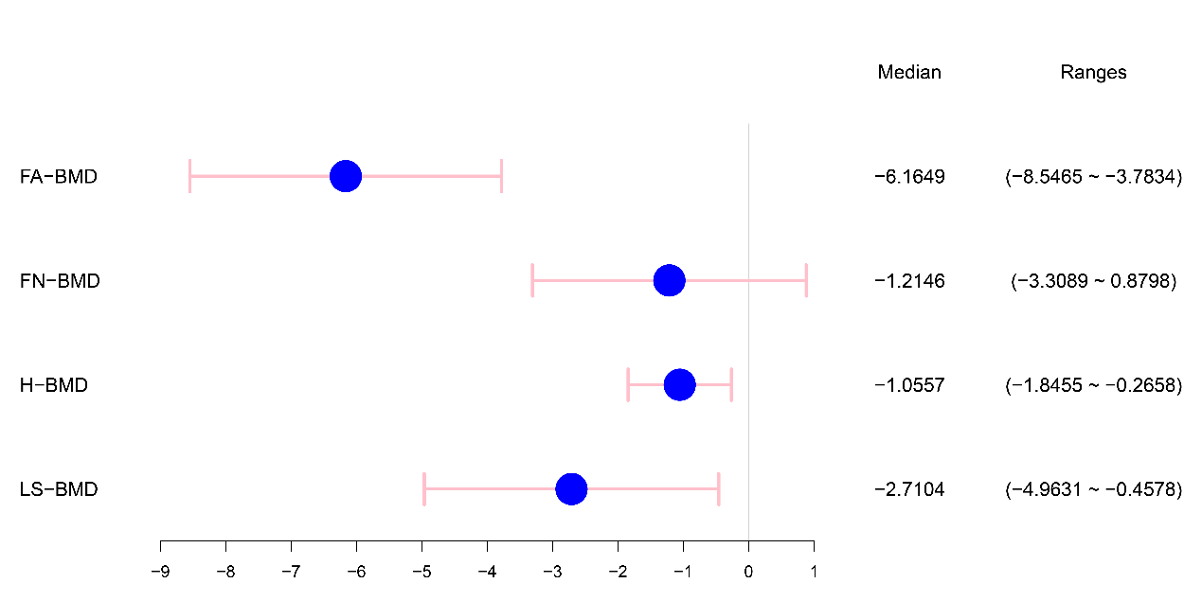
Figure 2. Causal impact of genetically predicted the bone mineral density in multiple areas using genome-wide significant SNPs on the kidney stone disease. Forest plot depicting the effect using inverse-variance weighted Mendelian randomization.

2. Tables. S1 to S4
Table S1 Relationship between kidney stones and total-body bone mineral density by age stratification
 | Numberof SNPs | IVW |  |  | MR Egger |  |  | Weighted Median |  |  | Simple Mode |  |  | Weighted Mode
 | Numberof SNPs | Beta | Se | P | Beta | Se | P | Beta | Se | P | Beta | Se | P | Beta | Se | P
KS-TB-BMD | 39 | -3.5006 | 0.9677 | 0.0003 | -1.0983 | 2.8534 | 0.7025 | -3.4930 | 1.0581 | 0.0010 | -3.2299 | 2.6429 | 0.2292 | -3.3070 | 2.4064 | 0.1774
KS-TB-BMD(0-15) | 41 | -3.0738 | 1.5062 | 0.0413 | -0.1901 | 4.4761 | 0.9663 | -4.0157 | 2.1784 | 0.0653 | -5.7318 | 4.7575 | 0.2354 | -6.1895 | 4.5739 | 0.1836
KS-TB-BMD(15-30) | 41 | -5.5572 | 2.6848 | 0.0385 | 0.1522 | 7.9560 | 0.9848 | -2.6549 | 3.8599 | 0.4916 | 2.4997 | 8.4608 | 0.7692 | 3.1773 | 7.5449 | 0.6759
KS-TB-BMD(30-45) | 41 | -2.8258 | 2.2054 | 0.2001 | 5.8402 | 6.4341 | 0.3696 | -3.5368 | 2.7136 | 0.1925 | -8.9893 | 6.7045 | 0.1876 | -7.4351 | 5.7942 | 0.2068
KS-TB-BMD(45-60) | 42 | -5.4833 | 1.4885 | 0.0002 | -6.4637 | 4.4363 | 0.1529 | -5.6153 | 1.9138 | 0.0033 | -8.0653 | 4.3277 | 0.0695 | -7.6920 | 4.1646 | 0.0720
KS-TB-BMD(>60) | 41 | -3.6293 | 1.2027 | 0.0025 | -0.5760 | 3.5396 | 0.8716 | 0.1961 | 4.0635 | 0.9618 | 0.2945 | 4.1479 | 0.9438 | -2.5392 | 1.7841 | 0.1547

Table S2 Relationship between renal calculi and bone mineral density at various sites
 | Numberof SNPs | IVW |  |  | MR Egger |  |  | Weighted Median |  |  | Simple Mode |  |  | Weighted Mode
 | Numberof SNPs | Beta | Se | P | Beta | Se | P | Beta | Se | P | Beta | Se | P | Beta | Se | P
KS-FA-BMD | 40 | -6.1649 | 1.2151 | <0.0001 | -5.4096 | 3.6884 | 0.0002 | 0.3764 | 1.7342 | <0.0001 | -10.0794 | 3.8022 | 0.0115 | -9.8018 | 3.8132 | 0.0141
KS-FN-BMD | 41 | -1.2146 | 1.0685 | 0.2557 | 1.3252 | 3.1404 | 0.4901 | 0.4979 | 1.2622 | 0.5891 | -0.3528 | 2.7235 | 0.8976 | -0.0875 | 2.4674 | 0.9719
KS-H-BMD | 35 | -1.0557 | 0.4030 | 0.0088 | -1.3722 | 1.1844 | 0.7559 | 0.4504 | 0.3895 | 0.0127 | -1.8912 | 1.2344 | 0.1348 | -1.7696 | 1.0155 | 0.0905
KS-LS-BMD | 41 | -2.7104 | 1.1493 | 0.0184 | 0.2833 | 3.3696 | 0.0071 | 0.1603 | 1.4878 | 0.1060 | -7.5650 | 4.0499 | 0.0691 | -7.0458 | 3.7821 | 0.0698

Table S3 Heterogeneity test and Pleiotropy test of renal calculi and bone mineral density at various ages
 | Number of SNPs | Heterogeneity  (IVW) | Pleiotropy  (MR Egger Regression.)
KS-TB-BMD | 39 | 0.0002 | 0.3764
KS-TB-BMD(0-15) | 41 | 0.4901 | 0.4979
KS-TB-BMD(15-30) | 41 | 0.7559 | 0.4504
KS-TB-BMD(30-45) | 41 | 0.0071 | 0.1603
KS-TB-BMD(45-60) | 42 | 0.0329 | 0.8154
KS-TB-BMD(>60) | 41 | 0.2876 | 0.3646

Table S4 Heterogeneity test and Pleiotropy test of renal calculi and bone mineral density at various sites
 | Number of SNPs | Heterogeneity  (IVW) | Pleiotropy  (MR Egger Regression.)
KS-FA-BMD | 40 | 0.8010 | 0.8295
KS-FN-BMD | 41 | 0.0187 | 0.3948
KS-H-BMD | 35 | 1.05E-09 | 0.7776
KS-LS-BMD | 41 | 0.0875 | 0.3503

