Graphical Abstract
Schematic presentation of experiments.
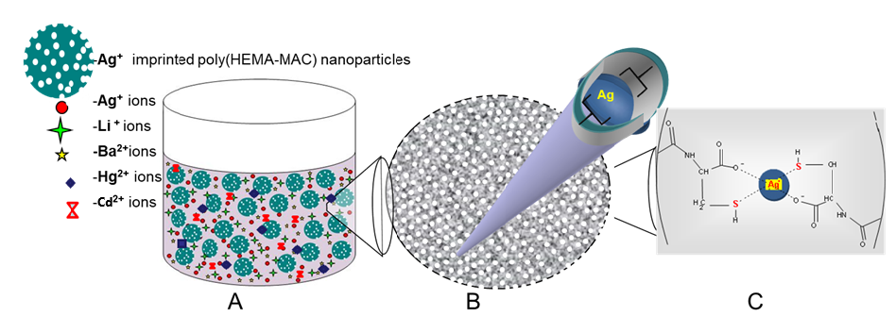 A) Ag⁺ binding medium, which contain competitive ions and Ag⁺ IIP nanoparticles
B) A single Ag⁺ imprinted nanoparticles with tailored cavities for Ag⁺ ions
C) Adsorption of Ag⁺ ion on the surface by forming compleks with sulfhydryl (-SH) groups

