Supplementary material\

Superior Sorption of Mn (VII) @ Functionalized Cellulose Nanocrystals Derived from Sustainable Newspapers

S-1. Physicochemical characterization of the prepared samples.
The functional groups, surface area, nanoscale structures, and morphology of MCNC adsorbent, were characterized by Fourier-transform infrared (FTIR, Bruker Vector 33 FTIR spectrometer), Brunauer-Emett-Teller (BET, NOVA, version 11.04, Quantachrome USA) and the total pore volume (Vtotal) was estimated from the amount of the adsorbed N2gas at P/P0, X–ray diffraction patterns (XRD, Philips APD–3720 diffractometer with Cu Kα radiation (40 kV, 40 mA), Transmission electron microscopy (TEM, JEOL-2100 PLUS) at 100 kV, N5 submicron particle size analyzer (PSA, Beckman Coulter, USA), and scanning electron microscopy (SEM, JSM-6700F, JEOL, Japan). PSA,
S-2. Batch adsorption studies.
The fabricated FCNC was tested as adsorbent for removal of Mn (VI) from simulated water using batch technique. A stock synthetic solution of 10000 mg/l of Mn (VII) was prepared by dissolving 28.76 g of KMnO₄ in 1 L of distilled water. The effect of pH was studied by varying the initial pH of the Mn (VII) solution within the range (2-9), using either HCl or NaOH. The batch adsorption experiments of Mn(VII) were performed by mixing a known metal concentration with predetermined mass of the FNCC in a 100 mL conical flask using orbital shaker (Yellow line, Germany). The resulting mixtures were centrifuged after sorption for 30 min at 12000 rpm (Centrifuge, Hettich, Model: EBA 200, Germany). The Mn (VII) concentrations in the supernatant were estimated using a single beam UV/Vis spectrophotometer (HACH DR 6000 Model) at wavelength 525 nm.
The percentage removal and the adsorption capacity of FCNC adsorbent were derived as:

$q=\frac{(C_{0}-C_{t})V}{W}$ (1)
$R\%=\frac{C_{0}-C_{t}}{C_{0}}×100$ (2)
Where C_{o} and C_{e} are the initial and equilibrium Mn (VII) concentration at time “t” (mg/L) respectively, while the mass of the adsorbent and volume of the Mn(VII) metal solution were denoted as “m” (g) and “V” (mL).
S-3. Computational analysis
Adsorption kinetics
The adsorption path and mechanism as well as the adsorption rate was analyzed and determined by applied the linear fitting of the pseudo-first-order (Eq:3), pseudo-second-order (Eq:4), intraparticle diffusion (Eq:5), and Boyd model (Eq. 6 and 7) for the experimental data evaluation.
(3)
(4)
$q_{t}=K_{p}t^{0.5}+C$ (5)
$$F=1-\frac{6}{π^{2}}\sum_{n=1}^{∞}{\frac{1}{n^{2}}\exp\left(-n^{2 }Bt\right)} (6)$$
$Bt={\left(\sqrt{π}- \sqrt{π-\left(\frac{π^{2}F}{3}\right)}\right)}^{2}$ For F < 0.85 (7)
$Bt= -0.498-\ln\left(1-F\right)$ For F > 0.85 (8)

where qt and qe indicates the adsorbed quantity of Mn(VII) at time “t” and the adsorbed quantity of at equilibrium respectively. k₁(min⁻¹), k₂ (mg/g.min), and k_{p} (mg/g.min^{0.5}) denotes the constant rates for pseudo-first order, pseudo-second order and intraparticle diffusion models. C refers to the thickness of boundary layer (mg/g). F is the fraction of Mn(VII) adsorbed at any time (F = qt/qe).
Adsorption isotherm
The equilibrium investigation was applied to indicate the interaction between the adsorbed metal ions and the used adsorbent by fitting the experimental equilibrium data to the linearized forms of Langmuir and Freundlich isotherm models:
$$\frac{C_{e}}{q_{e}}=\frac{1}{q_{max}K_{L}}+\frac{C_{e}}{q_{max}}$$ | (9)
 | (10)
where Ce(mg/L) indicates the Mn(VII) concentration at equilibrium, q_{e} is the sorption capacity of Mn(VII) at equilibrium (mg/g), q_{m} refers to the maximum monolayer coverage of Mn(VII) on the adsorbent surface (mg/g). K_{L}(L.mg⁻¹) and K_{F}(mg/g) is the Langmuir and Freundlich constant and nF denoting the heterogeneity of adsorption process onto the FNCC adsorbent. On the other hand, the dimensionless separation factor (R_{L}) which outlines the fundamental characteristics of the Langmuir isotherm can be expressed by the following expression:
(11)
Adsorption thermodynamics
The nature, spontaneity, and interior energy change of the adsorption of Mn(VII) onto FNCC surface was determined by the evaluation of the thermodynamic parameters including the Gibbs free energy (△G, kJ/mol), enthalpy (△H, J mol⁻¹), entropy (△S, J K⁻¹mol⁻¹) and the activation energy (E_{a}) by Van’t Hoff expression as shown in Eqs.(15) and (16) respectively:
$\ln{K_{D}}=-\frac{∆H}{RT}+ \frac{∆S}{R}$ (12)
$ΔG=∆H-T∆S$ (13)
Where K_{D} (K_{D} = q_{e}/C_{e}) is the thermodynamic constant, R is the universal gas constant (8.314 JK⁻¹mol⁻¹), and T is the adsorption temperature in K. The values of △H and △S was determines from the slope and intercept of a linear plot of In q_{e}/C_{e} against1/T.
S-4. Reusability investigation
Adsorption/desorption experiments of Mn (VII) were conducted at 25 ºC using 100 mL of NaOH (0.5 M) as an adsorbing agent. An orbital shaker was used to agitate a FCNC loaded with Mn (VII) at 150 rpm for 60 min. The regeneration round was repeated six times. After each adsorption cycle, the loaded FCNC was washed several times by distilled water and then dried at for 12 h 70 ◦C before the subsequent desorption cycle.

Table S1. Box-Behnken factorial design of experiments with five significant operational factors for optimization of Mn (VII) removal amount (mg/g) using FCNC.

Trail | pH | Initial metal concentration (mg/L) | Adsorbent dose  (mg) | Contact time  (min) | Temperature  (C°) | q (mg/g)
 |  |  |  |  |  | Measured | Predicted
1 | 5 | 150 | 6 | 2 | 35 | 625 | 700.182
2 | 5 | 100 | 2 | 30 | 15 | 1250 | 1251.995
3 | 2 | 100 | 6 | 30 | 15 | 417 | 427.988
4 | 5 | 100 | 6 | 30 | 35 | 417 | 422.155
5 | 2 | 100 | 12 | 30 | 35 | 208 | 198.496
6 | 5 | 100 | 6 | 30 | 35 | 417 | 422.155
7 | 5 | 100 | 6 | 30 | 35 | 417 | 422.155
8 | 5 | 25 | 12 | 30 | 35 | 52 | 226.165
9 | 5 | 100 | 2 | 2 | 35 | 1250 | 1244.515
10 | 5 | 100 | 12 | 30 | 15 | 208 | 213.395
11 | 8 | 150 | 6 | 30 | 35 | 625 | 694.352
12 | 5 | 150 | 6 | 90 | 35 | 625 | 668.225
13 | 5 | 100 | 6 | 90 | 55 | 417 | 428.035
14 | 8 | 100 | 2 | 30 | 35 | 1250 | 1247.204
15 | 5 | 100 | 12 | 90 | 35 | 208 | 205.915
16 | 5 | 150 | 12 | 30 | 35 | 313 | 195.665
17 | 5 | 25 | 6 | 90 | 35 | 104 | 59.725
18 | 8 | 100 | 6 | 90 | 35 | 417 | 468.652
19 | 2 | 100 | 6 | 2 | 35 | 417 | 436.516
20 | 5 | 100 | 6 | 30 | 35 | 417 | 422.155
21 | 8 | 25 | 6 | 30 | 35 | 104 | 31.477
22 | 5 | 100 | 2 | 90 | 35 | 1250 | 1240.115
23 | 5 | 100 | 2 | 30 | 55 | 1250 | 1250.235
24 | 8 | 100 | 12 | 30 | 35 | 208 | 206.224
25 | 8 | 100 | 6 | 30 | 15 | 417 | 430.892
26 | 8 | 100 | 6 | 2 | 35 | 417 | 405.292
27 | 5 | 100 | 6 | 90 | 15 | 417 | 430.115
28 | 2 | 25 | 6 | 30 | 35 | 104 | 23.623
29 | 2 | 100 | 2 | 30 | 35 | 1250 | 1235.516
30 | 5 | 100 | 6 | 2 | 55 | 417 | 429.619
31 | 5 | 150 | 6 | 30 | 15 | 625 | 699.345
32 | 5 | 25 | 6 | 30 | 55 | 104 | 36.265
33 | 5 | 100 | 6 | 2 | 15 | 417 | 431.699
34 | 5 | 100 | 12 | 2 | 35 | 208 | 203.275
35 | 5 | 100 | 6 | 30 | 35 | 417 | 422.155
36 | 5 | 150 | 2 | 30 | 35 | 1875 | 1695.665
37 | 5 | 25 | 6 | 2 | 35 | 104 | 15.109
38 | 2 | 100 | 6 | 90 | 35 | 303.8 | 369.988
39 | 2 | 100 | 6 | 30 | 55 | 417 | 418.708
40 | 5 | 25 | 6 | 30 | 15 | 108 | 38.345
41 | 5 | 100 | 6 | 30 | 35 | 417 | 422.155
42 | 5 | 25 | 2 | 30 | 35 | 313 | 573.665
43 | 5 | 100 | 12 | 30 | 55 | 208 | 210.835
44 | 2 | 100 | 6 | 30 | 55 | 417 | 418.708
45 | 2 | 150 | 6 | 30 | 35 | 625 | 682.748
46 | 5 | 150 | 6 | 30 | 55 | 625 | 697.265

Table S2. ANOVA results for the adsorption of Mn (VII)
Source | Sum of Square | df | Mean of Square | F-Value | p-Value | Significant or  insignificant  model terms
Model | 5012661 | 5 | 1002532 | 18.04359 | 0.000000 | Significant
A | 2907 | 1 | 2907 | 0.3503 | 0.559273
B | 797902 | 1 | 797902 | 96.1380 | 0.000000 | Significant
C | 2513207 | 1 | 2513207 | 302.8124 | 0.000000 | Significant
D | 165 | 1 | 165 | 0.0199 | 0.889053
E | 3 | 1 | 3 | 0.0004 | 0.985143
A² | 2143.7 | 1 | 2143.7 | 0.44681 | 0.551688
B² | 3600.0 | 1 | 3600.0 | 0.75033 | 0.450096
C² | 3306.3 | 1 | 3306.3 | 0.68910 | 0.467357
D² | 7225.0 | 1 | 7225.0 | 1.50586 | 0.307288
E² | 530 | 1 | 530 | 0.0639 | 0.802575
AB | 4 | 1 | 4 | 0.0005 | 0.982665
AC | 4 | 1 | 4 | 0.0005 | 0.982665
AD | 4615 | 1 | 4615 | 0.5560 | 0.462831
AE | 41 | 1 | 41 | 0.0050 | 0.944238
BC | 351704 | 1 | 351704 | 42.3762 | 0.000001
BD | 2264 | 1 | 2264 | 0.2728 | 0.606055
BE | 7 | 1 | 7 | 0.0009 | 0.976518
CD | 14 | 1 | 14 | 0.0017 | 0.967831
CE | 0 | 1 | 0 | 0.0000 | 0.996807
DE | 0 | 1 | 0 | 0.0000 | 0.994498
Error | 207489 | 25 | 8300
Total SS | 7235128 | 45

Table S3. Parameter of selected quadratic model for the adsorption of Mn(VII)

Std. dev. | 400.97 | R-squared (r2) | 0.971
Mean | 501.54 | Adjusted R-Squared | 0.948
C. V. % | 79.95 | Predicted R-Squared | 0.899
PRESS | 503586.96 | Adequate Precision | 5.15

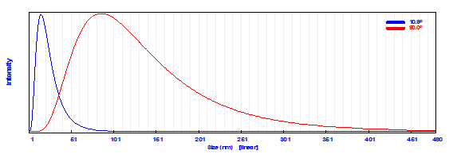
Figure S1: PSA of FCNC.

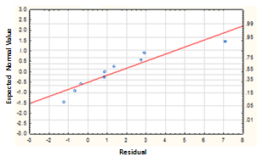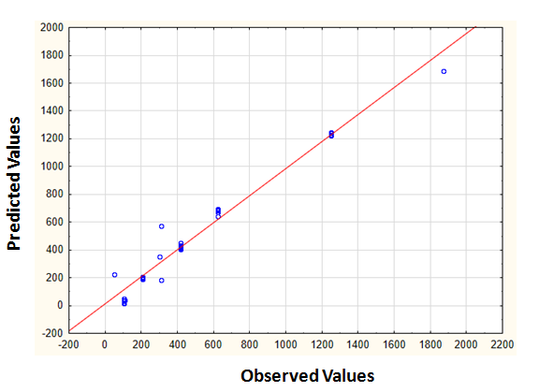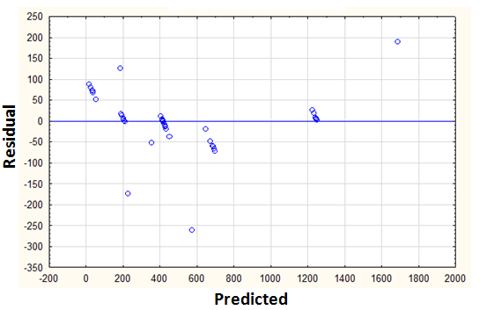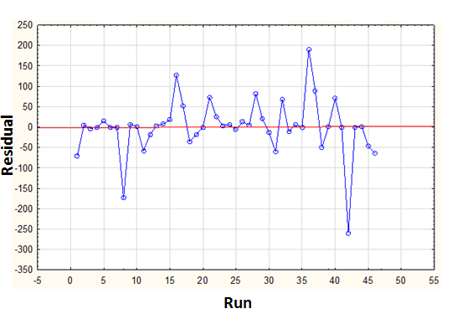
a
d
b
c

Figure S2: Distributive plotting of experimental data against the predicted values for Mn (VII) removal amount: (a) Normal plot of residual, (b) Observed vs. predicted values, (c) Residual vs. predicted values, and (d) Residual vs. run.

