Appendix

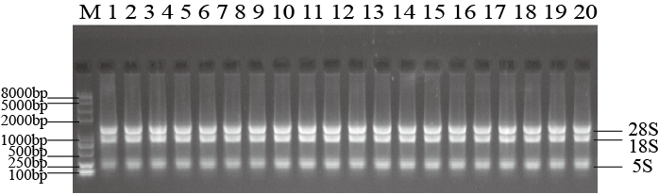
Appendix A: H. radicata RNA 1.5% Agarose gel electrophoresis. M: Trans2K® Plus II DNA Marker; 1: CK; 2-3: heat stress; 4-7: salt stress; 8-9: pH stress; 10-11: oxidative stress; 12-13: cadmium stress; 14-17: drought stress; 18-20: different tissue.

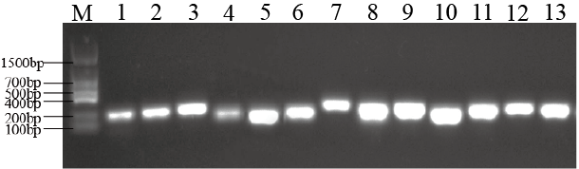

Appendix B: Agarose gel electrophoresis analysis of primer specificity. M: Trans DNA Marker Ⅱ; 1: RPL6; 2: ACT; 3: PP2A; 4: TUA; 5: UBQ10; 6: TUB; 7: RPB2; 8: CYP; 9: EF; 10: UBC; 11: GAPDH; 12: HSP70; 13: hyd1

