Supplementary Appendix

SGLT-2 inhibitors in patients with heart failure and a preserved ejection fraction: a systematic review and meta-analysis of five randomized controlled trials

Search strings/MesH terms

Pubmed Search:
(("heart failure"[MeSH]) OR (((cardiac failure) OR (Heart Decompensation)) OR (HF))) AND (("Sodium-Glucose Transporter 2 Inhibitors"[MeSH]) OR ((((((((((SGLT2 inhibitors) OR (canagliflozin)) OR (dapagliflozin)) OR (empagliflozin)) OR (ertugliflozin)) OR (sotagliflozin)) OR (ipragliflozin)) OR (remogliflozin)) OR (sergliflozin)) OR (tofogliflozin)))Filters: Randomized Controlled Trial

Risk of bias table

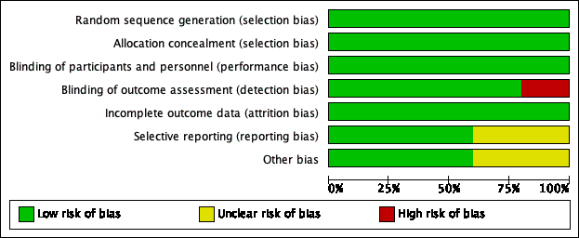
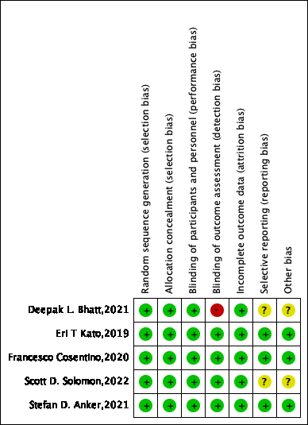
Characteristics of included trials
Trial | Author | Year | Country | SGLT2 inhibitor tested | Sample | EF at baseline | Median follow-up | Diabetes mellitus (DM) status of participants | Renal function at baseline | Primary outcome
EMPEROR-Preserved | Stefan D. Anker | 2021 | international;  multicenter | Empagliflozin | 5988 | EF≧40%;  IG=54.3±8.8;  CG=54.3±8.8 | 26.2 months | DM ＋ non-DM | IG=60.6±19.8mL/min/1.73 m2;  CG=60.6±19.9mL/min/1.73 m2 | a composite of adjudicated cardiovascular death or hospitalization for heart failure
DELIVER | Scott D. Solomon | 2022 | international;  multicenter | Dapagliflozin | 6263 | EF≥40%;  IG=54.0±8.6;  CG=54.3±8.9 | 2.3 years | DM ＋ non-DM | IG=61±19mL/min/1.73 m2;  CG=61±19mL/min/1.73 m2 | a composite of  worsening heart failure, which was defined as  either an unplanned hospitalization for heart  failure or an urgent visit for heart failure, or  cardiovascular death.
VERTIS CV | Francesco Cosentino | 2020 | multicenter | Ertugliflozin | 1007 | EF >45%; | 3.0 years | DM | eGFR <60 and >_60 mL/min/1.73 m2 | the time to first major adverse cardiovascular event
DECLARE-TIMI 58 | Eri T Kato | 2019 | multicenter | Dapagliflozin | 808 | EF >45%; | 4.2 years | DM | eGFR >60 mL/min/1.73 m2 | the dual primary composite end point of the trial of cardiovascular death or HHF, its individual components, and all-cause mortality (ACM).
SCORED | Deepak L. Bhatt | 2021 | multicenter | Sotagliflozin | 1667 | EF ≥50% | 16 months | DM | eGFR 25–60 mL/min/1.73 m2 | the composite of the total number of deaths from cardiovascular causes, hospitalizations for heart failure, and urgent visits for heart failure.

Search strategy and source of included studies
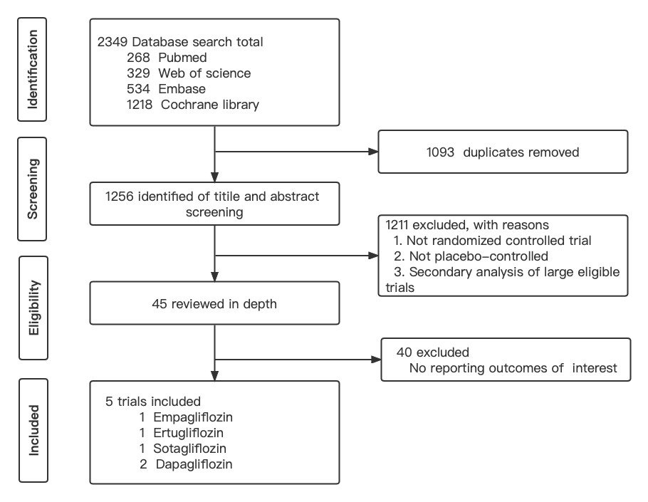

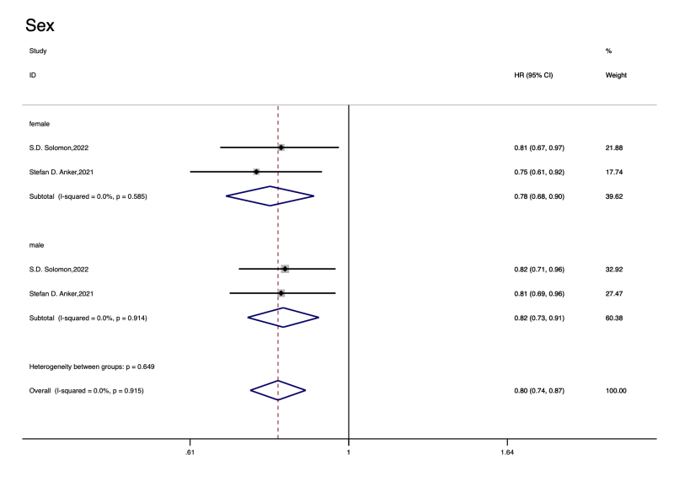
Subgroup analyses on the gender according to primary composite endpoint when analyzed by fixed effect
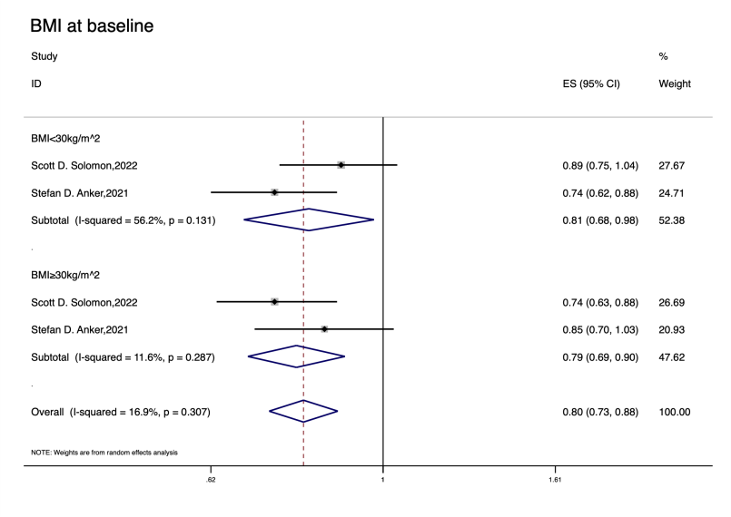
Subgroup analyses on the BMI according to primary composite endpoint when analyzed by random effect
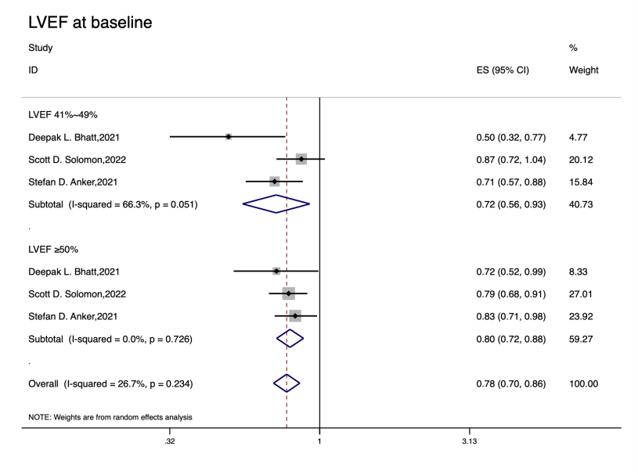
Subgroup analyses on the LVEF according to primary composite endpoint when analyzed by random effect

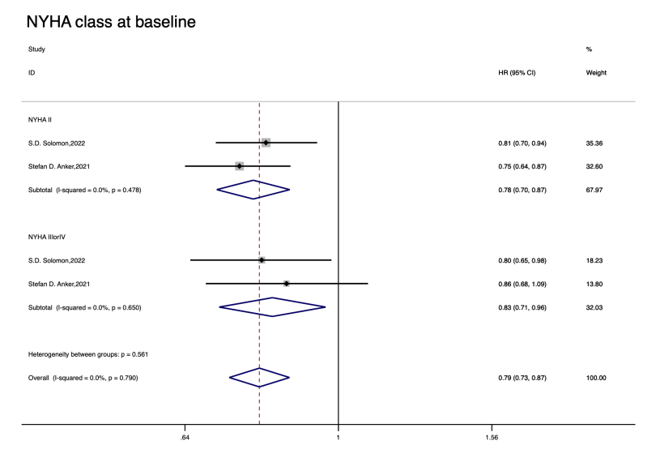
Subgroup analyses on the NYHA class according to primary composite endpoint when analyzed by fixed effect

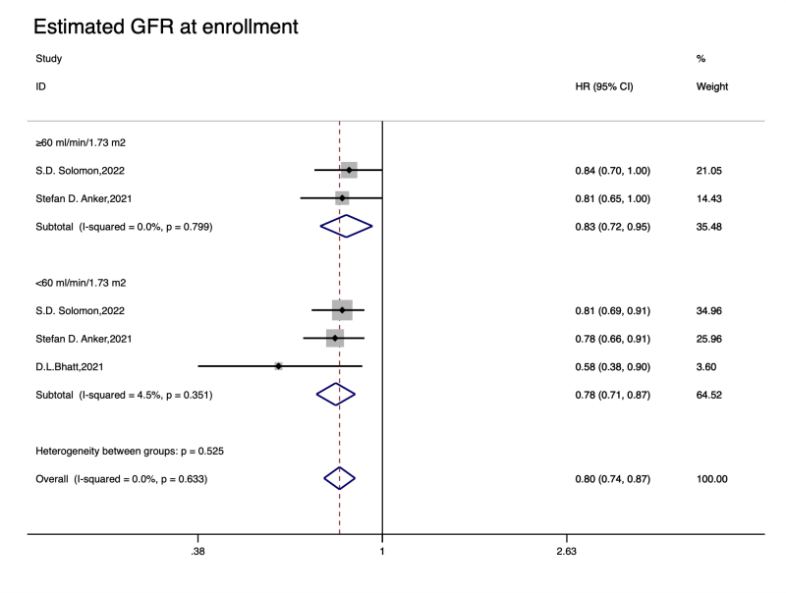
Subgroup analyses on the eGFR according to primary composite endpoint when analyzed by fixed effect
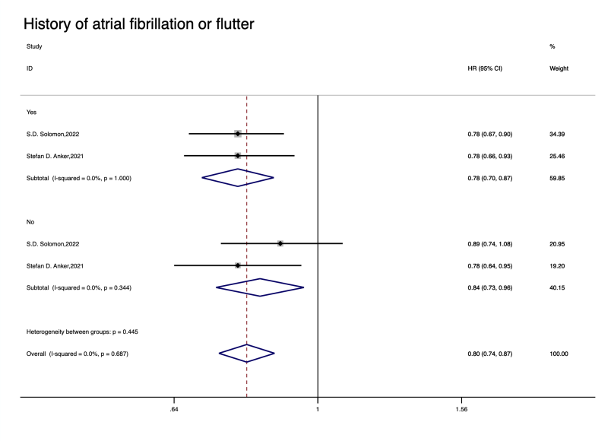
Subgroup analyses on the history of atrial fibrillation or atrial flutter according to primary composite endpoint when analyzed by fixed effect

