Figure S1. PIK3C3 gene expression level in 19 tumor tissues and normal tissues in GEO database.

Figure S2. Correlation between PIK3C3 promoter methylation and DSS in several patients.

Figure S3. Correlation between PIK3C3 promoter methylation and DFI in several patients.

Figure S4. Correlation between PIK3C3 promoter methylation and PFI in several patients.

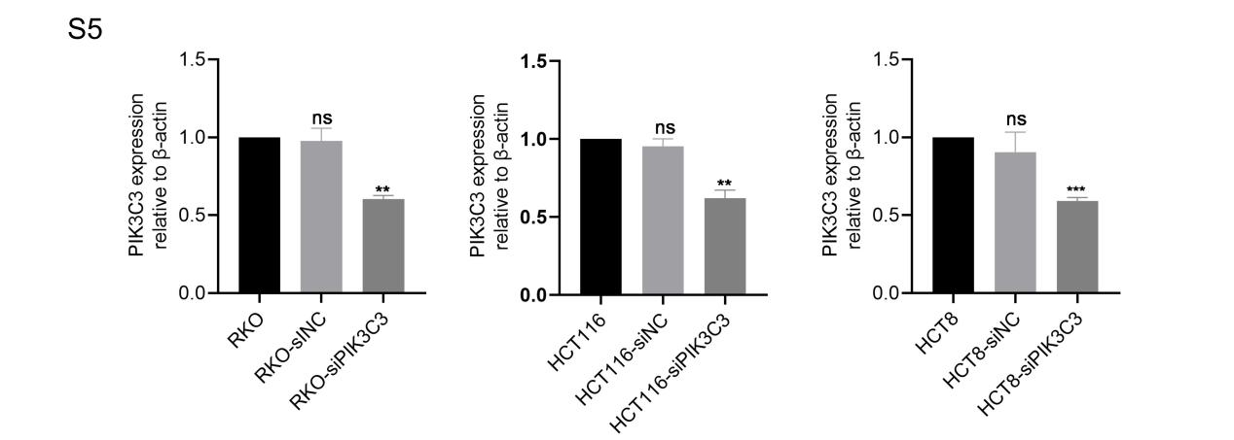
Figure S5. The average knockdown rate of PIK3C3 protein. **p < 0.01, and ***p < 0.001.

