Fig. S1 The FT-IR spectrum of [Zn(^{2Me}bpy)₃](ClO₄)₂.

Fig. S2 UV−Vis spectrum [Zn(^{2Me}bpy)₃](ClO₄)₂ in H₂O/DMSO, [complex] = 40 µM. Inset: Time-dependent stability studies of the complex in H₂O/DMSO during 1 week.

Fig. S3 Plots of viability (%) vs. concentration of the the ZnCl₂ and ^{2Me}bpy ligand (µM) against MCF˗7 after 48 h (n = 3).

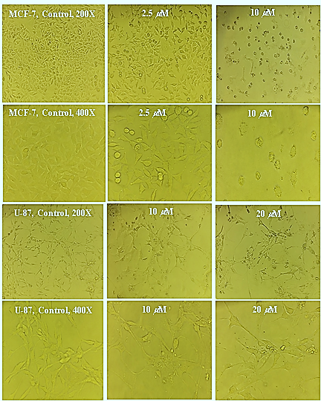
Fig. S4 Morphological changes of MCF˗7 and U˗87MG cells at magnifications of 200X and 400X after 48 h treatment by the indicated concentrations of the complex (the number inside each photo).

