Supplemental file
Title: Improvement of multilineage hematopoiesis in hematopoietic stem cell-transferred c-kit mutant NOG-EXL humanized mice

Authors
Ryoji Ito,^{1*} Yusuke Ohno,¹ Yunmei Mu,^{1,2} Yuyo Ka,¹ Shuko Ito,¹ Maiko Emi-Sugie,¹ Misa Mochizuki¹, Kenji Kawai¹, Motohito Goto,¹ Tomoyuki Ogura,¹ Riichi Takahashi,¹ Akira Niwa,³ Tatsutoshi Nakahata,¹ Mamoru Ito¹

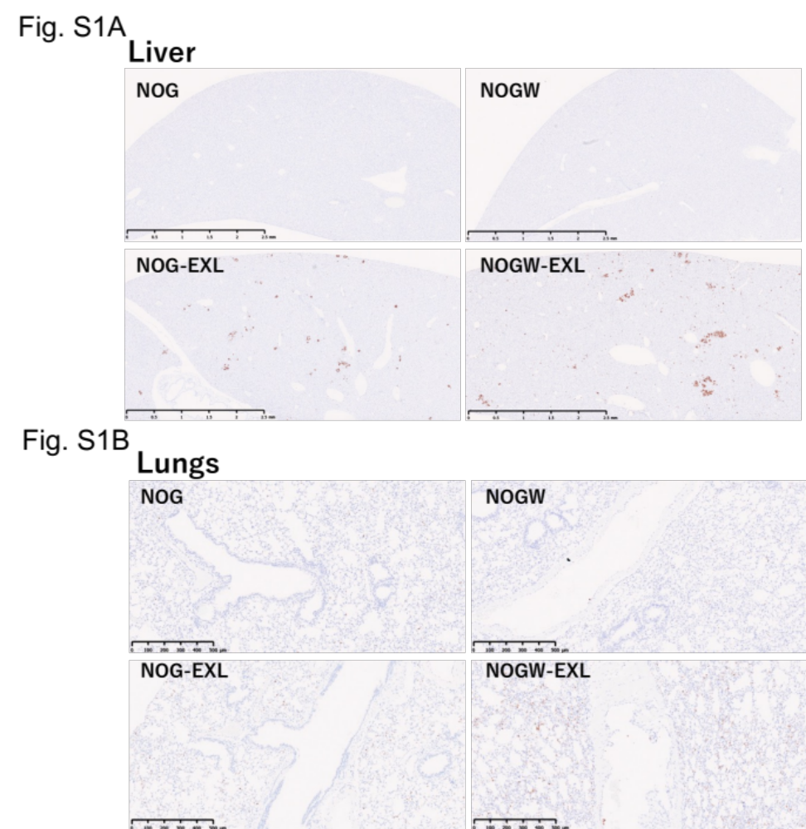
Figure S1. Tissue-resident human macrophages in humanized mice
Immunohistochemistry images of human CD68⁺ macrophages in the liver (A) and lungs (B) of humanized NOG, NOG-EXL, NOGW, and NOGW-EXL mice 20 weeks after HSC transplantation. Images are representative of three independent experiments.

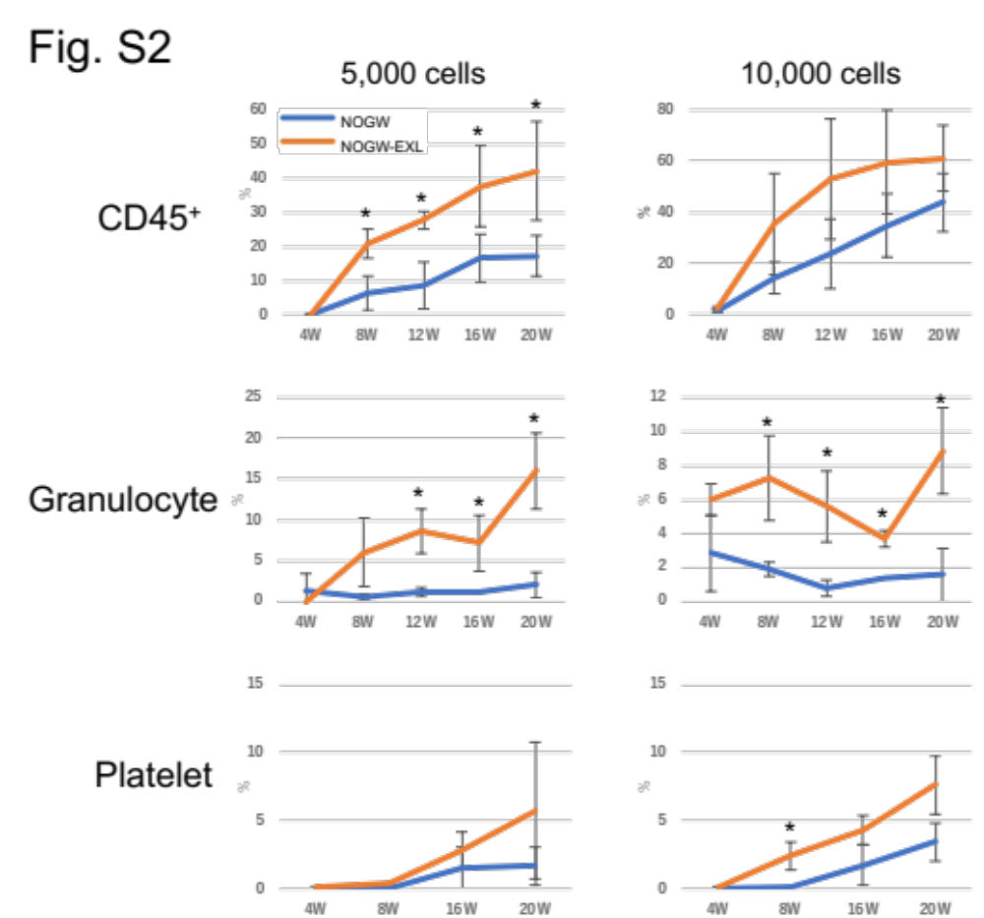
Figure S2. HSC limiting dilution assay in NOGW-EXL mice
Frequencies of human CD45⁺ cells, CD66b⁺ granulocytes, and CD41⁺ platelets in the PB of humanized NOGW and NOGW-EXL mice 4–20 weeks after transplantation of 5,000 or 10,000 HSCs (n = 5). *p < 0.05.

