Supporting Information

Unveiling cell metabolic bioprocess of programmed cell death ligand 1 (PD-L1) expression through nutrients-driven cancer immunomarker progression using SERS technique
Muhammad Muhammad ^{a,b}, Chang-Sheng Shao ^{a,c}, Mona Alrasheed Bashir ^{a,d}, Yahui Wu ^{a,d}, Jie Zhan ^{b}, Leisheng Zhang^{a, e *}, Qing Huang ^{a,d*}
ª CAS Key Laboratory of Ion-beam Bioengineering, Institute of Intelligent Machines, Hefei Institutes of Physical Science, Chinese Academy of Sciences, Hefei 230031, China
^{b} CAS Key Laboratory of Atmospheric Optics, Anhui Institute of Optics and Fine Mechanics, Chinese Academy of Sciences, Hefei 230031, China
^{c} CAS High Magnetic Field Laboratory, Hefei Institutes of Physical Science, Chinese Academy of Sciences, Hefei 230031, China
^{d} Science Island Branch of Graduate School, University of Science and Technology of China, Hefei 230026, China
^{e} NHC Key Laboratory of Diagnosis and Therapy of Gastrointestinal Tumor & Key Laboratory of Molecular Diagnostics and Precision Medicine for Surgical Oncology, Gansu Provincial Hospital, Lanzhou 730000, China

* Corresponding authors:
Prof. Qing Huang, huangq@ipp.ac.cn, ORCID: 0000-0002-8884-2064
Prof. Leisheng Zhang, leisheng_zhang@163.com, ORCID: 0000-0001-6540-0943

Nanoparticle characterization
The DNA sequences were synthesized and supplied by Gene Universal Inc. (Delaware, USA). The verification of structural integrity and elemental distribution was conducted using High-Resolution Transmission Electron Microscopy (HR-TEM) with the FEI TECNAI G2 transmission electron microscope, as well as Field Emission Scanning Electron Microscopy (FE-SEM) using the Hitachi S4800 instrument. Light absorption spectroscopy analyses were carried out utilizing the SHIMADZU UV-2550 instrument.

PD-L1 aptamer modified Au/4-ATP/Ag nanotags
Nanotags were prepared and utilized according core/shell method¹. First, Au nanospheres were synthesized by reducing Au salt using citrate as reducing and surface stabilizing agent ². Next, the surface of Au nanospheres was functionalized with Raman reporter 4-ATP (0.01 M) via thiol-Au chemistry. The mixture was centrifuged twice and stored at 4 °C for 4-5 h. Ascorbic acid (0.1 M) was added to the mixture followed by dropwise addition of AgNO₃ (1 mM) to yield optimum light absorption band. The solution turned red to dark orange in 1 min which indicated the formation of Ag shell on 4-ATP modified Au nanospheres. The final product was washed twice with deionized water and stored at 4 °C for future use.
To prepare aptamer functionalized nanotags, PD-L1 aptamer was heat-treated at 95 ºC and desalted using the procedure reporter in our previous work¹. An equal volume of thiolated-PD-L1 aptamer and Au/4-ATP/Ag nanotags were mixed thoroughly with pipette and incubated at 4 °C for 10 h. The product was washed with water and dispersed in PBS. Next, MCH (10⁻⁷ M, 1:10 v/v) was added and incubated for 2 h at 4 °C. The nanotags were washed again with PBS and stored at 4 °C for future use.
Chemicals
Silver nitrate, tetrachloroauric acid (HAuCl₄.3H₂O), ethanol, mercaptoethanol, and methanol were purchased from Sinopharm Chemical Reagent Co. Ltd Shanghai, China. Trisodium citrate, 4-aminothiophenol, Tris (2-carboxyethyl) phosphine (TCEP), glucose, and ascorbic acid were obtained from Aladdin Biochemical Technology Co. Ltd Shanghai, China. The designed PD-L1 DNA aptamer sequences and modified sequences were provided by General Biosystems Inc. China. IL-6 and IFN-γ proteins were acquired from Sangon Biotech Co. Ltd Shanghai, China. PD-L1 antibodies were purchased from Β-Nicotinamide Adenine Dinucleotide Phosphate (NADPH) was obtained from Beyotime Biotechnology Shanghai, China. All the chemicals and DNA sequences were of HPLC grade and used without further purification. For chemical synthesis experiments, magnetic stirring bars ad glassware were cleaned by using aqua regia and ultra-pure water. Water purification was performed with Millipore water system (resistivity of 18.25 MΩ/cm).
Aptamer sequences
Table S1: List of the aptamer oligonucleotide sequences used in the experiments.
Target | Sequence
PD-L1 | 5’ –TTTTTTACG GGC CAC ATC AAC TCA TTG ATA GAC AAT GCG TCC ACT GCC CGT – 3’
Modified PD-L1 | 5’ – SH – TTTTTTTACG GGC CAC ATC AAC TCA TTG ATA GAC AAT GCG TC C ACT GCC CGT – 3’
Fluorescent labelling | 5’ – SH – Cy3- TTTTTTTACG GGC CAC ATC AAC TCA TTG ATA GAC AAT GCG TC C ACT GCC CGT – 3’

TEM images of Au/4-ATP/Ag nanotags
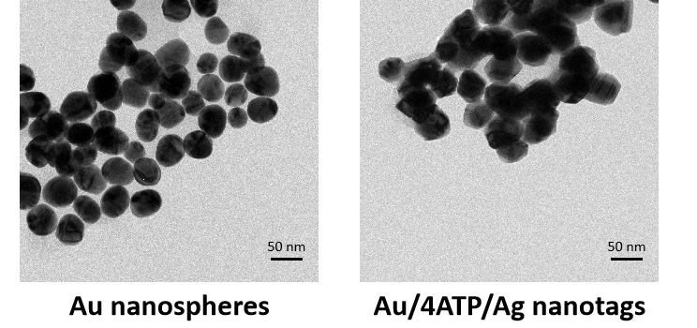
Figure S1: TEM images of the bare Au nanospheres (left panel) and Au/4-ATP/Ag nanotags (right panel).

Light absorption characterization of Au/4-ATP/Ag nanotags
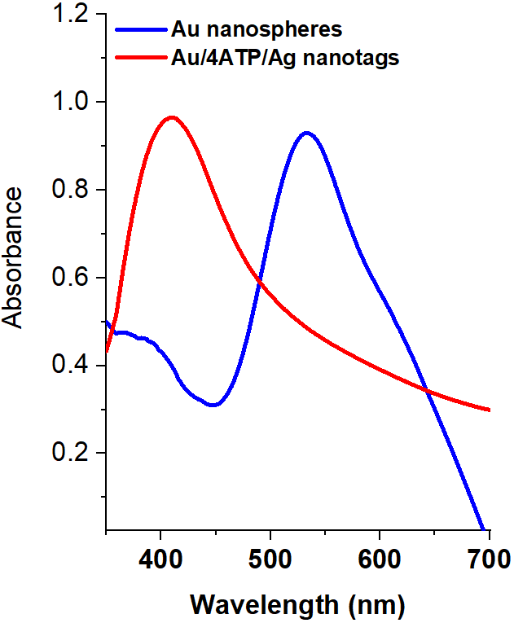
Figure S2: Light absorption spectroscopy profile of the Au nanospheres and Au/4-ATP/Ag nanotags obtained in visible region.

Spectral acquisition optimization
The integrity of Raman signals originated from SERS tags was investigated and optimized by changing the laser exposed power and signal accumulation time. The laser was operated at 5.7 mW (10% laser filter) and spectra (n=7) were acquired with 5 s of accumulation time. At the same point, the laser power was enhanced to 28.5 mW (50% laser filter) and then to 57 mW (100% laser filter) and spectra were acquired under the same conditions. According to the Figure S3A, no noise peak and sample burning was noticed which shows stability of nanotags at even high laser power. However, to acquire faster Raman images, we figured out the Raman signals at relatively smaller acquisition time (5 ms). At the same points, the spectra were acquired under the same laser conditions and noise-signal quality was assessed (Figure S3B). We noticed a relatively higher level of noise in each case especially when the laser was operated at 5.7 mW and 28.5 mW (Figure S3C). The acquired spectra were denoised using Periodic Wavelet Transform (PWT) algorithm and the transformed spectra in each case reduced the noise to a significant level (Figure S3C). It is to be noted that noise level was minimal when the laser was operated at 57 mW for 5 ms without causing any damage to the nanoprobes. Therefore, rest of the experiments were performed under the same laser conditions to yield maximum Raman output. The obtained mapping and point spectra were treated and represented as denoised images throughout the work.
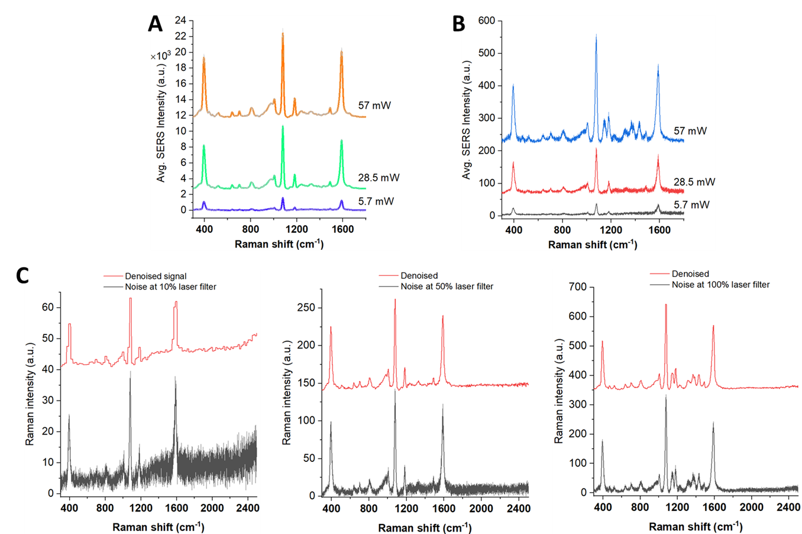
Figure S3: Optimization of laser power and acquisition time cell imaging experiments. (A) Average point spectra (n=7) obtained with 57 mW, 28.5 mW, and 5.7 mW power at the same point for 1 s. (B) Average point spectra (n=7) obtained with 57 mW, 28.5 mW, and 5.7 mW power at the same point for 0.005 s. (C) Signal denoising through Periodic Wavelet Tranform algorithm at different laser powers.
HeLa cells with Cy3-PD-L1 aptamer
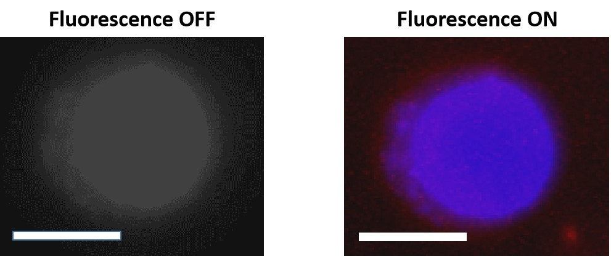
Figure S4: Fluorescence microscopy obtained image of single HeLa treated with cy-3 modified PD-L1 aptamer.
PCA biplot of time dependent PD-L1 elevation
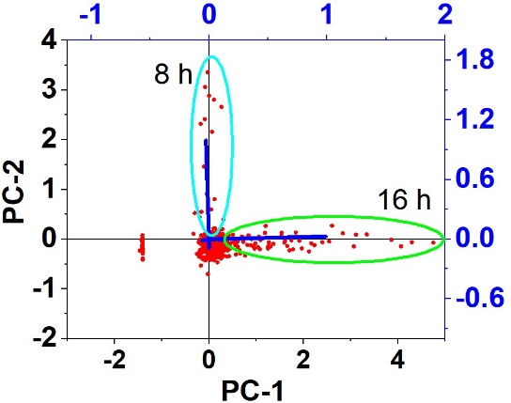
Figure S5: PCA biplot showing the difference in PD-L1 expression different more visible with 8 h and 16 h group treated with cytokine cocktail.
Time-dependent reversion of PD-L1 detected by SERS
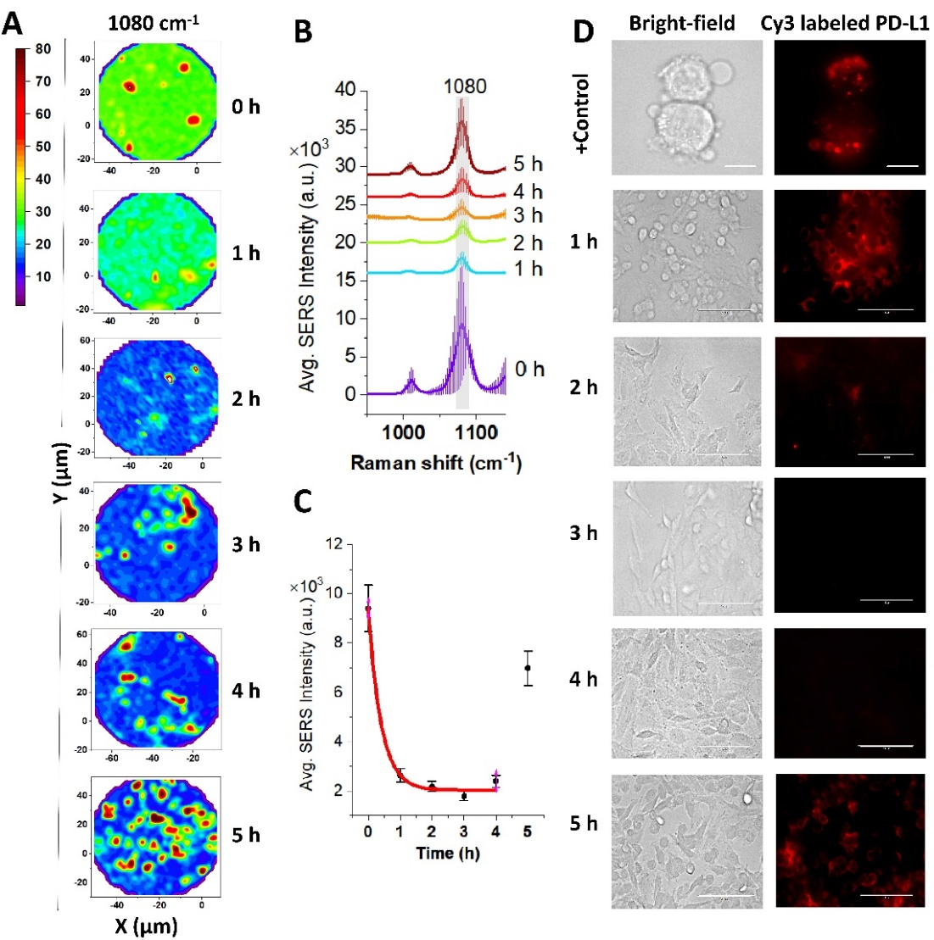
Figure S6. Dynamic reversion of PD-L1 expression in single HeLa cell with anti-PD-L1 mAbs treatment. (A) SERS images and (B) SERS spectra of 4-ATP reporter of single HeLa cell after treatment with cytokine cocktail (1 mg/mL IL-6 and 1 mg/mL IFN-γ) and/or anti-PD-L1 mAb (1:1500) at 37 ℃ at the indicated time points (0 h, 1 h, 2 h, 3 h, 4 h, 5 h). (C) Dynamic variations in SERS intensity of 4-ATP reporter after treatment of HeLa cells with anti-PD-L1 mAb (R² = 0.98). Shaded regions in spectra and error bars demonstrate the standard deviation (n=7). (D) Bright-field and fluorescence microscopy obtained dynamic PD-L1 expression in cells under anti-PD-L1 mAbs treatment. Positive-control images were obtained through 100× objective (scale bar: 10 μm), and time-lapse images were obtained through 20× objective (scale bar: 100 μm).
Bright-field images of HeLa cells under mAbs treatment
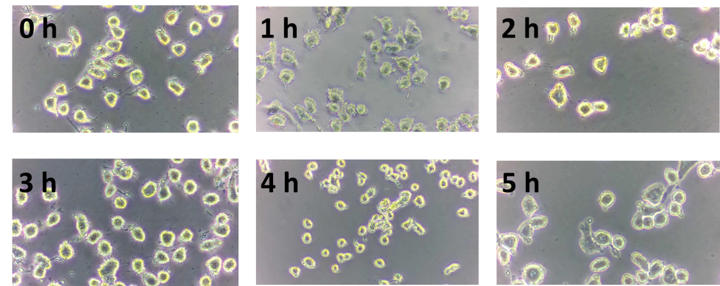
Figure S7: Bright-field HeLa cells images obtained after the treatment with anti PD-L1 mAbs for different times.
References
1. Muhammad, M., Shao, C.-S., Liu, C., Song, G., Zhan, J., and Huang, Q. (2022). Monitoring of circulating exosomal immuno checkpoint in tumor microenvironment through ultrasensitive aptamer-functionalized SERS probes. Biosens. Bioelectron. X 12, 100177. 10.1016/j.biosx.2022.100177.
2. Duff, D.G., Baiker, A., Gameson, I., and Edwards, P.P. (1993). A new hydrosol of gold clusters. 2. A comparison of some different measurement techniques. Langmuir 9, 2310–2317. 10.1021/la00033a011.

