Devosia lacusdianchii sp. nov., an attached bacterium of Microcystis aeruginosa
Qing-Lin Deng†, Yao Xiao†, Ru Jia, Xin Xie, Le Wang, Xin Wang, Jian-Yuan Yang, Bing-Huo Zhang*
College of Pharmacy and Life Science, Jiujiang University, Jiujiang, 332000, People’s Republic of China

Author for correspondence:
Bing-huo Zhang
Tel & Fax: +86-792-8565939
E-Mail: binghuozh@126.com
† These authors have contributed equally to this work and share first authorship

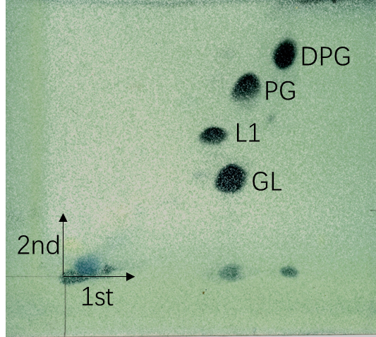
Figure S1 The polar lipids of strain JXJ CY 41^{T} as revealed by two-dimensional TLC.
DPG, diphosphatidylglycerol; PG, phosphatidylglycerol; GL, glycolipid; L1, unidentified lipid.

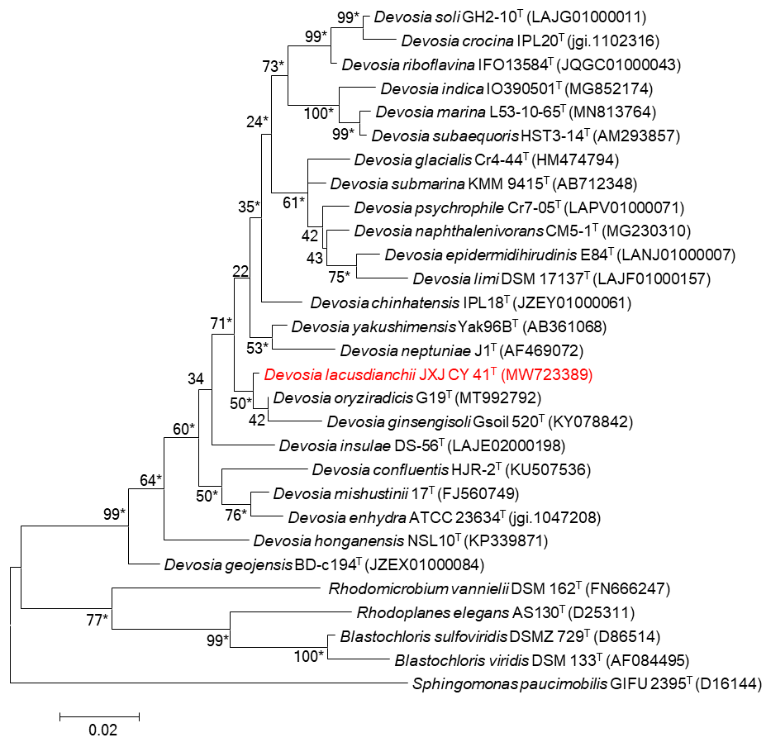
Figure S2 Maximum-likelihood phylogenetic tree based on 16S rRNA gene sequences of strain JXJ CY 41^{T} and its closest relative species of the genus Devosia. * indicated clades that were conserved in neighbour-joining, maximum-likelihood and maximum-parsimony trees. Bootstrap values (expressed as percentages of 1000 replications) are given at nodes. Bar, 0.02 changes per nucleotide position.

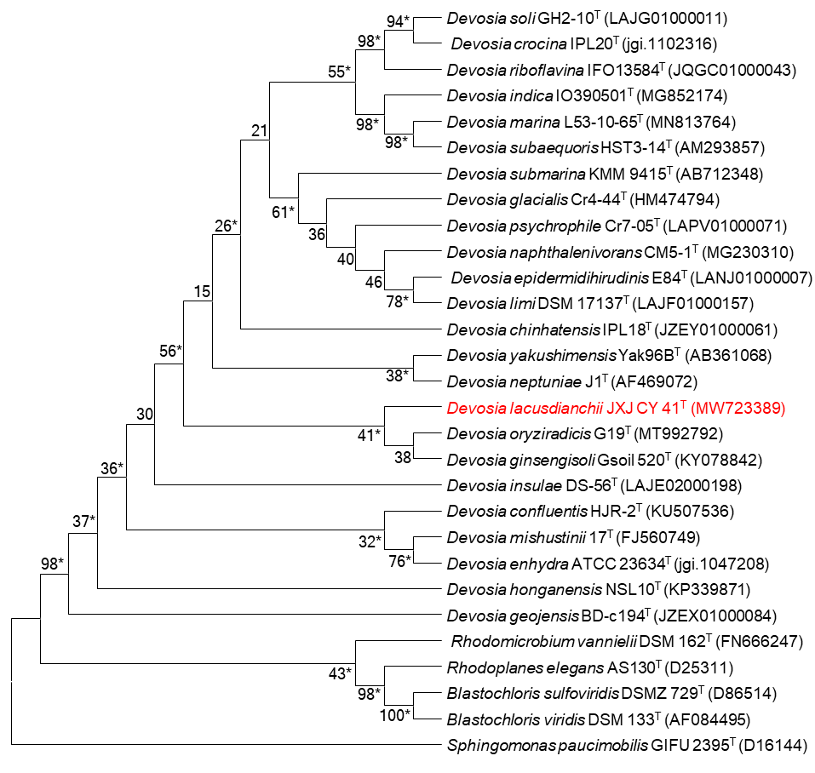
Figure S3 Maximum-parsimony phylogenetic tree based on 16S rRNA gene sequences of strain JXJ CY 41^{T} and its closest relative species of the genus Devosia. * indicated clades that were conserved in neighbour-joining, maximum-likelihood and maximum-parsimony trees. Bootstrap values (expressed as percentages of 1000 replications) are given at nodes.
Table S1 Cellular fatty acid profile of strain JXJ CY 53^{T} and related reference strains
Fatty acid | 1 | 2 | 3
C_{14:0} | 0.45 | N | N
C_{16:0} | 28.11 | 20.4 | 22.4
C_{10:0} 3-OH | 0.93 | N | 0.6
C_{17:0} | 0.75 | N | 2.0
C_{17:0} cyclo | 0.52 | N | 0.4
C_{19:0} cyclo ω8c | 0.96 | N | 6.8
C_{18:0} | 6.27 | 2.5 | 5.4
isoC_{14:0} | - | 1.8 | N
isoC_{15:0} | 0.26 | 2.6 | N
isoC_{16:0} | - | 2.2 | N
anteiso C13:0 | - | 1.2 | N
anteiso C15:0 | 0.1 | 2.7 | N
C_{17:0} 2-OH | - | 2.2 | N
C_{16:0} 3-OH | - | 3.6 | N
C_{18:0} 3-OH | 1.76 | N | N
iso C_{15:0} 3-OH | - | 1.2 | N
iso C_{17:0} 3-OH | - | 4.8 | N
iso C_{18:0} 3-OH | - | N | 2.9
C_{18:1} ω5c | - | 1.2 | N
C_{18:1} ω7c | 20.81 | 26.3 | 21.8
C_{18:1} ω9c | 0.54 | N | N
C_{20:1} ω7c | 0.44 | N | N
11-Methyl C_{18:1}ω7c | 36.68 | 23.5 | 35.0
1, Strain JXJ CY 41^{T}; 2, D. oryziradicis G19^{T} (Chhetri et al., 2022); 3, D. yakushimensis Yak96B^{T} (Bautista et al., 2010). -, not detected; N, no data.

Table S2 Gene annotation of strain JXJ CY 41^{T} in various databases
Annotated database | Number of Unigenes | Percentage (%)
CDD | 3583 | 83.68
COG | 3329 | 77.74
NR | 4194 | 97.94
PFAM | 3381 | 78.96
Swissprot | 3025 | 70.64
TrEMBL | 4191 | 97.87
GO | 2912 | 68.01
KEGG | 1925 | 44.96
At least one database | 4198 | 98.04
All database | 1809 | 42.25
Total Unigenes | 4282 | 100

Table S3 The possibly partial important genes or gene clusters for strain JXJ CY 41^{T} to adapt to the ecology of Maf
Level | GO | Term | Ontology | Gene_num | Gene_list
2 | GO:0002376 | immune system process | biological_process | 3 | PROKKA_03378, PROKKA_01454, PROKKA_00857
3 | GO:0002682 | regulation of immune system process | biological_process | 1 | PROKKA_03378
3 | GO:0002683 | negative regulation of immune system process | biological_process | 1 | PROKKA_03378
3 | GO:0006955 | immune response | biological_process | 3 | PROKKA_03378, PROKKA_01454, PROKKA_00857
3 | GO:0044110 | growth involved in symbiotic interaction | biological_process | 1 | PROKKA_04143
4 | GO:0044068 | modulation by symbiont of host cellular process | biological_process | 1 | PROKKA_03615
4 | GO:0044116 | growth of symbiont involved in interaction with host | biological_process | 1 | PROKKA_04143
4 | GO:0045087 | innate immune response | biological_process | 1 | PROKKA_00857
4 | GO:0050776 | regulation of immune response | biological_process | 1 | PROKKA_03378
4 | GO:0050777 | negative regulation of immune response | biological_process | 1 | PROKKA_03378
4 | GO:0051817 | modification of morphology or physiology of other organism involved in symbiotic interaction | biological_process | 2 | PROKKA_03615, PROKKA_03378
4 | GO:0052173 | response to defenses of other organism involved in symbiotic interaction | biological_process | 6 | PROKKA_03615, PROKKA_03378, PROKKA_00101, PROKKA_02374, PROKKA_04143, PROKKA_03171
5 | GO:0044003 | modification by symbiont of host morphology or physiology | biological_process | 2 | PROKKA_03615, PROKKA_03378
5 | GO:0044117 | growth of symbiont in host | biological_process | 1 | PROKKA_04143
5 | GO:0051807 | evasion or tolerance of defense response of other organism involved in symbiotic interaction | biological_process | 1 | PROKKA_00101
5 | GO:0051832 | avoidance of defenses of other organism involved in symbiotic interaction | biological_process | 1 | PROKKA_00101
5 | GO:0052040 | modulation by symbiont of host programmed cell death | biological_process | 1 | PROKKA_03615
5 | GO:0052248 | modulation of programmed cell death in other organism involved in symbiotic interaction | biological_process | 1 | PROKKA_03615
5 | GO:0052255 | modulation by organism of defense response of other organism involved in symbiotic interaction | biological_process | 2 | PROKKA_03615, PROKKA_03378
5 | GO:0052552 | modulation by organism of immune response of other organism involved in symbiotic interaction | biological_process | 1 | PROKKA_03378
5 | GO:0052561 | negative regulation by organism of immune response of other organism involved in symbiotic interaction | biological_process | 1 | PROKKA_03378
5 | GO:0052564 | response to immune response of other organism involved in symbiotic interaction | biological_process | 5 | PROKKA_03378, PROKKA_00101, PROKKA_02374, PROKKA_04143, PROKKA_03171
6 | GO:0034053 | modulation by symbiont of host defense-related programmed cell death | biological_process | 1 | PROKKA_03615
6 | GO:0044119 | growth of symbiont in host cell | biological_process | 1 | PROKKA_04143
6 | GO:0051805 | evasion or tolerance of immune response of other organism involved in symbiotic interaction | biological_process | 1 | PROKKA_00101
6 | GO:0051834 | evasion or tolerance of defenses of other organism involved in symbiotic interaction | biological_process | 1 | PROKKA_00101
6 | GO:0052031 | modulation by symbiont of host defense response | biological_process | 2 | PROKKA_03615, PROKKA_03378
6 | GO:0052553 | modulation by symbiont of host immune response | biological_process | 1 | PROKKA_03378
6 | GO:0052562 | negative regulation by symbiont of host immune response | biological_process | 1 | PROKKA_03378
6 | GO:0052572 | response to host immune response | biological_process | 5 | PROKKA_03378, PROKKA_00101, PROKKA_02374, PROKKA_04143, PROKKA_03171
7 | GO:0020012 | evasion or tolerance of host immune response | biological_process | 1 | PROKKA_00101
7 | GO:0051810 | active evasion of immune response of other organism involved in symbiotic interaction | biological_process | 1 | PROKKA_00101
8 | GO:0042783 | active evasion of host immune response | biological_process | 1 | PROKKA_00101

Table S4 The possibly partial important genes or gene clusters for strain JXJ CY 41^{T} to provide MAF with available P and N
Level | GO | Term | Ontology | Gene_num | Gene_list
6 | GO:0016791 | phosphatase activity | molecular_function | 29 | PROKKA_02238, PROKKA_03679, PROKKA_01714, PROKKA_02538,P ROKKA_01474, PROKKA_03157, PROKKA_01288, PROKKA_00384, PROKKA_02202, PROKKA_03102, PROKKA_01481, PROKKA_02970, PROKKA_03186, PROKKA_01453, PROKKA_02528, PROKKA_03415, PROKKA_02699, PROKKA_02443, PROKKA_00662, PROKKA_03352, PROKKA_03582, PROKKA_01612, PROKKA_01292, PROKKA_02310, PROKKA_03114, PROKKA_00185, PROKKA_00861, PROKKA_02316, PROKKA_00372
5 | GO:0016053 | organic acid biosynthetic process | biological_process | 161 | PROKKA_01391, PROKKA_01873, PROKKA_01552, PROKKA_02470, PROKKA_02764, PROKKA_00526, PROKKA_02339, PROKKA_02685, PROKKA_03760, PROKKA_01888, PROKKA_02368, PROKKA_03237, PROKKA_04107, PROKKA_00099, PROKKA_01030, PROKKA_03473, PROKKA_01399, PROKKA_03307, PROKKA_01907, PROKKA_03627, PROKKA_01316, PROKKA_04101, PROKKA_01802, PROKKA_04272, PROKKA_02857, PROKKA_01535, PROKKA_01848, PROKKA_01265, PROKKA_04186, PROKKA_04333, PROKKA_01545, PROKKA_02996, PROKKA_02461, PROKKA_03782, PROKKA_01045, PROKKA_02453, PROKKA_03764, PROKKA_02159, PROKKA_03896, PROKKA_04226, PROKKA_00595, PROKKA_02656, PROKKA_00857, PROKKA_01278, PROKKA_02160, PROKKA_04228, PROKKA_03065, PROKKA_03003, PROKKA_01616, PROKKA_00374, PROKKA_04269, PROKKA_02185, PROKKA_00100, PROKKA_02717, PROKKA_03898, PROKKA_02475, PROKKA_00627, PROKKA_00769, PROKKA_03104, PROKKA_01290, PROKKA_04223, PROKKA_01898, PROKKA_01676, PROKKA_02235, PROKKA_02699, PROKKA_01400, PROKKA_02989, PROKKA_00790, PROKKA_04345, PROKKA_03586, PROKKA_03726, PROKKA_02178, PROKKA_04225, PROKKA_02658, PROKKA_02370, PROKKA_02162, PROKKA_02966, PROKKA_03867, PROKKA_03588, PROKKA_00702, PROKKA_02147, PROKKA_03912, PROKKA_02221, PROKKA_04211, PROKKA_02935, PROKKA_01849, PROKKA_03910, PROKKA_02161, PROKKA_03761, PROKKA_03007, PROKKA_00394, PROKKA_00460, PROKKA_02686, PROKKA_04108, PROKKA_04087, PROKKA_01847, PROKKA_00588, PROKKA_04158, PROKKA_03855, PROKKA_03746, PROKKA_04319, PROKKA_03334, PROKKA_01544, PROKKA_02853, PROKKA_03838, PROKKA_03441, PROKKA_04102, PROKKA_00015, PROKKA_04232, PROKKA_00461, PROKKA_04035, PROKKA_01504, PROKKA_00521, PROKKA_04250, PROKKA_00596, PROKKA_02664, PROKKA_01511, PROKKA_01401, PROKKA_03183, PROKKA_01830, PROKKA_03308, PROKKA_04229, PROKKA_02703, PROKKA_02616, PROKKA_01685, PROKKA_03376, PROKKA_02548, PROKKA_00101, PROKKA_02338, PROKKA_01354, PROKKA_04034, PROKKA_01611, PROKKA_03695, PROKKA_00133, PROKKA_00523, PROKKA_03909, PROKKA_00878, PROKKA_04342, PROKKA_02236, PROKKA_00791, PROKKA_03717, PROKKA_00564, PROKKA_03731, PROKKA_03778, PROKKA_02459, PROKKA_04116, PROKKA_02512, PROKKA_03868, PROKKA_03582, PROKKA_01042, PROKKA_03618, PROKKA_02493, PROKKA_02234, PROKKA_02137, PROKKA_00720, PROKKA_03483, PROKKA_02590, PROKKA_03603, PROKKA_00959, PROKKA_01648, PROKKA_01402
5 | GO:0009877 | nodulation | biological_process | 16 | PROKKA_00995, PROKKA_01400, PROKKA_03986, PROKKA_00386, PROKKA_03988, PROKKA_03626, PROKKA_00994, PROKKA_01285, PROKKA_01793, PROKKA_02429, PROKKA_02451, PROKKA_01286, PROKKA_03344, PROKKA_00341, PROKKA_02439, PROKKA_03987
5 | GO:0009399 | nitrogen fixation | biological_process | 16 | PROKKA_01889, PROKKA_02106, PROKKA_03580, PROKKA_01459, PROKKA_00664, PROKKA_02599, PROKKA_01888, PROKKA_00073, PROKKA_00023, PROKKA_01120, PROKKA_03344, PROKKA_00407, PROKKA_01865, PROKKA_02101, PROKKA_02102, PROKKA_02105

Table S5 The possibly partial important genes and gene clusters related to the nutrient exchanges between strain JXJ CY 41^{T} and Maf
Level | GO | Term | Ontology | Gene_num | Gene_list
3 | GO:0043190 | ATP-binding cassette (ABC) transporter complex | cellular_component | 44 | PROKKA_03363, PROKKA_01569, PROKKA_03644, PROKKA_03814, PROKKA_00266, PROKKA_03783, PROKKA_03652, PROKKA_03215, PROKKA_02317, PROKKA_03406, PROKKA_03138, PROKKA_03601, PROKKA_00284, PROKKA_03154, PROKKA_00287, PROKKA_01709, PROKKA_00456, PROKKA_03032, PROKKA_01636, PROKKA_00643, PROKKA_01666, PROKKA_00416, PROKKA_00443, PROKKA_01483, PROKKA_02132, PROKKA_02381, PROKKA_00283, PROKKA_01460, PROKKA_03508, PROKKA_03214, PROKKA_03873, PROKKA_01582, PROKKA_01831, PROKKA_03121, PROKKA_04001, PROKKA_00699, PROKKA_01060, PROKKA_00694, PROKKA_02418, PROKKA_02414, PROKKA_03213, PROKKA_00558, PROKKA_00048, PROKKA_00243
5 | GO:0009306 | protein secretion | biological_process | 18 | PROKKA_01439, PROKKA_03269, PROKKA_01496, PROKKA_02579, PROKKA_02574, PROKKA_02297, PROKKA_01457, PROKKA_03110, PROKKA_00502, PROKKA_01710, PROKKA_01455, PROKKA_03281, PROKKA_02156, PROKKA_01711, PROKKA_02572, PROKKA_01795, PROKKA_01440, PROKKA_00506
5 | GO:0050708 | regulation of protein secretion | biological_process | 1 | PROKKA_03110
3 | GO:0030256 | type I protein secretion system complex | cellular_component | 2 | PROKKA_01439, PROKKA_01455
3 | GO:0030257 | type III protein secretion system complex | cellular_component | 1 | PROKKA_03281
6 | GO:0030253 | protein secretion by the type I secretion system | biological_process | 2 | PROKKA_01439, PROKKA_01455
6 | GO:0030254 | protein secretion by the type III secretion system | biological_process | 1 | PROKKA_03281
6 | GO:0015926 | glucosidase activity | molecular_function | 8 | PROKKA_01577, PROKKA_00761, PROKKA_03798, PROKKA_04348, PROKKA_00773, PROKKA_00772, PROKKA_03502, PROKKA_03002
7 | GO:0004558 | alpha-glucosidase activity | molecular_function | 2 | PROKKA_00761, PROKKA_00773
7 | GO:0008422 | β-glucosidase activity | molecular_function | 6 | PROKKA_01577, PROKKA_03798, PROKKA_04348, PROKKA_00772, PROKKA_03502, PROKKA_03002
8 | GO:0004338 | glucan exo-1,3-β-glucosidase activity | molecular_function | 1 | PROKKA_03002
8 | GO:0008706 | 6-phospho-β-glucosidase activity | molecular_function | 1 | PROKKA_03502
8 | GO:0032450 | maltose α-glucosidase activity | molecular_function | 2 | PROKKA_00761, PROKKA_00773
6 | GO:0080030 | methyl indole-3-acetate esterase activity | molecular_function | 2 | PROKKA_02359, PROKKA_04246
8 | GO:0006596 | polyamine biosynthetic process | biological_process | 1 | PROKKA_02246
3 | GO:0051183 | vitamin transporter activity | molecular_function | 3 | PROKKA_00971, PROKKA_00882, PROKKA_02929
4 | GO:0015225 | biotin transporter activity | molecular_function | 2 | PROKKA_00971, PROKKA_00882
4 | GO:0051180 | vitamin transport | biological_process | 3 | PROKKA_02931, PROKKA_03300, PROKKA_03299
5 | GO:0009110 | vitamin biosynthetic process | biological_process | 62 | PROKKA_03753, PROKKA_02368, PROKKA_00837, PROKKA_03890, PROKKA_01099, PROKKA_00836, PROKKA_00749, PROKKA_00410, PROKKA_03349, PROKKA_02631, PROKKA_03782, PROKKA_00838, PROKKA_00839, PROKKA_00613, PROKKA_00826, PROKKA_04250, PROKKA_03755, PROKKA_00215, PROKKA_03712, PROKKA_03183, PROKKA_03003, PROKKA_03308, PROKKA_00151, PROKKA_01067, PROKKA_01103, PROKKA_00016, PROKKA_01104, PROKKA_00808, PROKKA_02487, PROKKA_04269, PROKKA_03376, PROKKA_01354, PROKKA_03663, PROKKA_01250, PROKKA_00133, PROKKA_02683, PROKKA_01408, PROKKA_03104, PROKKA_01101, PROKKA_01537, PROKKA_01898, PROKKA_02236, PROKKA_00827, PROKKA_04145, PROKKA_02235, PROKKA_03717, PROKKA_02989, PROKKA_03512, PROKKA_00609, PROKKA_00829, PROKKA_01251, PROKKA_02370, PROKKA_00834, PROKKA_00966, PROKKA_02234, PROKKA_01102, PROKKA_01098, PROKKA_00702, PROKKA_02590, PROKKA_04063, PROKKA_00835, PROKKA_01100
5 | GO:0015888 | thiamine transport | biological_process | 2 | PROKKA_03300, PROKKA_03299
6 | GO:0009102 | biotin biosynthetic process | biological_process | 6 | PROKKA_02989, PROKKA_03376, PROKKA_02590, PROKKA_03183, PROKKA_01898, PROKKA_03003
6 | GO:0009229 | thiamine diphosphate biosynthetic process | biological_process | 3 | PROKKA_03349, PROKKA_00609, PROKKA_00354
7 | GO:0009228 | thiamine biosynthetic process | biological_process | 6 | PROKKA_03512, PROKKA_00609, PROKKA_03712, PROKKA_03349, PROKKA_00151, PROKKA_03663
7 | GO:0009231 | riboflavin biosynthetic process | biological_process | 10 | PROKKA_01067, PROKKA_00016, PROKKA_02487, PROKKA_00808, PROKKA_00215, PROKKA_01537, PROKKA_00410, PROKKA_00749, PROKKA_04063, PROKKA_04145
7 | GO:0009234 | menaquinone biosynthetic process | biological_process | 4 | PROKKA_02711, PROKKA_02471, PROKKA_00106, PROKKA_00890
7 | GO:0009236 | cobalamin biosynthetic process | biological_process | 23 | PROKKA_01103, PROKKA_01104, PROKKA_03753, PROKKA_02631, PROKKA_00838, PROKKA_01251, PROKKA_00829, PROKKA_00839, PROKKA_00613, PROKKA_00826, PROKKA_01250, PROKKA_00834, PROKKA_00837, PROKKA_03755, PROKKA_01102, PROKKA_01098, PROKKA_01101, PROKKA_03890, PROKKA_00827, PROKKA_00835, PROKKA_01099, PROKKA_01100, PROKKA_00836
7 | GO:0042819 | vitamin B6 biosynthetic process | biological_process | 4 | PROKKA_00966, PROKKA_02683, PROKKA_03308, PROKKA_01408
4 | GO:0004096 | catalase activity | molecular_function | 1 | PROKKA_02768
3 | GO:0004601 | peroxidase activity | molecular_function | 11 | PROKKA_01861, PROKKA_00212, PROKKA_01454, PROKKA_00888, PROKKA_01433, PROKKA_03272, PROKKA_02768, PROKKA_01021, PROKKA_02772, PROKKA_01911, PROKKA_00225

