Table3 lists the compounds that passed the PAINS filter and had suitable drug-like characteristics.
Entry | PAINS Filter | Structure | Docking Score  Kcal/mol
1 | Pass | 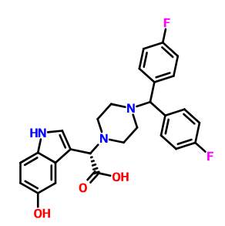 | -10.09
2 | Pass | 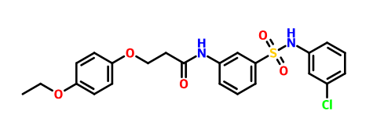 | -11
3 | Pass | 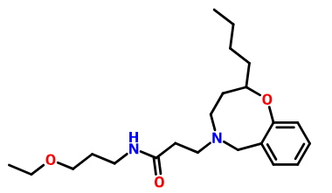 | -9.8
4 | Pass | 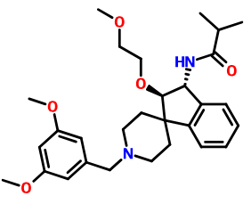 | -8.96
5 | Pass | 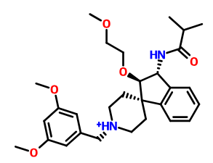 | -9.09

Table 4 The areas enclosed and red color parts make these chemistries as artefacts.
PAINS |  | Reason of being PAINS
 |  | TOXOFLAVIN Redox cycler: can produce hydrogen peroxide, which can activate or inactivate different proteins.
 |  | ISOTHIAZOLONES Covalent modifier: reacts chemically with proteins in non-specific, non-drug-like ways.
 |  | CURCUMIN Covalent modifier, membrane disruptor: muddles response of membrane receptors.
 |  | HYDROXYPHENYL HYDRAZONES Covalent modifier, metal complexer: sequesters metal ions that inactivate proteins.
 |  | ENE-RHODANINE Covalent modifier, metal complexer.
 |  | PHENOL-SULPHONAMIDES Redox cycler, covalent modifier, unstable compound: breaks down into molecules that give false signals.
 |  | ENONES Covalent modifier
 |  |  | QUINONES AND CATECHOLS Redox cycler, metal complexer, covalent modifier.

