Supplemental tables and figures:

Table S1: List of the antibodies used for immunoblots.

Figure S1: Correlation of Hariba pH meter with Mettler-Toledo pH meter.
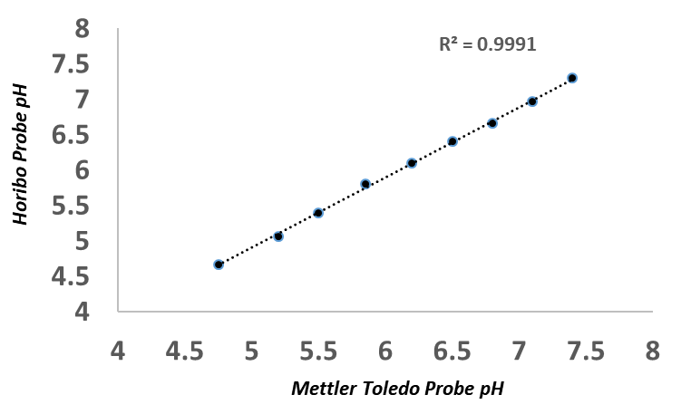
Both pH meters were used to measure standardized solutions in parallel and results were compared.

Figure S2: Immunoblot results of evaluated proteins.
A.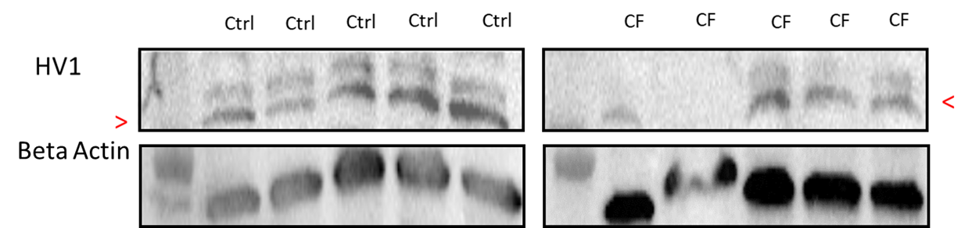

B.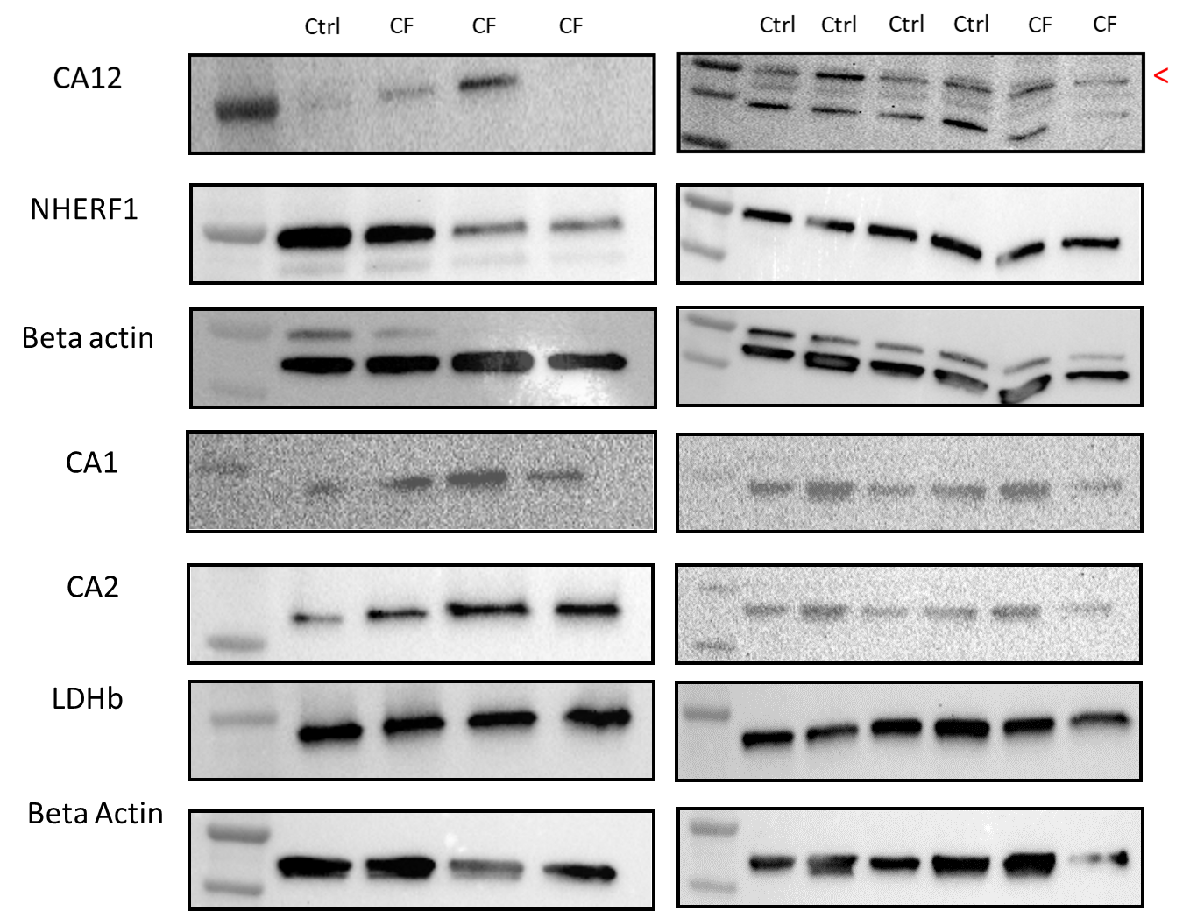
C. 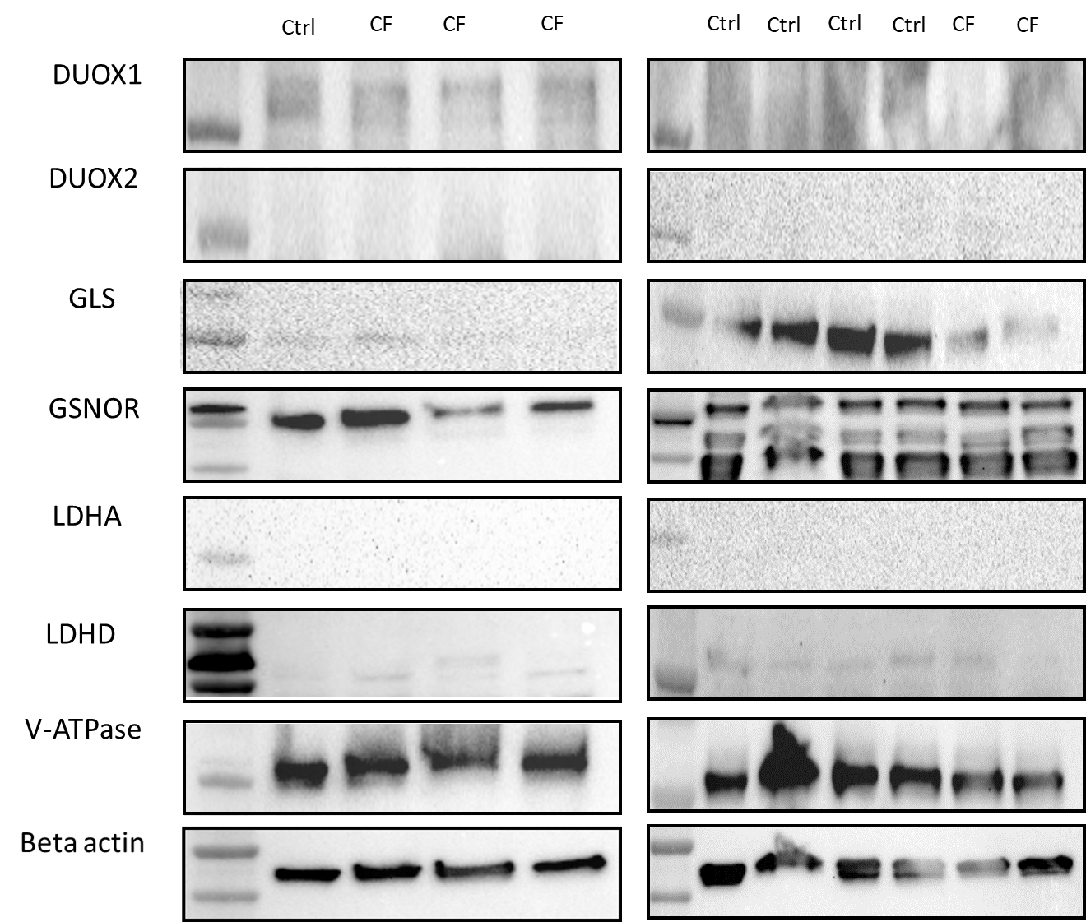

Figure S2: Volcano plot of mRNA levels of genes encoding proteins in bronchial cells from CF subjects and those from healthy controls.
