Supplementary Information
Tetrahydrocannabinol derivative ameliorates 5-FU mediated DNA damage propensity coupled with Vimentin suppression leading to autophagy induction

Khalid Bashir Mir^{1,2*}, Souneek Chakraborty^{2,3*}, Tanzeeba Amin^{1,2}, Aviral Kumar^{4,5}, Abdul Raouf War², Yedukondalu Nalli^{1,6}, Rakesh Kumar⁷, Lekha Dinesh Kumar⁴, Asif Ali^{1,8} and Anindya Goswami^{1,2#}

.
- Academy of Scientific & Innovative Research (AcSIR), Ghaziabad, India
- Pharmacology Division, CSIR-Indian Institute of Integrative Medicine, Jammu-180001, India
- Childern Mercy Research Institute, Kansas City, MO 64108
- Cancer Biology, CSIR-Centre for Cellular & Molecular Biology, Hyderabad 500007, India
- Cancer Biology Laboratory, Department of Biosciences and Bioengineering, Indian Institute of Technology (IIT) Guwahati, Assam-781039, INDIA.
- Natural Products and Medicinal Chemistry Division, CSIR-Indian Institute of Integrative Medicine, Canal Road, Jammu 180001, India
- School of Biotechnology, Shri Mata Vaishno Devi University, Katra 182320, India
- Medicinal & Process Chemistry Division, CSIR-Central Drug Research Institute, Lucknow 226031, Uttar Pradesh, INDIA

* These authors have contributed equally to this work
# CORRESPONDENCE
Anindya Goswami
Senior Principal Scientist
Pharmacology Division,
CSIR-IIIM, Jammu
Email: agoswami@iiim.res.in

Figure 1

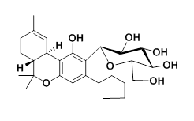

Δ⁹-tetrahydrocannabinol-1-O-β-D-glucopyranoside (THC-09-OG)

Δ⁹-tetrahydrocannabinol-1-O-β-D-glucopyranoside
¹H NMR (400 MHz, MeOD) δ 6.55 (d, J = 1.1 Hz, 1H), 6.30 (d, J = 1.1 Hz, 1H), 5.45 (d, J = 2.8 Hz, 1H), 4.92 (d, J = 7.2 Hz, 1H, anomeric proton), 4.03 – 3.87 (m, 1H), 3.75 (dd, J = 12.0, 5.0 Hz, 1H), 3.56 – 3.40 (m, 4H), 3.36 – 3.28 (m, 1H), 2.86 (td, J = 11.1, 4.7 Hz, 1H), 2.51 (t, J = 7.7 Hz, 2H), 2.25 – 2.10 (m, 1H), 1.94 – 1.79 (m, 1H), 1.80 – 1.64 (m, 5H), 1.66 – 1.53 (m, 2H), 1.48 – 1.27 (m, 8H), 1.08 (s, 3H), 0.94 (t, J = 7.0 Hz, 3H); ¹³C NMR (100 MHz, MeOD) δ 156.82, 154.06, 142.25, 134.57, 118.99, 112.90, 111.10, 106.35, 100.43 (anomeric carbon), 77.15, 76.76, 76.20, 73.82, 70.13, 61.27, 45.50, 36.61, 35.42, 31.66, 31.24, 30.62, 27.60, 26.61, 22.33, 22.18, 17.26, 13.00; (+) HRESIMS m/z477.2819 [M+H]⁺ (calcd for C₂₇H₄₁O₇ 477.2847).

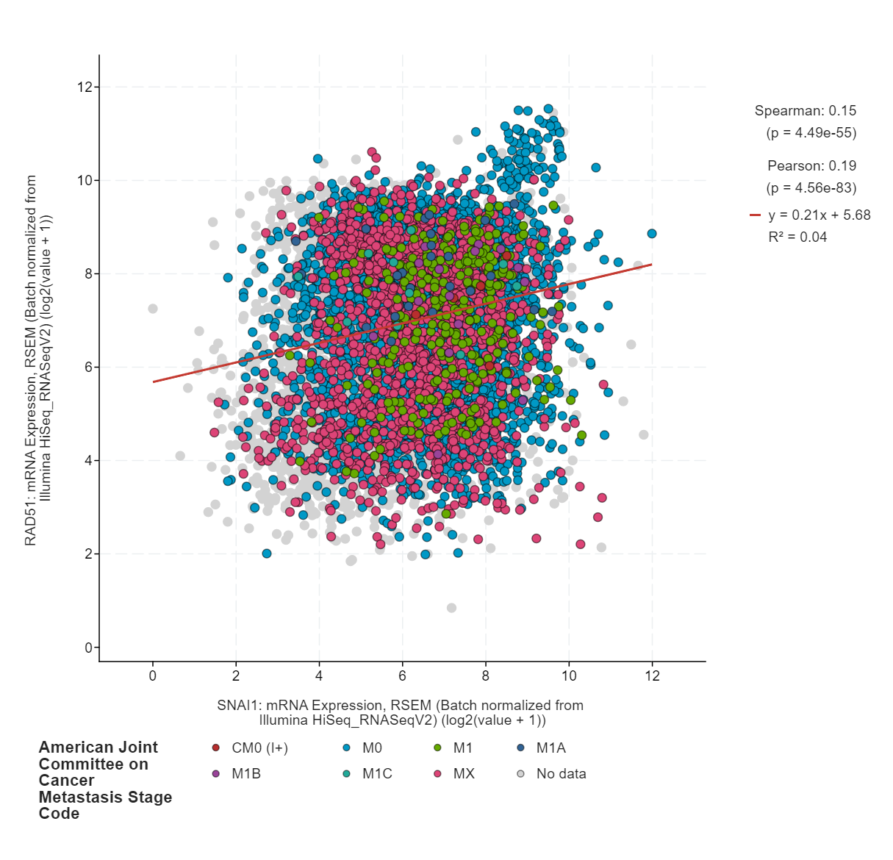

Figure 2: Relationship between RAD51 and Snail-1

Various research findings indirectly suggest an intricate connection between the factors responsible for EMT activation and DNA damage and repair components. Hence, to clearly understand this relationship we analyzed and compared the mRNA expression between RAD 51 (vital regulator in DNA repair) and Snail-1. The TCGA pan cancer data mining results depicted a significant relationship between genes responsible for EMT and DNA repair. Moreover, a significant population of patients with metastatic tumor (AJCC stage code: M1A) depicted higher expression of both SNAIL-1 and RAD 51.

Figure 3: Annexin and propidium iodide analysis

THC-9-OG in combination increases the apoptosis potential of 5FU. 1x10⁶ HCT-116 cells were seeded on 60 mm petridish and were treated with Vehicle, and 750nM 5FU+3μM THC-9-OG for 36 h. Following termination, the cells were stained with Annexin-FITC, propidium iodide and analysed through flow cytometry. Bar graph represents different phases of apoptosis (n=3 error bars ±s. d)

Supplementary Table 1
 | Antibody | Cat.No | Dilutions
  S.No.
1 | Snail1 | #3879S | 1:1000
2 | TWIST1 | #69366S | 1:1000
3 | RAD51 | #8875S | 1:1000/1:200
4 | MRE11 | #4895S | 1:1000/1:200
5 | E-Cadherin | #3195 | 1:1000
6 | Bax |  | 1;1000
  #5023
7 | ATM |  | 1:1000
  #2873
8 | vimentin | #5741 | 1:1000/1:100
9 | y-H2A.X | 9718 | 1:1000/1:200
10 | H2A.X | #7631 | 1:1000
11 | ZEB1 | Sc-81428 | 1:1000
12 | p-ATM | #13050 | 1:1000
13 | STAT-3 | 9139 | 1:1000
14 | XRCC-1 | #2735 | 1:1000/1:200
16 | Cleaved caspase-3 | #9664 | 1:1000
17 |  | SC-492 | 1:1000
  BCL2
19 | Vimentin | Sc-373717 | 1:1000
20 | P53 | #2524S | 1:1000
21 | SQSTM1 (D-3) | D5L7G | 1:1000
22 | p-AKT | #9271 | 1:1000
23 | LC3B | 2775S | 1:1000
24 | NFKB | #8242 | 1:1000
25 | AKT | #9272 | 1:1000

Reagents and chemicals
Supplementary Table 2

S. No | Name of chemical | Manufacturer
1 | RPMI, DMEM, L-15 and FBS | Invitrogen
2 | Trypsin-EDTA, | Sigma-Aldrich
3 | Dithiothreitol (DTT), | Sigma-Aldrich
4 | Doxorubicin,  Phenylmethylsulfonyl fluoride (PMSF), | Sigma-Aldrich
5 | NP-40 | Sigma-Aldrich
6 | Triton-X-100 | Sigma-Aldrich
7 | Dimethyl sulfoxide (DMSO) | Sigma-Aldrich
8 | penicillin/streptomycin | Sigma-Aldrich
9 | Protease inhibitor cocktail (PI) | Sigma-Aldrich
11 | Bradford’s reagent | Sigma-Aldrich

