Supplementary information for
Triexciton induced RGB emission of organic-inorganic zirconium halide perovskites

Chuying Wang¹, Wen Meng¹, Guigen Luo¹, Guangyong Xu¹, Min Peng¹, Bin Xu¹, Shuming Nie² and Zhengtao Deng^{1*}

¹ College of Engineering and Applied Sciences, State Key Laboratory of Analytical Chemistry for Life Science, National Laboratory of Solid State Microstructures, Nanjing University Nanjing, Jiangsu 210023, P. R. China
² Departments of Bioengineering, Chemistry, Electrical and Computer Engineering, and Materials Science and Engineering, University of Illinois at Urbana-Champaign, Urbana, IL, 61801, USA

*E-mail: dengz@nju.edu.cn

Table| S1 The fitting results of the PL decay curves of red, green and blue, ((C₂H₅)₄N)₂ZrCl₆ powders under different irradiation.
 | Blue powder | Red powder |  |  | Green powder
Excitation | 260 nm | 260 nm |  | 365 nm | 260 nm | 300 nm
Emission | 510 nm | 510 nm | 625 nm | 625 nm | 510 nm | 525 nm
A₁ | 25521.77 | 107.429 | 102.351 | 97.323 | 39.793 | 116.354
A₁% | 100% | 96.670 | / | 86.362 | 14.318 | 76.974
τ₁ (μs) | 3.871 | 4.621 | 4.937 | 6.267 | 1.833 | 1.461
A₂ | / | 0.6086 | / | 4.451 | 65.521 | 1.270
A₂% | / | 3.330 | / | 13.638 | 85.682 | 23.026
τ₂ (μs) | / | 28.099 | / | 21.643 | 6.665 | 40.035
τ_{ave} (μs) | 3.871 | 5.403 | 4.937 | 8.364 | 5.973 | 10.343
Time-resolved PL decay curves of the perovskite are fitted by single or biexponential functions (see Eqs. 1 and 2):
A(t) = A₁ exp(-t / τ₁) | (Eqs.1)
A(t) = A₁ exp(-t / τ₁) + A₂ exp(-t / τ₂) | (Eqs.2)
The ratio of lifetimes is calculated using
A_{i}% = (A_{i}τ_{i})/( A₁τ₁ + A₂τ₂) | (Eqs.3)
The average lifetimes are calculated using
τ_{avg} = (A₁τ₁² + A₂τ₂²)/( A₁τ₁ + A₂τ₂) | (Eqs.4)

Table| S2 Summary of crystal data and reflection collection parameters.
Empirical formula | C₁₆H₄₀Cl₆N₂Zr
Formula weight | 564.1134
Crystal system | Monoclinic
Space group | C2/c
a, Å | 14.0708(17)
b, Å | 14.4783(19)
c, Å | 13.253(2)
α, degree | 90
β, degree | 90.530(5)
γ, degree | 90
V, Å³ | 2699.8(6)
Z | 4
ρcalc., g cm⁻³ | 1.389
μmm-1 | 1.006
F000 | 1159.947
2θ max,deg(Completeness ) | 50.5(100%)
Total reflections | 21777
Unique reflections | 3102
Highest peak | 0.6652
Deepest hole | -0.4520
R_{int} | 0.0535
R₁ [obs I>4σ (I)] | 0.0429
R₁ (all data) | 0.0527
wR₂ | 0.1249
Goodness-of-fit on F² | 1.0477

Scheme S| Schematic diagram of fabrication process of the ((C₂H₅)₄N)₂ZrCl₆ powder samples.

Figure S1| PL emission spectrum of green ((C₂H₅)₄N)₂ZrCl₆ powder under excitation at 265 nm.

Figure S2| SEM image and EDS mappings of ((C₂H₅)₄N)₂ZrCl₆ single crystals.

Figure S3| The crystal structures of ((C₂H₅)₄N)₂ZrCl₆ viewed along a axis, b axis, and c axis.

Figure S4| XRD patterns of ((C₂H₅)₄N)₂ZrCl₆ samples.

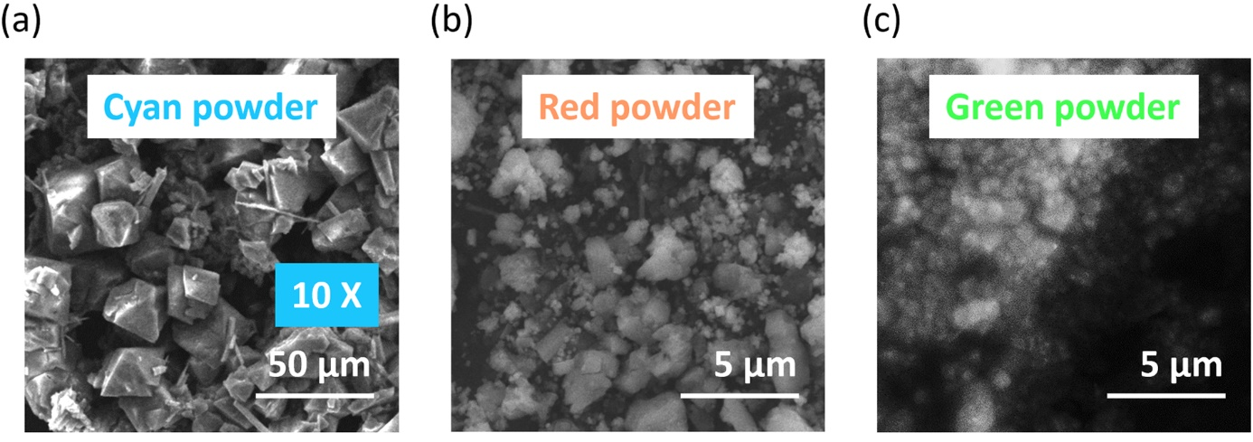
Figure S5| SEM images of blue, red and green ((C₂H₅)₄N)₂ZrCl₆ powder samples.

Figure S6| Photographs of green powder stored before (left) and after (right) a day at RF of 100%. The insets are the corresponding PL emission spectra of the samples.

Figure S7| Photographs of ((C₂H₅)₄N)₂ZrCl₆ samples evaporated on (a) glasses and (b) lids through different concentration of ZrCl₄ precursor.

Figure S8| Photographs of samples evaporated in tube under different irradiation.

Figure S9| Absorption and PL emission spectra of (C₁₃H₃₀N)₂ZrCl₆ powders under different excitation.

Figure S10| Photographs of pixelated patterns of the green and blue powders under (a) room light and (b) 375 nm irradiation.

