Assessing the Impact of Hurricane Ivan on Aboveground Carbon in Trees and Foliage of Perdido Bay Watershed in the Gulf Coast

Supplementary Tables
Supplementary Table 1: Affected and non-affected plots with stand type in three different counties in Perdido Bay watershed. Affected plots marked with bold fonts in the table.
Year vs Stand Type | Plot Affected Status | Baldwin | Colbert | Escambia | Total
Hardwood |  | 10 | 0 | 0 | 10
2001 | No | 2 | 0 | 0 | 2
2002 | No | 2 | 0 | 0 | 2
2003 | No | 3 | 0 | 0 | 3
2004 | Yes | 1 | 0 | 0 | 1
2007 | No | 2 | 0 | 0 | 2
Mixed |  | 46 | 3 | 19 | 68
2001 | No | 5 | 1 | 0 | 6
2002 | No | 9 | 0 | 4 | 13
2003 | No | 5 | 0 | 4 | 9
2004 | No | 1 | 0 | 0 | 1
2004 | Yes | 8 | 0 | 4 | 12
2005 | No | 8 | 1 | 0 | 9
2006 | No | 6 | 1 | 5 | 12
2007 | No | 4 | 0 | 2 | 6
Softwood |  | 18 | 1 | 2 | 21
2001 | No | 5 | 0 | 0 | 5
2002 | No | 3 | 0 | 0 | 3
2003 | No | 2 | 0 | 0 | 2
2004 | Yes | 3 | 0 | 1 | 4
2005 | No | 2 | 0 | 0 | 2
2006 | No | 0 | 1 | 0 | 1
2007 | No | 3 | 0 | 1 | 4

Supplementary Table 2: Log-linear model selection considering Akaike Information Criterion (AIC) and Bayesian Information Criterion (BIC).
Model (Trees with Foliage) | AIC_{t} | AIC_{wt} | BIC_{t} | BIC_{wt}
Model 1 | 144.09 | 0.67 | 191.16 | 0.76
Model 2 | 146.90 | 0.16 | 194.88 | 0.12
Model 3 | 147.06 | 0.15 | 195.04 | 0.11
Model 4 | 152.77 | 0.01 | 198.84 | 0.02
Model (Foliage only) | AIC_{f} | AIC_{wf} | BIC_{f} | BIC_{wf}
Model 1 | 241.93 | 0.58 | 289.00 | 0.66
Model 2 | 243.86 | 0.22 | 291.83 | 0.16
Model 3 | 244.43 | 0.17 | 292.40 | 0.12
Model 4 | 247.94 | 0.03 | 294.01 | 0.05
** t stands model for carbon in trees with foliage and f stands model for carbon in foliage only. wt and wf stands for weightage of the model for trees and foliage in the selection

Supplementary Figures

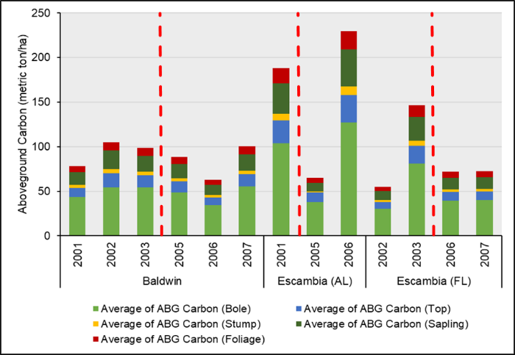
Supplementary Figure 1: Distribution of aboveground carbon changes before (2001-2003) and after (2005-2007) hurricane Ivan period in Baldwin and Escambia (AL, FL) counties. Due to geographic location of the watershed boundary and county area size, some inventory years plot data were not available.

Regression Diagonostics for predicting aboveground carbon in trees
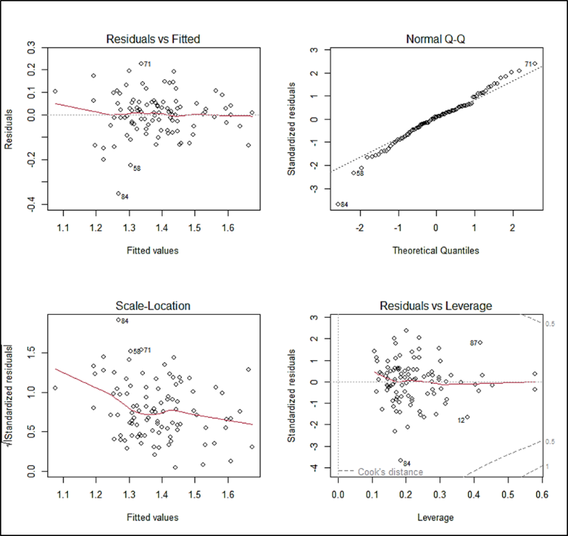
Supplementary Figure 2: 1) Residuals vs Fitted - Used to check the linear relationship assumptions. A horizontal line, without distinct patterns is an indication for a linear relationship, what is good, 2) Normal Q-Q. Used to examine whether the residuals are normally distributed. It’s good if residuals points follow the straight dashed line, 3) Scale-Location (or Spread-Location). Used to check the homogeneity of variance of the residuals (homoscedasticity). Horizontal line with equally spread points is a good indication of homoscedasticity. 4) Residuals vs Leverage. Used to identify influential cases, that is extreme values that might influence the regression results when included or excluded from the analysis.

Regression Diagonostics for predicting aboveground carbon in foliage
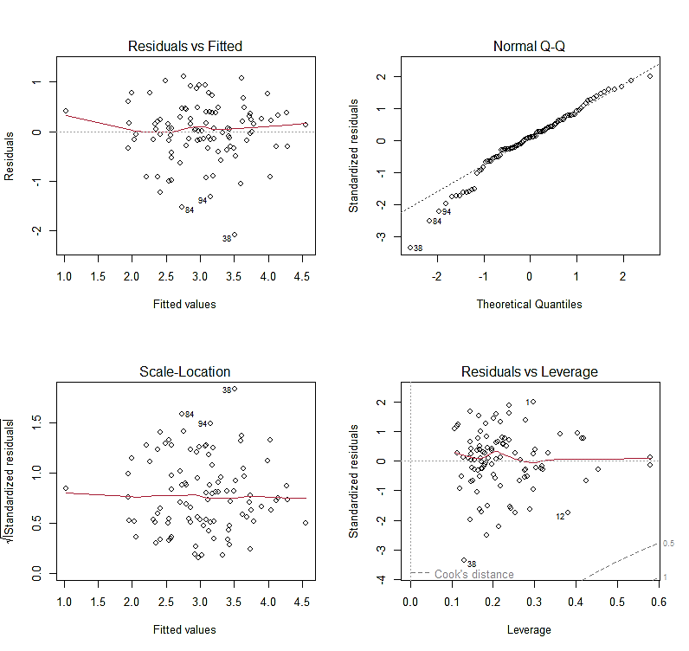
Supplementary Figure 3: 1) Residuals vs Fitted - Used to check the linear relationship assumptions. A horizontal line, without distinct patterns is an indication for a linear relationship, what is good, 2) Normal Q-Q. Used to examine whether the residuals are normally distributed. It’s good if residuals points follow the straight dashed line, 3) Scale-Location (or Spread-Location). Used to check the homogeneity of variance of the residuals (homoscedasticity). Horizontal line with equally spread points is a good indication of homoscedasticity. 4) Residuals vs Leverage. Used to identify influential cases, that is extreme values that might influence the regression results when included or excluded from the analysis.

R code for Log-linear model
#Set up the working directory#
setwd("D://FIA_Data")

#=======================================================================================================#
#Access the database from the local disk
perdido_data_2001_2007 <- read.xlsx("Perdido_Carbon_Analysis_v2.xlsx", sheet = 'Perdido_Carbon_Analysis_01_07_P') #set the location
colnames(perdido_data_2001_2007) #to see the column names in the dataset

perdido_data_2001_2007 <- read.xlsx("Perdido_Carbon_Analysis_v2.xlsx", sheet = 'PLOT_TimeSeries') #set the location
colnames(perdido_data_2001_2007) #to see the column names in the dataset

#+++++++++++++++++++++++++++++++++++++++++++++++++++++++++++++++++++++++++++++++++++++++++++++++++++++++#
#Run a multiple linear regression model for 2001-2007 period
perdido_lm_2001_2007_WF <- lm(log(CARBON_AG_WT_Foliage) ~ as.character(INVYR)+COUNTY+HT+STDSZ_NAME+AFFETED_STATUS+FLD_AGE+ELEV+PHYSCL_NAME+STAND_TYPE, data = perdido_data_2001_2007)
summary(perdido_lm_2001_2007_WF)
ggcoef_model(perdido_lm_2001_2007_WF, facet_row = NULL)
par(mfrow=c(2,2)) # init 4 charts in 1 panel
plot(perdido_lm_2001_2007_WF)
coeftest(perdido_lm_2001_2007_WF, confint = TRUE, ci.width = .3, vcov = vcovHC(perdido_lm_2001_2007_WF, type = "HC0"))

perdido_coef_WF <- coeftest(perdido_lm_2001_2007_WF, confint = TRUE, ci.width = .3, vcov = vcovHC(perdido_lm_2001_2007_WF, type = "HC0"))
perdido_coef_WF
BIC(perdido_coef_WF)
ggcoef_model(perdido_coef_WF, facet_row = NULL)+ xlab("estimate for tree and foliage")
par(mfrow=c(2,2)) # init 4 charts in 1 panel
plot(perdido_coef_WF)
ggcoef(perdido_coef_WF, color = "blue", vline_color = "red", vline_linetype = "solid", size =3 , shape = 18)

#Model for ANOVA test (with foliage)
perdido_lm_2001_2007_WF_m2 <- lm(log(CARBON_AG_WT_Foliage) ~ as.character(INVYR)+COUNTY+STDSZ_NAME+AFFETED_STATUS+FLD_AGE++ELEV+PHYSCL_NAME+STAND_TYPE, data = perdido_data_2001_2007)
summary(perdido_lm_2001_2007_WF_m2)
coeftest(perdido_lm_2001_2007_WF_m2, confint = TRUE, ci.width = .3, vcov = vcovHC(perdido_lm_2001_2007_WF, type = "HC0"))
perdido_lm_2001_2007_WF_int <- lm(log(CARBON_AG_WT_Foliage) ~ as.character(INVYR)+COUNTY+STDSZ_NAME+AFFETED_STATUS+HT*FLD_AGE++ELEV+PHYSCL_NAME+STAND_TYPE, data = perdido_data_2001_2007)
summary(perdido_lm_2001_2007_WF_int)
coeftest(perdido_lm_2001_2007_WF_int, confint = TRUE, ci.width = .3, vcov = vcovHC(perdido_lm_2001_2007_WF, type = "HC0"))
perdido_lm_2001_2007_WF_blc <- lm(log(CARBON_AG_WT_Foliage) ~ as.character(INVYR)+COUNTY+STDSZ_NAME+AFFETED_STATUS+HT+FLD_AGE++ELEV+PHYSCL_NAME+STAND_TYPE+BASAL_AREA, data = perdido_data_2001_2007)
summary(perdido_lm_2001_2007_WF_blc)
coeftest(perdido_lm_2001_2007_WF_blc, confint = TRUE, ci.width = .3, vcov = vcovHC(perdido_lm_2001_2007_WF, type = "HC0"))

model.set <- list("Model 1" = perdido_lm_2001_2007_WF, "Model 2" = perdido_lm_2001_2007_WF_m2, "Model 3" = perdido_lm_2001_2007_WF_int, "Model 4" = perdido_lm_2001_2007_WF_blc)
ggcoef_compare(model.set, type = "faceted")+ xlab("estimate for tree and foliage")
model.names <- c("Original", "Dropping", "Interaction", "Blocking")
anova(perdido_lm_2001_2007_WF, perdido_lm_2001_2007_WF_m2, perdido_lm_2001_2007_WF_int, perdido_lm_2001_2007_WF_blc)
aictab(model.set, modnames = model.names)
bictab(model.set, modnames = model.names)

lmtest::bptest(perdido_lm_2001_2007_WF) # Breusch-Pagan test
perdido_box <- caret::BoxCoxTrans(perdido_data_2001_2007$CARBON_AG_WT_Foliage)
print(perdido_box)

perdido_data_2001_2007 <- cbind(perdido_data_2001_2007, box_new = predict(perdido_box,perdido_data_2001_2007$CARBON_AG_WT_Foliage))
head(perdido_data_2001_2007)
perdido_lm_2001_2007_WF_het <- lm(log(box_new) ~ as.character(INVYR)+COUNTY+HT+STDSZ_NAME+AFFETED_STATUS+FLD_AGE++ELEV+PHYSCL_NAME+STAND_TYPE, data = perdido_data_2001_2007)
bptest(perdido_lm_2001_2007_WF_het)
par(mfrow=c(2,2)) # init 4 charts in 1 panel
plot(perdido_lm_2001_2007_WF_het)

# Look at relationship between fitted values and residuals with foliage and trees
ggplot(perdido_lm_2001_2007_WF, aes(x = .fitted, y = .resid)) +
geom_point(color = "black", size = 2) +
geom_smooth(method = "lm", color = "red")+
xlab("Fitted Values")+
ylab("Residuals")+
scale_x_continuous(labels = number_format(accuracy = 0.1))

#++++++++++++++++++++++++++++++++++++++++++++++++++++++++++++++++++++++++++++++++++++++++++++++++++++++#

#Run a multiple linear regression model for 2001-2007 period for foliage only
perdido_lm_2001_2007_Fol <- lm(log(Foliage) ~ as.character(INVYR)+COUNTY+HT+STDSZ_NAME+AFFETED_STATUS+FLD_AGE++ELEV+PHYSCL_NAME+STAND_TYPE, data = perdido_data_2001_2007)
summary(perdido_lm_2001_2007_Fol)
ggcoef(perdido_lm_2001_2007_Fol, color = "red", size =4 , shape = 20)
par(mfrow=c(2,2)) # init 4 charts in 1 panel
plot(perdido_lm_2001_2007_Fol)

# Robust standard errors t test with lm() function
perdido_coef_Fol <- coeftest(perdido_lm_2001_2007_Fol, confint = TRUE, ci.width = .3, vcov = vcovHC(perdido_lm_2001_2007_Fol, type = "HC0"))
perdido_coef_Fol
par(mfrow=c(2,2)) # init 4 charts in 1 panel
plot(perdido_coef_Fol)
ggcoef_model(perdido_coef_Fol, facet_row = NULL)+ xlab("estimate for foliage only")
ggcoef(perdido_coef_Fol, color = "blue", vline_color = "red", vline_linetype = "solid", size =3 , shape = 18)

#Model for ANOVA test (Foliage)
perdido_lm_2001_2007_Fol_m2 <- lm(log(Foliage) ~ as.character(INVYR)+COUNTY+STDSZ_NAME+AFFETED_STATUS+FLD_AGE++ELEV+PHYSCL_NAME+STAND_TYPE, data = perdido_data_2001_2007)
summary(perdido_lm_2001_2007_Fol_m2)
coeftest(perdido_lm_2001_2007_Fol_m2, confint = TRUE, ci.width = .3, vcov = vcovHC(perdido_lm_2001_2007_Fol, type = "HC0"))
perdido_lm_2001_2007_Fol_int <- lm(log(Foliage) ~ as.character(INVYR)+COUNTY+STDSZ_NAME+AFFETED_STATUS+HT*FLD_AGE++ELEV+PHYSCL_NAME+STAND_TYPE, data = perdido_data_2001_2007)
summary(perdido_lm_2001_2007_Fol_int)
coeftest(perdido_lm_2001_2007_Fol_int, confint = TRUE, ci.width = .3, vcov = vcovHC(perdido_lm_2001_2007_Fol, type = "HC0"))
perdido_lm_2001_2007_Fol_blc <- lm(log(Foliage) ~ as.character(INVYR)+COUNTY+STDSZ_NAME+AFFETED_STATUS+HT+FLD_AGE++ELEV+PHYSCL_NAME+STAND_TYPE+BASAL_AREA, data = perdido_data_2001_2007)
summary(perdido_lm_2001_2007_Fol_blc)
coeftest(perdido_lm_2001_2007_Fol_blc, confint = TRUE, ci.width = .3, vcov = vcovHC(perdido_lm_2001_2007_Fol, type = "HC0"))

model.set <- list("Model 1" = perdido_lm_2001_2007_Fol, "Model 2" = perdido_lm_2001_2007_Fol_m2, "Model 3" = perdido_lm_2001_2007_Fol_int, "Model 4" = perdido_lm_2001_2007_Fol_blc)
ggcoef_compare(model.set, type = "faceted")+ xlab("estimate for foliage only")
anova(perdido_lm_2001_2007_Fol, perdido_lm_2001_2007_Fol_m2, perdido_lm_2001_2007_Fol_int, perdido_lm_2001_2007_Fol_blc)
model.names <- c("Original", "Dropping", "Interaction", "Blocking")
aictab(model.set, modnames = model.names)
bictab(model.set, modnames = model.names)

lmtest::bptest(perdido_lm_2001_2007_Fol) # Breusch-Pagan test
perdido_box <- caret::BoxCoxTrans(perdido_data_2001_2007$Foliage)
print(perdido_box)

perdido_data_2001_2007 <- cbind(perdido_data_2001_2007, box_new = predict(perdido_box,perdido_data_2001_2007$CARBON_AG_WO_Foliage))
head(perdido_data_2001_2007)
perdido_lm_2001_2007_Fol_het <- lm(log(box_new) ~ as.character(INVYR)+COUNTY+HT+STDSZ_NAME+AFFETED_STATUS+FLD_AGE++ELEV+PHYSCL_NAME+STAND_TYPE, data = perdido_data_2001_2007)
bptest(perdido_lm_2001_2007_Fol_het)
par(mfrow=c(2,2)) # init 4 charts in 1 panel
plot(perdido_lm_2001_2007_Fol_het)

# Look at relationship between fitted values and residuals with foliage
ggplot(perdido_lm_2001_2007_Fol, aes(x = .fitted, y = .resid)) +
geom_point(color = "black", size = 2) +
geom_smooth(method = "lm", color = "red")+
xlab("Fitted Values")+
ylab("Residuals")+
scale_x_continuous(labels = number_format(accuracy = 0.1))
#+++++++++++++++++++++++++++++++++++++++++++++++++++++++++++++++++++++++++++++++++++++++++++++++++++++++#

