Appendix A: Interview-guide
Baseline Record available demographic variables from the Electronic Patient File.
Go over the Clinical Frailty Scale-score with Geriatric Specialist Team.
Administer Katz activities of daily living index when going to the patient.
Opening Introduction
Interview duration (60 min)
Audio recorded.
Explain purpose (i.e., emphasize that there are no consequences concerning treatment)
Address possible questions on the patient information letter and informed consent.
Go over the demographics and Katz index together with the patient.

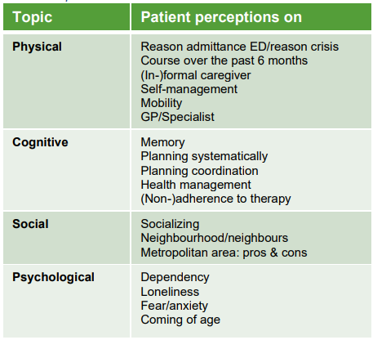
Topic list according to the CFS-construct
Physical
- Can you tell me the reason why you have been admitted to the ED?
Continue to ask questions on perception about the need for this and possible other solutions
- How have you been in the past 6 months? (Indicate benchmark: last summer)
- Have you noticed any changes compared to like 6 months ago?
Probing on which, positive/negative, perception on the occurrence of negative changes
- Do you take care of yourself at home?
Probing on level Katz index, groceries, cooking, cleaning, finances, etc.
- Do you get any help from someone close to you?
Continue to ask questions about informal care, professional help, whether or not care is needed.
- Do you also go out independently? For example, do you still drive a car/bicycle?
Continue to ask questions on possibilities/limitations that arise as a result.
- Do you have regular contact with your general practitioner/specialist?
Continue to ask questions on own initiative in this regard, frequency, reasons for contact, confidentiality/security in this relationship.
- Do you always go by yourself to appointments with your GP/specialist, or do you go with a 'contact person'/together with someone? Why this choice?

Cognitive
- How is your memory?
Probing questions on positive/negative changes, expressions thereof, experiences in daily life
- If something needs to be done around the house, do you arrange everything yourself?
Continue to ask questions about making appointments, administration, use of telephone or multimedia (e.g. mail), organizing
- Do you ever receive advice about your health?
Continue to ask questions on examples of the reason for this, possibly arranging and
taking medication and the reason why they are prescribed, ‘adherence’.
Social
- Do you have a social life?
Continue to ask questions on maintaining this and how the participant does this.
- Are you ever lonely or do you feel anxious about that?
Probing on examples, possibilities/limitations related to these feelings.
- How would you describe your contact with your neighbours?
Continue to ask on: appeal to the neighbours for help and when.
- You live in a big city; is this an advantage or a disadvantage for you?
Continue to ask perception of why and in what respect

Psychological
- Do you feel you depend on others around you?
Continue to ask questions about examples of experiences, perception of ageing, the future and discussing this with third parties, 'advance care planning'.
- Do you think that your age plays a part in this ED-visit? That you were admitted to the ED. If so,
why?

Closing 'Member check' based on the categories of the Clinical Frailty Scale: physical, cognitive, social, psychological.
Do you have any questions or do you want to address or elaborate on a previous
answer?

