Supporting Information

Solvent-promoted selective hydroxymethylation of
biomass-derived furan compounds
Weipeng Song¹, Junhua Zhang¹, Yong Sun², Rui Zhang¹, Lincai Peng^{1, *}, & Huai Liu^{1, *}
¹BiomassChem Group, Faculty of Chemical Engineering, Kunming University of Science and Technology, Kunming 650500, China
²Xiamen key Laboratory of Clean and High-valued Utilization for Biomass, College of Energy, Xiamen University, Xiamen 361102, China
*Correspondence: penglincai@kust.edu.cn; huailiu@kust.edu.cn

This file includes:
Supplementary Methods and Discussion
Figures S1 to S16
Tables S1 to S7

Supplementary Methods and Discussion
Chemical reagent
The Hβ zeolites were purchased from the Catalysis Centre of Nankai University (Tianjin, China), while two other molecular sieves, USY and ZSM-5 were purchased from Real & Lead Chemical Co., Ltd. (Tianjin, China). The chemicals used in this study, including furfuryl alcohol (FA), furfural, furan, 2,5-dihydroxymethylfuran (DHMF), γ-valerolactone, methylisobutylketone and acetone were purchased from Shanghai Aladdin Reagent (Shanghai, China). The different furan platform including furan, 2-methylfuran, 5-hydroxymethyl-2-methylfuran, 2-furoic acid, 5-(hydroxymethyl) furan-2-carboxylic acid were purchased from Shanghai Macklin Reagent (Shanghai, China). The solvents 1,4-dioxane was obtained from Sinopharm Chemical Reagent Co., Ltd. (Shanghai, China). Formalin was purchased from Shanghai Rowan Reagent Co., Ltd. (Shanghai, China). Unless otherwise stated, all the chemicals and materials used in the study were commercially sourced and used without further purification.
Catalyst reusability test
The potential reusability of the Hβ-29 molecular sieve catalyst in the hydroxymethylation of FA to DHMF was evaluated. After each reaction cycle, the catalyst was separated, cleaned and dried, and the reaction was repeated. However, the activity of the reused catalyst decreased significantly after several cycles due to catalyst deactivation and carbon deposition on the surface. XRD analysis (Supplementary Fig. 4a) showed that the crystalline form of the spent catalyst was largely retained, but the response values were reduced in some crystalline planes (101, 004 and 201). FTIR analysis (Supplementary Fig. 4b) revealed a new characteristic peak (871 cm⁻¹) in the spent catalyst corresponding to the C–H characteristic peak of the product DHMF. SEM analysis (Supplementary Fig. 5) showed impurities on the surface of the spent catalyst. NH₃-TPD and Py-FTIR analysis (Supplementary Fig. 4c, d) showed a significant decrease in the acid content of the spent catalyst, which is a fatal weakness.
To restore the activity of the spent catalyst, it was calcined in a muffle furnace at 550 °C for 6 h prior to each recovery run. The resulting carbon deposits of the regenerated catalyst were successfully removed (Supplementary Fig. 5c) and its physical properties were restored. XRD, FTIR and Py-FTIR analyses showed that the crystal structure and acidic sites of the regenerated catalyst recovered their basic properties. NH₃-TPD analysis showed that the percentage of highly acidic sites increased in the used catalyst. The factor contributing to the increase in the strong acidity of the post-used molecular sieve was the high temperature decomposition of the humic substances attached to the molecular sieve during the NH₃-TPD analysis, which affected the strong acidic sites of the TPD curve. As expected, the reused catalyst was used for the subsequent FA hydroxymethylation reaction under the same conditions as the initial reaction. In five consecutive runs the product yields were measured and compared with the initial reaction (Supplementary Fig. 2). The results showed that the regenerated catalyst was only slightly less active than the fresh catalyst, indicating that the Hβ molecular sieve catalyst can be effectively recovered and reused in the FA hydroxymethylation reaction after muffle reaction and activation.

Supplemental Figures
 | 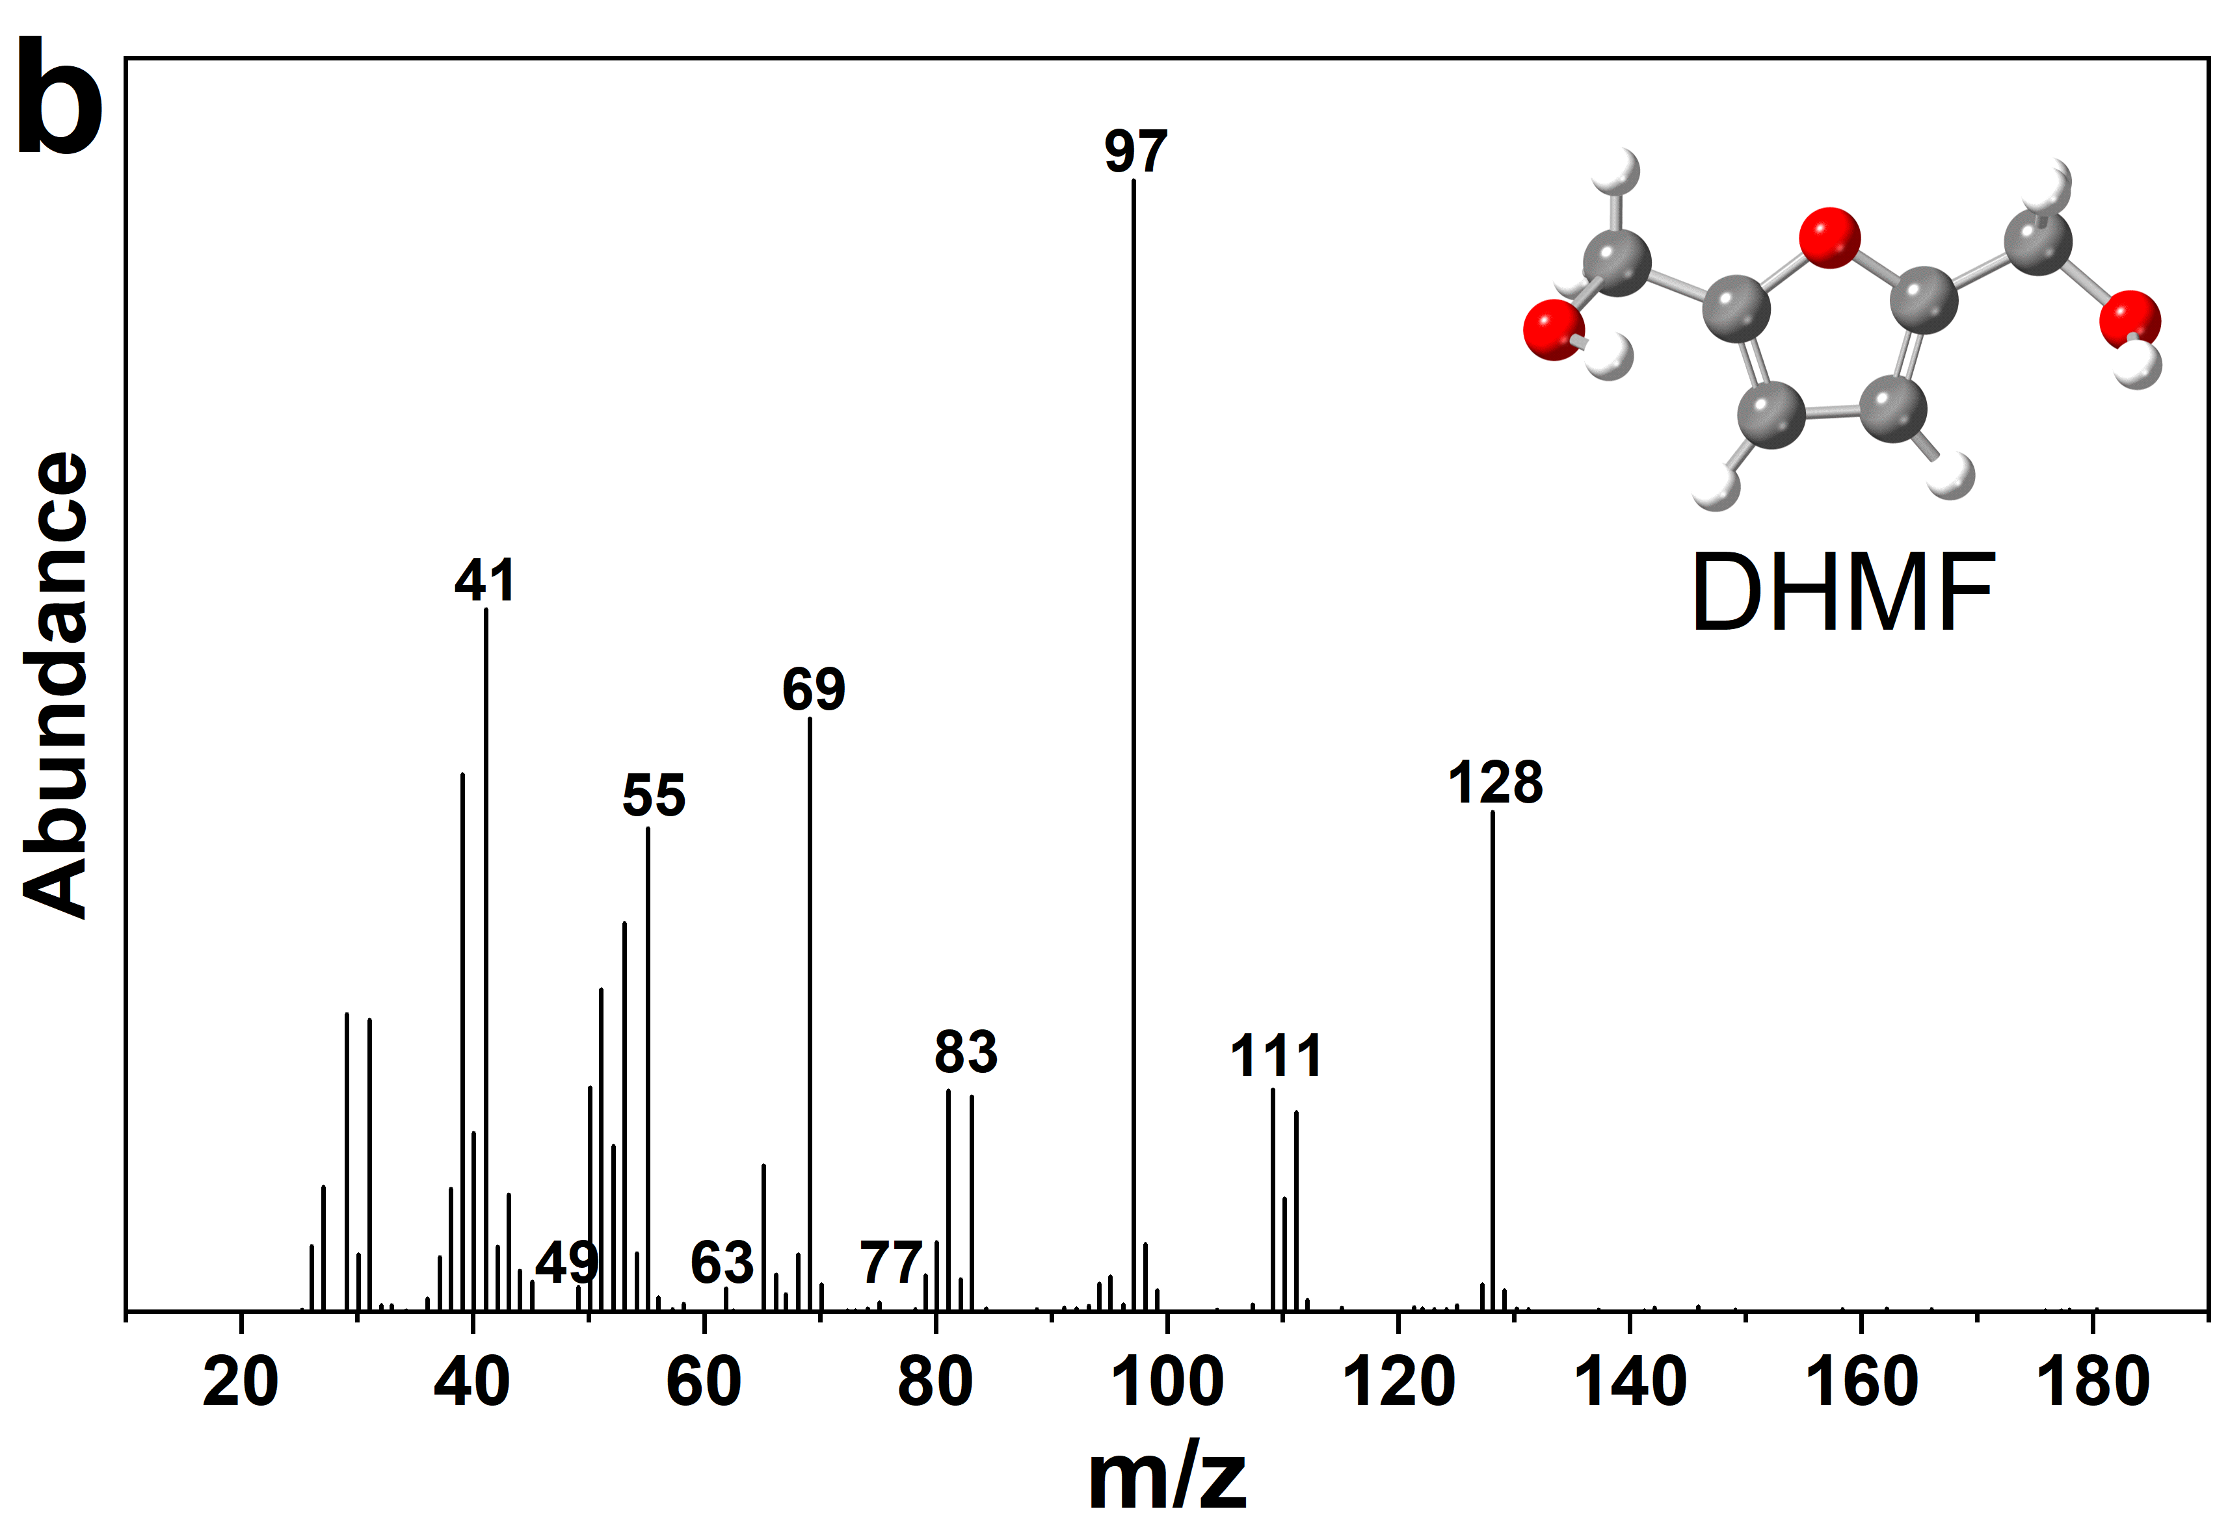
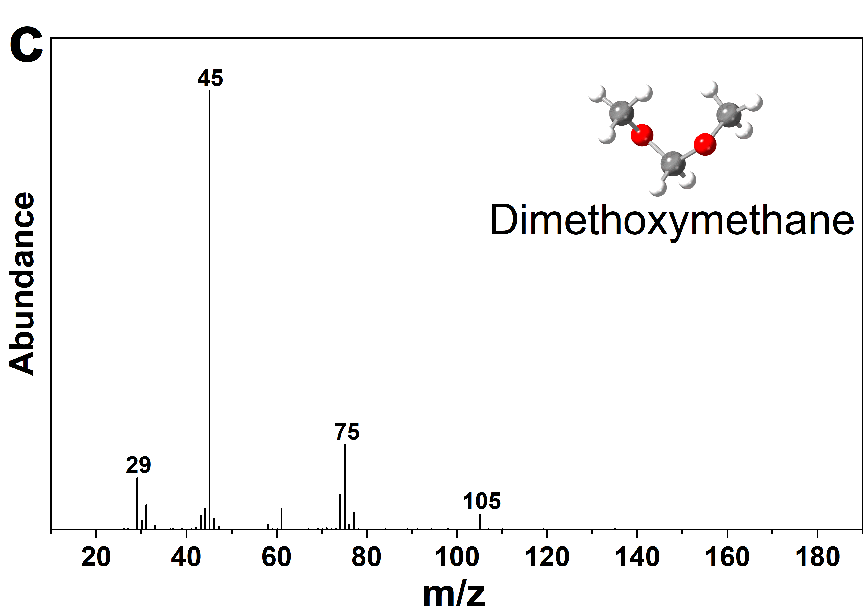 | 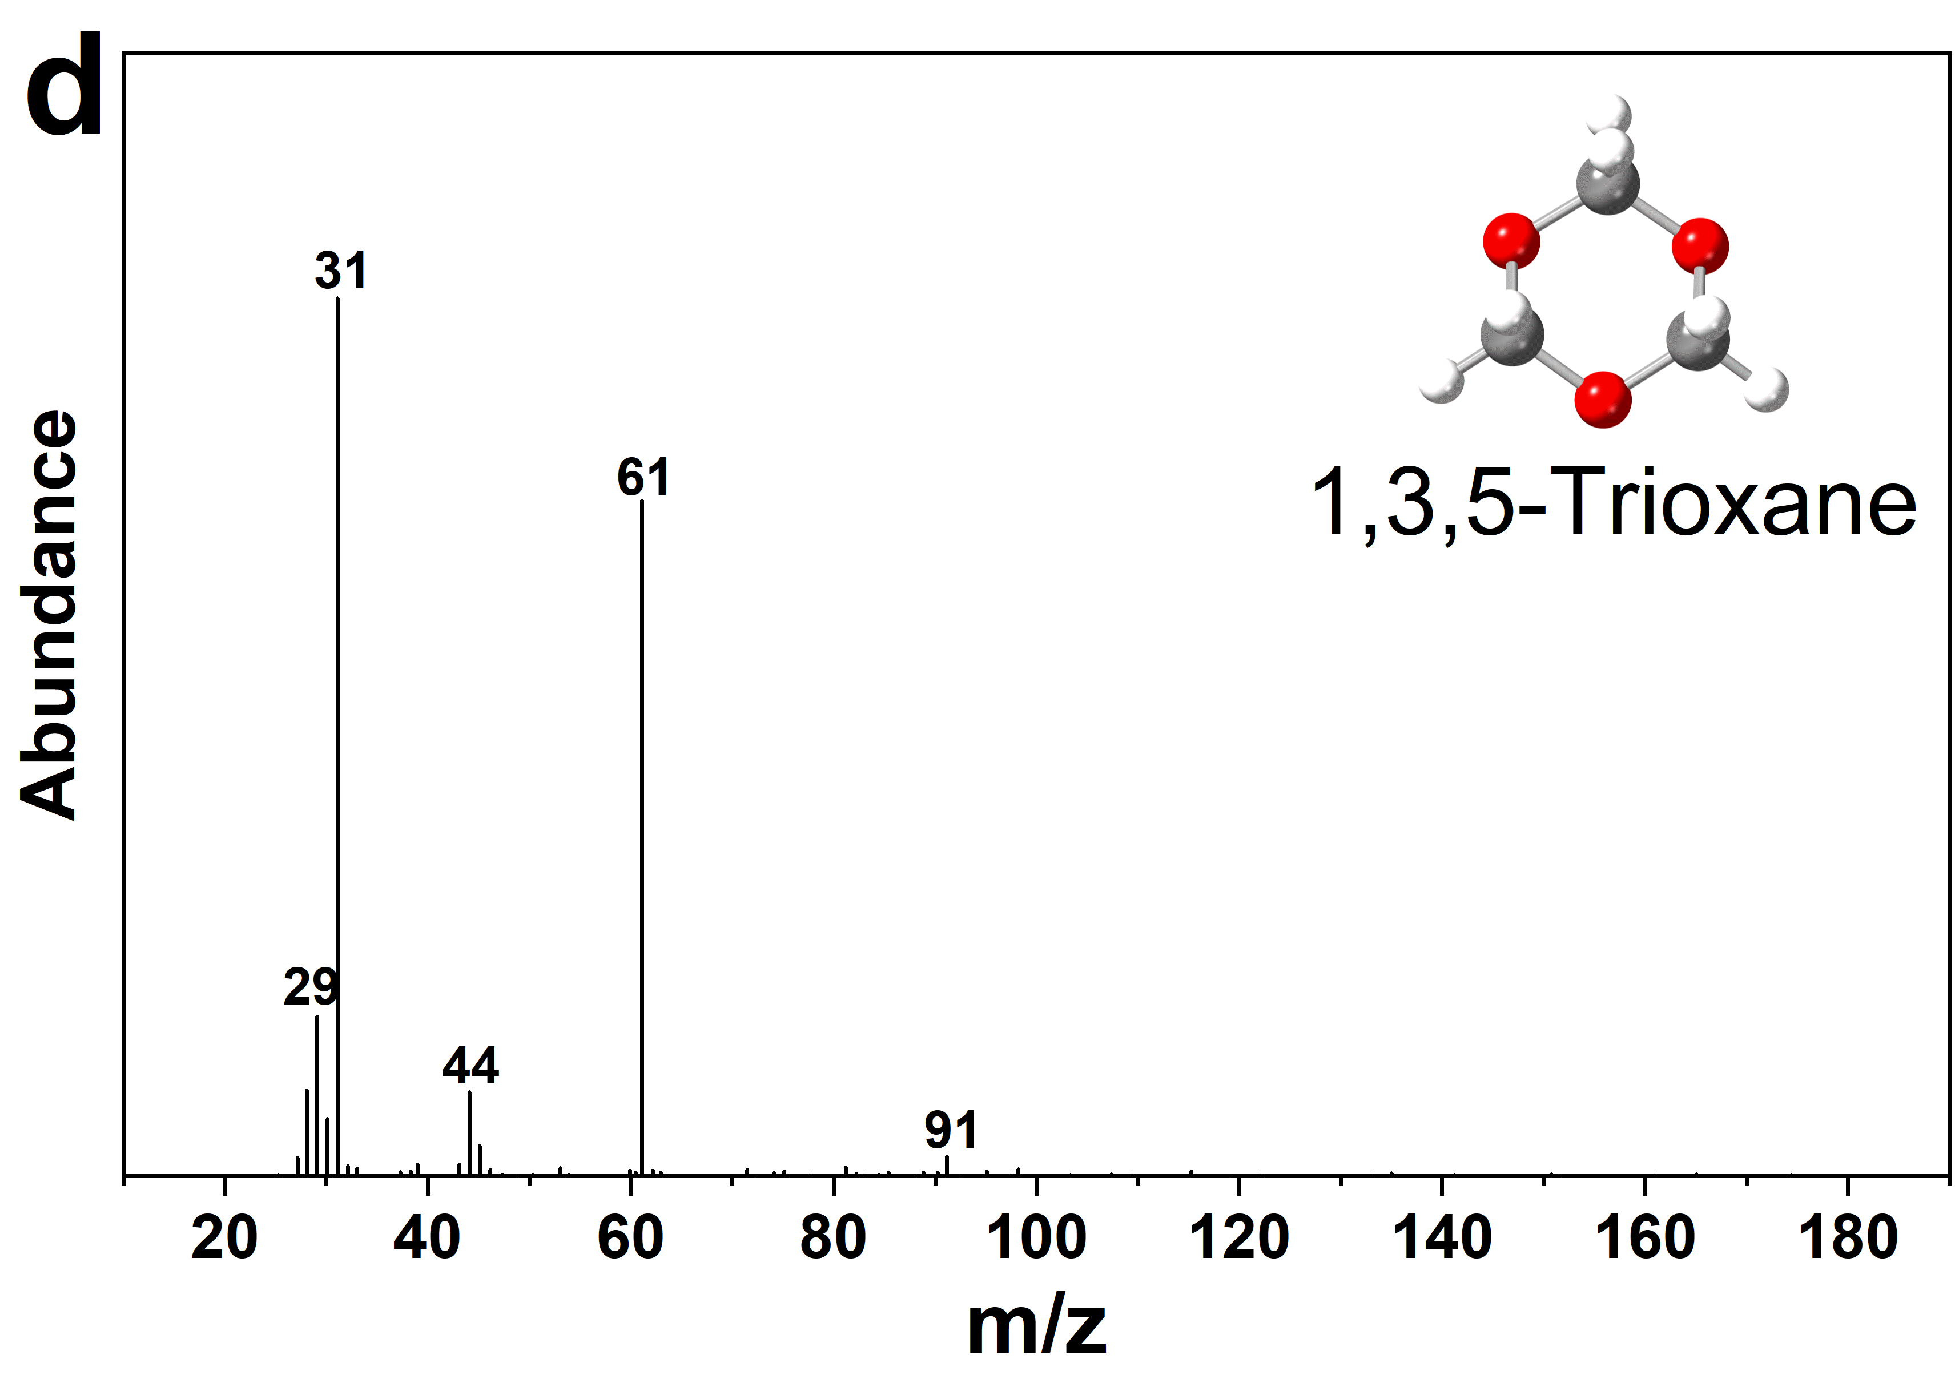
Supplementary Fig. 1. GC-MS spectrum of product at 60 °C for 60 min.

Supplementary Fig. 2. Conversion of FA to DHMF over various catalyst in formaldehyde. Reaction conditions: 0.05 g FA, 0.1 g catalyst, 5 mL formaldehyde, 60 °C, 60 min; Regenerated Hβ-29: the deposited carbonaceous materials on the surface of the spent Hβ-29 zeolite were removed by calcining it in a muffle furnace at 550 °C for 6 h before recycling run.

Supplementary Fig. 3. NH₃-TPD (a) and Py-FTIR (b) results of the Hβ-26, Hβ-29, Hβ-38, USY-5.2, and ZSM-5-25.

Supplementary Fig. 4. Reusability test of Hβ-29 catalyst in the conversion of FA to DHMF. XRD (a), FT-IR (b), NH₃-TPD (c), Py-FTIR (d).

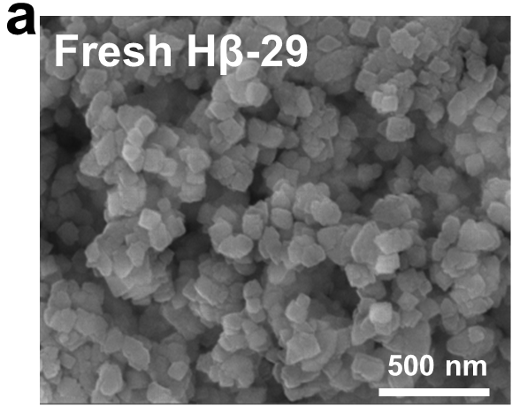 | 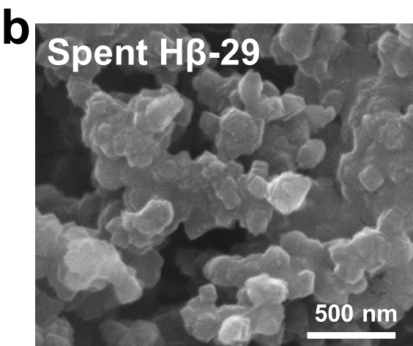
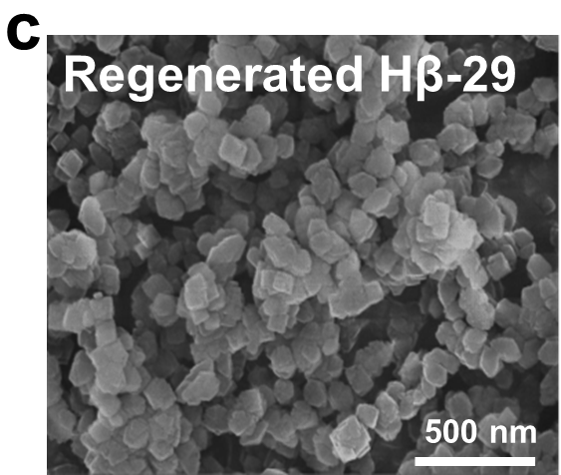
Supplementary Fig. 5. SEM images (a–c) of fresh, spent, and regenerated Hβ-29 catalysts. Regenerated Hβ-29: the deposited carbonaceous materials on the surface of the spent Hβ-29 zeolite were successfully removed by calcining it in a muffle furnace at 550 °C for 6 h before recycling run.

Supplementary Fig. 6. FT-IR spectra of FA, FA absorbed on Hβ-29 (a), FA absorbed on USY-5.2 (b), FA absorbed on ZSM-5-25 (c), after adsorption of FA in various zeolites (d).

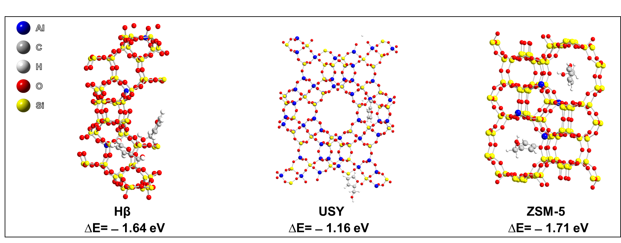
Supplementary Fig. 7. Structures and adsorption energies (ΔE) of two FA molecules on molecular sieve catalysts.

Supplementary Fig. 8. The correlation between all experiments and predicted values of FA conversion and the yield of DHMF at 30 °C (a); 40 °C (b); 50 °C (c); 60 °C (d); and 70 °C (e). Reaction conditions: 0.05 g FA, 0.1 g Hβ-29, 5 mL formalin.
Supplementary Fig. 9. The correlation between all experiments and predicted values of FA conversion and the yield of DHMF at 30 °C (a); 40 °C (b); 50 °C (c); 60 °C (d); and 70 °C (e). Reaction conditions: 0.05 g FA, 0.1 g Hβ-29, 4 mL formalin +1 mL 1,4-dioxane.

Supplementary Fig. 10. Arrhenius plot of the k₁ (a, d); k₂ (b, e); and k₃ (c, f) for conveting FA to DHMF. Reaction conditions: 0.05 g FA, 0.1 g Hβ-29.

Supplementary Fig. 11. ESI-MS spectrum of FA after hydroxymethylation at 60 °C for 60 min, 5 mL formalin (a), 4 mL formalin + 1 mL 1,4-dioxane (b).

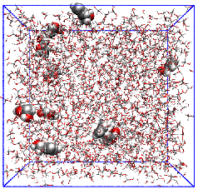 | 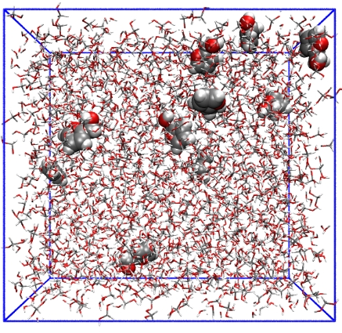 | 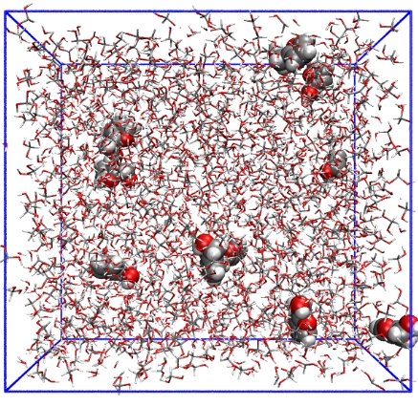
0 ns | 10 ns | 20 ns
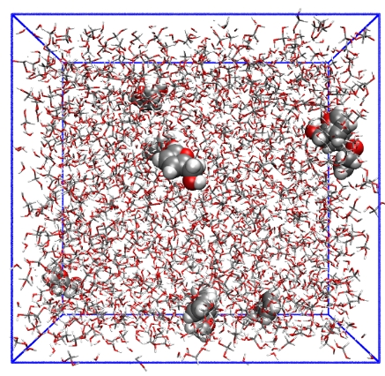 | 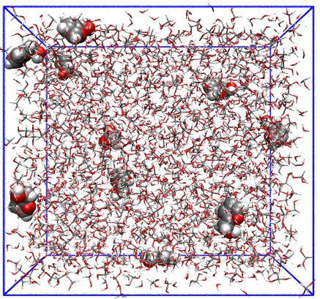 | 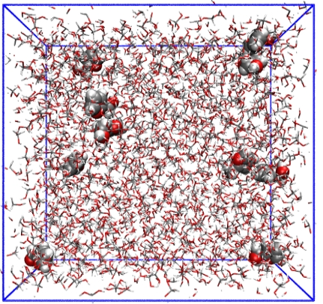
30 ns | 40 ns | 50 ns
Supplementary Fig. 12. Snapshots of formalin systems before and after molecular dynamics simulation. Simulation conditions: 1 furfuryl alcohol molecule corresponds to 98 formaldehyde hydrate molecules, 83 water molecules.

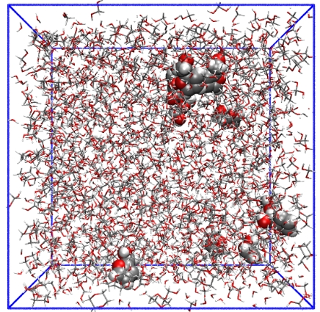 | 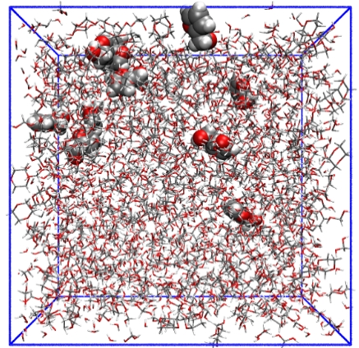 | 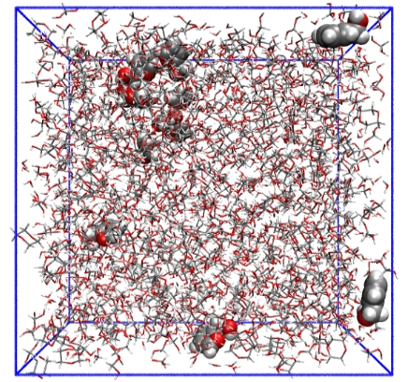
0 ns | 10 ns | 20 ns
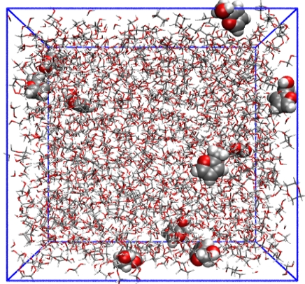 | 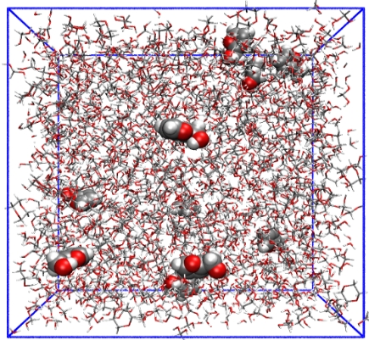 | 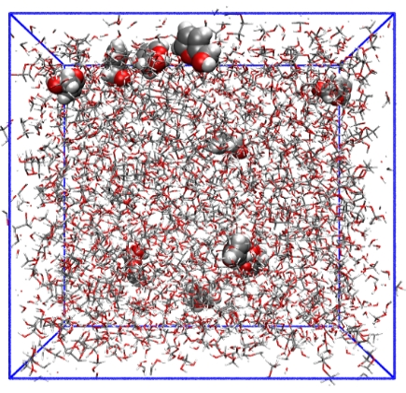
30 ns | 40 ns | 50 ns
Supplementary Fig. 13. Snapshots of formalin/1,4-dioxane mixture systems before and after molecular dynamics simulation. Simulation conditions: 1 furfuryl alcohol molecule corresponds to 78 formaldehyde hydrate molecules, 67 water molecules, and 23 1,4-dioxane molecules.

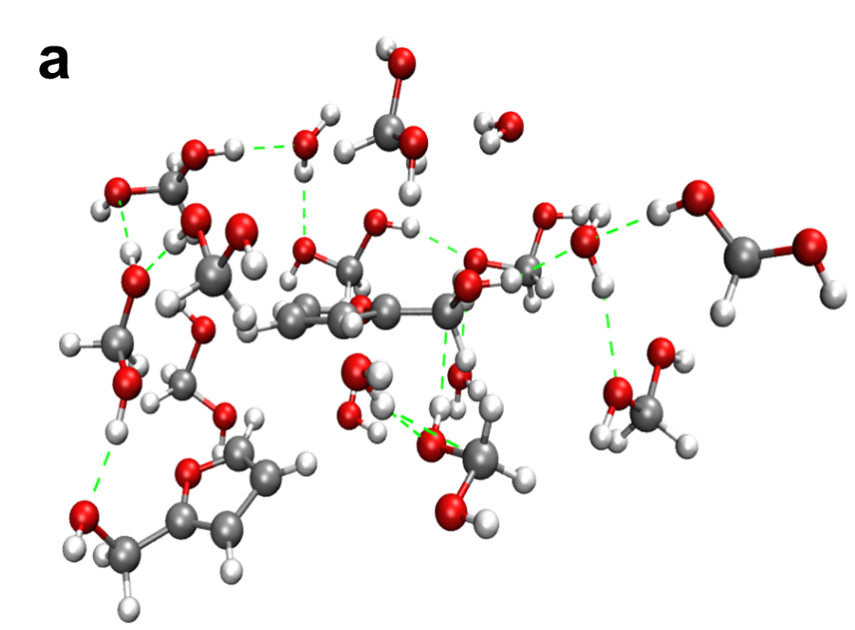 | 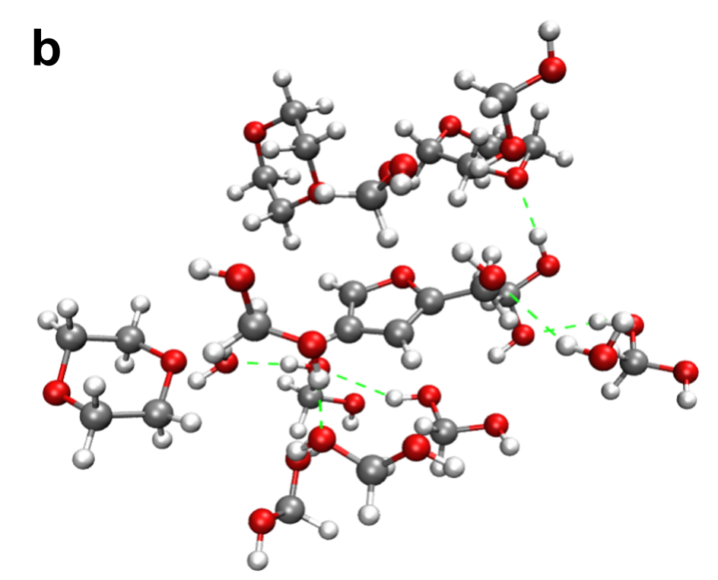
Supplementary Fig. 14. Coordination of FA with solvent molecules. Formalin systems (a), formalin/1,4-dioxane mixture systems (b).

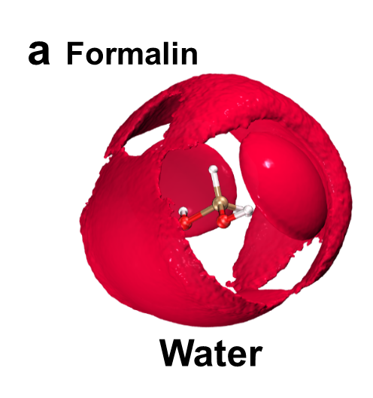
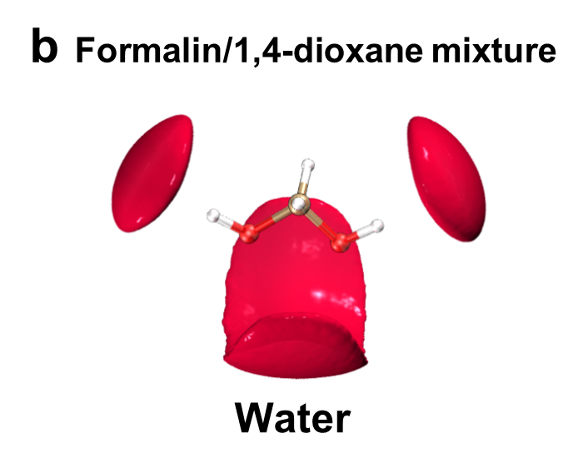 | 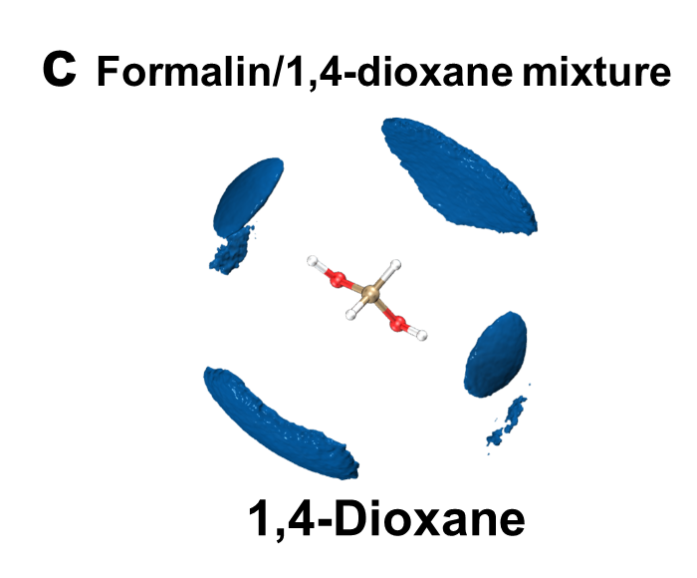
Supplementary Fig. 15. Spatial density functions (SDF) of water (red) (a) around formaldehyde hydrate in the formalin system. Spatial density functions (SDF) of water (red) (b) and 1,4-dioxane (purple) (c) around formaldehyde hydrate in co-solvent system. Formalin system: 1 furfuryl alcohol molecule corresponds to 98 formaldehyde hydrate molecules, 83 water molecules. Formalin/1,4-dioxane mixture system: 1 furfuryl alcohol molecule corresponds to 78 formaldehyde hydrate molecules, 67 water molecules, and 23 1,4-dioxane molecules.

Supplementary Fig. 16. FT-IR spectra of formaldehyde, formaldehyde absorbed on USY-5.2 (a), formaldehyde absorbed on ZSM-5-25 (b).

Supplemental Tables
Supplementary Table 1. Hydroxymethylation of different furan platform.
Reactant-  furan platform | Product-  C6 platform | Temperature  and time | C5 platform conversion (%) | C6 platform  yield (%)
Furfural | HMF | 90 °C, 360 min | 80.5 | 18.7
2-Furoic acid | 5-(Hydroxymethyl) furan-2-carboxylic acid | 90 °C, 360 min | 70.8 | 34.7
FA | DHMF | 60 °C, 60 min | 67.5 | 41.6
Furan | DHMF | 60 °C, 60 min | - | 39.5
2-Methylfuran | 5-Hydroxymethyl-2-methylfuran | 60 °C, 60 min | 94.5 | 35.9
Reaction conditions: 0.10 g reactant, 0.10 g Hβ-29, 5 mL formalin.

Supplementary Table 2. The acidity of the samples.
Samples | 200 °C |  | 350 °C
Samples | B acid (μmol/g) | L acid (μmol/g) | B acid (μmol/g) | L acid (μmol/g)
Hβ-26 | 227.3 | 261.6 | 198.3 | 151.1
Hβ-29 | 203.3 | 234.9 | 151.2 | 135.9
Hβ-38 | 142.6 | 161.2 | 111.0 | 89.3
Hβ-29ª | 98.7 | 113.8 | 77.6 | 98.3
Hβ-29^{b} | 202.7 | 225.9 | 150.6 | 133.8
USY-5.2 | 334.2 | 261.2 | 274.2 | 73.4
ZSM-5-25 | 426.1 | 65.1 | 242.7 | 20.1
Analyzed by in-situ FTIR spectra of surface species derived from pyridine-adsorption
ªSpent Hβ-29 catalyst after the first run.
^{b}Regenerated Hβ-29 catalyst after the first run by calcination.

Supplementary Table 3. Textural properties of various catalysts.
Entry | Catalyst | BET surface area, m² g^{–1} | Pore volume, cm³ g^{–1} | Pore diameter, nm
1 | Hβ-26 | 556.31 | 0.22 | 2.21
2 | Hβ-29 | 590.25 | 0.30 | 2.45
3 | Hβ-38 | 619.26 | 0.31 | 2.51
4 | Hβ-29ª | 300.80 | 0.24 | 3.14
5 | Hβ-29^{b} | 557.59 | 0.29 | 2.56
6 | USY-5.2 | 382.08 | 0.41 | 3.41
7 | ZSM-5-25 | 210.23 | 0.12 | 2.19
ªSpent Hβ-29 catalyst after the first run.
^{b}Regenerated Hβ-29 catalyst after the first run by calcination.

Supplementary Table 4. FA adsorption on molecular sieve catalysts.
Entry | Catalyst | FA adsorption, %
Entry | Catalyst | 20 °C | 60 °C
1 | Hβ-26 | 60.7 | 87.9
2 | Hβ-29 | 71.8 | 97.1
3 | Hβ-38 | 73.9 | 98.7
4 | USY-5.2 | 0.3 | 2.2
5 | ZSM-5-25 | 30.7 | 46.2
Reaction conditions: 0.10 g FA, 1 g molecular sieve catalysts, 5 mL water, 60 min.

Supplementary Table 5. Hydroxymethylation of different furan platform and in different solvent system.
Reactant-  furan platform | Product-  C6 platform | Solvent system | Temperature  and time | C5 platform conversion (%) | C6 platform  yield (%)
Furfural | HMF | Formalin | 90 °C, 360 min | 80.5 | 18.7
Furfural | HMF | Formalin  /1,4-dioxane mixture | 90 °C, 360 min | 87.6 | 28.9
2-Furoic acid | 5-(Hydroxymethyl) furan-2-carboxylic acid | Formalin | 90 °C, 360 min | 70.8 | 34.7
2-Furoic acid | 5-(Hydroxymethyl) furan-2-carboxylic acid | Formalin/  1,4-dioxane mixture | 90 °C, 360 min | 66.5 | 41.2
FA | DHMF | Formalin | 60 °C, 60 min | 67.5 | 41.6
FA | DHMF | Formalin/  1,4-dioxane mixture | 60 °C, 60 min | 84.3 | 76.4
Furan | DHMF | Formalin | 60 °C, 60 min | - | 39.5
Furan | DHMF | Formalin/  1,4-dioxane mixture | 60 °C, 60 min | - | 74.9
2-Methylfuran | 5-Hydroxymethyl-2-methylfuran | Formalin | 60 °C, 60 min | 94.5 | 35.9
2-Methylfuran | 5-Hydroxymethyl-2-methylfuran | Formalin/  1,4-dioxane mixture | 60 °C, 60 min | 97.3 | 57.8
Reaction conditions: 0.10 g reactant, 0.10 g Hβ-29. Formaldehyde: 5 mL formaldehyde; formalin/1,4-dioxane mixture: 4 mL formaldehyde+1 mL 1,4-dioxane.
Supplementary Table 6. Reaction rate constant of each step at different temperatures.
Reaction temperature (°C) | K₁ (min⁻¹) |  | K₂ (min⁻¹) |  | K₃ (min⁻¹) |  | R²
Reaction temperature (°C) | a | b | a | b | a | b | a | b
30 | 0.0007331 | 0.0014784 | 0.0002504 | 0.0000636 | 0.0001528 | 0.0000246 | 0.9568 | 0.9959
40 | 0.0027158 | 0.0046465 | 0.0007276 | 0.0001162 | 0.0004569 | 0.0002763 | 0.9605 | 0.9944
50 | 0.0070307 | 0.0112828 | 0.0020289 | 0.0004325 | 0.0008598 | 0.0006321 | 0.9856 | 0.9966
60 | 0.0159938 | 0.0282999 | 0.0047246 | 0.0004676 | 0.009828 | 0.0045392 | 0.9879 | 0.9528
70 | 0.0300003 | 0.0464254 | 0.0066301 | 0.0033449 | 0.0173315 | 0.0081929 | 0.9776 | 0.9725
Reaction conditions:
ª0.05 g FA, 0.10 g Hβ-29, 5 mL formaldehyde.
^{b}0.05 g FA, 0.10 g Hβ-29, 4 mL formaldehyde +1 mL 1,4-dioxane.

Supplementary Table 7. The stability of FA and DHMF in different solvents.
Time | Formaldehyde |  | Formalin/1,4-dioxane mixture
Time | FA retention, % | DHMF retention, % | FA retention, % | DHMF retention, %
30 min | 91.3 | 81.4 | 95.1 | 92.5
60 min | 87.5 | 74.9 | 90.6 | 91.4
90 min | 85.1 | 72.3 | 87.4 | 89.7
120 min | 82.2 | 68.5 | 85.7 | 88.9
Formaldehyde: 5 mL formaldehyde; formalin/1,4-dioxane mixture: 4 mL formaldehyde+1 mL 1,4-dioxane. Reaction conditions: 0.05 g FA or DHMF, 60 °C.

