When is health inequality acceptable?
Appraisals of inevitability, complexity and causal explanations

Supplemental Materials and Analysis

Supplemental Methods and Analysis for Study 1
Methods
Participants and Design
In total, 701 participants (351 from UK Prolific and 350 from US Prolific) completed this study. Participants had a mean age of 38.27 (SD = 13.93, 18-83) and 447 (63.77%) identified as female, 249 (35.52%) identified as male, four identified as non-binary and one as agender. In addition to the 602 participants who were allocated to the six bases of categorization and are reported in the main manuscript, an additional 99 participants took part in the study and were allocated to a condition in which no basis of categorization was provided. These participants were not asked to provide ratings of acceptability, priority, malleability or inevitability, responding to causal explanations only, and therefore were not reported in the main manuscript.
Materials
Participants in all seven conditions were asked to indicate to what extent differences in life expectancy (by the given basis of categorization) were “driven by chance”, “driven by biological factors (such as genetics, hormones, evolutionary)”, “driven by psychological factors (such as traits, choices, motivations)” and “driven by sociocultural factors (such as social role, opportunities, childhood experiences, culture)”. The order in which the four explanations were presented was randomized and all were responded to on a scale where 0 = not at all driven by and 100 = strongly driven by. We refer to these variables as measures of perceived causation. On the next page, they were then presented with a similar question and response options, which instead asked participants “to what extent do you think differences in life expectancy (by the provided basis of categorization) should be driven by the following factors” (henceforth, ‘ideal causation’).
Results
Causal Explanations. Ratings of each causal explanation are presented in Figure S3 separated by basis of categorization and perceived-ideal. Perceived explanations were generally higher than ideal explanations and this was notably the case for chance and, to a lesser extent, biological causes. The following exploratory ANOVAs and follow-up contrasts confirm this pattern.
An initial mixed 7 (between: basis of categorization) x 4 (within: causal explanation) x 2 (within: perceived-ideal) revealed main effects of basis of categorization (F(6,682) = 5.019, p < .001, η² = 0.010), causal explanation (F(3,2046) = 81.98, p < .001, η² = 0.035), and perceived-ideal (F(1,682) = 457.43, p < .001, η² = 0.070), as well as interactions between causal explanation and basis of categorization (F(18,2046) = 10.26, p < .001, η² = 0.026), causal explanation and perceived-ideal (F(3,2046) = 163.77, p < .001, η² = 0.045) and a three-way interaction (F(18,2046) = 3.69, p < .001, η² = 0.006).
Simple main effects contrasts for perceived-ideal were conducted for each causal explanation to unpack the two-way interaction between these variables. Ratings were always significantly higher for perceived than ideal causal explanations but this was most strongly the case for chance explanations and least the case for psychological and sociocultural explanations (chance, F(1) = 765.84, p < .001; biological, F(1) = 107.09, p < .001; psychological, F(1) = 32.38, p < .001; sociocultural, F(1) = 31.06, p < .001).
The three-way interaction was deconstructed with separate 7 (basis of categorization) x 4 (causal explanation) mixed ANOVAs conducted for perceived and ideal causal explanation ratings. For perceived ratings, there were main effects of basis of categorization (F(6,688) = 4.152, p < .001, η² = 0.011), causal explanations (F(3,2064) = 130.059, p < .001, η² = 0.098) and an interaction (F(18,2064) = 12.899, p < .001, η² = 0.058). Simple main effects examined effects of categorization at each level of explanation. There was no effect of categorization on biological explanations (F(6) = 0.871, p = .515), whilst there were effects of basis of categorization for psychological (F(6) = 20.019, p < .001), sociocultural (F(6) = 5.131, p < .001) and chance explanations (F(6) = 11.134, p < .001). Figure S3 shows that psychological ratings were highest in the no-basis and genetics conditions, whilst sociocultural and chance ratings were lowest for genetics.
For ideal ratings there were also main effects of categorization (F(6,686) = 3.959, p < .001, η² = 0.013), causal explanation (F(3,2058) = 103.739, p < .001, η² = 0.077) and an interaction (F(18,2058) = 3.911, p < .001, η² = 0.017). Simple main effects revealed no effects of categorization on biological (F(6) = 1.684, p = .122) or chance (F(6) = 1.658, p = .129) explanations, but significant effects on psychological (F(6) = 9.588, p < .001) and sociocultural explanations (F(6) = 2.44, p = .024). Participants indicated that psychological factors should play the greatest role for life expectancy differences by genetics and the no-basis condition. They also indicated that sociocultural factors should be greater for life expectancy by lifestyle than life expectancy by genetics.
Between-country analyses. We conducted unplanned analyses to examine whether effects of categorization interacted with country for each key variable. Separate 2 (country, UK; US) x 6 (categorization) between-subjects ANOVAs were conducted for judgments of acceptability, priority, malleability and inevitability. There were no main effects of country for acceptability, priority or malleability, however, inevitability ratings were significantly higher in the UK compared to the US (F(1,586) = 4.64, p = .032, η² = 0.008). No interactions between country and categorization reached significance (ps <.07).
Categorical Mediation. We intended to determine whether perceptions of malleability and inevitability predicted acceptability and priority ratings. In order to directly ascertain whether these ratings varied with categorization and explore mediating effects, we replaced planned analyses with a multi-categorical mediation model, using PROCESS.(1) Bases of categorization were dummy coded with education as a reference category. Perceptions of malleability and inevitability ratings were included as parallel mediators and age, being in the UK (vs. US) and being male (vs. all other genders) were included as covariates of interest.
Table S2 reports the direct and indirect effects from this model for acceptability and priority ratings. Acceptability was higher and priority ratings lower for male respondents than those with other identified-genders. There were also total main effects of categorization: relative to education as a category, acceptability was significantly higher for genetics and lifestyle choices. Priority ratings showed the opposite pattern: these ratings were lower for genetics and lifestyle categories (relative to education). These effects of categorization were partially mediated through malleability and inevitability. Relative to education-related inequality, genetics-related inequality was seen as comparatively more inevitable and this explained 14.53% of the total effect of this category on acceptability.
There were also indirect effects of malleability, for genetics, social class and neighbourhood relative to education. These three categorization bases were viewed as significantly less malleable than education and this partly explained their lower acceptability. In the case of genetics, this operated as a suppressor effect against the total effect of increased acceptability. In sum, 88.94% of the direct effect of a genetic categorization basis (relative to education) was direct, -3.49% was indirect through ratings of malleability and 14.52% was indirect through inevitability ratings.
A similar pattern of negative indirect effects through ratings of malleability was observed for priority ratings. Relative to education-related inequality, differences by genetics, social class and neighbourhood were viewed as less malleable and subsequently lower in priority to address.
Study 1 Supplemental Results Summary
A number of aspects of the analysis of causal explanations in Study 1 indicated that participants were not interpreting these questions as we would expect them to. For instance, we did not observe any effects of categorization on biological explanations, which should be highest for genetics. Rather, the most highly endorsed causal explanation for genetics as a basis of categorization was psychological. Chance explanations were viewed as contributing a great deal to most bases of categorization but least of all to genetics, which again ran directly counter to expectations. Our primary concern was that respondents were interpreting superordinate category labels and exemplars (e.g., biological factors such as genetics, hormones, evolutionary factors) rather differently to how they would if these were presented as individual factors, as in Nettle et al.(2)
We also observed main effects of perceived-ideal, which indicated that causal ratings were always higher for perceived than ideal causal explanations and this was most strongly the case for chance explanations. One possibility was that, in the case of the final ideal causation questions, participants were interpreting these questions as further indicators of whether there should be different kinds of life expectancy inequalities, rather than meaningful judgments about the causes that might or should drive them. We therefore applied alternative wording for questions about ideal causal explanations in Study 2, to address this.

Supplemental Methods and Analysis for Study 1
Methods
Materials
To measure ideal causation, participants were presented with text stating that Some people think that there will always be differences in life expectancy due to [basis of categorization]. Assuming that is true and that there will always be some differences in life expectancy due to [basis of categorization], to what extent do you think should these SHOULD BE driven by the following factors. The same 12 factors and response options were presented as in the previous question.
Results
Malleability, Inevitability and Complexity. In order to determine whether explanation target influenced malleability, inevitability and complexity ratings, these were subject to a 6 (categorization basis: income, neighbourhood, education, genetics, lifestyle, social class) x 2 (explanation target: life expectancy by categorization basis, categorization basis) between-subjects MANOVA. There was a main effect of categorization (F(5,600) = 8.552, p < .001) and an effect of explanation target (F(1,600) = 3.41, p = .017) but the interaction (F(5,600) = 1.086, p = .364) did not reach significance. However, the corresponding 6 x 2 ANOVA for inevitability ratings, did reveal a role for explanation target. For this variable only, there was a significant main effect of explanation target (F(1,601) = 5.052, p = .025, η² = 0.007) and an interaction (F(5,601) = 2.323, p = .042, η² = 0.017). Inevitability ratings were higher when the explanation target was basis of categorization (e.g., differences by education) than life expectancy by categorization (e.g., life expectancy differences by education). The exceptions to this were lifestyle choices (no difference as a function of target) and social class, where the reverse pattern was observed (see Figure S4).
Causal Explanations. In line with the pre-registration, the perceived causal explanation components were subjected to a 6 (basis of categorization: income, neighbourhood, education, genetics, lifestyle, social class) x 2 (explanation target: life expectancy by categorization basis, categorization basis) between-subjects MANOVA. The MANOVA revealed a main effect of categorization (F(5,601) = 16.47, p < .001) and a significant interaction (F(5,601) = 3.07, p < .001), but no main effect of explanation target (F(1,601) = .960, p = .429). Corresponding 6 x 2 ANOVAs on each perceived causal explanation component showed that the categorization x explanation target was significant for all components (biological, F(5,602) = 3.58, p = .003; sociocultural, F(5,601) = 3.49, p = .004; psychological, F(5,602) = 3.02, p = .011) except for chance (F(5,602) = 1.60, p = .158). Simple main effects analyses on biological explanations showed that these were significantly higher for genetics per se compared to life expectancy by genetics (p = .0012), and were significantly lower for income differences compared to life expectancy by income (p < .001), but that there were no other differences by explanation target (see Figure S4). Simple main effects analyses on sociocultural explanations showed that these were significantly lower for genetics per se than life expectancy by genetics (p < .001; no other significant effects). Simple main effects on psychological explanations revealed that these were significantly lower for genetics per se compared to life expectancy by genetics (p = .027) but also higher for education per se than life expectancy by education (p = .016).
Rather than the pre-registered 7 (basis of categorization) x 2 (perceived/ideal causation) MANOVA on causal explanations, we conducted an initial 7 (between-subjects: basis of categorization) x 2 (repeated measures: perceived/ideal) x 4 (repeated measures: causal explanation) mixed ANOVA to determine whether any interactions between categorization basis and perceived-ideal causation varied for the four causal explanation dimensions (see Figure S5). There were main effects of causal explanation (F(Greenhouse-Geisser corrected: 2.59,1835.20) = 181.65, p < .001, η² = 0.073), perceived/ideal (F(1,708) = 133.31, p < .001, η² = 0.012) and categorization basis (F(6,708) = 12.75, p < .001, η² = 0.033). There were significant two-way interactions between causal explanation and basis of categorization (F(15.55,541.85) = 29.67, p < .001, η² = 0.072) and between causal explanation and perceived/ideal (F(2.69,1903.72) = 158.05, p < .001, η² = 0.028) as well as a three-way interaction (F(16.13,1903.72) = 3.13, p < .001, η² = 0.003). Generally, perceived explanations were higher than for ideal, but this was most notably the case for perceived sociocultural explanations which were significantly higher than ideal sociocultural explanations across all seven bases of categorization (ps < .001; see Figure S5).
Between-country analyses. Figure S6 shows acceptability and support for intervention ratings by basis of categorization and country. Additional analyses again examined whether effects of categorization interacted with country for each appraisal. Separate 2 (country, UK; US) x 6 (categorization) between-subjects ANOVAs were conducted for judgments of acceptability, priority, malleability, inevitability, complexity and each of the four perceived causal explanations. There were main effects of country for support for intervention (F(1,703) = 4.10, p = .043, η² = 0.005) and inevitability judgments (F(1,703) = 6.076, p = .014, η² = 0.008), both of which were higher in the UK. There were no interactions between country and categorization with the exception of sociocultural explanations (F(1,703) = 2.67, p = .015, η² = 0.020). Simple main effects of country for each categorization basis showed that US respondents rated sociocultural explanations significantly lower than UK respondents in the genetics category only (p < .001).
In order to examine whether country moderated any of the mediation pathways, we conducted an unplanned moderated mediation model using the PROCESS macro. Specifically, we examined whether being in the UK (vs. US) moderated (i) each direct effect of basis of categorization (vs. no-basis) on acceptability and support for intervention, and (ii) both a and b pathways of the indirect effects. Models included age and being male as covariates and all seven parallel mediators were included for comparison with the main analyses. Standard errors were robust to heteroscedasticity (Cribari-Neto) and 10,000 bootstraps were drawn to obtain confidence intervals for indirect effects. There were no significant interactions with UK for any of the pathways for support for intervention. Psychological explanations interacted with UK to predict acceptability ratings (B = .237, SE = .106, p = .024). Conditional effects of psychological explanations on acceptability ratings showed that these were significant for the UK sample (B = .368, SE = .070, p < .001) but not the US sample (B = .130, SE = .079, p = .097). There were no other significant interactions with UK. Care is needed not to overinterpret these findings, however. Whilst this approach is appropriate for confirming moderation of mediation, the absence of significance effects does not disconfirm moderation mediation.(1, 3)

References
1. Hayes A. Introduction to Mediation, Moderation, and Conditional Process Analysis: A Regression-Based Approach: Guilford Press; 2013.
2. Nettle D, Frankenhuis W, Panchanathan K. Biology, society, or choice: How do non-experts interpret scientific explanations of behaviour? Open Mind. 2023.
3. Hayes AF, Rockwood NJ. Conditional process analysis: Concepts, computation, and advances in the modeling of the contingencies of mechanisms. American Behavioral Scientist. 2020;64(1):19-54.

Figure S1. Screenshot depicting text, graphical representation and questions on acceptability and priority as presented to participants in the social class condition in Study 1.
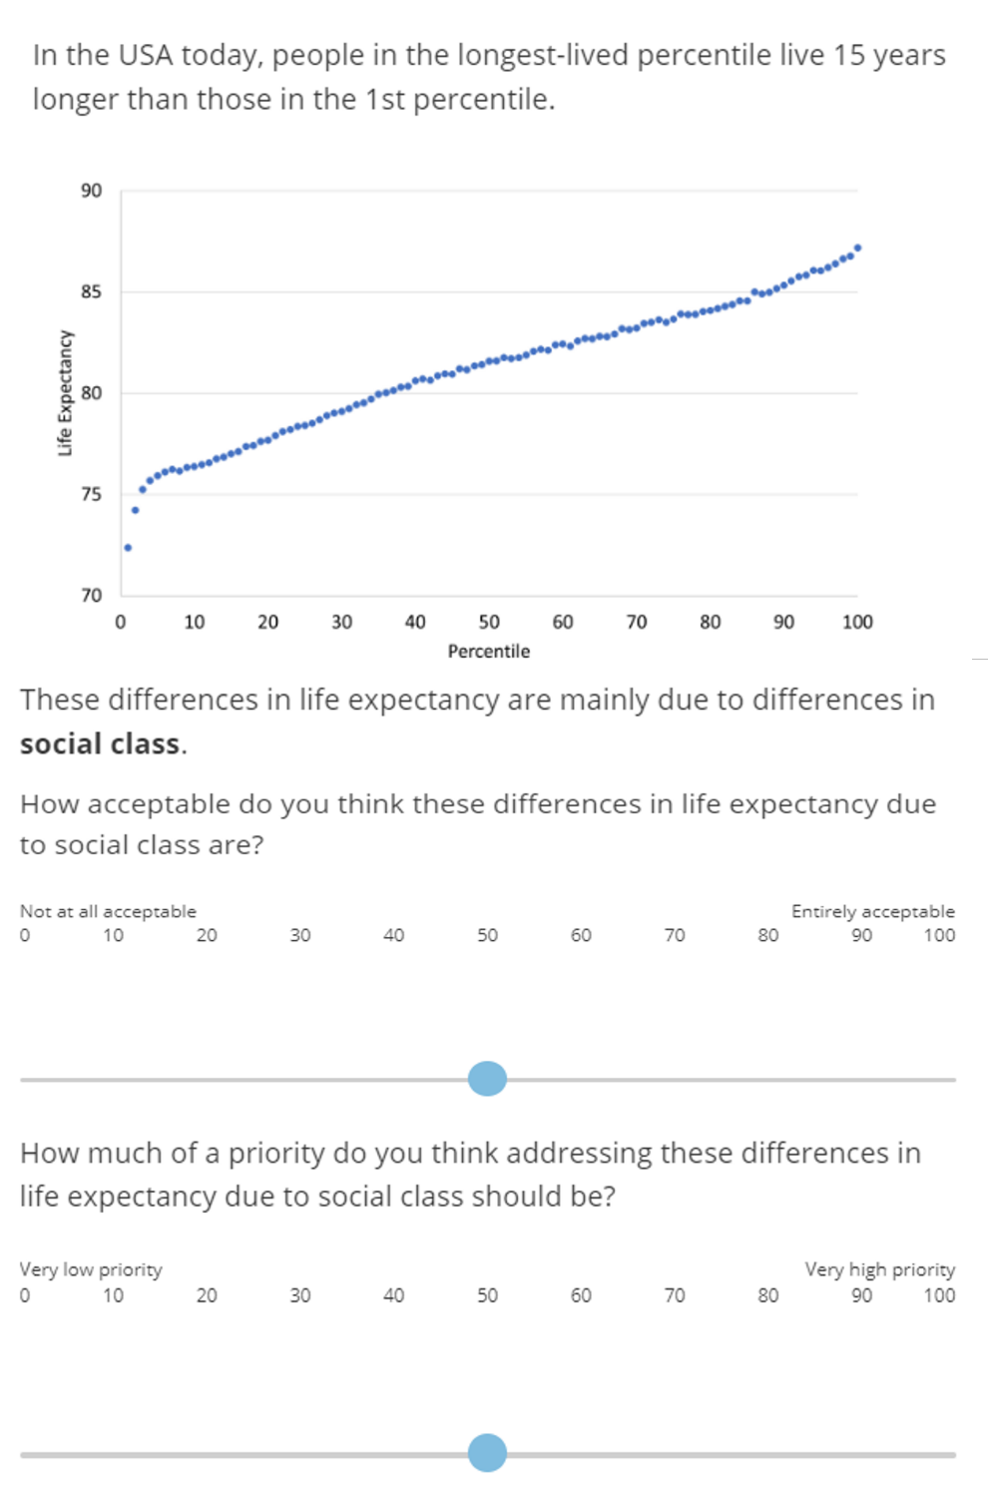

Figure S2. Distribution and density plots of participants’ answers to questions on how easily something could be done about life expectancy differences (malleability), for each basis of categorization in Study 2. Thick lines represent the mean and shaded boxes depict 95% confidence intervals.

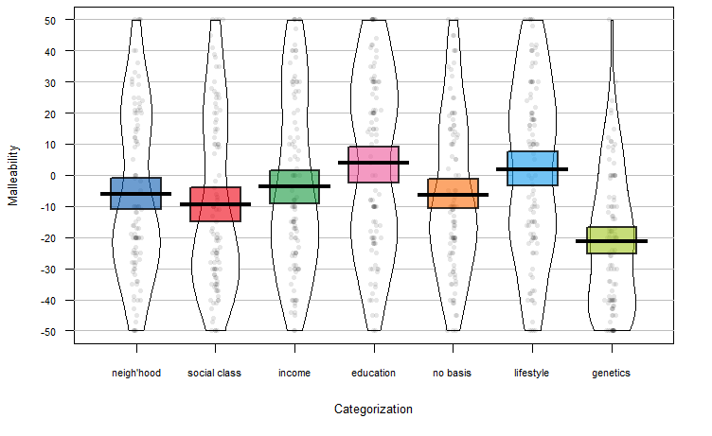

Figure S3. Distribution and density plots of extent to which differences are (perceived) and should be (ideal) driven by biological (upper left), chance (upper right), sociocultural (lower left) and psychological explanations (lower right), in Study 1. Thick lines represent the mean and shaded boxes depict 95% confidence intervals.

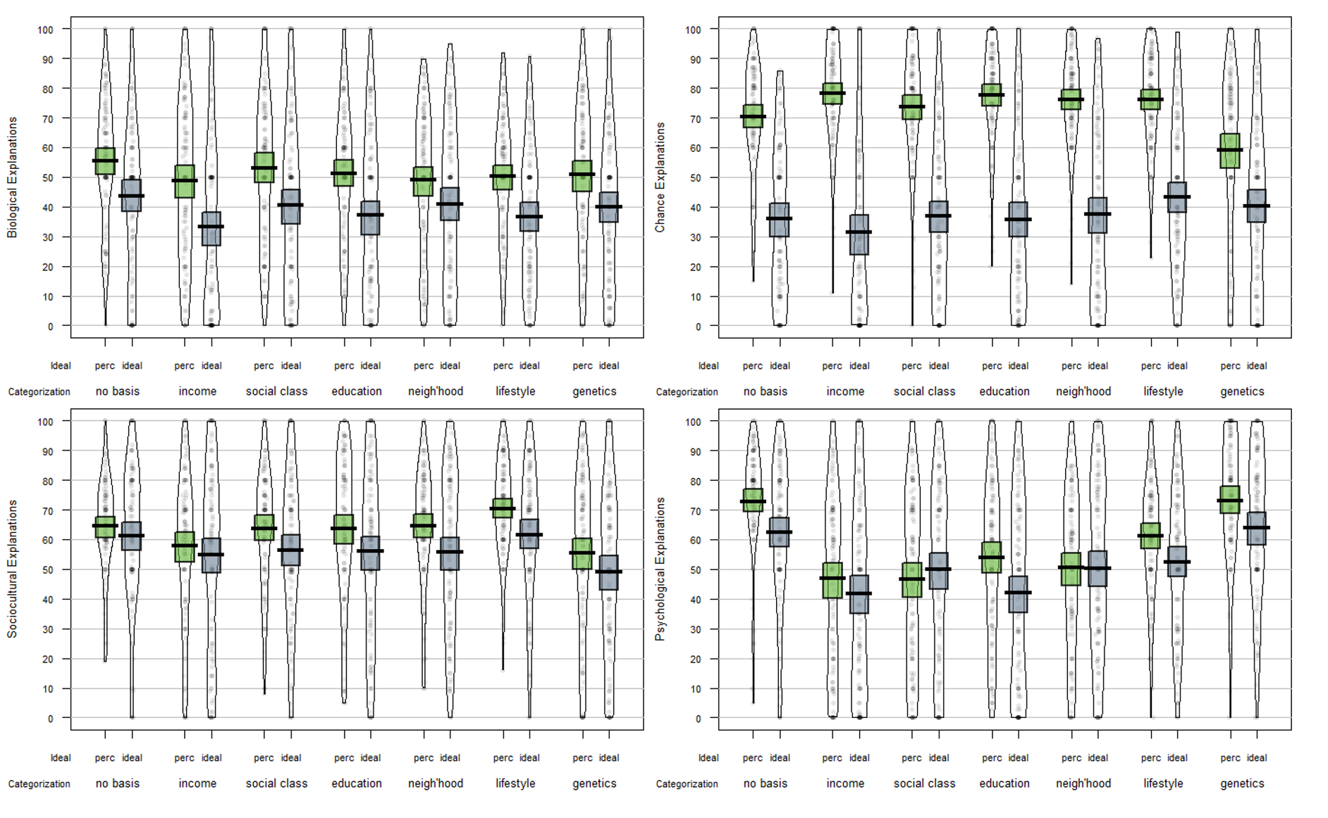

Figure S4. Distribution and density plots of inevitability (upper left), biological (upper right), sociocultural (lower left) and psychological explanations (lower right), in Study 2, by explanation target and categorization. Thick lines represent the mean and shaded boxes depict 95% confidence intervals.
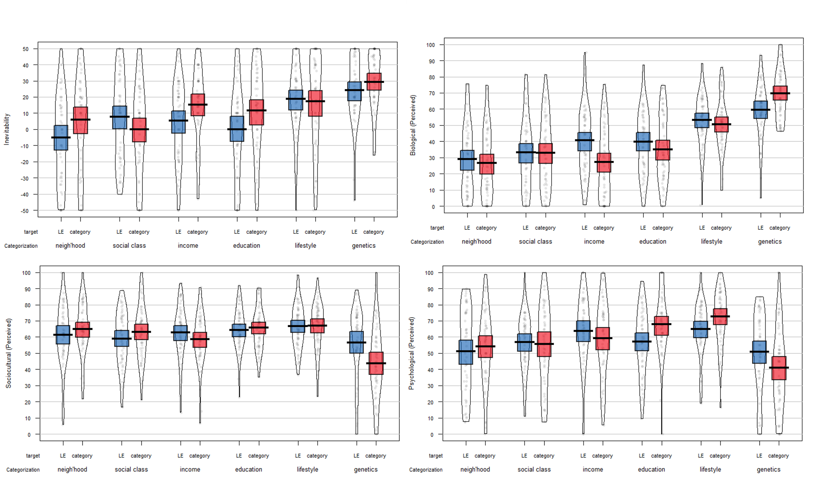
Figure S5. Distribution and density plots of extent to which differences are (perceived) and should be (ideal) driven by biological (upper left), chance (upper right), sociocultural (lower left) and psychological explanations (lower right), in Study 2. Thick lines represent the mean and shaded boxes depict 95% confidence intervals.
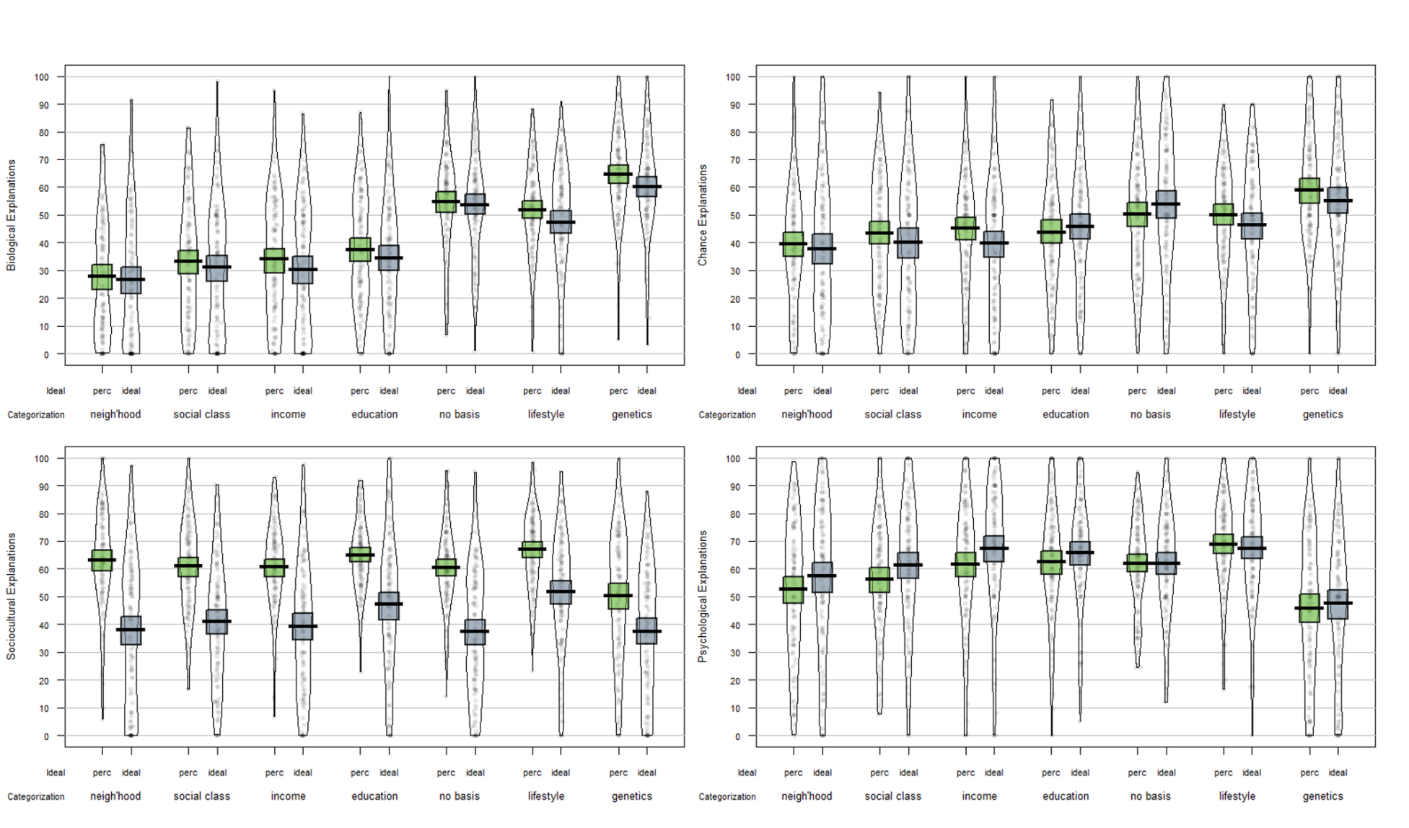

Figure S6. Distribution and density plots of participants’ answers to questions on how acceptable (left), how much of a priority (right), for each basis of categorization in Study 2 and for UK respondents on the left and US respondents on the right. Thick lines represent the mean and shaded boxes depict 95% confidence intervals.
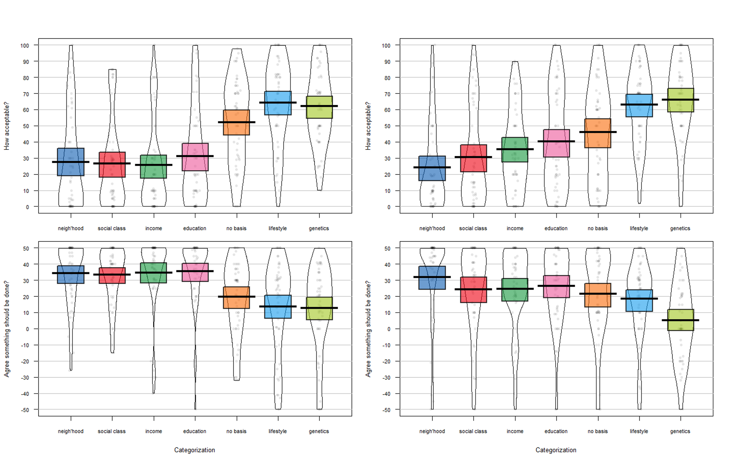
Table S1. Zero-order correlations in Study 1 (n ~ 597)
Variable | 2 | 3 | 4
1. Acceptability | —
2. Priority | .363*** | —
3. Malleability | .052 | .247*** | —
4. Inevitability | .354*** | -.099* | -.091*

Table S2. Total and indirect effects for multi-categorical mediation model predicting ratings of acceptability and how much of a priority in Study 1. Parentheses report upper and lower 95% confidence intervals (based on 10,000 bootstrap samples). ***p < .001, **p < .01, *p < .05.

 |  | How acceptable? |  | How much of a priority?
 |  | B | UL,LL 95% CI | B | UL,LL 95% CI
 | Intercept | 28.24*** | 18.74,37.75 | 79.88*** | 72.44,87.32
Category | No basis (ref)
 | Income | -7.97 | -16.03,.08 | .71 | -5.91,7.33
 | Neighbourhood | 2.16 | -5.93,10.25 | -4.30 | -10.52,1.91
 | Social Class | -1.65 | -9.82,6.51 | -3.15 | -9.49,3.18
 | Genetics | 33.87*** | 25.85,41.89 | -16.77*** | -23.68,-9.87
 | Lifestyle Choices | 30.16*** | 22.58,37.74 | -7.28* | -13.45,-1.11
Covariates | UK | -3.12 | -7.75,1.51 | -.55 | -4.55,3.45
 | Male | 7.36** | 2.54,12.18 | -5.28* | -9.38,-1.19
 | Age | .09 | -.09,.26 | -.07 | -.23,.08
 |  | Indirect Effects |  | Indirect Effects
Neighbourhood | Malleability | -1.04 | -2.35,-.08 | -2.07 | -3.98,-.55
Social Class | Malleability | -1.33 | -2.85,-.16 | -2.60 | -4.63,-.98
 | Inevitability | 3.20 | .28,6.33
Genetics | Malleability | -1.19 | -2.61,-.13 | -2.26 | -4.15,-.72
 | Inevitability | 4.92 | 2.01,8.09

Table S3. Overview of design and sample size per cell in Study 2

 |  | Basis of Categorization
Sample | Explanation target | income | n'hood | education | genetics | lifestyle | social class | no basis
UK | Life expectancy by basis | 29 | 25 | 26 | 25 | 26 | 26 | 53
 | Basis of categorization | 26 | 25 | 26 | 25 | 26 | 26 | 53
US | Life expectancy by basis | 25 | 26 | 26 | 25 | 26 | 25 | 51
 | Basis of categorization | 25 | 25 | 25 | 26 | 25 | 25 | 51

Table S4. Zero-order correlations in Study 2 (n ~ 717)
Variable | 1 | 2 | 3 | 4 | 5 | 6 | 7 | 8 | 9 | 10 | 11 | 12
1. Acceptability | —
2. Something should be done | -.600*** | —
3. Malleability | -.048 | .189*** | —
4. Inevitability | .456*** | -.376*** | -.216*** | —
5. Complexity | -.013 | -.018 | -.435*** | .102** | —
6. Biological (perceived) | .439*** | -.273*** | -.094* | .304*** | .108** | —
7. Chance (perceived) | .293*** | -.199*** | -.159*** | .281*** | .154*** | .549*** | —
8. Sociocultural (perceived) | -.033 | .133*** | .115** | .012 | -.045* | .091* | .067 | —
9. Psychological (perceived) | .258*** | -.192*** | .075* | .262*** | -.083* | .235*** | .227*** | .477*** | —
10. Biological (ideal) | .443*** | -.265*** | -.031 | .258*** | .034 | .749*** | .418*** | .013 | .171*** | —
11. Chance (ideal) | .244*** | -.133*** | -.003 | .172*** | .093* | .383*** | .514*** | .050 | .138*** | .510*** | —
12. Sociocultural (ideal) | .282*** | -.125*** | .105** | .141*** | -.136*** | .297*** | .222*** | .423*** | .418*** | .368*** | .208***
13. Psychological (ideal) | .143*** | -.129*** | .006 | .210*** | -.030 | .105** | .083* | .390*** | .549*** | .065 | .045 | .360***

