Table 1: Optimization of reaction condition for synthesis of 1, 8-dioxo-octahydroxanthenes.
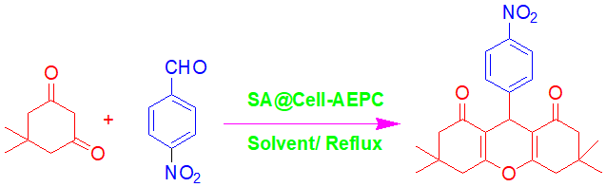
Entry | Catalyst  Quantity (g) | Reaction  Condition | Reaction  Time (min) | Isolated  Yield (%)ª
1 | 0.05 | Toluene/Reflux | 40 | 28
2 | 0.05 | Chloroform/Reflux | 40 | 34
3 | 0.05 | DCM/Reflux | 40 | 40
4 | 0.05 | Acetonitrile/Reflux | 40 | 45
5 | 0.05 | EDC/Reflux | 40 | 49
6 | 0.05 | THF/Reflux | 40 | 53
7 | 0.05 | Acetone/Reflux | 40 | 57
8 | 0.01 | Ethanol/Reflux | 40 | 75
9 | 0.03 | Ethanol/Reflux | 40 | 82
10 | 0.05 | Ethanol/Reflux | 40 | 93
Reaction conditions: Dimedone (2 mmol), 4-Nitrobenzaldehyde (1 mmol) and SA@Cell-AEPC in solvent (5 mL) at given condition. ª In all reaction 100% conversion were obtained.

Table 2: SA@Cell-AEPC catalyzed reaction between dimedone and aryl aldehydes.
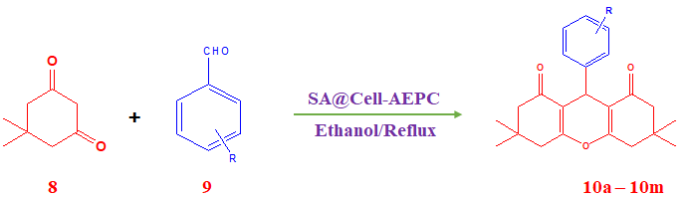
Entries | Aryl aldehyde (9) | Product (10) | Time (min) | Yield (%)ª
1 | Benzaldehyde | 10a | 50 | 90
2 | 4-Nitrobenzaldehyde | 10b | 40 | 93
3 | 4-Cyanobenzaldehyde | 10c | 35 | 92
4 | 4-Bromobenzaldehyde | 10d | 50 | 86
5 | 4-Chlorobenzaldehyde | 10e | 40 | 85
6 | 4-Methylbenzaldehyde | 10f | 50 | 86
7 | 4-Hydroxybenzaldehyde | 10g | 55 | 88
8 | 4-Methoxybenzaldehyde | 10h | 45 | 85
9 | 3-Methoxybenzaldehyde | 10i | 50 | 80
10 | 2-Nitrobenzaldehyde | 10j | 45 | 84
11 | 2,5-Dimethoxybenzaldehyde | 10k | 50 | 80
12 | 3,4,5-Trimethoxybenzaldehyde | 10l | 55 | 82
13 | Furfuraldehyde | 10m | 60 | 80
Reaction conditions: Dimedone (2 mmol), aryl aldehyde (1 mmol), and SA@Cell-AEPC (0.05 g, 0.0075 mmol) in ethanol (5 mL) were stirred at reflux condition. ª Isolated yield.

Table 3: SA@Cell-AEPC catalyzed synthesis of 2-substituted benzimidazole derivatives.
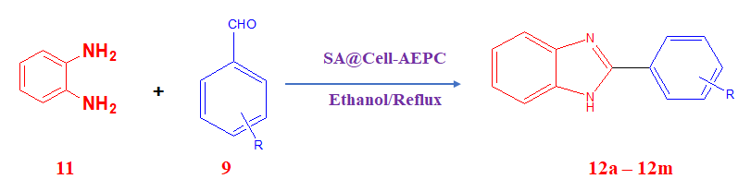
Entries | Aryl aldehyde (9) | Product (12) | Time (min) | Yield (%)ª
1 | Benzaldehyde | 12a | 70 | 88
2 | 4-Nitrobenzaldehyde | 12b | 65 | 92
3 | 4-Cyanobenzaldehyde | 12c | 60 | 92
4 | 4-Bromobenzaldehyde | 12d | 75 | 85
5 | 4-Chlorobenzaldehyde | 12e | 75 | 88
6 | 4-Hydroxybenzaldehyde | 12f | 80 | 86
7 | 4-Methylbenzaldehyde | 12g | 90 | 85
8 | 4-Methoxybenzaldehyde | 12h | 85 | 88
9 | 2-Nitrobenzaldehyde | 12i | 80 | 85
10 | Salicylaldehyde | 12j | 95 | 82
11 | 3,4,5-Trimethoxybenzaldehyde | 12k | 95 | 80
12 | Furfuraldehyde | 12l | 95 | 80
13 | Ferrocenecarboxyldehyde | 12m | 90 | 75
Reaction conditions: o-phenylenediamine (1 mmol), aryl aldehyde (1 mmol), and SA@Cell-AEPC (0.05 g, 0.0075 mmol) in ethanol (5 mL) were stirred at reflux condition. ª Isolated yield.

