Electronic Supporting Information (ESI)
Cellulose-based surface-modified heterogeneously feasible novel solid acid catalyst to access bioactive heterocycles
Shrikrishna Karhale^{1, 2}*, Ankush Kadam¹
- Department of Chemistry, Karmaveer Bhaurao Patil Mahavidyalaya Pandharpur (Autonomous), Dist. Solapur, Maharashtra, India. E-mail: sskarhale80@gmail.com
2 Department of Chemistry, R. B. Narayanrao Borawake College, Shrirampur (Autonomous), Dist. Ahmednagar, Maharashtra, India. E-mail: ankushkadam2009@gmail.com
_____________________________________________
Experimental:
i) General Remarks:
Chemicals like dimedone, ethylenediamine, Itaconic acid, chlorosulphonic acid, o-phenylenediamine and aryl aldehydes were purchased from local supplier and used without further purification. ¹H and ¹³C NMR spectra were recorded on Bruker AC NMR Spectrometer using TMS as an internal standard in CDCl₃. The chemical shifts (δ) are expressed in ppm. The morphology of catalyst was observed by using FESEM of MIRA3 TESCAN microscope. Solid state CP/MAS ¹³C-NMR spectrum was recorded on JEOL-ECX400 spectrometer while Perkin-Elmer Spectrum one FT-IR spectrophotometer is used for recording infrared spectrum.
ii) Preparation of N-(2-aminoethy) 2-pyrrlodone 4-carboxylic acid (3):
Itaconic acid (1) react with ethylenediamine (1:1) in ethanol under reflux for 12 h. The reaction mixture was cooled, and the precipitate was filtered and washed with ethanol; the product was then dried in vacuum at room temperature to afford the N-(2-aminoethyl)-2-pyrrolidone 4-carboxylic acid (3) as shown in Fig 2.
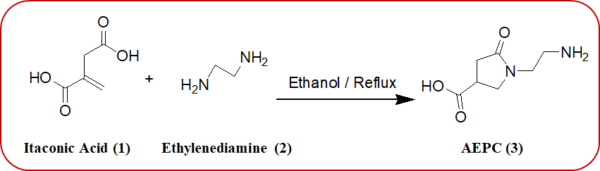
Fig. 2: Preparation of N-(2-aminoethy) 2-pyrrlodone 4-carboxylic acid (AEPC).
iii) Preparation of cellulose-alumina composite (5):
Cellulose-alumina composite (5) was prepared according to the literature method [1]. The calcination of composite (0.3 g) at 600 °C for 8 h gave 3.18 wt% aluminium oxide residue corresponding to 0.63 mmol/g of aluminium.
iv) Preparation of SA@Cell-AEPC (6):
In 25 mL RB flask, cellulose-alumina composite (3 g) reacted with N-(2-aminoethyl)-2-pyrrolidone-4-carboxylic acid (3.5 g) reflux in ethanol for 24 h. The reaction mixture was filtered, washed with ethanol and dried at room temperature to form amino-functionalized cellulose with good degree of organofunctionalization. Thereafter, chlorosulphonic acid was covalently grafted in the matrix of functionalized cellulose using free N-aminoethyl group resulting in the formation of desired catalyst acronymed as SA@Cell-AEPC (6). FT-IR (KBr) (cm⁻¹): 3406, 3162, 3005, 2927, 1680, 1156, 1053, 893, 739, 698, 594; ¹³C CP-MAS NMR (500 MHz.): δ 175.28 (s, carbonyl group), 103.89 (s, cellulose-C₁), 87.75 (s, cellulose-C₄), 73.80-71.37 (d, cellulose-C₂, C₃, C₅), 63.94 (s, cellulose-C₆), 49.63 (s, -CH- of AEPC skeleton), 37.20 (s, N-CH₂-CH₂), 35.37 (s, CH₂-CH₂-NHSO₃H); Back Titration Method: Loading 0.15 mmol [H⁺]/ gram of catalyst.
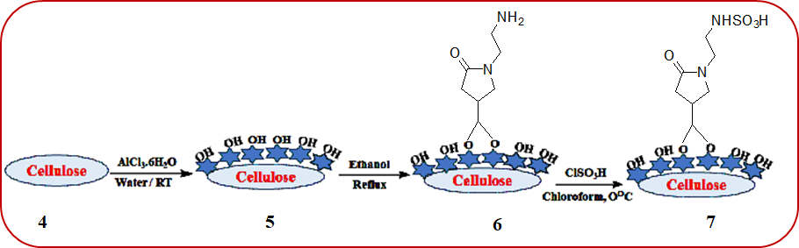
Fig. 3: Preparation of heterogeneous solid acid catalyst SA@Cell-AEPC.
General procedure for synthesis of 1, 8-dioxo-octahydroxanthenes:
The mixture of dimedone (2 mmol) and aryl aldehyde (1 mmol) in presence of SA@Cell-AEPC (0.05 g, 0.0075 mmol) was refluxed in ethanol (5 mL). On the completion of reaction (TLC monitored), reaction mixture was again diluted with hot ethanol (5 mL) and filtered to remove the catalyst. After the evaporation of solvent, crude product was recrystallized from ethanol to obtain the expected 1,8-dioxo-octahydroxanthenes.
General procedure for synthesis of 2-substituted benzimidazole derivatives:
In 25 mL RB flask, the mixture of o-phenylenediamine (1 mmol) and aryl aldehyde (1 mmol) in presence of SA@Cell-AEPC (0.05 g, 0.0075 mmol) was refluxed in ethanol (5 mL). On the completion of reaction (TLC monitored), reaction mixture was again diluted with hot ethanol (5 mL) and filtered to remove the catalyst. After the evaporation of solvent, crude product was recrystallized from ethanol to obtain the desired 2-substituted benzimidazole derivatives.
----------------------------------------------------------------------------------------------------------------
Spectral data of representative compounds:
1,8-dioxo-octahydroxanthenes:
3, 3, 6, 6-Tetramethyl-9-(phenyl)-1,8-dioxo-octahydroxanthene (Table 2, Entry 1):
Yield 90%, Mp. 200-201°C, (Mp. 200-202°C) Lit. [2]; FT-IR (KBr) (cm⁻¹): 3020, 2923, 1678, 1647, 1372, 1190, 1023, 897, 755, 629, 511; ¹H NMR (400 MHz, CDCl₃): δ (ppm) 7.28-7.55 (m, 5H, Ar-H), 5.23 (s, 1H, CH), 2.31-2.52 (m, 8H, CH₂), 1.18 (s, 6H, CH₃), 1.11 (s, 6H, CH₃); ¹³C NMR (100 MHz, DMSO-d₆): δ (ppm) 28.1, 30.6, 32.3, 118.5, 127.8, 130.9, 138.2, 181.1, 189.3, 190.4; MS(EI): m/z 348 [M]⁺.
3,3,6,6-Tetramethyl-9-(4-nitrophenyl)-1,8-dioxo-octahydroxanthene (Table 2, Entry 2):
Yield: 93%, Mp: 227-229 °C, (Mp. 226-230°C) Lit. [2]; FT-IR (KBr) (cm⁻¹): 3086, 3047, 2931, 2862, 1597, 1527, 1350, 1211, 948, 817, 732, 671; ¹H-NMR (400 MHz, CDCl₃): δ (ppm) 8.08-8.10 (d, J = 8.0 Hz, 2H), 7.46-7.48 (d, 2H), 4.82 (s, 1H), 2.49 (s, 4H), 2.14-2.27 (s, 4H), 1.11 (s, 6H), 0.98 (s, 6H); ¹³C-NMR (100 MHz, CDCl₃): δ (ppm) 27.2, 29.2, 32.3, 40.8, 50.5, 114.5, 123.4, 129.3, 146.4, 151.5, 162.9, 196.2; MS (EI): m/z 393 [M]⁺.
3,3,6,6-Tetramethyl-9-(4-cyanophenyl)-1,8-dioxo-octahydroxanthene (Table 2, Entry 3):
Yield: 92%, Mp. 218-220 °C, (Mp. 218-222°C) Lit. [2]; FT-IR (KBr) (cm⁻¹): 2970, 2931, 2229, 1396, 1056, 948, 871, 671, 594; ¹H-NMR (400 MHz, CDCl₃): δ (ppm) 7.51-7.53 (m, 2H, Ar-H), 7.26-7.42 (m, 2H, Ar-H), 4.77 (s, 1H, CH), 2.43-2.53 (m, 4H, CH₂), 2.14-2.26 (m, 4H, CH₂), 1.11 (s, 6H, CH₃), 0.98 (s, 6H, CH₃); ¹³C-NMR (100 MHz, CDCl₃): δ (ppm) 27.2, 29.2, 32.4, 40.8, 50.5, 110.2, 114.5, 119.0, 129.3, 131.9, 149.4, 162.8, 196.3; MS(EI): m/z 373 [M]⁺.
3,3,6,6-Tetramethyl-9-(4-bromophenyl)-1,8-dioxo-octahydroxanthene (Table 2, Entry 4):
Yield 86%, Mp. 237-240 °C, (Mp. 238-240°C) Lit. [2]; FT-IR (KBr) (cm⁻¹): 3011, 2933, 1643, 1347, 918, 845, 743, 651, 505; ¹H NMR (400 MHz, CDCl₃): δ (ppm) 7.23-7.59 (m, 4H), 4.72 (s, 1H), 2.44 (s, 8H), 1.21 (s, 6H), 1.08 (s, 6H); ¹³C NMR (100 MHz, CDCl₃): δ (ppm) 23.3, 28.5, 31.1, 32.8, 41.2, 52.3, 111.7, 124.1, 126.3, 128.4, 132.8, 141.2, 161.4, 190.7, 196.2; MS(EI): m/z 426 [M]⁺.
…………………………………………………………………………………………………..

2-substituted benzimidazole derivatives
2-Phenyl-1H-benzimidazole (Table 3, entry 1):
Yield: 88%, Mp. 291-292 °C, (Mp. 290-292°C) Lit. [3]; FT-IR (KBr) (cm⁻¹): 3368, 3022, 1581, 1392,1341, 1275, 980, 828, 779, 657; ¹H-NMR (400 MHz, CDCl₃): δ (ppm) 7.81-7.90 (m, 5H, Ar-H), 7.58-7.61 (m, 2H, Ar-H), 7.46-7.49 (m, 2H, Ar-H), 5.42 (s, 1H, NH); ¹³C-NMR: δ (ppm) (100 MHz, CDCl₃): 111.2, 123.1, 123.8, 126.5, 127.7, 128.6, 129.7, 130.4, 135.9, 144.1, 155.4; MS(EI): m/z 194 [M]⁺.

2-(4-Nitrophenyl)-1H-benzimidazole (Table 3, entry 2):
Yield: 92%, Mp. 301-304 °C, (Mp. > 300°C) Lit. [3]; FT-IR (KBr) (cm⁻¹): 3464, 2944, 1581, 1319, 1242, 955, 888, 823, 739, 656; ¹H-NMR (400 MHz, CDCl₃): δ (ppm) 8.32-8.33 (d, 1H, J = 4 Hz, Ar-H), 8.24-8.26 (d, 1H, J = 8 Hz, Ar-H), 8.10-8.24 (m, 1H, Ar-H), 8.49-8.24 (m, 1H, Ar-H), 7.47-7.49 (m, 1H, Ar-H), 7.19-7.26 (m, 2H, Ar-H), 7.37-7.67 (m, 1H, Ar-H), 4.39 (s, 1H, NH); ¹³C-NMR: δ (ppm) (100 MHz, CDCl₃): 29.9, 110.5, 116.4, 124.6, 126.7, 128.0, 129.3, 137.4, 140.7, 143.3, 156.3; MS(EI): m/z 239 [M]⁺.
2-(4-cyanophenyl)-1H-benzimidazole (Table 3, entry 3):
Yield: 92%, Mp. 261-263 °C, (Mp. 262-263°C) Lit. [4]; FT-IR (KBr) (cm⁻¹): 3345, 2968, 2240, 1339, 1220, 948, 853, 813, 758, 628; ¹H-NMR (400 MHz, CDCl₃): δ (ppm) 7.90-7.92 (d, 1H, J = 8 Hz, Ar-H), 7.66-7.90 (m, 2H, Ar-H), 7.33-7.41 (m, 2H, Ar-H), 7.32-7.18 (m, 3H, Ar-H), 5.52 (s, 1H, NH); ¹³C-NMR: δ (ppm) (100 MHz, CDCl₃): 48.1, 110.1, 112.4, 113.8, 118.0, 120.7, 124.3, 129.6, 132.6, 133.1, 135.9, 141.0, 143.1, 156.6; MS(EI): m/z 219 [M]⁺.
2-(4-Chlorophenyl)-1H-benzimidazole (Table 3, entry 5)
Yield: 88 %, Mp: 301-302°C (Mp. 300-302°C) Lit. [3]; FT-IR (KBr) (cm⁻¹): 3444, 3034, 2940, 1628, 1523, 984, 846, 742, 656; ¹H-NMR (400 MHz, CDCl₃): δ (ppm) 7.82-7.84 (d, 2H, J = 8 Hz, Ar-H), 7.61-7.73 (m, 2H, Ar-H), 7.45-7.60 (m, 4H, Ar-H), 4.48 (s, 1H, NH); ¹³C-NMR (100 MHz, CDCl₃): δ 45.1, 111.7, 119.5, 123.2, 128.1, 132.7, 137.3, 141.9, 154.5, 156.2; MS(EI): m/z 228 [M]⁺.

¹H-NMR and ¹³C-NMR Spectra of representative compounds
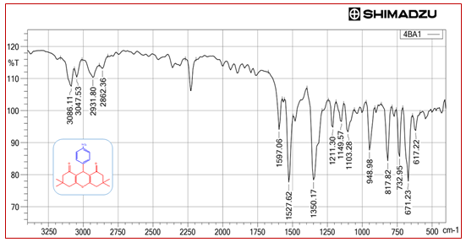
FT-IR spectrum of 3,3,6,6-Tetramethyl-9-(4-nitrophenyl)-1,8-dioxo-octahydroxanthene (10b)

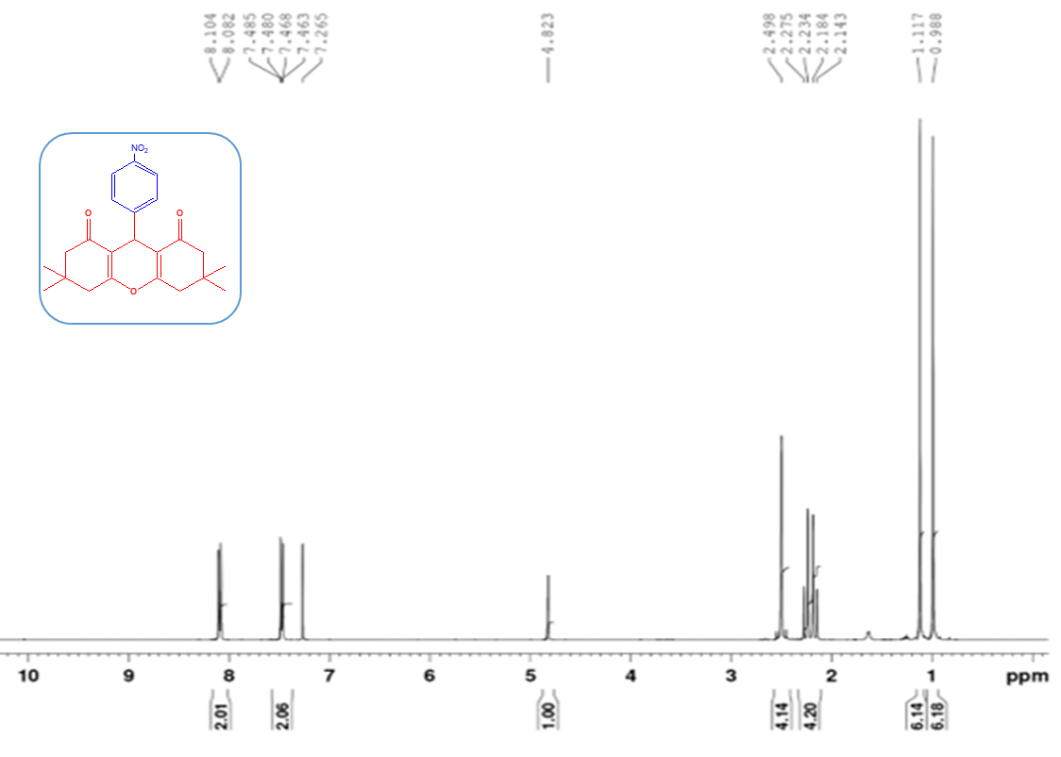
¹H-NMR spectrum of 3,3,6,6-Tetramethyl-9-(4-nitrophenyl)-1,8-dioxo-octahydroxanthene (10b)

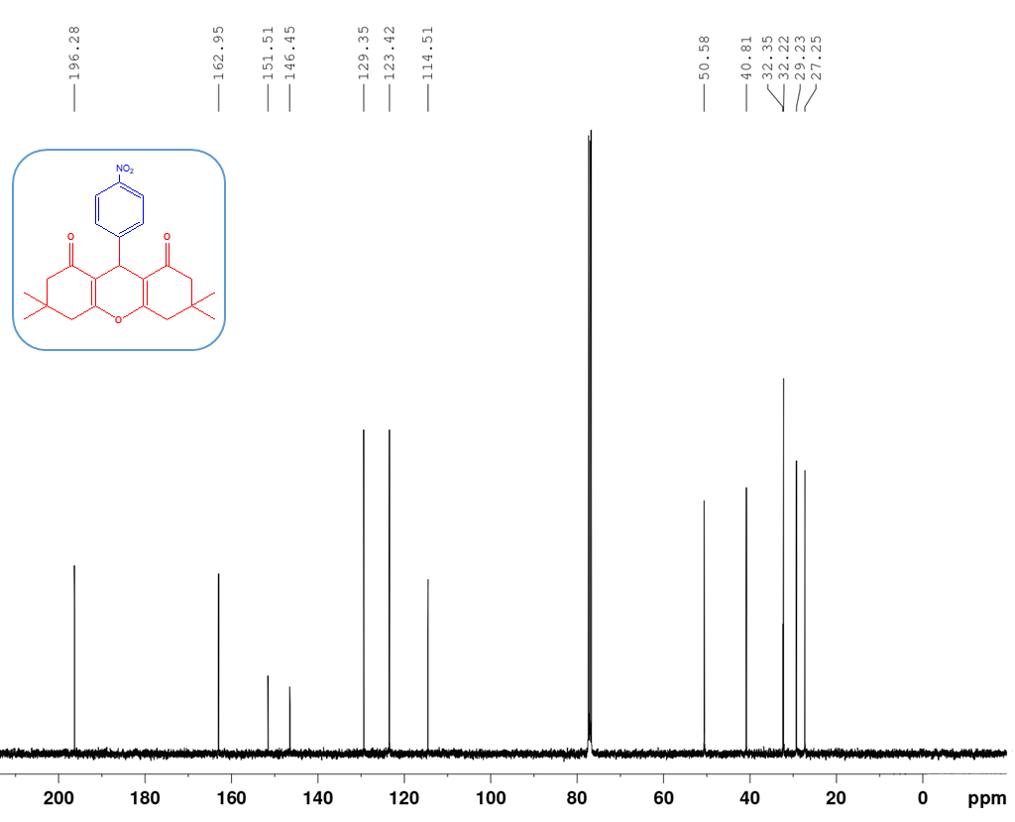
¹³C-NMR spectrum of 3,3,6,6-Tetramethyl-9-(4-nitrophenyl)-1,8-dioxo-octahydroxanthene (10b)

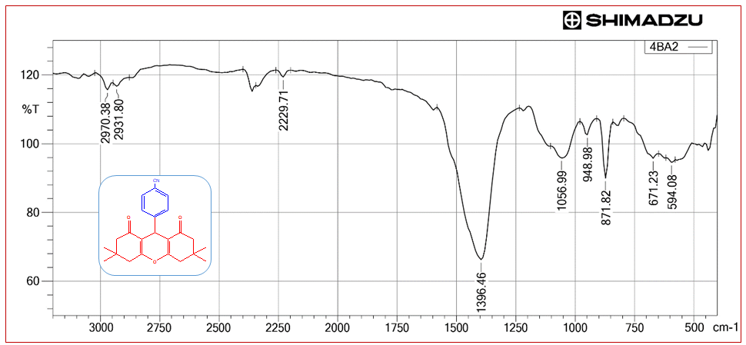
FT-IR spectrum of 3,3,6,6-Tetramethyl-9-(4-cyanophenyl)-1,8-dioxo-octahydroxanthene (10c)

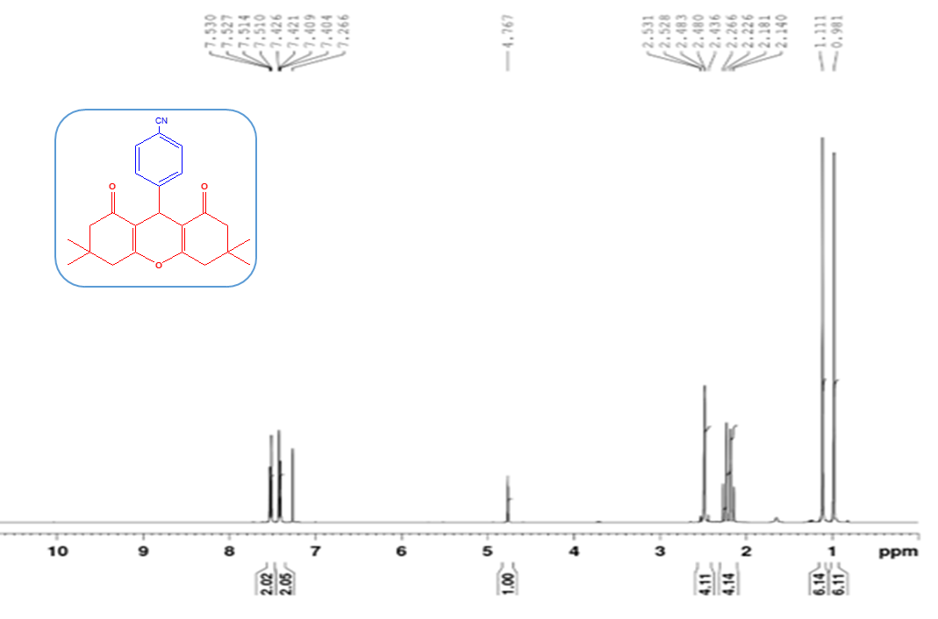
¹H-NMR spectrum of 3,3,6,6-Tetramethyl-9-(4-cyanophenyl)-1,8-dioxo-octahydroxanthene (10c)

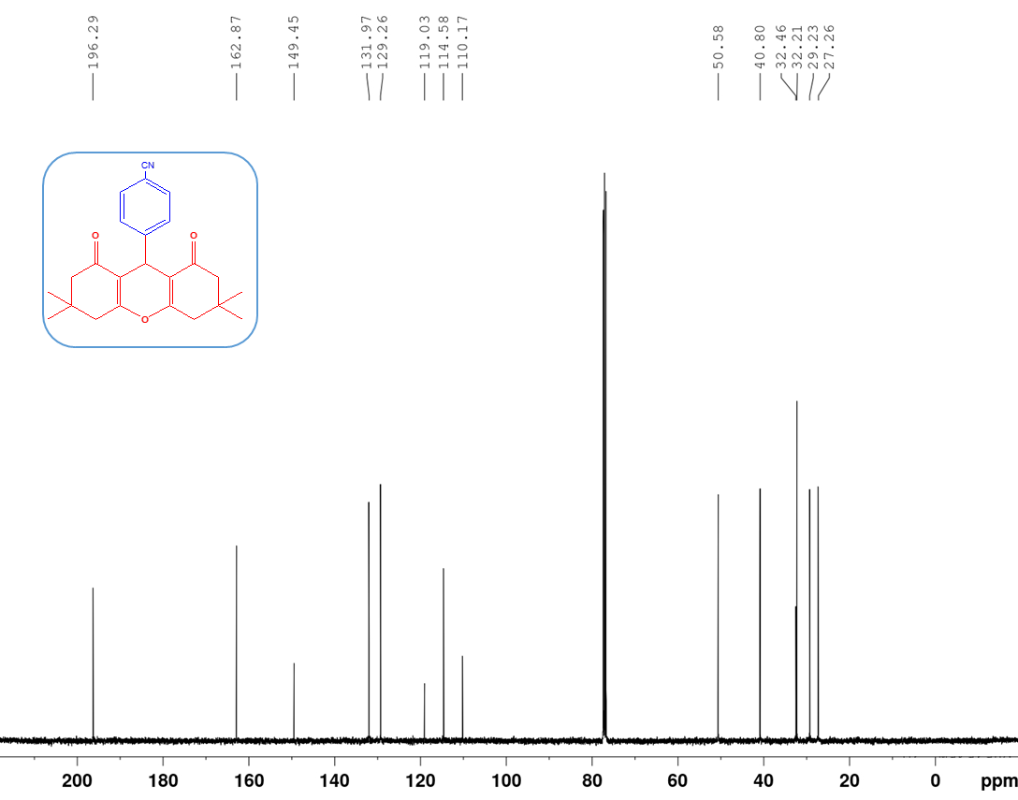
¹³C-NMR spectrum of 3,3,6,6-Tetramethyl-9-(4-cyanophenyl)-1,8-dioxo-octahydroxanthene (10c)

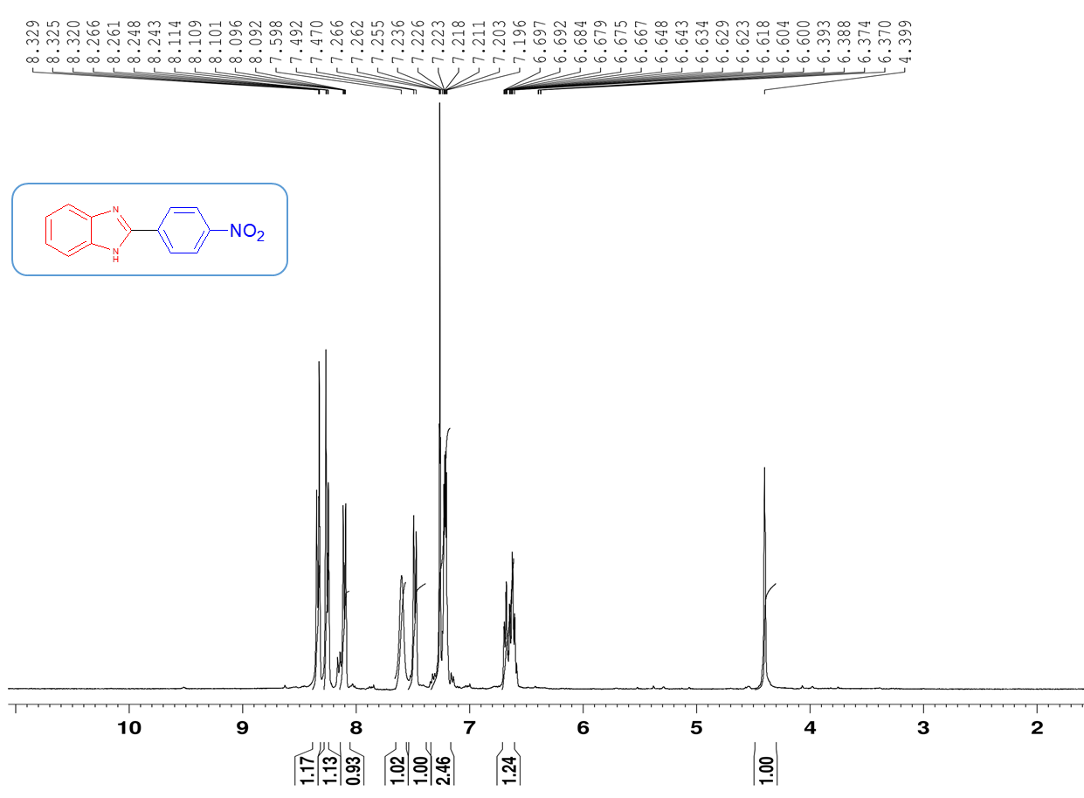
¹H-NMR spectrum of 2-(4-Nitrophenyl)-1H-benzimidazole (12b)

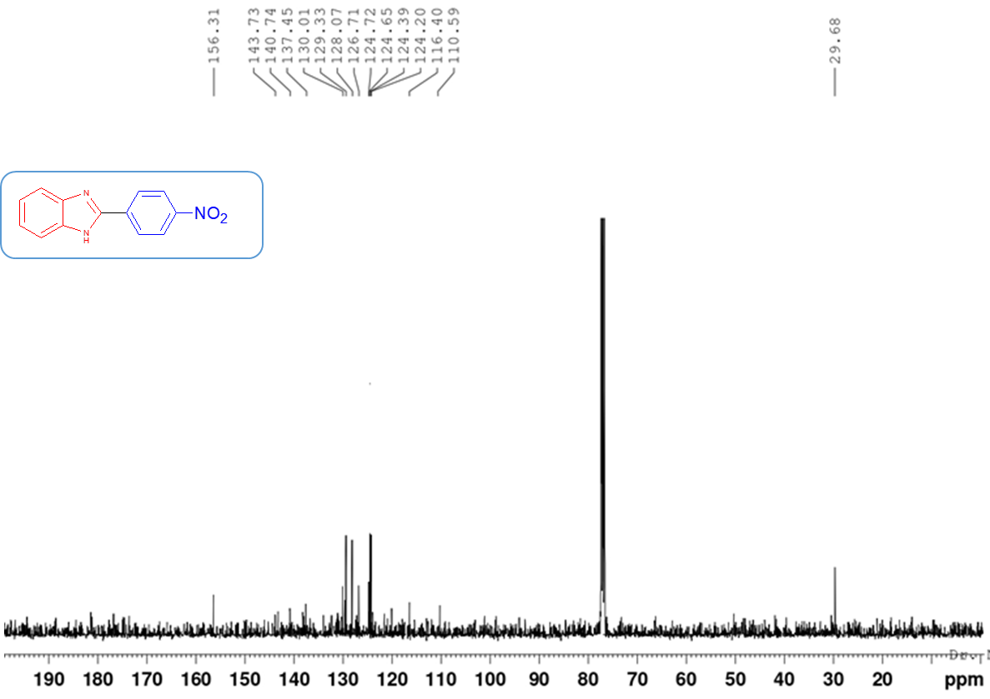
¹³C-NMR spectrum of 2-(4-Nitrophenyl)-1H-benzimidazole (12b)
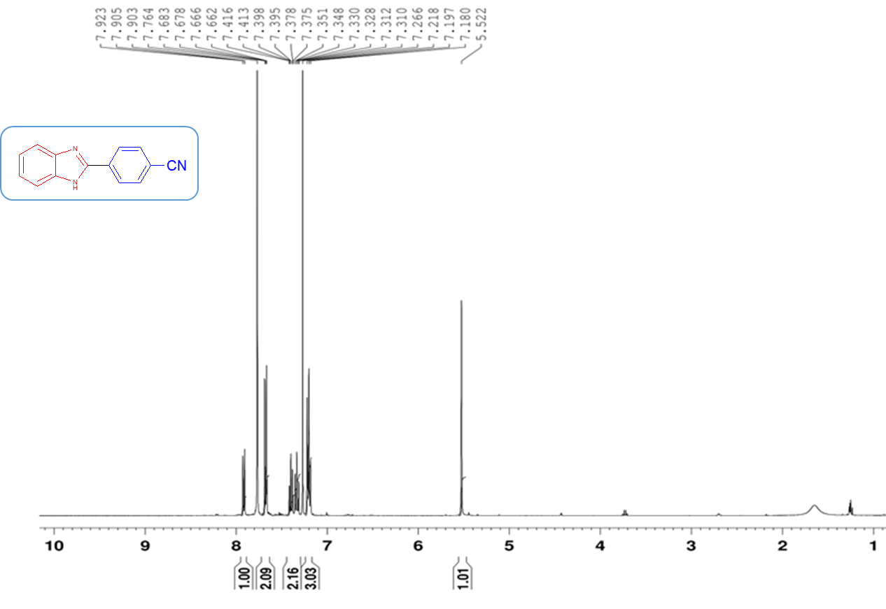
¹H-NMR spectrum of 2-(4-cyanophenyl)-1H-benzimidazole (12c)

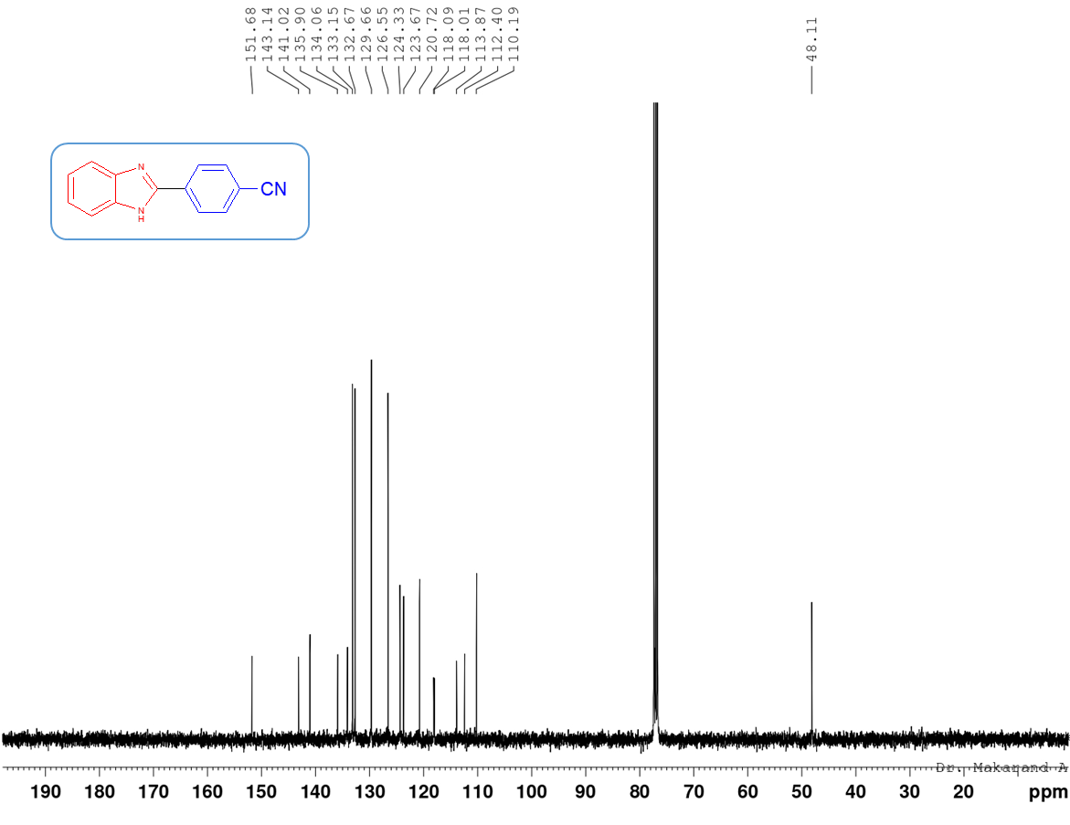
¹³C-NMR spectrum of 2-(4-cyanophenyl)-1H-benzimidazole (12c)

References:
- S. Karhale, C. Bhenki, G. Rashinkar, V. Helavi, New J. Chem., 41, 5133 (2017).
- S. Karhale, Res. Chem. Intermed., 46, 3085 (2020).
- S. Karhale, K. Patil, C. Bhenki, G. Rashinkar, V. Helavi, Res. Chem. Intermed., 42, 7257 (2016).
- C. Yu, P. Guo, C. Jin, W. Su, J. Chem. Res., 2009, 333 (2009).

