Supplementary data
Free and Cued Selective Reminding Test Procedure
The patients had to sequentially learn a series of 16 words from different semantic categories presented as sets of four items on cards containing 2x2 grids. Each quadrant contained one of the words from another semantic category. The test consisted of four distinct phases: (1) encoding and immediate recall. The patient had to identify the corresponding word (e.g., “grapes”) to the given semantic cue (e.g., “what is the fruit on this list?”) on the grid. The instructor removed the card to ensure an appropriate encoding and requested the patient recall the four presented items immediately. This phase was repeated for each set of four words; (2) free/cued recalls. After a distracting task of 20 seconds (backward counting), the patient had to retrieve all 16 items (free recall). For each missing word, the instructor provided the appropriate semantic cue for retrieval (cued recall, e.g., “what was the name of the fruit?”). This procedure was repeated three times, each separated by the same short distracting task. For each repetition, a total recall score was calculated as the sum of free and cued recalls; (3) recognition. Immediately after the third free/cued recall, the instructor showed a list of 48 items containing the 16 target items, 16 semantic distractors and 16 neutral distractors. The patient had to identify the 16 target items from the list correctly; (4) free/cued delayed recalls. Twenty minutes after the recognition phase, the instructor asked the patient to remember as many words as possible from the original word list. Similarly to phase 2, the instructor provided semantic cues for each missing item.
Supplementary Table 1 – Individual free and total recall scores for each group (n = 100)
 | Free recall scores |  |  |  | Total recall scores
 | FR1 | FR2 | FR3 | Delayed | TR1 | TR2 | TR3 | Delayed
Amnestic iNPH, n = 38 | 3.7 (1.4) | 3.3 (2.2) | 3.7 (2.3) | 3.5 (2.6) | 9.1 (2.4) | 9.7 (3.2) | 11.0 (3.0) | 10.0 (3.5)
Non-amnestic iNPH, n = 62 | 5.8 (2.0) | 6.8 (2.5) | 8.1 (2.8) | 7.7 (3.3) | 14.2 (1.6) | 15.0 (1.3) | 15.3 (0.8) | 15.0 (1.2)

Supplementary Table 2 – Neuropsychological profile of the iNPH patients (n = 100)
 | Amnestic, n = 38 |  |  | Non-amnestic, n = 62
 | Pre-CSF tapping | Post-CSF tapping | p-value | Pre-CSF tapping | Post-CSF tapping | p-value
Executive functions
Color Trails Test [s]
Part 1 | 140.6 (85.6)ª | 131.6 (77.6)^{b} | 0.194 | 103.2 (54.3)ª | 101.5 (66.0)^{b} | 0.177
Part 2 | 250.1 (85.3)ª | 222.9 (95.1) | 0.079 | 197.6 (88.9)ª | 187.2 (84.3) | 0.059
Index* | 1.4 (0.9) | 1.3 (0.7) | 0.811 | 1.3 (0.6) | 1.1 (0.6) | 0.274
Verbal fluency (2 minutes) [#]
Semantic | 11.1 (4.5)ª | 11.5 (3.4)^{b} | 0.128 | 14.3 (3.8)ª | 16.6 (5.0)^{b} | <0.001
Phonemic | 7.2 (4.3)ª | 9.1 (5.7)^{b} | 0.015 | 14.3 (6.4)ª | 14.9 (6.6)^{b} | 0.570
Stroop Test [s]
Dot | 22.6 (7.9)ª | 22.0 (6.4)^{b} | 0.696 | 18.5 (6.1)ª | 17.7 (7.1)^{b} | 0.025
Color | 30.9 (8.3)ª | 28.3 (10.0)^{b} | 0.009 | 26.9 (13.9)ª | 24.8 (12.6)^{b} | <0.001
Word | 52.7 (15.7) | 51.4 (22.3) | 0.093 | 49.9 (27.3) | 44.9 (23.5) | 0.355
Index$ | 2.4 (0.8) | 2.2 (0.9) | 0.174 | 2.5 (1.1) | 2.3 (0.8) | 0.636
Attention, working memory
Wechsler Adult Intelligence Scale-III [#]
Symbol Digit Modalities Test | 25.5 (9.6)ª | 27.3 (12.7)^{b} | 0.112 | 33.4 (12.5)ª | 35.8 (13.6)^{b} | 0.013
Forward verbal digit span | 4.9 (1.3)ª | 5.1 (1)^{b} | 0.012 | 5.6 (1.3)ª | 5.7 (1.3)^{b} | 0.753
Backward verbal digit span | 3.4 (0.9) | 3.3 (0.9)^{b} | 0.819 | 3.7 (1.1) | 4.1 (1.3)^{b} | 0.014
Wechsler Memory Scale-III [#]
Forward visual span | 4.1 (1.2) | 4.4 (1) | 0.039 | 4.4 (1.1) | 4.6 (1.1) | 0.186
Backward visual span | 3.4 (1) | 3.5 (1)^{b} | 0.840 | 3.7 (1.1) | 4.0 (1.1)^{b} | 0.007
Callosal transfer
Verbal dichotic listening index [%] | 51.5 (49.2) | 44.0 (43.4) | 0.272 | 40.3 (43.8) | 40.2 (36) | 0.493
Manual dexterity
Purdue Pegboard Test, right hand [#] | 8.7 (2.5) | 8.2 (2.1)^{b} | 0.437 | 9.7 (3) | 10.5 (2.2)^{b} | 0.010
Purdue Pegboard Test, left hand [#] | 7.8 (2.5) | 8.0 (2.2)^{b} | 0.081 | 9.0 (3.1) | 9.2 (2.1)^{b} | 0.803
Behaviour
Hospital Anxiety and Depression scale [#]
Anxiety | 7.7 (3.4) | - | - | 7.0 (3.9) | - | -
Depression | 7.6 (4.3) | - | - | 5.9 (2.8) | - | -
Starkstein’s Apathy Scale [#] | 18.6 (5.7)ª | - | - | 14.4 (5.0)ª | - | -
Abbreviations: WAIS, Wechsler Adult Intelligence Scale; WMS, Wechsler Memory Scale. Comparisons are based on Mann-Whitney U tests; significant differences (p < 0.05, two-tailed) are highlighted in bold. For comparisons between groups in each condition (pre- and post-CSF tap test), differences are indicated as follows:
- A significant difference in the pre-CSF tapping condition.
- A significant difference in the post-CSF tapping condition.
*Colour Trails Test index is calculated as follows: (Part 2 – Part 1)/Part 1.
$The Stroop index is calculated as follows: (Colour condition)/(Dot condition).
#The Verbal dichotic listening index is calculated as follows: 100 x (right ear – left ear)/(right ear + left ear).

Supplementary Table 2 – Gait profile of the iNPH patients (n = 100)
 | Pre-CSF tapping |  |  | Post-CSF tapping
 | Amnestic | Non-amnestic | p-value | Amnestic | Non-amnestic | p-value
Gait parameters, simple task
Walking speed [m/s] | 0.7 (0.3) | 0.8 (0.3) | 0.049 | 0.8 (0.3) | 0.9 (0.3) | 0.040
Cadence [# steps/min] | 96.3 (17.9) | 101.2 (13.1) | 0.124 | 50.9 (7.4) | 53.2 (5.5) | 0.103
Stride time variability [%] | 6.4 (10.9) | 4.7 (8.6) | 0.403 | 3.7 (1.9) | 3.8 (5.3) | 0.887
Stride length [m] | 0.8 (0.3) | 0.9 (0.3) | 0.055 | 0.9 (0.3) | 1.0 (0.3) | 0.066
Swing phase [%] | 67.3 (5.2) | 66.2 (3.9) | 0.234 | 66.5 (4.1) | 65.1 (3.5) | 0.075
Step width [m] | 0.1 (0.1) | 0.1 (0.0) | 0.464 | 0.1 (0.1) | 0.1 (0.0) | 0.661
Comparisons are based on independent samples t-tests. Significant differences (p < 0.05, two-tailed) are highlighted in bold.

Supplementary Figure 1 – Mean CSF biomarkers levels for AD pathology [ng/L] in amnestic versus non-amnestic iNPH.
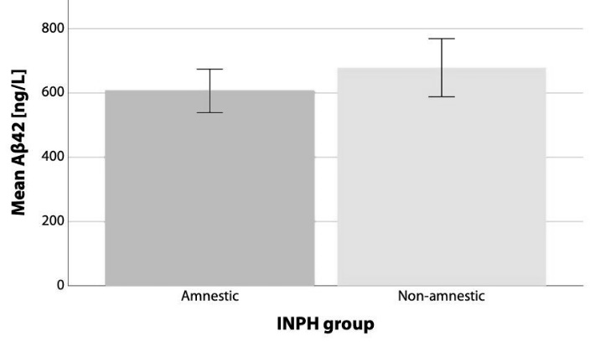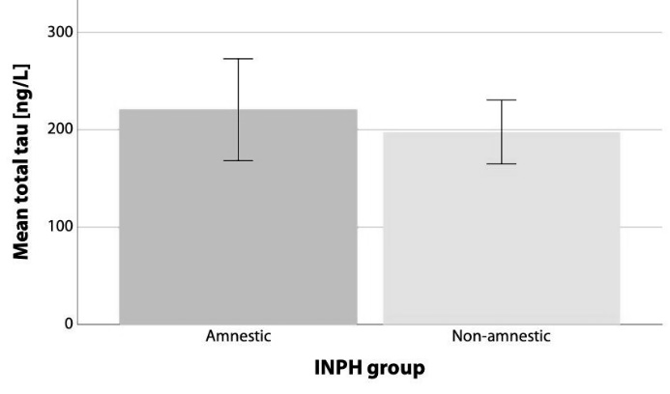
The error bars indicate 95% confidence intervals.

