Seasonal changes in cell size of the dominant diatom species in the waters of Lake Biwa

Aquatic Ecology
Deb Soumya, Weilhoefer Christine L, Keitaro Fukushima, Yukiko Goda, Tetsuji Akatsuka, Shin-ichi Nakano

S. Nakano (Corresponding Author)
Center for Ecological Research, Kyoto University, 2-509-3, Hirano, Otsu, Shiga 520-2113, Japan
Tel: +81-77-549-8239
Fax: +81-77-549-8201
e-mail: nakano@ecology.kyoto-u.ac.jp
ORCID ID: 0000-0001-5235-8547

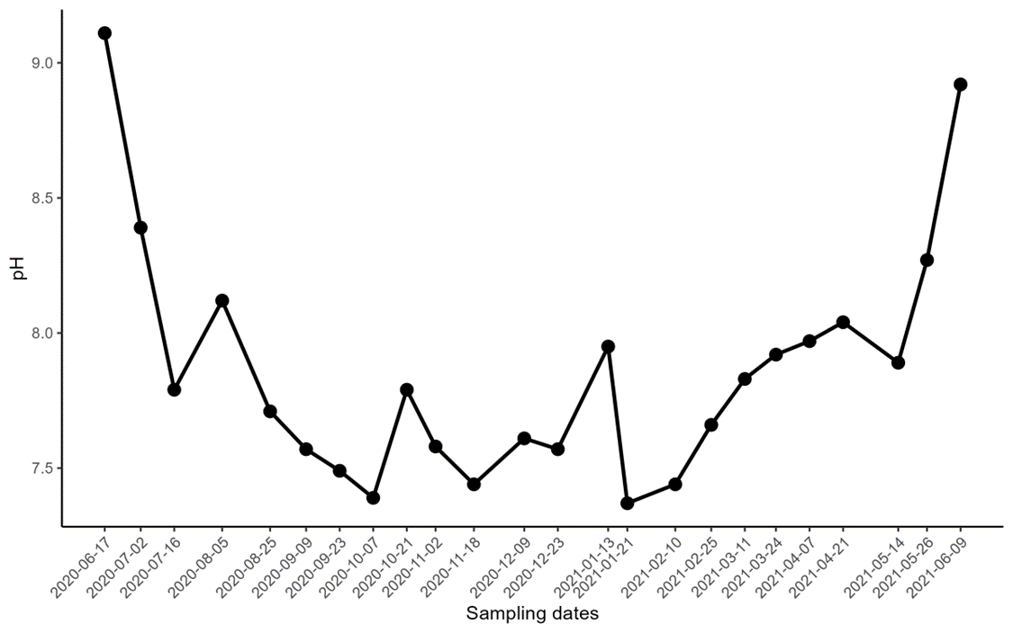
Fig. S1 Seasonal pH in the surface water of Lake Biwa

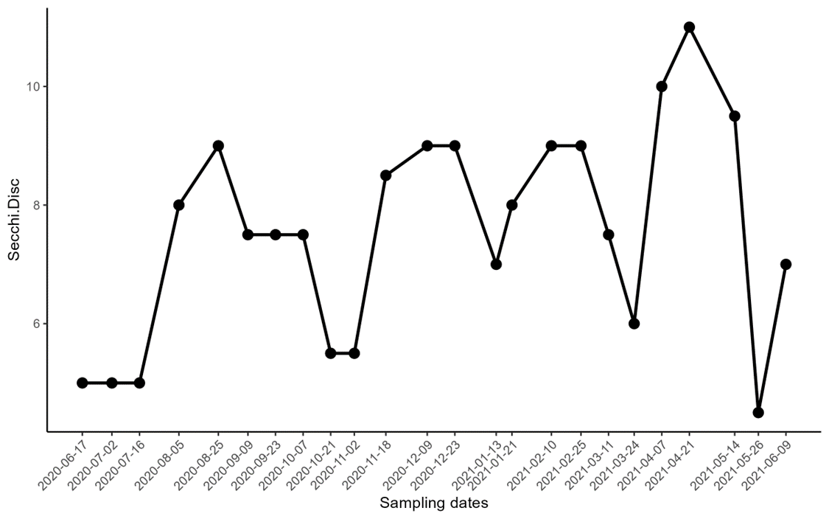
Fig. S2 Seasonal water transparency in Lake Biwa

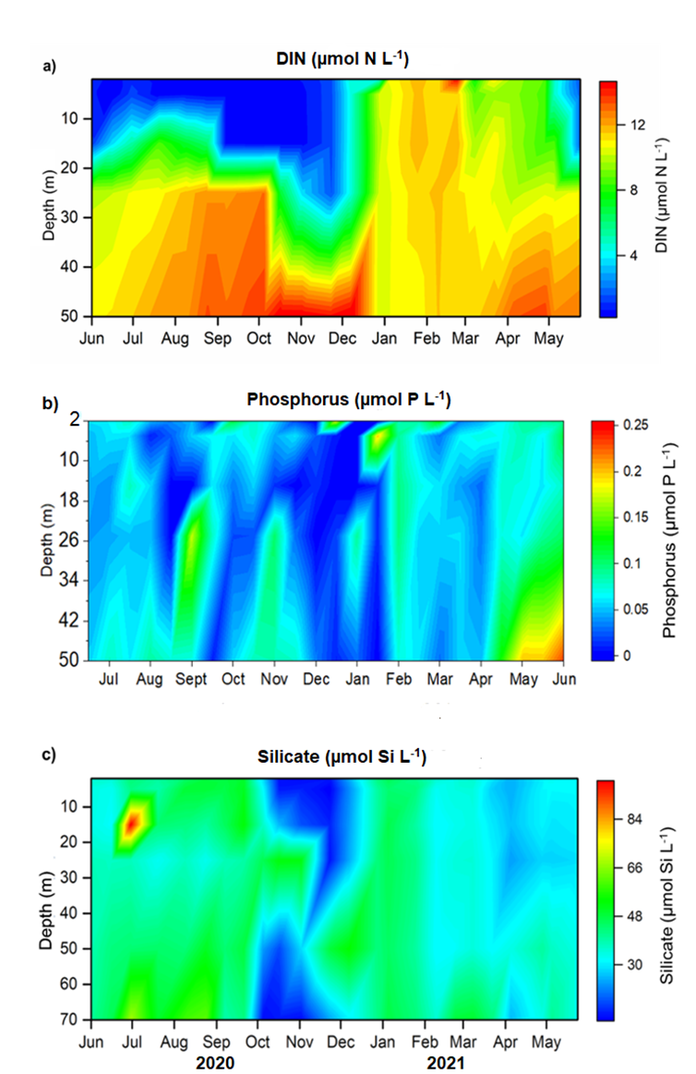

Fig. S3 Seasonal changes in the vertical profile of nutrients (a) Dissolved inorganic nitrogen (DIN), b) phosphorus, and c) silicate concentrations in the water column of Lake Biwa at Ie-1

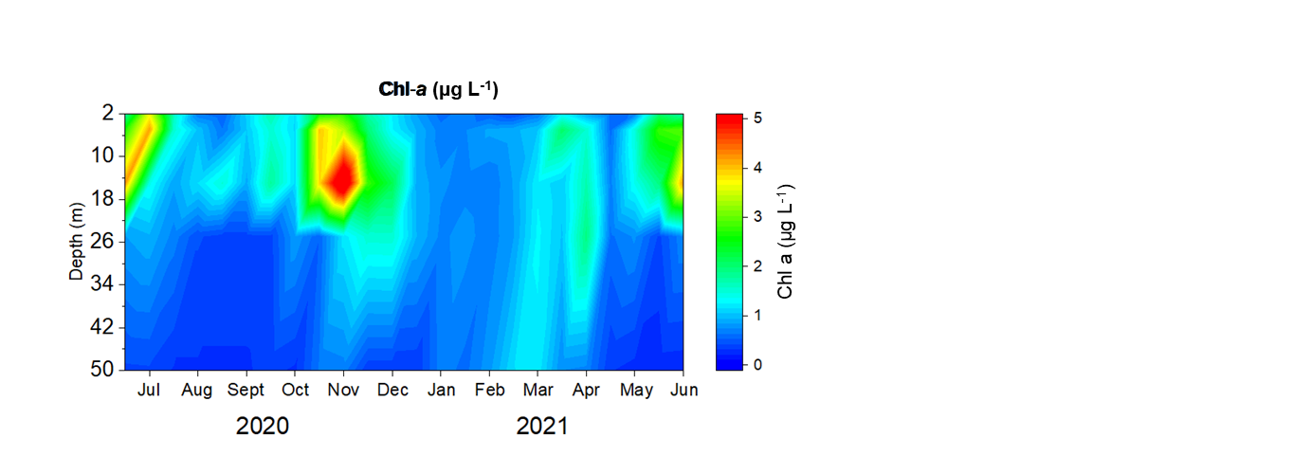
Fig. S4 Seasonal changes in the vertical profile of Chlorophyll a in the water column of Lake Biwa at Ie-1

