Supplementary information

Genetic compatibility exceeds possible ‘good genes' effects of sexual selection in lake char

Laura Garaud¹#, David Nusbaumer¹#, Christian de Guttry¹#, Lucas Marques da Cunha¹, Laurie Ançay¹, Audrey Atherton¹, Emilien Lasne^{2,3} & Claus Wedekind¹*

¹ Department of Ecology & Evolution, University of Lausanne, Lausanne, Switzerland
² Université Savoie Mont Blanc, INRAE, MR CARRTEL, Station d’Hydrobiologie Lacustre, Thonon Cedex, France
³ UMR DECOD (Ecosystem Dynamics and Sustainability), INRAE, Institut Agro, IFREMER, Rennes, France

* Correspondence: Claus Wedekind, claus.wedekind@unil.ch; orcid.org/0000-0001-6143-4716
# Equal contributors

Content

Figure S1. Yolk-sac larvae at hatching and 14 days later
Figure S2. Larval lengths and yolk sac volumes over time
Figure S3. Larval growth 14dph predicted by treatment and male characteristics
Figure S4. Offspring inbreeding coefficients predicted by male inbreeding coefficients

Table S1. Linear mixed model on larval length 14 days post hatching (1st experiment)

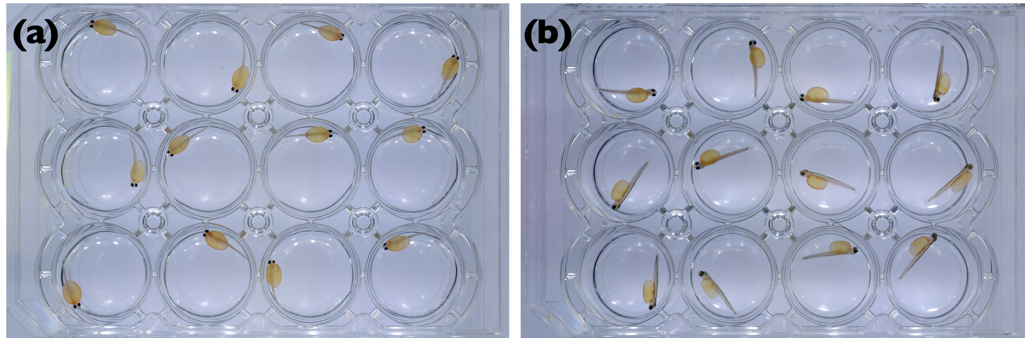

Supplementary Figure S1. Yolk-sac larvae raised at 4.5°C in 12-well plates from hatching on. The photos were taken (a) at hatching and (b) 14 days later.

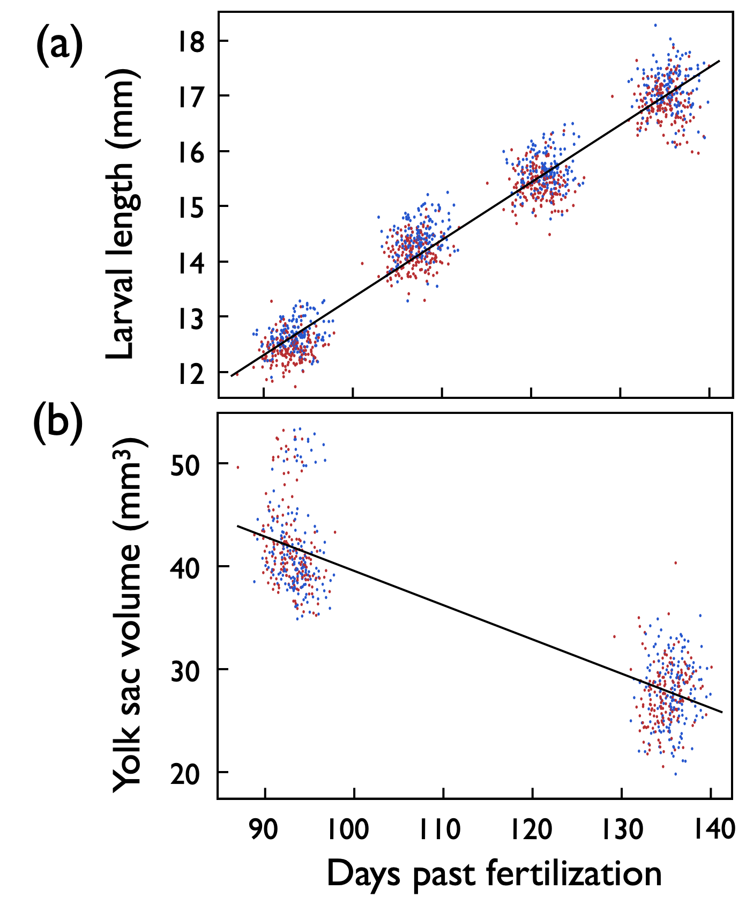

Supplementary Figure S2. Days past fertilization (dpf) versus (a) average larval length and (b) average yolk sac volume per full-sib family and treatment (red: exposed to Aeromonas salmonicida, blue: sham exposed). Larval lengths were measured at the day of hatching and 14, 28, and 42 days later. Yolk sac volumes were measured at the day of hatching and 42 days later. The lines give the linear regressions.
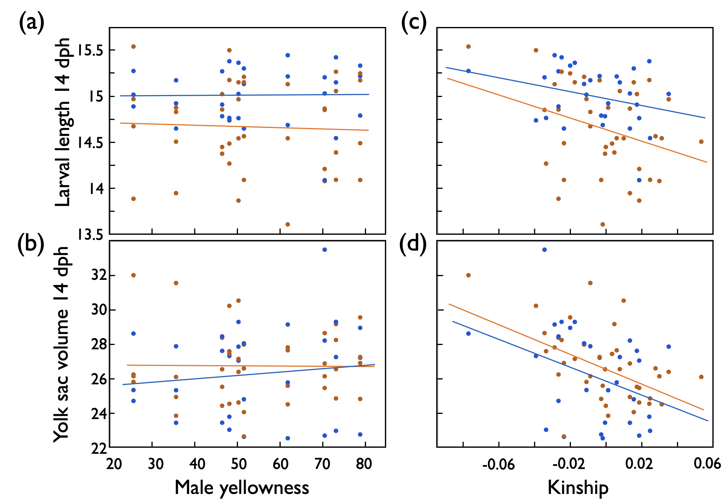

Supplementary Figure S3. Larval growth in 1st experiment: Mean larval length (mm) 14 days past hatching (dph), and mean yolk sac volume at that time (means per full-sib family) predicted by (a,b) male skin coloration (yellowness) or (c,d) by the genetic similarity between males and females (kinship) after exposure to remainders of ovarian fluids (orange symbols and regression lines), or sham exposed (blue). See Table S1 for statistics.

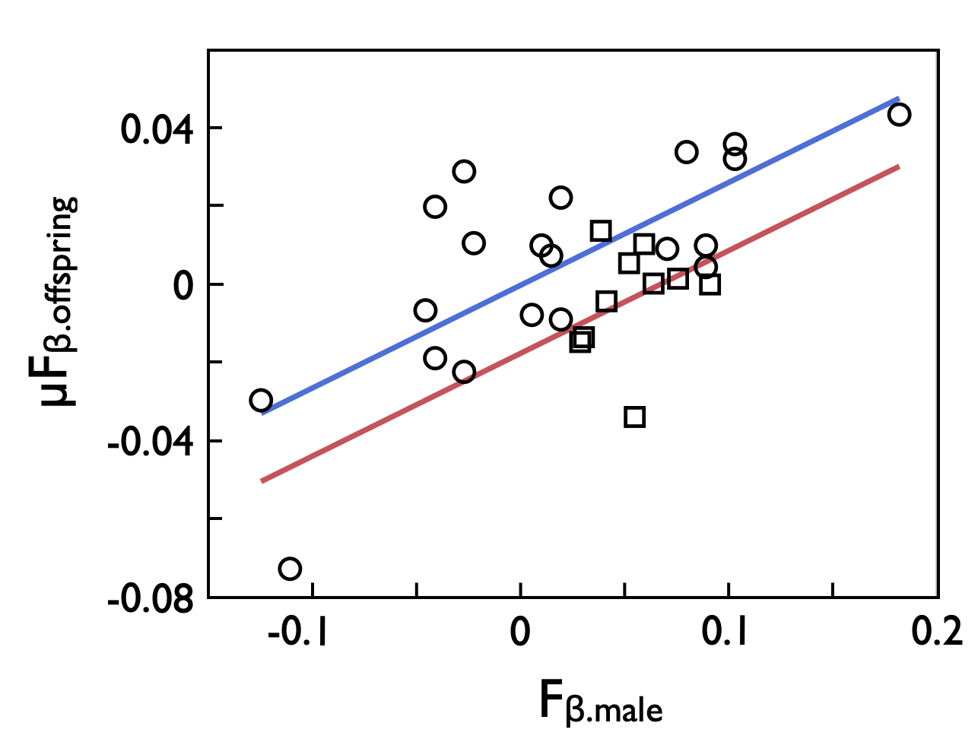

Supplementary Figure S4. The mean expected inbreeding coefficients of each male’s offspring (µF_{β.offspring}, corresponds to the mean kinship coefficients of each male to the females in the respective full-factorial breeding experiment) predicted by the males’ inbreeding coefficients (F_{β.male}) for the 10 males of the 1st experiment (squared symbols, red line) and the 21 males of the 2nd experiment (round symbols, blue line). The lines give the fits from a multiple regression after removal of the non-significant interaction term. See text for statistics.
Supplementary Table S1. Testing for effects on larval growth in 1st experiment: Linear mixed model on larval length 14 days post hatching (dph) when predicted by treatment and (a) male skin coloration (yellowness) or (b) the genetic similarity between males and females (kinship). Hatching date was included as further fixed factor. Family identity and the interaction between family ID and treatment were included as random factors. New significant p-values are highlighted in bold (effects of treatment and hatching date had already been reported in Nusbaumer et al. (2021)).

 |  | Larval length 14 dph |  |  |  |  |  | Yolk sac volume 14 dph
Effects | d.f. | F |  | Variance component |  | p |  |  | F | Variance component | p
(a) Male skin coloration
Fixed effects:
Treatment | 1 | 17.1 |  |  |  | <0.001 |  |  | 3.4 |  | 0.08
Yellowness | 1 | 0.9 |  |  |  | 0.95 |  |  | 0.2 |  | 0.65
Treatment x yellowness | 1 | 0.9 |  |  |  | 0.88 |  |  | 0.9 |  | 0.34
Hatching date | 1 | 38.0 |  |  |  | <0.001 |  |  | 79.5 |  | <0.001
Random effects:
Family ID¹ |  |  |  | 0.13±0.04 |  |  |  |  |  | 2.01±0.76
Family x treatment¹ |  |  |  | 0.05±0.02 |  |  |  |  |  | 0.28±0.44
Residual |  |  |  | 0.65±0.03 |  |  |  |  |  | 26.8±1.3
(b) Male & female kinship
Fixed effects:
Treatment | 1 | 17.4 |  |  |  | <0.001 |  |  | 4.5 |  | 0.04
Kinship | 1 | 2.9 |  |  |  | 0.09 |  |  | 14.3 |  | <0.001
Treatment x kinship | 1 | 1.2 |  |  |  | 0.29 |  |  | 0.7 |  | 0.40
Hatching date | 1 | 37.3 |  |  |  | <0.001 |  |  | 86.9 |  | <0.001
Random effects:
Family ID¹ |  |  |  | 0.12±0.04 |  |  |  |  |  | 1.13±0.59
Family x treatment¹ |  |  |  | 0.04±0.02 |  |  |  |  |  | 0.25±0.46
Residual |  |  |  | 0.65±0.03 |  |  |  |  |  | 26.8±1.1
¹REML unbounded variance components ± standard error

