Samples of Wetland Types
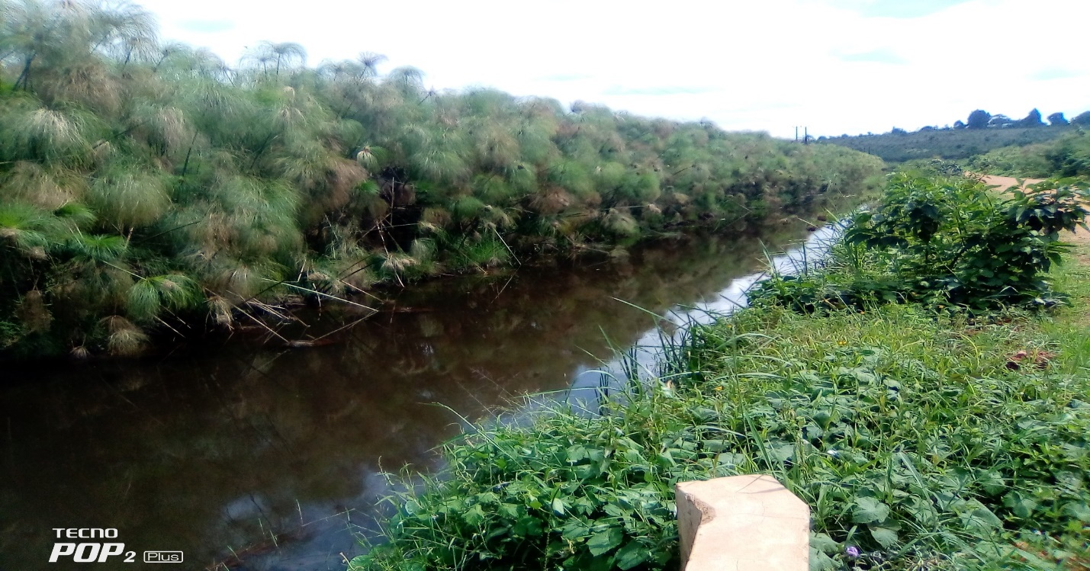
Field Photo: A section of Nyanzi permanent swamp in the Lake Wamala catchment zone covered with papyrus
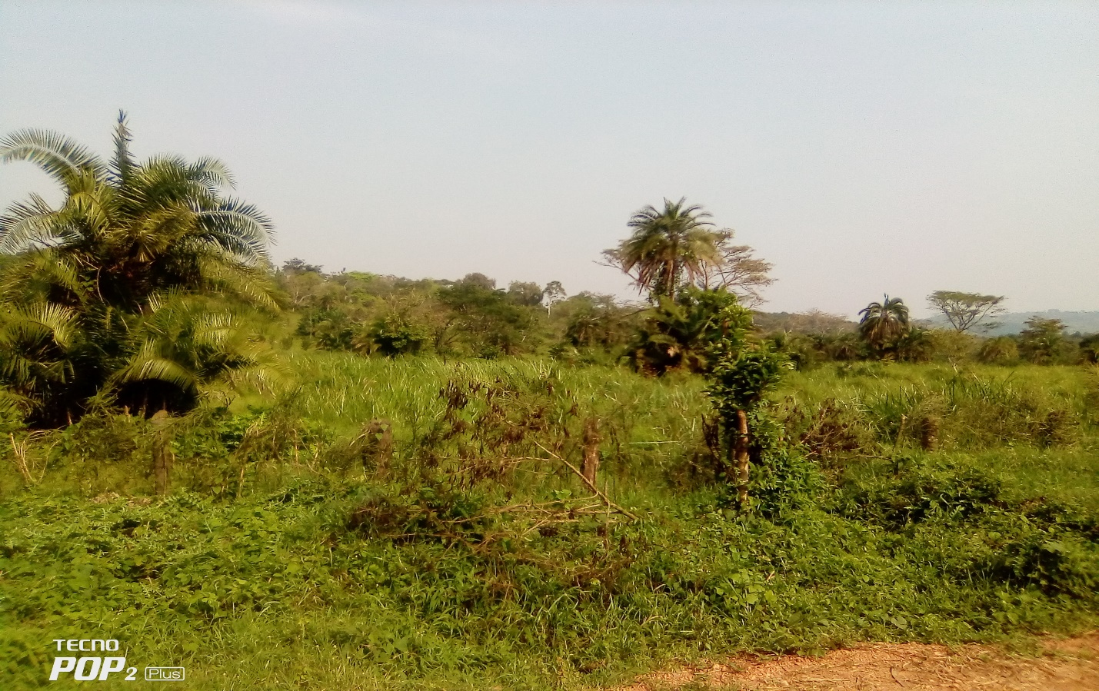
Seasonal swamp vegetation in Namigavu wetland in Kikandwa/Busunju

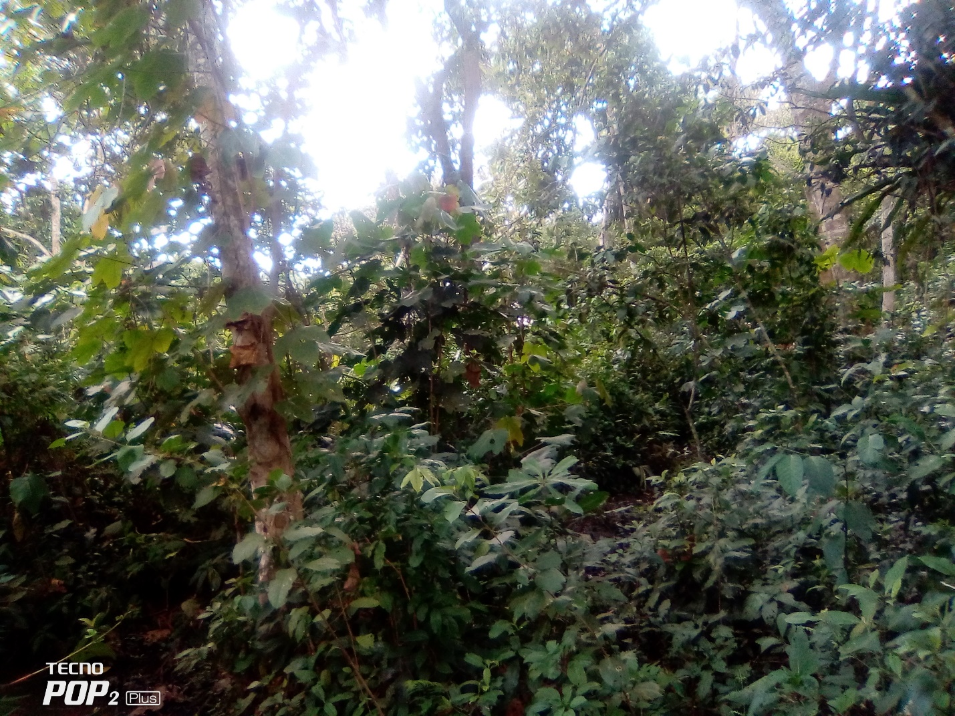
Field Photo: A section of a permanent swamp forest in Nabajegere Permanent Swamp

Wetland resources
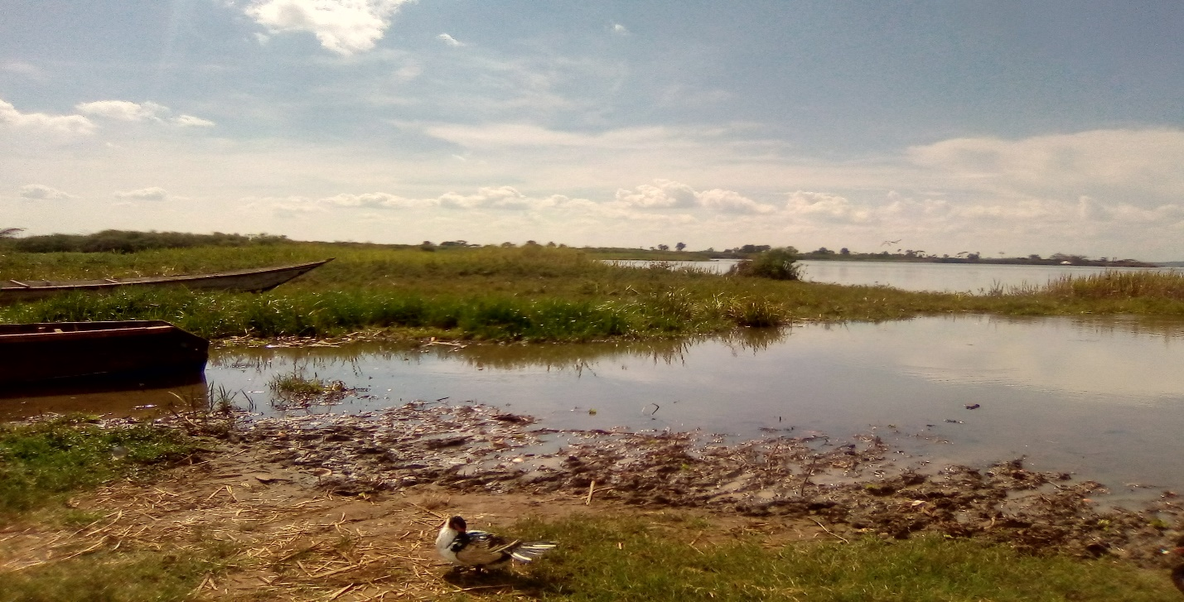
Unique bird species observed along Lusalira wetland in Banda SC.
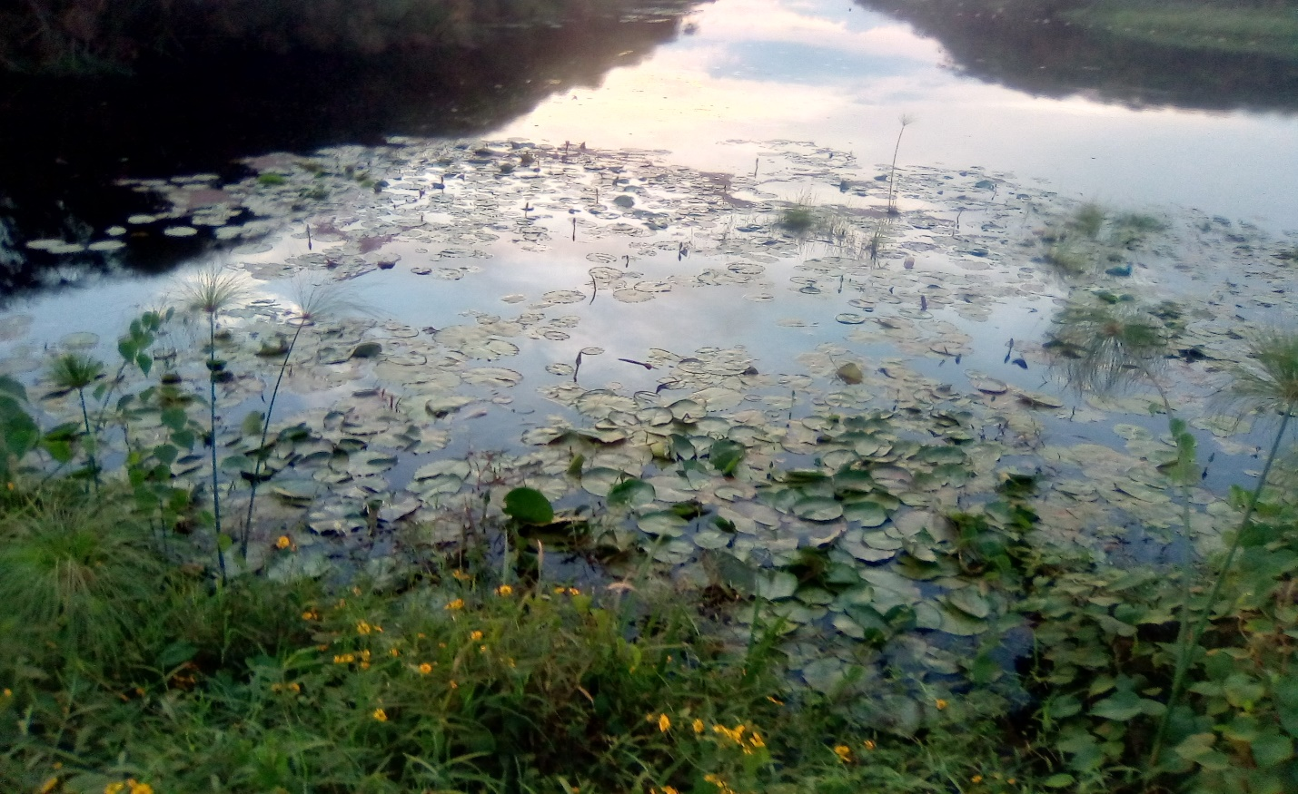
Water lilies and other floating vegetation in Kabasuma wetland in Banda TC and Nyanzi in Maanyi SC.
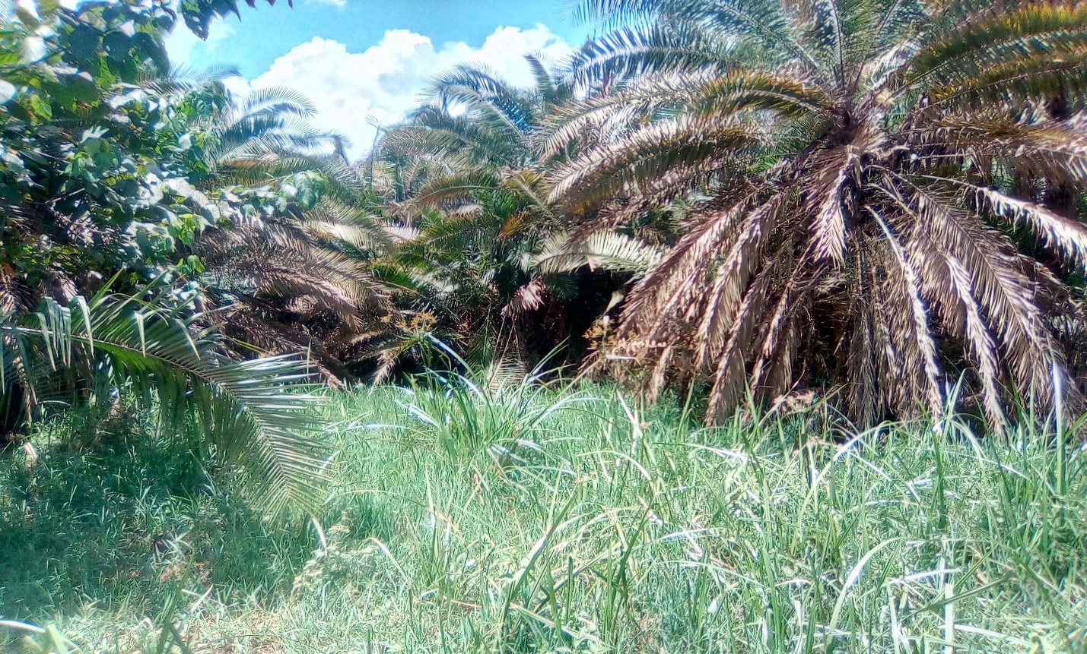
Field Photo: Palm trees in Lusanja permanent wetland in Bulera Sub-County (SC).
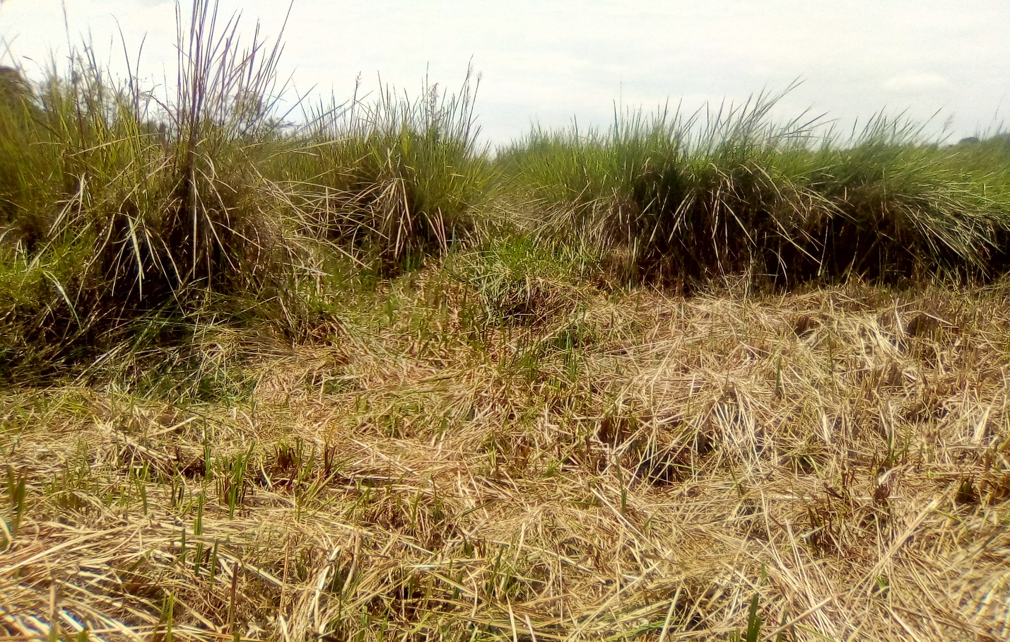
Swamp grasses in Kamanje seasonal swamp in Kalangaalo.
Wetland activities
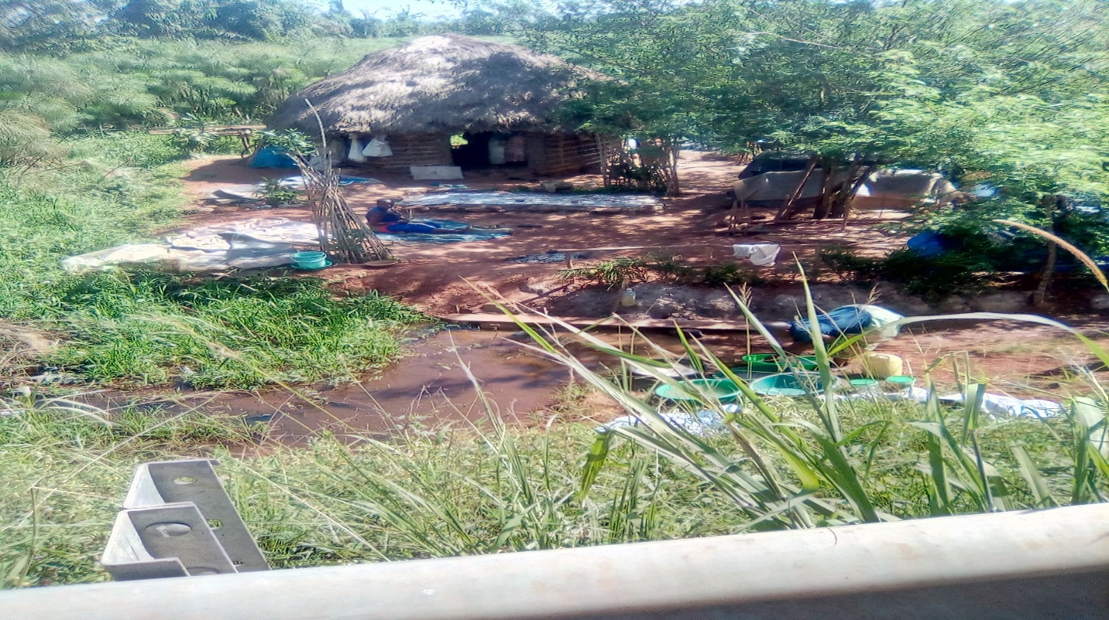
Field Photo: Buganda cultural site in River Mayanja wetland near Busunju
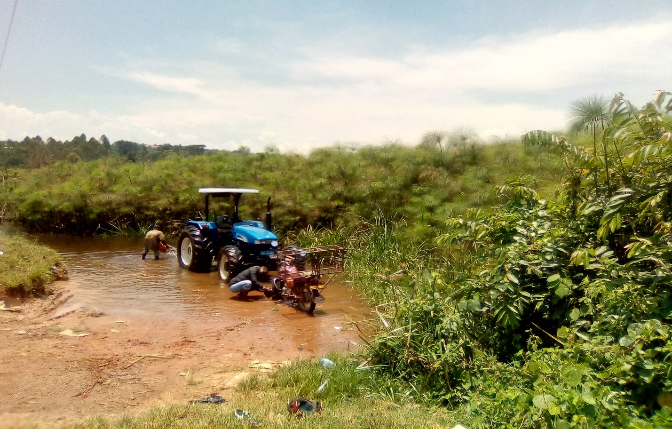
Car and motorcycle washing bay in Kamirantumbwe wetland in Malangala SC.
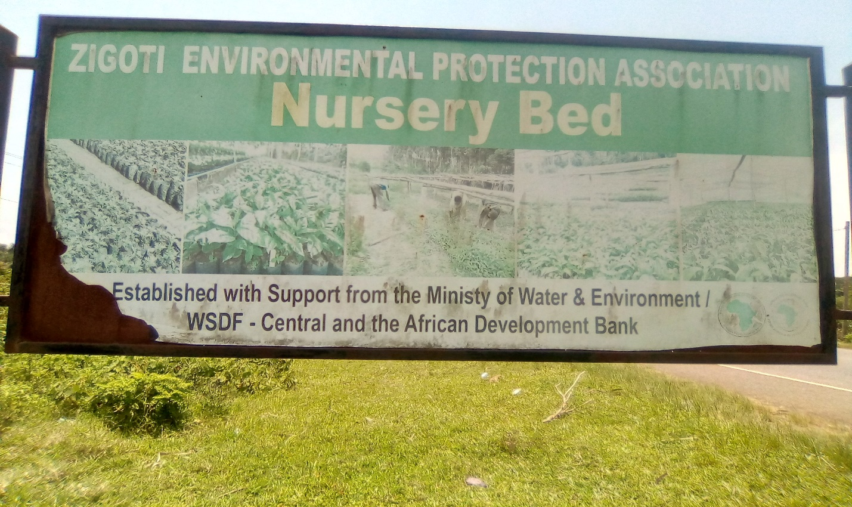
Tree Nursery beds in Kizikibi wetland in Zigoti TC/Malangala SC.
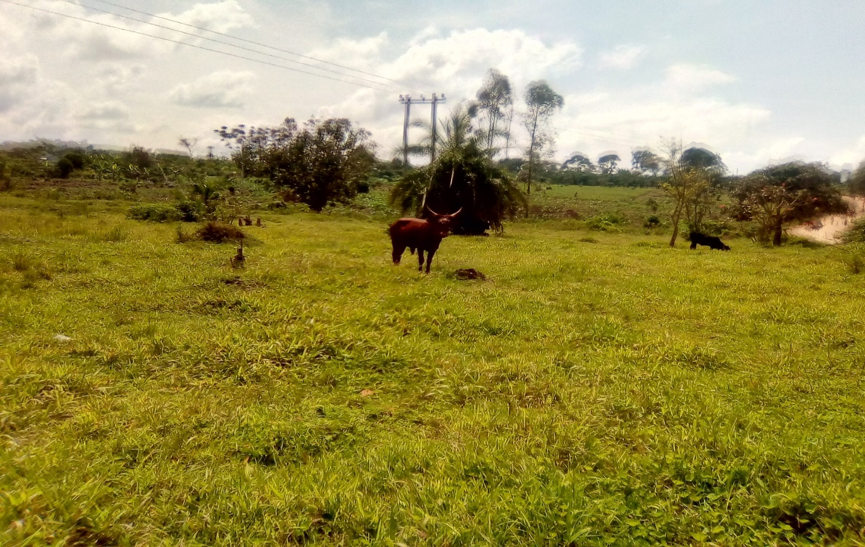
Livestock rearing in seasonal wetlands of Kiryampande in Namungo SC.
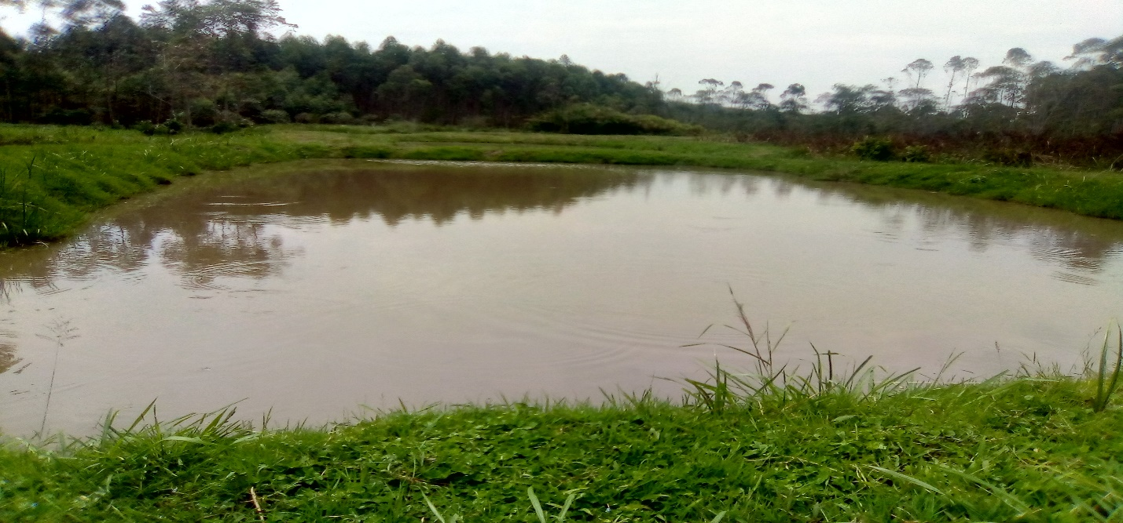
Fish farming in Gundimunda wetland in Butayunja
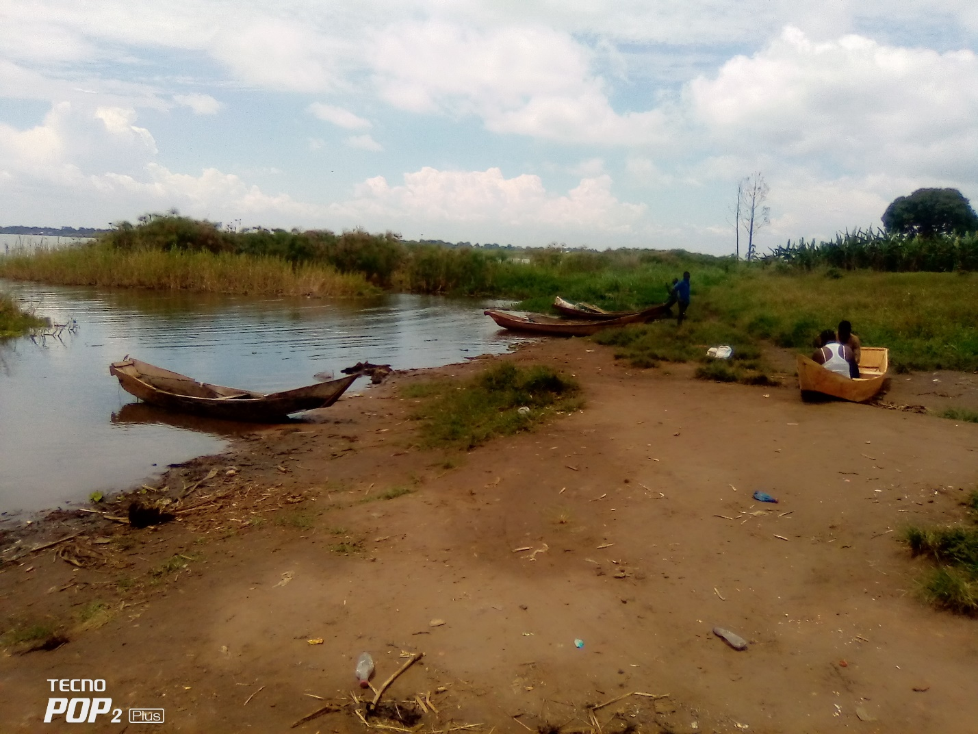
Fishing along Lubajja wetlands along Lake Wamala in Maanyi SC
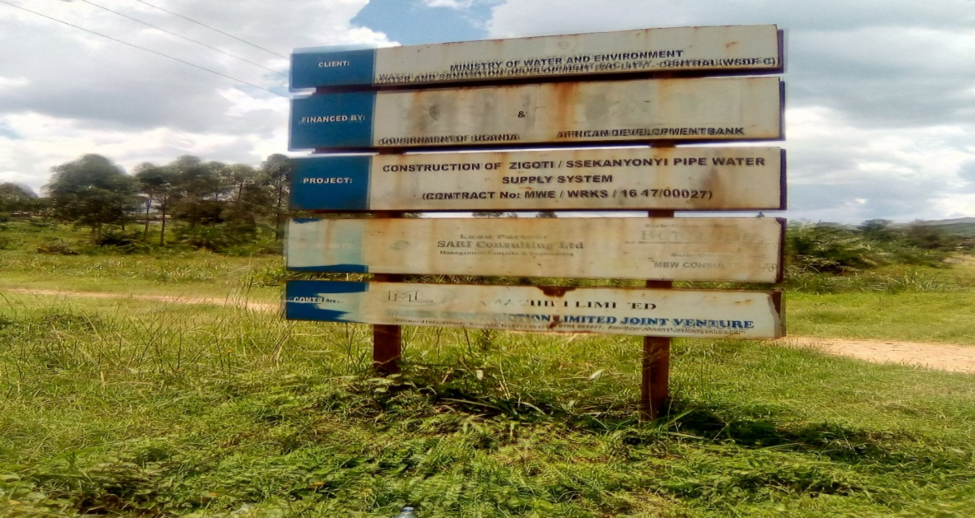
Field Photo: Water supply system from Kiragwe wetland near Sekanyonyi town
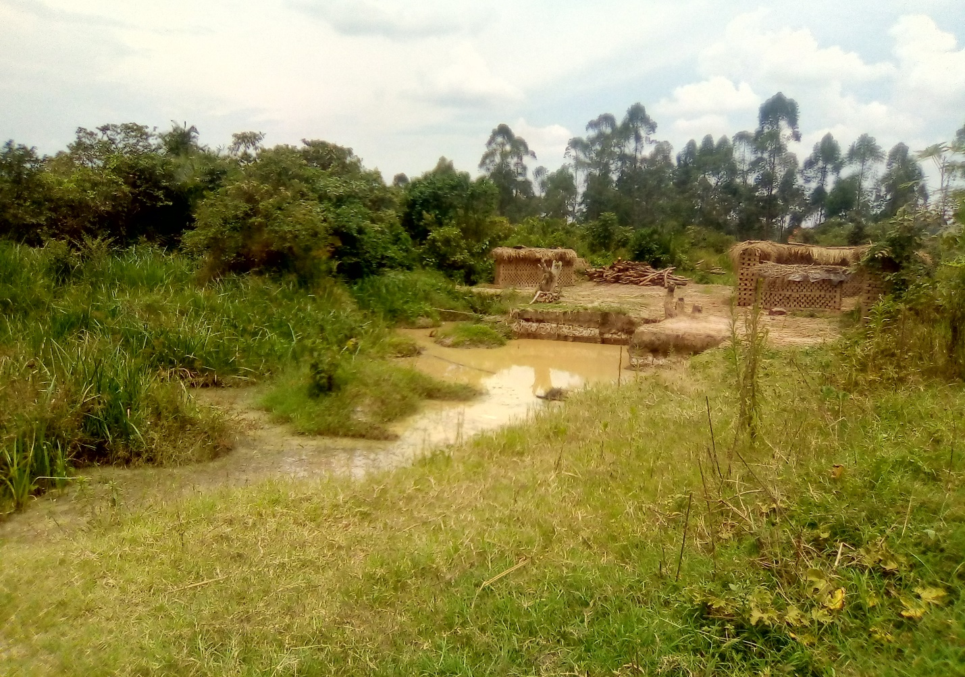
Brick making in Luttabakadde wetland in Butayunja SC.
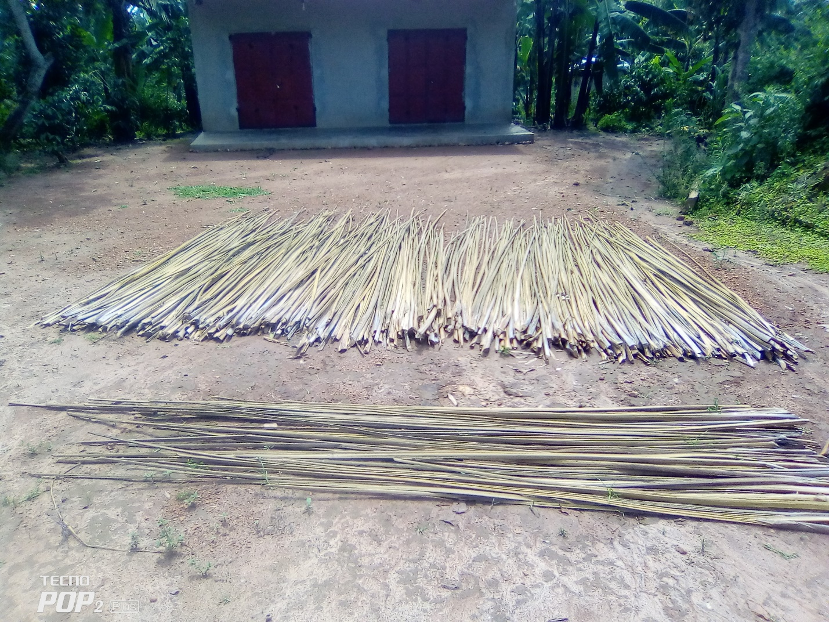
Field photo: Harvested papyrus for crafts/mats making around Matte wetland in Kikandwa SC

Main threats
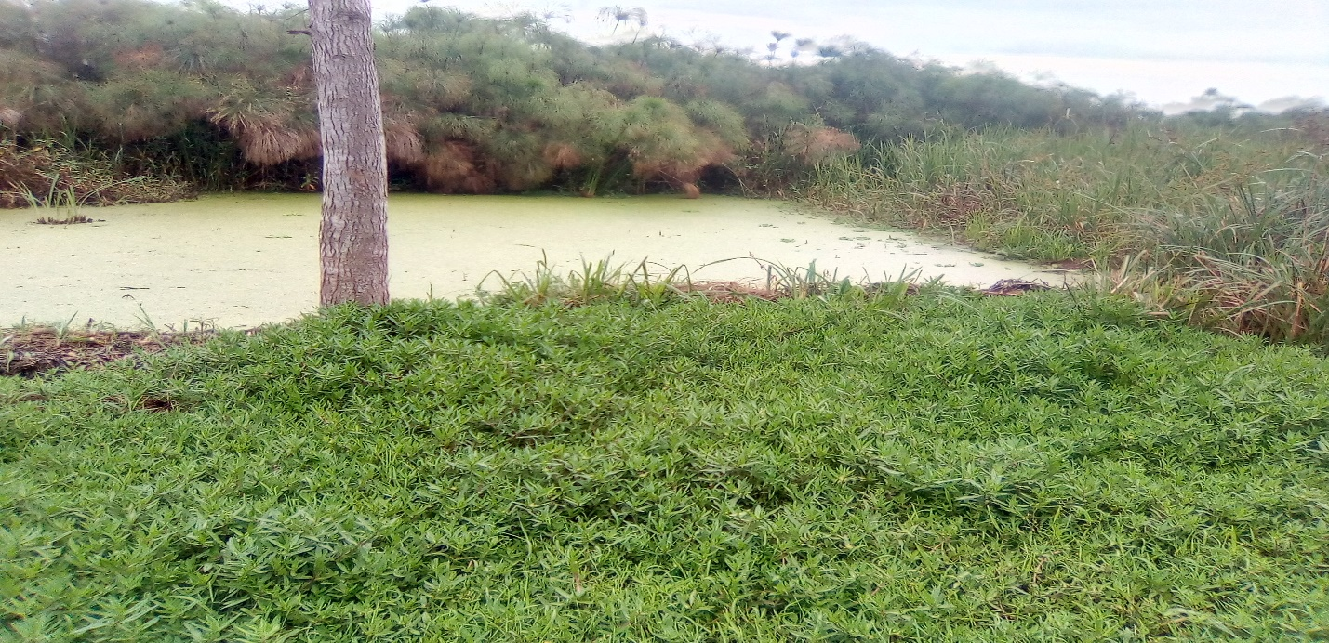
Water pollution (Algae blooms) near Kimuli wetlands in Maanyi SC.
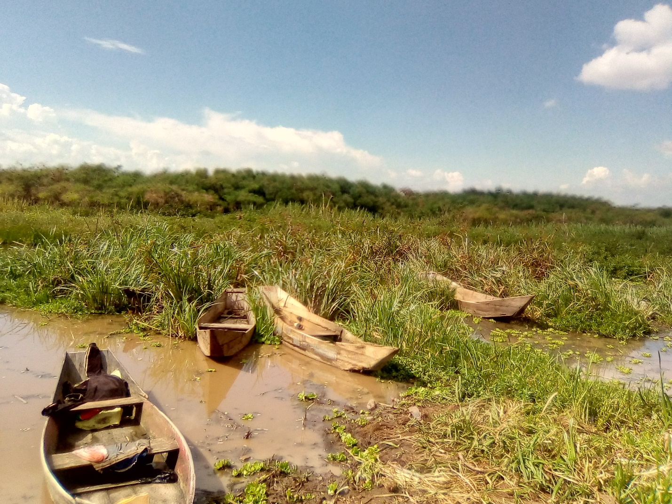
Water hyacinth and floating vegetation near Buzibazi wetland in Banda SC.
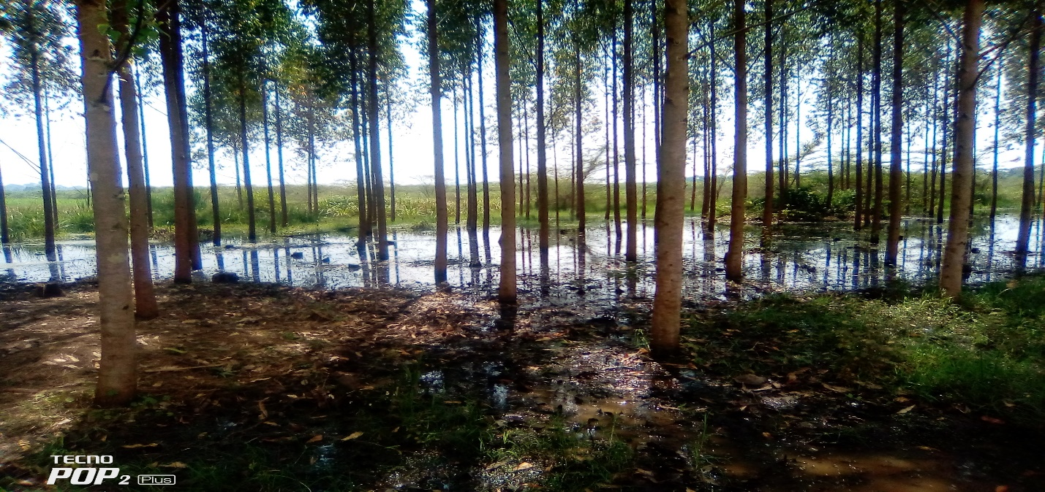
Commercial Eucalyptus tree planting in Lubajja wetland along Lake Wamala
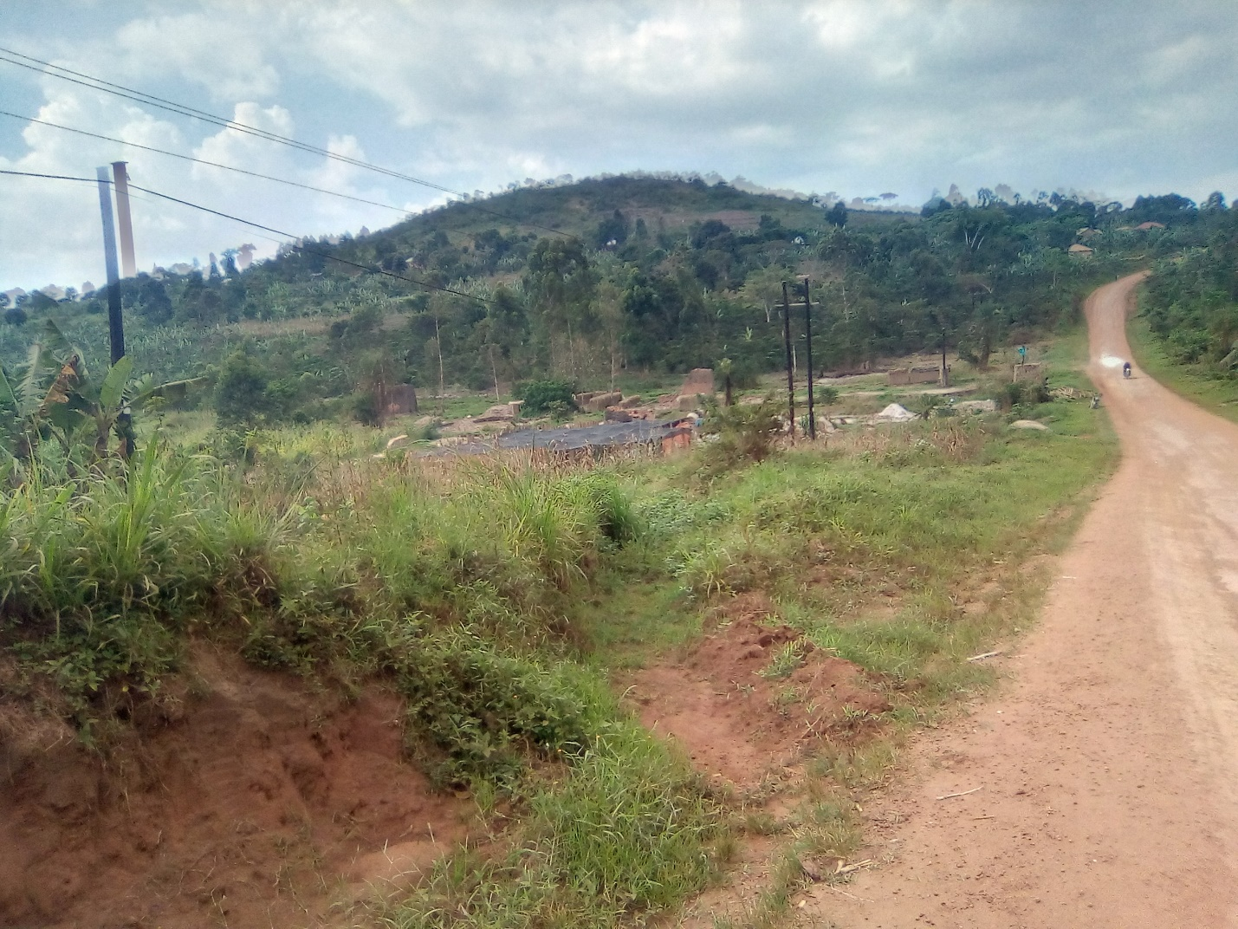
Degraded section of Bugoye/Nfumbye wetland in Maanyi SC due to sand excavation, brick making and other human activities
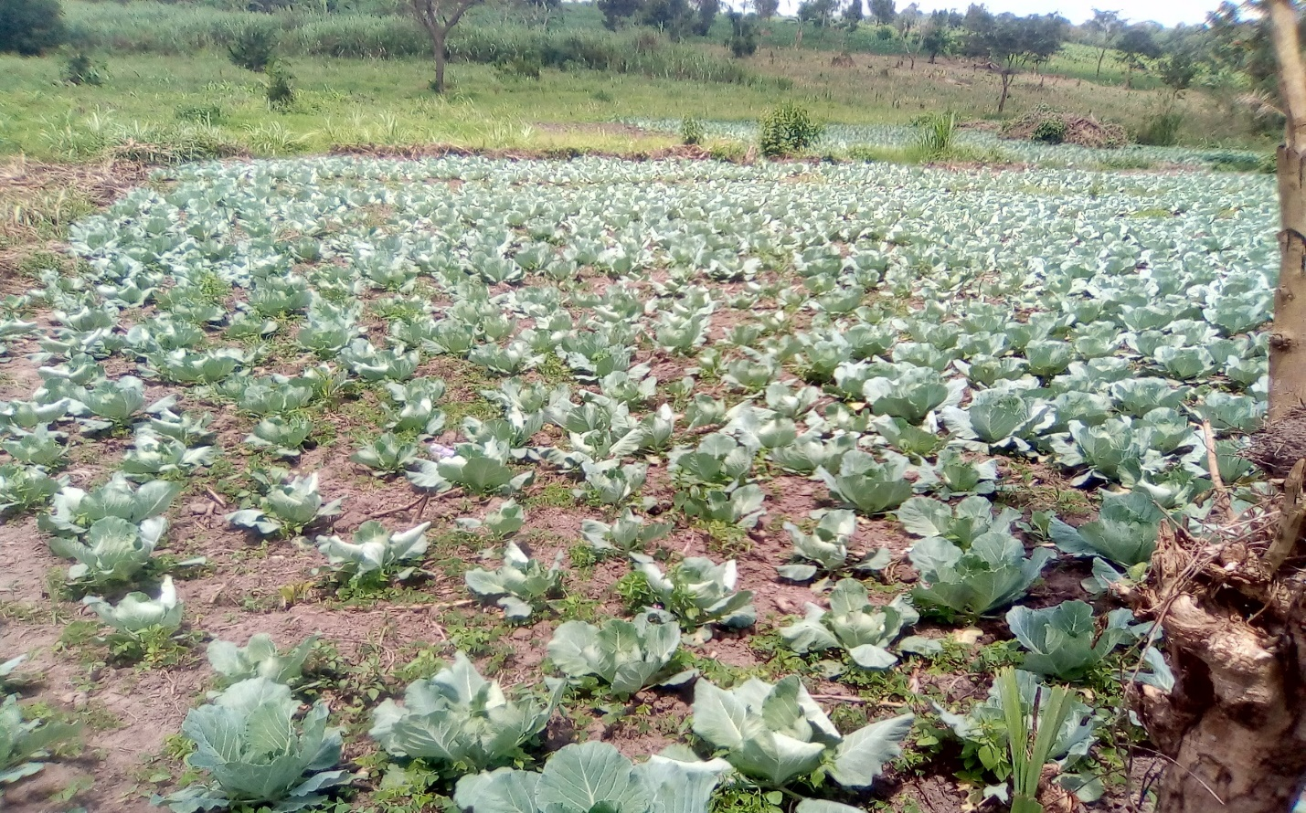
Field Photo: Degraded section of Sebbobbo wetland in Sekanyonyi due to subsistence cabbage cultivation.
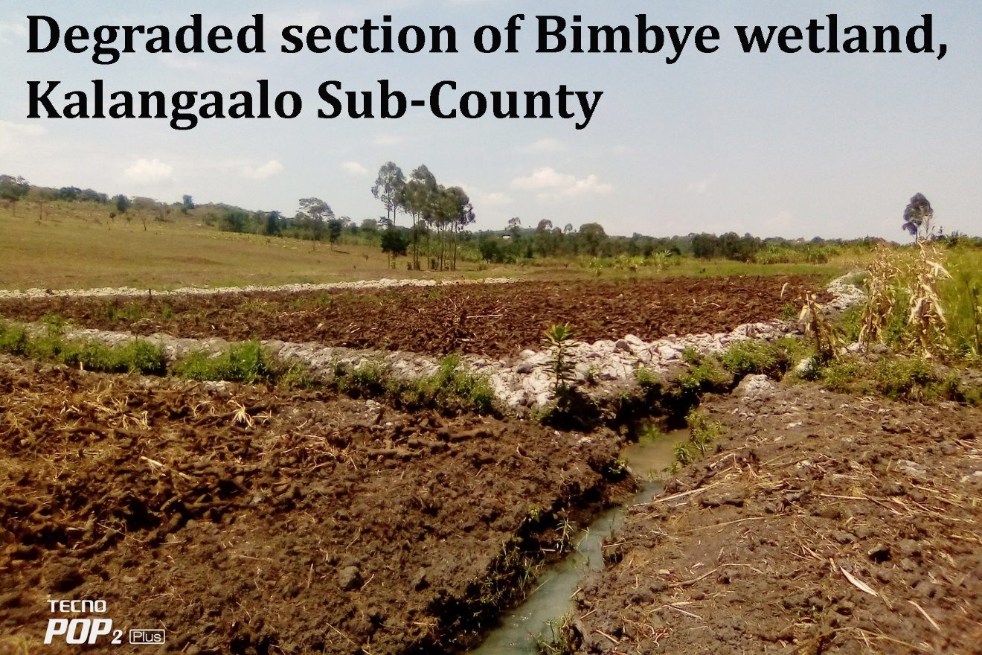

Samples of Wetland Management Interventions/Practices
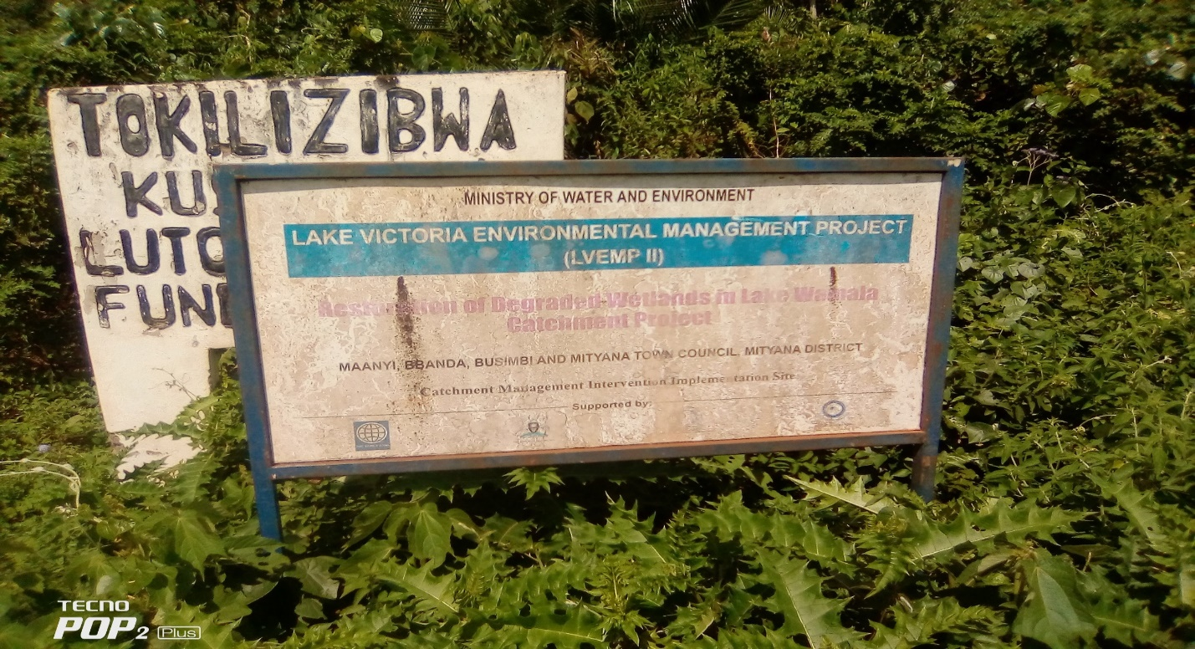
Field Photo: Lake Victoria Environment Management Project II Marking of Nakatongoli swamp forest zones to protect it from encroachment
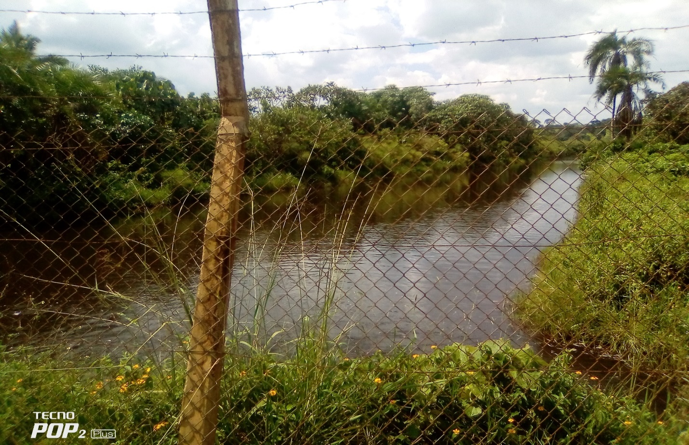
Field Photo: Fencing of Nakatongoli urban water supply wetland zone
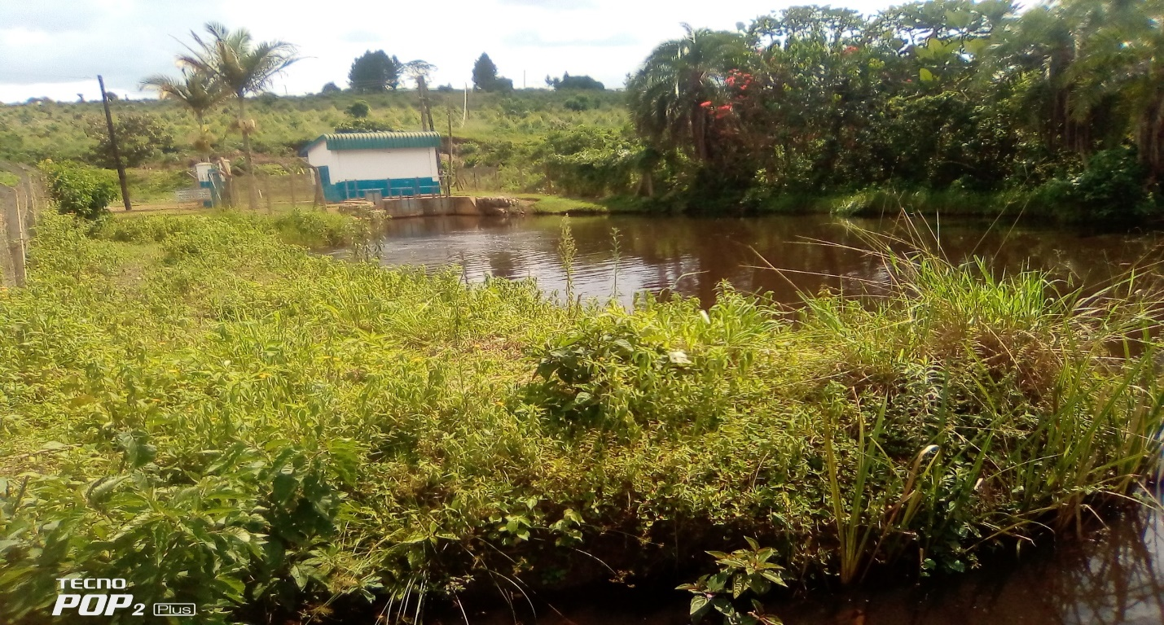
Fenced Zones of the Wetland and a water purification point of Nakatongoli permanent swamp
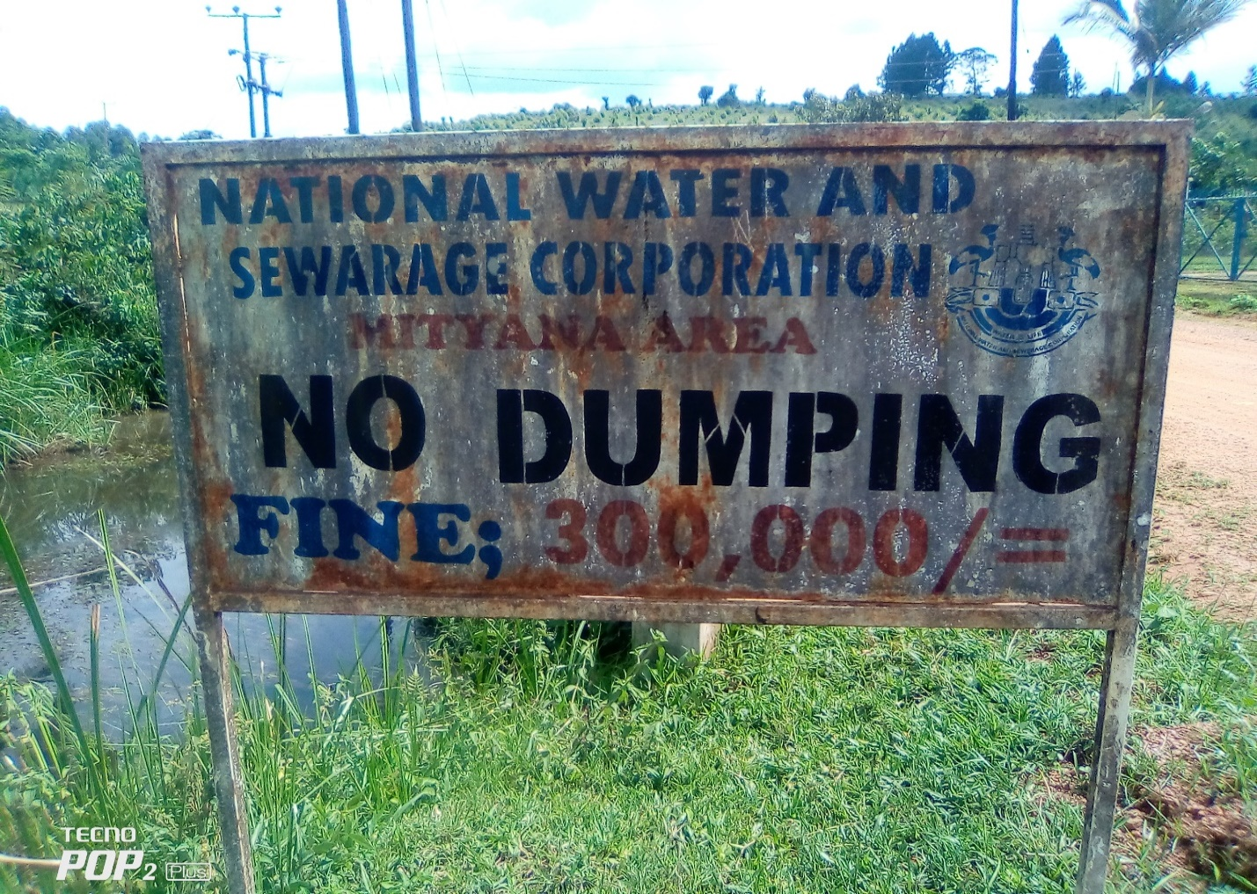
Field Photo: Restricted Dumping Zone
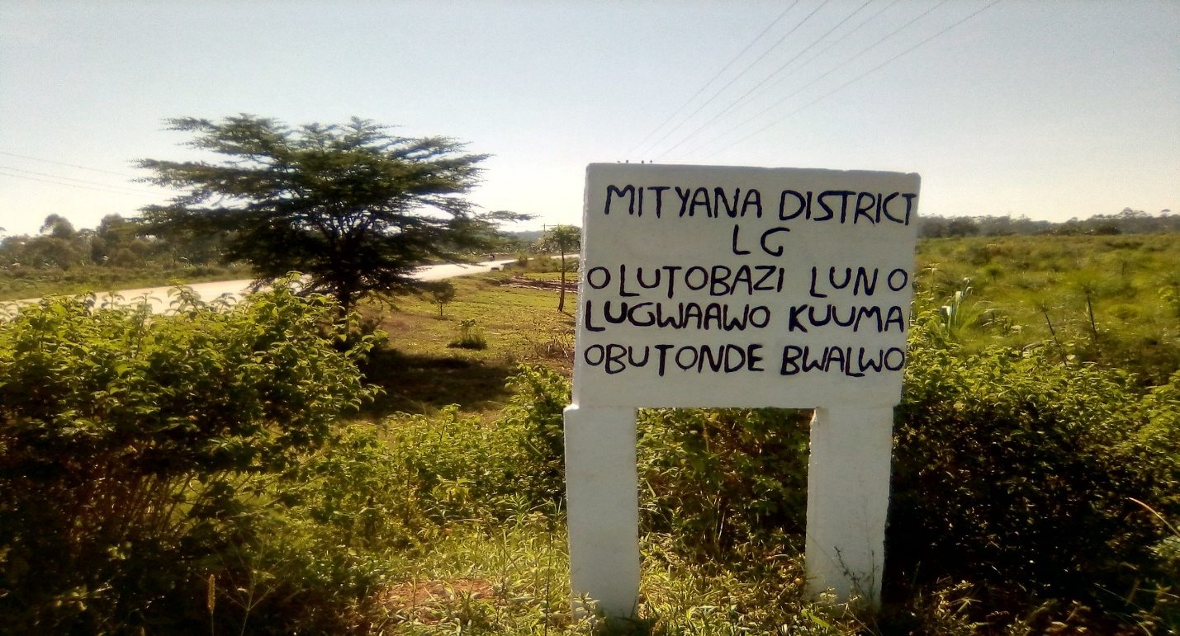
Field Photo: Wetland Pillars/Markings for community awareness along River Mayanja wetland near Busunju Town
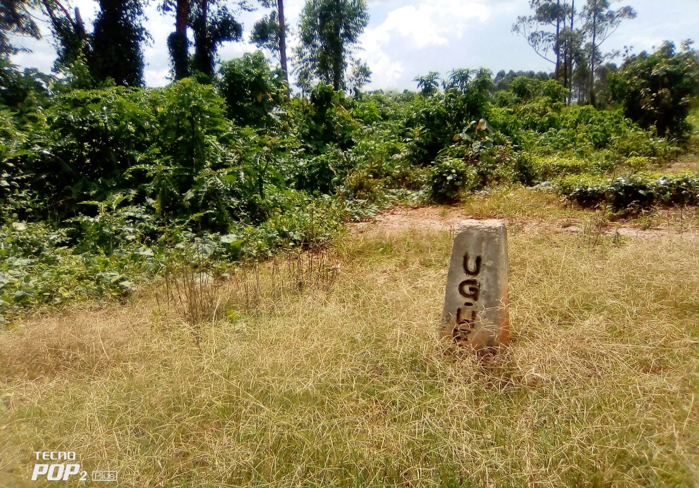
Field Photo: Stone markings to demarcate wetland boundaries and limit encroachment in Wakitundu and Mpamujjugu wetlands in the Lake Wamala system
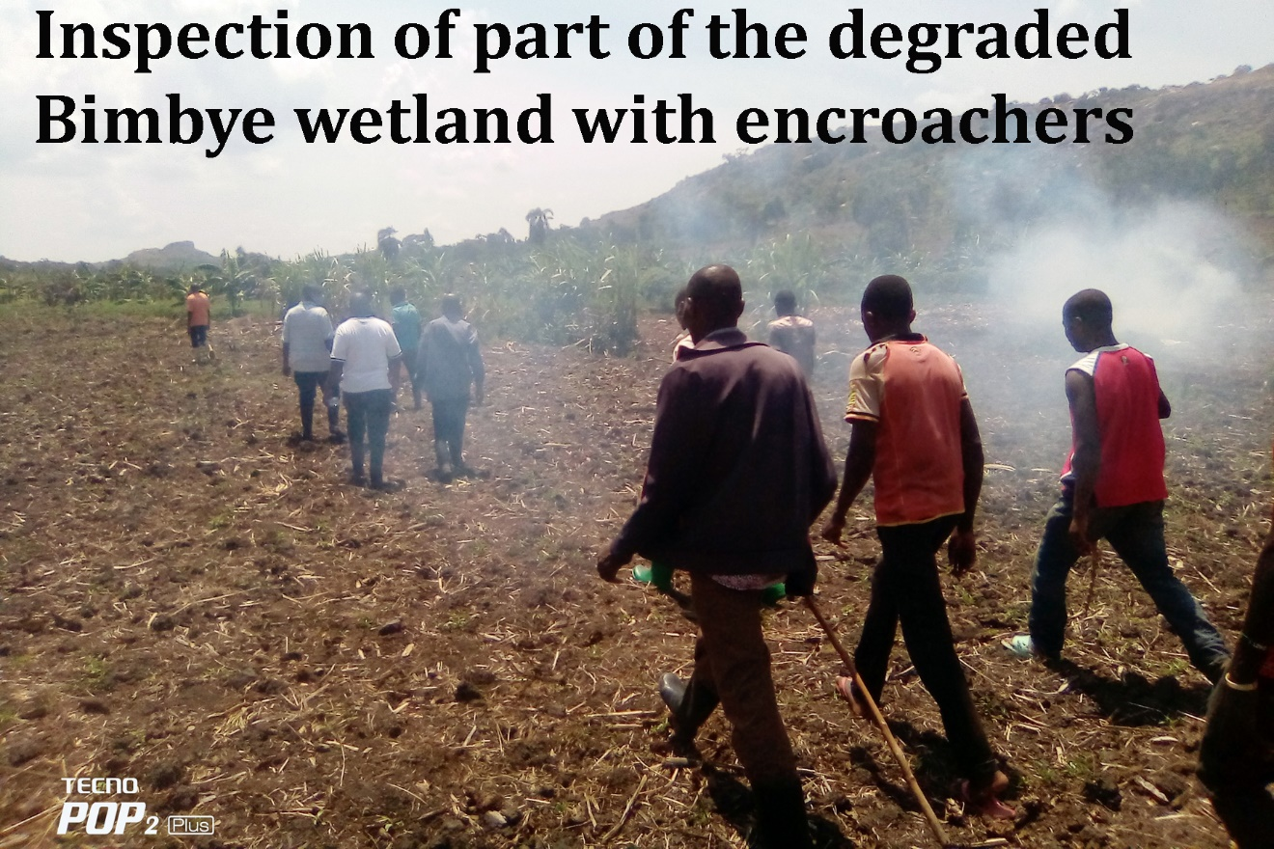
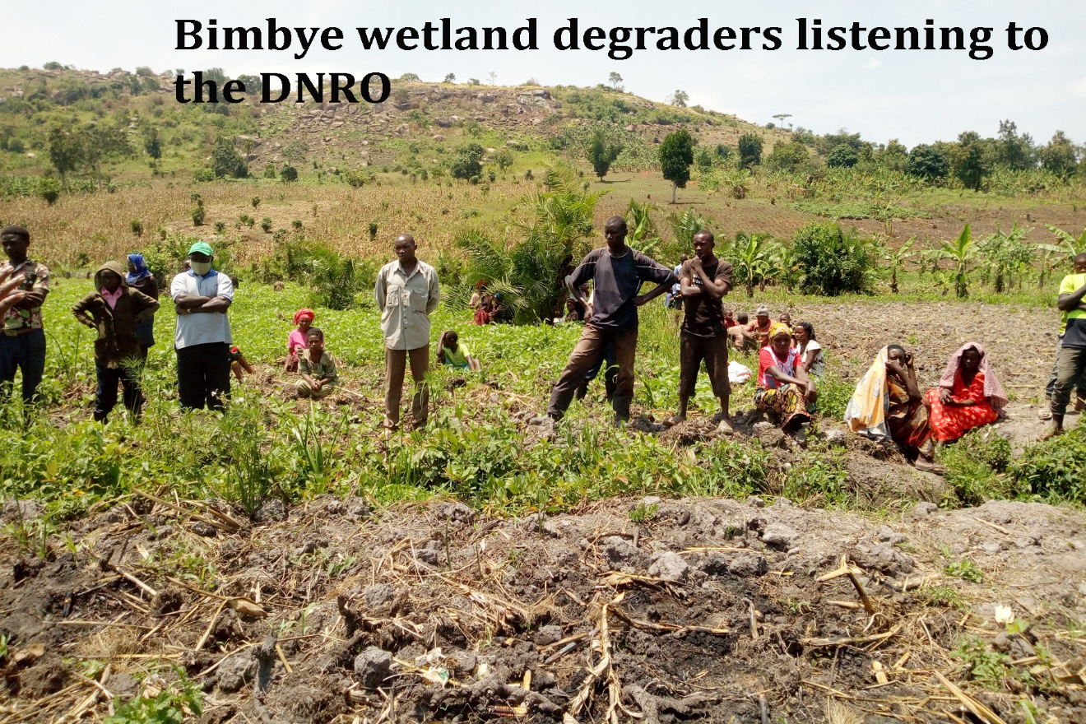
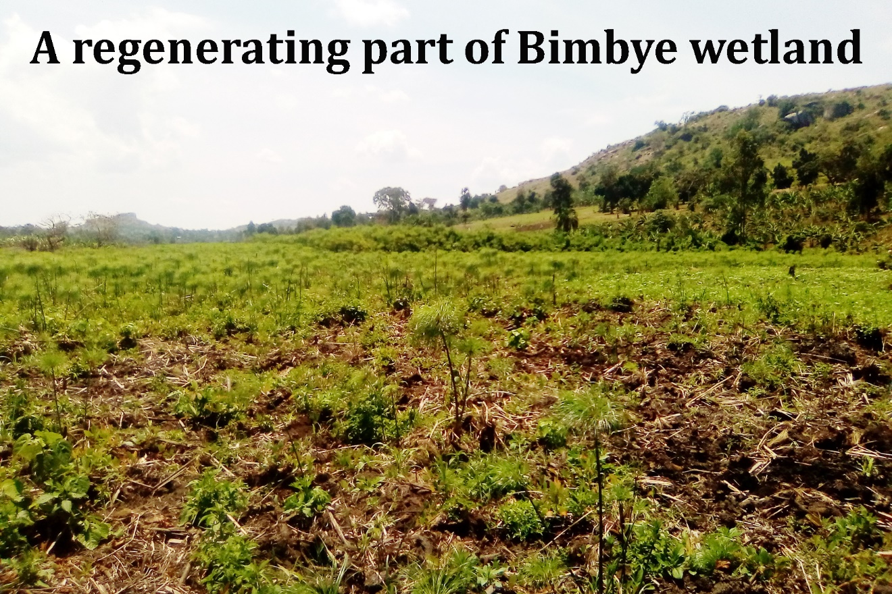
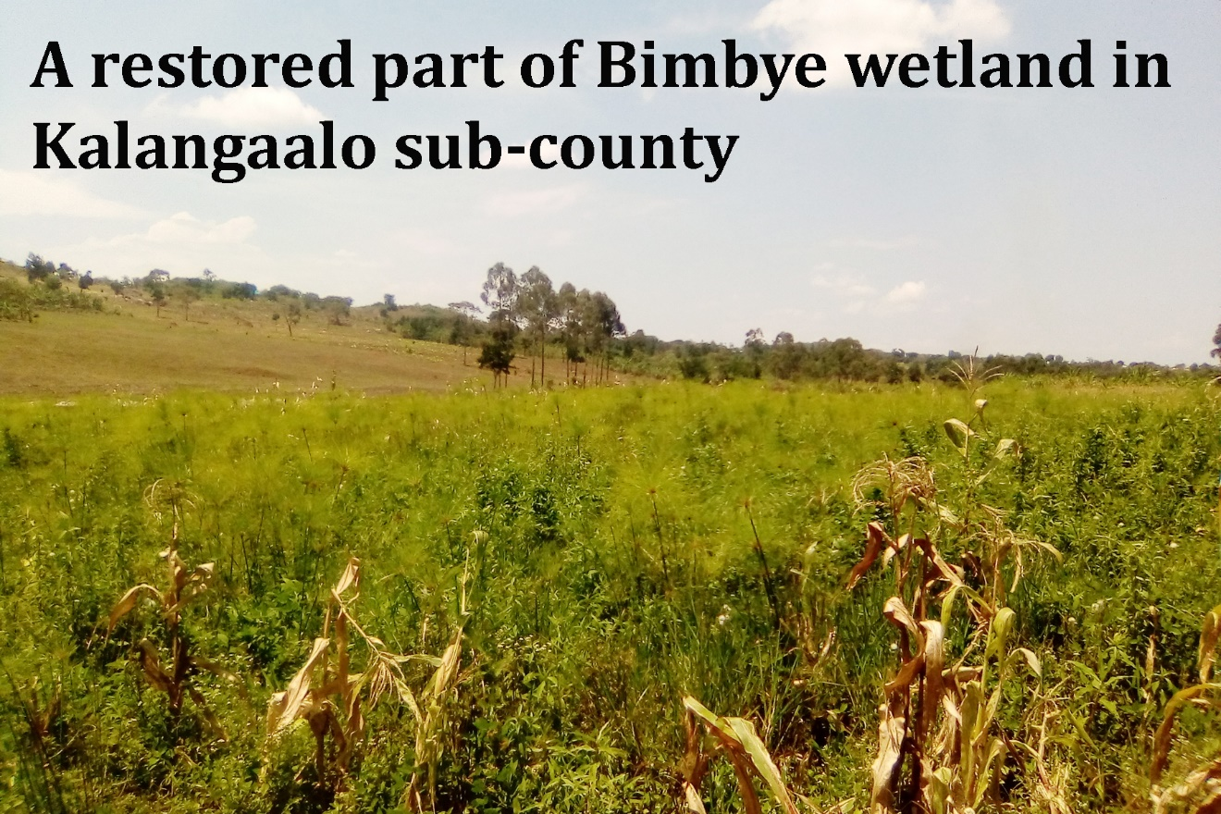

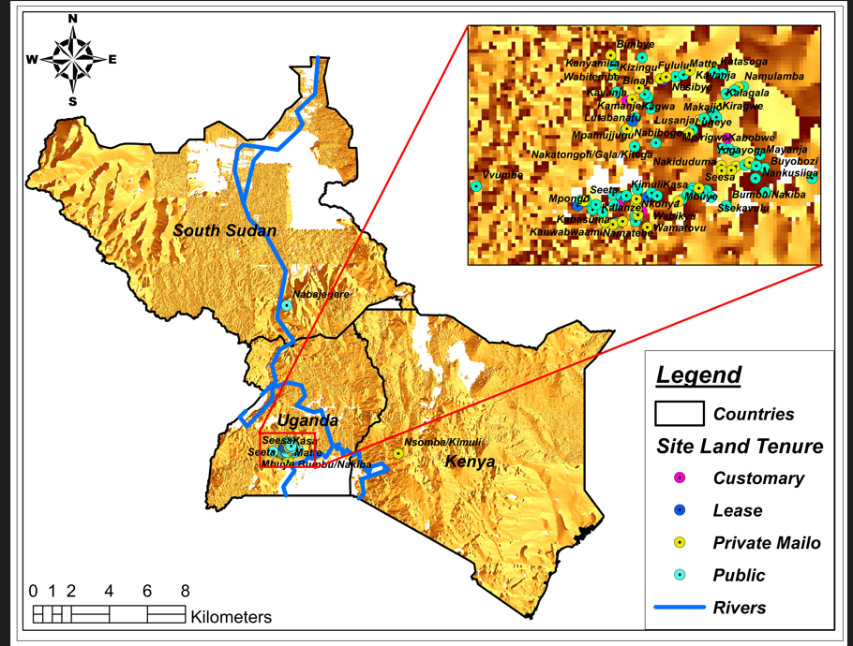
Main Land Tenure Systems reported during the study.

