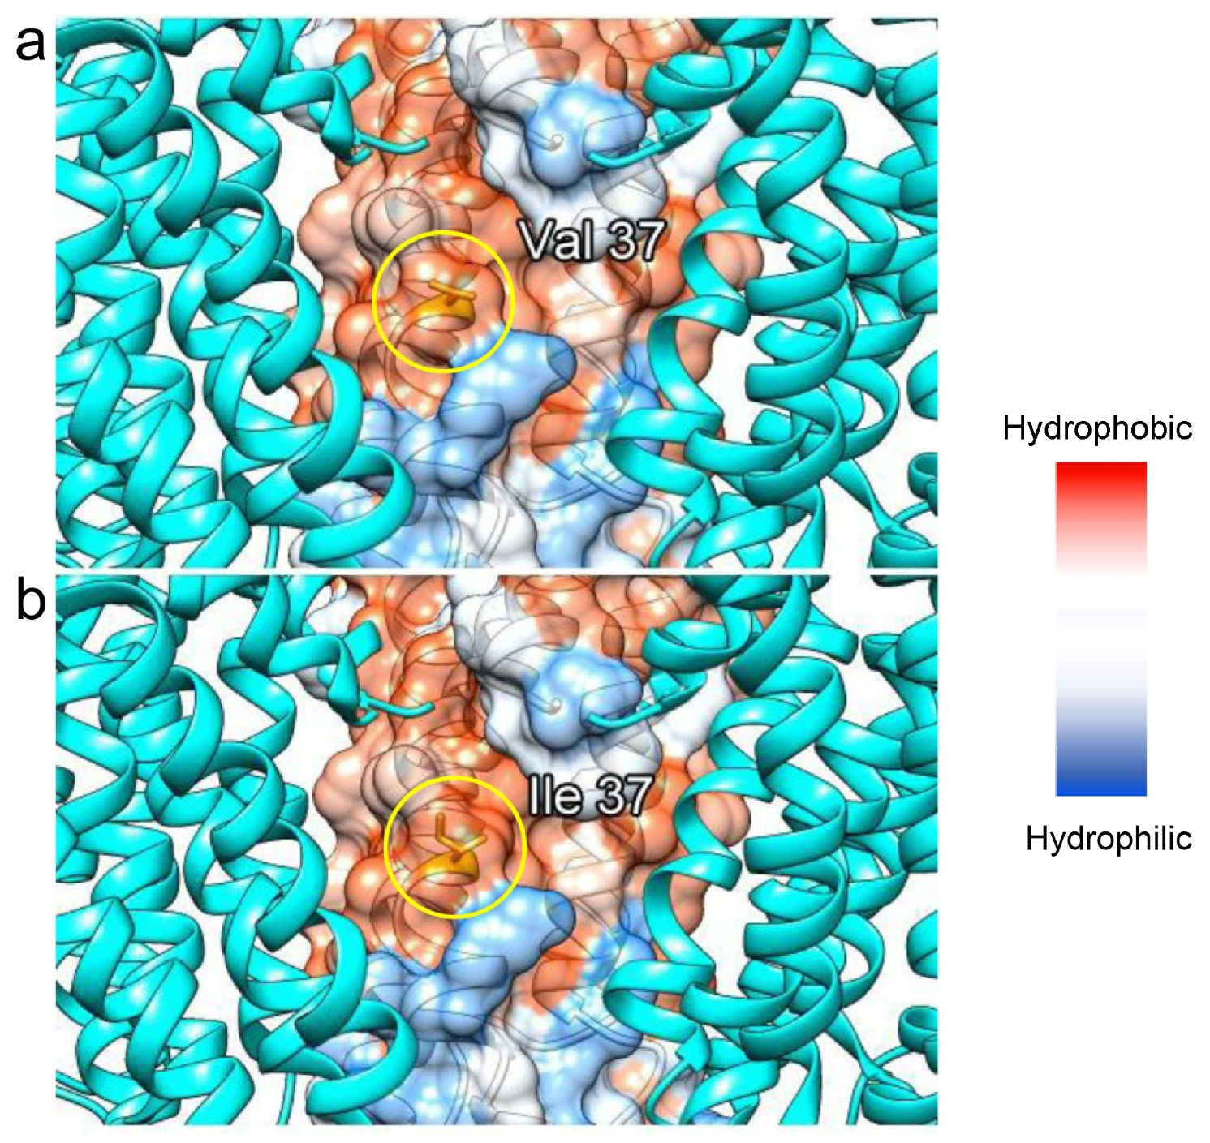

Supplemental Fig. 1. Comparison of the hydrophobic environment between the wild-type and V37I variant
The side chain and main chain of valine 37 in the wild type (a) and isoleucine 37 in the variant (b) are presented in yellow circles on a single component of GJB2, which are shown by the hydrophobic surface. Hydrophilic (blue) and hydrophobic (red) residues shown in a surface representation model.

