Extended Data Figures
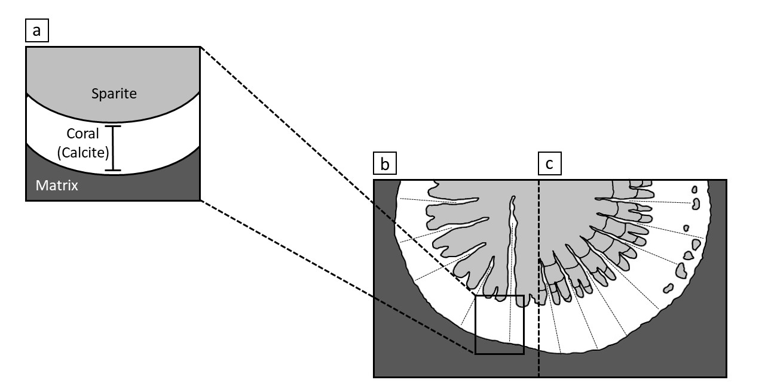
Extended Data Figure 1. a) Schematic representation of phases (matrix, coral skeleton, sparite), which were used for careful sample extraction. Cross section with distribution of phases in b) Dendrostella trigemme and c) Temnophyllum latum. Note that each phase may yield contamination from the other, due to the skeletal architecture of analyzed corals (e.g., intra-skeletal sparite content).

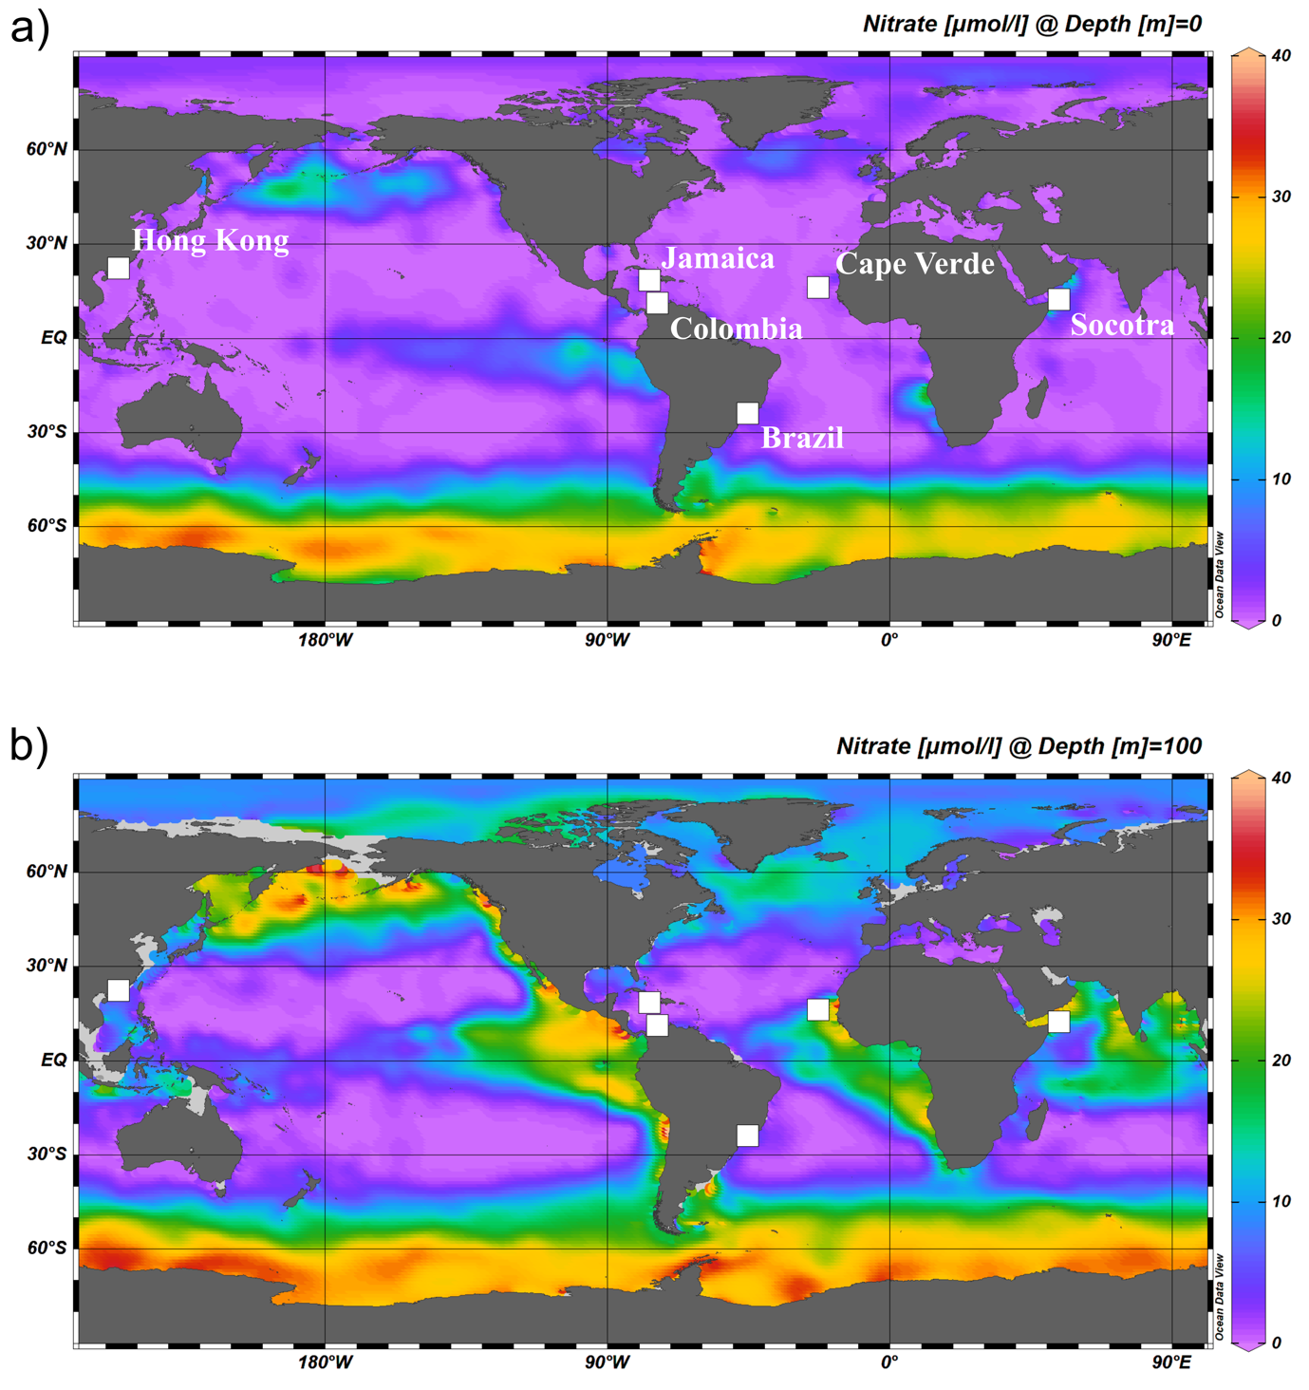 Extended Data Figure 2. a) Global surface nitrate concentrations with respect to of modern symbiont-bearing and symbiont-barren coral pairs. b) Global nitrate concentrations at 100 m depth. Visualizations were created with Ocean Data View Version 5.6.3 (Sept. 2022) (https://odv.awi.de/).
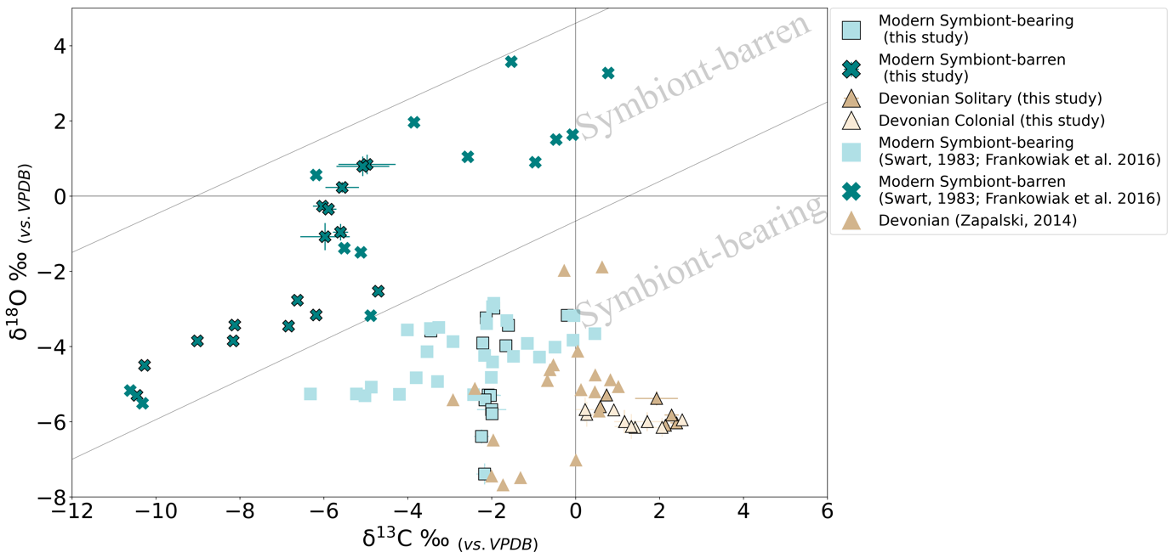
Extended Data Figure 3. Scatterplot of oxygen and carbon isotope values measured on Paleozoic colonial and solitary corals and their respective sedimentary matrix from the Hagen Balve Reef and Eifel region. Modern analogues of symbiont-bearing (light green squares) and symbiont-barren (dark green crosses) species from various locations were measured. A compilation of previously measured modern symbiont-bearing and symbiont-barren corals are also included from Swart (1983) and Frankowiak et al. (2016), where samples indicate distinct spaces for symbiont-bearing and symbiont-barren species as indicated by the respective field (adapted from Swart, 1983). Previously published Devonian values are shown as brown triangles, with darker and lighter brown tones indicating solitary and colonial species, respectively. Notably, all Paleozoic samples from this study cluster within the symbiotic range and would indicate no difference between coral groups.

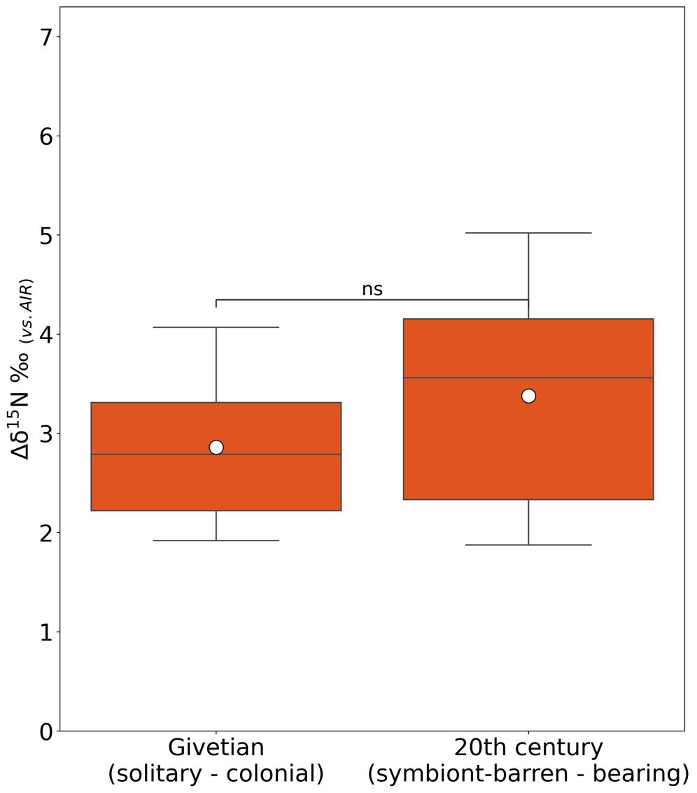

Extended Data Figure 4. Average N isotopic differences between solitary and tabulate/loosely colonial rugose species from the Mid-Devonian (Givetian) compared to the difference between modern symbiont-bearing and symbiont-barren corals. A Welch’s t-test for unequal variances indicates that there is no significant difference between the values of ∆δ¹⁵N from ancient reefs and the ∆δ¹⁵N differences between the co-occurring symbiont-bearing and -barren corals from modern reefs (P = 0.459).

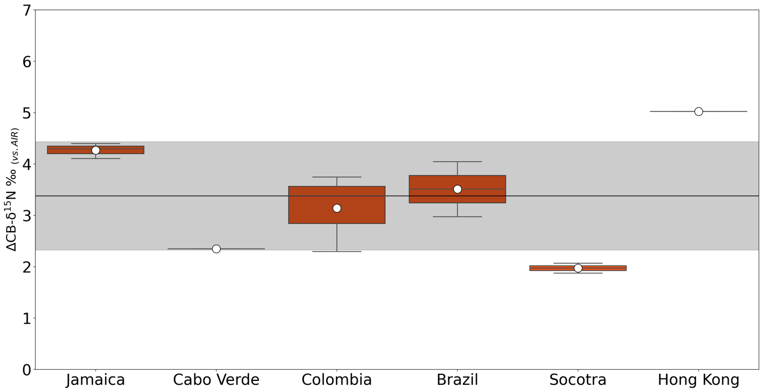

Extended Data Figure 5. Average differences between symbiont-barren and -bearing species based on location and expressed as ∆δ¹⁵N = δ¹⁵N_{non-sym.} - δ¹⁵N_{sym}. Differences vary between 1.97‰ and 5.02‰ with an average ∆δ¹⁵N of 3.38 ±1.05‰ as indicated by the black vertical line and the grey shaded area.

Extended Data Figure 6. Conodont fragments from Binolen. (a) Bipennatus bipennatus MT α, Bed 4, GMM B9A.15-1. (b) Bi. bipennatus MT α, Bed 4, GMM B9A.15-2. (c) Bi. bipennatus MT α, Bed 18a, GMM B9A.15-15. (d) Bi. bipennatus MT α, Bed 29, GMM B9A.15-31. (e) Polygnathid Pb element, Bed 18a, GMM B9A.15-17. (f) Polygnathid ramiform element, Bed 23, GMM B9A.15-26. (g) Polygnathid ramiform element, Bed 23, GMM B9A.15-27.

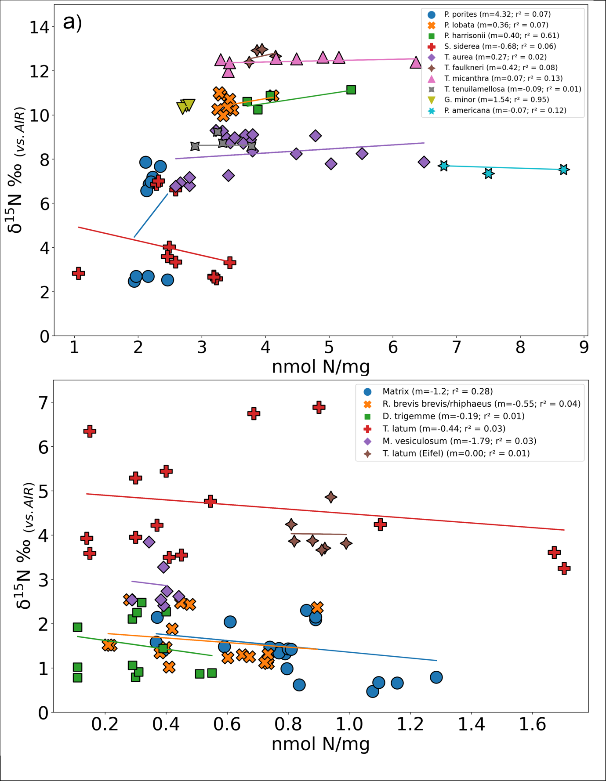 Extended Data Figure 7. a) The relationship between nitrogen content per mg of cleaned carbonate powder and the nitrogen isotope composition of each species that was analyzed in the recent reefs. For each species, the slope (m) and correlation coefficient (r²) are given. b) The relationship between nitrogen content per mg of cleaned carbonate powder and the nitrogen isotope composition of each species that was analyzed on the Mid-Devonian reefs. For each species, the slope (m) and correlation coefficient (r²) are given.

Supplementary Tables

Species | Bed No.  (Löw et al. 2022) | GMM No.  (Löw et al. 2022) | CAI
Bipennatus bipennatus, MT α | 4 | GMM B9A.15-1 | 4
Bi. bipennatus, MT α | 4 | GMM B9A.15-2 | 4
Icriodus ?latecarinatus | 4 | GMM B9A.15-3 | 4
Drepanodus sp. | 4 | GMM B9A.15-4 | 4
?Neopanderodus sp. | 5 | GMM B9A.15-5 | 4
Prioniodina sp. | 6 | GMM B9A.15-6 | 4
Dvorakia chattertoni | 6 | GMM B9A.15-7 | 4
Dv. chattertoni | 6 | GMM B9A.15-8 | 4
Dv. chattertoni | 6 | GMM B9A.15-9 | 4
Belodella resima | 6 | GMM B9A.15-10 | 4
Neop. perlineatus | 6 | GMM B9A.15-11 | 4
Prioniodina sp. | 9 | GMM B9A.15-12 | 4
Panderodus sp. | 16 | GMM B9A.15-13 | 4
Bel. resima | 16 | GMM B9A.15-14 | 4
Bi. bipennatus, MT α | 18a | GMM B9A.15-15 | 4
Bi. bipennatus, MT α | 18a | GMM B9A.15-16 | 4
Polygnathid Pb element | 18a | GMM B9A.15-17 | 4
?Prioniodid ramiform element | 18a | GMM B9A.15-18 | 4
Bi. bipennatus, MT α | 18b | GMM B9A.15-19 | 4
Bel. resima | 20 top | GMM B9A.15-20 | 4
Dv. chattertoni | 20 top | GMM B9A.15-21 | 4
Polygnathid ramiform element | 20 top | GMM B9A.15-22 | 4
Panderodus cf. unicostatus | 21 | GMM B9A.15-23 | 4
?Neopanderodus sp. | 21 | GMM B9A.15-24 | 4
Dv, chattertoni | 22 | GMM B9A.15-25 | 4
Polygnathid ramiform element | 23 | GMM B9A.15-26 | 4
Polygnathid ramiform element | 23 | GMM B9A.15-27 | 4
Bi. bipennatus, MT α | 23 | GMM B9A.15-28 | 4
Dv, chattertoni | 25 | GMM B9A.15-29 | 4
Bi. bipennatus, MT α | 28 | GMM B9A.15-30 | 4
Bi. bipennatus, MT α | 29 | GMM B9A.15-31 | 4
Dv. klapperi | 50 | GMM B9A.15-32 | 4
Dv. klapperi | 50 | GMM B9A.15-33 | 4
Supplementary Table 1. Conodonts from Binolen and their respective CAI value (determination of conodonts by Z. S. Aboussalam and R. T. Becker).

Sample | δ¹⁵N | ±1SD | nmol N/mg | ±1SD | n=
Hagen Balve Reef - Binolen

Marine limestones [host rock] | 1.57(-3.80) | 0.46(6.60) | 0.71(3.49) | 0.18(3.80) | 16(10)
Marine cements [sparite] | 1.45(3.59) | 0.58(4.08) | 0.35(1.72) | 0.21(1.44) | 20(12)
Tabulata [auloporid morphotypes]
Roemerolites brevis rhiphaeus (1) | 1.18(1.34) | 0.23(0.99) | 0.40(1.08) | 0.02(0.55) | 2(3)
Roemerolites brevis rhiphaeus (2) | 1.63(0.99) | 0.30(0.77) | 0.41(0.71) | 0.01(0.02) | 2(3)
Roemerolites brevis rhiphaeus (3) | 1.52(3.67) | 0.01(0.99) | 0.22(0.74) | 0.01(0.22) | 2(2)
Roemerolites brevis rhiphaeus (4) | 2.45(2.70) | 0.07(0.53) | 0.53(0.60) | 0.26(0.09) | 4(2)
Mean of values | 1.85(1.97) | 0.56(1.30) | 0.41(0.80) | 0.19(0.34) | 10(10)
Rugosa [dendroid morphotypes]
Dendrostella trigemme (1) | 0.90(-0.66) | 0.12(0.16) | 0.11(3.74) | 0.00(0.04) | 3(2)
Dendrostella trigemme (2) | 2.38(1.79) | 0.15(1.34) | 0.36(0.37) | 0.06(0.01) | 2(2)
Dendrostella trigemme (3) | 0.86(2.42) | 0.06(2.16) | 0.37(1.75) | 0.12(2.46) | 3(3)
Dendrostella trigemme (4) | 1.47(2.37) | 0.43(0.58) | 0.41(2.91) | 0.13(0.79) | 3(2)
Dendrostella trigemme (5) | 2.18(-) | 0.10(-) | 0.30(-) | 0.01(-) | 2(-)
Mean of values | 1.45(1.58) | 0.66(1.77) | 0.31(2.14) | 0.14(1.79) | 13(9)
Rugosa [solitary morphotypes]
Temnophyllum latum | 5.16(2.05) | 0.88(0.79) | 1.06(1.39) | 0.64(0.66) | 5(3)
Temnophyllum astrictum | 5.52(1.60) | 1.49(0.45) | 0.53(0.55) | 0.33(0.27) | 4(6)
Rugosa indet. | 3.57(1.37) | 0.22(1.98) | 0.31(1.75) | 0.14(1.60) | 6(4)
Mean of values  Eifel Region – Sötenich Syncline  Marine limestone [host rock]  Tabulata [auloporid morphotype]  Roemerolites brevis brevis  Rugosa [solitary morphotype]  Temnophyllum latum  Eifel Region – Dollendorf Syncline  Marine limestone [host rock]  Rugosa [solitary morphotype]  Mesophylum vesiculosum | 4.62(1.63)  1.27  1.22  4.01  0.83  3.06 | 1.24(1.11)  0.16  0.08  0.42  0.13  0.47 | 0.62(1.11)  1.15  0.32  0.89  1.47  0.32 | 0.51(1.03)  0.09  0.05  0.13  0.05  0.09 | 15(13)  4  7  7  4  7
Supplementary Table 2. Raw nitrogen isotope and N content/mg values for clean and unclean samples from the Devonian. As expected, unclean samples contain more N/mg and show a greater variation, which implies that cleaning of carefully extracted sample material is preferential. Note that unclean samples are given in parentheses next to the respective clean value. Eifel samples were provided by the Senckenberg Research Institute and Natural History Museum Frankfurt, Germany.

Sample | δ¹⁵N | ±1SD | nmol N/mg | ±1SD | n=
Cape Verde [São Tiago]
Tubastraea sp. | 9.17 | 0.19 | 3.85 | 0.66 | 7
Siderastrea radians | 6.83 | 0.19 | 2.40 | 0.17 | 3
Colombia [Magdalera]
Tubastraea aurea | 8.93 | 0.17 | 3.49 | 0.14 | 6
Tubastraea tenuilamellosa  Gardineria minor | 8.95  10.42 | 0.46  0.02 | 3.31  2.78 | 0.37  0.02 | 5  3
Porites porites  Porites asteroids  Mycetophyllia ferox | 7.14  5.69  6.05 | 0.44  0.05  0.89 | 2.16  1.22  3.02 | 0.06  0.01  0.24 | 8  2  2
Jamaica [Collection A. Podzorski]
Tubastraea aurea (1) | 6.91 | 0.18 | 2.72 | 0.11 | 4
Tubastraea aurea (2)  Thalamophyllia riisei  Phyllangia americana | 8.16  6.28  7.53 | 0.25  0.58  0.17 | 4.71  1.99  7.66 | 0.74  0.29  0.95 | 4  2  3
Porites porites  Porites furcata  Siderastrea siderea | 2.72  3.01  2.82 | 0.18  0.25  0.29 | 2.06  2.58  2.25 | 0.10  0.01  0.25 | 5  2  5
Socotra [Gulf of Aden]
Tubastrea faulkneri | 12.74 | 0.27 | 3.93 | 0.17 | 4
Tubastraea micanthra (1) | 12.54 | 0.11 | 5.23 | 0.81 | 4
Tubastraea micanthra (2) | 12.35 | 0.27 | 3.58 | 0.40 | 4
Porites harrisoni | 10.72 | 0.39 | 4.25 | 0.74 | 4
Porites lobata (1) | 10.87 | 0.12 | 3.53 | 0.40 | 4
Porites lobata (2) | 10.19 | 0.15 | 3.37 | 1.06 | 4
Supplementary Table 3. Pairs of nitrogen isotope and N content/mg values for clean samples from a range of different locations. Symbiont-barren (i.e., Tubastraea spp.) and symbiont-bearing (i.e., Porites spp.) species were sampled from the same location based on collections at the Senckenberg Research Institute and Natural History Museum Frankfurt, Germany.

Sample | δ¹³C | ±1SD | δ¹⁸O | ±1SD | n=
Hagen Balve Reef - Binolen

Marine limestones [host rock] | 2.39 | 0.04 | -6.64 | 0.18 | 7
Marine cements [sparite] | 2.29 | 0.21 | -5.57 | 0.35 | 19
Tabulata [auloporid morphotypes]
Roemerolites brevis rhiphaeus (1) | 1.17 | 0.05 | -5.77 | 0.01 | 3
Roemerolites brevis rhiphaeus (2) | 1.33 | 0.40 | -6.13 | 0.33 | 3
Roemerolites brevis rhiphaeus (3) | 2.06 | 0.42 | -6.15 | 0.25 | 3
Roemerolites brevis rhiphaeus (4) | 2.54 | 0.01 | -5.95 | 0.10 | 2
Mean of values | 1.71 | 0.61 | -6.00 | 0.25 | 11
Rugosa [dendroid morphotypes]
Dendrostella trigemme (1) | 1.29 | 0.07 | -6.32 | 0.04 | 2
Dendrostella trigemme (2) | 1.42 | 0.05 | -6.15 | 0.09 | 2
Dendrostella trigemme (3) | 0.91 | 0.07 | -5.69 | 0.01 | 3
Mean of values | 1.17 | 0.25 | -6.00 | 0.31 | 7
Rugosa [solitary morphotypes]
Temnophyllum latum | 1.93 | 0.51 | -5.38 | 0.19 | 8
Temnophyllum astrictum | 2.14 | 0.15 | -6.03 | 0.15 | 8
Rugosa indet. | 2.29 | 0.17 | -5.82 | 0.10 | 4
Mean of values  Eifel Region – Sötenich Syncline  Marine limestone [host rock]  Tabulata [auloporid morphotype]  Romerolites brevis brevis  Eifel Region – Dollendorf Syncline  Marine limestone [host rock]  Rugosa [solitary morphotype]  Mesophylum vesiculosum | 2.19  2.14  0.59  2.05  0.74 | 0.40  0.10  0.01  0.04  0.07 | -5.73  -6.09  -5.60  -6.47  -5.29 | 0.34  0.11  0.03  0.06  0.09 | 20  3  3  3  3
Supplementary Table 4. Carbon and oxygen isotope values for our Paleozoic samples from the Hagen Balve Reef and the Eifel region. Individual values are given and summarized as means for different morphotypes. Eifel samples were provided by the Senckenberg Research Institute and Natural History Museum Frankfurt, Germany.
Sample | δ¹³C | ±1SD | δ¹⁸O | ±1SD | n=
Cape Verde [São Tiago]
Tubastraea sp. | -6.63 | 0.07 | -2.77 | 0.18 | 4
Siderastrea radians | -1.60 | 0.10 | -3.44 | 0.03 | 4
Colombia [Magdalera]
Tubastrea aurea | -10.27 | 0.29 | -4.50 | 0.13 | 4
Tubastraea tenuilamellosa  Gardineria minor | -8.16  -2.87 | 0.09  0.20 | -3.85  -1.39 | 0.03  0.11 | 3  3
Porites porites  Porites asteroids  Mycetophyllia ferox | -1.66  -1.98  -3.07 | 0.02  0.06  1.25 | -3.98  -4.81  -2.85 | 0.08  1.82  0.43 | 3  4  4
Jamaica [Collection A. Podzorski]
Tubastraea aurea (1) | -4.70 | 0.13 | -2.53 | 0.06 | 3
Tubastraea aurea (2)  Thalamophyllia riisei  Phyllangia americana | -5.77  1.60  -3.79 | 1.19  0.35  1.64 | -2.99  -0.09  -2.26 | 0.51  0.53  0.35 | 3  3  4
Porites porites  Porites furcata  Siderastrea siderea | -3.45  -2.06  -0.75 | 0.06  0.31  0.05 | -3.59  -2.75  -3.40 | 0.01  0.07  0.02 | 5  2  3
Socotra [Gulf of Aden]
Tubastraea faulkneri | -6.18 | 0.18 | -3.16 | 0.06 | 4
Tubastraea micanthra (1) | -9.01 | 0.05 | -3.85 | 0.12 | 3
Tubastraea micanthra (2) | -8.12 | 0.15 | -3.43 | 0.14 | 3
Porites harrisoni | -2.21 | 0.10 | -3.91 | 0.05 | 4
Porites lobata (1) | -1.95 | 0.09 | -2.89 | 0.04 | 3
Porites lobata (2) | -2.13 | 0.04 | -3.24 | 0.02 | 3
Supplementary Table 5. Carbon and oxygen isotope values for recent pairs of symbiont-barren and symbiont-bearing species from a range of different locations. Skeletal material was sampled at the Senckenberg Research Institute and Natural History Museum Frankfurt, Germany.

