Design, synthesis, and molecular dynamics simulation studies of some novel kojic acid fused 2-amino-3-cyano-4H-pyran derivatives as tyrosinase inhibitors

Zahra Najafi,^{a*} Maryam Zandi Haramabadi,ª Gholamabbas Chehardoli,^{b} Ahmad Ebadi‬^{b} ‬‬‬‬ Aida Iraji ^{c,d*}‬‬‬‬‬‬

ª Department of Medicinal Chemistry, School of Pharmacy, Hamadan University of Medical Sciences, Hamadan, Iran.
^{b} Department of Medicinal Chemistry, School of Pharmacy, Medicinal Plants and Natural Products Research Center, Hamadan University of Medical Sciences, Hamadan, Iran.
^{c} Stem Cells Technology Research Center, Shiraz University of Medical Sciences, Shiraz, Iran.
^{d} Research Center for Traditional Medicine and History of Medicine, Department of Persian Medicine, School of Medicine, Shiraz University of Medical Sciences, Shiraz, Iran.

*Corresponding authors:
E-mail najafi.zch@gmail.com;z.najafi@umsha.ac.ir
and aida. iraji@gmail.com; iraji@sums.ac.ir

Molecular dynamics simulation results for S-enantiomer of compound 6b
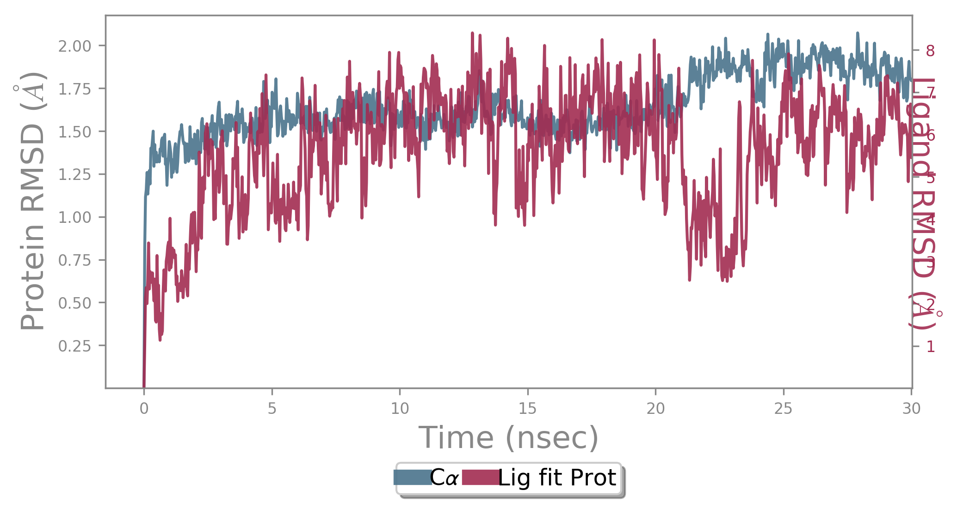
Fig. S1. RMSD of S enantiomer of 6b during MD run against tyrosinase
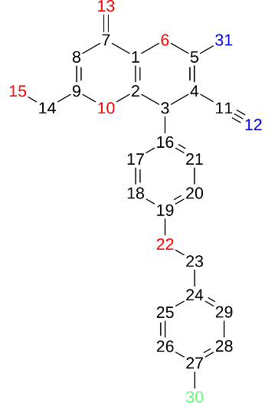
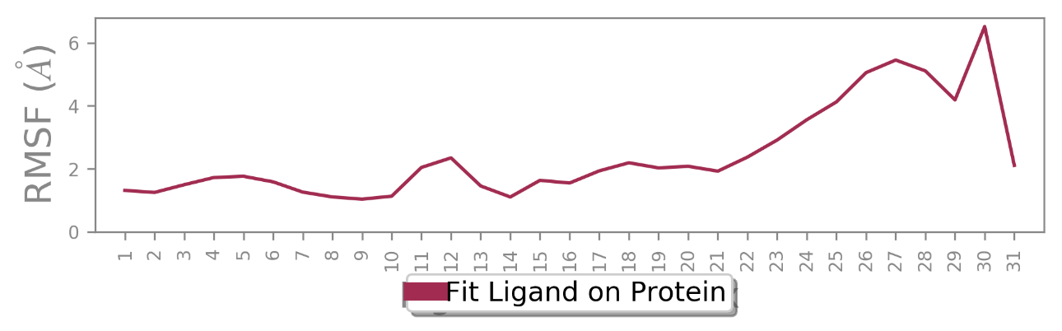

Fig. S2. RMSF of S-enantiomer of 6b MD run against tyrosinase.

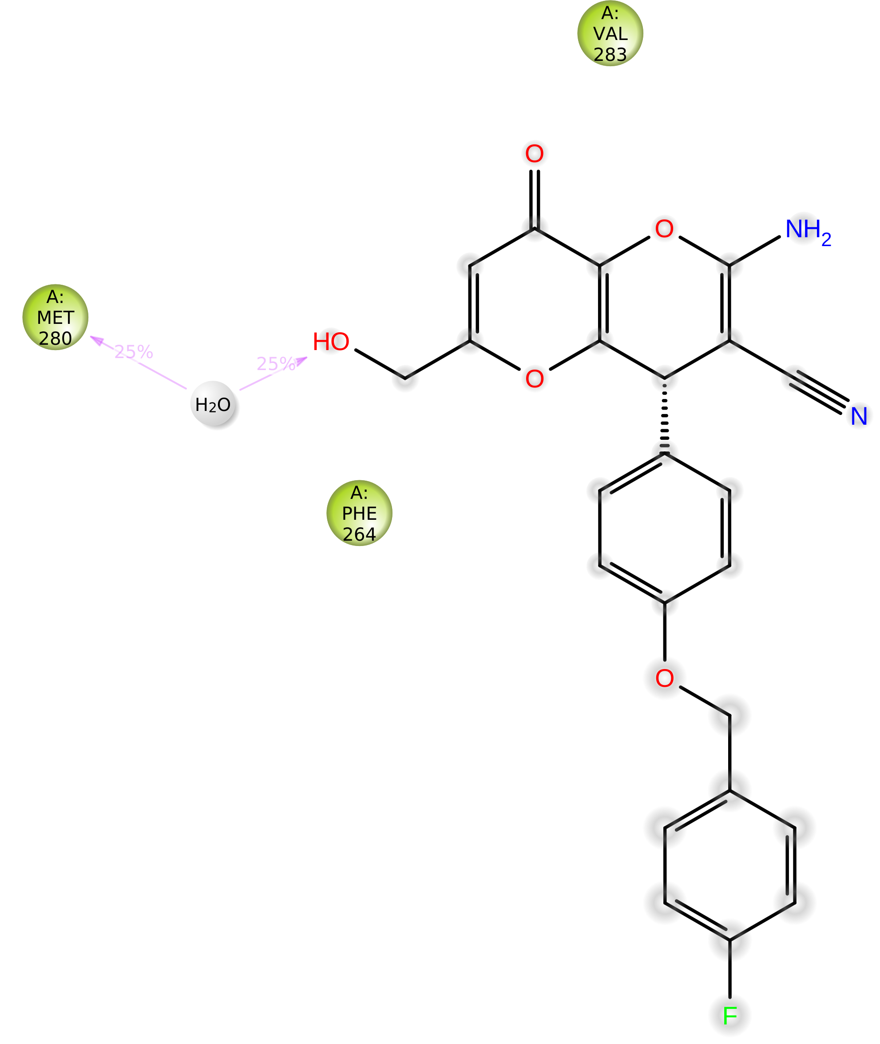
Fig. 3. A schematic of detailed S enantiomer of 6b atom interactions with the protein residues. Interactions that occur more than 25.0% of the simulation time.

FT-IR, ¹H NMR and ¹³C NMR spectrums of 2-amino-4-(4-(benzyloxy) phenyl)-6-(hydroxymethyl)-8-oxo-4, 8-dihydropyrano [3, 2-b] pyran-3-carbonitrile (6a):
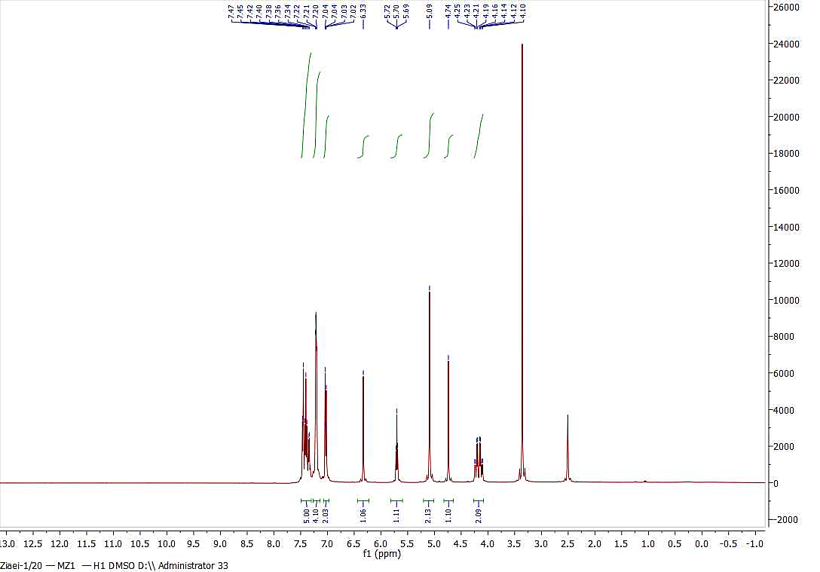
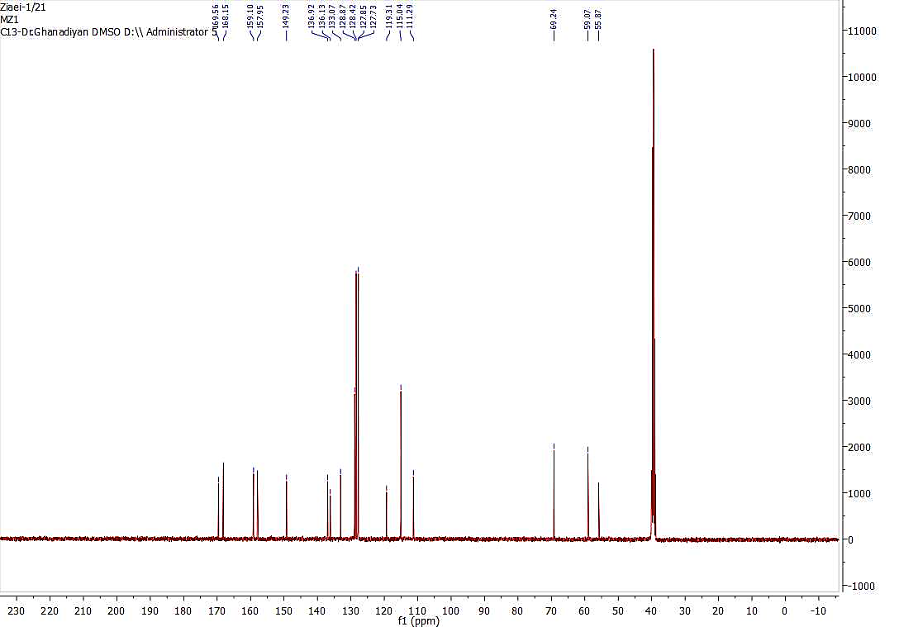

FT-IR, ¹H NMR and ¹³C NMR spectrums of 2-amino-4-(4-((4-fluorobenzyl)oxy)phenyl)-6-(hydroxymethyl)-8-oxo-4,8-dihydropyrano[3,2-b]pyran-3-carbonitrile (6b):
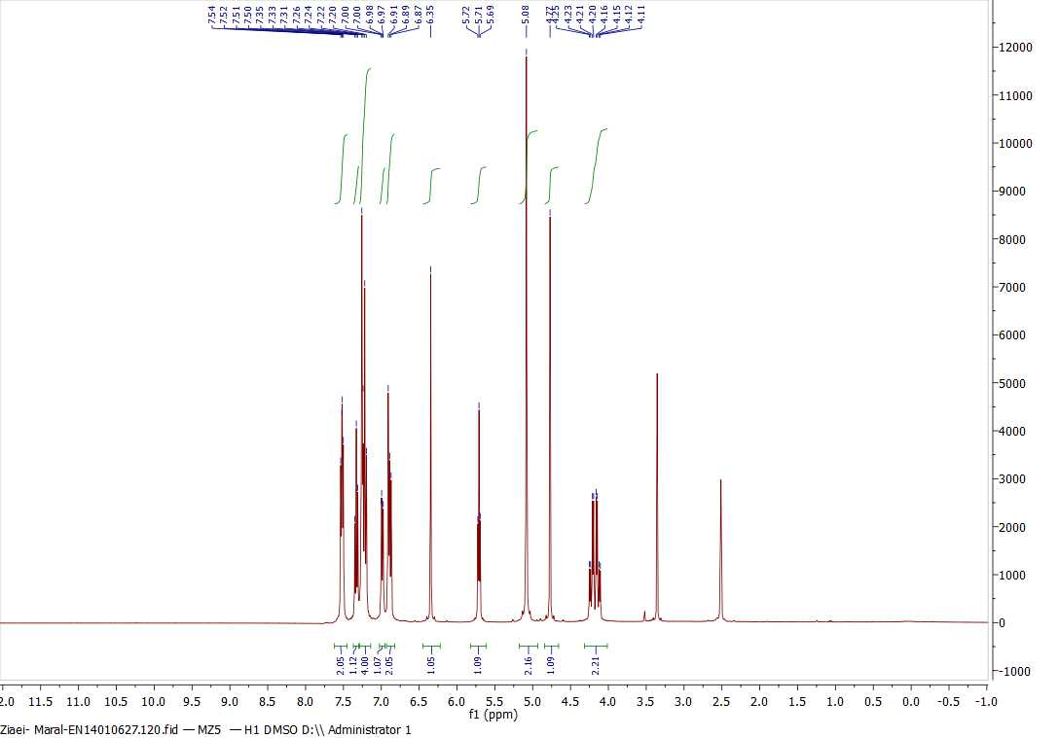
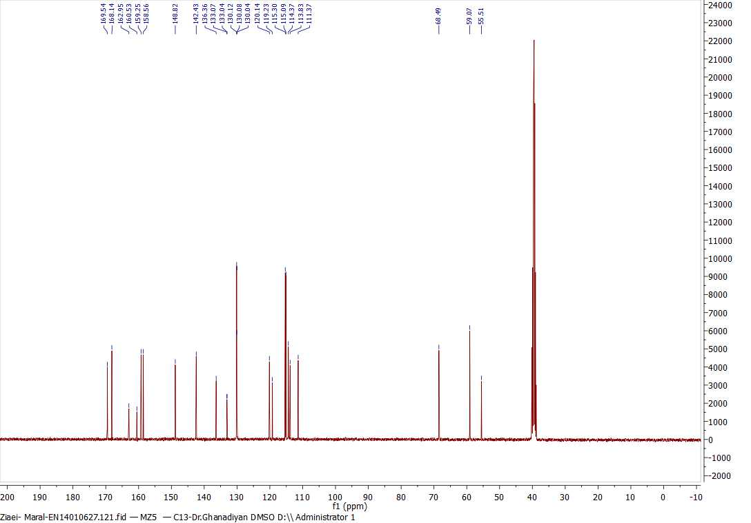

FT-IR, ¹H NMR and ¹³C NMR spectrums of 2-amino-4-(4-((4-chlorobenzyl)oxy)phenyl)-6-(hydroxymethyl)-8-oxo-4,8 dihydropyrano[3,2-b]pyran-3-carbonitrile (6c):
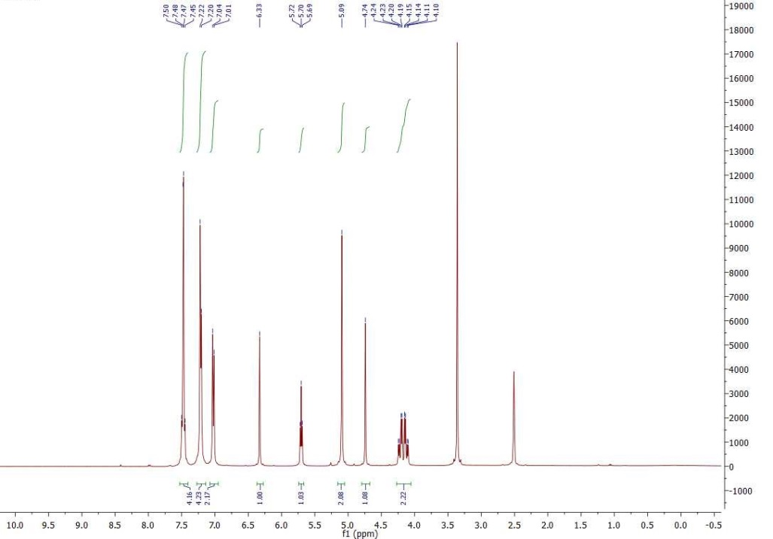
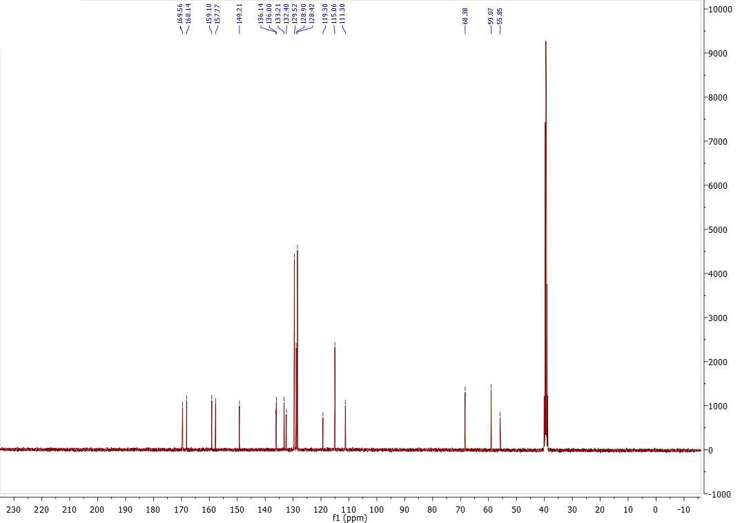

FT-IR, ¹H NMR and ¹³C NMR spectrums of 2-amino-4-(4-((4-boromobenzyl)oxy)phenyl)-6-(hydroxymethyl)-8-oxo-4,8 dihydropyrano[3,2-b]pyran-3-carbonitrile (6d):

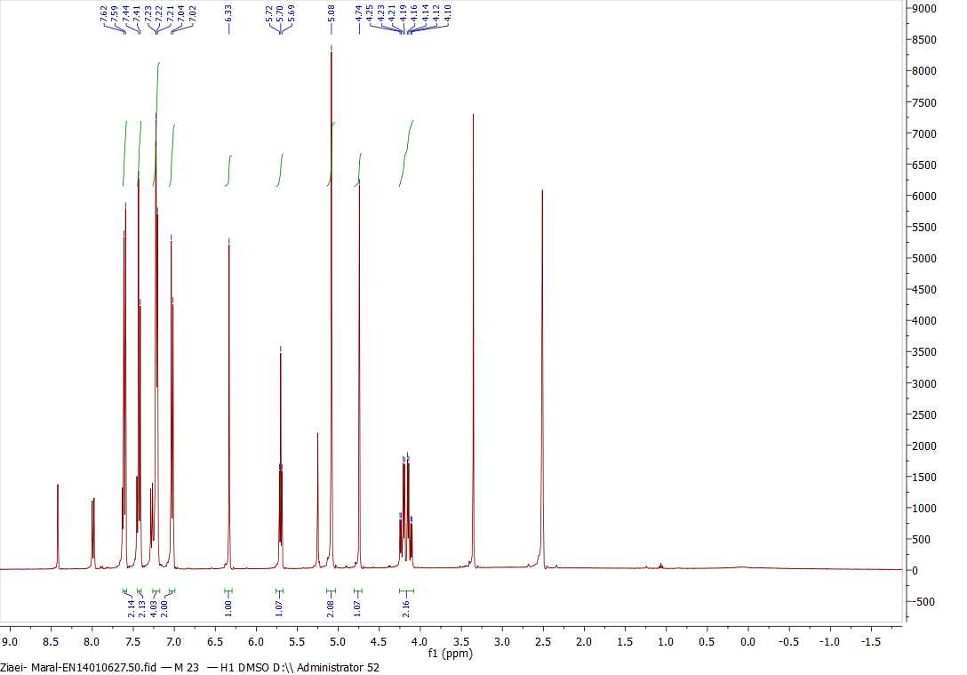

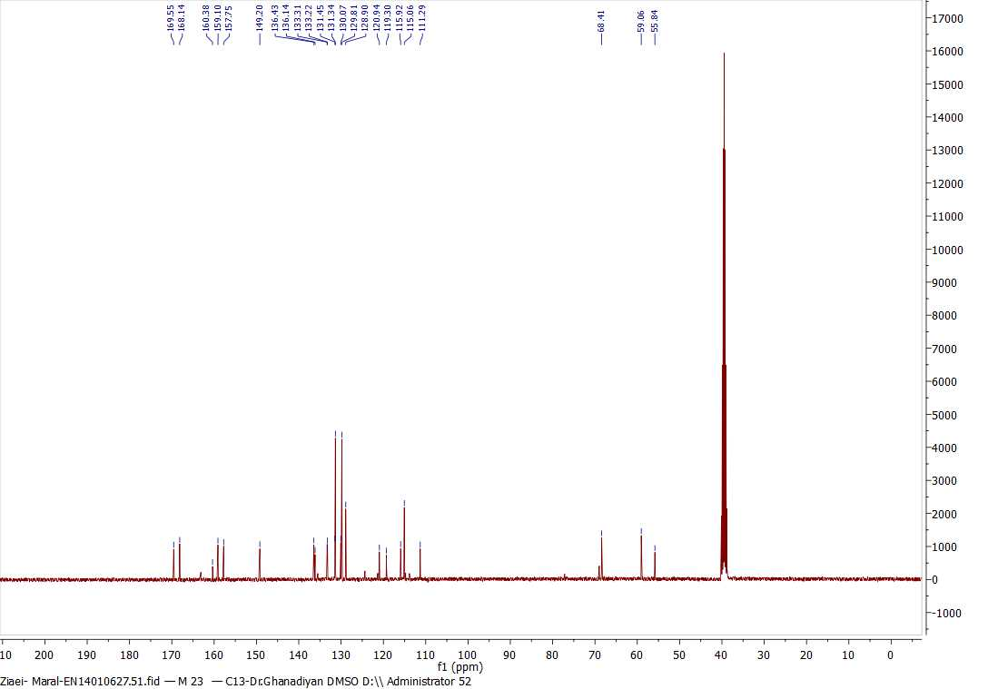
FT-IR, ¹H NMR and ¹³C NMR spectrums of 2-amino-6-(hydroxymethyl)-4-(4-((4-methylbenzyl)oxy)phenyl)-8-oxo-4,8-dihydropyrano[3,2-b]pyran-3-carbonitrile (6e):
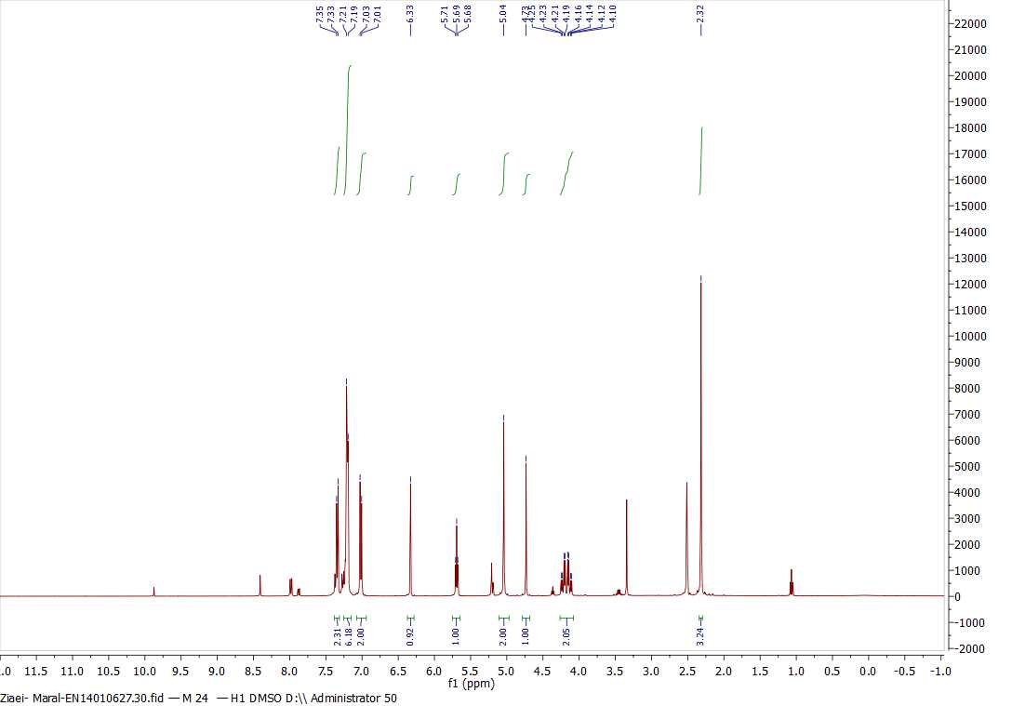
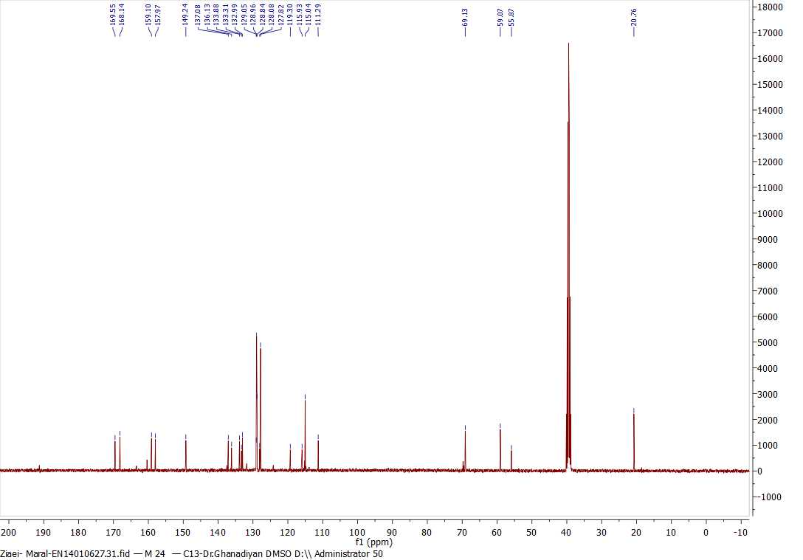

FT-IR, ¹H NMR and ¹³C NMR spectrums of 2-amino-4-(3-(benzyloxy)phenyl)-6-(hydroxymethyl)-8-oxo-4,8-dihydropyrano[3,2-b]pyran-3-carbonitrile (6f):
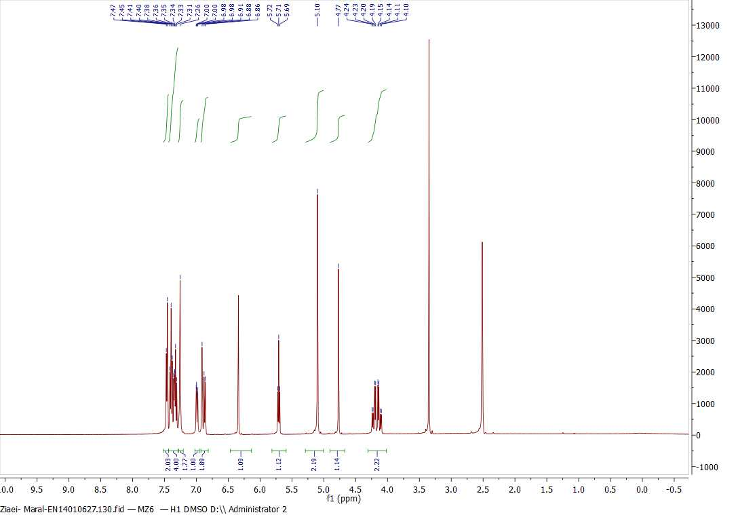
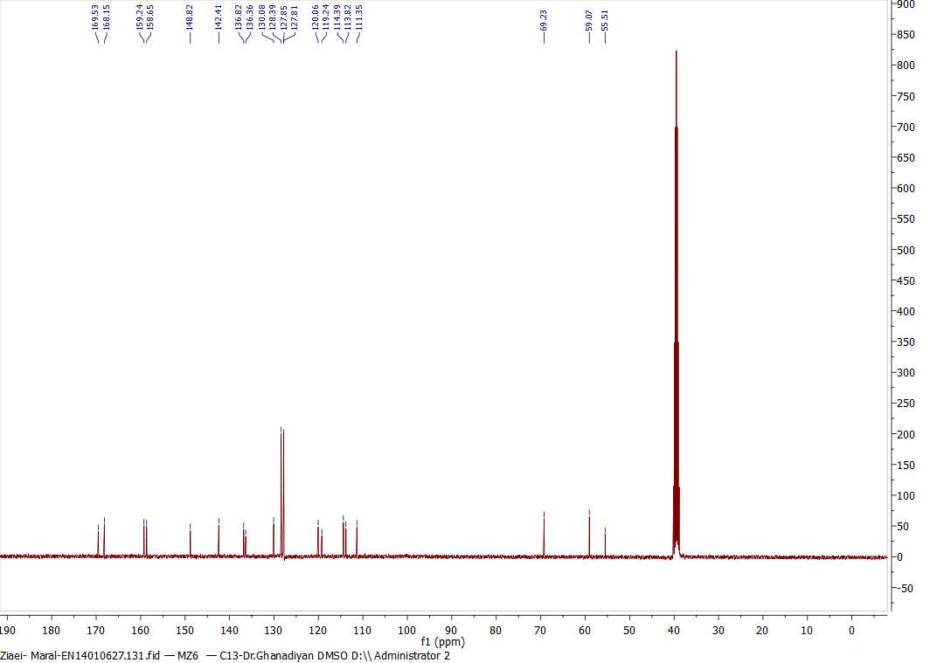

FT-IR, ¹H NMR and ¹³C NMR spectrums of 2-amino-4-(3-((4-fluorobenzyl)oxy)phenyl)-6-(hydroxymethyl)-8-oxo-4,8-dihydropyrano[3,2-b]pyran-3-carbonitrile (6g):

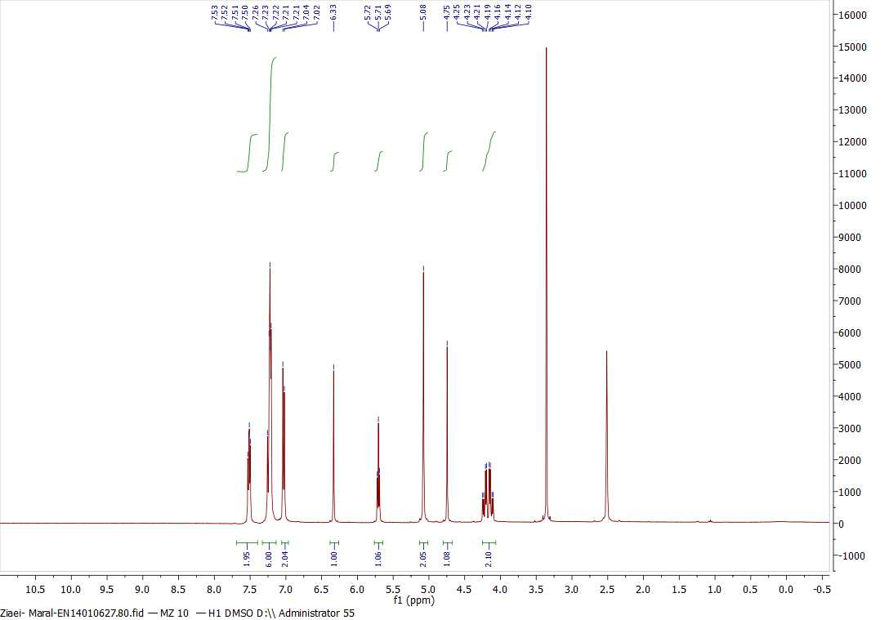
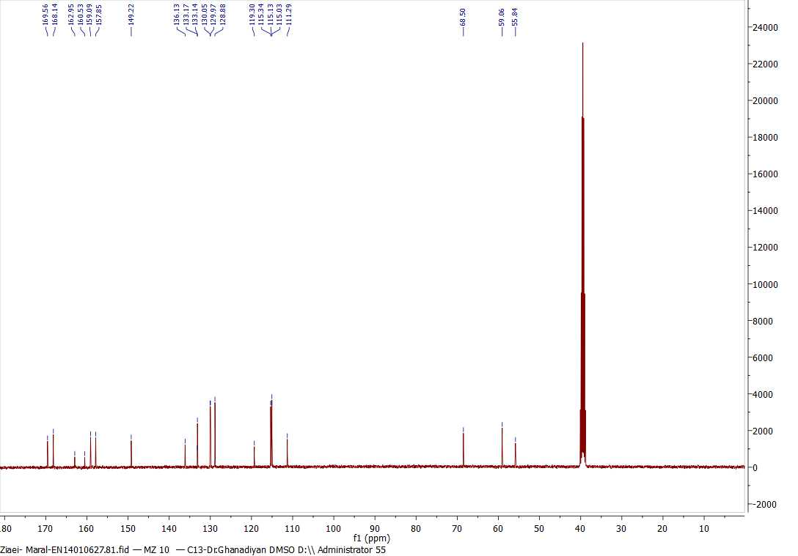

FT-IR, ¹H NMR and ¹³C NMR spectrums of 2-amino-4-(3-((4-chlorobenzyl)oxy)phenyl)-6-(hydroxymethyl)-8-oxo-4,8-dihydropyrano[3,2-b]pyran-3-carbonitrile (6h):

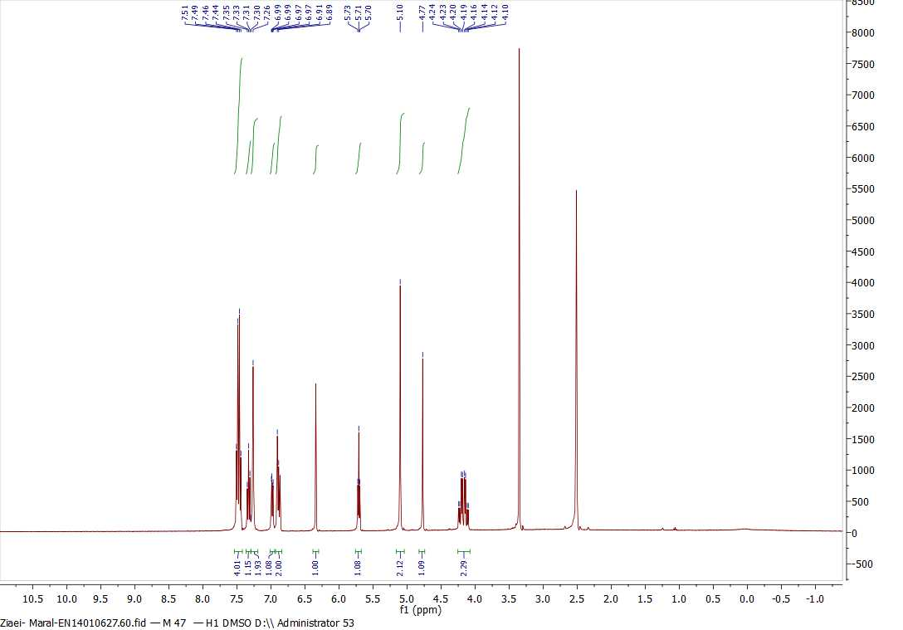

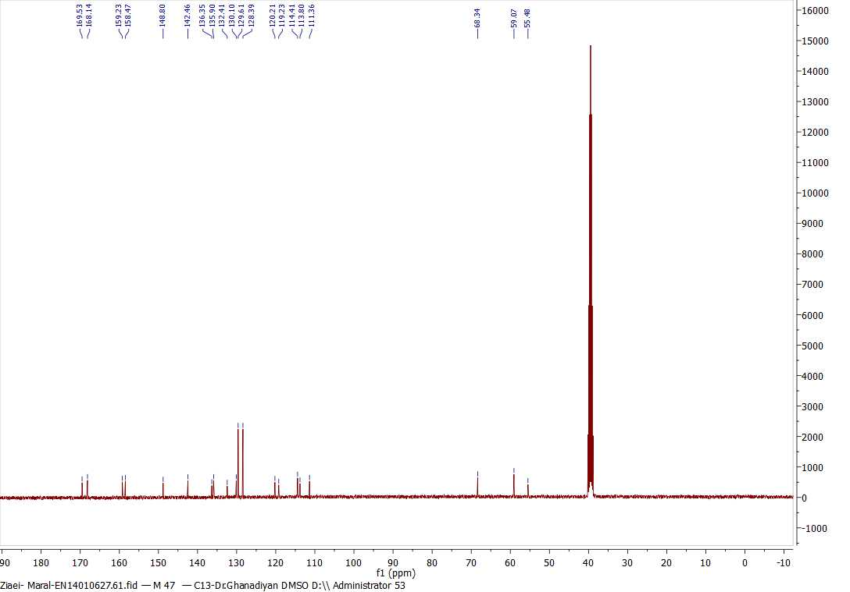

FT-IR, ¹H NMR and ¹³C NMR spectrums of 2-amino-4-(3-((4-boromobenzyl)oxy)phenyl)-6-(hydroxymethyl)-8-oxo-4,8-dihydropyrano[3,2-b]pyran-3-carbonitrile (6i):

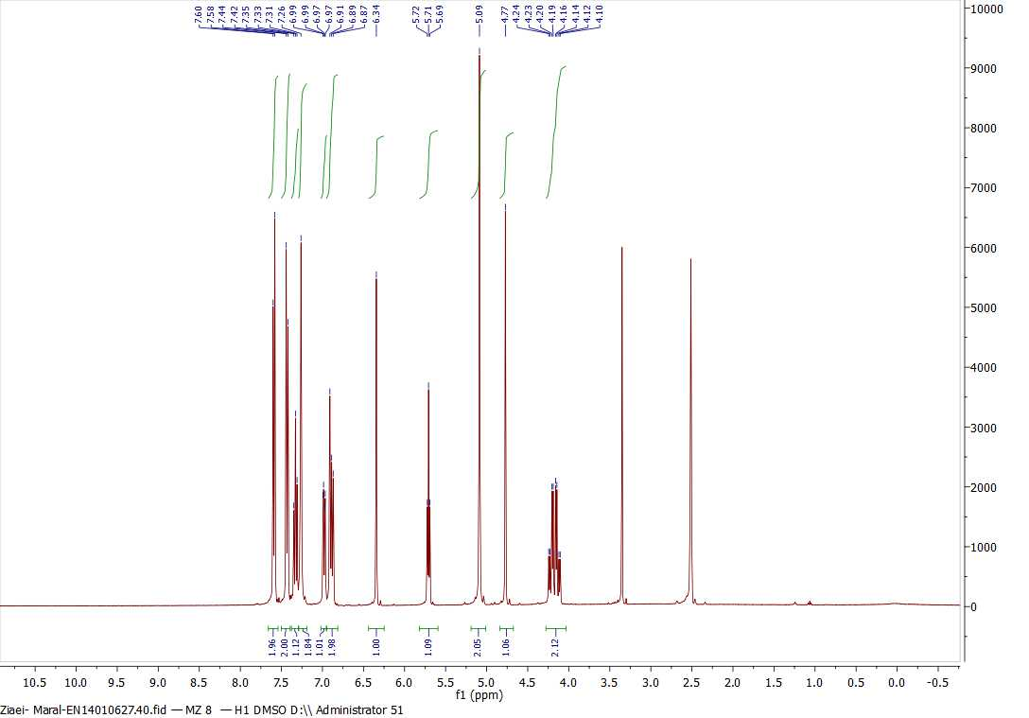
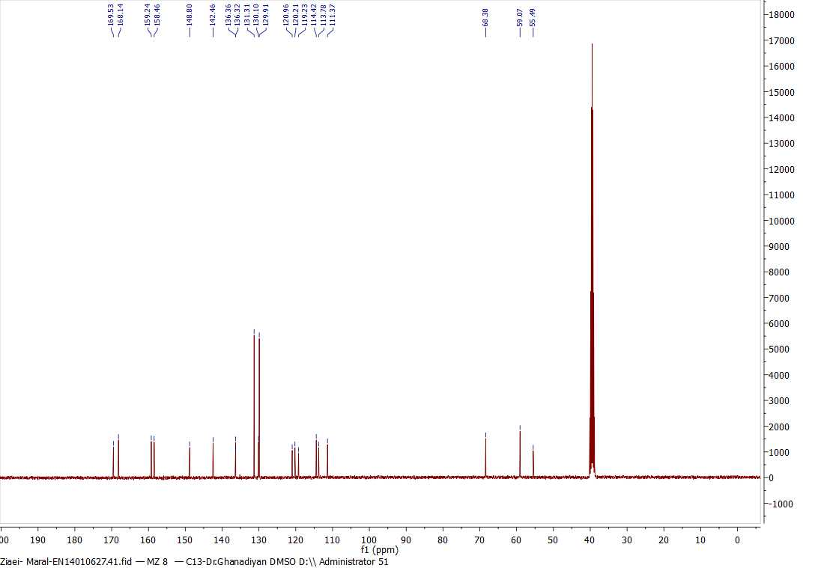

FT-IR, ¹H NMR and ¹³C NMR spectrums of 2-amino-4-(3-((4-boromobenzyl)oxy)phenyl)-6-(hydroxymethyl)-8-oxo-4,8-dihydropyrano[3,2-b]pyran-3-carbonitrile (6j):

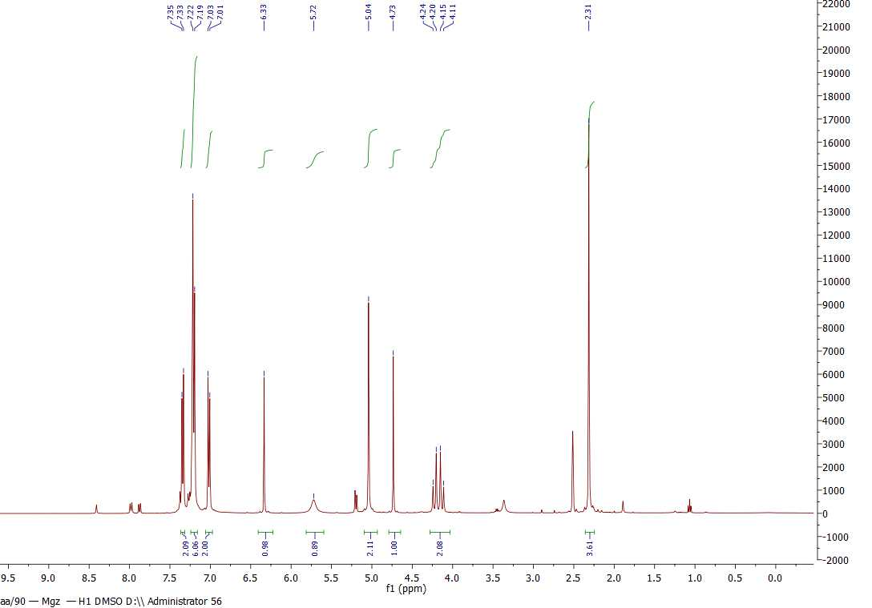
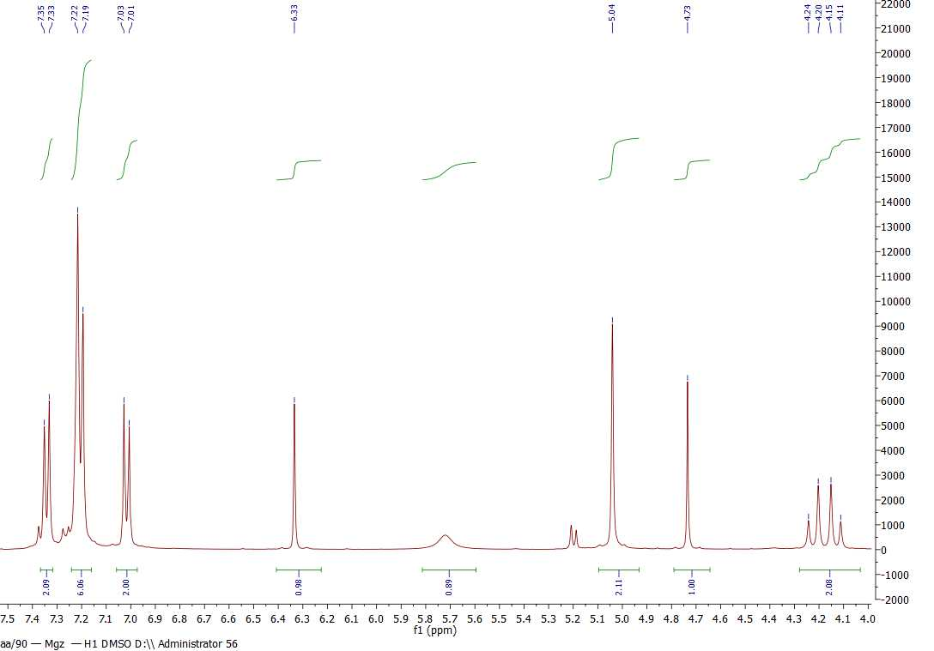

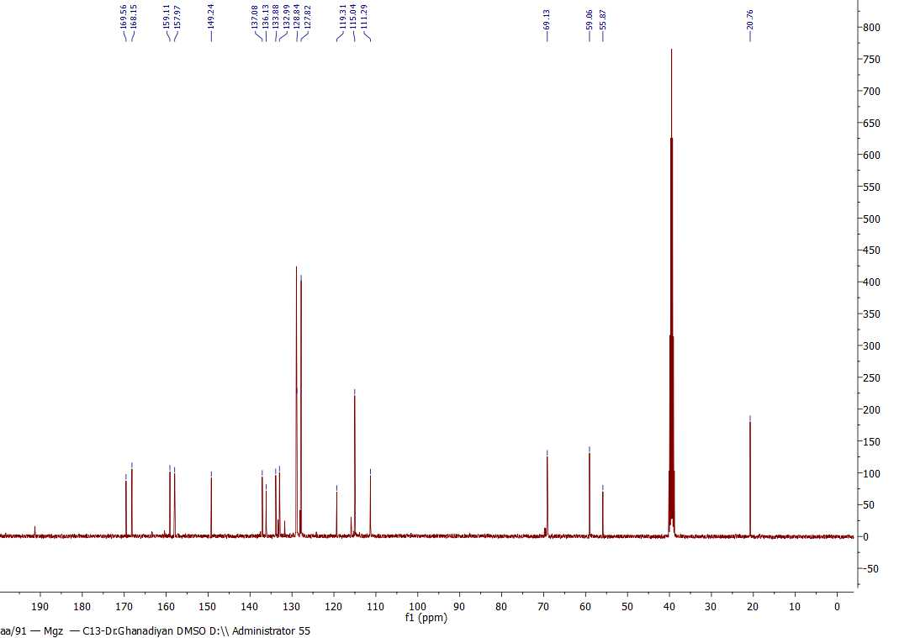

FT-IR, ¹H NMR and ¹³C NMR spectrums of 2-amino-4-(4-(benzyloxy)-3-methoxyphenyl)-6-(hydroxymethyl)-8-oxo-4,8 dihydropyrano[3,2-b]pyran-3-carbonitrile (6k):

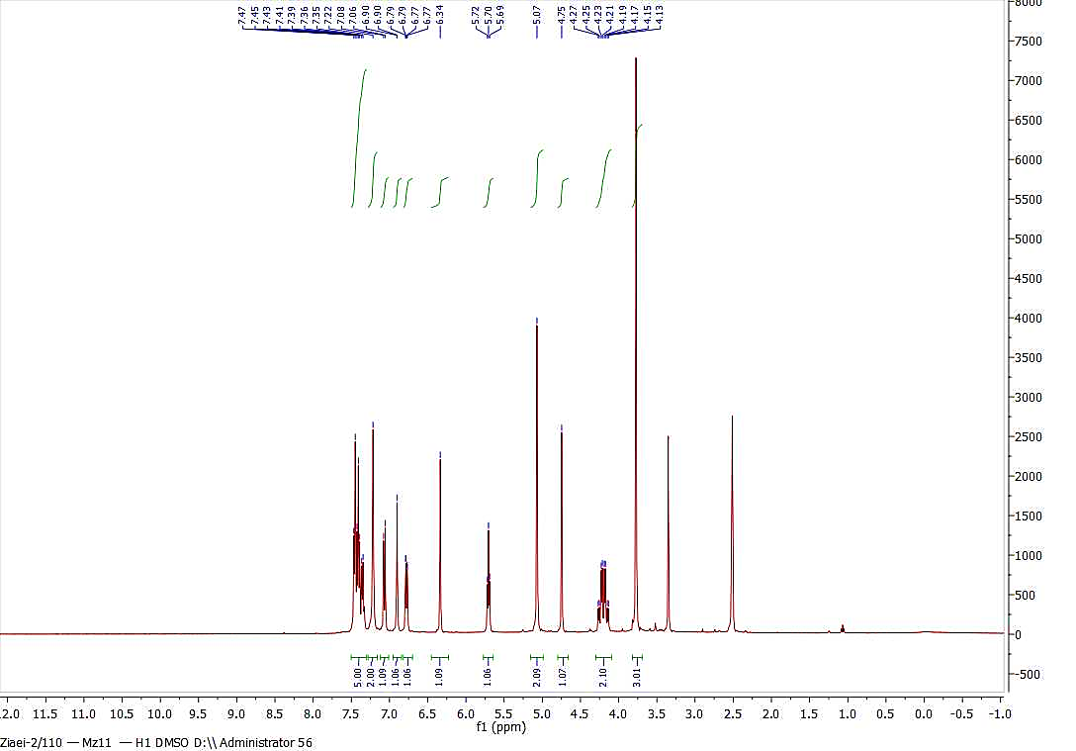

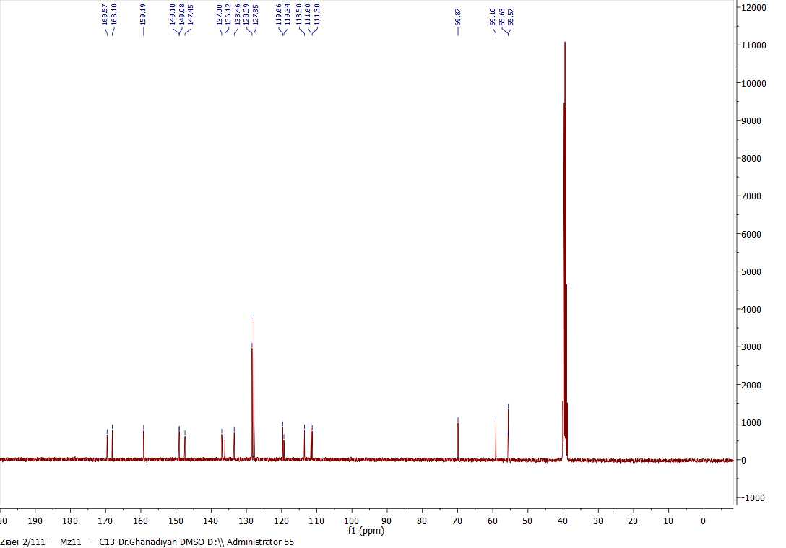

FT-IR, ¹H NMR and ¹³C NMR spectrums of 2-amino-4-(4-((4-fluorobenzyl)oxy)-3-methoxyphenyl)-6-(hydroxymethyl)-8-oxo-4,8-dihydropyrano[3,2-b]pyran-3-carbonitrile (6l):

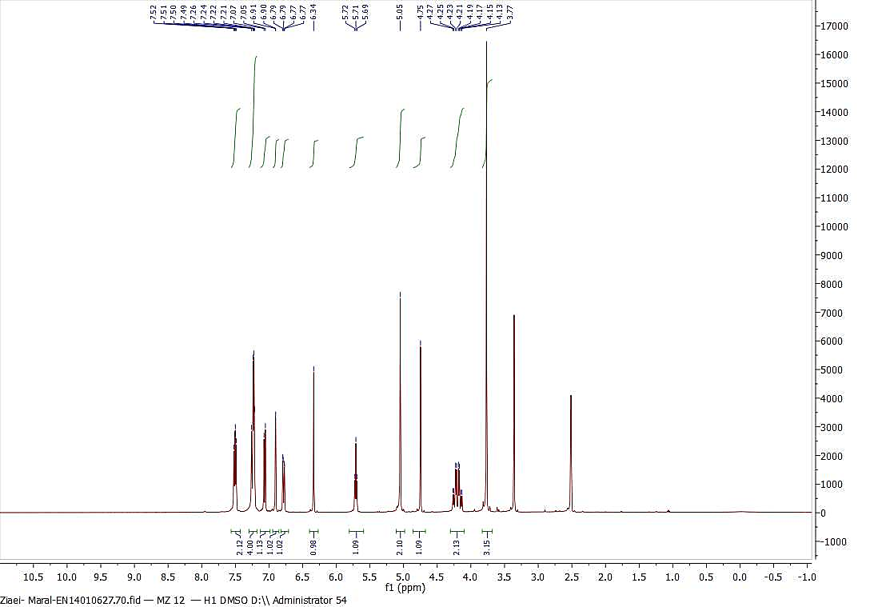

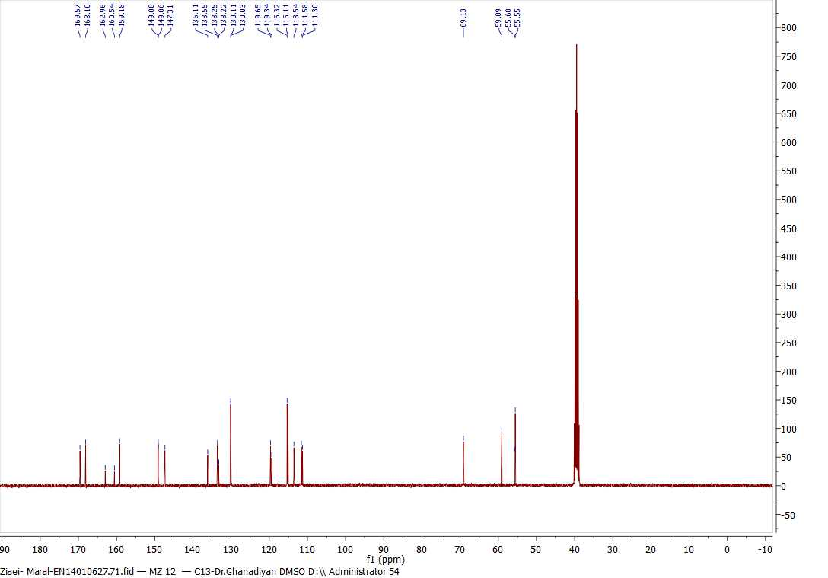

FT-IR, ¹H NMR and ¹³C NMR spectrums of 2-amino-4-(4-((4-cholorobenzyl)oxy)-3-methoxyphenyl)-6-(hydroxymethyl)-8-oxo-4,8-dihydropyrano[3,2-b]pyran-3-carbonitrile (6m):

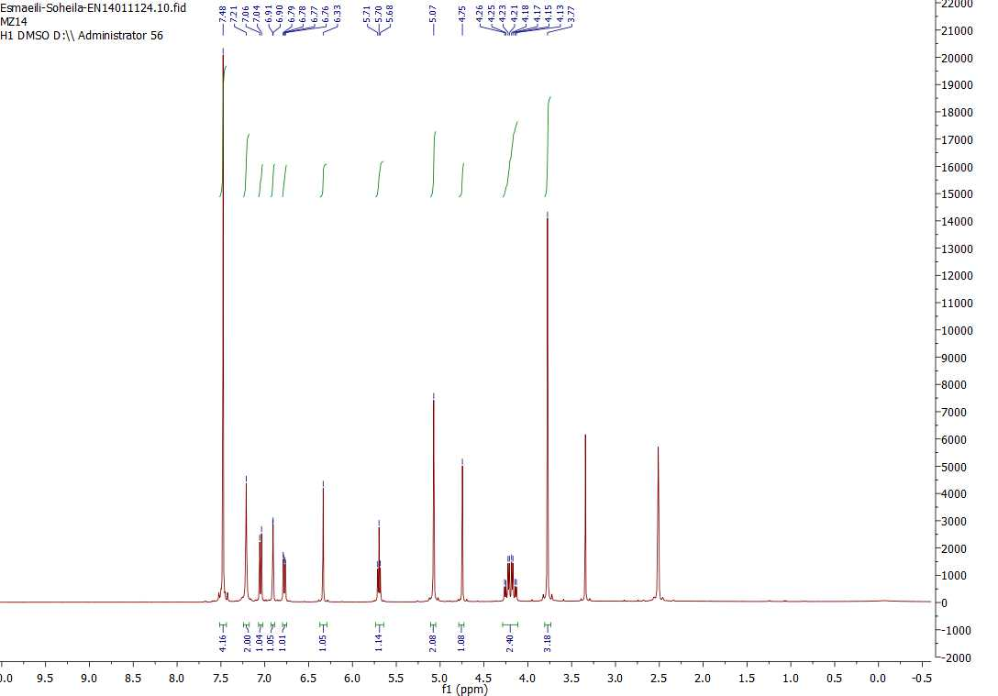
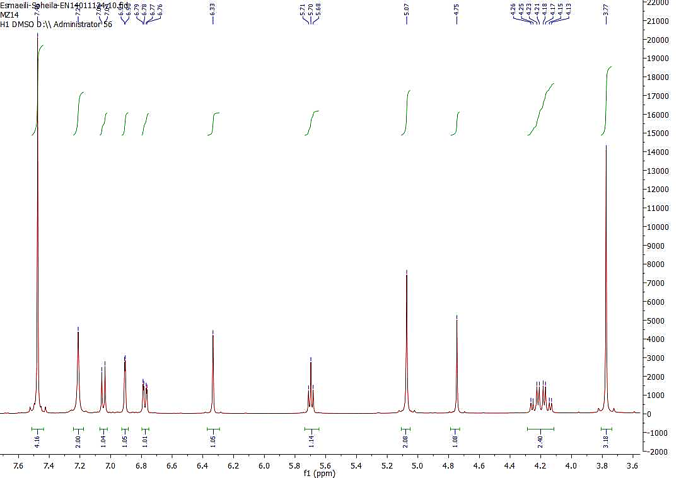

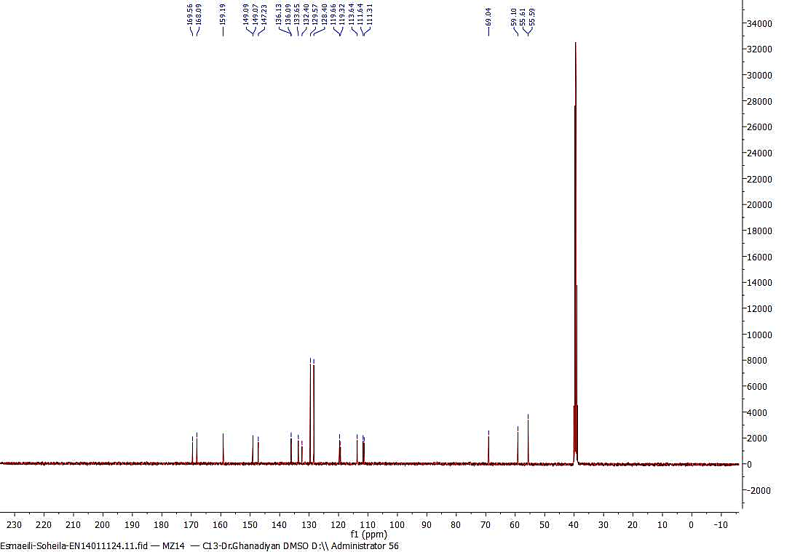

FT-IR, ¹H NMR and ¹³C NMR spectrums of 2-amino-4-(4-((4-boromobenzyl)oxy)-3-methoxyphenyl)-6-(hydroxymethyl)-8-oxo-4,8-dihydropyrano[3,2-b]pyran-3-carbonitrile (6n):

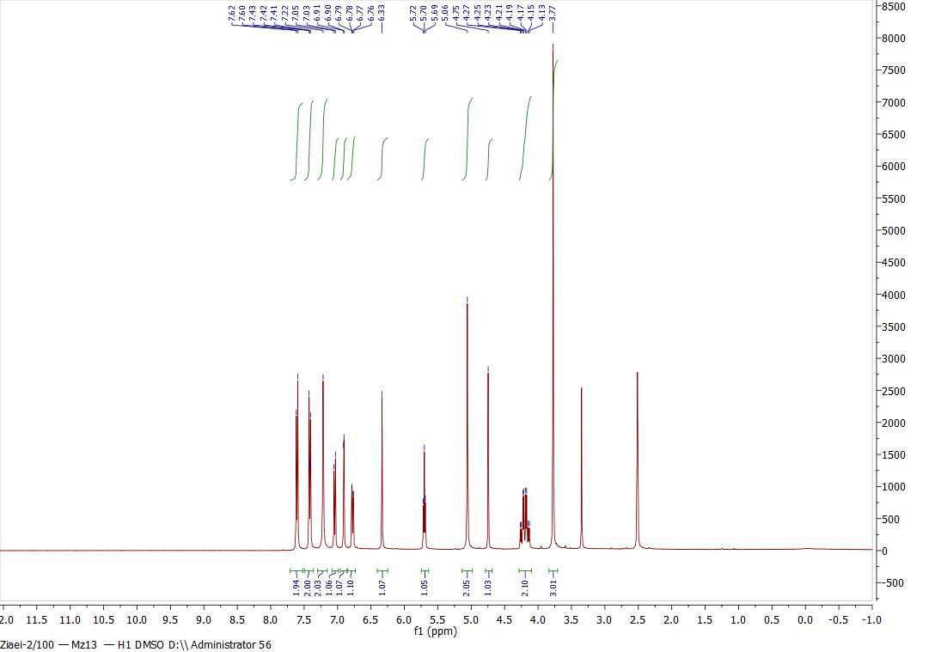

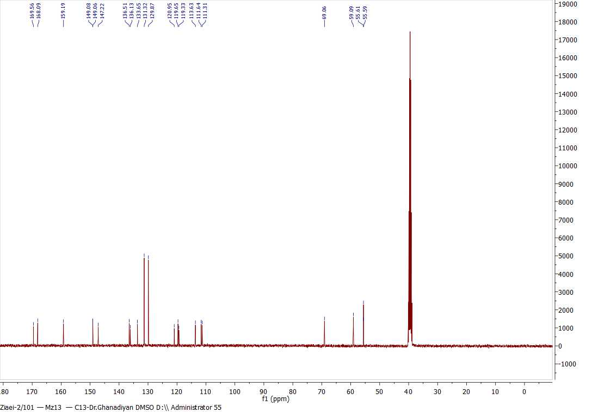

FT-IR, ¹H NMR and ¹³C NMR spectrums of 2-amino-6-(hydroxymethyl)-4-(3-methoxy-4-((4-methylbenzyl)oxy)phenyl)-8-oxo-4,8 dihydropyrano[3,2-b]pyran-3-carbonitrile (6o):
