Appendix A. Supplementary material

Table S1 Joinpoint regression analysis results of influenza in Yinchuan, 2012−2022
Region | Whole Year |  |  |  | Section 1 |  |  |  | Section 2
Region | year | AAPC  (%) | 95%CI(%) |  | Start-stop year | APC  (%) | 95%CI(%) |  | Start-stop year | APC(%) | 95%CI(%)
Yinchuan | 2012-2022 | 18.57* | 7.50-37.75 |  | 2012-2022 | 18.57* | 7.50-37.75
Xingqing | 2012-2022 | 11.57 | -2.51-33.77 |  | 2012-2022 | 11.57 | -2.51-33.77
Jinfeng | 2012-2022 | 35.35* | 26.62-57.69 |  | 2012-2022 | 35.35* | 26.62-57.69
Xixia | 2012-2022 | 5.75 | -3.92-18.36 |  | 2012-2022 | 5.75 | -3.92-18.36
Yongning | 2012-2022 | 21.99* | 9.04-54.32 |  | 2012-2022 | 21.99* | 9.04-54.32
Helan | 2012-2022 | 20.58* | 4.57-82.34 |  | 2012-2019 | 40.40* | 15.13-1005.88 |  | 2019-2022 | -15.46 | -66.84-29.38
Lingwu | 2012-2022 | -9.81* | -19.18-2.24 |  | 2012-2022 | 9.81* | -19.18-2.24
* Indicates that the Monthly Percent Change (MPC) is significantly different from 0 at the $α$ = 0.05.
Table S2 Global spatial auto-correlation test of influenza in Yinchuan, China, 2012–2022
Year | Moran’s I | P-value | Z-score
2012 | 0.0743 | 0.093 | 1.3386
2013 | 0.0754 | 0.055 | 1.8118
2014 | 0.0083 | 0.186 | 0.4023
2015 | 0.3277 | 0.002 | 4.8323
2016 | 0.2536 | 0.001 | 6.1502
2017 | 0.1222 | 0.048 | 2.0417
2018 | 0.3065 | 0.001 | 4.5510
2019 | 0.2996 | 0.003 | 4.0538
2020 | 0.2586 | 0.001 | 4.1016
2021 | 0.1517 | 0.004 | 3.9953
2022 | 0.1879 | 0.004 | 4.6592
Table S3 High–high areas (hot spots) detected in the LISA analysis for influenza from 2012 to 2022
Year | Towns/streets |  | Hot-spot lists
2012 | 2 | Xingjing Town, Haojiaqiao Town
2013 | 3 | Culture Street, Yuhuangge North Street, Qianjin Street
2014 | 0
2015 | 4 | Mancheng North Street, Shanghai West Road, Fengdeng Town, Xihuayuan Road
2016 | 7 | Jiefang West Street, Cultural Street, Funing Street, Xinhua Street, Yuhuangge North Street, Qianjin Street, Zhongshan South Street
2017 | 1 | Xingjing Town
2018 | 3 | Changcheng Middle Road, Shanghai West Road, Liangtian Town
2019 | 5 | Jiefang West Street, Funing Street, Qianjin Street, Shanghai West Road, Liangtian Town
2020 | 2 | Changcheng Middle Road, Shanghai West Road
2021 | 4 | Huanghe East Road, Changcheng Middle Road, Shanghai West Road, Liangtian Town
2022 | 3 | Changcheng Middle Road, Shanghai West Road, Liangtian Town
Average | 4 | Funing Street, Changcheng Middle Road, Shanghai West Road, Liangtian Town

Table S4 Clusters identified by the space-time scan statistics on influenza, 2012–2022
Cluster pattern * | Range of cluster time | Towns/Streets | Coordinates/  radius | Observed  cases | Expected  cases | RR | LLR | P-value
1 | 2018/1/1 to 2022/12/31 | Changcheng Middle Road | (38.4 N, 106.22E) / 0 km | 967 | 158.44 | 7.72 | 1031.70 | ＜0.0001
2 | 2019/1/1 to 2019/12/31 | Fenghuang North Street, Jiefang West Street, Wenhua Street, Yuhuangge North Street, Lijing Street, Mancheng North Street, Beijing Middle Road, Shanghai West Road, Fengdeng Town, Xihuayuan Road, Beijing West Road, Zhenbeibu Town, Xigang Town, Nanliangttaizi | (38.55N,106.23E) /11.37 km | 266 | 114.28 | 2.42 | 75.99 | ＜0.0001
3 | 2014/1/1 to 2014/12/31 | Wutongshu Town | (38.16N,106.26E)/ 0 km | 37 | 2.58 | 14.47 | 64.28 | ＜0.0001
4 | 2012/1/1 to 2012/12/31 | Chongxing Town | (38.03N,106.35E)/ 0 km | 31 | 5.89 | 5.30 | 26.46 | ＜0.0001
1 is the most likely cluster area, and 2-4 is the second possible cluster area.
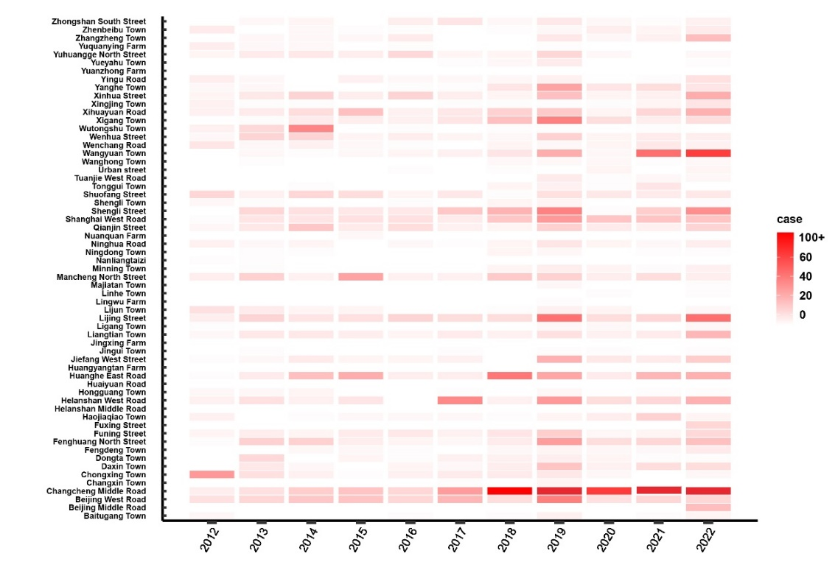
Fig. S1. Case of influenza in Yinchuan at the township level, China, 2012–2022 (/100,000)
Fig. S2. Annual incidence of influenza at the township level in Yinchuan, China, 2012–2022

