Appendix 1 PubMED search strategy

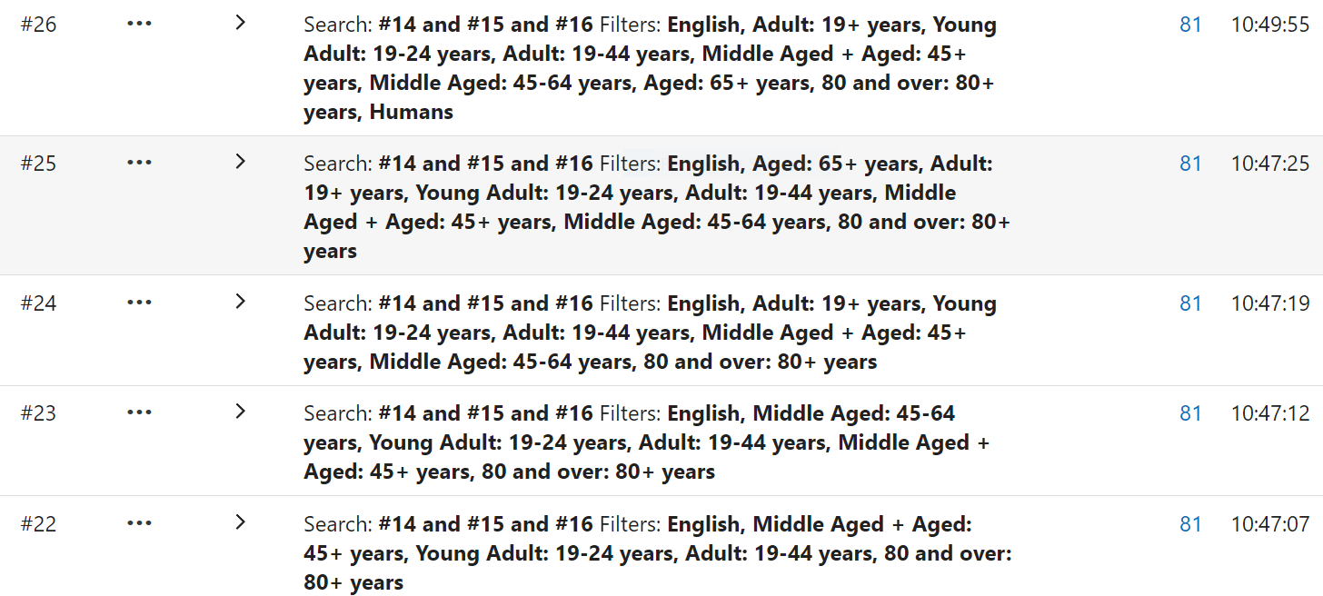
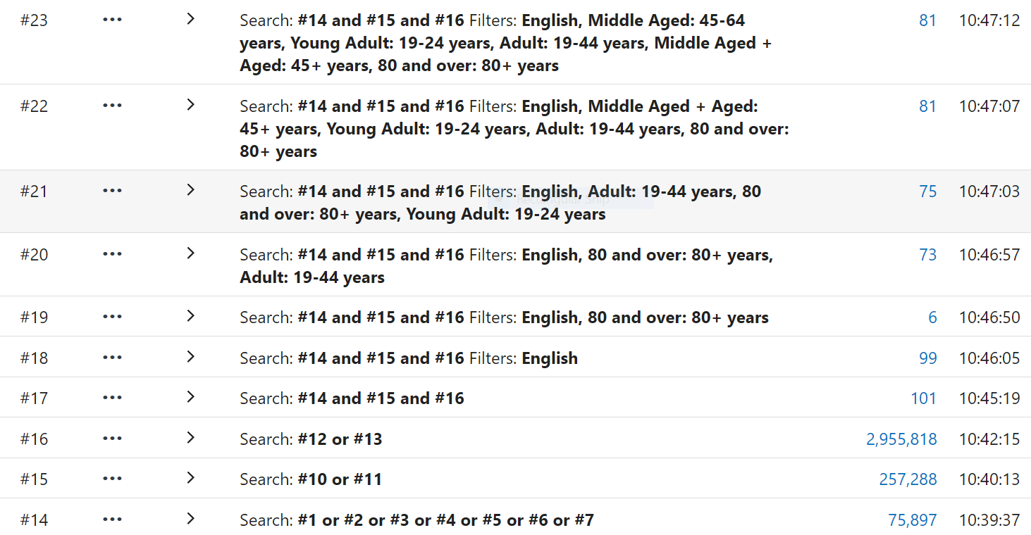
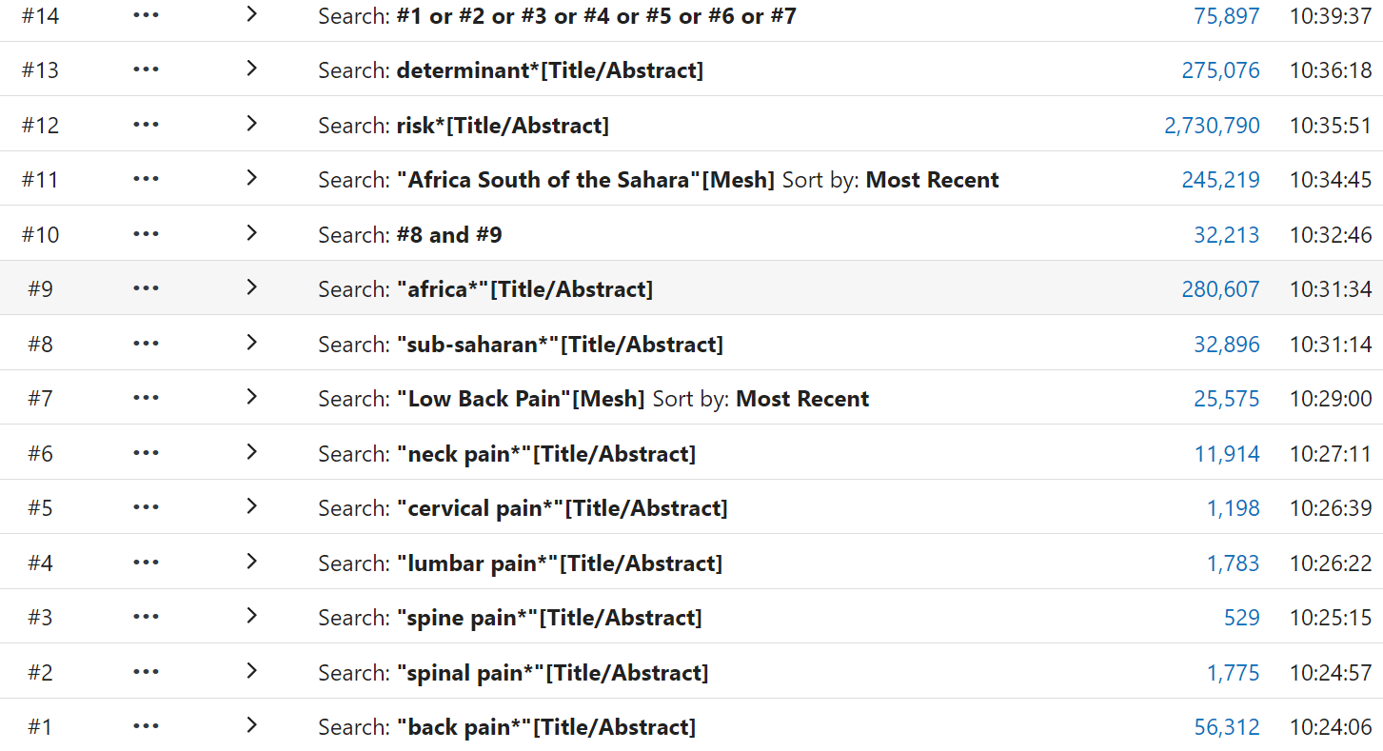

Note for editor(s) – Table 1 to be placed between the last paragraph on the ‘data analysis’ section and the first paragraph of the ‘Results’ section.
Table 1 Quality appraisal using AXIS tool (key criteria in bold text)
First author and date (listed in alphabetical order) | Were the aims/objectives of the study clear? |  | Was the study design appropriate for the stated aim(s)? |  | Was the sample size justified? | Was the target/  reference population clearly defined? (Is it clear who the research was about?) |  | Was the sample frame taken from an appropriate population base so that it closely represented the target/  reference population under investigation? | Was the selection process likely to select subjects/  participants that were representative of the target/reference population under investigation? |  | Were measures undertaken to address and categorise non-responders? |  | Were the risk factor and outcome variables measured appropriate to the aims of the study? |  | Were the risk factor and outcome variables measured correctly using instruments/  measurements that had been trialled, piloted or published previously? | Is it clear what was used to determine statistical significance and/or precision estimates? (e.g. p-values, confidence intervals)? |  | Were the methods (including statistical methods) sufficiently described to enable them to be repeated? | Were the basic data adequately described? | Does the response rate raise concerns about non-response bias? |  | If appropriate,  was information about non-responders described? |  | Were the results internally consistent? | Were the results presented for all the analyses described in the methods? |  | Were the authors' discussions and conclusions justified by the results? |  | Were the limitations of the study discussed? | Were there any funding sources or conflicts of interest that may affect the authors’ interpretation of the results? |  | Was ethical approval or consent of participants attained? |  | Overall rating of study quality
Abaragou et al 2016 | Y |  | Y |  | Y | Y |  | Y | Y |  | Y |  | Y |  | P | Y |  | P | Y | N |  | Y |  | N | Y |  | Y |  | Y | N |  | Y |  | Good
Abaragou et al 2018 | Y |  | Y |  | N | Y |  | Y | Y |  | N |  | Y |  | Y | Y |  | Y | Y | Y |  | N |  | Y | Y |  | Y |  | Y | N |  | Y |  | Good
Akodu et al 2016 | Y |  | Y |  | N | Y |  | Y | CD |  | N |  | Y |  | CD | Y |  | P | Y | CD |  | N |  | N | Y |  | Y |  | N | N |  | Y |  | Moderate
Bester 1996 | N |  | Y |  | N | Y |  | Y | Y |  | N/A |  | Y |  | N | N/A |  | Y | Y | N/A |  | N/A |  | P | Y |  | Y |  | N | N |  | N |  | Moderate
Booyens 2009 | Y |  | Y |  | N | Y |  | Y | Y |  | N |  | Y |  | N | Y |  | Y | Y | Y |  | N |  | Y | Y |  | Y |  | Y | N |  | CD |  | Good
Eggers et al 2018 | Y |  | Y |  | N | Y |  | Y | Y |  | N |  | Y |  | Y | Y |  | Y | Y | Y |  | N |  | Y | Y |  | Y |  | Y | N |  | Y |  | Good
Egwuonwu 2013 | Y |  | Y |  | N | Y |  | Y | Y |  | N |  | Y |  | Y | Y |  | Y | Y | Y |  | N |  | Y | Y |  | P |  | N | N |  | Y |  | Moderate
Fabunmi 2005 | Y |  | Y |  | N | Y |  | Y | Y |  | CD |  | N |  | N | CD |  | Y | Y | N |  | N/A |  | Y | N |  | P |  | N | N |  | N |  | Poor
Jaiyesinmi 2018 | Y |  | Y |  | N | Y |  | Y | Y |  | P |  | Y |  | Y | Y |  | Y | Y | CD |  | N |  | Y | Y |  | Y |  | Y | N |  | Y |  | Good
Jimam and Etukumana 2017 | Y |  | Y |  | N | N |  | N | CD |  | P |  | Y |  | N | N |  | P | Y | CD |  | CD |  | N | Y |  | Y |  | Y | CD |  | Y |  | Poor
Jimam et al 2015 | Y |  | Y |  | N | Y |  | N | N |  | N |  | Y |  | N | N |  | N | Y | CD |  | N/A |  | Y | Y |  | Y |  | Y | CD |  | Y |  | Poor
Kahere and Ginindza 2021 | Y |  | Y |  | Y | Y |  | CD | N |  | N |  | Y |  | N | Y |  | Y | Y | CD |  | N |  | Y | Y |  | Y |  | Y | N |  | Y |  | Moderate
Kahere and Ginindza 2022 | Y |  | Y |  | Y | Y |  | N | N |  | N |  | Y |  | Y | Y |  | Y | Y | CD |  | N/A |  | Y | Y |  | Y |  | Y | Y |  | ? |  | Good
Kuhmalo and Hafajee 2022 | Y |  | N |  | Y | Y |  | Y | Y |  | CD |  | Y |  | Y | Y |  | Y | Y | N |  | N |  | N | P |  | P |  | Y | N |  | Y |  | Moderate
Kaka 2019 (Conference abstract) | Y |  | Y |  | N | Y |  | Y | Y |  | CD |  | Y |  | Y | Y |  | Y | Y | CD |  | CD |  | Y | Y |  | Y |  | N | N |  | Y |  | Good
Nottidge et al 2018 | Y |  | Y |  | Y | Y |  | CD | N |  | N |  | Y |  | Y | N |  | Y | Y | CD |  | N |  | Y | Y |  | Y |  | Y | N |  | Y |  | Moderate
Ojukwa 2017 | Y |  | Y |  | N | Y |  | Y | Y |  | N |  | Y |  | N | Y |  | Y | Y | CD |  | N |  | Y | Y |  | Y |  | Y | N |  | Y |  | Good
Oluka 2020 | Y |  | Y |  | Y | Y |  | Y | Y |  | N/A |  | Y |  | Y | Y |  | Y | N | N/A |  | Y |  | Y | Y |  | Y |  | Y | N |  | Y |  | Good
Omoke 2021 | Y |  | Y |  | N | Y |  | Y | CD |  | N |  | Y |  | N | Y |  | Y | Y | CD |  | CD |  | N | Y |  | CD |  | Y | N |  | Y |  | Poor
Omokhodion 2002 | Y |  | Y |  | N | Y |  | Y | Y |  |  |  | Y |  | N | N |  | P | CD | CD |  | N/A |  | N | N |  | Y |  | N | CD |  | N |  | Moderate
Omokhodion and Folashade 2004 | Y |  | Y |  | N | Y |  | CD | CD |  | N |  | Y |  | CD | N |  | N | Y | CD |  | CD |  | P | Y |  | Y |  | N | N |  | N |  | Poor
Omokhodion and Sanya 2003 | Y |  | Y |  | N | Y |  | Y | Y |  | N |  | Y |  | N | N |  | P | Y | Y |  | N |  | Y | N |  | Y |  | N | CD |  | N |  | Moderate
Rufa'I et al 2015 | Y |  | Y |  | Y | Y |  | Y | Y |  | N/A |  | Y |  | Y | Y |  | Y | Y | Y |  | Y |  | Y | Y |  | Y |  | Y | Y |  | Y |  | Good
Sikiru and Hanifa 2009 | Y |  | Y |  | N | Y |  | Y | Y |  | N |  | Y |  | Y | Y |  | Y | N | Y |  | N |  | N | Y |  | Y |  | N | CD |  | N |  | Moderate
Sikiru and Hanifa 2010 | Y |  | Y |  | N | Y |  | Y | CD |  | N |  | Y |  | Y | Y |  | Y | Y | CD |  | N |  | Y | ? |  | CD |  | N | CD |  | N |  | Moderate
Tella et al 2013 | Y |  | Y |  | N | Y |  | Y | Y |  | CD |  | Y |  | P | Y |  | P | N | CD |  | Y |  | N | CD |  | Y |  | N | N |  | Y |  | Moderate
van Vuuren 2005 Maganese | Y |  | Y |  | N | Y |  | Y | Y |  | N |  | Y |  | Y | Y |  | Y | Y | Y |  | N |  | Y | Y |  | Y |  | N | CD |  | Y |  | Good
van Vuuren 2005 Steel | Y |  | Y |  | N | Y |  | Y | Y |  | CD |  | Y |  | Y | Y |  | Y | Y | CD |  | CD |  | Y | Y |  | Y |  | Y | CD |  | Y |  | Good
van Vuuren 2006 Maganese | Y |  | Y |  | N | Y |  | Y | Y |  | N |  | Y |  | Y | Y |  | Y | Y | Y |  | Y |  | Y | Y |  | Y |  | P | N |  | Y |  | Good
van Vuuren 2006 Steel | Y |  | Y |  | N | Y |  | Y | Y |  | N |  | Y |  | P | Y |  | P | N | CD |  | CD |  | P | Y |  | Y |  | Y | N |  | Y |  | Moderate
van Vuuren 2007 Maganese | Y |  | Y |  | N | Y |  | Y | N/A |  | N |  | Y |  | Y | Y |  | Y | Y | Y |  | N |  | Y | Y |  | Y |  | Y | N |  | Y |  | Good
van Vuuren 2007 Steel | Y |  | Y |  | N | Y |  | Y | Y |  | N |  | Y |  | Y | Y |  | Y | N | Y |  | N |  | Y | Y |  | Y |  | Y | N |  | Y |  | Good
Table 2 Quality appraisal using CASP tool (key criteria in bold text)
 |  | Did the study address a clearly focused issue? |  | Did the authors use an appropriate method to answer their question? |  |  | Were the cases recruited in an acceptable way? |  |  | Were the controls selected in an acceptable way? |  | Was the exposure accurately measured to minimise bias? |  | Aside from the experimental intervention, were the groups treated equally? |  |  | Have the authors taken account of the potential confounding factors in the design and/or in their analysis? |  |  |  | How large was the treatment effect? |  | How precise was the estimate of the treatment effect? |  |  | Do you believe the results? |  | Can the results be applied to the local population? |  |  | Do the results of this study fit with other available evidence? |  | Overall rating of study quality
Abanobi et al 2015 |  | Y |  | Y |  |  | Y |  |  | Y |  | N |  | Y |  |  | N |  |  |  | N |  | N |  |  | Y |  | N |  |  | Y |  | Poor
CD Cannot determine N No N/A Non applicable NR Not reported P Partially reported Y Yes

Note for editor(s) – Table 4 to be placed at the end of the ‘Results’ section before the ‘Discussion’.
Table 4 – Detailed summary of results
SOCIODEMOGRAPHIC
Risk Factor (Number reported) | Effect Measure  X² (Chi square)  OR (Odds Ratio)  aOR (adjusted Odds Ration)  RR (Risk Ratio) | Quality of Evidence | Summary
Age (9)
Ages 45-60 AND >60yrs (Rufa’l et al 2015) | Crude OR 0.18 (CI 0.40 - 0.71)  (p= 0.015)  AND  > 60 years with Crude OR 0.09  (CI 0.01 - 0.54) (p = 0.010). | Good | Two studies (n=442) of good quality evidence and One study (n=563) of moderate quality evidence indicated increasing/advancing age as a risk factor.
Advancing age was significantly associated with low back pain (Abaraogu et al 2018) | X² 19.885 (p=0.001) | Good
Increasing age (40-60yrs) (Nottidge 2018) | Univariable logistic regression  OR 1.03 (1.01-1.05) (p=0.004) | Moderate
Old age (Omokhodion 2004) | Participant’s response | Poor | Two studies (n=974) of poor quality evidence indicated old age as a risk factor.
Old age (Fabunmi 2004) | Participant’s response | Poor
Younger than 41 years (Jaiyesinmi et al 2018) | X² p<0.05 (p=0.000) | Good | Two studies (n= 676) of good quality evidence indicated middle age as a risk factor.
The age category 38–47 years (Kahere and Ginindza 2022) | aOR: 23.4 (CI: 1.2–453.4) (p = 0.037) | Good
Age (Akodu et al 2016) | OR: 23.61 (p=0.0001) | Moderate | One study (n=285) of moderate quality evidence and one study (n=400) of poor quality evidence indicated age as a risk factor.
Age (Jimam and Etukumana 2017) | X² 103.3 (p < 0.0001) | Poor
Gender (7)
Female gender (Kahere and Ginindza 2022) | aOR: 12.4 (CI:3.1–49.8) (p < 0.001) | Good | Two studies (n=654) of good quality evidence and three studies (n=1371) of moderate quality evidence indicated female gender as a risk factor.
Female gender (Oluka et al 2020) | OR: 10.26 (p= 0.021) | Good
Female gender (Sikiru and Hanif 2009) | X² 4.000 (p = 0.465) | Moderate
Female gender (Nottidge 2018) | Univariable logistic regression  OR: 2.08 (CI1.46-2.98) (p<0.001) | Moderate
Female gender (Khumalo and Haffejee 2022) | aOR: 3.76 (CI1.91-7.41) (p<0.001) | Moderate
Male gender (males had significantly higher annual and point prevalence than females) (Tella et al 2013) | Mann Whitney U statistic of 105 384.00 (annual) and 105 912.00 (point) (p < 0.05) | Moderate | One study (n=604) of moderate quality evidence and one study (n=474) of poor quality evidence indicated male gender as a risk factor.
Male gender (Omokhodion 2004) | OR 1.46 (CI 1.11-1.93) (p=0.006) | Poor
PMH (LBP) (5)
A medical history of trauma or lower back treatment. (Boyens 2009) | OR: 2.96 (CI: 1.41-6.23) | Good | One study (n=362) of good quality evidence, one study (n=408) of moderate and one study (n=474) of poor quality evidence quality evidence indicated history of trauma or LBP as a risk factor.
Previous trauma (Sikiru and Hanif 2010) | Participant’s perception | Moderate
History of trauma ((Folashade and Omokhodion 2004) | OR: 4.14 (CI1.99-8.61) (p0.000) | Poor
Injury/accident (Omokhodion 2004) | Participant’s perception | Poor | One study (n=474) of poor quality evidence indicated previous injury or accident as a risk factor.
Medical conditions (Fabunmi et al 2005) | Participant’s perception | Poor | One study (n=500) of poor quality evidence indicated ongoing medical conditions as a risk factor.
Education (4)
Secondary school education (Jaiyesinmi et al 2018) | X² p<0.05 p=0.000 | Good | One study (n=122) of good quality evidence indicated secondary school education as a risk factor.
No formal education (Kahere and Ginindza 2021) | aOR: 6.1 (CI: 2.1 – 18.1) (p=0.001) | Moderate | One study (n=678) of moderate quality evidence indicated no formal education as a risk factor.
Level of education (Kaka et al 2009) | X² (p < 0.05) | Good | One study (n=274) of good quality evidence and one study (n=400) of poor quality evidence indicated level of education/educational status as a risk factor.
Educational status (Jimam and Etukumana 2017) | X² 13.82 (p = 0.0002) | Poor
Marital status (2)
Married Jaiyesinmi et al 2018 | X² p<0.05 p=0.000 | Good | One study (n=122) of good quality evidence indicated being married as a risk factor.
Marital status Jimam and Etukumana 2017 | X² = 25.72 (p < 0.0001) | Poor | One study (n=1) of poor quality evidence indicated marital status as a risk factor.
Other (1)
Place of residence (Jimam and Etukumana 2017) | X² = 6.04 (p = 0.01) | Poor | One study (n=400) of poor quality evidence indicated place of residence as a risk factor.
LIFESTYLE
Risk Factor | Effect Measure | Quality of Evidence | Summary
Smoking (5)
Prevalence of back pain was associated with smoking, was lowest among those who had never smoked and highest among current smokers (Omokhodion and Sanya 2003) | (p< 0.05). | Moderate | Three studies (n=1518) of moderate quality evidence indicated smoking as a risk factor.
Smoking 1 to 10 (Kahere and Ginindza 2021) | aOR: 4.5 (CI: 2.0 – 10.2) (p<0.001) | Moderate
More than 11 cigarettes per day (Kahere and Ginindza 2021) | aOR: 25.3 (CI: 10.4 – 61.2) (p<0.001) | Moderate
Past history of smoking (Folashade and Omokhodion 2004) | OR 6.24 (CI: 1.33 - 29.23) (p0.020) | Poor | Two studies (n=874) of poor quality evidence indicated smoking as a risk factor.
Cigarette smoking (Jimam and Etukumana 2017) | X² 10.02 (p = 0.0015) | Poor
Pregnancy (4)
Utilisation of the rear Infant Carrying Method (ICM) (Ojukwa 2017) | Participant reported (54.3%) | Good | One study (n=227) of good quality evidence indicated utilisation of the rear Infant Carrying Method (ICM) as a risk factors.
Previous history of LBP in and | Multivariable analysis;  OR: 24.76 (CI: 6.88-89.11) (p< 0.001) | Poor | One study (n=478) of poor quality evidence indicated the following; previous history of LBP, pregnancy baby birth weight of >4kg and absence of domestic help as risk factors.
Pregnancy baby birth weight of >4kg | Multivariable analysis;  OR: 4.15 (CI: 2.05- 8.42) (p < 0.001) | Poor
Absence of domestic help | Multivariable analysis;  OR: 0.50 (CI: 0.31 - 0.82) (p=0.006) | Poor
Alcohol (3)
Occasional and frequent consumption of alcohol (Kahere and Ginindza 2021) | aOR: 2.5 (CI: 1.1 -5.9) | Moderate | One study (n=678) of moderate quality evidence indicated alcohol consumption as a risk factor.
Alcohol consumption (Abanobi et al 2015) | OR 2.45 (CI1.10 - 5.47) (p = 0.03) | Poor | Two studies (n=500) of poor quality evidence indicated alcohol consumption as a risk factor.
Alcohol consumption (Jimam and Etukumana 2017) | X² 11.96 (p = 0.0005) | Poor
Weight (4)
Obesity (Kahere and Ginindza 2022) | aOR: 8.7 (CI:1.0–74.1) (p= 0.048) | Good | One study (n=554) of good quality evidence indicated obesity as a risk factor.
Overweight (Kahere and Ginindza 2021) | Multivariate analysis  aOR: 3.7 (CI: 1.1 – 12.3) (p=0.032) | Moderate | One study (n=678) of moderate quality evidence indicated being overweight as a risk factor.
BMI >25 (Nottidge 2018) | X² (p=0.013) | Moderate | One study (n=563) of moderate quality evidence indicated a BMI >25 as a risk factor.
High body mass index [BMI] (Jimam and Etukumana 2017) | X² 120.29 (p < 0.0001) | Poor | One study (n=400) of poor quality evidence indicated a high BMI as a risk factor.
Physical activity (3)
A sedentary lifestyle (Kahere and Ginindza 2021) | aOR: 31.8 (CI: 11.2 – 90.2) | Moderate | One study (n=678) of moderate quality evidence indicated a sedentary lifestyle as a risk factor.
Lack of regular physical exercises (Kahere and Ginindza 2021) | aOR: 2.2, 95% CI: 1.0 – 4.8 (p=0.044) | Moderate | One study (n=678) of moderate quality evidence indicated a lack of regular exercise as a risk factor
Non-engagement in organised exercise (Abanobi et al 2015) | OR = 1.79 (CI = 0.80 - 4.01) (p = 0.11) | Moderate | One study (n=100) of moderate quality evidence indicated non-engagement in organised exercise as a risk factor.
Other (1)
Domestic activities (Sikiru and Hanif 2010) | Participant’s perception | Moderate | One study (n=408) of moderate quality evidence indicated domestic activities as a risk factor
OCCUPATIONAL
Risk Factor | Effect Measure | Quality of Evidence | Summary
Occupational Activity (13) | Effect Measure | Quality of Evidence | Summary
Nature of work (Kaka et al 2009) | X² (p < 0.05) | Good | Two studies (n=516) of good quality evidence indicated the nature of work and work schedule, respectively, as risk factors.
Work schedule (Abaraogu et al 2016) | OR 6.3 (CI1.2 -6.1) (p0.03) | Good
There was significant association between activities (causative factors) and incident of LBP (Sikiru and Hanif 2010) | X²152.000  (p-value 0.000 significant at p< 0.05). | Moderate | One study (n=408) of moderate quality evidence indicated work based activities (Nursing) as a risk factor.
Occupation (Nursing) (Sikiru and Hanif 2010) | Participant’s perception. | Moderate
The nature of employment (Omokhodion 2004) | Participant’s perception | Poor | One study (n=474) of poor quality evidence indicated work based activities (Farming) as a risk factor.
Car driving (Rufa’l et al 2015) | aOR 5.52 (CI: 1.55-19.64) (p = 0.008) | Good | One study (n=200) of good quality evidence indicated car driving as a risk factor.
Driving motorcycles for 1-5 years (Jaiyesinmi et al 2018) | X² p<0.05 (p=0.000) | Good | One study (n=122) of good quality evidence indicated between 1 – 5 years of driving motorcycles as a risk factor.
Long years of farming (Tella et al 2013) | Participants perception | Moderate | One study (n=) of moderate quality evidence indicated farming as an occupation as a risk factor.
Farming as an occupation  (Omokhodion 2004) | OR 4.06 (CI1.24-12.95) (p=0.018) | Poor | Two studies (n=974) of poor quality evidence indicated farming as an occupation as a risk factor.
Farming (the activity of) (Fabunmi et al 2005) | Participants perception | Poor
Years of experience (Akodu et al 2016) | X² 23.61 (p=0.0001) | Moderate | Two studies (n=1185) of moderate quality evidence indicated years of experience and/or staff seniority as risk factors.
Prevalence was higher among senior grade staff compared with junior staff (Omokhodion and Sanya 2003) | (p < 0.05). | Moderate
Computer use (Eggers et al 2018) | Participant’s perception | Good | One study (n=97) of good quality evidence indicated teaching (computer use) as a risk factor.
Posture (14)
Strenuous posture (Abaraogu et al 2016) | OR 6.9 (CI0.8 -4.25) (p0.016) | Good | Two studies (n=1046) of good quality evidence and one study (n=474) of poor quality evidence reported a strenuous/poor posture as a risk factor.
A patient chair that is difficult to adjust (Booyens 2009) | OR 3.82 (1.51-9.70)* | Good
Poor posture during work (Omokhodion 2004) | Participant’s perception | Poor
Marking of written assessments (Eggers et al 2018) | X² p<0.05 (p =0.016) | Good | One study (n=97) of good quality evidence, two studies (n=381) of moderate quality evidence and one study (n=474) of poor quality evidence indicated repetitive posture/positioning (including the marking of written assessments) as a risk factor.
Repetitive strain injury (Bester 1996) | Author’s hypothesis | Moderate
Task repetition (Egwuonwu 2013) | OR: 3.05 (C.I:1.47 - 6.29) | Moderate
Prolonged static work (Omokhodion 2004) | Participant’s perception | Poor
Sitting (Van Vuuren et al 2005 (Steel)) | OR 2.33 | Good | One study (n=366) of good quality evidence indicated sitting and one study (n=678) of moderate quality evidence indicated sitting (including stooped sitting) posture as a risk factor.
A stooped sitting posture (Kahere and Ginindza 2021) | aOR: 6.0 (CI: 2.0 – 17.6) | Moderate
Twisting and bending (Van Vuuren et al 2005 (Steel)) | OR 2.81 | Good | Two studies (n=463) of good quality evidence, two studies (n=1167) of moderate quality and one study (n=474) of poor quality evidence indicated twisting and/or bending as a risk factor.
Standing for a prolonged time and working in a bent posture for prolonged periods (Eggers et al 2018) | Participants perception | Good
Forward bending (Nottidge 2018) | p>0.05 | Moderate
Prolonged bending (Tella et al 2013) | Participants perception | Moderate
Bending (Omokhodion 2004) | Participant’s perception | Poor
Heavy Lifting (10)
Heavy physical workload (Abaraogu et al 2016) | OR 4.3 (CI0.71 -16.31) (p0.042) | Good | Two studies (n=1450) of good quality evidence, two studies (n=267) of moderate quality evidence two studies (n=874) of poor quality evidence indicated heavy lifting as a risk factor.
Carrying 5 – 15kg objects (Van Vuuren et al 2005 (Steel)) | OR 7.20 | Good
Lifting heavy objects (Khumalo and Haffejee 2022) | aOR:9.96 (CI2.17-45.89) (p <0.003)* | Moderate
Heavy lifting (Bester 1996) | Participant’s perception | Moderate
78 (44. 8%) out of 174 subjects whose job involved heavy lifting activity had low back pain compared to 46 (20.4%) out of 226 subjects whose job did not involve heavy lifting activity but also had low back pain (Jiman 2015) | X² 27.52 (P<0.0001). | Poor
Heavy physical work (Omokhodion 2004) | Participant’s perception | Poor
Manual handling (Abaraogu et al 2016) | OR 7.2 (CI1.4 -13.9) (p0.011) | Good | Two studies (n=781) of good quality evidence and one study (n=678) of moderate quality evidence indicated manual work (including carrying/lifting equipment/teaching resources)  as a risk factor.
Carrying/lifting equipment/teaching resources (Eggers et al 2018) | Participant’s perception | Good
Manual work (Kahere and Ginindza 2021) | aOR: 26.2 (CI: 10.1 – 68.4) | Moderate
Vibration (Abaraogu et al 2016) | OR 5.4 (CI0.98 -5.75) p0.008 | Good | One study (n=684) of good quality evidence indicated vibration as a risk factor.
Occupational Psychosocial (7)
Negative perceptions of support at the workplace Van Vuuren (MANGANESE) 2006 | Multivariate analyses adjusted for confounders  OR 3.29 (CI 0.95–11.30). | Good | One study (n=109) of good quality evidence indicated negative perceptions of support at the workplace as a risk factor.
Negative perceptions of the family support system Van Vuuren (MANGANESE) 2006 | Multivariate analyses adjusted for confounders  OR 2.56 (CI 0.69–9.52) | Good | One study (n=109) of good quality evidence indicated negative perceptions of the family support system as a risk factor.
Inadequate task clarity Abaraogu et al 2016 | OR 3.57 (CI0.98-12.6) (p=0.04) | Good | One study (n=684) of good quality evidence indicated inadequate task clarity as a risk factor.
Inadequate auxiliary support Abaraogu et al 2016 | OR 1.8 (CI1.5 -20.2) (p=0.004) | Good | One study (n=684) of good quality evidence indicated inadequate auxiliary support as a risk factor.
Work-related fear-avoidance beliefs (Van Vuuren (MANGANESE) 2005) | RR 6.07 (CI 1.89–19.55) | Good | Two studies (n=763) of good quality and one study (n=366) of moderate quality evidence indicated work-related fear-avoidance beliefs as a risk factor.
Fear-avoidance belief work sub-scale (Kahere and Ginindza 2022) | aOR: 1.2 (CI: 1.0–1.3) (p = 0.029) | Good
Work related fear avoidance beliefs (Van Vuuren et al 2006 (Steel)) | OR 3.40 (CI 2.20–5.25) | Moderate
Job duration/hours worked (5)
Job duration was significantly associated with low back pain (Abaraogu et al 2018) | X²13.387 (p=0.001) | Good | Three studies (n=638) of good quality evidence indicated occupational workload/duration as a risk factor.
Hours of work per day (Kaka et al 2009) | X² p< 0.05. | Good
Worked long hours and many days per week (Jaiyesinmi et al 2018) | X² p<0.05 (p=0.000) | Good
Driving >15hrs/day (Rufa’l et al 2015) | aOR 0.04 (CI: 0.01-0.20) (p = 0.001) | Good | One study (n=200) of good quality evidence indicated driving >15hrs/day as a risk factor.
Working for more than 1 hour in total with hands above shoulder heights was significant with low back pain (Abaraogu et al 2018). | X² 6.374 (p=0.012) | Good | One study (n=242) reported good quality evidence indicating working for more than 1 hour with hands above shoulder height as a risk factor.
Occupational stress (5)
Control over the pace of work (protective risk) (Van Vuuren (MANGANESE) 2006) | OR 0.40 (CI 0.12–1.35) | Good | Three studies (n=3) of good quality evidence indicated occupational stress as a risk factor. 1 study (n=684) indicated lack of job autonomy. 1 study (n=366) working under time pressures and deadlines and 1 study (n=109) indicated having control; over the pace of work indicated a protective risk factor.
Lack of job autonomy (Abaraogu et al 2016) | OR 3.9 (CI1.7-8.04) (p0.01) | Good
Working under time pressures and deadlines (Van Vuuren et al 2007 (Steel)) | Univariate OR 3.42 (CI 1.71–6.83) Multivariate OR 2.83 (CI 1.24–6.48) | Good
Noise in the environment (Abaraogu et al 2016) | OR 2.7 (CI0.9 -4.5) (p=0.007) | Good | One study (n=684) of good quality evidence indicated noise in the work environment as a risk factor.
42% of subjects who had stressful jobs had low back pain compared to 16.7% of subjects who do not have stressful jobs but also had low back pain. (Jiman 2015) | X² 29.57 (p<0.0001). | Poor | One study (n=400) of poor quality evidence indicated occupational stress as a risk factor.
Fatigue/Tiredness (4)
Took breaks of an hour or more (Jaiyesinmi et al 2018) | X² p<0.05 (p=0.000) | Good | One study (n=122) of good quality evidence indicated taking breaks of an hour or more, being easily tired and resting when tired as risk factors.
Were easily tired (Jaiyesinmi et al 2018) | X² p<0.05 (p=0.000) | Good
Rested when tired (Jaiyesinmi et al 2018) | X² p<0.05 (p=0.000) | Good
Less than 6hr/day sleep (DGW) (Oluka et al 2020) | OR = 0.56 (p= 0.004) | Good | One study (n=100) of good quality evidence indicated less than 6hrs/day sleep as a risk factor.
Other (1)
Reduced knowledge of back care hygiene/ergonomics (Sikiru and Hanif 2009) | X²1.069 (p-value 0.000)* | Moderate | One study (n=620) of moderate quality evidence indicated reduced knowledge of back care hygiene/ergonomics as a risk factor.
PSYCHOSOCIAL
Risk Factor | Effect Measure | Quality of Evidence | Summary
Psychosocial (5)
Disease conviction (Kahere and Ginindza 2022) | aOR: 19.1 (CI:6.7–55.0) (p<0.001) | Good | One study (n=678) of good quality evidence indicated disease conviction, affective disturbance, denial as risk factors.
Affective disturbance (Kahere and Ginindza 2022) | aOR: 3.3 (CI: 1.2–8.8) (p=0.020) | Good
Denial (Kahere and Ginindza 2022) | aOR: 4.2 (CI: 1.6–11.1) (p=0.004) | Good
Catastrophizing (Van Vuuren et al 2006 (Steel)) | OR 1.31 (CI: 1.01–1.7) | Moderate | One study (n=366) of moderate quality evidence indicated catastrophizing as a risk factor.
Pain coping self-statements (Van Vuuren et al 2006 (Steel)) | OR 1.47 (CI: 1.16–1.87) | Moderate | One study (n=366) of moderate quality evidence indicated pain coping self-statements as a risk factor.
Other (1)
Uncertain (Fabunmi et al 2005) | Participant’s perception | Poor | One study (n=500) of poor quality evidence indicated uncertainty over the cause of low back pain.

