Supplement figure 3
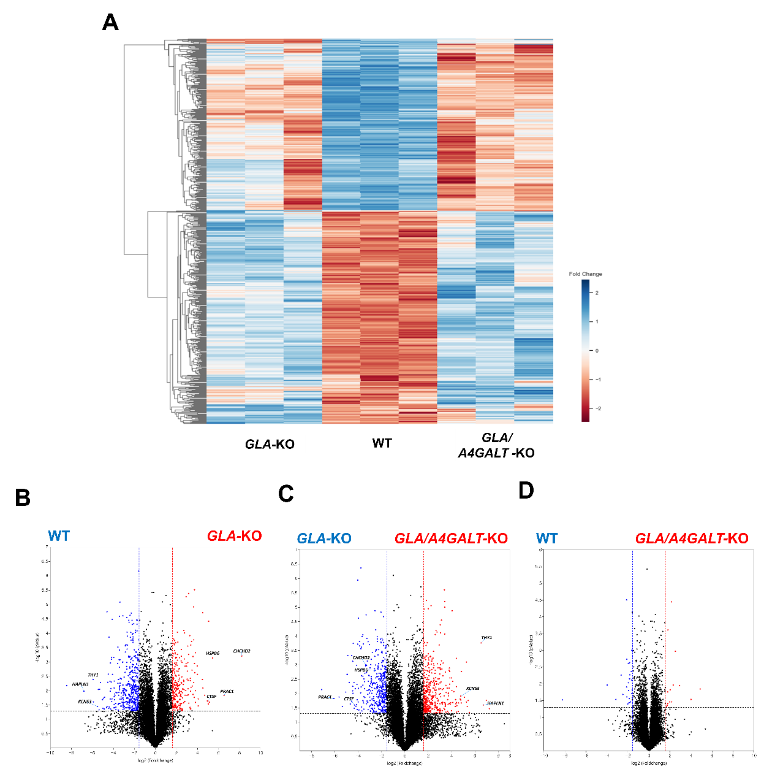
Figure S3. (A) Heatmap analysis shows differentially expressed genes (Fold Change > 3.0, p-value < 0.05) in ECs from each replicate of WT, GLA- KO, and GLA/A4AGLT-KO. Volcano plot analysis for the differentially expressed genes between (B) GLA-KO vs WT, (C) GLA/A4AGLT-KO vs GLA-KO, (D) GLA/A4GALT-KO vs. WT
ECs, endothelial cells

Supplement figure 4
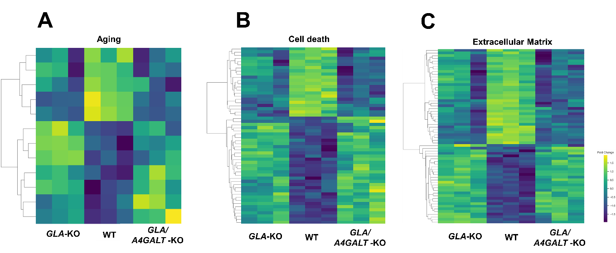

Figure S4. Heatmap analysis of differentially expressed genes (Fold Change > 3.0, p-value < 0.05) associated with (A) Aging, (B) Cell death, and (C) Extracellular matrix (ECM) in hiPSC-ECs.
ECs, endothelial cells; hiPSC, human induced pluripotent stem cells

Supplement figure 5
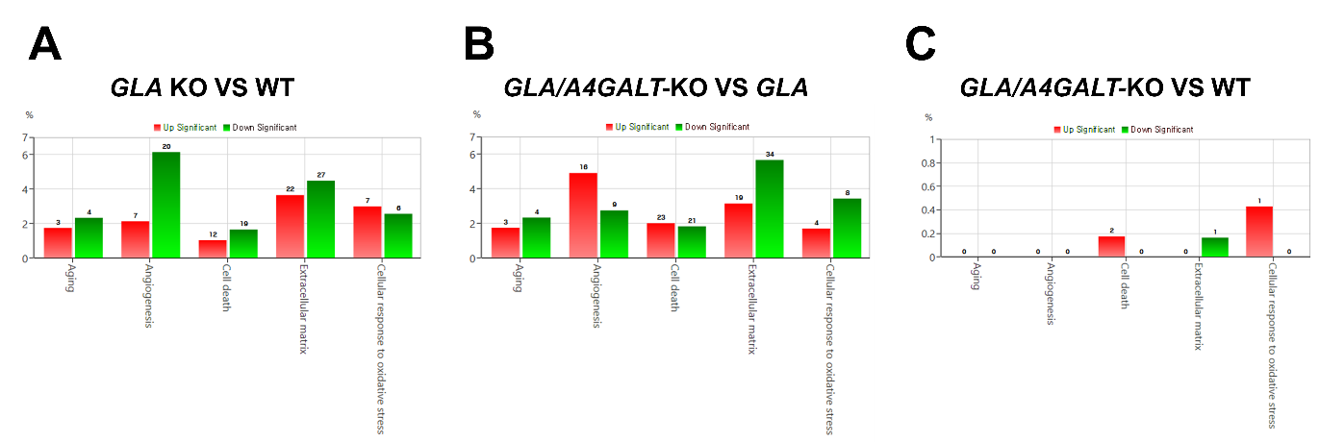
Figure S5. The number of differentially expressed genes involved in Aging, Angiogenesis, Cell death, Extracellular matrix, and Cellular response to oxidative stress between (A) GLA-KO vs WT, (B) GLA/A4AGLT-KO vs GLA-KO, (C) GLA/A4GALT-KO vs. WT

